UN/SCETDG/53/INF.42

Committee of Experts on the Transport of Dangerous Goods
and on the Globally Harmonized System of Classification
and Labelling of Chemicals 18 June 2018
Sub-Committee of Experts on the Transport of Dangerous Goods
Fifty-third session

Geneva, 25 June-4 July 2018
Item 5 (b) of the provisional agenda
Transport of gases: miscellaneous
Comments on ST/SG/AC.10/C.3/2018/36: Provision for the carriage of waste gas cartridges (UN No. 2037)
Transmitted by European Cylinder Maker Association (ECMA)
Introduction
1. UN 2037 RECEPTACLES, SMALL, CONTAINING GAS (GAS CARTRIDGES) are filled only with gas. Any liquid inside them is liquefied gas which will immediately change to a gas when it is released from the receptacle. Therefore, for gas cartridges there is no need for a “means for retaining any free liquid that might escape during carriage …”.
2. There are two methods of releasing the contents from UN 2037 RECEPTACLES, SMALL, CONTAINING GAS (GAS CARTRIDGES). In the first method the closure of the receptacle is a self-closing valve. The release device is provided by a component on the operating device into which the gas cartridge is fitted for use. The second method relies on the operating device piercing either a sealing membrane or the wall of the cartridge. Some examples of this latter type of gas cartridge are shown on the next page.
3. The proposal in document 2018/36 treats both these types of cartridge in the same way, but there is an important difference. Gas cartridges fitted with a self-closing valve are capable of retaining significant quantities of gas when they are removed from the operating device. On the other hand, gas cartridges which are pierced will immediately loose pressure (if there is any) upon removal from the operating device. It is true, as stated in the final sentence of paragraph 8 of document 2018/26, that punctured gas cartridges may contain gas residues at time of disposal. However, the quantities are very small and will only be of concern if the gas is toxic or flammable. Therefore, the precautions required by the proposal in document 2018/36 are unnecessary if the gases are non-flammable non-toxic.
4. The main purpose of this document is to request that pierced gas cartridges are excluded from Special Provision 327 provided they were filled with non-flammable non-toxic gases. Care has been taken to link the piercing process to use of the gas cartridge so as to exclude piercing waste gas cartridges with a valve.
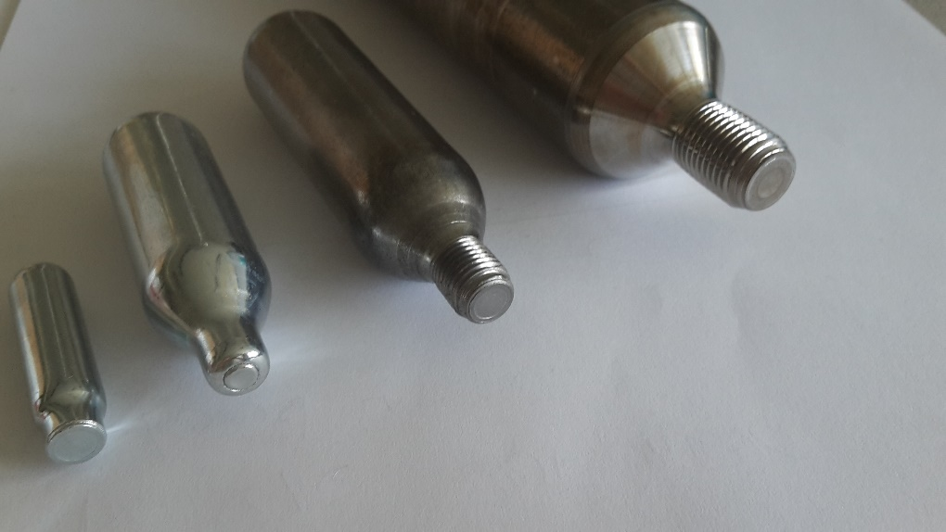
Picture 1 closed small receptacles
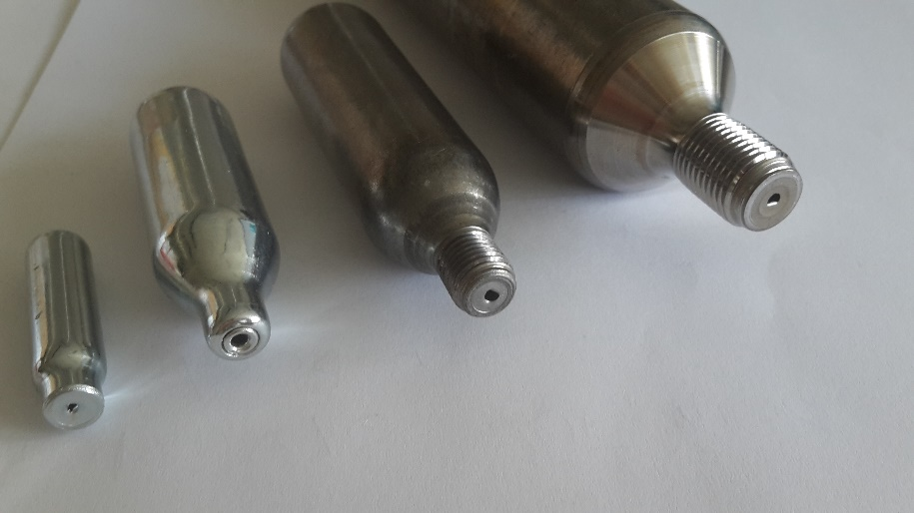
Picture 2 opened small receptacles
Proposal
5. Add the following paragraph to the end of Special Provision 327.
“This special provision does not apply to UN 2037 WASTE GAS CARTRIDGES which are designed to release the gases for use by piercing the receptacle and which were filled with gases of Division 2.2.”

