UN/SCETDG/53/INF.41
Committee of Experts on the Transport of Dangerous Goods
and on the Globally Harmonized System of Classification
and Labelling of Chemicals 18 June 2018
Sub-Committee of Experts on the Transport of Dangerous Goods
Fifty-third session

Geneva, 25 June-4 July 2018
Item 4 (f) of the provisional agenda
Electric storage systems: miscellaneous
Dimensions of the lithium battery mark
Transmitted by the Rechargeable Battery Association (PRBA) and the Advanced Rechargeable & Lithium Batteries Association (RECHARGE)
Introduction
1. The Model Regulations require the lithium battery mark in section 5.2.1.9 and shown below to be placed on nearly all packages containing small lithium ion and lithium metal cells and batteries when shipped in accordance with Special Provision 188. The mark is also widely used on packages of consumer electronic devices such as cellular phones, notebooks, tablets, and power tools that are packed with or contain lithium ion batteries.
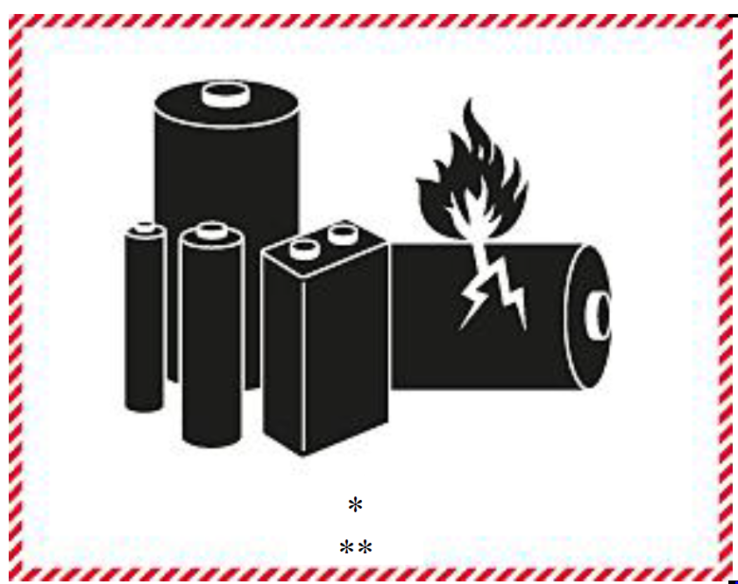
2. Section 5.2.1.9 requires the dimensions of the lithium battery mark to be a minimum 120 mm wide and 110 mm high unless the “the package size so requires, the dimensions/line thickness may be reduced to not less than 105 mm wide and 74 mm high.”
3. Over the last 17 years, the volume of lithium ion and lithium metal cells and batteries and consumer electronic devices manufactured and powered by these cells and batteries has grown exponentially. This is reflected in the manufacturing data provided below. For example, in 2017, approximately 7.2 billion lithium ion cells, 2 billion cellular phones, and 330 million notebooks and tablets were manufactured and shipped worldwide. See Figure 1 below for cellular phone, notebook, and tablet data.

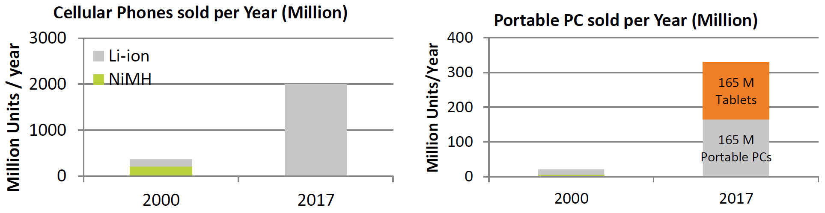
Figure 1. Approximately 2 billion cellular phones and 330 million notebooks and tablets were manufactured in 2017. (Source: AVICENNE Energy 2018)

4. In addition, the percentage of power tools equipped with lithium ion batteries has increased dramatically since 2004 as reflected in Figure 2 below.

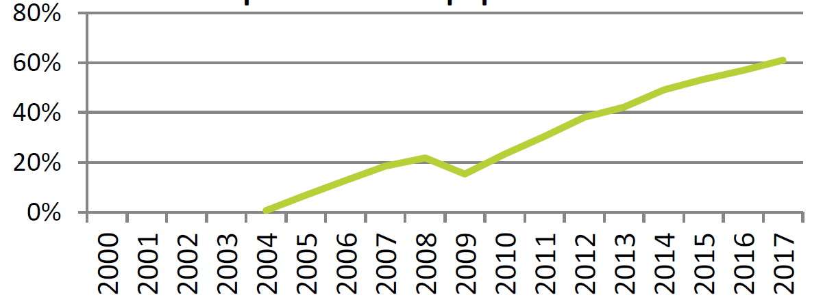
Figure 2. Percentage of power tools equipped with lithium ion batteries. (Source: AVICENNE Energy 2018)

5. The packages used to ship lithium cells and batteries and products powered by them vary tremendously in size and shape. The marking and labelling requirements for a package of batteries also varies depending on the mode of transport used. For example, a small package of four 50 Watt-hour lithium ion batteries shipped by road requires the lithium battery mark. That same package shipped by air requires the lithium battery mark, Class 9 hazard label, Cargo Aircraft Only label, and proper shipping name and UN number. The small package used for ground transport would not likely accommodate all the marks and labels required for air transport. To complicate matters, an employee working in a high volume, e-commerce shipping area must often quickly decide whether the use of a smaller lithium battery mark is authorized when they are in the process of preparing thousands of packages for transport.
6. The shipping scenario described above occurs daily at thousands of battery, electronics, e-commerce, and distribution companies. For example, one of PRBA’s members ships daily as many as 5,000 individual package consignments requiring the lithium battery mark. In some cases, companies buy oversized packages simply to accommodate the larger lithium battery mark and remove the guess work out of which mark to use. This unnecessarily increases costs and, more importantly, is a waste of resources.
7. While it is recognized that the use of two different size marks has some advantages and is authorized for other dangerous goods (e.g., Limited Quantity shipments), the volume of lithium battery and equipment shipments and the wide variations in packaging used to ship these products that require the lithium battery mark has created significant logistics and compliance challenges for thousands of shippers. PRBA and RECHARGE would therefore like the Sub-Committee to consider a minor modification to the lithium battery mark requirement by authorizing the use of the smaller mark (105 mm x 74 mm) on all packages and eliminating the reference to the larger mark. This small change would greatly simplify matters for the battery, electronics, and e-commerce industries and improve compliance for the large network of distributors who ship billions of lithium batteries and electronic devices each year.
8. It is worth noting that the Model Regulations authorize a 100 mm x 100 mm mark for excepted quantities and limited quantities as shown below. This is a smaller mark than the larger 120 mm x 110 mm lithium battery mark. In addition, a limited quantity mark as small as 50 mm x 50 mm is authorized, which is significantly smaller than the 105 mm x 74 mm lithium battery mark.

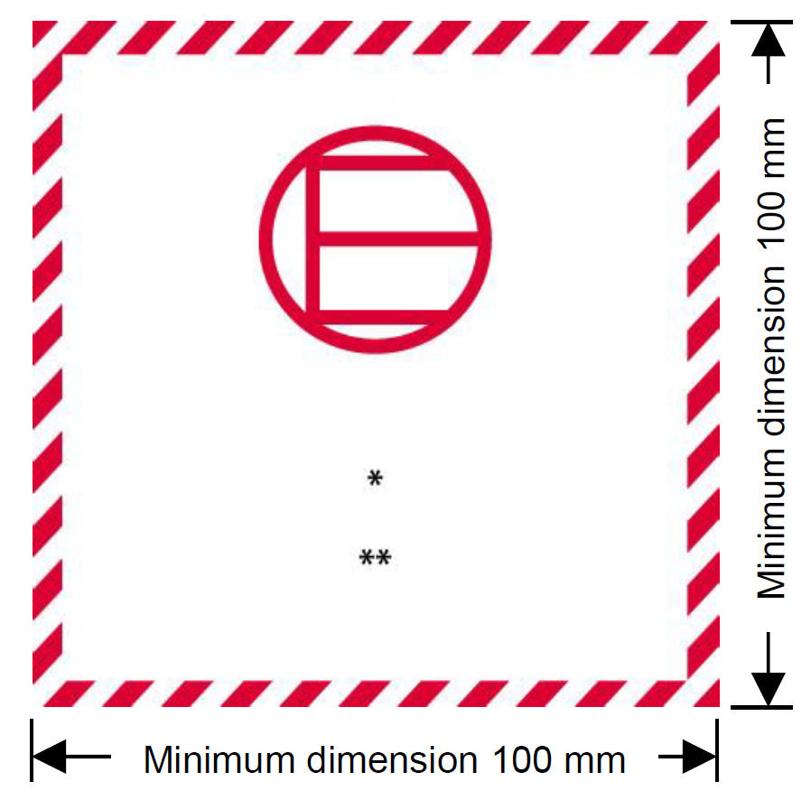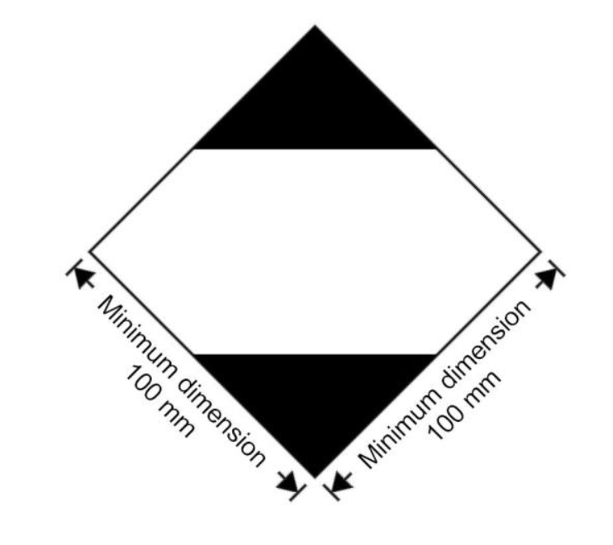
Proposal
9. The Sub-Committee is requested to consider the following changes to the last paragraph in Part 5, Section 5.2.1.9.2 of the Model Regulations:
“The mark must be in the form of a rectangle with hatched edging. The dimensions shall be a minimum of 120 105 mm wide x 110 74 mm high and the minimum width of the hatching must be 5 mm. The symbol (group of batteries, one damaged and emitting flame) above the UN number for lithium ion or lithium metal batteries or cells) shall be black on white or suitable contrasting background. The hatching shall be red. If the size of the package so requires, the dimensions/line thickness may be reduced to not less than 105 mm wide x 74 mm high. Where dimensions are not specified, all features shall be approximate proportion to those shown.”
_____________

