UN/SCETDG/53/INF.38
Committee of Experts on the Transport of Dangerous Goods
and on the Globally Harmonized System of Classification
and Labelling of Chemicals 18 June 2018
Sub-Committee of Experts on the Transport of Dangerous Goods
Fifty-third session

Geneva, 25 June-4 July 2018
Item 4 (f) of the provisional agenda
Electric storage systems: miscellaneous
Examples of lithium battery test summary and additional question and answers
Transmitted by The Rechargeable Battery Association (PRBA), the Advanced Rechargeable & Lithium Batteries Association (RECHARGE) and the Medical Device Battery Transport Council (MDBTC)
Introduction
1. Beginning January 1, 2020, the Model Regulations, IMDG Code, and ICAO Technical Instructions will require manufacturers and distributors of lithium cells and batteries and equipment powered by cells and batteries make available a “test summary” as specified in the Manual of Tests and Criteria, Part III, sub-section 38.3, paragraph 38.3.5. Questions regarding compliance with the new test summary requirement were compiled in Informal Paper INF.58 (52nd session) filed by the Medical Device Battery Transport Council (MDBTC) during the Sub-Committee’s fifty-second session.
2. During a lunchtime working group at the fifty-second session, we agreed to provide examples of test summaries prepared by PRBA members. Attached are three examples for review and consideration by the Sub-Committee. Example 1 (pages 4 and 5) list several battery model numbers that were tested by one of the four labs listed. Example 2 (page 6) list one equipment model number and the battery associated with it. Note the confidential/proprietary information associated with the name of the battery manufacturer. As previously explained to the Sub-Committee, an equipment manufacturer may not want to disclose the name of their battery suppliers in certain cases.
3. We have also reproduced the questions and answers originally presented in informal paper INF.58 (52nd session) and included clarifying text in question 2 and added questions 8, 9, and 10 for the Sub-Committee’s consideration. We expect more questions to be added over the next 18 months leading up to the January 1, 2020 test summary compliance date.
4. Question 8 is particularly important in that it addresses whether manufacturers and distributors are required to follow a specific format when presenting the information in the test summary. We do not believe a specific format is mandated by the Model Regulations.

Questions and answers related to compliance
with the test summary

- Does the TS apply to products and cells or batteries contained within products/parts or just standalone cells or batteries?

The TS applies to the cells and batteries themselves which ship as standalone cells or batteries and subsequently to the cells and batteries contained in equipment at such time when the cell or battery is added to a product.

- Can multiple batteries/manufacturers/products be listed on one report?

Yes, it is acceptable to have a single document that addresses multiple batteries/manufacturers/products, provided all required information is stated. For example, a tablet manufacturer may purchase lithium ion batteries from three different battery manufacturers. The tests summary for the product will therefore list batteries and all related information (e.g., Watt-hours, test labs) from the three battery manufacturers without naming the manufacturer due to confidentiality issues.

- Is it acceptable to list the various test houses, tests and range of revisions tested to for the UN 38.3 revision and amendments?

Yes, it is acceptable to have multiple test houses and their addresses, email etc. information listed provided all required information is stated. The Test house is not required to be aligned to a specific battery or product on test summary when the test summary covers multiple batteries/products. It is required to have the test report number and date of test for each cell/battery/product listed on the test summary.

- What is meant by physical description of cell or battery? (Should read physical description of cell/battery/product.)

A physical description is intended to provide a check for the person requesting the test summary to know that it applies to the cell/battery/product covered by the test summary. i.e. if cell phone, description could be the invoice description or marketing name of the product as the physical description.

- What does availability of report mean: “When requested?”.

Any individual or entity in the supply chain may request the test summary. i.e. regulator, consumer, transport provider.

- Can the test summary provider require a requestor to obtain the document from a website?

Yes, it is acceptable for the provider to require the requestor to obtain a document electronically from a provider's website. The provider must ensure that the cell/battery/product has appropriate identifiers to align to the test summary.

- If a manufacturer considers their suppliers, test house and battery data confidential and competitive information, how would test summary compliance be achieved?

All 10 data elements and listed subsets of information is required to be on the test summary. As indicated above, the test house information may be listed to cover a range of products.

- Is there a mandated format for the test summary that manufacturers and distributors must follow?

No. Manufacturers and distributors may compile the information required in the test summary using any format.
- If a test summary is requested by a dangerous goods enforcement agency, how quickly must the test summary be made available? For example, would a manufacturer be expected to immediately produce a test summary or provide it within a certain amount of time (e.g., 72 hours)

Due to the large volume of lithium batteries and lithium battery powered products that are shipped daily, manufacturers and distributors should not be expected to immediately provide a test summary for every product they ship. Manufacturers and distributors should be provided a reasonable amount of time to provide the required test summary.
- Would manufacturers and distributors of battery powered vehicles (UN3171) and hybrid vehicles containing a lithium battery (UN3166) be expected to provide a test summary?
Yes. The test summary requirement applies to manufacturers and distributors of lithium battery powered vehicles and other vehicles containing lithium batteries.

Example 1 of lithium ion battery test summary
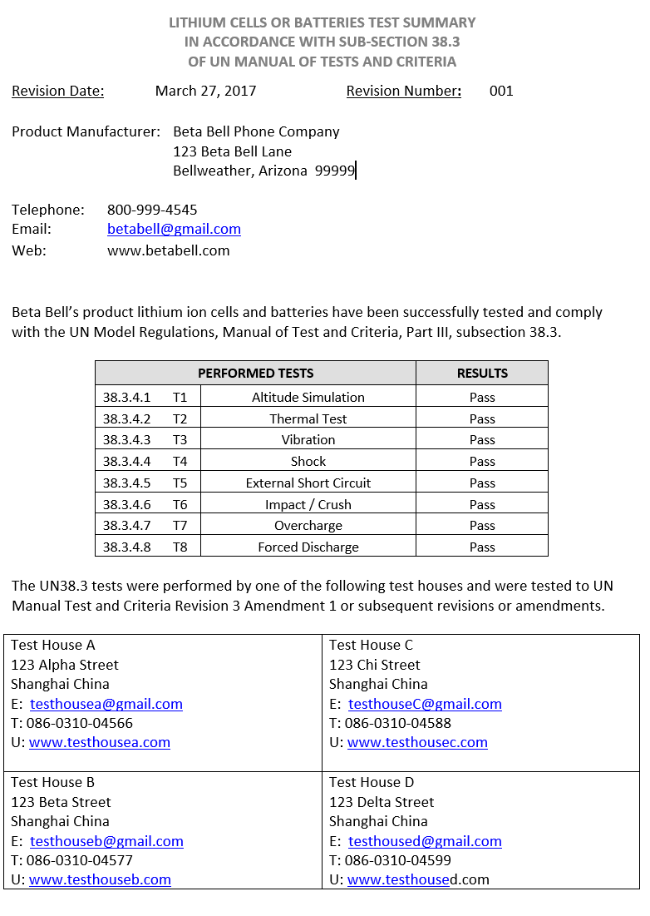
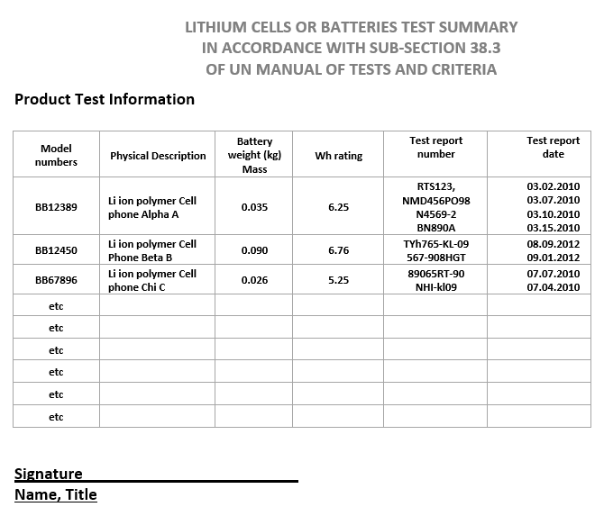

Example 2 of lithium ion battery test summary
UN38.3 Lithium Battery Test Summary for GreenTech
Tablet Model No. T54321
1 | Battery Manufacturer  Confidential and Proprietary GreenTech Information
2 | Product Manufacturer  GreenTech  123 Main Street  Annapolis, MD 21012  888.111.2345  contact@greentech.com; www1.greentech.com
3 | UN38.3 Test Lab  Bob’s Battery Test Lab  1600 Pennsylvania Avenue  Smithfield, VA 12345  Phone: 211.789.2345  bob@testlab.org; www.testlab.org
4 | Test Report Number  Liion621345
5 | Date of Test Report  April 1, 2017
6 | Description of Cell or Battery  7.4 V, 1800 mAh, 13.32 Wh  Li ion battery, Model No. P1789  Small, rectangular plastic case, 100 grams
7 | UN38.3 Tests Performed and Successfully Passed  T.1, T.2, T.3, T.4, T.5, and T.7. (Note that T.6 and T.8 are not applicable to batteries.)
8 | Assembled Battery Testing Requirements  Not Applicable
9 | Edition of UN Manual of Tests and Criteria Used  Sixth Revised Edition
10 | Name and Title of Signatory  Jason Alexander  Jason Alexander  GreenTech Staff Engineer

Example 3 of lithium ion cell test summary



