|  |  |  |  |
| --- | --- | --- | --- |
|  | United Nations | ST/SG/AC.10/C.3/2018/52 | |
| _unlogo | **Secretariat** | | Distr.: General 6 April 2018  Original: English |

**Committee of Experts on the Transport of Dangerous Goods  
and on the Globally Harmonized System of Classification  
and Labelling of Chemicals**

**Sub-Committee of Experts on the Transport of Dangerous Goods**

**Fifty-third session**

Geneva, 25 June-4 July 2018

Item 2 (e) of the provisional agenda

**Explosives and related matters: miscellaneous**

Determination of electrostatic sensitiveness discharge (ESD) using the Allegany Ballistics Laboratory (ABL) ESD machine

Transmitted by the Sporting Arms and Ammunition Manufacturer’s Institute (SAAMI)[[1]](#footnote-2)

Introduction

1. Model Regulations, Volume II, Part 4, 4.1.1.14 states that “plastic packagings shall not be liable to generate or accumulate sufficient static electricity so that a discharge could cause the packaged explosive substance or articles to initiate, ignite or function.” However, the amount of static electricity necessary for ignition varies with different explosives, and there are no technical methods provided/referenced to determine the sensitivity of explosives to electrostatic discharge.
2. This paper addresses a proposed method for determining the sensitivity of explosives to electrostatic discharge that has been utilized by government and industry laboratories since the 1970s.

Discussion

3. The ABL ESD machine is a device that determines the electrostatic discharge sensitivity of a solid, semisolid, powder, or liquid substance using a sample of approximately 20 mg (refer to Figures 1, 2 and 3).

4. The ABL ESD machine can be used to express electrostatic discharge sensitivity results in calibrated engineering units (Joules). These data can be then compared to the potential charge generation and discharge capability of plastic packagings.

5. The machine consists of a grounded base plate, a metal sample holder that attaches to the base plate, a discharge needle above the sample, a high-voltage supply and a capacitor bank. The high-voltage supply charges a capacitor or series of capacitors after which the charged capacitor(s) are discharged to ground through the discharge needle and sample. The amount of electrostatic energy imparted to the sample is controlled by varying the voltage and capacitance in the capacitor bank. Initiation can be observed via several methods including operator senses (audible report, or production of smoke, fire, charring or visible light), gas analysis, or analysis of high-speed camera images. Initiation sensitivity at different ESD energies can be determined by various methods including Probit, Bruceton, Langlie, or Sequential Experimental Designs for Generalized Linear Models.

6. The ABL ESD machine is capable of an applied voltage range from 0 – 10,000 volts direct current (VDC). The capacitance values can be adjusted to predetermined values ranging between 0.10 × 10-4 – 0.75 microfarads (µF), resulting in discharge energies from 0.001 - 37.5 Joules (J).

7. The critical aspects of the ABL ESD machine have been standardized via the Explosives Testing Users’ Group (ETUG) including machine operation, calibration, sample preparation, and reaction determination. The ETUG is an international group of explosives testing experts with a charter to systematically minimize the variability associated with energetic materials testing to enable consistent/repeatable test data and interpretation of test results.

Proposal

8. The Sub-Committee is requested to review this proposal and provide input on possible ways forward. SAAMI may return with a proposal for further consideration at the fifty-fourth session.

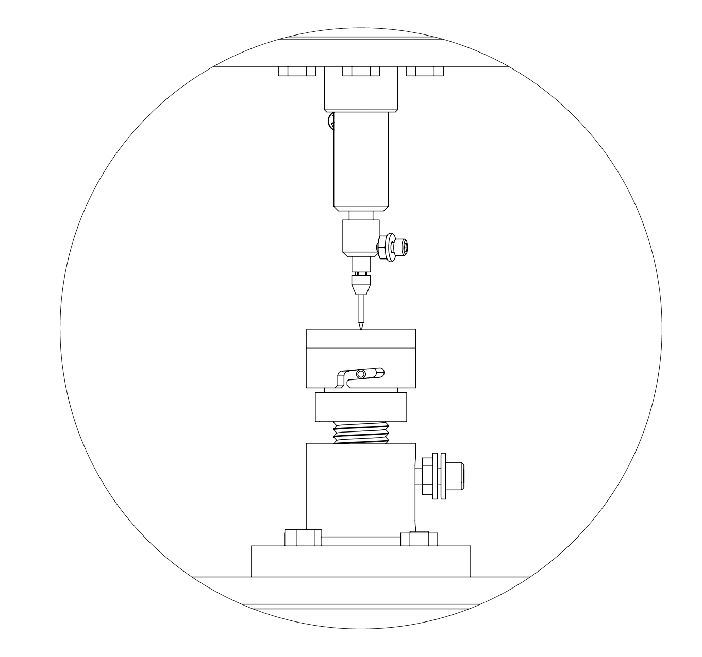

D

C

B

A

|  |  |  |  |
| --- | --- | --- | --- |
| (A) | Sample Holder | (B) | High-voltage connection |
| (C) | Needle | (D) | Ground connection |

**Figure 1: Example drawing of needle, sample holder, and grounding for an ABL ESD Machine**

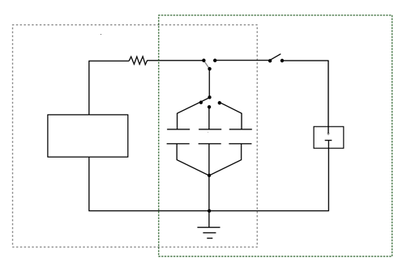

Charging circuit

Firing circuit

High-voltage

supply

Capacitor Bank

Device/Substance

under test

**Figure 2: Diagram of example wiring for charging and firing circuits for an ABL   
ESD machine**

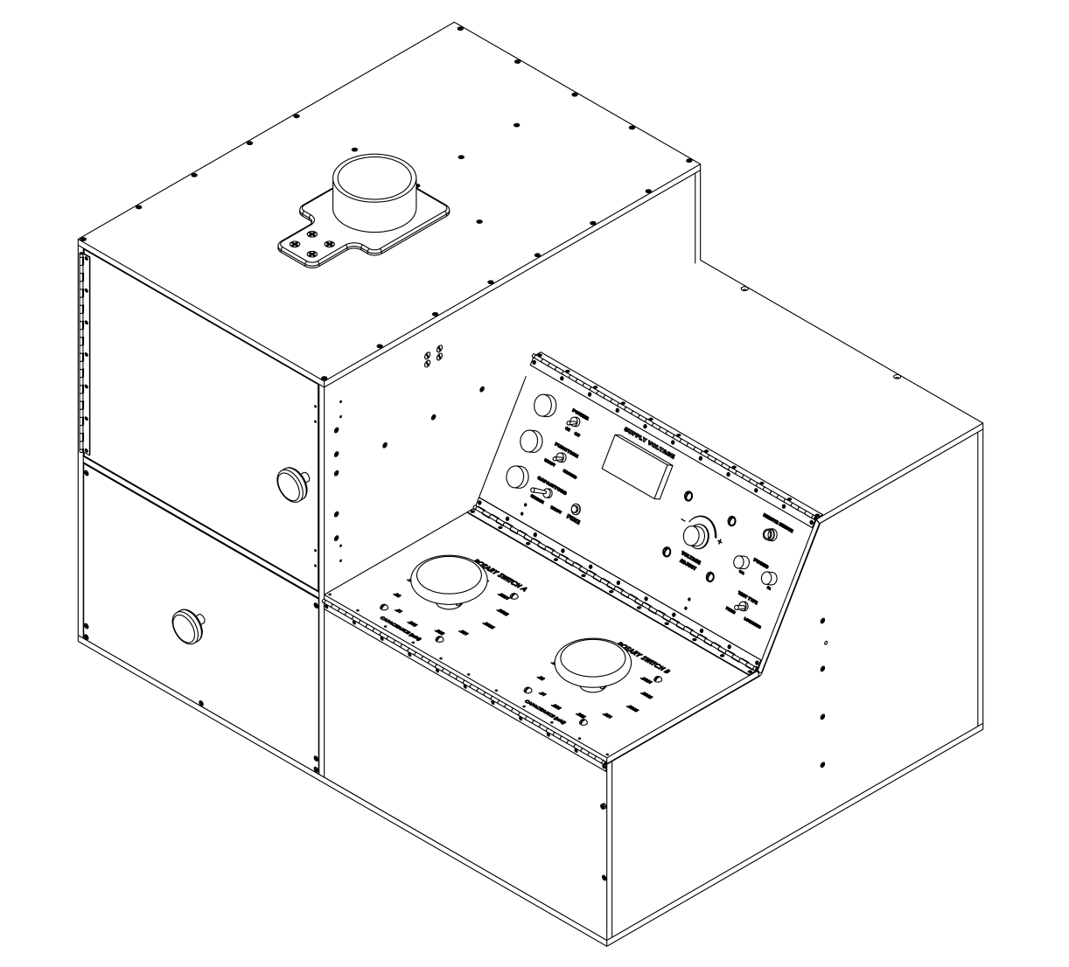

B

C

A

|  |  |
| --- | --- |
| (A) | Dials to adjust the capacitance |
| (B) | Voltage display |
| (C) | Voltage adjust dial |

**Figure 3: Example ABL ESD machine”**

1. In accordance with the programme of work of the Sub-Committee for 2017–2018 approved by the Committee at its eighth session (see ST/SG/AC.10/C.3/100, paragraph 98 and ST/SG/AC.10/44, paragraph 14). [↑](#footnote-ref-2)