|  |  |  |  |
| --- | --- | --- | --- |
|  | United Nations | ST/SG/AC.10/C.3/2018/102 | |
| _unlogo | **Secretariat** | | Distr.: General  5 September 2018  Original: English |

**Committee of Experts on the Transport of Dangerous Goods  
and on the Globally Harmonized System of Classification  
and Labelling of Chemicals**

Sub-Committee of Experts on the Transport of Dangerous Goods

**Fifty-fourth session**

Geneva, 26 November-4 December 2018  
Item 6 of the provisional agenda  
**New proposals for amendments to the Model Regulations   
on the Transport of Dangerous Goods**

Optical differentiation of labels for gases

Submitted by the expert from Spain[[1]](#footnote-2)

Introduction

1. Different labels corresponding to different classes differentiate themselves only by the number indicated in the lower part of the label. This occurs for labels 2.1 and 3, and labels 2.3 and 6:

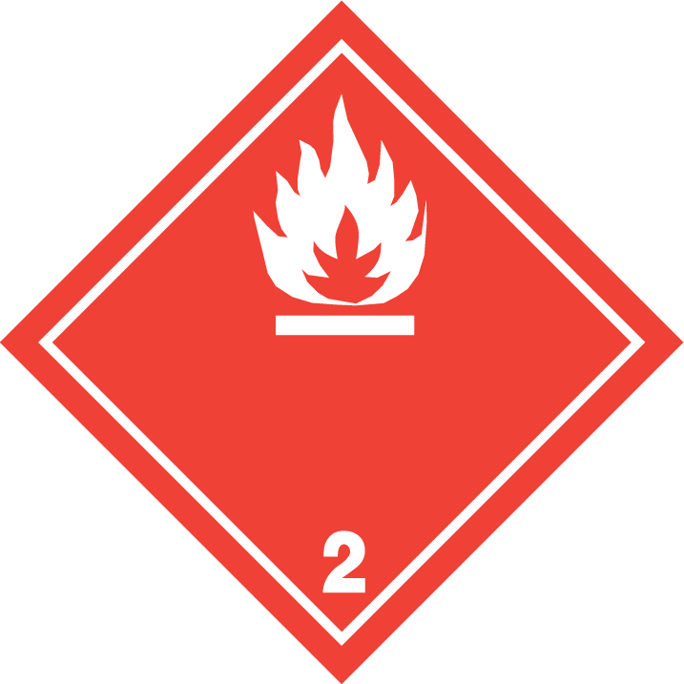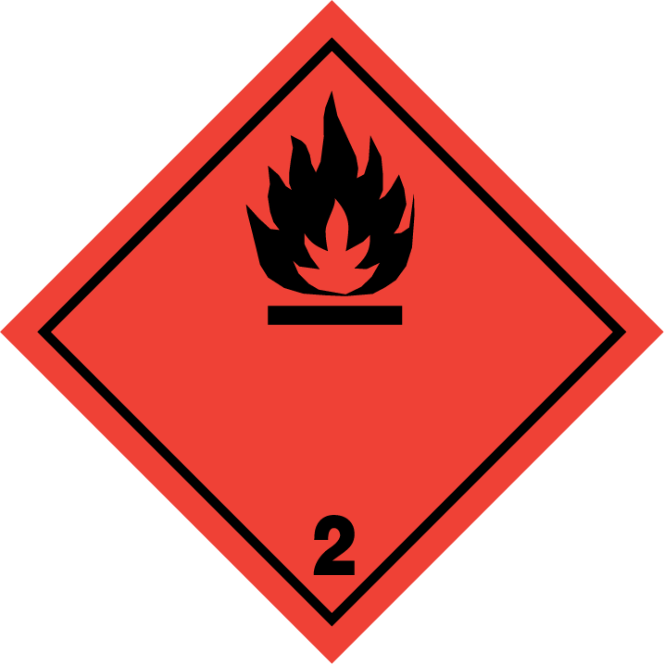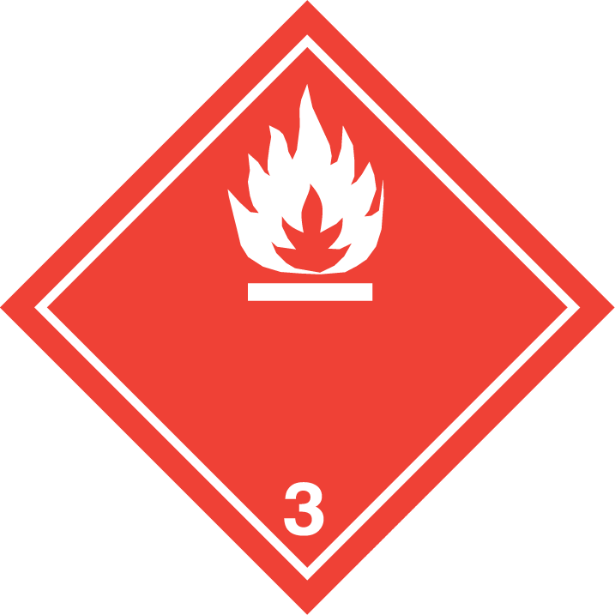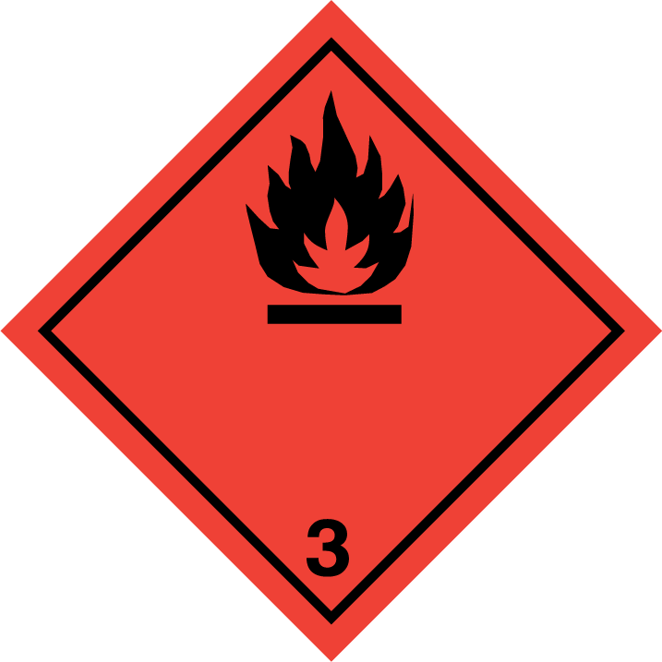

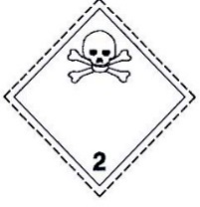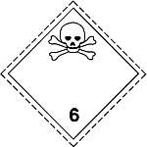

2. This situation can create some difficulties for the first emergency responders (police, firefighters, etc), which should be able to distinguish easily one label from another. Not doing so could lead to erroneous responses at the site of an accident. Responses to incidents with flammable gases are very different from those involving flammable liquids, and it is also different to have a toxic gas or a toxic liquid or solid.

Analysis

3. The labels mentioned above have the same colour and symbol, being the only difference the class number indicated in the lower part of the label.

4. The colour of the labels is a clear and overwhelming clue to differentiate the labels from the distance, and to allow first emergency to have a clear view of the problem they are faced with.

5. Label 2.2 is green and therefore easily distinguished from the distance:

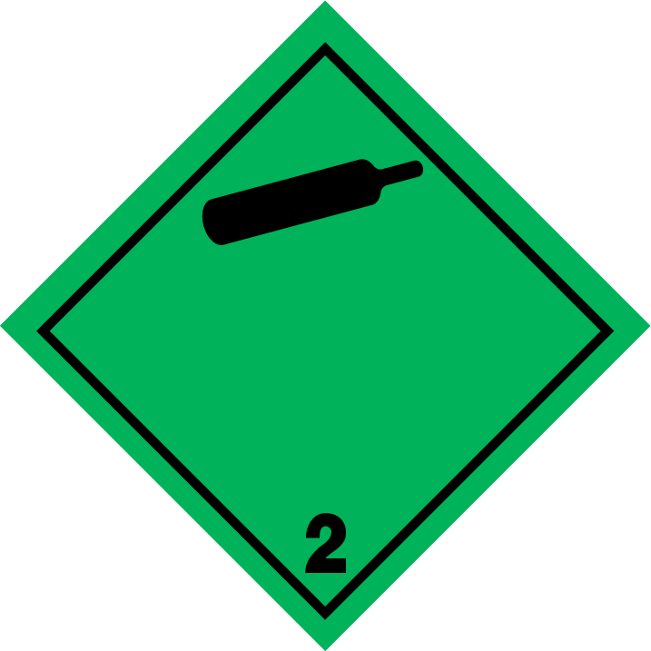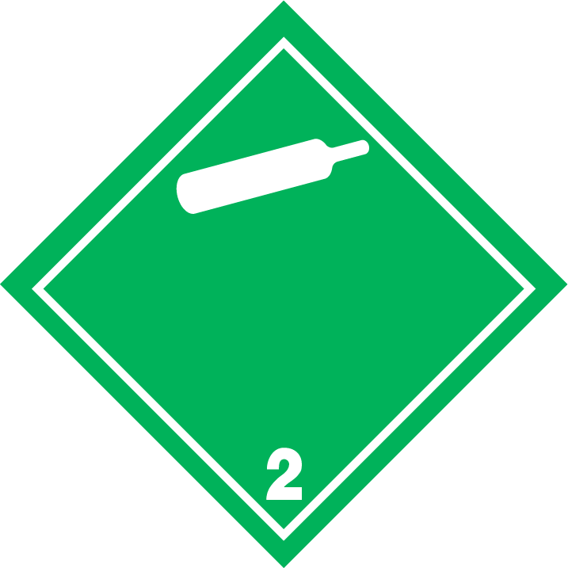

6. It would perhaps be interesting to modify labels 2.1 and 2.3 to include the green colour, to easily transmit the information that the product is not only flammable or toxic, but also gas. A possible design that would convey this information could be the following:

1. Label 2.1, Flammable gases:



1. Label 2.3, Toxic gases:

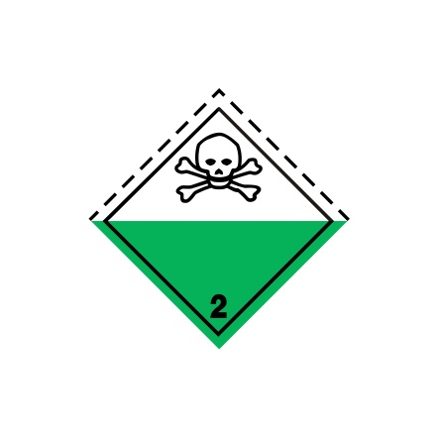

7. In this design, the upper part of the label remains like in its present design, and the green colour, already associated with gases, is included in the lower part. All gas labels would be partially green, and this would allow an easy recognition of these labels also from the distance.

 

8. A similar change has already been carried out in label 5.2 to easily differentiate organic peroxides, including a different colour in the upper and lower parts of the label:

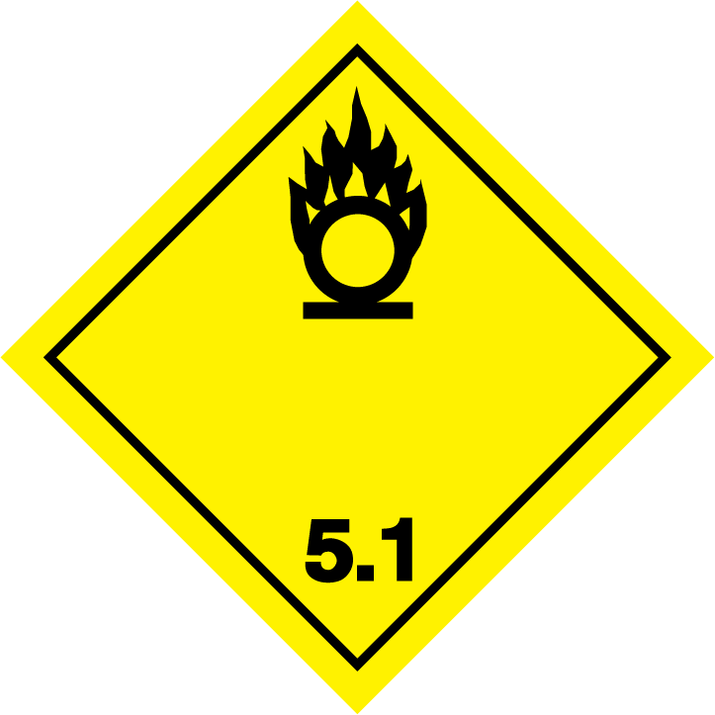

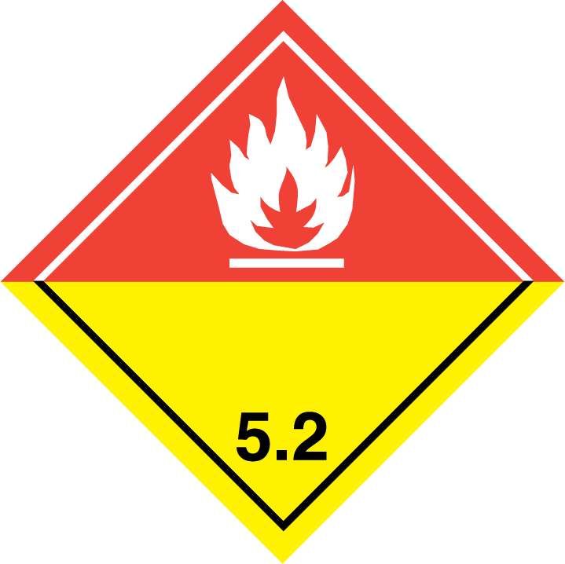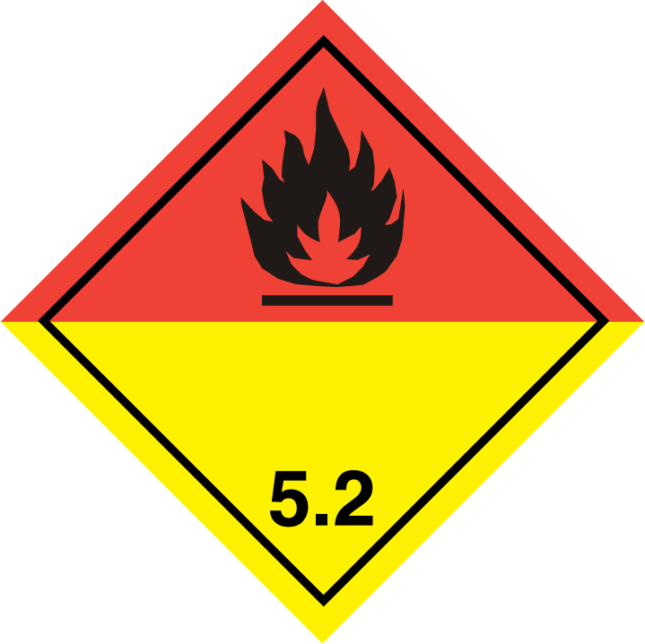

Proposal

9. Spain proposes to modify labels 2.1 and 2.3 to include a green lower part into these labels. Therefore, the expert from Spain proposes to modify 5.2.2.2.2 for label numbers 2.1 and 2.3. Deleted text is stricken through, new text in bold; for the specimen labels of labels 2.1 and 2.3, only the new labels are shown, as it is not possible to strike through or underline the labels.

|  |  |  |  |  |  |  |  |
| --- | --- | --- | --- | --- | --- | --- | --- |
| **Label model No.** | **Division or Category** | **Symbol and symbol colour** | **Background** | **Figure in bottom corner**  **(and figure colour)** | **Specimen labels** | | **Note** |
| **Class 2: Gases** | | | | | | | |
| 2.1 | Division 2.1: Flammable gases (except as provided for in 5.2.2.2.1.6 d)) | Flame: black or white | ~~Red~~ **Upper half red, lower half green** | 2  (black or white) | Z:\Silvia en Z\_TDG\TDG 2018.12\Mitad verde de la etiqueta 2.3\Etiqueta_rojo_verde_negro_2.jpg | Z:\Silvia en Z\_TDG\TDG 2018.12\Mitad verde de la etiqueta 2.3\Etiqueta_rojo_verde_blanco_2.jpg | - |
| 2.2 | Division 2.2:  Non-flammable, non-toxic gases | Gas cylinder: black or white | Green | 2  (black or white) |  |  | - |
| 2.3 | Division 2.3: Toxic gases | Skull and crossbones: black | ~~White~~ **Upper half white, lower half green** | 2  (black) | Z:\Silvia en Z\_TDG\TDG 2018.12\Mitad verde de la etiqueta 2.3\Etiqueta 2_3 gas toxico.jpg | | - |

10. Additionally, a transitory period for this measure should be introduced into the different modal regulations, of at least 4 years, to allow the older models of labels to still be used.

1. In accordance with the programme of work of the Sub-Committee for 2017–2018 approved by the Committee at its eighth session (see ST/SG/AC.10/C.3/100, paragraph 98 and ST/SG/AC.10/44, para. 14). [↑](#footnote-ref-2)