Submitted by the expert from Belgium | Informal document GRSP-62-04  (62nd GRSP, 12-15 December 2017  agenda item 10)

Proposal for Supplement 3 to the 05 series of amendments Regulation No. 22 (Protective helmets)
Submitted by the expert from Belgium
The text reproduced below was prepared by the expert from Belgium. It introduces amendments to Regulation No. 22 (Helmets). The modifications to the existing text of the UN Regulation are marked in bold for new or strikethrough for deleted characters.
I. Proposal
Annex 12, amend to read:
"Annex 12
Type approval scheme (Flow chart)
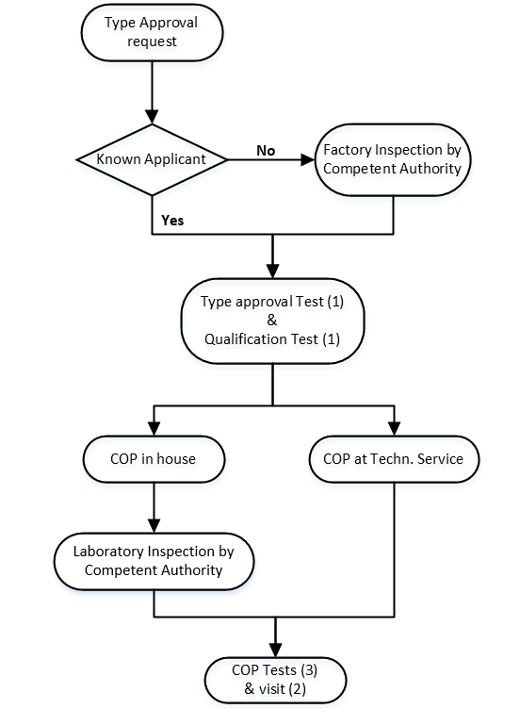

- Or an equivalent standard, i.e. one that delivers the same or better levels of quality.
- To be carried out at the same technical service or the same accredited independent laboratory.
- Visit of the manufacturer for inspection and random sampling by the authority or technical service:
- if there is no ISO 9002* or an equivalent standard : 3 1 times a year
- if there is an ISO 9002* or an equivalent standard : 1 time every 1 to 2 years, depending on the results of the inspection.
- Tests in accordance to paragraph 10.5 and/or 10.6 on samples taken out of the production:
- if there is no ISO 9002* : of the authority or technical service during the visit of footnote 2 a) of the manufacturer between the visits of footnote 2 a)
- if there is an ISO 9002* : taken by the manufacturer, procedure checked during visit of footnote 2 b)
* or an equivalent standard, i.e. one that delivers the same or better levels of quality."
II. Justification
The flowchart has been simplified but there is no change of content.

Currently all the contracting parties do not respect the frequency of visit for inspection and random sampling indicated at annex 12, it is indeed disproportionate. The proposal aims to have a frequency more appropriate while ensuring an effective control of the conformity of production and which could be respected by all contracting parties.

