Submitted by the expert from Germany | Informal document GRSG-112-31  (112th GRSG, 24-28 April 2017  agenda item 7)

Proposal for amendments to UN Regulation No. 67 (LPG vehicles)

The text reproduced below was prepared by the experts from Germany. It proposes a new series of amendments to UN Regulation No. 67 to improve the specifications for the LPG-Multi-valve. The modifications to the current text of UN Regulation No. 67 are marked in bold for new characters and strikethrough for deleted characters.

I. Proposal

Paragraph 16.5.8.1., amend to read:

"6.15.8. Provisions Regarding the Pressure Relief Valve (Discharge Valve)

6.15.8.1. The pressure relief valve shall be mounted inside the container or on the container, in the area where the fuel is in gaseous state. Any components connecting the pressure relief valve with the gaseous phase shall be made of metallic material. "

Paragraph 6.15.8.7., amend to read:

"6.15.8.7. The pressure relief device shall be mounted on the container in the gaseous zone. Any components connecting the pressure relief device with the gaseous phase shall be made of metallic material. "

II. Justification

With this Informal Document the expert from Germany wants to address the necessity to improve the requirements of the regulation and to invite other contracting parties to share their experience, aiming at preparing a working document for the next GRSG session.

In 2014 an incident happened in Germany where a LPG-vehicle was set on fire as a result of an accident. During the rescue operations, the LPG-container exploded, resulting in 10 partial serious injured fire figthers.
The analysis of the incident, triggered by the German Type Approval Authority (KBA), came to the conclusion that the hose connecting the PRV/PRD of the multivalve to the gaseous phase was fallen apart and hose-fragments blocked both PRV and PRD, so pressure could not be reduced in time.
PRV and PRD were activated, but the fragments reduced the effective section of the relevant piping too much to release the pressure.

This section shows the relevant part of the component with PRV, PRD and the hose connecting both with the gaseous phase:  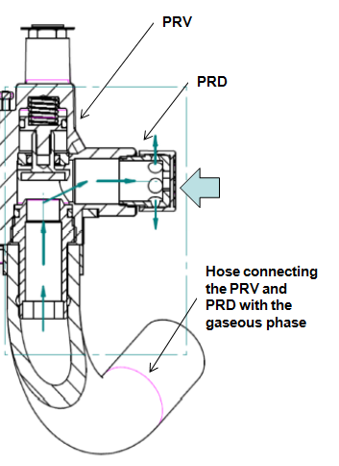 | View through PRD-port (direction of arrow) with rubber-fragment:  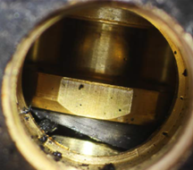
View from connection piece from PRV-side blocked by hose fragment:
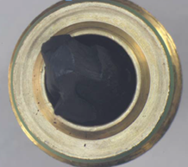

Tests performed on other (identical) multi-valves reproduced the results.
Recall and optimization was an immediate action.

Since the hose had passed the type approval tests (e.g. LPG compatibility) but the effect was reproducible, it leads to the conclusion that these tests might not be sufficient especially for non-metallic materials permanently in contact with especially liquid LPG.
The composition of LPG may vary pretty much, plus additives and/or odorisation of LPG affect non-metallic material in a way that might not be sufficiently covered by the specifications given in UN-R67.
The mandatory use of metallic material for the hose under discussion would exclude that hose-fragments could block the PRV and PRD and will therefore increase the safety level.

____________

