|  |  |  |  |
| --- | --- | --- | --- |
|  | United Nations | ECE/TRANS/WP.29/GRRF/2017/8 | |
| Description: _unlogo | **Economic and Social Council** | | Distr.: General  10 November 2016  Original: English |

**Economic Commission for Europe**

Inland Transport Committee

**World Forum for Harmonization of Vehicle Regulations**

**Working Party on Brakes and Running Gear**

**Eighty-third session**

Geneva, 23-27 January 2017

Item 9(a) of the provisional agenda

**Steering equipment: Regulation No. 79**

Proposal for amendments to Regulation No. 79 (Steering equipment)

Submitted by the expert from the European Commission[[1]](#footnote-2)\*

The text reproduced below was prepared by the expert from the European Commission and already proposed for review at the eighty-second session of the Working Party on Brakes and Running Gear (GRRF). The proposal is aimed at clarifying the requirements set in Annex 6 to Regulation No. 79. The modifications to the existing text of the Regulation are marked in bold for new or strikethrough for deleted characters.

I. Proposal

*Annex 6*

*Paragraph 1.,* amend to read (insert a last subparagraph):

"1. General

…

**Involvement of the technical service at an early stage in the design process is recommended for an effective assessment of "The System" to the requirements of this annex.**"

*Paragraph 3.2.,* amend to read:

"3.2. Description of the **design process methodology and** functions of "The System"

**A description should be provided of the methodology applied for the design of “The System”, which includes the processes and standards followed within the design and development life cycle, for example for the automotive industry these may include ISO 26262, MISRA C and Automotive SPICE. The application of the methodology shall be demonstrated by an assessment report established by a competent authority. This may include a certificate of accreditation issued by an accreditation body.**"

*Paragraph 3.4.4.,* amend to read:

"3.4.4. The documentation shall be supported, by an analysis which shows, in overall terms, how the system will behave on the occurrence of any one of those ~~specified~~ **identified** **hazards or** faults which will have a bearing on vehicle control performance or safety.

~~This may be based on a Failure Mode and Effect Analysis (FMEA), a Fault Tree Analysis (FTA) or any similar process appropriate to system safety considerations.~~

The chosen analytical approach(es) shall be established and maintained by the Manufacturer and shall be made open for inspection by the technical service at the time of the type approval.

**The technical service shall perform an audit of the application of the analytical approach(es). The audit shall include:**

* **Inspection of the safety approach at the concept (vehicle) level with confirmation that it includes consideration of interactions with other vehicle systems. This may be based on a Hazard and Operability analysis (HAZOP) or any similar process appropriate to system safety.**
* **Inspection of the safety approach at the system level. This may be based on a Failure Mode and Effect Analysis (FMEA), a Fault Tree Analysis (FTA) or any similar process appropriate to system safety.**
* **Inspection of the validation plans. This may include Hardware in the Loop (HIL) testing and vehicle on–road operational testing with expert and/or non-expert drivers or any similar testing appropriate for validation.**

**The audit shall consist of spot checks of selected hazards and faults to establish that argumentation supporting the safety concept is understandable and logical and validation plans are suitable and have been completed.**

**Recommendations may be made for tests to be performed in paragraph 4. to verify the safety concept.**"

*Insert new paragraph 3.4.4.2.*, to read:

"**3.4.4.2. This documentation shall describe the resistance of "The System" to environmental influences, e.g. climate, mechanical resistance and electromagnetic compatibility.**"

*Paragraph 4.1.2.*, amend to read:

"4.1.2. Verification of the safety concept of paragraph 3.4.

The reaction of "The System" shall, at the discretion of the type approval authority, be checked under the influence of a failure in any individual unit by applying corresponding output signals to electrical units or mechanical elements in order to simulate the effects of internal faults within the unit.

**It is recommended that these tests include aspects that impact on vehicle controllability and user information (HMI aspects).**"

*Paragraph 5.,* amend to read:

**5. Reporting by technical service**

**Reporting of the audit by technical service shall be performed in such a manner that allows traceability, e.g. versions of documents inspected are coded and listed in the records of the technical service.**

**An example of a possible layout for the report from the technical service to the type approval authority is given in the template in Part II of this document.**

II. Example of Report Layout

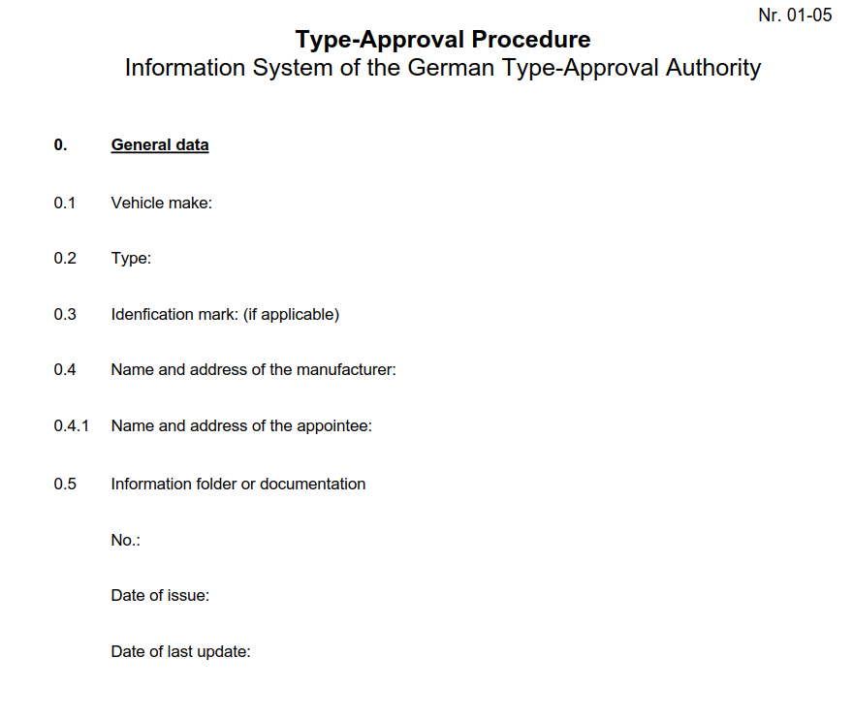

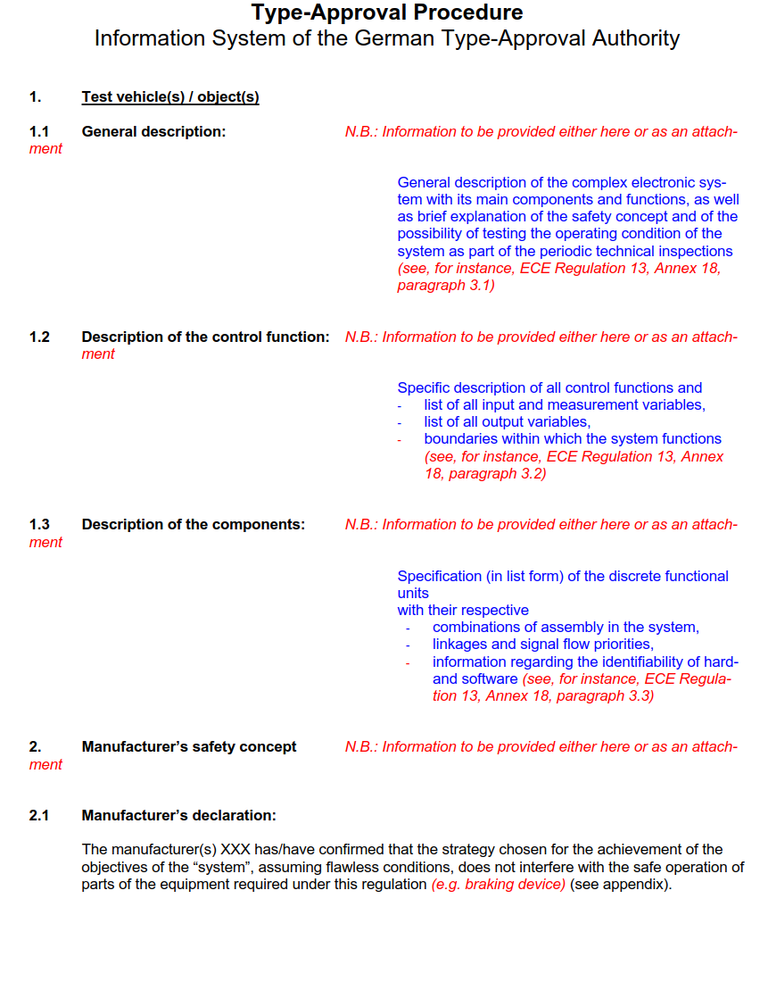

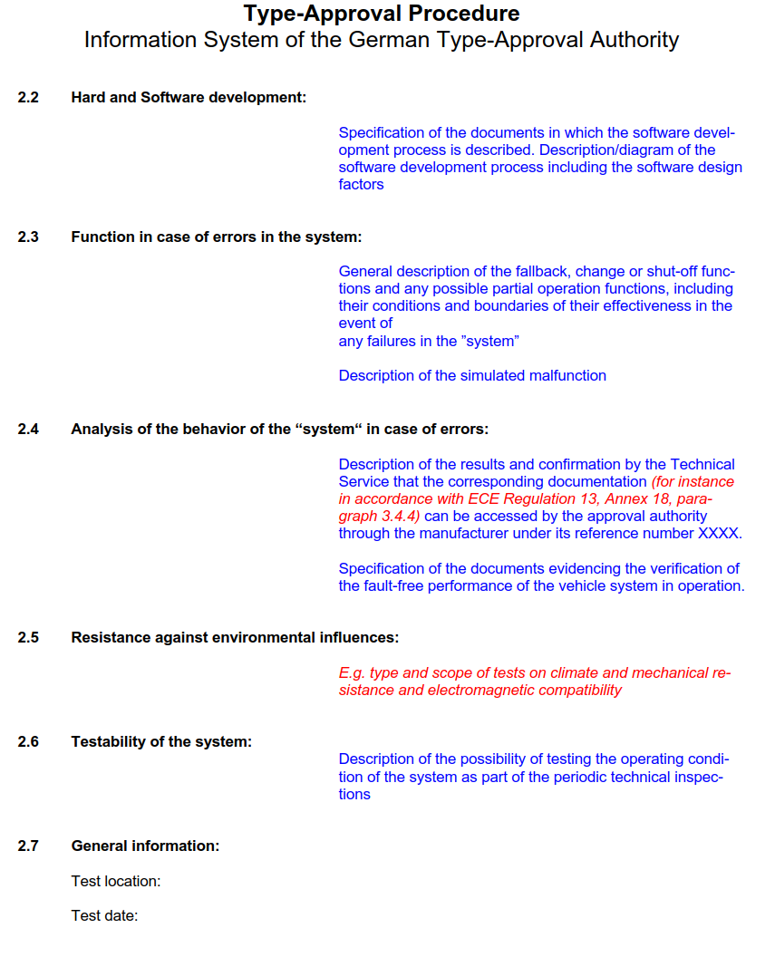

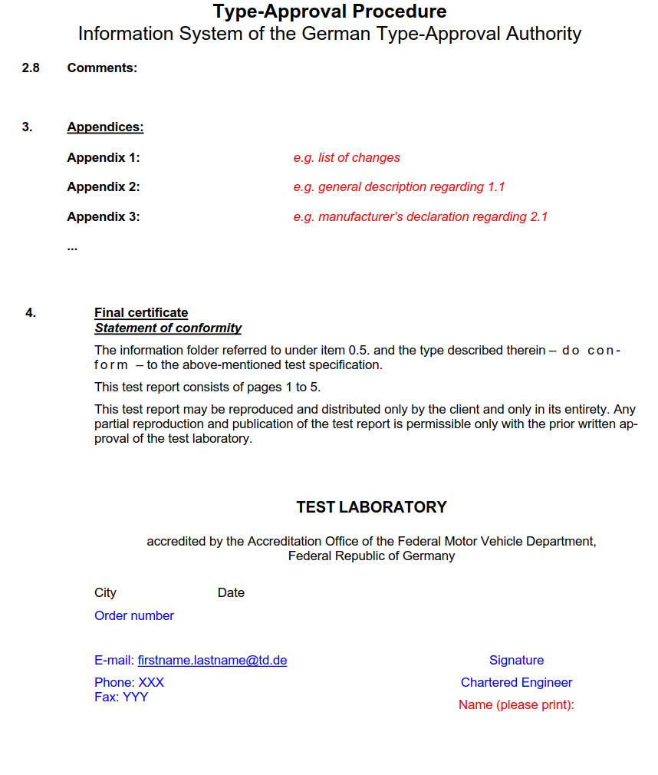

III. Justification

GRRF reviewed this proposal as in informal document GRRF-82-19 at its eighty-second session, agreed to resume consideration of this proposal at its eighty-third session and requested the secretariat to distribute the original document with an official symbol at its eighty-third session

1. \* In accordance with the programme of work of the Inland Transport Committee for 2016–2017 (ECE/TRANS/254, para. 159 and ECE/TRANS/2016/28/Add.1, cluster 3.1), the World Forum will develop, harmonize and update Regulations in order to enhance the performance of vehicles. The present document is submitted in conformity with that mandate. [↑](#footnote-ref-2)