|  |  |  |  |
| --- | --- | --- | --- |
|  | United Nations | ECE/TRANS/WP.29/GRE/2017/18 | |
| _unlogo | **Economic and Social Council** | | Distr.: General  7 August 2017  Original: English |

**Economic Commission for Europe**

Inland Transport Committee

**World Forum for Harmonization of Vehicle Regulations**

**Working Party on Lighting and Light-Signalling**

**Seventy-eighth session**

Geneva, 24–27 October 2017

Item 5 of the provisional agenda

**Regulations Nos. 37 (Filament lamps), 99 (Gas discharge light sources), 128 (Light emitting diodes light sources) and the Consolidated Resolution on the common specification of light source categories**

Proposal for amendment 1 to the original version of the Consolidated Resolution on the common specification of light source categories

Submitted by the expert from the International Automotive Lighting and Light-Signalling Expert Group (GTB)[[1]](#footnote-2)\*

The text reproduced below was prepared by the expert from GTB to correct and amend some details of light source category specifications in the Consolidated Resolution on the common specification of light source categories (R.E.5) (ECE/TRANS/WP.29/2016/111). There are no associated amendments to Regulation Nos. 37, 99 or 128. The modifications to the existing text of the Resolution are marked in bold for new or strikethrough for deleted characters.

**I. Proposal**

*The Status table*, amendto read:

"**Status table**

This consolidated version of this Resolution contains all provisions and amendments adopted so far by the World Forum for Harmonization of Vehicle Regulations (WP.29) and is valid from the date as indicated in the following table until the date on which the next revision of this Resolution becomes valid:

|  |  |  |  |  |
| --- | --- | --- | --- | --- |
| *Version of the Resolution* | *Date \* as from which the version is valid* | *Adopted by WP.29* | | *Clarification* |
| *Session No.* | *Amendment document No.* |
| **1 (**Original**)** | [2017-xx-xx] | 170 | ECE/TRANS/WP.29/2016/111 | Based upon Annexes 1 of Regulations:   * No. 37, up to and including Supplement 44 * No. 99, up to and including Supplement 11 * No. 128, up to and including Supplement 5 |
| **[2]** | **[2018-xx-xx]** | **[173]** | **[ECE/TRANS/WP.29/2017/xx]** | **Amended details in sheets:**  **C21W/2, H1/1, H3/1, H3/2, H4/4, H9/1, H11/2, H13/4, H14/1, H15/5, H20/3, H20/4, HS6/1, P13W/3, P21W/1, P21/5W, P27/7W/3, PSX26W/3, R5W/1, R10W/1, T1.4W/1, W15/5W/1, W21/5W/1, WT21W/1** |

\* This date is the date of adoption of the amendment to the Resolution by WP.29 or the date of entering into force of an amendment to Regulation No. 37, 99 or 128 adopted by AC.1 as a package with the amendment to the Resolution in the same session of WP.29.

”

*Annex 1,*

*Sheet C21W/2,* amend to read:

"Test procedure and requirements

1. The filament light source is placed in a holder (socket) capable of being so rotated through 360° about the reference axis that the front elevation is seen on the screen on to which the image of the filament is projected. The reference ~~plane~~ **axis** on the screen shall coincide with the centre of the filament light source. The central axis sought on the screen shall coincide with the centre of the filament light source length.

2. ..."

*Sheet H1/1, middle right drawing (View C),* amend to read (indicate the reference axis):

"

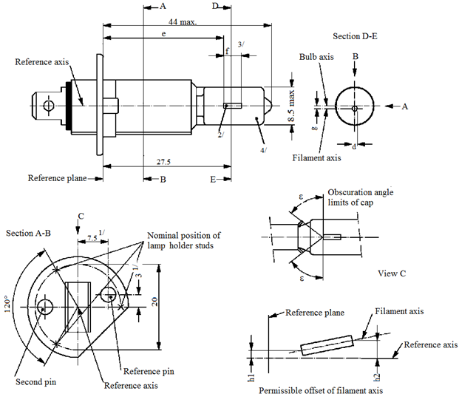

8.5 max.

Filament axis

44 max.

E

B

D

A

A

B

d

g

Reference axis

Reference plane

Section D-E

Bulb axis

27.5

3

Permissible offset of filament axis

h2

h1

Nominal position of filament light source holder studs

Obscuration angle

limits of cap

Section A-B

ε

ε

View C

Second pin

Reference pin

Reference axis

Reference plane

Filament axis

Reference axis

C

120°

20

7.5 1/

e

f

3/

2/

1/

4/

**Reference axis**

"

*Sheet H3/1, left bottom drawing,* amend to read (indicate the reference axis):

"

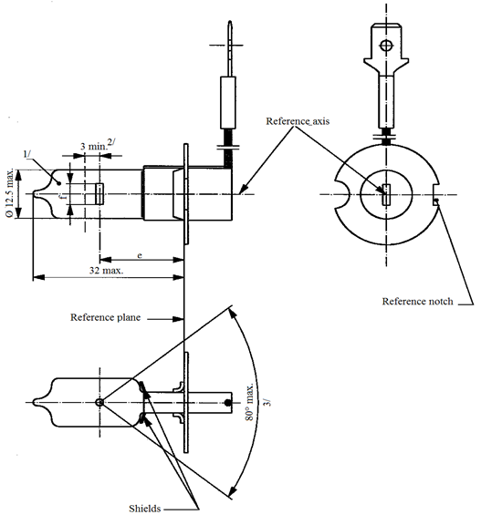

Reference axis

Reference plane

Reference notch

Shields

32 max

80° max.

3 min.2/

e

1/

3/

Ø 12.5 max

**Reference axis**

"

*Sheet H3/2, top left drawing,* amend to read (move the arrow “reference axis” upwards):

"

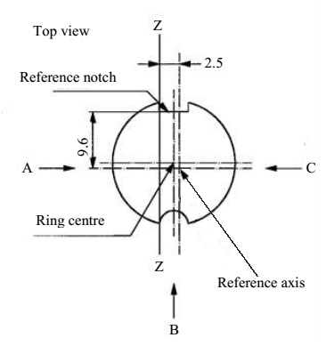

Definition: Ring centre and reference axis4/

9.6

Top view

Z

Definition of Z - Z

Z

B

9.6

2.5

C

A

**Reference axis**

Ring centre

Reference notch

"

*Sheet H4/4, table, last row but two,* amend to read:

"….….

|  |  |  |  |  |  |
| --- | --- | --- | --- | --- | --- |
| … | … | … | … | | … |
| IC 11/,14 **12**/ | 5.5 | 5.25 | ±0.50 | ±0.80 | ±0.35 |
| … | … | | … | | … |
| … | … | | … | | … |

"

*Sheet H9/1, figure 1,* amend to read:

Replace by the correct drawing, to read:

"



e

f

Reference axis2/

Reference plane1/

e

f

Category H9

Category H9B

B

A

B

4/

A

4/

Reference axis2

Figure1 – Main drawings

*Sheet H11/2, top right drawing,* amend to read:

"

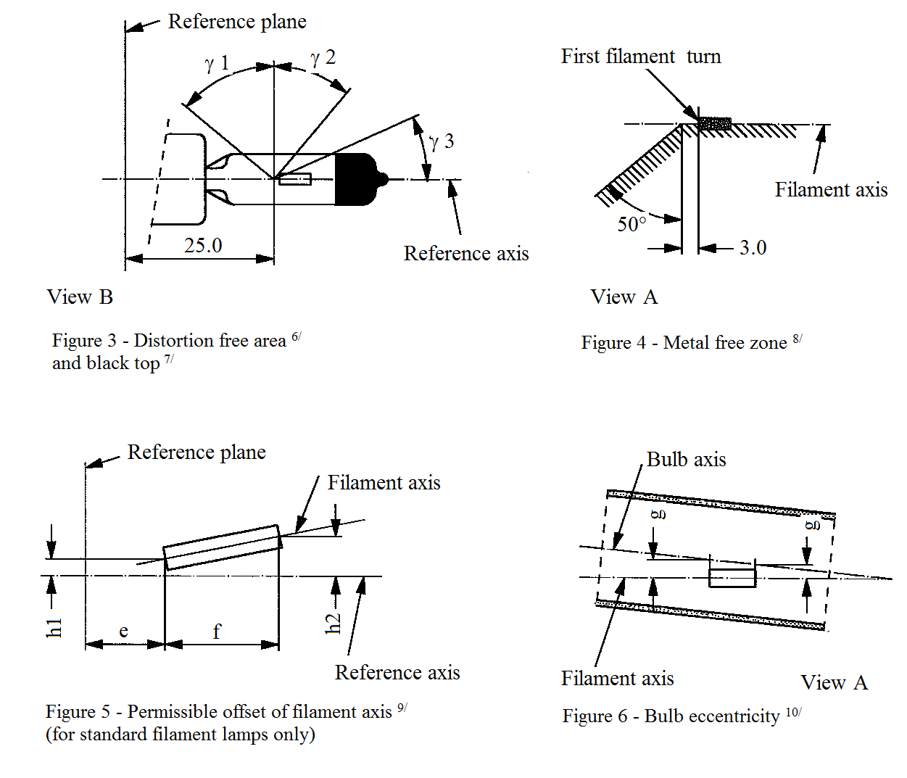

Reference plane

Reference plane

Reference axis

Reference axis

Filament axis

Filament axis

View A

View A

Filament axis

View B

Distortion free area6 and black top7

Bulb axis

Figure 4 – Metal free zone8

Figure 6 – Bulb eccentricity10

Figure 5 – Permissible offset of filament axis9

(for standard filament light sources only)

ɣ1

ɣ2

ɣ3

50°

3.0

25.0

f

e

h1

h2

g

g

**First** filament turn

"

*Sheet H13/4,* amend to read:

"

| *Dimensions in mm* | | *Tolerance* | |
| --- | --- | --- | --- |
| *Filament light sources of normal production* | *Standard filament light source* |
| … | … | … | … |
| m 10 **11**/ | 0 | ±0.20 | ±0.13 |
| n 10 **11**/ | 0 | ±0.20 | ±0.13 |
| … | … | … | … |

"

Sheet H14/1, figure 1, amend to read (correct the position of the reference plane):

"

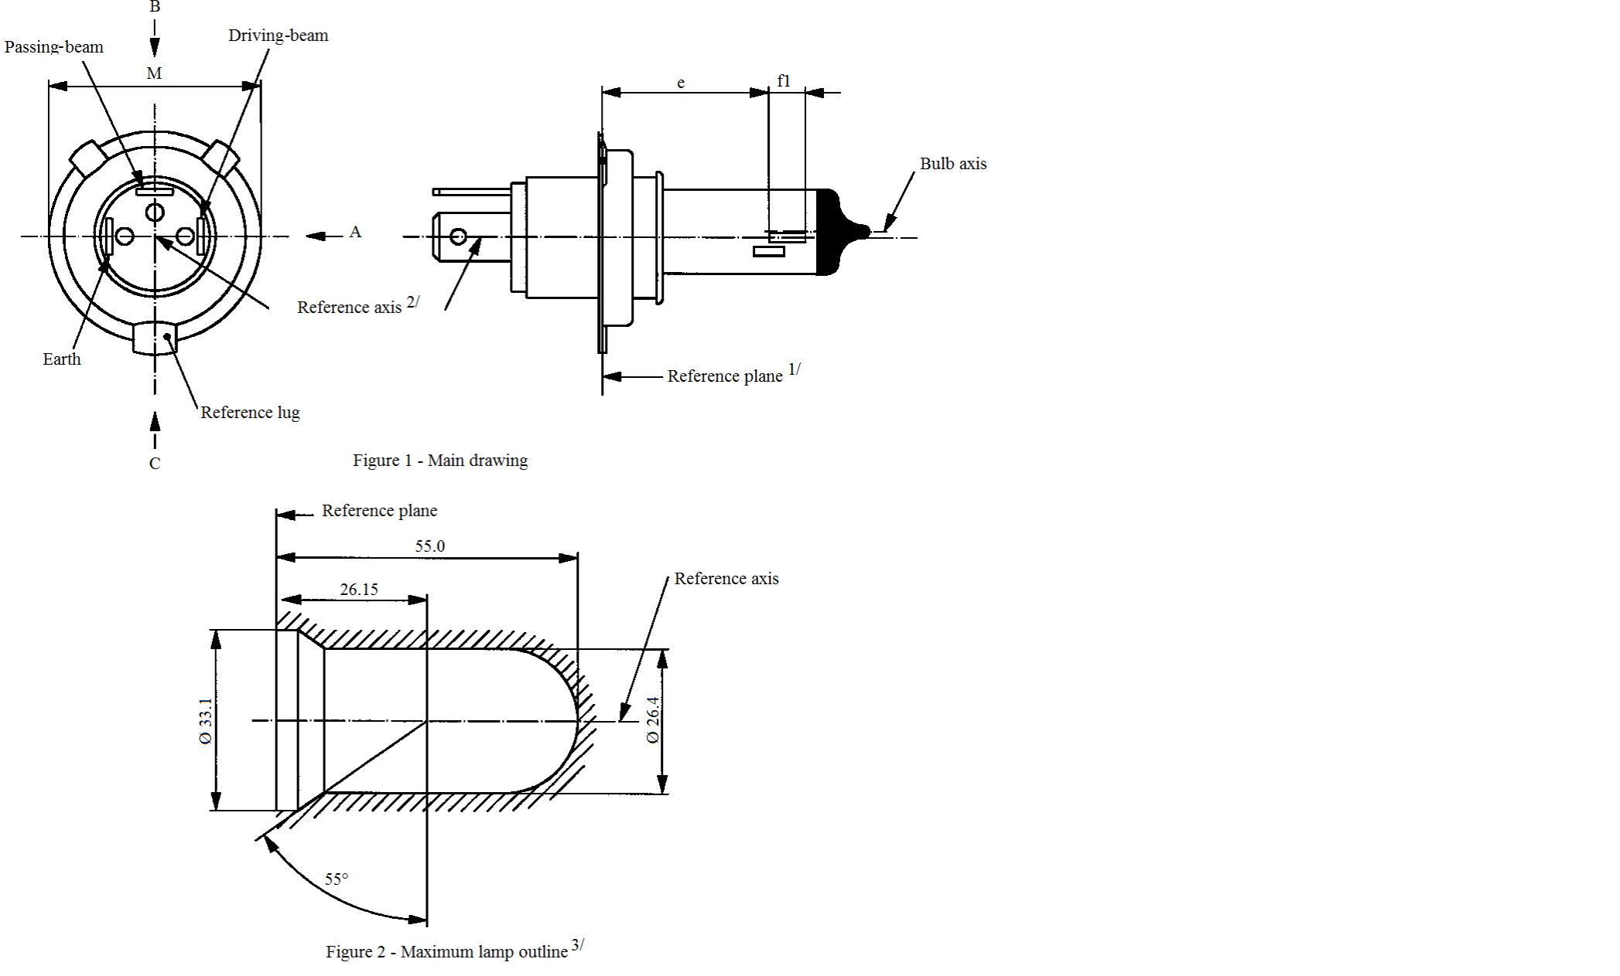

Passing-beam

Driving-beam

Reference lug

Earth

Reference axis2/

**Reference plane1/**

Reference axis

Figure 2 – Maximum filament light source outline3/

**Reference plane**

Figure 1 – Main drawing

B

M

A

C

55.0B

26.15

55°

Bulb axis

e

f1

Ø 33.1

Ø 26.4

"

*Sheet H15/5, note 10,* amend to read:

"10 "e" denotes the distance from the reference plane to the beginning of the ~~driving-beam~~ **high wattage** filament as defined above."

*Sheet H20/3, note 8*, amend to read:

"8 The ends of the filament are defined as the points where, when the viewing direction is direction A as shown in Figure 1 on sheet H20/1, the projection of the outside of the end turns crosses the filament axis. ~~(Special instructions for coiled-coil filaments are under consideration).~~"

*Sheet H20/4, last paragraph*, amend to read:

"The ends of the filament as defined on sheet H20/3, note 9 **8**, shall lie between lines Z1 and Z2 and between Z3 and Z4."

*Sheet HS6/1, figure 1,* amend to read (insert the viewing direction “B’ in the right drawing):

"

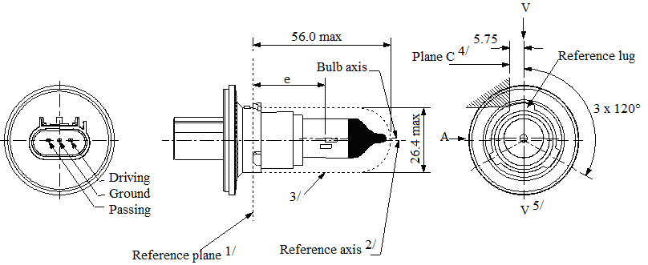

56.0 max.

5.75

3 x 120°

Plane C4/

V5/

V

**B**

3/

e

A

Bulb axis

Reference axis2/

Reference plane1/

Reference lug

Driving

Ground

Passing

Ø 26.4 max.

"

*Sheet P13W/3,* amend to read:

"…

The ends of the filament as defined on sheet P13W/2, footnote 4/ 5/, shall lie between Z1 and Z2 and between the lines Z3 and Z4.

…"

*Sheet P21W/1, table,* amend to read:

"…

|  |  |
| --- | --- |
| Cap BA15s in accordance with IEC Publication 60061 (sheet 7004-11A-**10**) 2 |  |

…"

*Sheet P21/5W/1, table,* amend to read:

"…

|  |  |
| --- | --- |
| Cap BAY15d in accordance with IEC Publication 60061 (sheet 7004-11B-**8**) |  |

…"

*Sheet P27/7W/3,* amend to read (remove twice the character “Ø”):

"

Ø 27.9 to

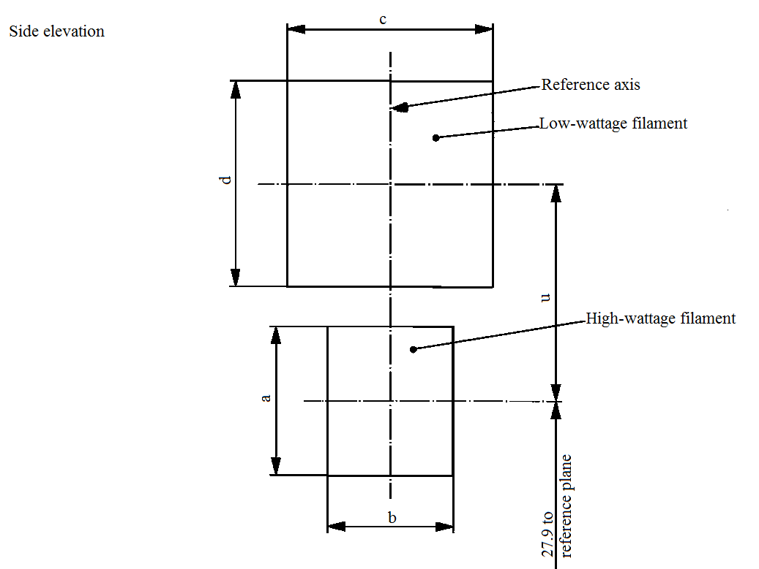

reference plane

Reference axis

Side elevation

Low wattage filament

High wattage filament

**~~Ø~~** 27.9 to

c

b

a

d

u

…

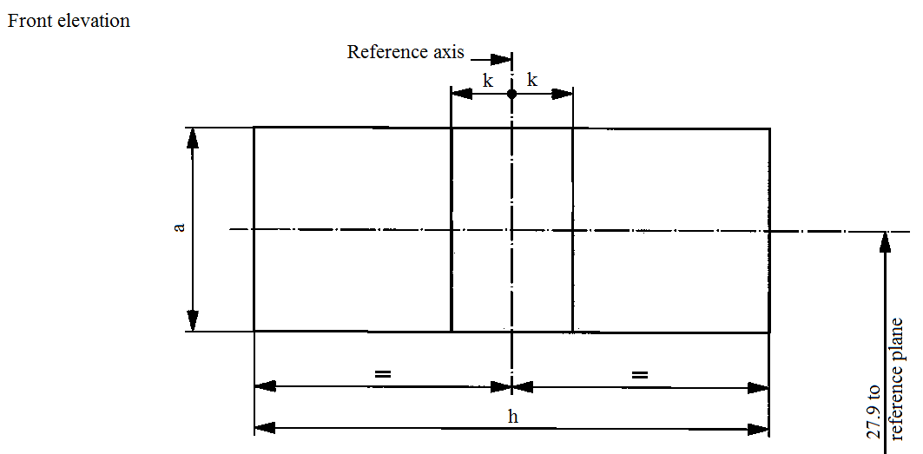

**~~Ø~~** 27.9 to

reference plane

Reference axis

Front elevation

k

k

h

a

"

*Sheet PSX26W/3,* amend to read:

"The ends of the filament as defined on sheet PSX26W/2, footnote 4 **5**/, shall lie between Z1 and Z2 and between the lines Z3 and Z4."

*Sheet R5W/1, table,* amend to read:

"…

|  |  |  |
| --- | --- | --- |
| |  | | --- | | R5W: BA15s in accordance with IEC Publication 60061 (sheet 7004-11A-**10**) 1/ | |  |

…"

*Sheet R10W/1, table,* amend to read:

"…

|  |  |  |
| --- | --- | --- |
| |  | | --- | | R10W: BA15s in accordance with IEC Publication 60061 (sheet 7004-11A-**10**) 1/ | |  |

…"

*Sheet T1.4W/1, figure,* amend to read:

"

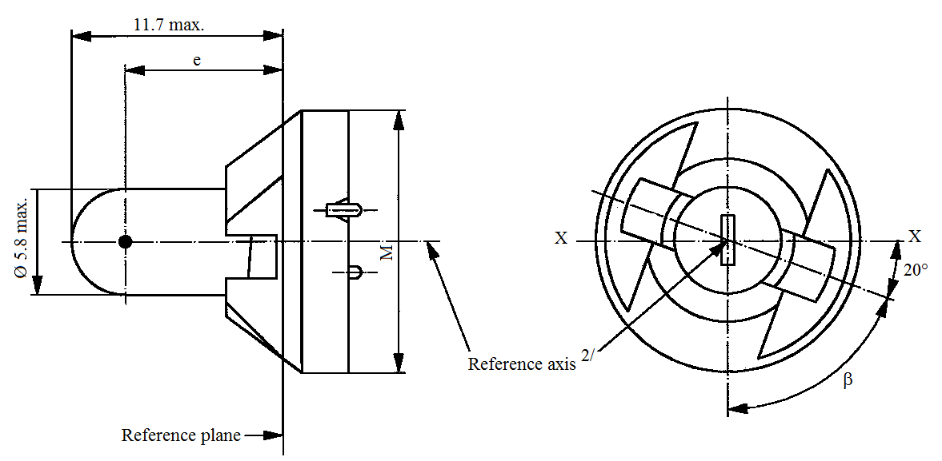

11.7 max.

Ø 5.8 max.

Reference **~~plane~~ axis2**/

Reference plane

e

X

X

β

20°

M

"

*Sheet W15/5W/1, drawing,* amend to read (in the left drawing, remove the second character “b”; in the right drawing, move the arrow of the reference axis upwards).

"

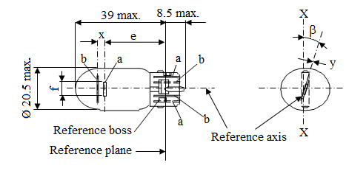

39 max.

8.5 max.

Ø 20.5 max.

Reference plane

Reference axis

Reference boss

f

X

X

y

ß

x

e

b

b

b

a

a

a

"

*Sheet W21/5W/1,* right drawing, amend to read (move the dimension “y” upwards):

"

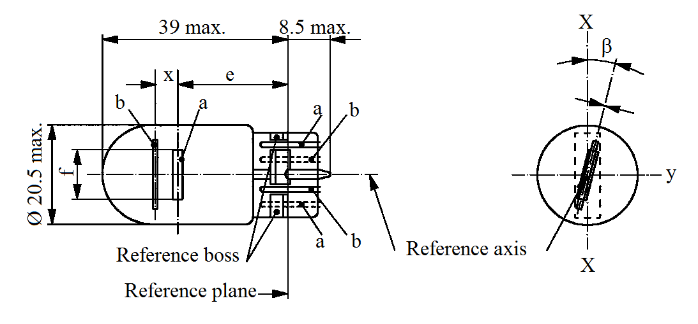

39 max.

8.5 max.

Ø 20.5 max.

Reference axis

Reference boss

Reference plane

X

X

ß

b

b

b

a

a

a

e

x

y

"

*Sheet WT21/W/1, note 2,* amend to read:

"2 Maximum lateral deviation of the ~~major (high wattage)~~ filament centre from two mutually perpendicular planes both containing the reference axis and one containing the axis through the reference keys."

II. Justification

1. With the publication of Revision 8 of Regulation No. 37 and the subsequent adoption of the Consolidated Resolution on the common specification of light source categories (R.E.5) (ECE/TRANS/WP.29/2016/111), light source experts and users of light source Regulations have made the correct linkages between the Resolution and third party documents. As links are established, the content of R.E.5 is continuously reviewed.

2. This proposal corrects a number of minor editorial errors in sheets of filament light sources that were discovered while making such linkages and that were not detected before. Some errors were already present at the introduction of the respective light source category; others appeared after revisions of the regulation documents. Some corrections are intended to avoid misinterpretation but do not change the substance. All corrections are self-explanatory.

3. Although editorial errors are normally corrected by corrigenda, all corrections are presented as an amendment to the Consolidated Resolution, because corrections to older revisions of Regulation No. 37 would create an enormous administrative issue while these errors were not essential for type approval.

4. This proposal further includes a number of customary administrative updates of International Electrotechnical Commission (IEC) cap sheet numbers in the IEC cap sheet references.

1. \* In accordance with the programme of work of the Inland Transport Committee for 2016–2017 (ECE/TRANS/254, para. 159 and ECE/TRANS/2016/28/Add.1, cluster 3.1), the World Forum will develop, harmonize and update Regulations in order to enhance the performance of vehicles. The present document is submitted in conformity with that mandate. [↑](#footnote-ref-2)