|  |  |  |  |
| --- | --- | --- | --- |
|  | United Nations | ECE/TRANS/WP.11/2017/7 | |
| _unlogo | **Economic and Social Council** | | Distr.: General  24 July 2017  English  Original: French |

**Economic Commission for Europe**

Inland Transport Committee

**Working Party on the Transport of Perishable Foodstuffs**

**Seventy-third session**

Geneva, 10-13 October 2017

Item 5 (b) of the agenda

**Proposals of amendments to ATP: New proposals**

Proposal to add requirements for the measurement of   
K values of fixed walls for multi-compartment equipment

Transmitted by the Government of France

|  |
| --- |
| *Summary* |
| **Executive summary**: Annex 1, appendix 2, paragraph 7.3, of the ATP agreement sets out rules for the dimensioning of refrigerated multi-temperature equipment. To estimate the thermal losses between compartments, paragraph 7.3.7 sets thermal transfer coefficients (K coefficients) for internal dividing walls. |
| The aim of this proposal is to introduce the possibility of measuring the actual heat transfer coefficient of fixed internal dividing walls rather than using these set values. The proposal also sets out the test method to be used for such measurement. |
| **Action to be taken**: Amend the wording of annex 1, appendix 2, paragraph 7.3.7, of ATP. |
| **Related documents**: Other key documents are listed. |
|  |

Introduction

1. Annex 1, appendix 2, paragraph 7.3.7, of ATP establishes the values of the coefficient of heat transfer (K coefficient) of removable and fixed internal dividing walls. These coefficients take into account two types of factors:

* Positioning in the transport equipment; and
* Type of material covering the surface of the floor under the dividing walls.

In order to verify the value of these coefficients, ATP requires minimum foam thicknesses for the dividing walls.

2. The values of the coefficients given in ATP are pre-established and go well beyond actual needs. The requirements do not allow for differentiation between the quality of dividing walls’ thermal insulation for a given use; they provide no incentive to use dividing walls with improved thermal insulation and thus with higher K coefficients.

3. It would be useful, in addition to the pre-established K coefficient values, to include a method for measuring the K coefficients of the dividing walls.

4. This proposal deals only with fixed dividing walls.

I. Proposal

5. This proposal introduces a test methodology to measure the dividing walls’ heat transfer coefficients. The methodology is to be included in paragraph 7.3.7 as a method producing results that can be used instead of the default K coefficient values set forth for fixed dividing walls. Removable dividing walls are excluded because of the mechanical wear to which they are subjected during use, which affects their thermal insulation capacity.

6. The test methodology is based on the one described in annex 1, appendix 2, section 2, of ATP, entitled “Insulating capacity of equipment”, in the version validated on 30 September 2015.

7. By adding an amendment to paragraph 7.3.7, it introduces adjustments required to meet the need to:

* adapt the test method for multi-temperature mechanical refrigeration units in paragraph 7.2 so as to include the multiple evaporator refrigeration units thus included in ATP; and
* encourage manufacturers to propose better solutions for compartmentalized transport units meeting ATP requirements.

The methodology is based on:

* establishment of a controlled heat flux through a removable or fixed internal dividing wall whose K coefficient is to be determined;
* cancellation of heat fluxes from all other sides, be they internal or external, if they are not part of the removable or fixed internal dividing wall whose value is being determined.

The two examples below explain the method for different configurations:

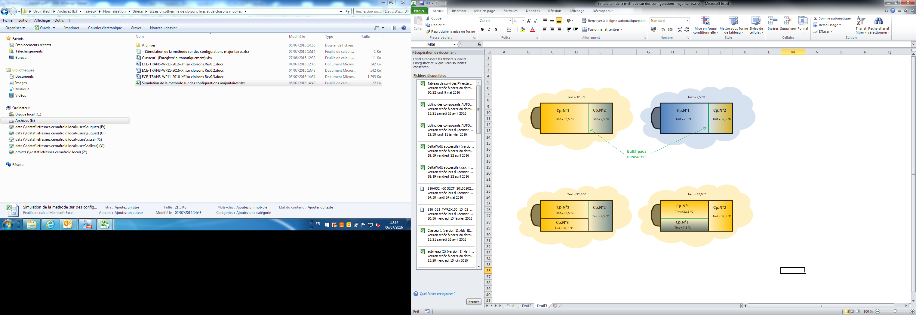

Where “Cp. No.X” means compartment number X.

Proposed amendment to ATP

8. It is proposed to amend annex 1, appendix 2, paragraph 7.3.7, of ATP with the following text:

“7.3.7 Internal dividing walls

7.3.7.1 General requirements

Thermal losses through internal dividing walls shall be calculated using the K coefficients in the following table. For fixed dividing walls, the pre-established values of the table may be replaced with K coefficients measured according to the test methodology under 7.3.7.3.

7.3.7.2 Pre-established K coefficient values of internal dividing walls

|  | *K coefficient — [W/m²K]* | | *Minimum foam thickness [mm]* |
| --- | --- | --- | --- |
|  | *Fixed* | *Removable* |
| Longitudinal — alu floor  Longitudinal — GRP floor | 2.0  1.5 | 3.0  2.0 | 25  25 |
| Longitudinal — alu floor  Longitudinal — GRP floor | 2.0  1.5 | 3.2  2.6 | 40  40 |

K coefficients of movable dividing walls include a safety margin for specific ageing and unavoidable thermal leakages.

For specific designs with additional heat transfer caused by additional thermal bridges compared to a standard design, the partition K coefficient shall be increased.

7.3.7.3 Measurements of the K coefficient of fixed internal dividing walls

The K coefficient shall be measured in continuous operation either by the internal cooling method or by the internal heating method. In either case, the empty body shall be placed in an insulated chamber.

The configuration of the equipment and internal temperatures in each compartment shall be selected in such a way that they allow only a single heat flux through the fixed internal dividing wall.

In the case of:

* Cooled compartments, one or more heat exchangers shall be placed inside the body;
* Heated compartments, electrical heating appliances (resistors, etc.) shall be positioned in it, all in accordance with paragraphs 2.1.2 and 2.1.3 of this appendix, where the empty volume and the internal surfaces of the body respectively correspond with the empty volume and the internal surfaces of each of the compartments under consideration.

The mean temperature of the insulated chamber shall throughout the test be kept uniform and constant in compliance with paragraph 1.7 of this appendix, at a level such that the temperature difference between the inside of the body and the insulated chamber is:

* 25 °C ± 1 K, the average temperature of the walls of the body for the compartment under consideration being maintained at + 20 °C ± 0.25 K, for compartments at 7.5 °C; or
* 25 °C ± 1 K, the average temperature of the walls of the body for the compartment under consideration being maintained at + 32.5 °C ± 0.25 K, for compartments at 32.5 °C.

The entire test shall be in conformity with paragraphs 2.1.5, 2.1.6, 2.1.7 and 2.1.8 of this appendix.

The K coefficient of the fixed internal dividing wall shall be determined as follows:



where W is either the heating power or the cooling capacity, as the case may be, required to maintain a constant absolute temperature difference ΔT between the mean inside temperature Ti of the compartments closed by the removable or fixed internal dividing wall, when the mean outside temperature Te is constant for the exchange surface of dividing wall S.

The test reports shall mention the type of material covering the surface of the floor supporting the dividing wall.

The uncertainty of the value of the K coefficient shall comply with the limits under paragraph 2.3.2 of this appendix.”

II. Justification

| Cost | The proposal merely presents a new possibility; it thus does not involve any direct costs.  For equipment manufacturers who use this method, the proposed test will come with costs that can be recuperated by improving the dimensioning of the fixed internal dividing walls. |
| --- | --- |
| Feasibility | The proposal to use this method is an adaptation of a method already described in the agreement. Its feasibility apparently poses no problem. |
| Environmental impact | This proposal is aimed at providing more precise dimensioning of fixed internal dividing walls, thus resulting in possible savings in insulation. |
| Enforceability | This new possibility will only be optional. |