|  |  |  |  |
| --- | --- | --- | --- |
|  | United Nations | ECE/TRANS/WP.15/2017/13 | |
| _unlogo | **Economic and Social Council** | | Distr.: General  28 July 2017  English  Original: French |

**Economic Commission for Europe**

Inland Transport Committee

**Working Party on the Transport of Dangerous Goods**

**103rd session**

Geneva, 6-10 November 2017

Item 5 (b) of the provisional agenda

**Proposals for amendments to Annexes A and B of ADR:**

**Miscellaneous proposals**

Amendment to additional provision CV36 of 7.5.11

Transmitted by the Government of Switzerland[[1]](#footnote-1)\*

|  |
| --- |
| *Summary* |
| **Executive summary**: For the carriage of asphyxiant gases for which additional provision CV36 of 7.5.11 is assigned, apply the same safety measures for the driver and the passengers as those applied when asphyxiant gases are used as a conditioning agent in 5.5.3.3.3.  Clarify that sheeted vehicles are also authorized for such gases. |
| **Action to be taken**: Amend the wording of additional provision CV36 of 7.5.11. |
|  |

Introduction

1. We have tried to determine whether vehicles such as those shown in the annex could be used for the carriage of gases to which additional provision CV36 of 7.5.11 of ADR is assigned.

2. We have come to the conclusion that the wording of SP CV36 of 7.5.11 raises difficulties of interpretation that need to be addressed. The various stakeholders do not agree on the vehicles that are covered by these provisions, in part because of the terms used. In French, there is mention of vehicles that are “*ouverts*” or “*fermés*”, terms that do not appear in any definition of vehicles given in 1.2.1, which leaves a certain freedom of interpretation.

3. The English version uses the terms “closed” or “open” vehicles, which are defined in ADR, thus restricting the room for interpretation and the types of vehicles that are authorized.

4. From the point of view of road transport safety, these differences in interpretation would be less important if measures were taken to prevent the existence of a dangerous atmosphere for the driver and occupants of the vehicle. The issue of different interpretations of the meaning of the term “*véhicule fermé*” in French (“not opened vehicle” in English) within the scope of application of CV36 would thus only be of importance in respect of safety during unloading.

5. There are road vehicles that may be “sheeted vehicles” or “closed vehicles”, in which the load compartment is not separate from the passengers’ and driver’s compartment (see first image in annex). Ventilation must be ensured not only on opening the doors of the load containing gases assigned to CV36, but also during carriage. In ADR 2017, provisions were introduced in 5.5.3.3.3 to ensure the safety of the driver during carriage of loads containing asphyxiant gases used for conditioning purposes according to the provisions of section 5.5.3. To avoid the driver being affected by the asphyxiant gases, the load must be separated using a load compartment that is isolated from the driver’s compartment. If the driver’s cab is not separated in this way, the requirement that a warning marking be affixed to the cargo doors for persons opening or entering the vehicle is of no use during transport. Consequently, measures recommended for the safety of the driver include ensuring that vehicles are well ventilated or that gas detection systems are used during transport.

6. Given that these safety issues also arise in respect of the provisions of CV36, it would be useful to adopt in CV36 the same provisions as in 5.5.3.3.3.

Proposal 1

7. Amend additional provision CV36 of 7.5.11 as follows (new text underlined in bold):

“CV36 Packages shall preferably be loaded in open or ventilated vehicles or open or ventilated containers. If this is not feasible and packages are carried in other closed vehicles or containers**, the following conditions must be met:**

**- Gas exchange between the load compartment and the driver’s cab shall be prevented; and**

- The cargo doors of the vehicles or containers shall be marked with the following in letters not less than 25 mm high:

‘WARNING

CLOSED MEANS OF CONTAINMENT

OPEN WITH CAUTION’

This shall be in a language considered appropriate by the consignor.”

8. Another topic on which stakeholders do not agree is that of applying the marking provided for in CV36 in the case of sheeted vehicles. Some types of sheeted vehicle are considered as closed vehicles (see images in annex) as they are not sufficiently ventilated and ought to bear the marking prescribed in CV36. The assessment of whether ventilation is sufficient and whether marking is required causes problems during highway checks.

9. On examining the matter in detail, it can be seen that the differences in interpretation are compounded by differences between the language versions. The use in French of terms that are not defined in ADR — “*véhicules ouverts*” instead of “*véhicules découverts*” (open vehicles) in the first sentence, and “*fermés*” instead of “*couverts*” (closed) in the second sentence — leaves it up to the stakeholders to decide whether a “*véhicule bâché*” (sheeted vehicle), a term which is defined in ADR, can be considered to be a “*véhicule fermé*” (closed vehicle) because it does not have adequate air vents or whether it should be considered to be “*ouvert*” (open). We believe that this room for interpretation is necessary from the point of view of safety and should be retained. It is only by checking that the intention of the provision, that is, to ensure that the vehicle is adequately aired, is met in each individual case that an exemption from marking can be decided on.

10. According to the French text, given the terms used, it is possible to use a sheeted vehicle, whether or not it is sufficiently ventilated. If it is not sufficiently ventilated, a sheeted vehicle must bear the marking. It seems that not all sheeted vehicles can be considered to be sufficiently “open” and that marking is required for such vehicles that have certain types of particularly tight sheets. An extreme case is illustrated in the images in the annex.

11. In the English version, however, the use in the first sentence of the term “open … vehicle” would appear to exclude the use of “sheeted vehicles”. The term “ventilated”, contrasted with “open”, in the same sentence should be understood as meaning the forced ventilation of a vehicle which is not “open”. In general, a sheeted vehicle often does not require forced ventilation, as it is sufficiently aired. However, in modern sheeted vehicles, adequate ventilation is not guaranteed in all cases. Even if a sheeted vehicle were considered acceptable in the first sentence in the English version, it could not be used, even with marking, if it was not a “closed vehicle” within the meaning of the second sentence. There is no justification for the English version’s apparent exclusion of sheeted vehicles in the first sentence and insufficiently ventilated sheeted vehicles, even those bearing the appropriate marking, in the second sentence of CV36.

12. The terminology used in English, which is too close to the definitions in ADR, leads to false conclusions, which cause disagreements during highway checks. According to the English version, it may be considered that sheeted vehicles are prohibited for the carriage of the gases in question, which is not the case with the French version.

13. We believe it is essential to guarantee safety in all cases, but also to ensure that the texts do not place unjustified bans on sheeted vehicles. To that end, the very specific terms from the definitions of vehicles given in 1.2.1 should not be used; this is already the case in the French version. The French version would not actually need to be changed, as it does not use the terms from the definitions of vehicles given in 1.2.1. It already guarantees the desired flexibility of interpretation and authorizes “sheeted vehicles”. One possible solution to this problem is submitted in proposal 2 below:

Proposal 2

14. Amend the first paragraph of CV36 of 7.5.11 as follows (deleted text crossed out and in bold; added text underlined and in bold):

“CV36 Packages shall preferably be loaded in **~~open or~~** ventilated **or not closed** vehicles or **~~open or~~** ventilated **or not closed** containers. If this is not feasible ~~and packages are carried in other closed vehicles or containers~~, the cargo doors of the vehicles or containers shall be marked with the following in letters not less than 25 mm high: …”.

Justification

15. The term “not closed” includes both “open vehicles” and “sheeted vehicles”. The terms that we propose deleting in the second sentence do not provide any additional information and may in fact lead to confusion. Hence they should be deleted.

Annex

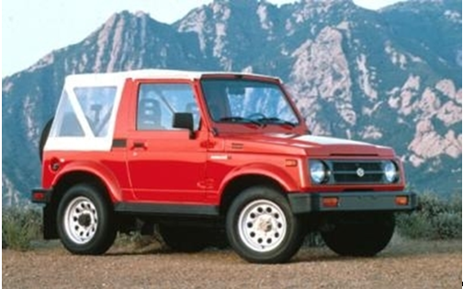

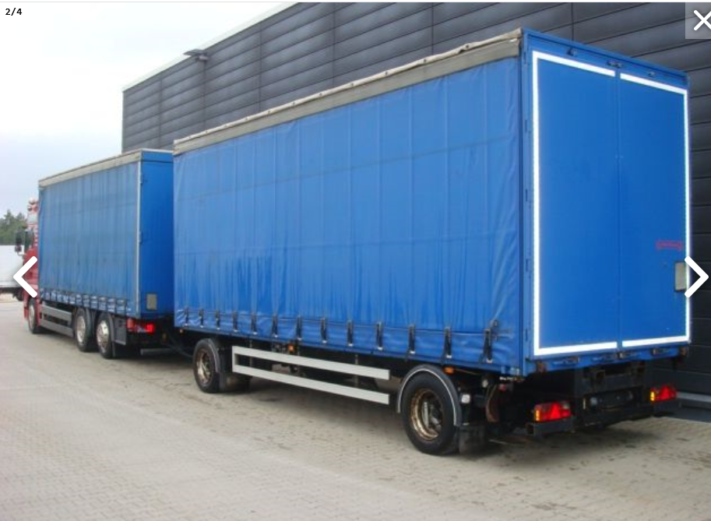

1. \* In accordance with the programme of work of the Inland Transport Committee for 2016-2017 (ECE/TRANS/2016/28/Add.1, para. 9.1). [↑](#footnote-ref-1)