Committee of Experts on the Transport of Dangerous Goods
and on the Globally Harmonized System of Classification
and Labelling of Chemicals
Sub-Committee of Experts on the Globally Harmonized
System of Classification and Labelling of Chemicals 7 December 2017
Thirty-fourth session
Geneva, 6-8 December 2017
Item 3 (a) of the provisional agenda
Hazard communication:
labelling of small packagings
Labelling of sets or kits: Comments on document ST/SG/AC.10/C.4/2017/5
Transmitted by the expert from the United States of America
Proposal
Example 10: Labelling of - sets or kits
Scenario A:
Inner container label
As the area available for a label on the inner containers is not sufficient to include all the required GHS label elements, the following minimum information is included on the label of each hazardous substance or mixture:
- product identifier, and an identifier for each substance or mixture matching the identifier used on the outer packaging label and SDS for that substance or mixture, e.g., “Reagent 1” and “Reagent 2”
- pictogram(s)
- signal word
- the statement “Read full label”
- supplier identification (i.e. name and telephone number)
Comment: Recommend putting the company name and phone number on the label below similar to other small packages examples

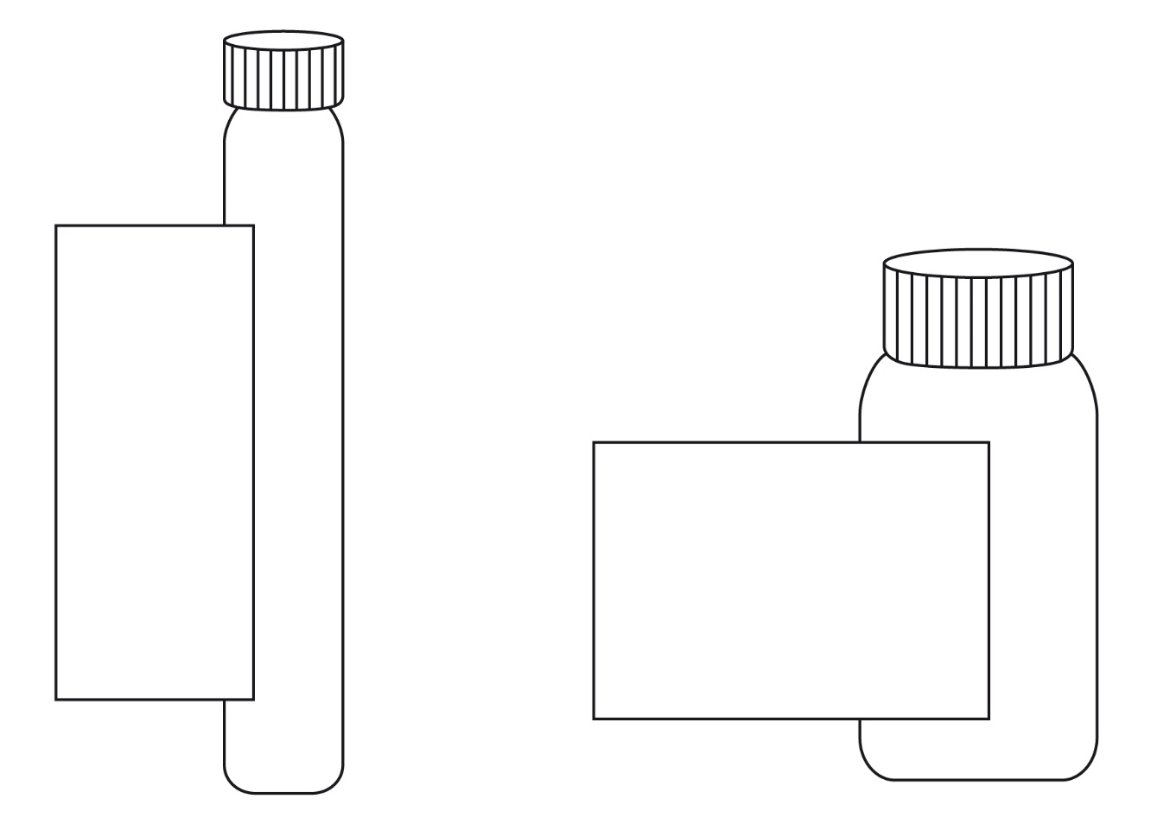
Reagent 2
Product ident. (see 1.4.10.5.2 (d)(ii)) 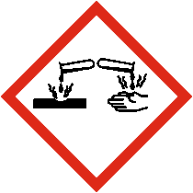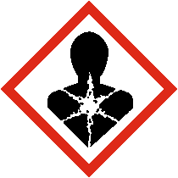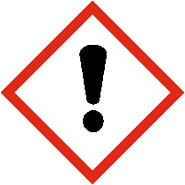
Signal word (see1.4.10.5.2(a))
Read full label
Supplier ident.

Reagent 1
Product ident.
(see 1.4.10.5.2 (d) (ii))
Signal word
(see 1.4.10.5.2 (a))
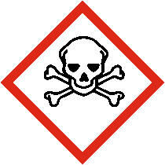
Read full label
Supplier ident.
Outer packaging label
In addition to the set or kit identifier, in this case Reagent Kit for water analysis (see below), all the required GHS label elements appear on the outer packaging for each hazardous substance or mixture.
The label elements for each substance or mixture are grouped together on the outer packaging in order to distinguish clearly which label elements are assigned to which substance or mixture.
However, the supplier identification need appear only once on the outer packaging. Where possible any supplemental information may also be included on the outer packaging.

When a large number of precautionary statements are required, the precautionary statements may be located separately from the rest of the label elements, though general precautionary statements (Table A3.2.1) and precautionary statements for storage need only appear once. (See also A3.3.2 in Annex 3 on flexibility in the use of precautionary statements to avoid inappropriate statements, taking into account the nature of the user (e.g. consumers, employers and workers) the quantities supplied, and the intended and foreseeable circumstances of use). In these circumstances, the precautionary statements for each substance or mixture should be grouped together on the same side of the outer packaging and on a surface that is visible under normal conditions of use.

Scenario B:
Paragraph: “This scenario …and shape of this packaging)”: unchanged.
This scenario presents a sample kit used for marketing purposes, which consists of a large number of different substances or mixtures in individual containers (sample bottles) presented in an outer packaging (e.g. a box). Depending upon the contents of each bottle, some or all of the different substances or mixtures may be classified as hazardous. The individual inner containers (e.g. bottles) are stored in the outer packaging throughout the lifecycle of the sample kit. Customers may select individual bottles and remove them from the box to check clarity, colour or odour and then replace them into the open slot within the outer packaging.
Individual container label
As the area available for a label on the different individual containers is not sufficient to include all required GHS label elements, the following minimum required information should be required:
- supplier identification (i.e. name and telephone number)
Comment: Recommend putting the company name and phone number on the label below similar to other small packages examples
- product identifier
- pictogram(s)
- signal word
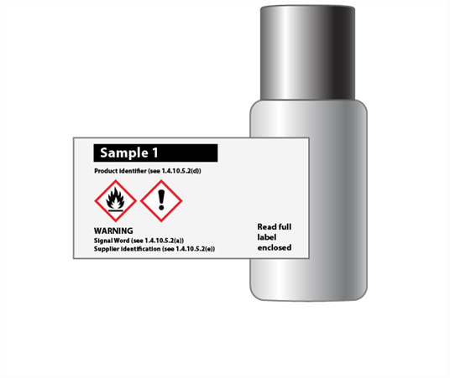
- the statement “Read full label enclosed”
Example of individual container label
Comment: Delete reference to reference to “1.4.10.5.2(e)” in the example because address is not required
Full label information
Product identifier  (see 1.4.10.5.2 (d) (ii)) | Pictogram(s)  (see 1.4.10.4) | Signal word  (see 1.4.10.5.2 (a)) | Hazard statement(s)  (see 1.4.10.5.2 (b)) | Precautionary statement(s)  (see 1.4.10.5.2 (c)) | Supplemental information  (see 1.4.10.5.4.2)
123 | Flame  Exclamation mark  Environment  Comment: insert actual pictograms instead of words | Warning | Flammable liquid and vapour.  Causes skin irritation.  Toxic to aquatic life with long lasting effects. | Keep away from heat/sparks/open flames/hot surfaces. No smoking.  Keep container tightly closed.  Use explosion-proof electrical/ventilating/ lighting/equipment.  Use only non-sparking tools.  Take precautionary measures against static discharge.  Avoid release to the environment.  Wear protective gloves/ protective clothing eye protection/face protection.  IF ON SKIN (or hair): Remove/Take off immediately all contaminated clothing. Rinse skin with water/ shower.  In case of fire: Use dry sand, dry chemical or alcohol-resistant foam for extinction.  Store in a well-ventilated place. Keep cool.

If hazardous components are required on the label, they are displayed in the appropriate languages on the outer packaging label.
Where hazardous components are required to be identified on the label they are displayed in the appropriate languages as part of the full label information attached to the inside of the kit.

