UN/SCETDG/52/INF.50/Rev.1
Committee of Experts on the Transport of Dangerous Goods
and on the Globally Harmonized System of Classification
and Labelling of Chemicals
Sub-Committee of Experts on the Transport of Dangerous Goods 30 November 2017
Fifty-second session
Geneva, 27 November-6 December 2017
Item 6 (d) of the provisional agenda
Miscellaneous proposals for amendments to the Model
Regulations on the Transport of Dangerous Goods:
other miscellaneous proposals
Proposal of amendments to 5.5.3
Note by the secretariat
Revision
Outcome of the discussion on ST/SG/AC.10/C.3/2017/46
Proposal 1
5.5.3 In the text in parentheses, after “(UN 1951)”, insert “or nitrogen”. Add the following new Note at the end:
“NOTE: In the context of this section the term “conditioning” may be used in a broader scope and includes protection.”.
Proposal 2
5.5.3.6.2 In Figure5.5.2, amend the heading to read “Asphyxiation warning mark for cargo transport units”. Delete the reference to note ** and the corresponding note. In note *, at the beginning, replace “of the coolant/conditioner” by “or the name of the asphyxiant gaz used as the coolant/conditioner”. At the end of note * add “Additional information such as “AS COOLANT” or “AS CONDITIONER” may be added.”. At the end of 5.5.3.6.2, delete the Note.
5.5.3.6.2 would read as follows:
“5.5.3.6.2 The warning mark shall be as shown in Figure 5.5.2.
Figure 5.5.2
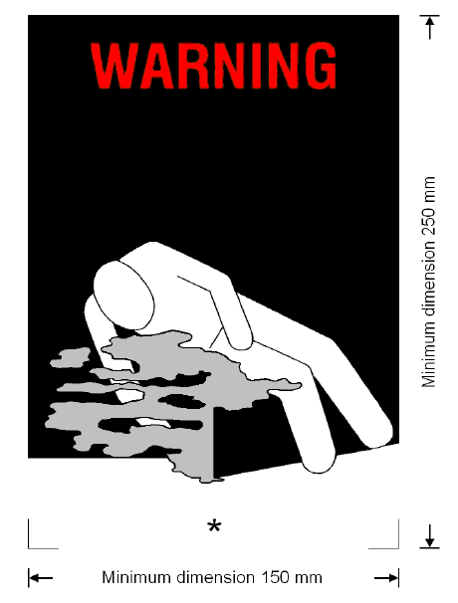
Asphyxiation warning mark
* Insert proper shipping name or the name of the asphyxiant gaz used as the coolant/conditioner. The lettering shall be in capitals, all be on one line and shall be at least 25 mm high. If the length of the proper shipping name is too long to fit in the space provided, the lettering may be reduced to the maximum size possible to fit. For example: CARBON DIOXIDE, SOLID. Additional information such as “AS COOLANT” or “AS CONDITIONER” may be added.
The mark shall be a rectangle. The minimum dimensions shall be 150 mm wide × 250 mm high. The word "WARNING" shall be in red or white and be at least 25 mm high. Where dimensions are not specified, all features shall be in approximate proportion to those shown.”.

