UN/SCETDG/52/INF.12

Committee of Experts on the Transport of Dangerous Goods
and on the Globally Harmonized System of Classification
and Labelling of Chemicals 6 November 2017
Sub-Committee of Experts on the Transport of Dangerous Goods
Fifty-second session

Geneva, 27 November-6 December 2017
Item 2 (j) of the provisional agenda
Explosives and related matters: miscellaneous
Transport of energetic samples for further testing
Transmitted by the European Chemical Industry Council (CEFIC)
Introduction
- Research and development in industry, public institutes, and universities frequently need to transport substances for the purpose of testing, i.e. the determination of physical, chemical, biological, toxicological or ecotoxicological properties and behavior, fitness for use or application.
- These substances usually consist of organic molecules, which are active ingredients, building blocks or intermediates for pharmaceutical or agricultural chemicals.
- Generally, the amounts of substance are small, and reliable information about the proper classification is not available due to the lack of test data.
- Although not designed to be explosives of Class 1, many of these substances carry functional groups listed in tables A6.1 and/or A6.3 in Annex 6 (Screening Procedures) of the Manual of Tests and Criteria, indicating potential explosive or self-reactive properties.
- Whereas the transport of samples of self-reactive substances and organic peroxides is permitted under the provisions of 2.4.2.3.2.4 (b) and 2.5.3.2.5.1, respectively, substances considered to meet the criteria for Class 1 are prohibited for transport by 2.0.4.2 (b).
- However, at this early stage of development, test data are usually not available to distinguish candidates for Class 1 and self-reactive substance of Division 4.1. Thus, there is a need to find a proper solution for the transport of energetic samples for the purpose of testing in small amounts, to define appropriate criteria for classification in cases of limited test data, and to specify the required packaging.
- CEFIC’s proposal ST/SG/AC.10/C.3/2016/61 was adopted in the last biennium. The new provisions in section 2.0.4.3 allow for the transport of small amounts of samples (up to 1 g / 1 ml) as self-reactive substances type C under certain restrictions in a very specific package.
- As a next step towards a comprehensive solution, CEFIC gave an informal presentation in the Explosives Working Group meeting during the summer 2017 session of the TDG Subcommittee, introducing their concept on how to proceed for samples in larger amounts. There was general support for the ideas brought forward, and CEFIC was encouraged to submit a flow chart for further discussions in the group.
- Accordingly, CEFIC submits this informal paper for further discussions. Both the Subcommittee and the Explosives Working Group are invited to comment and are asked for guidance how to proceed further in this matter.
Discussion
Initial considerations
- The adopted solution in section 2.4.0.3 for small samples (up to 1 g scale) is built on a safe design:
- The package is sufficiently strong to survive the detonation even of an intentional explosive (see proposal 2016/61), and
- The inner design prevents a propagation of detonation from one sample to another.
- For larger amounts of samples, this concept is obviously not applicable. Therefore, further proceedings have to be based on increased knowledge about safety-relevant properties of the sample.
- Generally, the decomposition energy and the onset of decomposition can be easily determined by DSC methods (see UN Test Manual, section 20.3.3.3). This paper describes how this information may be used as the basis for a preliminary assessment of the samples.
Decomposition energy
- A representative set of samples (369 substances) was investigated with respect to their decomposition energy. For this purpose, screening DSCs were measured at heating rates of 3-5 K/min in agreement with the requirements lined out in the Manual of Tests and Criteria, section 20.3.3.3.
- For comparison, literature data for known explosives were compiled (J. Köhler, R. Meyer, Explosivstoffe, Wiley-VCH). The results are shown in figure 1:
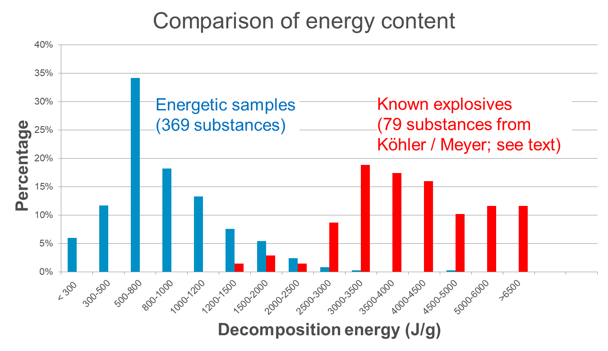
Figure 1: Decomposition of energetic samples vs. known explosives
- Evidently, the energetic samples form a group of lower decomposition energies clearly separated from the explosives with much higher energies. Their energy distribution is well coherent with the realm of self-reactive substances, which justifies their treatment under this entry. Except for one substance (lead azide, 1480 J/g), no known explosive could be identified with a decomposition energy <1500 J/g.
- The large majority of known explosives have a decomposition energy of 2500 J/g or more. Samples exhibiting such energies have an increased chance of being an explosive substance, and would need closer inspection before transport.
- The intermediate range of (roughly) 1500 to 2500 J/g contains salts of oxidizers, such as ammonium perchlorate, and initiators like lead azide and lead trinitroresorcinate. The first group of substances has been already excluded from the energetic samples by 2.0.4.3.1 (b) whereas the second type of substances can be easily identified by their mechanical sensitivity (tests UN 3(a) and 3 (b) of the UN Manual of Tests and Criteria).
- Therefore, it appears justified to allow the transport of energetic samples as self-reactive substances Type C under the provisions of 2.4.2.3.2.4 (b) depending on their energy content as follows:
< 1500 J/g: No further testing required
≥ 1500 … < 2500 J/g: Tests for mechanical sensitivity (UN 3 (a) + 3 (b), outcome both “-“)
≥ 2500 J/g: Additional testing required; suggested: 1 Koenen test (UN E.1, not violent) AND 1 Trauzl test (UN F.3, outcome “no” or “low”).
- Based on these considerations, a tentative flowchart incorporating already existing provisions has been drafted (see figure 2).
- Boxes 1 through 9, 11 and 12 refer to already existing provisions.
- Box 10 would be new text requiring the determination of the decomposition behavior (energy and onset) of the sample.
- Box 11 identifies low-energy samples that
(a) are not candidates for self-reactive substances due to their thermal stability, and
(b) do not require the Class 1 acceptance procedure based on the criteria outlined in table 6.2 of Annex 6 of the UN Manual of Tests and Criteria.
23. Boxes 14 to 21 establish the criteria suggested in section 18 above.
24. The flowchart as presented would greatly contribute to a comprehensive solution for the transport of energetic samples; the provisions are clear, practical and generally applicable.
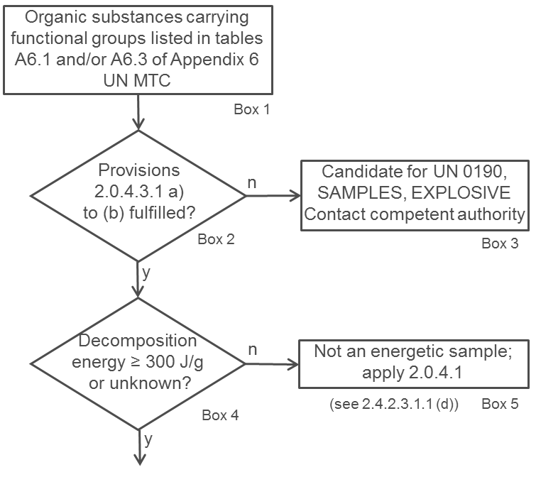
Figure 2: Tentative flowchart for energetic samples

Thermal stability
25. The remaining issue to be solved is thermal stability and, in this context, the determination of possible temperature control requirements (see box 13 of the flowchart).
26. According to 2.4.2.3.4, temperature control is not required if the substance is thermally stable, i.e. SADT ≥ 60 °C.
27. Since SADT tests H.1 to H.4 are not designed for small sample amounts, a thermal stress test is suggested as alternative approach. One such test is described below, which can be easily performed by DSC measurements.
28. The concept is to determine whether the decomposition behavior changes after the application of thermal stress for a defined period of time. For practical reasons, 24 hours are suggested.
29. A screening DSC (heating rate 2-5 K/min in a closed crucible; see UN Manual of Tests and Criteria, section 20.3.3.3) is measured for the sample as offered for transport. A second sample is taken, and thermal stress is applied (practically realized by tempering the sample in a DSC crucible at a defined constant temperature over a certain period of time; see above).
30. If the decomposition behavior remains unchanged in terms of decomposition onset, shape of curve, and energy within a measurement uncertainty of 10%, then the sample is stable at the stress temperature applied. If the stress test is passed at 60 °C, no temperature control is required. For a conservative approach, the decomposition onset should be taken as the temperature of the first noticeable exothermic effect (i.e. the heat production signal leaves the baseline).
31. In case the stress test at 60 °C is not passed, the same procedure should be applied at decreasing temperatures in steps of 10 K until the decomposition behavior remains unchanged. That temperature should be deemed the estimated SADT of the sample, and the control and emergency temperatures may then be derived in accordance with section 28.2.3 and table 28.2 of the UN Manual of Tests and Criteria.
32. An example of a sample passing the thermal stress test as described above is given in figure 3. It is obvious that the shape, the location of the curve, as well as the energy values remain unchanged within the tolerance of measurement. Also, the endothermic melting peak has not changed.
Figure 3: Example of a sample passing the thermal stress test
33. An example of a negative outcome of the thermal stress test is given in figure 4: Upon thermal stress, the shape of the curve has changed dramatically. The first peak at about 100 °C has completely disappeared, and the decomposition energy has decreased by about 20%. These findings are clear evidence that a reaction has taken place under the conditions of thermal stress applied, and thus temperature control would be necessary.
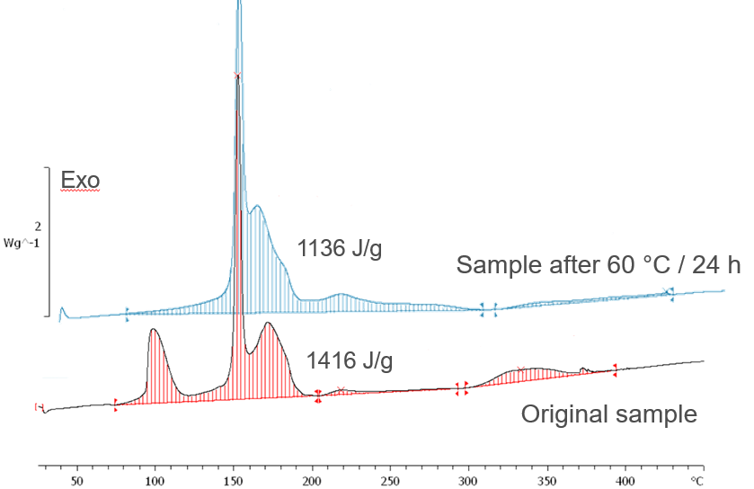
Figure 4: Example of a sample failing the thermal stress test
34. According to the so-called “100 K rule”, sufficient thermal stability may be assumed if the decomposition onset in the screening DSC is 160 °C or above, thus not requiring temperature control.
35. A flowchart for the procedure described above is shown in figure 5.

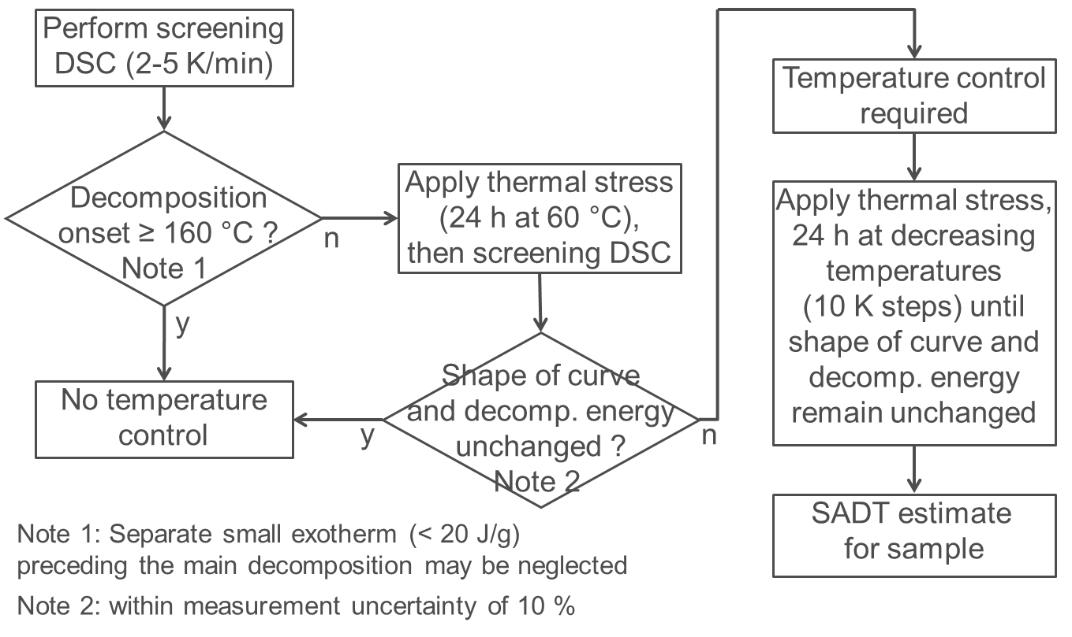

Figure 5: Flowchart for temperature control of energetic samples

Proposal
36. Based on the discussions above, CEFIC suggests to:
- Further develop the provisions in section 2.0.4.3 for energetic samples and to incorporate a flowchart based on figure 2, and
- To incorporate provisions about temperature control and estimation of SADT for energetic samples in the UN Manual of Tests and Criteria. An appropriate place appears to be in the context of section 20.3.3.3. Incorporation of a flowchart as presented in figure 5 is deemed helpful.

