UN/SCETDG/51/INF.29
Committee of Experts on the Transport of Dangerous Goods
and on the Globally Harmonized System of Classification
and Labelling of Chemicals
Sub-Committee of Experts on the Transport of Dangerous Goods 27 June 2017
Fifty-first session
Geneva, 3-7 July 2017
Item 6 (d) of the provisional agenda
Miscellaneous proposals for amendments to the Model Regulations
on the Transport of Dangerous Goods: other miscellaneous proposals

Comments on document ST/SG/AC.10/C.3/2017/21 Proposal of amendment to section 5.5.3
Transmitted by the expert from Austria
Introduction
1. Section 5.5.3 defines special provisions applicable to packages, wagons and containers containing substances presenting a risk of asphyxiation when used for cooling or conditioning purposes (such as UN 1845 Dry ice, UN 1977 Nitrogen, refrigerated liquid or UN 1951 Argon, refrigerated liquid).
2. Document 21 deals with the addition of “protection” as reason for the application of an asphyxiating gas. Therefore the proposal is to add to the two versions of figure 5.5.2 with “AS COOLANT” and “AS CONDITIONER” an additional version with “AS PROTECTIVE AGENT”. That means that additional versions of the figure have to be printed and made available.
3. The warning mark is used to inform that inside the cargo transport unit is an asphyxiate atmosphere, it does not matter if it for cooling, conditioning, or protection purposes! The resulting measures will be exactly the same in all these cases.
4. Therefore we propose an even simpler solution as in document 21 for the footnote to figure 5.5.2 and that is to eliminate the double asterix and the text for it under the figure.
5. This will solve another problem in ADR/RID/ADN as well, where the text “AS COOLANT” or “AS CONDITIONER” does not fit for the transport of dry ice as load.
Proposal
Eliminate the double asterix in the figure and the corresponding text for it under the figure to read 5.5.6.2 as follows.

5.5.3.6.2 The warning mark shall be as shown in Figure 5.5.2.
Figure 5.5.2
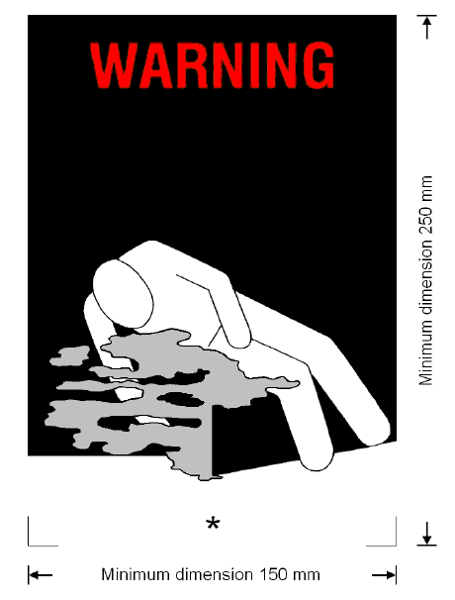
Coolant/conditioning/protective agent warning mark for cargo transport units
* Insert proper shipping name of the coolant/conditioner/protective agent. The lettering shall be in capitals, all be on one line and shall be at least 25 mm high. If the length of the proper shipping name is too long to fit in the space provided, the lettering may be reduced to the maximum size possible to fit. For example: CARBON DIOXIDE, SOLID.
The mark shall be a rectangle. The minimum dimensions shall be 150 mm wide × 250 mm high. The word "WARNING" shall be in red or white and be at least 25 mm high. Where dimensions are not specified, all features shall be in approximate proportion to those shown.

