UN/SCETDG/51/INF.25

Committee of Experts on the Transport of Dangerous Goods
and on the Globally Harmonized System of Classification
and Labelling of Chemicals 27 June 2017
Sub-Committee of Experts on the Transport of Dangerous Goods
Fifty-first session
Geneva, 3-7 July 2017
Item 4 (a) of the provisional agenda
Electric storage systems: testing of lithium batteries
Lithium battery test summary document and comments on ST/SG/AC.10/C.3/2017/27
Submitted by PRBA – The Rechargeable Battery Association
1. As noted in working document ST/SG/AC.10/C.3/2017/27, the Sub-Committee agreed at the fiftieth session to require manufacturers of lithium batteries and any entity that ships lithium batteries or lithium battery-powered devices to make available a test summary in accordance with Section 2.9.4(g) of the Model Regulations. A copy of what is required in the test summary is provided on the following page.
2. PRBA members include many of the largest lithium ion and lithium metal cell and battery manufacturers in the world as well as some of the largest distributors of portable electronic devices (PEDs). For example, some of our members manufacture millions of lithium ion and lithium metal cells on a daily basis. Some manufacturers have been producing high-quality cells for over 35 years, which are shipped in full compliance with the international dangerous goods regulations. Safety and compliance with the dangerous goods regulations are their top priorities.
3. PRBA members also safely manufacture and ship millions of lithium battery-powered PEDs on a regular basis. In 2016, approximately two billion cellular phones and 400 million tablets/notebooks were manufactured. The lithium cells and batteries that power these PEDs are manufactured by dozens of different manufacturers worldwide.
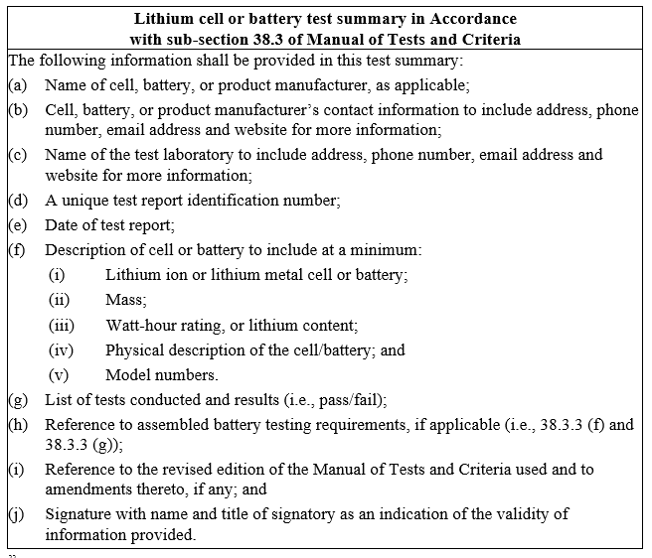
Test Summary Adopted at Fiftieth Session of UN Sub-Committee of Experts December 2016
4. Members of PRBA fully support the need for a test summary and are taking steps to comply with this new requirement in order to provide for more transparency on whether lithium batteries offered for transport have been subject to the UN38.3 testing requirements. However, our members believe it may not be possible to be fully compliant with the test summary by January 1, 2019 due to the very large volume of products subject to the requirements, the need to provide all of the information to downstream distributors, and the uncertainty of how compliance may be achieved as highlighted in the list of questions noted in ST/SG/AC.10/C.3/2017/27. Therefore, additional time is needed to ensure PRBA members and their partners in the logistics chain are able to comply with this new regulatory requirement.
5. PRBA agrees with the point made by MDBTC in ST/SG/AC.10/C.3/2017/27 that the test summary should only apply to lithium batteries manufactured after 1 January 2019. In some cases, it will not be possible to secure all the information required in a summary document for older battery designs because a battery manufacturer or testing lab may no longer be in business.
6. We recommend that a lunchtime working group be held to consider:
- The questions and amendments in MDBTC’s working document ST/SG/AC.10/C.3/2017/27,
- An extension for complying with the new test summary, and
- An exception from the test summary requirement for cells and batteries manufactured prior to January 1, 2019.

