UN/SCETDG/51/INF.17
Committee of Experts on the Transport of Dangerous Goods
and on the Globally Harmonized System of Classification
and Labelling of Chemicals
Sub-Committee of Experts on the Transport of Dangerous Goods 21 June 2017
Fifty-first session
Geneva, 3-7 July 2016
Item 6 (a) of the provisional agenda
Miscellaneous proposals for amendments to the Model
Regulations on the Transport of Dangerous Goods:
Marking and labelling
Specification of hazard labels and marks
Submitted by the International Air Transport Association (IATA)
Introduction
1. The Sub-Committee adopted changes to the hazard labels and certain marks in the eighteenth revised edition of the Model Regulations to provide greater specificity on the dimensions of these labels and marks. Included in these specifications was a requirement that for the hazard labels that “… the minimum width of the line inside the edge forming the diamond shall be 2 mm.”
2. Similar changes were adopted for the specification of the limited quantity mark and the diamond-shaped marks for UN 3245 and UN 3373, where in all cases the minimum width of the line forming the diamond is required to be 2 mm.
3. These changes were adopted with a transitional period of two years and have become mandatory starting from 1 January of this year. In general the introduction of greater specificity for the dimensions of hazard labels and diamond-shaped marks has been well received by industry as it has clarified exactly the boundaries for the 100 x 100 mm dimensions. However, the requirement for a line of at least 2 mm in thickness for hazard labels is proving problematic, particularly for air transport.
4. For air transport there is a mandatory requirement for the operator (airline) to perform an acceptance check of dangerous goods consignments to verify that the consignment is in compliance with the regulatory requirements. To support the performance of the acceptance check to a consistent standard most operators adopt an acceptance checklist form that has a series of questions that point to the applicable regulatory text, e.g. all required hazard labels correctly applied.
5. The result of introducing into the regulations a mandatory requirement that for hazard labels the thickness of the shall be a minimum of 2 mm is that some operators, or their ground handling agents, are rejecting consignments of dangerous goods because the line on the hazard labels is less than 2 mm.
6. While it could be argued that the thickness of the line on the hazard label is not a safety issue and therefore this portion of the regulations doesn’t really apply, the fact is that the provision is a “shall”, just the same as packages shall be marked with the UN number and proper shipping name, and packages shall bear hazard labels that shall be applied on the package in a certain way. For the people who are tasked with performing the acceptance checks they do not have the authority to decide which “shalls” are mandatory and which are just a good idea.
7. Beyond air transport there are also issues at the national level where not all jurisdictions have aligned their dangerous goods regulations to those of the Model Regulations with the result that hazard labels, while being 100 x 100 mm do not have a line of 2 mm thickness to describe the diamond shape. This further complicates and causes frustrations for consignors when their consignments are stopped for having hazard labels that don’t meet the provisions of the international modal regulations.
8. In looking back at the changes that the Sub-Committee adopted on the design and specification of hazard labels and diamond-shaped marks, the adoption of very reference marks to identify the boundaries of the 100 mm dimensions was a very useful clarification to remove any ambiguity. However, the need for a line of 2 mm minimum thickness is questioned.
9. A line a 2 mm thickness in a label of 100 x 100 mm takes on a prominence that diverts from the information that the hazard label is designed to convey, being the colour and the pictogram to identify the hazard.
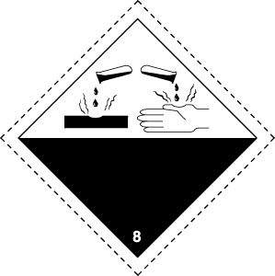 | 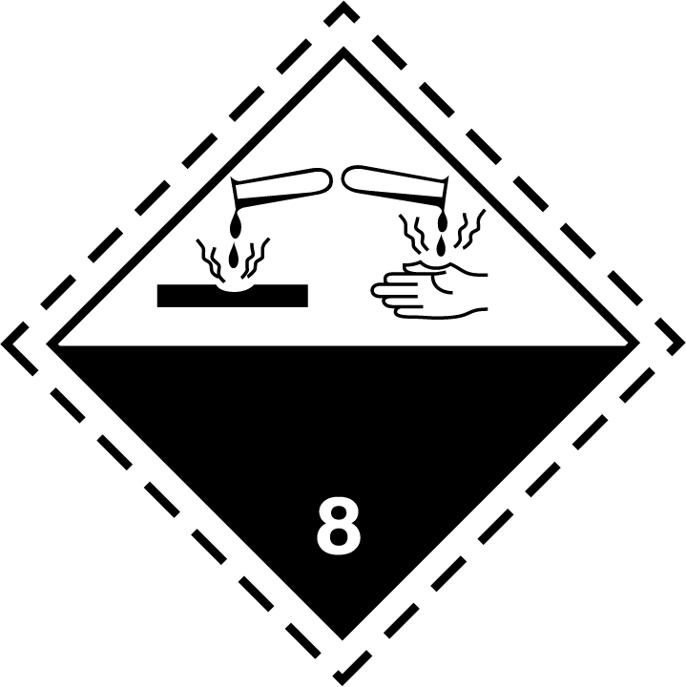
Proposal
10. The Sub-Committee is invited to consider a revision to the provisions for the hazard labels, limited quantity mark and marks for UN 3245 and UN 3373 to remove the requirement for the line forming the diamond to be a minimum of 2 mm in thickness. If there is support for this a formal paper with the proposed changes to the regulatory provisions will be presented at the next session.

