|  |  |  |  |
| --- | --- | --- | --- |
|  | United Nations | ST/SG/AC.10/C.3/2017/21 | |
|  | **Secretariat** | | Distr.: General  7 April 2017  Original: English |

**Committee of Experts on the Transport of Dangerous Goods  
and on the Globally Harmonized System of Classification  
and Labelling of Chemicals**

**Sub-Committee of Experts on the Transport of Dangerous Goods**

**Fifty-first session**

Geneva, 3-7 July 2016

Item 6 (d) of the provisional agenda **Miscellaneous proposals for amendments to the Model Regulations   
on the Transport of Dangerous Goods: other miscellaneous proposals**

Proposal of amendment to section 5.5.3

Transmitted by the expert from the Russian Federation[1]

Introduction

1. Section 5.5.3 defines special provisions applicable to packages, wagons and containers containing substances presenting a risk of asphyxiation when used for cooling or conditioning purposes (such as UN 1845 Dry ice, UN 1977 Nitrogen, refrigerated liquid or UN 1951 Argon, refrigerated liquid).

2. In the Russian Federation and other CIS countries, large capacity universal containers with liner bags are used for the transport of terephthalic acid (non-dangerous goods). The existing technology for transport of terephthalic acid loaded into liner bags in order to exclude the risk of explosion and the formation of clouds of acidic dust, uses compressed nitrogen as a protective agent. After transport, a certain amount of nitrogen may remain, since at the top of the liner-bag, during transport, nitrogen may penetrate the walls of the liner bag in the cargo space of large universal containers.

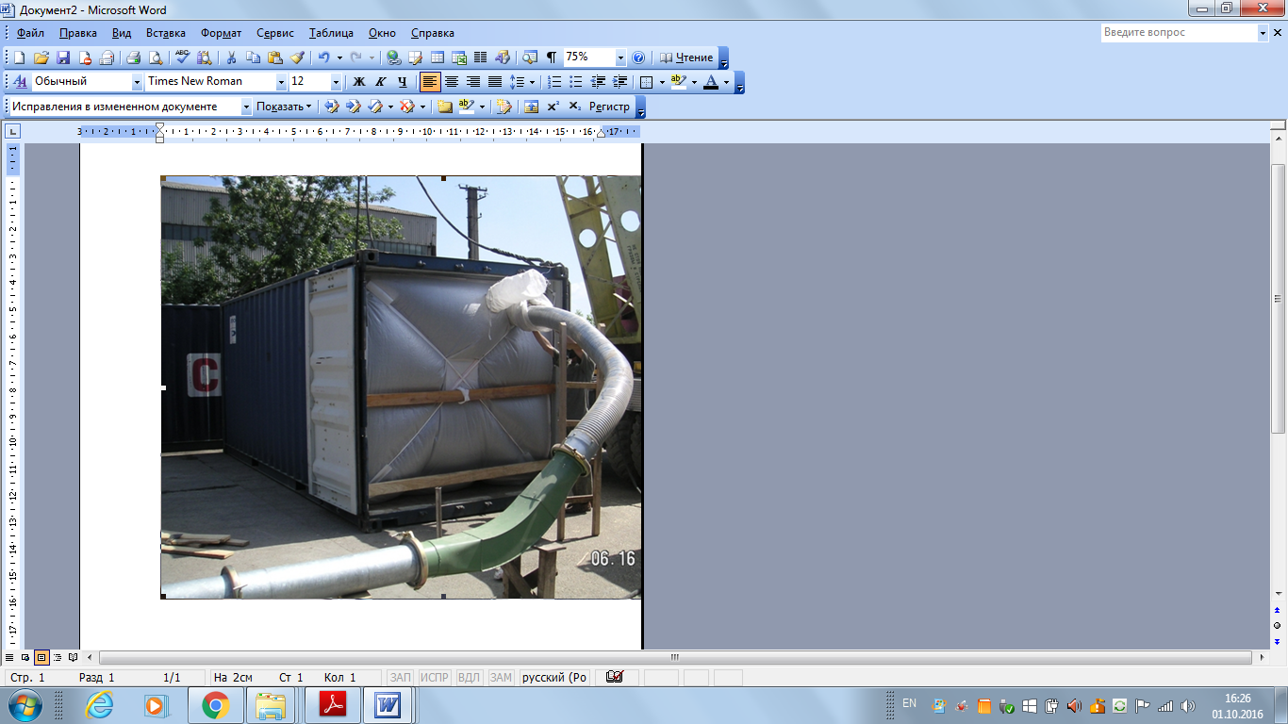

3. Since no warning mark as specified in 5.5.3.6.2 is prescribed for large capacity universal containers, there is no information about the presence of a dangerous concentration of nitrogen in the cargo space and people entering it may be asphyxiated.

Proposal

4. It is proposed to amend 5.5.3, as follows:

"5.5.3 Special provisions applicable to packages and cargo transport units containing substances presenting a risk of asphyxiation when used for cooling, ~~or~~ conditioning or protection purposes (such as dry ice (UN 1845) or nitrogen, refrigerated liquid (UN 1977) or argon, refrigerated liquid (UN 1951) or nitrogen, compressed (UN 1066))

5.5.3.1 *Scope*

5.5.3.1.1 This section is not applicable to substances which may be used for cooling, ~~or~~ conditioning or protection purposes when transported as a consignment of dangerous goods. When they are transported as a consignment, these substances shall be transported under the relevant entry of the Dangerous Goods List in Chapter 3.2 in accordance with the associated conditions of transport.

5.5.3.1.2 This section is not applicable to gases in cooling cycles.

5.5.3.1.3 Dangerous goods used for cooling, ~~or~~ conditioning or protecting portable tanks or MEGCs during transport are not subject to this section.

5.5.3.1.4 Cargo transport units containing substances used for cooling, ~~or~~ conditioning or protection purposes include cargo transport units containing substances used for cooling, ~~or~~ conditioning or prot**e**ction purposes inside packages as well as cargo transport units with unpackaged substances used for cooling, ~~or~~ conditioning or protection purposes.

5.5.3.2 *General*

5.5.3.2.1 Cargo transport units containing substances used for cooling, ~~or~~ conditioning or protection purposes (other than fumigation) during transport are not subject to any provisions of these Regulations other than those of this section.

5.5.3.2.2 When dangerous goods are loaded in cargo transport units containing substances used for cooling, ~~or~~ conditioning or protection purposes any provisions of these Regulations relevant to these dangerous goods apply in addition to the provisions of this section.

5.5.3.2.3 For air transport, arrangements between consignor and operator shall be made for each consignment, to ensure that ventilation safety procedures are followed.

5.5.3.2.4 Persons engaged in the handling or transport of cargo transport units containing substances used for cooling, ~~or~~ conditioning or protection purposes shall be trained commensurate with their responsibilities.

5.5.3.3 *Packages containing a coolant, ~~or~~ conditioner or protective agent*

5.5.3.3.1 Packaged dangerous goods requiring cooling or conditioning assigned to packing instructions P203, P620, P650, P800, P901 or P904 of 4.1.4.1 shall meet the appropriate requirements of that packing instruction.

5.5.3.3.2 For packaged dangerous goods requiring cooling or conditioning assigned to other packing instructions, the packages shall be capable of withstanding very low temperatures and shall not be affected or significantly weakened by the coolant, ~~or~~ conditioner or protective agent. Packages shall be designed and constructed to permit the release of gas to prevent a build-up of pressure that could rupture the packaging. The dangerous goods shall be packed in such a way as to prevent movement after the dissipation of any coolant, ~~or~~ conditioner or protective agent.

5.5.3.3.3 Packages containing a coolant, ~~or~~ conditioner or protective agent shall be transported in well ventilated cargo transport units.

5.5.3.4 *Marking of packages containing a coolant, ~~or~~ conditioner or protective agent*

5.5.3.4.1 Packages containing dangerous goods used for cooling, ~~or~~ conditioning or protection shall be marked with the proper shipping name of these dangerous goods followed by the words "AS COOLANT", ~~or~~ "AS CONDITIONER" or "AS PROTECTIVE AGENT" as appropriate.

5.5.3.4.2 The marks shall be durable, legible and placed in such a location and of such a size relative to the package as to be readily visible.

5.5.3.5 *Cargo transport units containing unpackaged dry ice*

5.5.3.5.1 If dry ice in unpackaged form is used, it shall not come into direct contact with the metal structure of a cargo transport unit to avoid embrittlement of the metal. Measures shall be taken to provide adequate insulation between the dry ice and the cargo transport unit by providing a minimum of 30 mm separation (e.g. by using suitable low heat conducting materials such as timber planks, pallets etc).

5.5.3.5.2 Where dry ice is placed around packages, measures shall be taken to ensure that packages remain in the original position during transport after the dry ice has dissipated.

5.5.3.6 *Marking of cargo transport units*

5.5.3.6.1 Cargo transport units containing dangerous goods used for cooling, ~~or~~ conditioning or protection purposes shall be marked with a warning mark, as specified in 5.5.3.6.2, affixed at each access point in a location where it will be easily seen by persons opening or entering the cargo transport unit. This mark shall remain on the cargo transport unit until the following provisions are met:

(a) The cargo transport unit has been well ventilated to remove harmful concentrations of coolant, ~~or~~ conditioner or protective agent; and

(b) The cooled, ~~or~~ conditioned or protected goods have been unloaded.

5.5.3.6.2 The warning mark shall be as shown in Figure 5.5.2.

**Figure 5.5.2**

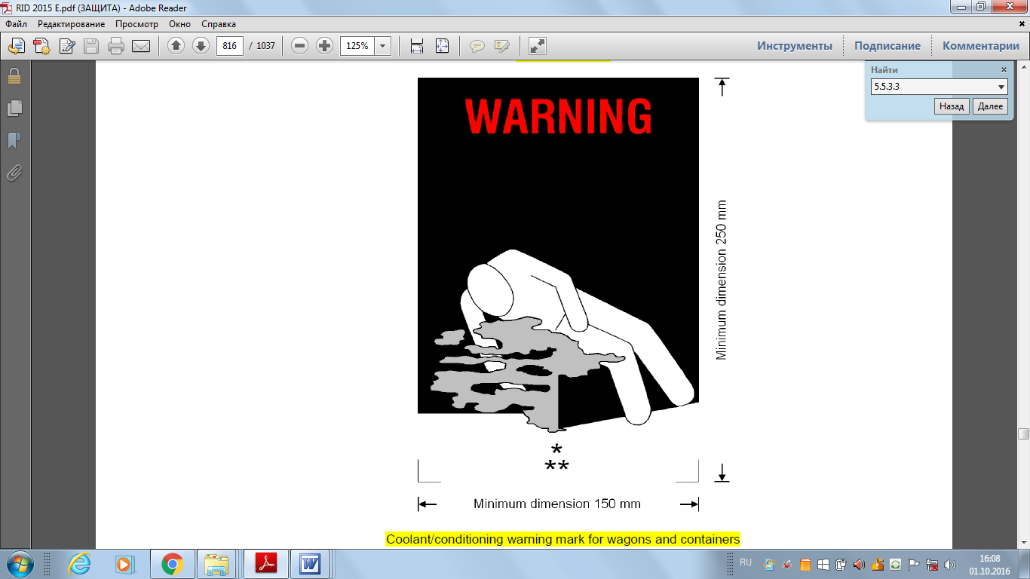

Coolant/conditioning/protective agent warning mark for cargo transport units

* Insert proper shipping name of the coolant/conditioner/protective agent. The lettering shall be in capitals, all be on one line and shall be at least 25 mm high. If the length of the proper shipping name is too long to fit in the space provided, the lettering may be reduced to the maximum size possible to fit. For example: CARBON DIOXIDE, SOLID.

** Insert "AS COOLANT" or "AS CONDITIONER" or "AS PROTECTIVE AGENT" as appropriate. The lettering shall be in capitals, all be on one line and be at least 25 mm high.

The mark shall be a rectangle. The minimum dimensions shall be 150 mm wide × 250 mm high. The word "WARNING" shall be in red or white and be at least 25 mm high. Where dimensions are not specified, all features shall be in approximate proportion to those shown.

5.5.3.7 *Documentation*

5.5.3.7.1 Documents (such as a bill of lading, cargo manifest) associated with the transport of cargo transport units containing or have contained substances used for cooling, ~~or~~ conditioning or protective purposes and have not been completely ventilated before transport shall include the following information:

(a) The UN number preceded by the letters "UN"; and

(b) The proper shipping name followed by the words "AS COOLANT", or "AS CONDITIONER" or "AS PROTECTIVE AGENT" as appropriate.

For example: "UN 1845, CARBON DIOXIDE, SOLID, AS COOLANT".

5.5.3.7.2 The transport document may be in any form, provided it contains the information required in 5.5.3.7.1. This information shall be easy to identify, legible and durable."

Justification

5. This amendment ensures safe working conditions for persons involved in the processing of goods in the presence of a protective agent.

Enforceability

6. The use of this proposal does not imply any difficulties.

1. In accordance with the programme of work of the Sub-Committee for 2017–2018 approved by the Committee at its eighth session (see ST/SG/AC.10/C.3/100, paragraph 98 and ST/SG/AC.10/44, paragraph 14).