Draft Corrigendum to ECE/TRANS/WP.29/GRSG/2016/13
I. Proposal
Paragraph 5.1., the table, correct to read:
"
Technical specifications |  | Vehicle designation (according to chapter 9.1 of Annex b to ADR)
 |  | EX/II | EX/III | AT | FL | OX
… | …
5.1.1.2.1. | Wiring General provisions | X | X | X | X | X
… | …
5.1.2. | Braking equipment
5.1.2.1. |  | X | X | X | X
… | …
5.1.2.6.3.5. | Vehicle endurance braking | X | X | X | X | X
… | …
"
New paragraphs 5.1.1.2.1. and 5.1.1.2.2., correct to read (inserting existing Figures 1 to 4):
"5.1.1.2.1. Cables
No cable in …
… thermal stresses.
5.1.1.2.2. Additional Protection
Cables located …
… or one of the examples in Figures 1 to 4 below or another configuration that offers equally effective protection is used.
Cables of wheel speed sensors do not need additional protection.
EX/II vehicles being one stage built panel vans where the wiring behind the driver's cab is protected by the body are deemed to comply comply with this requirement.
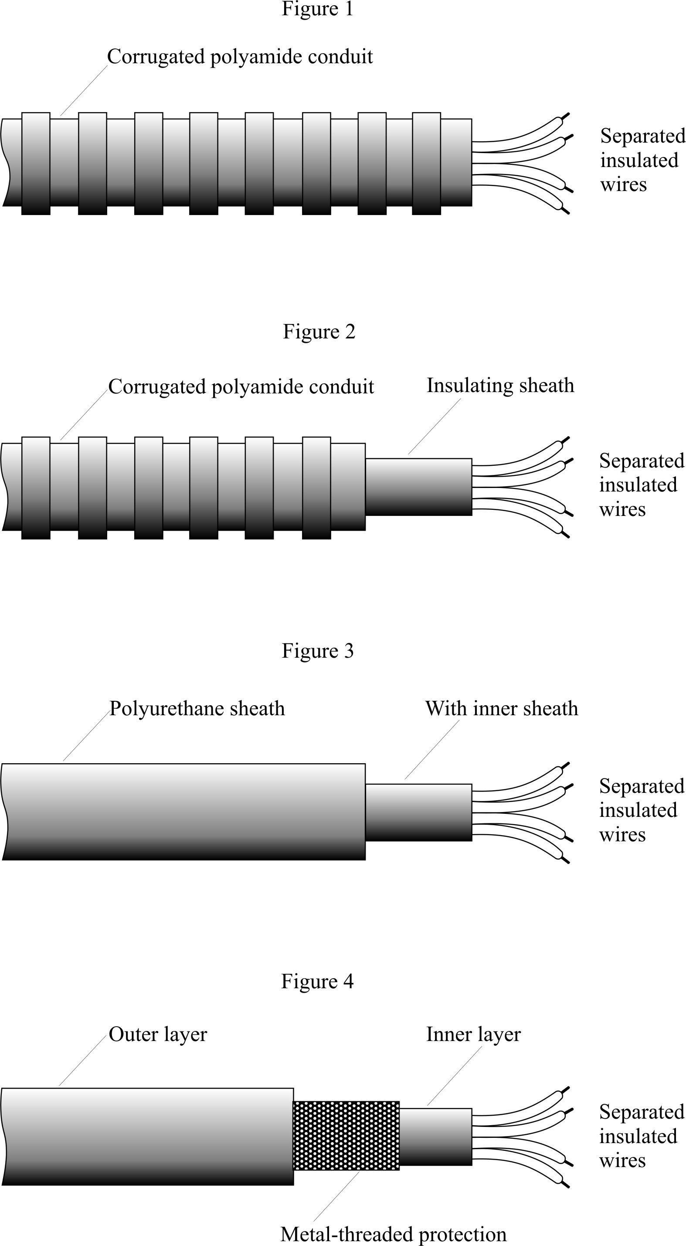
"
Paragraph 5.1.1.5., correct "Lamp sources" to read "Light sources"
Paragraphs 5.1.3. to 5.1.3.2. (former), correct to read:
"5.1.2. Braking equipment
5.1.2.1. EX/II, EX/III, AT, FL, OX and MEMU vehicles shall fulfil all relevant requirements of Regulation No. 13, including those of Annex 5."

II. Justification
This proposal aims at correcting some errors (marked in track-changes) in ECE/TRANS/WP.29/GRSG/2016/13 and to fully align it with the provisions of ADR 2017.

