|  |  |  |  |
| --- | --- | --- | --- |
|  | United Nations | ECE/TRANS/WP.29/GRSG/2016/24 | |
|  | **Economic and Social Council** | | Distr.: General  25 July 2016  Original: English |

**Economic Commission for Europe**

Inland Transport Committee

**World Forum for Harmonization of Vehicle Regulations**

**Working Party on General Safety Provisions**

**111th session**

Geneva, 11–14 October 2016

Item 11 of the provisional agenda

**Regulation No. 118 (Burning behaviour of materials)**

Proposal for amendments to Regulation No. 118 (Burning behaviour of materials)

Submitted by the experts from Finland, France and Germany [1]*

The text reproduced below was prepared by the experts from Finland, France and Germany to improve the test requirements on cables, cable sleeves and conduits. The modifications to the current text of the 02 series of amendments of UN Regulation No. 118 including the adopted amendment of ECE/TRANS/WP.29/GRSG/2015/29 and Corr.1 are marked in bold for new characters and strikethrough for deleted characters.

**I. Proposal**

*List of contents, Annexes*, insert a new reference to Annex 10 to read:

"**Annex 10 Test to determine the resistance to flame propagation of electrical cables**"

*Insert new definitions 2.10. to 2.12.,* to read:

"**2.10. *"Electrical cable"* means a single-core or multi-core cable, when applicable sheathed, screened and unscreened, two or more cores running side by side and bonded, twisted, or braided together, including cores to form a single assembly enabling the transfer of electrical signals from one device to the other.**

**2.11. *"Cable sleeve"* means any component that enfolds single cables to a multi-core cable or electrical harness.**

**2.12. *"Cable conduit"* means any component that covers electrical cables to guide or route the cables (e.g. tubes, channels, ducts) or fasten electrical cables to the vehicle**."

*Paragraph 6.2.6.*, amend to read:

"6.2.6. Any electrical cable ~~(e.g. single-core, multi-core, screened, unscreened, sheathed cables)~~ exceeding a length of 100 mm used in the vehicle shall undergo the resistance to flame propagation test described in **Annex 10 to this Regulation** ~~ISO standard 6722-1:2011, paragraph 5.22~~. **Test reports and approvals of components obtained according to ISO 6722:2006, paragraph 12. shall remain valid**.

**As an alternative to these requirements, the test procedure described in ISO Standard 6722-1:2011, paragraph 5.22. may be applied.**

The exposure to the test flame shall be finished:

**(1)** **for single-core cables**:

**(a)** when the conductor ~~(in case of single-core cables) or the first conductor (in case of multi-core cables)~~ becomes visible, or

**(b)** after 15 s for cables with conductor sizes ~~of each~~ less or equal than 2.5 mm2, and

**(c)** after 30 s for cables with conductor sizes greater than 2.5 mm2,

**or**

**(2) for sheathed, screened and unscreened single- or multi-core cables with a sum of conductor sizes smaller than or equal to 15 mm2:**

**(a) until a conductor becomes visible or for 30 s, for all cables, whichever comes first,**

**or**

**(3) for sheathed, screened and unscreened single- or multi-core cables with a sum of conductor sizes greater than 15 mm2:**

**(a) according to (1) or (2), whichever is applicable.**

**Electrical cables according to (2) may be tested either completely or separately.**

**Electrical cables according to (3) shall be tested separately.**

The result of the test shall be considered satisfactory if, taking into account the worst test result, any combustion flame of insulating material shall extinguish within 70 seconds and a minimum of 50 mm insulation at the top of the test sample shall remain unburned."

*Insert a new paragraph 6.2.7.*, to read:

"**6.2.7. Any cable sleeve or cable conduit exceeding a length of 100 mm shall undergo the test to determine the burning rate of materials as specified in Annex 8.**"

*Paragraphs 6.2.7. to 6.2.7.3. (former)*, renumber as paragraphs 6.2.8. to 6.2.8.3.

Paragraph *6.2.7.4. (former),* renumber as paragraph 6.2.8.4. and amend to read:

"6.2.**8**.4. Elements for which it is not possible to extract a sample in the prescribed dimensions as specified in paragraph 3.1. of Annex 6**,** ~~and~~ paragraph 3. of Annex 7**, and paragraph 3.1. of Annex 8**."

*Annex 6, insert a new paragraph 3.1.3.*, to read:

"**3.1.3. The size of the sample shall be mentioned in the test report.**"

*Annex 7, insert a new paragraph 3.1.*, to read:

"**3.1. The size and the mass of the sample shall be mentioned in the test report.**"

*Annex 8*

*Paragraph 2.1.,* amend to read:

"2.1. The specimen holder shall consist of a rectangular frame of 560 mm high and shall have two rigidly connected parallel rods spaced 150 mm apart on which pins shall be fitted for mounting the test specimen which is located in a plane at least 20 mm from the frame. The mounting pins shall be not greater than 2 mm in diameter and at least ~~27~~ **40** mm long. The pins shall be located on the parallel rods at locations shown in Figure 1. The frame shall be fitted onto a suitable support to maintain the rods in a vertical orientation during testing (for the purpose of locating the specimen on the pins in a plane away from the frame, spacer stubs 2 mm in diameter may be provided adjacent to the pins).

**The specimen holder shown in Figure 1 may be modified in width to allow the fixation of the sample.**

**To fix the sample in a vertical position, a support may be provided consisting of 0.25 mm diameter heat resistant wires that horizontally span the sample at 25 mm intervals along the complete height of the specimen holder. Alternatively, the sample may be fixed by additional clamps to the specimen holder**."

*Paragraph 2.3.,* amend to read:

"2.3. The test apparatus may be placed in a fume cupboard assembly ~~provided that the internal volume is at least 20 times, but not more than 110 times, greater than the volume of the test apparatus and provided that: no single height, width, or length dimension of the fume cupboard is greater than 2.5 times either of the other two dimensions~~. **The size and shape of the fume cupboard shall be such that the test results are not affected**. Before the test, the vertical velocity of the air through the fume cupboard shall be measured 100 mm in front of and behind the final position where the test apparatus will be located. It shall be between 0.10 and 0.30 m/s in order to avoid possible discomfort, by combustion products, to the operator. It is possible to use a fume cupboard with natural ventilation and an appropriate air velocity."

*Paragraphs 3.1. and 3.2.*, amend to read:

"3.1. **Materials according to paragraph 6.2.3.:** The samples dimensions are: 560 mm x 170 mm.

If the dimensions of a material do not permit taking a sample of the given dimensions the test shall be carried out **taking a sample having the dimensions of at least 380 mm in height and at least 3 mm in width**. ~~in accordance with the Technical Service, on the fitted size of the material which shall be mentioned in the test report.~~

**Cable sleeves and cable conduits: The samples dimensions are:   
length: 560 mm, but at least 380 mm; width: initial dimension**.

3.2. **Materials according to paragraph 6.2.3.:** When the thickness of the sample is more than 13 mm, it shall be reduced to 13 mm by a mechanical process applied to the side which does not face the respective compartment (interior, engine or separate heating compartment). If it is impossible, the test shall be carried out in accordance with the Technical Service the initial thickness of the material, which shall be mentioned in the test report. Composite materials (see paragraph 6.1.3.) shall be tested as if they were of uniform construction. In the case of materials made of superimposed layers of different composition which are not composite materials, all the layers of material included within a depth of 13 mm from the surface facing towards the respective compartment shall be tested individually."

*Insert a new paragraph 3.3.*, to read:

"**3.3. The size of the sample shall be mentioned in the test report**."

*Paragraph 3.3. (former)*, renumber as paragraph 3.4.

*Figure 1*, amend to read (removing "Burner" at the bottom and replacing "220" by "240"):

"Figure 1

**Specimen holder** (Dimensions in millimetres)

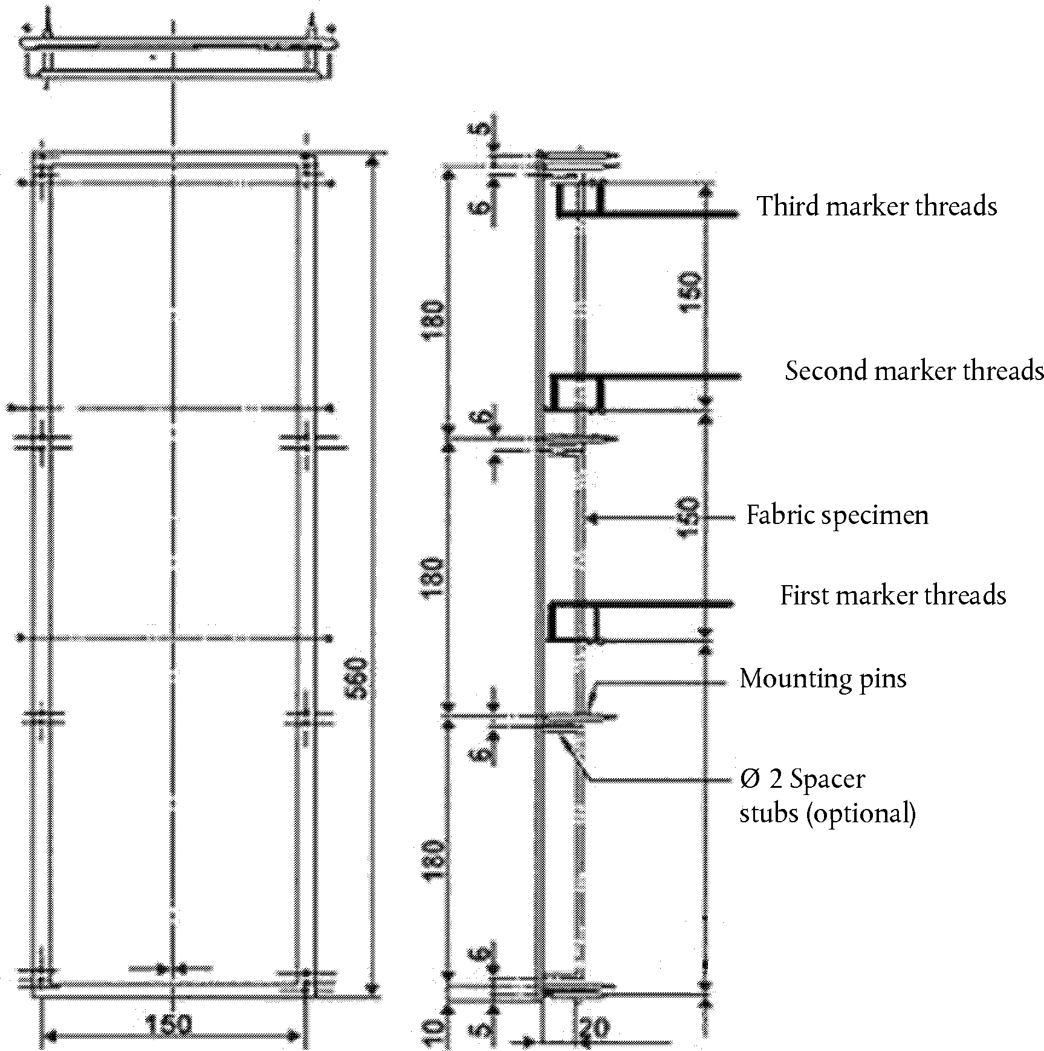

**240**

"

*Insert a new Annex 10*, to read:

**"ANNEX 10**

**Test to determine the resistance to flame propagation of electrical cables**

**1. Scope**

**This annex defines prescriptions to test the resistance to flame propagation of electrical cables used in the vehicle.**

**2. Sampling and principle**

**2.1. Five samples shall undergo the test**

**3. Samples**

**3.1. Test samples shall have a length of at least 600 mm of insulation.**

**4. Procedure**

**Determine the resistance to flame propagation using a Bunsen burner with an appropriate gas, having a combustion tube of 9 mm internal diameter, where the flame temperature at the tip of the inner blue cone shall be (950 +/- 50) °C.**

**Suspend the test sample in a draught-free chamber and expose the test sample to the tip of the inner cone of the flame, as shown in Figure 1. The upper end of the cable shall point away from the closest wall of the chamber. The sample shall be subject to a stress, e.g. by means of a weight over a pulley, in order to keep it straight at all times. The angle of the cable shall be 45° ± 1° relative to the vertical line. In any case, the shortest distance of any part of the sample shall be 100 mm minimum from any wall of the chamber. Apply the flame with the tip of the inner blue cone touching the insulation (500 ± 5) mm from the upper end of the insulation.**

# **Figure 1**

**Apparatus for resistance to flame propagation (Dimensions in millimetres)**

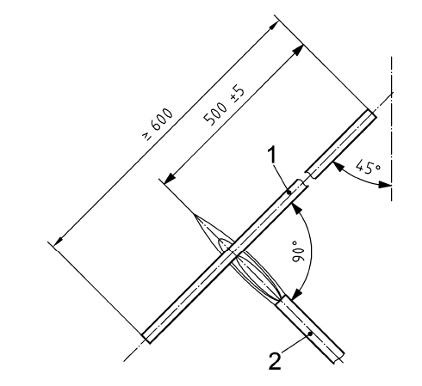

**Key**

**1 test sample**

**2 Bunsen burner**

# "

**II. Justification**

1. This proposal introduces improvements and clarifications on the approval of interior materials, cables and insulation materials. It adds new requirements for cable sleeves and conduits. Furthermore, the requirements of Annex 8 on vertical testing are modified to allow testing of small test samples and to clarify their fixation to the specimen holder.

2. A new Annex 10 is added that contains the provisions for testing electrical cables.

1. * In accordance with the programme of work of the Inland Transport Committee for 2016–2017 (ECE/TRANS/254, para. 159 and ECE/TRANS/2016/28/Add.1, cluster 3.1), the World Forum will develop, harmonize and update Regulations in order to enhance the performance of vehicles. The present document is submitted in conformity with that mandate.