|  |  |  |  |
| --- | --- | --- | --- |
|  | United Nations | ECE/TRANS/WP.29/GRSG/2016/11 | |
|  | **Economic and Social Council** | | Distr.: General  11 February 2016  Original: English |

**Economic Commission for Europe**

Inland Transport Committee

**World Forum for Harmonization of Vehicle Regulations**

**Working Party on General Safety Provisions**

**110th session**

Geneva, 26–29 April 2016

Item 8 of the provisional agenda

**Regulation No. 66 (Strength of superstructure (buses))**

Proposal for the 02 series of amendments to Regulation   
No. 66 (Strength of superstructure (buses))

Submitted by the experts from the International Organization of Motor Vehicle Manufacturers [1]*

The text reproduced below was prepared by the experts from the International Organization of Motor Vehicle Manufacturers (OICA) to amend the provisions of UN Regulation No. 66 with respect to intrusion into residual space. The modifications to the current text of the UN Regulation are marked in bold for new characters.

**I. Proposal**

*Paragraph 5.1.1.,* amend to read:

"5.1.1. No part of the vehicle which is outside the residual space at the start of the test (e.g. pillars, safety rings, luggage racks) shall intrude into the residual space during the test. Any structural parts, which are originally in the residual space (e.g. vertical handholds, partitions, kitchenettes, toilets) shall be ignored when evaluating the intrusion into the residual space. **Intrusion of handles and handholds which are positioned besides a service door, or located where any passenger interference would not occur due to the space being empty, shall also be ignored.**"

II. Justification

1. A rollover test, respectively, a corresponding Computer-Aided Engineering analysis has to be carried out to test the strength of the super structure of buses of categories M2 and M3.

2. After the test, no parts of the exterior structure or parts that are attached to the exterior structure are allowed to intrude into the pre-defined "survival/residual" space of the occupant compartment. Parts which are inside the residual space prior to the test are however exempt.

3. This could lead to a situation where parts that are mounted to the exterior and are located outside of the residual space, but which are very close to the residual space, especially the grab handles shown below, may cross the boundary of the residual space during rollover testing. While this may cause issues when these parts are mounted next to an occupant space, like a seating position, no issues with this would be seen if they intrude the residual space where occupant is not expected (like the entrance space of the bus shown in the pictures below, which is designed for seated occupants only). UN Regulation No. 107 specifies the ability to locate such grab handles outside the residual space and also provide for the best ergonomic solution. Therefore, it is proposed to amend UN Regulation No. 66.

4. The following pictures show such a grab handle and the residual space fixture prior to the test:

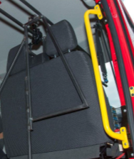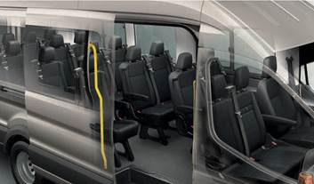

1. * In accordance with the programme of work of the Inland Transport Committee for 2014–2018 (ECE/TRANS/240, para. 105 and ECE/TRANS/2014/26, programme activity 02.4), the World Forum will develop, harmonize and update Regulations in order to enhance the performance of vehicles. The present document is submitted in conformity with that mandate.