Proposal for amendments to Regulations No. 13
(The text reproduced below was prepared by the expert from the European Association of Automotive Suppliers (CLEPA) introducing and amendment to the Regulation No. 13, based on the informal document GRRF-81-20-Rev.1. The modifications to the existing text of the Regulation are marked in bold for new and strikethrough for deleted characters.)
- Proposal
Paragraph 5.2.1.32., amend footnote 12 to read:
¹² Off-road vehicles, special purpose vehicles (e.g. mobile plant using nonstandard vehicle chassis, mobile cranes, hydro-static driven vehicles in which the hydraulic drive system is also used for braking and auxiliary functions, vehicles where the installation of a sensor(s) necessary for the function of the stability control cannot be installed due to the design of the vehicle chassis), N2 vehicles which have all of the following features: a gross vehicle mass between 3.5 and 7, 5 tonnes, a non-standard low-frame chassis, more than 2 axles and hydraulic transmission, Class I and Class A buses of categories M2 and M3, articulated buses and coaches, N2 tractors for semi-trailer with a gross vehicle mass (GVM) between 3.5 and 7.5 tonnes shall be excluded from this requirement.

II. Justification

UNECE R 13, paragraph 5.2.1.32. requires the installation of an electronic vehicle stability function for most motor vehicles N2, N3, M2 and M3, but exempts some vehicles from that requirement e.g. special purpose vehicles in footnote 12 to this paragraph. Unfortunately this group of vehicles is not precisely defined in any regulation and as an additional explanation some vehicles are described and listed in brackets.
Recently a very special type of vehicles was under discussion: trucks where the frame is cut behind the cabin and a new rear frame is added. Instead of a design with a rigid axle the rear wheels are mounted to independent wheel suspensions. This makes it possible to pick-up and transport load boxes which are placed in the area of the rear frame and directly between the rear wheels (see pictures). Typical loads to be carried are fork lifters and steel coils.
Electronic stability control systems need as input for the control algorithms signals of a lateral acceleration sensor and a yaw rate sensor. The installation positions of these sensors are given within an envelope specified by original vehicle manufacturers and are in the zone of the load box of above mentioned vehicles. For that reason an application of existing stability control systems is technically not possible and these vehicles should be exempted from the mandatory installation of electronic vehicle stability function.

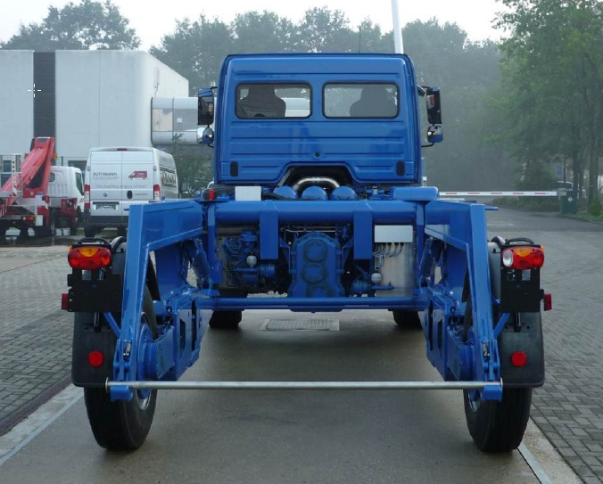

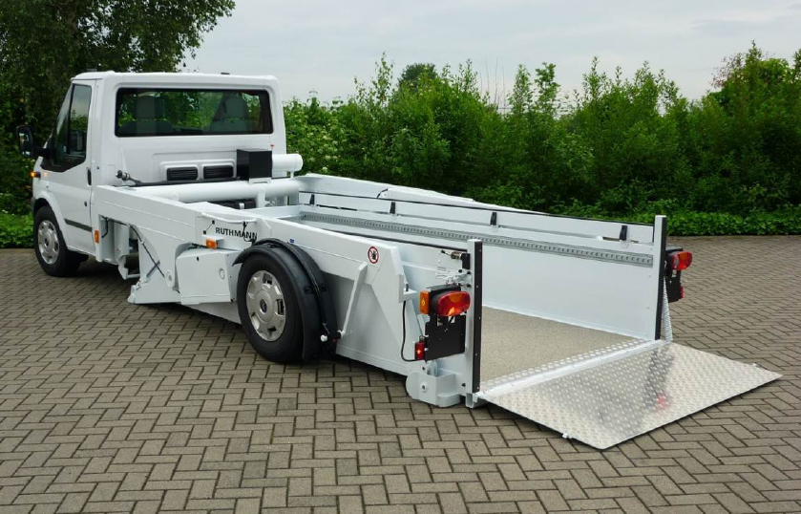

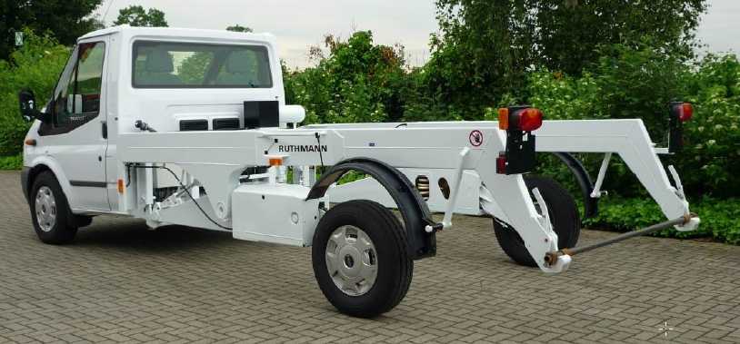
It would be possible to add another specific exemption to footnote 12 as follows to cover the above vehicle:

vehicles where due to their special purpose a sensor installation according to the specified requirements is technically not possible because the specified installation zone is located inside of a removable and separable load zone,

However, it is considered that this may not be an optimum solution therefore it is proposed to amend the existing footnote as proposed by deleting the reference to “mobile plant” and just referring to “vehicles using nonstandard vehicle chassis” as this also includes mobile plant which also has a nonstandard vehicle chassis.

