|  |  |  |  |
| --- | --- | --- | --- |
|  | United Nations | ECE/TRANS/WP.29/GRRF/2016/31 | |
| Description: _unlogo | **Economic and Social Council** | | Distr.: General  7 July 2016  Original: English |

**Economic Commission for Europe**

Inland Transport Committee

**World Forum for Harmonization of Vehicle Regulations**

**Working Party on Brakes and Running Gear**

**Eighty-second session**

Geneva, 20-23 September 2016

Item 4 of the provisional agenda

**Regulation No. 55**

Proposal for amendments to Regulation No. 55 (Mechanical couplings)

Submitted by the Chair of the informal working group on Regulation No. 55[[1]](#footnote-2)\*

The text reproduced below was prepared by the experts of the informal working group on Regulation No. 55 and introduces:

(a) The correction of an error in Annex 5, figures 12 and 17;

(b) An amendment that concerns identification of worst cases for design assessment;

(c) Clarifications on minimum articulation angles.

The modifications to the existing text of the Regulation are marked in bold for new or strikethrough for deleted characters.

1. Proposal

*Annex 5,*

*Figure 12,* amend as follow:

"…Change dimension sleeve bore diameter ~~Ø06H8~~ to **Ø60H8**…**"**

*Paragraph 7.3.2.,* amend to read:

"7.3.2. ~~±12°~~ **6° towards the front and 7° towards the rear** about the horizontal axis transverse to the direction of travel."

*Figure 17,* amend to read:

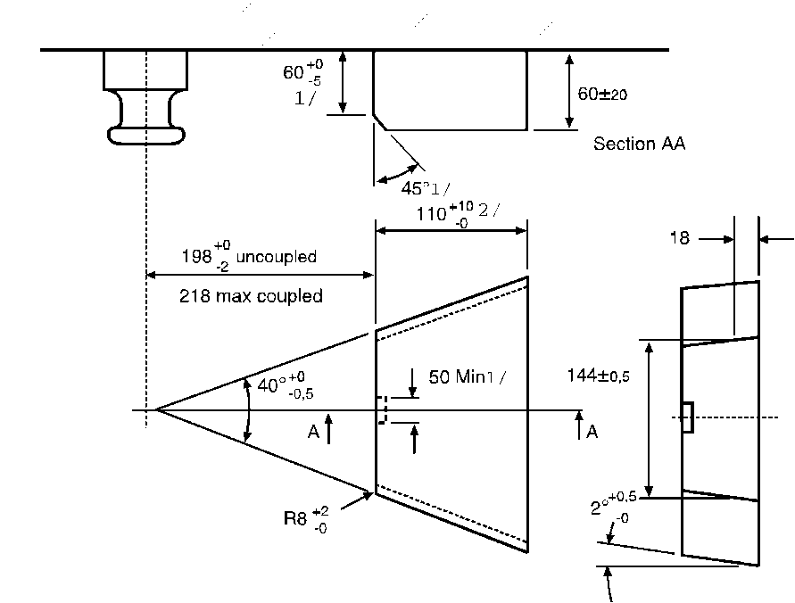

*Annex 6,*

*Paragraph 1.1*., amend to read:

1.1. Samples of coupling devices shall be tested for both strength and function. **Tests shall be performed in relation to worst case conditions.**

**Theoretical assessment may be carried out to determine worst case conditions** Physical testing shall be carried out wherever possible but unless stated otherwise the Type Approval Authority or Technical Service may waive a physical strength test if the simple design of a component makes a theoretical ~~check~~ **assessment** possible.

~~Theoretical checks may be carried out to determine worst case conditions.~~ In all cases, theoretical ~~checks~~ **assessments** shall ensure the same quality of results as with dynamic or static testing. In cases of doubt it is the results of physical testing that are overriding.

See also paragraph 4.8. of this Regulation.

*Paragraph 3.6.1.,* amend to read:

* + 1. Drawbars shall be tested in the same way as drawbar eyes (see paragraph 3.4.). The Type Approval Authority or Technical Service may waive an endurance test if the simple design of a component makes a theoretical ~~check~~ **assessment** of its strength possible. The design forces for the theoretical verification of the drawbar of centre axle trailers with a mass, C, of up to and including 3.5 tonnes shall be taken from ISO 7641/1:1983. The design forces for the theoretical verification of drawbars for centre axle trailers having a mass, C, over 3.5 tonnes shall be calculated asfollows:

Fsp = (g × S/1000) + V

Where the force amplitude V is that ~~given~~ **defined** in paragraph 2.11.4. of this Regulation.

The permissible stresses based on the design masses for trailers having a total mass, C, over 3.5 tonnes shall be in accordance with paragraph 5.3. of ISO 7641/1:1983. For bent drawbars (e. g. swan neck) and for the drawbars of full trailers, the horizontal force component Fhp = 1.0 × D shall be taken into consideration.

*Annex 7,*

*Insert a new paragraph 1.3.5.,* to read:

"**1.3.5. Minimum angles of articulation**

**When attached to the vehicle, the horizontal rotation of the drawbar eye elongated with an imaginary endless axis shall be at least 90° to each side of the centre line of the drawbar coupling and mounting.**

**Simultaneously, there shall be an angle of free vertical movement 20° above and below the horizontal.**

**In the case of a low underslung coupling (e.g. to enable a short distance between the towing and the towed vehicle) the angle of free vertical movement may be reduced to 6° above and below the horizontal.**"

*Paragraphs 1.3.5. to 1.3.8. (former),* renumber as paragraphs 1.3.6. to 1.3.9. respectively*.*

1. Justification

1. Currently, the way to identify worst case(s) is unclear. Therefore, the text in Annex 6, paragraph 1.1. has been amended.

2. In Annex 6, paragraph 1.1. and paragraph 3.6.1., the word "check" where applicable has been exchanged for the word "assessment" in order to make clear the action is towards an approval and not just a check.

3. It is proposed to correct two typos in Annex 5, figures 12 and 17.

4. The proposed change to the Conformity of Production (CoP) procedure also supports the intentions about market surveillance and transparency, which is an important subject of the current revision of the European framework directive.

1. \* In accordance with the programme of work of the Inland Transport Committee for 2016–2017 (ECE/TRANS/254, para. 159 and ECE/TRANS/2016/28/Add.1, cluster 3.1), the World Forum will develop, harmonize and update Regulations in order to enhance the performance of vehicles. The present document is submitted in conformity with that mandate. [↑](#footnote-ref-2)