|  |  |  |  |
| --- | --- | --- | --- |
|  | United Nations | ECE/TRANS/WP.29/GRRF/2016/30 | |
| Description: _unlogo | **Economic and Social Council** | | Distr.: General  7 July 2016  Original: English |

**Economic Commission for Europe**

Inland Transport Committee

**World Forum for Harmonization of Vehicle Regulations**

**Working Party on Brakes and Running Gear**

**Eighty-second session**

Geneva, 20-23 September 2016

Item 4 of the provisional agenda

**Regulation No. 55**

Proposal for amendments to Regulation No. 55 (Mechanical couplings)

Submitted by the Chair of the informal working group on Regulation No. 55[[1]](#footnote-2)\*

The text reproduced below was prepared by the experts of the informal working group on Regulation No. 55 and introduces a procedure to identify allowable combinations of performance values DC and V for drawbar coupling equipment. The modifications to the existing text of the Regulation are marked in bold for new or strikethrough for deleted characters.

1. Proposal

*Add new paragraph 5.3.5.2.,* to read:

"**5.3.5.2. Under the conditions given in Annex 8, paragraph 4.1.1. calculated performance requirements falling outside the conditions of the above paragraph 5.3.5.1. can be handled.**"

*Annex 8,*

*Insert new paragraph 4.*, to read:

**"4. Special Operation**

**In paragraph 5.3.5.1. the general requirement on the characteristic performance values are stated.**

**The designations Dcert, DC-cert, Vcert and Scert used below in this paragraph designate certified performance capacity of a coupling component under consideration. The designation DC-req, Vreq and Sreq designate vehicle combination performance requirements as calculated in accordance with the rules in this annex. They are to be evaluated against certified performance capacities."**

*Insert new paragraph 4.1. and 4.1.1.*, to read:

**"4.1. Clevis coupling systems including drawbeams and drawbar eyes**

**For each combination of certified performance capacity values a diagram as shown in the Figure 28 may be drawn and included in the user’s manual. Performance requirements DC-req and Vreq that would fall in the hatched area of the diagram are allowed to be operated in road traffic.**

**Sreq shall always be below or equal to 1000 kg.**

**4.1.1. If diagrams such as described in paragraph 4.1 of this annex is part of the information material at type approval the component manufacturer owning the type approval certificate for that product is entitled for that product to issue a manufactures certificate certifying the safe application for a combination with DC-req and Vreq laying in the hatched area. Such manufacturers certificate shall at all times be carried with the vehicle combination concerned. "**

**Figure 28**

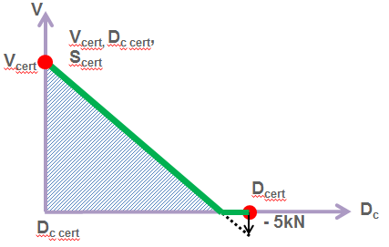

1. Justification

1. Presently, it is not possible to apply coupling equipment in an application where the calculated required performance values DC-req, Vreq and Sreq lay in the hatched area of figure 28. I.e. any application with a DCreq higher that DCcert and a Vreq above zero is not allowed.

2. It is possible to recertify those products for application points in the hatched area. This is also done occasionally. However this procedure result in a number of alternative performance values, some of which being on the type plate. According to the current proposal, recertification would only be necessary for an application above the hatched area in Figure 28.

3. This practice has been used on exemption basis with good results. The proposal has also been analysed from a theoretical standpoint, applying fatigue analysis involving Haig-formalism. This has shown that the static load shall be kept at the certified value Scert. Any change in Sreq cannot be traded towards change in V-value limit. I.e. new combinations of Scert shall be handled through recertification.

4. Some graphical explanation is given below:

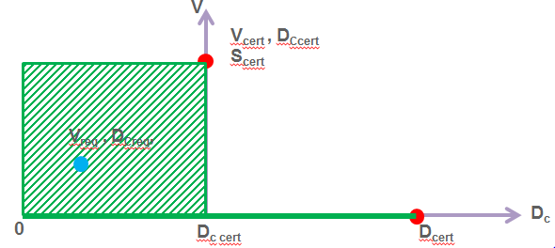

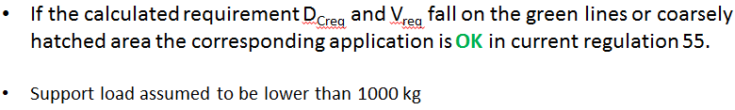

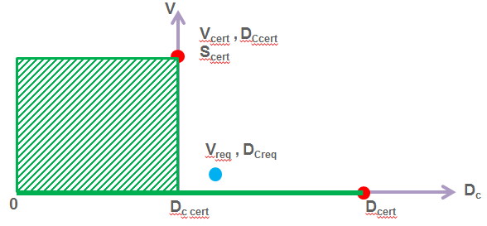

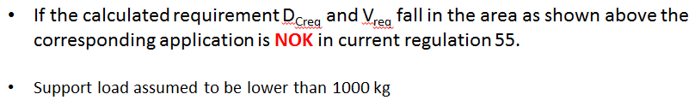

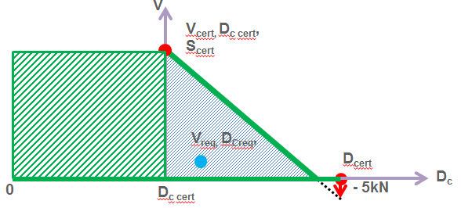

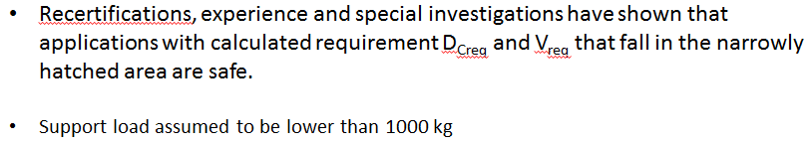

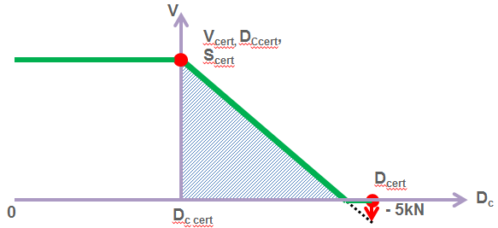

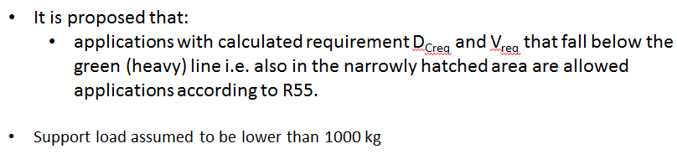

1. \* In accordance with the programme of work of the Inland Transport Committee for 2016–2017 (ECE/TRANS/254, para. 159 and ECE/TRANS/2016/28/Add.1, cluster 3.1), the World Forum will develop, harmonize and update Regulations in order to enhance the performance of vehicles. The present document is submitted in conformity with that mandate. [↑](#footnote-ref-2)