|  |  |  |  |
| --- | --- | --- | --- |
|  | United Nations | ECE/TRANS/WP.29/GRRF/2016/26 | |
| Description: _unlogo | **Economic and Social Council** | | Distr.: General  5 July 2016  Original: English |

**Economic Commission for Europe**

Inland Transport Committee

**World Forum for Harmonization of Vehicle Regulations**

**Working Party on Brakes and Running Gear**

**Eighty-second session**

Geneva, 20-23 September 2016

Item 3(c) of the provisional agenda

**Regulations Nos. 13 and 13-H - Clarifications**

Proposal for amendments to Regulation No. 13 (Braking)

Submitted by the expert from France[[1]](#footnote-2)\*

The text reproduced below was prepared by the expert from France, introducing an amendment to the Regulation No. 13. The modifications to the existing text of the Regulation are marked in bold for new or strikethrough for deleted characters.

1. Proposal

*Annex 12, paragraph 8.1.2.,* amend to read:

8.1.2. Drawing details are to be provided to demonstrate that the compensator articulation is sufficient to ensure equal cable tension is applied to each of the rear cables. The compensator needs to have sufficient distance across the width to facilitate the differential travels left to right. The jaws of the yokes also need to be deep enough relative to their width to make sure that they do not prevent articulation when the compensator is at an angle.

**The compensator's permissible** ~~D~~**d**ifferential travel ~~at compensator~~ ~~(s~~~~cd~~~~)~~ (**s’cd**) shall be derived from:

~~s~~~~cd~~~~≥ 1.2 x (S~~~~cr~~ ~~- S~~~~c~~~~')~~ **s'cd ≥ 1.2 x scd**

Where:

**scd = scr - scf**

~~S~~~~c~~~~' = S'/i~~~~H~~ **scf = sB × ig** (travel at compensator - forward operation) and ~~S~~~~c'~~~~= 2∙S~~~~B~~~~/i~~~~g~~

~~S~~~~cr~~ ~~= S~~~~r~~~~/i~~~~H~~ **scr = sr** (travel at compensator - rearward operation)

*Annex 12, Appendix 1, Figure 5A,* amend to read:

|  |
| --- |
| **~~S~~~~cd~~ scd**  **~~S~~~~cd~~ scd = Difference between ~~S~~~~cf~~ scf and ~~S~~~~cr~~ scr**  **~~S~~~~cr~~ scr**  **~~S~~~~cf~~ scf**  **Increased travel only on one side when only one brake goes into reverse mode** |

*Annex 12, Appendix 4, paragraph 6.1.3.,* amend to read:

6.1.3. ~~Maximum~~ **Compensator's** permissible differential ~~compensator~~ travel ~~s~~~~cd~~ **s’cd** = ..... mm **(shall be greater than or equal to: 1.2 x scd)**

1. Justification

**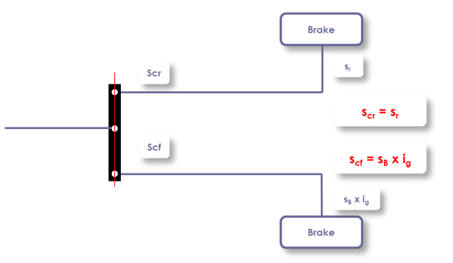**

1. Paragraph 8.1.2. aimed to check that the compensator is capable to accept a difference of the travel when one brake operates in forward direction and the other in rearward direction with a margin of twenty per cent.

2. The new formula expresses this above condition where s'cd is an own characteristic of the compensator to be compared to scd which results from the characteristics of the brakes.

3. The value scd is equal to scr minus scf (see 2.3.12.). These two last values (in mm) come from the characteristics of the brakes measured without adjustment during the test.

4. As shown on the figure above:

scr = sr where sr is the maximum permissible travel at the brake control lever when the trailer moves rearward (see 2.2.27.);

scf = sB x ig where 2 sB is the brake-shoe lift (brake-shoe application travel), in millimeters, measured on diameter parallel to applying device (see paragraph 2.2.21.); and

ig is the reduction ratio between travel of brake lever and lift (application travel) at brake-shoe center (see 2.3.4.).

1. \* In accordance with the programme of work of the Inland Transport Committee for 2016–2017 (ECE/TRANS/254, para. 159 and ECE/TRANS/2016/28/Add.1, cluster 3.1), the World Forum will develop, harmonize and update Regulations in order to enhance the performance of vehicles. The present document is submitted in conformity with that mandate. [↑](#footnote-ref-2)