 | United Nations | ECE/TRANS/WP.29/2016/111
 | Economic and Social Council |  | Distr.: General  5 September 2016  Original: English

Economic Commission for Europe
Inland Transport Committee
World Forum for Harmonization of Vehicle Regulations
170th session
Geneva, 15-18 November 2016
Item 8.4 of the provisional agenda
Other business:
Consideration of proposals for
a new consolidated resolution
Proposal for a draft Resolution on the common specification of light source categories (R.E.4)
Submitted by the Working Party on Lighting and Light-Signalling*
The text reproduced below was adopted by the Working Party on Lighting and Light-Signalling (GRE) at its seventy-fifth session (ECE/TRANS/WP.29/GRE/75, para. 8). It is based on ECE/TRANS/WP.29/GRE/2016/5 and Corr.1, as amended by Annex II to the report, and ECE/TRANS/WP.29/GRE/2016/6. It is submitted to the World Forum for Harmonization of Vehicle Regulations (WP.29) for consideration at its November 2016 session.

Resolution [R.E.4] on the common specification of light source categories
Status table
This consolidated version of this Resolution contains all provisions and amendments adopted so far by the World Forum for Harmonization of Vehicle Regulations (WP.29) and is valid from the date as indicated in the following table until the date on which the next revision of this Resolution becomes valid:

Version of the Resolution | Date * as from which the version is valid | Adopted by WP.29 |  | Clarification
Version of the Resolution | Date * as from which the version is valid | Session No. | Amendment document No. | Clarification
Original | [2017-xx-xx] | [170] | [ECE/TRANS/WP.29/2016/111] | Based upon Annexes 1 of Regulations:  - No. 37, up to and including Supplement 44  - No. 99, up to and including Supplement 11  - No. 128, up to and including Supplement 5
* This date is the date of adoption of the amendment to the Resolution by WP.29 or the date of entering into force of an amendment to Regulation No. 37, 99 or 128 adopted by the Administrative Committee AC.1 as a package with the amendment to the Resolution in the same session of WP.29.
Contents
Page
Preamble 3
Introduction 3
1. Scope 4
2. Definitions 4
3. Light source categories and their use 5
3.1. Filament light sources 5
3.2. Gas-discharge light sources 10
3.3. LED light sources 11
Annexes
1. Sheets for filament light sources 13
2. Sheets for gas-discharge light sources 198
3. Sheets for LED light sources 239
Preamble
1. The World Forum for Harmonization of Vehicle Regulations (WP.29),
2. DESIRING to harmonize technical requirements while ensuring high levels of safety, environmental protection, energy efficiency and anti-theft performance of wheeled vehicles, equipment and parts which can be fitted and/or be used on wheeled vehicles,
3. DESIRING to facilitate the trade of wheeled vehicles, equipment and parts with harmonized performance requirements among its participating countries,
4. BEARING IN MIND that the assessment of compliance with the technical prescriptions of Regulations concerning lighting and light signalling requires the specification of light sources in light source category sheets and/or information on which light source categories are applicable or excluded for use in particular lamps,
5. DESIRING to simplify the regulatory process for all stakeholders, while the technical specifications of the characteristics of light source categories and/or information on which light source categories are applicable or excluded for use in particular lamps, are subject of evaluation by the WP.29 Working Party on Lighting and Light-Signalling (GRE),
6. DECIDED that the specification of light sources in light source category sheets and/or the information which light source categories are applicable or excluded for use in particular lamps, are issued in a Resolution on the specification of light source categories.
Introduction
1. This Resolution finds its origin in the 1958 Agreement and its attached Regulations:
- Regulation No. 37 "Filament lamps", up to and including Supplement No. 44;
- Regulation No. 99 "Gas-discharge light sources", up to and including Supplement No. 11;
- Regulation No. 128 "Light emitting diodes (LED) light sources", up to and including Supplement No. 5.
2. This Resolution is intended for reference from and approval of light sources according to:
- Regulation No. 37 "Filament light sources";**
- Regulation No. 99 "Gas-discharge light sources";
- Regulation No. 128 "LED light sources".
3. This Resolution may also serve as a reference for other Regulations or standards.

1. Scope
This Resolution contains the specifications of light source categories and/or information on which light source categories are applicable or excluded for use in particular lamps.
In the case of "design to conform" requirements, reference should be made to values of characteristics of light sources of normal production, while values for standard (high accuracy) light sources may be ignored.
2. Definitions
2.1. General
2.1.1. "Light source" means one or more elements for visible radiation, with a base for mechanical and electrical connection, possibly assembled with one or more components to control the elements for visible radiation;
2.1.1.1. "Filament light source" means a light source where the only element for visible radiation is one or more filaments producing thermal radiation;
2.1.1.2. "Gas-discharge light source" means a light source where the only element for visible radiation is a discharge arc producing electroluminescence;
2.1.1.3. "Light-emitting diode (LED) light source" means a light source where the only element for visible radiation is one or more solid state junctions producing electroluminescence possibly completed with one or more elements for fluorescence-based conversion.
2.1.2. "Standard (étalon) light source" means a special light source used for the testing of lighting and light-signalling devices. It has reduced tolerances for dimensional, electrical and photometric characteristics as specified on the relevant data sheet.
2.1.3. "Ballast" means one or more components, either between supply and light source or integrated with a light source, to control the electrical current of the gas-discharge light source;
2.1.4. "Objective value(s)" means design value(s) to be achieved within specified tolerances when the light source or the ballast of the gas discharge light source is energized at specified test voltage(s)
2.2. Dimensional characteristics
2.2.1 "Reference axis" means an axis defined with reference to the cap and to which certain dimensions of the light source are referred.
2.2.2. "Reference plane" means a plane defined with reference to the cap and to which certain dimensions of the light source are referred.
2.2.3. "Light centre" means a point that represents the origin of the light emitted.
2.2.4. "Light centre length" means the distance between the reference plane and the light centre.
2.2.5. "Viewing axis on to the light source" means an axis through the nominal light centre at defined polar and azimuthal angle.
2.3. Electrical characteristics
2.3.1. "Test voltage" means the voltage, at the input terminals of the light source or at the terminals of the ballast for the gas-discharge light source, for which the electrical and photometric characteristics of the light source are intended and are to be tested.
2.3.2. "Rated voltage" means the voltage (in volts) marked on the light source or on the ballast.
2.3.3. "Rated wattage" means the wattage marked on the light source or on the ballast.
2.4. Photometric characteristics
2.4.1. "Reference luminous flux"means an accurately specified luminous flux value of a standard light source serving as a reference for the optical characteristics of a lighting or light signalling device.
2.4.2. "Measuring luminous flux"means specified value of the luminous flux for testing a filament light source with an internal shield to produce the cut-off.
2.4.3. "Cumulative luminous flux" means the luminous flux emitted by the light source under operating conditions, within a cone enclosing a specified solid angle and centred on the reference axis.
2.4.4. "Normalized luminous intensity" means luminous intensity divided by the luminous flux of the light source.
3. Light source categories and their use
3.1. Filament light sources
Characteristics* of categories of filament light sources as listed below are shown in Annex 1.
Luminous flux values in the light source category sheets concern white light unless otherwise specified in these sheets.
List of categories of filament light sources, grouped according to restrictions on use and their sheet numbers:
Group 1
Filament light source categories (or types within these categories) without general restrictions:
 | Category | Note(s) | Sheet number(s)
 | H1 | *⁶ | H1/1 to 3
 | H3 | *⁶ | H3/1 to 4
 | H4 |  | H4/1 to 5
 | H7 |  | H7/1 to 4
 | H8 |  | H8/1 to 4
 | H8B |  | H8/1 to 4
 | H9 | *³ | H9/1 to 4
 | H9B | *³ | H9/1 to 4
 | H10 |  | H10/1 to 3
 | H11 |  | H11/1 to 4
 | H11B |  | H11/1 to 4
 | H13 |  | H13/1 to 4
 | H15 |  | H15/1 to 5
 | H16 |  | H16/1 to 4
 | H16B |  | H16/1 to 4
 | H17 |  | H17/1 to 6
 | H18 |  | H18/1 to 4
 | H19 |  | H19/1 to 5
 | H20 |  | H20/1 to 4
 | H21W | *² | H21W/1 to 2
 | H27W/1 |  | H27W/1 to 3
 | H27W/2 |  | H27W/1 to 3
 | HB3 |  | HB3/1 to 4
 | HB4 |  | HB4/1 to 4
 | HIR2 |  | HIR2/1 to 3
 | HS1 | *⁶ | HS1/1 to 5
 | HS5 | *⁵ | HS5/1 to 4
 | PSX24W | *² | P24W/1 to 3
 | PSX26W | *² | PSX26W1 to 3
 | S2 | *⁵,*⁶ | S1/S2/1 to 2

Group 2
Filament light source categories (or types within these categories) only for use in signalling lamps, cornering lamps, reversing lamps and rear registration plate lamps:
 | Category | Note(s) |  | Sheet number(s)
 | C5W |  | *⁶ | C5W/1
 | H6W |  |  | H6W/1
 | H10W/1 |  |  | H10W/1 to 2
 | HY6W |  |  | H6W/1
 | HY10W |  |  | H10W/1 to 2
 | HY21W |  |  | H21W/1 to 2
 | P13W |  |  | P13W/1 to 3
 | P21W |  | *⁶ | P21W/1 to 2
 | P21/4W |  |  | P21/4W/1 |  | (P21/5W/2 to 3)
 | P21/5W |  | *⁶ | P21/5W/1 to 3
 | P27W |  |  | P27W/1 to 2
 | P27/7W |  |  | P27/7W/1 to 3
 | PR21W |  |  | PR21W/1 |  | (P21W/2)
 | PR21/5W |  |  | PR21/5W/1 |  | (P21/5W/2 to 3)
 | PS19W |  |  | P19W/1 to 3
 | PS24W |  |  | P24W/1 to 3
 | PSY19W |  |  | P19W/1 to 3
 | PSY24W |  |  | P24W/1 to 3
 | PW13W |  |  | P13W/1 to 3
 | PW16W |  |  | PC16W/1 to 3
 | PWR16W |  |  | PC16W/1 to 3
 | PWY16W |  |  | PC16W/1 to 3
 | PW19W |  |  | P19W/1 to 3
 | PWR19W |  |  | P19W/1 to 3
 | PWY19W |  |  | P19W/1 to 3
 | PW24W |  |  | P24W/1 to 3
 | PWR24W |  |  | P24W/1 to 3
 | PWY24W |  |  | P24W/1 to 3
 | PY21W |  |  | PY21W/1 | (P21W/2)
 | PY21/5W |  |  | PY21/5W/1 to 3
 | PY24W |  |  | P24W/1 to 3
 | PY27/7W |  |  | PY27/7W/1 | (P27/7W/2 to 3)
 | R5W |  | *⁶ | R5W/1
 | R10W |  | *⁶ | R10W/1
 | RR5W |  |  | R5W/1
 | RR10W |  |  | R10W/1
 | RY10W |  | *⁶ | R10W/1
 | T4W |  | *⁶ | T4W/1
 | W2.3W |  |  | W2.3W/1
 | W3W |  | *⁶ | W3W/1
 | W5W |  | *⁶ | W5W/1
 | W10W |  | *⁶ | W10W/1
 | W15/5W |  |  | W15/5W/1 to 3
 | W16W |  |  | W16W/1
 | W21W |  |  | W21W/1 to 2
 | W21/5W |  |  | W21/5W/1 to 3
 | WR5W |  |  | W5W/1
 | WR21/5W |  |  | WR21/5W/1 | (W21/5W/2 to 3)
 | WT21W |  |  | WT21W/1 to 2
 | WT21/7W |  |  | WT21/7W/1 to 3
 | WTY21W |  |  | WT21W/1 to 2
 | WTY21/7W |  |  | WT21/7W/1 to 3
 | WY5W |  | *⁶ | W5W/1
 | WY10W |  | *⁶ | W10W/1
 | WY16W |  |  | W16W/1
 | WY21W |  |  | WY21W/1 to 2

Group 3
Filament light source categories (or types within these categories) only for use in lamps as replacement parts for lamps on vehicles in use originally equipped with such lamps:
 | Category | Note(s) | Sheet number(s) | From date onwards**
 | C5W | *⁷, *⁸ | C5W/1 | 26 July 2013
 | C21W | *⁸ | C21W/1 to 2 | 11 June 2008
 | H1 | *⁷ | H1/1 to 3 | 26 July 2013
 | H3 | *⁷ | H3/1 to 4 | 26 July 2013
 | H12 |  | H12/1 to 3 | 15 July 2015
 | H13A |  | H13/1 to 4 | 15 July 2015
 | H14 |  | H14/1 to 4 | 26 July 2013
 | HB3A |  | HB3/1 to 4 | 15 July 2018
 | HB4A |  | HB4/1 to 4 | 15 July 2018
 | HIR1 | *³ | HIR1/1 to 3 | 15 July 2015
 | HS1 | *⁷ | HS1/1 to 5 | 26 July 2013
 | HS2 | *⁷ | HS2/1 to 3 | 26 July 2013
 | HS2 | *⁶ | HS2/1 to 3 | 1 September 2018
 | HS5A | *⁵ | HS5A/1 to 3 | 1 September 2018
 | HS6 | *⁴ | HS6/1 to 4 | 15 July 2018
 | P19W | *⁸ | P19W/1 to 3 | 28 October 2016
 | P21W | *⁷, *⁸ | P21W/1 to 2 | 26 July 2013
 | P21/5W | *⁷, *⁸ | P21/5W/1 to 3 | 26 July 2013
 | P24W | *⁸ | P24W/1 to 3 | 1 September 2018
 | PC16W | *⁸ | PC16W/1 to 3 | 28 October 2016
 | PCR16W | *⁸ | PC16W/1 to 3 | 28 October 2012
 | PCY16W | *⁸ | PC16W/1 to 3 | 28 October 2016
 | PR19W | *⁸ | P19W/1 to 3 | 28 October 2012
 | PR21/4W | *⁸ | PR21/4W/1 ;  (P21/5W/2 to 3) | 15 July 2015
 | PR24W | *⁸ | P24W/1 to 3 | 28 October 2012
 | PR27/7W | *⁸ | PR27/7W/1 ;  (P27/7W/2 to 3) | 15 July 2015
 | PSR19W | *⁸ | P19W/1 to 3 | 28 October 2012
 | PSR24W | *⁸ | P24W/1 to 3 | 28 October 2012
 | PX24W | *² | P24W/1 to 3 | 1 September 2018
 | PY19W | *⁸ | P19W/1 to 3 | 28 October 2016
 | R2 |  | R2/1 to 3 | 11 June 2008
 | R5W | *⁷, *⁸ | R5W/1 | 26 July 2013
 | R10W | *⁷, *⁸ | R10W/1 | 26 July 2013
 | RY10W | *⁷, *⁸ | R10W/1 | 26 July 2013
 | S1 |  | S1/S2/1 to 2 | 11 June 2008
 | S2 | *⁷ | S1/S2/1 to 2 | 26 July 2013
 | S3 |  | S3/1 | 26 July 2013
 | T1.4W | *⁸ | T1.4W/1 | 15 July 2015
 | T4W | *⁷, *⁸ | T4W/1 | 26 July 2013
 | W3W | *⁷, *⁸ | W3W/1 | 26 July 2013
 | W5W | *⁷, *⁸ | W5W/1 | 26 July 2013
 | W10W | *⁷, *⁸ | W10W/1 | 26 July 2013
 | WP21W | *⁸ | WP21W/1 to 2 | 1 September 2018
 | WPY21W | *⁸ | WP21W/1 to 2 | 1 September 2018
 | WY2.3W | *⁸ | WY2.3W/1 | 15 July 2015
 | WY5W | *⁷, *⁸ | W5W/1 | 15 July 2014
 | WY10W | *⁷, *⁸ | W10W/1 | 26 July 2013
* Tables, Electrical and Photometric characteristics:
Voltage is expressed in V;
Wattage is expressed in W;
Luminous flux is expressed in lm.
In a case of a category of filament light source where more than one value of reference luminous flux is specified, the value at approximately 12 V for a lighting device and 13.5 V for a light-signalling device shall be applied unless otherwise specified by the regulation used for the device.
*² Not for use in passing beam headlamps.
*³ Not for use in front fog lamps marked "B" as defined in Regulation No. 19.
*⁴ Not for use in Regulation No. 112 headlamps.
*⁵ Not for use in headlamps other than Regulation No. 113 class C headlamps.
*⁶ All types except from 6 V type.
*⁷ 6 V types only.
*⁸ Only for use in signalling lamps, cornering lamps, reversing lamps and rear registration plate lamps.
** From the original version of this Resolution onwards, this date is 1 September following the date of adoption of (the amendment to) this Resolution by WP.29, plus a multiple of 12 months thereafter.
3.2. Gas-discharge light sources
Characteristics of categories of gas-discharge light sources as listed below are shown in Annex 2.
Luminous flux values in the light source category sheets concern white light unless otherwise specified in these sheets.
List of categories of gas-discharge light sources, grouped according to restrictions on use and their sheet numbers:
Gas-discharge light source categories
only for use in passing beam, driving beam and cut-off front fog lamps:
 | Category |  | Sheet number(s)
 | D1R |  | DxR/1 to 7
 | D1S |  | DxS/1 to 6
 | D2R |  | DxR/1 to 7
 | D2S |  | DxS/1 to 6
 | D3R |  | DxR/1 to 7
 | D3S |  | DxS/1 to 6
 | D4R |  | DxR/1 to 7
 | D4S |  | DxS/1 to 6
 | D5S |  | D5S/1 to 5
 | D6S |  | D6S/1 to 5
 | D8R |  | D8R/1 to 6
 | D8S |  | D8S/1 to 5
 | D9S |  | D9S1 to 5
3.3. LED light sources
Characteristics of categories of LED light sources as listed below as shown in Annex 3.
Luminous flux values in the light source category sheets concern white light unless otherwise specified in these sheets.
List of categories of LED light sources, grouped according to restrictions on use and their sheet numbers:
"RESERVED"
Group 1
LED light source categories without general restrictions:
 | Category |  | Sheet number(s)

Group 2
LED light source categories only for use in signalling lamps, cornering lamps, reversing lamps and rear registration plate lamps:
 | Category |  | Sheet number(s)
 | LR1 |  | LR1/1 to 5
 | LW2 |  | LW2/1 to 5
 | LR3A |  | L3/1 to 6
 | LR3B |  | L3/1 to 6
 | LW3A |  | L3/1 to 6
 | LW3B |  | L3/1 to 6
 | LY3A |  | L3/1 to 6
 | LY3B |  | L3/1 to 6
 | LR4A |  | LR4/1 to 5
 | LR4B |  | LR4/1 to 5
 | LR5A |  | L5/1 to 6
 | LR5B |  | L5/1 to 6
 | LW5A |  | L5/1 to 6
 | LW5B |  | L5/1 to 6
 | LY5A |  | L5/1 to 6
 | LY5B |  | L5/1 to 6
Annex 1
Sheets for filament light sources
List of sheets for filament light sources and their sequence in this annex:
Sheet number(s)
C5W/1
C21W/1 to 2
H1/1 to 3
H3/1 to 4
H4/1 to 5
H7/1 to 4
H8/1 to 4
H9/1 to 4
H10/1 to 3
H11/1 to 4
H12/1 to 3
H13/1 to 4
H14/1 to 4
H15/1 to 5
H16/1 to 4
H17/1 to 6
H18/1 to 4
H19/1 to 5
H20/1 to 4
H6W/1
H10W/1 to 2
H21W/1 to 2
H27W/1 to 3
HB3/1 to 4
HB4/1 to 4
HIR1/1 to 3
HIR2/1 to 3
HS1/1 to 5
HS2/1 to 3
HS5/1 to 4
HS5A/1 to 3
HS6/1 to 4
P13W/1 to 3
P19W/1 to 3
P21W/1 to 2
P21/4W/1
P21/5W/1 to 3
P24W/1 to 3
P27W/1 to 2
P27/7W/1 to 3
PC16W/1 to 3
PR21W/1
PR21/4W/1
PR21/5W/1
PR27/7W/1
PSX26W/1 to 3
PY21W/1
PY21/5W/1 to 3
PY27/7W/1
R2/1 to 3
R5W/1
R10W/1
S1/S2/1 to 2
S3/1
T1.4W/1
T4W/1
W2.3W/1
W3W/1
W5W/1
W10W/1
W15/5W/1 to 3
W16W/1
W21W/1 to 2
W21/5W/1 to 3
WP21W/1 to 2
WR21/5W/1
WT21W/1 to 2
WT21/7W/1 to 3
WY2.3W/1
WY21W/1 to 2

Category C5W Sheet C5W/1
The drawings are intended only to illustrate the essential dimensions (in mm) of the filament light source
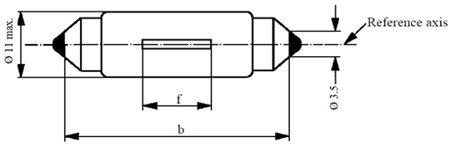
f
b
Ø 11 max.
Reference axis
Ø 3.5

Dimensions in mm |  |  |  | Filament light sources of normal production |  |  |  | Standard filament light source
 |  |  |  | Min. |  | Nom. | Max. | Standard filament light source
b ^{1/} |  |  |  | 34.0 |  | 35.0 | 36.0 | 35.0 ± 0.5
f ^{2/,3/} |  |  |  | 7.5 ^{4/} |  |  | 15 ^{5/} | 9 ± 1.5
Cap SV8.5 in accordance with IEC Publication 60061 (sheet 7004-81-4)
Electrical and photometric characteristics
Rated values |  | Volts | 6 |  | 12 |  | 24 | 12
 |  | Watts | 5 |  |  |  |  | 5
Test voltage |  | Volts | 6.75 |  | 13.5 |  | 28.0 | 13.5
Objective values | Watts |  | 5.5 max. |  |  |  | 7.7 max. | 5.5 max.
Objective values | Luminous flux |  | 45 ± 20 %
Reference luminous flux: 45 lm at approximately 13.5 V
^{1/} This dimension corresponds to a distance between two apertures of 3.5 mm diameter each bearing against one of the caps.
^{2/} The filament shall be housed in a cylinder 19 mm long co-axial with the filament light source and placed symmetrically about the filament light source centre.
The diameter of the cylinder is for 6 V and 12 V filament light sources: d + 4 mm (for standard filament light sources: d + 2 mm) and for 24 V filament light sources: d + 5 mm, "d" being the nominal diameter of the filament as stated by the manufacturer.
^{3/} The deviation of the filament centre from the centre of the filament light source shall not be more than ±2.0 mm (for standard filament light sources: ±0.5 mm) measured in the direction of the reference axis.
^{4/} 4.5 mm for 6 V filament light sources.
^{5/} 16.5 mm for 24 V filament light sources.
Category C21W Sheet C21W/1
The drawings are intended only to illustrate the essential dimensions (in mm) of the filament light source

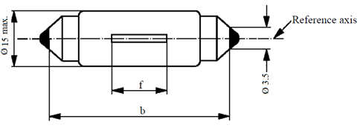
Reference axis
Ø 3.5
f
b
Ø 15 max.

Dimensions in mm |  |  |  | Filament light sources of normal production |  |  | Standard filament light source
 |  |  |  | Min. | Nom. | Max. | Standard filament light source
b ^{1/} |  |  |  | 40.0 | 41.0 | 42.0 | 41.0 ± 0.5
f ^{2/} |  |  |  | 7.5 |  | 10.5 | 8 ± 1.0
Cap SV8.5 in accordance with IEC Publication 60061 (sheet 7004-81-4)
Electrical and photometric characteristics
Rated values |  | Volts | 12 |  |  |  | 12
 |  | Watts | 21 |  |  |  | 21
Test voltage |  | Volts | 13.5 |  |  |  | 13.5
Objective values | Watts |  | 26.5 max. |  |  |  | 26.5 max.
Objective values | Luminous flux |  | 460 ± 15 %
Reference luminous flux: 460 lm at approximately 13.5 V
^{1/} This dimension corresponds to a distance between two apertures of 3.5 mm diameter.
^{2/} The position of the filament is checked by means of a "Box system"; sheet C21W/2.
Category C21W Sheet C21W/2
Screen projection requirements
This test is used to determine, by checking whether the filament is correctly positioned relative to the reference axis and to the centre of the filament light source's length, whether a filament light source complies with the requirements.
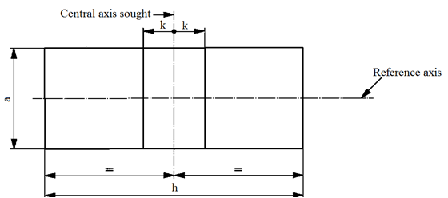
Central axis sought
Reference axis
k
k
h
a
12 V | a | h | k
Filament light sources of normal production | 4.0 + d | 14.5 | 2.0
Standard filament light source | 2.0 + d | 14.5 | 0.5
d = nominal filament diameter as stated by the manufacturer.
Test procedure and requirements
1. The filament light source is placed in a holder (socket) capable of being so rotated through 360° about the reference axis that the front elevation is seen on the screen on to which the image of the filament is projected. The reference plane on the screen shall coincide with the centre of the filament light source. The central axis sought on the screen shall coincide with the centre of the filament light source length.
2. Front elevation
2.1. The projection of the filament shall lie entirely within the rectangle when the filament light source is rotated through 360°.
2.2. The centre of the filament shall not be offset by more than distance "k" from the central axis sought.
Category H1 Sheet H1/1
The drawings are intended only to illustrate the essential dimensions (in mm) of the filament light source
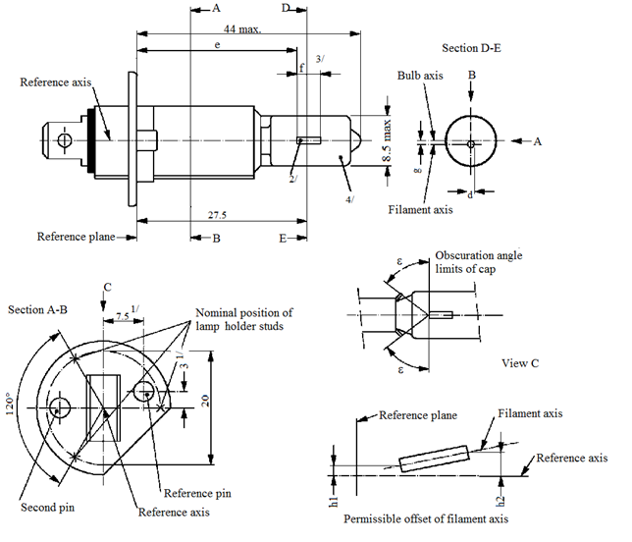
8.5 max.
Filament axis
44 max.
E
B
D
A
A
B
d
g
Reference axis
Reference plane
Section D-E
Bulb axis
27.5
3
Permissible offset of filament axis
h2
h1
Nominal position of filament light source holder studs
Obscuration angle
limits of cap
Section A-B
ε
ε
View C
Second pin
Reference pin
Reference axis
Reference plane
Filament axis
Reference axis
C
120°
20
7.5 ^{1/}
e
f
3/
2/
1/
4/

^{1/} The reference axis is perpendicular to the reference plane and passes through the point defined by the dimensions marked with 1.
^{2/} Both current lead-in legs shall be positioned in the bulb, the longer leg above the filament (the filament light source being viewed as shown in the figure). The internal design should be then such that stray light images and reflections are reduced to the minimum, e.g. by fitting cooling jackets over the non-coiled parts of the filament.
^{3/} The cylindrical portion of the bulb over length "f" shall be such as not to deform the projected image of the filament to such an extent as appreciably to affect the optical results.
^{4/} The colour of the light emitted shall be white or selective-yellow.
Category H1 Sheet H1/2

Dimensions in mm |  | Filament light sources of normal production |  |  |  | Standard filament light source
 |  | 6 V | 12 V |  | 24 V | 12 V
e ^{6/,10/} |  | 25.0 ^{9/} |  |  |  | 25.0 ± 0.15
f ^{6/,10/} |  | 4.5 ± 1.0 | 5.0 ± 0.5 |  | 5.5 ± 1.0 | 5.0 + 0.50 / -0.00
g ^{7/,8/} |  | 0.5 d ± 0.5 d |  |  |  | 0.5 d ± 0.25 d
h1 |  | ^{9/} |  |  |  | 0 ± 0.20 ^{5/}
h2 |  | ^{9/} |  |  |  | 0 ± 0.25 ^{5/}
ε |  | 45° ± 12° |  |  |  | 45° ± 3°
Cap P14.5s in accordance with IEC Publication 60061 (sheet 7004-46-2)
Electrical and photometric characteristics
Rated values | Volts | 6 | 12 |  | 24 | 12
Rated values | Watts | 55 |  |  | 70 | 55
Test Voltage | Volts | 6.3 | 13.2 |  | 28.0 | 13.2
Objective  values | Watts | 63 max. | 68 max. |  | 84 max. | 68 max.
Objective  values | Luminous flux  ± % | 1,350 | 1,550 |  | 1,900
Objective  values | Luminous flux  ± % | 15
Reference luminous flux at approximately |  |  |  | 12 V |  | 1,150
 |  |  |  | 13.2 V |  | 1,550
^{5/} The eccentricity is measured only in the horizontal and vertical directions of the filament light source as shown in the figure. The points to be measured are those where the projections of the outside of the end turns nearest to or furthest from the reference plane crosses the filament axis.
^{6/} The viewing direction is the perpendicular to the reference axis contained in the plane defined by the reference axis and the centre of the second pin of the cap.
^{7/} Offset of filament in relation to bulb axis measured at 27.5 mm from the reference plane.
^{8/} d: diameter of filament.
^{9/} To be checked by means of a "Box system", sheet H1/3.
^{10/} The ends of the filament are defined as the points where, when the viewing direction is as defined in footnote 6/ above, the projection of the outside of the end turns nearest to or furthest from the reference plane crosses the reference axis (special instructions for coiled-coil filaments are under consideration).
Category H1 Sheet H1/3
Screen projection requirements
This test is used to determine, by checking whether the filament is correctly positioned relative to the reference axis and reference plane, whether a filament light source complies with the requirements.
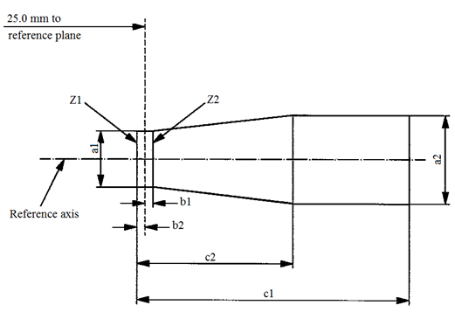
reference plane
25.0 mm to
Reference axis
Z1
Z2
b1
b2
c1
c2
a1
a2

 | a1 | a2 | b1 | b2 | c1 | c2
6 V | 1.4d | 1.9 d | 0.25 |  | 6 | 3.5
12 V | 1.4d | 1.9 d |  |  | 6 | 4.5
24 V | 1.4d | 1.9 d |  |  | 7 | 4.5
d = diameter of filament.
The filament position is checked solely in directions A and B as shown on sheet H1/1.
The filament shall lie entirely within the limits shown.
The beginning of the filament as defined on sheet H1/2, footnote 10/, shall lie between lines Z1 and Z2.
Category H3 Sheet H3/1
The drawings are intended only to illustrate the essential dimensions (in mm) of the filament light source
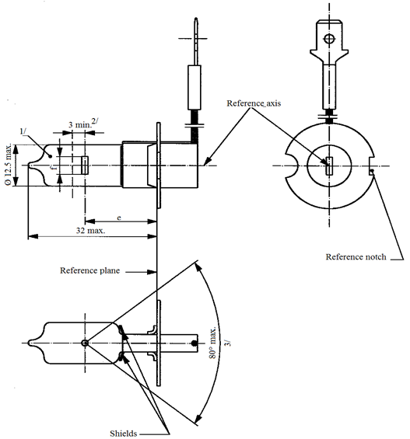
Reference axis
Reference plane
Reference notch
Shields
32 max
80° max.
3 min.^{2/}
e
1/
3/
Ø 12.5 max

^{1/} The colour of the light emitted shall be white or selective-yellow.
^{2/} Minimum length above the height of the light emitting centre ("e") over which the bulb shall be cylindrical.
^{3/} The distortion of the base-end portion of the bulb shall not be visible from any direction outside the obscuration angle of 80° max. The shields shall produce no inconvenient reflections. The angle between the reference axis and the plane of each shield, measured on the bulb side, shall not exceed 90°.
Category H3 Sheet H3/2

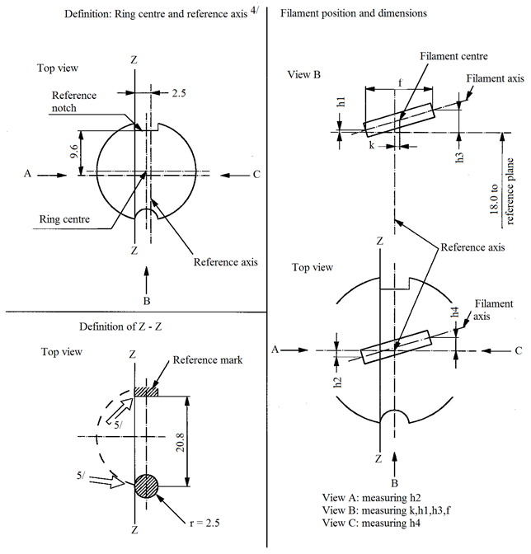
Definition: Ring centre and reference axis^{4/}
9.6
Top view
Filament position and dimensions
B
Top view
Top view
C
Z
View B
Z
Definition of Z - Z
Z
Definition of Z - Z
Z
Z
View B
Z
Z
B
A
B
9.6

2.5
C
A
Reference axis
Ring centre
Reference notch
reference plane
h1
Filament axis
Filament centre
Reference axis
Filament
axis
h2
h3
h4
Z
f
k
18.0 to
Reference mark
r = 2.5
5/
5/
View A: measuring h2
View B: measuring k, h1, h3, f
View C: measuring h4
20.8

^{4/} The permissible deviation of the ring centre from the reference axis is 0.5 mm in the direction perpendicular to the Z-Z line and 0.05 mm in the direction parallel to the Z-Z line.
^{5/} The cap shall be pressed in these directions.

Category H3 Sheet H3/3

Dimensions in mm |  | Filament light sources of normal production |  |  |  | Standard filament light source
 |  | 6 V | 12 V |  | 24 V | 12 V
e |  | 18.0 ^{6/} |  |  |  | 18.0
f ^{8/} |  | 3.0 min. | 4.0 min. |  |  | 5.0 ± 0.50
k |  | 0 ^{6/} |  |  |  | 0 ± 0.20
h1, h3 |  | 0 ^{6/} |  |  |  | 0 ± 0.15 ^{7/}
h2, h4 |  | 0 ^{6/} |  |  |  | 0 ± 0.25 ^{7/}
Cap PK22s in accordance with IEC Publication 60061 (sheet 7004-47-4)
Electrical and photometric characteristics
Rated values | Volts | 6 | 12 |  | 24 | 12
Rated values | Watts | 55 |  |  | 70 | 55
Test voltage | Volts | 6.3 | 13.2 |  | 28.0 | 13.2
Objective  values | Watts | 63 max. | 68 max. |  | 84 max. | 68 max.
Objective  values | Luminous flux  ± % | 1,050 | 1,450 |  | 1,750
Objective  values | Luminous flux  ± % | 15
Reference luminous flux at approximately |  |  |  | 12 V |  | 1,100
 |  |  |  | 13.2 V |  | 1,450
^{6/} To be checked by means of a "Box system"; sheet H3/4.
^{7/} For standard filament light sources the points to be measured are those where the projection of the outside of the end turns crosses the filament axis.
^{8/} The positions of the first and the last turn of the filament are defined by the intersections of the outside of the first and of the last light emitting turn, respectively, with the plane parallel to and 18 mm distant from the reference plane. (Additional instructions for coiled-coil filament are under consideration).

Category H3 Sheet H3/4
Screen projection requirements
This test is used to determine, by checking whether the filament is correctly positioned relative to the reference axis and reference plane, whether a filament complies with the requirements.
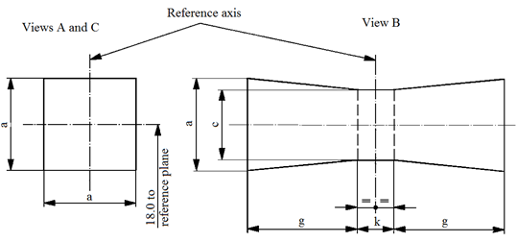
Reference axis
Views A and C
View B
18.0 to
reference plane
a
a
c
a
g
g
k

 | a | c | k | g
6 V | 1.8 d | 1.6 d | 1.0 | 2.0
12 V | 1.8 d | 1.6 d | 1.0 | 2.8
24 V | 1.8 d | 1.6 d | 1.0 | 2.9
d = diameter of filament
The filament shall lie entirely within the limits shown.
The centre of the filament shall lie within the limits of dimension k.
Category H4 Sheet H4/1
The drawings are intended only to illustrate the essential dimensions (in mm) of the filament light source
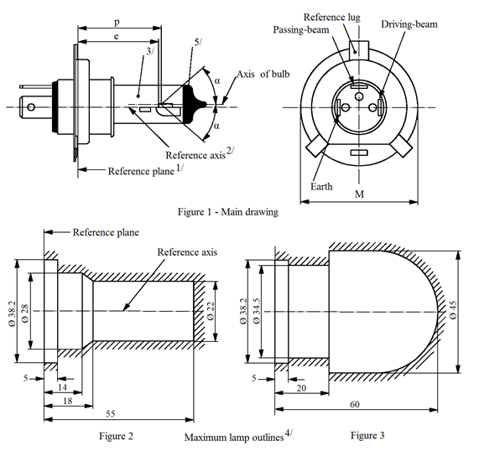
Reference lug
Passing-beam
Driving-beam
Axis of bulb
Figure 1 – Main drawing
Reference plane
Reference axis
Earth
Reference plane^{1/}
Reference axis^{2/}
Maximum filament light source outlines^{4/}
Figure 3
Figure 2
M
p
e
3/
5/
α
α
5
5
14
18
55
20
60
Ø 38.2
Ø 28
Ø 38.2
Ø 22
Ø 34.5
Ø 45
^{1/} The reference plane is the plane formed by the seating points of the three lugs of the cap ring.
^{2/} The reference axis is perpendicular to the reference plane and passes through the centre of the circle of diameter "M".
^{3/} The colour of the light emitted shall be white or selective-yellow.
^{4/} The bulb and supports shall not exceed the envelope as in Figure 2. However, where a selective-yellow outer bulb is used the bulb and supports shall not exceed the envelope as in Figure 3.
^{5/} The obscuration shall extend at least as far as the cylindrical part of the bulb. It shall also overlap the internal shield when the latter is viewed in a direction perpendicular to the reference axis.

Category H4 Sheet H4/2

Dimensions in mm |  |  | Filament light sources of normal production |  |  |  |  | Standard filament light source
 |  |  | 12 V |  | 24 V |  |  | 12 V
e |  |  | 28.5 +0.35/-0.25 |  | 29.0 ± 0.35 |  |  | 28.5 + 0.20 / -0.00
p |  |  | 28.95 |  | 29.25 |  |  | 28.95
α |  |  | max. 40° |  |  |  |  | max. 40°
Cap P43t in accordance with IEC Publication 60061 (sheet 7004-39-6)
Electrical and photometric characteristics
Rated values |  | Volts | 12 ^{6/} |  | 24 ^{6/} |  |  | 12 ^{6/}
 |  | Watts | 60 | 55 | 75 |  | 70 | 60 | 55
Test voltage |  | Volts | 13.2 |  | 28.0 |  |  | 13.2
Objective  values | Watts |  | 75 max. | 68 max. | 85 max. |  | 80 max. | 75 max. | 68 max.
Objective  values | Luminous flux  ± % |  | 1,650 | 1,000 | 1,900 |  | 1,200
Objective  values |  |  | 15
Measuring flux ^{7/} lm |  |  | - | 750 | - |  | 800
Reference luminous flux at approximately |  |  |  |  |  | 12 V |  | 1,250 |  | 750
 |  |  |  |  |  | 13.2 V |  | 1,650 |  | 1,000
^{6/} The value indicated in the left hand column relate to the driving-beam filament. Those indicated in the right-hand column relate to the passing-beam filament.
^{7/} Measuring luminous flux according to the provisions for filament light sources with an internal shield to produce the cut-off.

Category H4 Sheet H4/3

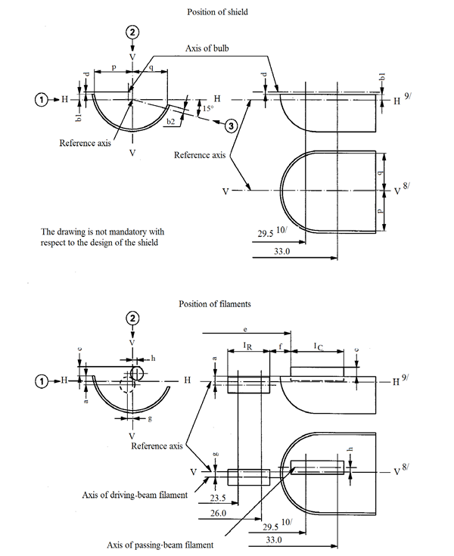
I_{C}
H
H
p
q
Position of shield
Axis of bulb
Reference axis
The drawing is not mandatory with
respect to the design of the shield
H^{9/}
V^{8/}
V
V
H
29.5 ^{10/}
33.0
H
b1
b1
b2
e
15°
d
Position of filaments
V ^{8/}

H ^{9/}

Reference axis
e
V
Axis of passing-beam filament
Axis of driving-beam filament
I_{R}
I_{C}
V
29.5^{10/}
33.0
H
H
23.5
26.0
g
c
a
c
h
h
a
g
V
b1
d
d
Reference axis
f
Category H4 Sheet H4/4

Table of the dimensions (in mm) referred to in the drawings on sheet H4/3
Reference* |  |  | Dimension** |  | Tolerance
 |  |  |  |  | Filament light sources of normal production |  | Standard filament light source
12 V | 24 V |  | 12 V | 24 V | 12 V | 24 V | 12 V
a/26 |  |  | 0.8 |  | ±0.35 |  | ±0.20
a/23.5 |  |  | 0.8 |  | ±0.60 |  | ±0.20
b1/29.5 | 30.0 |  | 0 |  | ±0.30 | ±0.35 | ±0.20
b1/33 |  |  | b1/29.5 mv | b1/30.0 mv | ±0.30 | ±0.35 | ±0.15
b2/29.5 |  | 30.0 | 0 |  | ±0.30 | ±0.35 | ±0.20
b2/33 |  |  | b2/29.5 mv | b2/30.0 mv | ±0.30 | ±0.35 | ±0.15
c/29.5 | 30.0 |  | 0.6 | 0.75 | ±0.35 |  | ±0.20
c/33 |  |  | c/29.5 mv | c/30.0 mv | ±0.35 |  | ±0.15
d |  |  | min. 0.1 |  | - |  | -
e ^{13/} |  |  | 28.5 | 29.0 | +0.35  -0.25 | ±0.35 | +0.20  -0.00
f ^{11/,12/,13/} |  |  | 1.7 | 2.0 | +0.50  -0.30 | ±0.40 | +0.30  -0.10
g/26 |  |  | 0 |  | ±0.50 |  | ±0.30
g/23.5 |  |  | 0 |  | ±0.70 |  | ±0.30
h/29.5 | 30.0 |  | 0 |  | ±0.50 |  | ±0.30
h/33 |  |  | h/29.5 mv | h/30.0 mv | ±0.35 |  | ±0.20
I_{R} ^{11/,14/} |  |  | 4.5 | 5.25 | ±0.80 |  | ±0.40
I_{C} ^{11/,14/} |  |  | 5.5 | 5.25 | ±0.50 | ±0.80 | ±0.35
p/33 |  |  | Depends on the shape of the shield |  | - |  | -
q/33 |  |  | (p+q)/2 |  | ±0.60 |  | ±0.30

* "../26" means dimension to be measured at the distance from the reference plane indicated in mm after the stroke.
** "29.5 mv" or "30.0 mv" means the value measured at a distance of 29.5 or 30.0 mm from the reference plane.
Category H4 Sheet H4/5

^{8/} Plane V-V is the plane perpendicular to the reference plane and passing through the reference axis and through the intersection of the circle of diameter "M" with the axis of the reference lug.
^{9/} Plane H-H is the plane perpendicular to both the reference plane and plane V-V and passing through the reference axis.
^{10/} 30.0 mm for the 24-volt type.
^{11/} The end turns of the filament are defined as being the first luminous turn and the last luminous turn that are at substantially the correct helix angle. For coiled-coil filaments, the turns are defined by the envelope of the primary coil.
^{12/} For the passing-beam filament, the points to be measured are the intersections, seen in direction 1, of the lateral edge of the shield with the outside of the end turns defined under footnote 11/.
^{13/} "e" denotes the distance from the reference plane to the beginning of the passing-beam filament as defined above.
^{14/} For the driving-beam filament the points to be measured are the intersections, seen in direction 1, of a plane, parallel to plane H-H and situated at a distance of 0.8 mm below it, with the end turns defined under footnote 11/.
Additional explanations to sheet H4/3
The dimensions below are measured in three directions:
1 For dimensions a, b1, c, d, e, f, I_{R} and I_{C};
2 For dimensions g, h, p and q;
3 For dimension b2.
Dimensions p and q are measured in planes parallel to and 33 mm away from the reference plane.
Dimensions b1, b2, c and h are measured in planes parallel to and 29.5 mm
(30.0 mm for 24 V filament light sources) and 33 mm away from the reference plane.
Dimensions a and g are measured in planes parallel to and 26.0 mm and 23.5 mm away from the reference plane.
Note: For the method of measurement, see Appendix E of IEC Publication 60809.
Category H7 Sheet H7/1
The drawings are intended only to illustrate the essential dimensions (in mm) of the filament light source
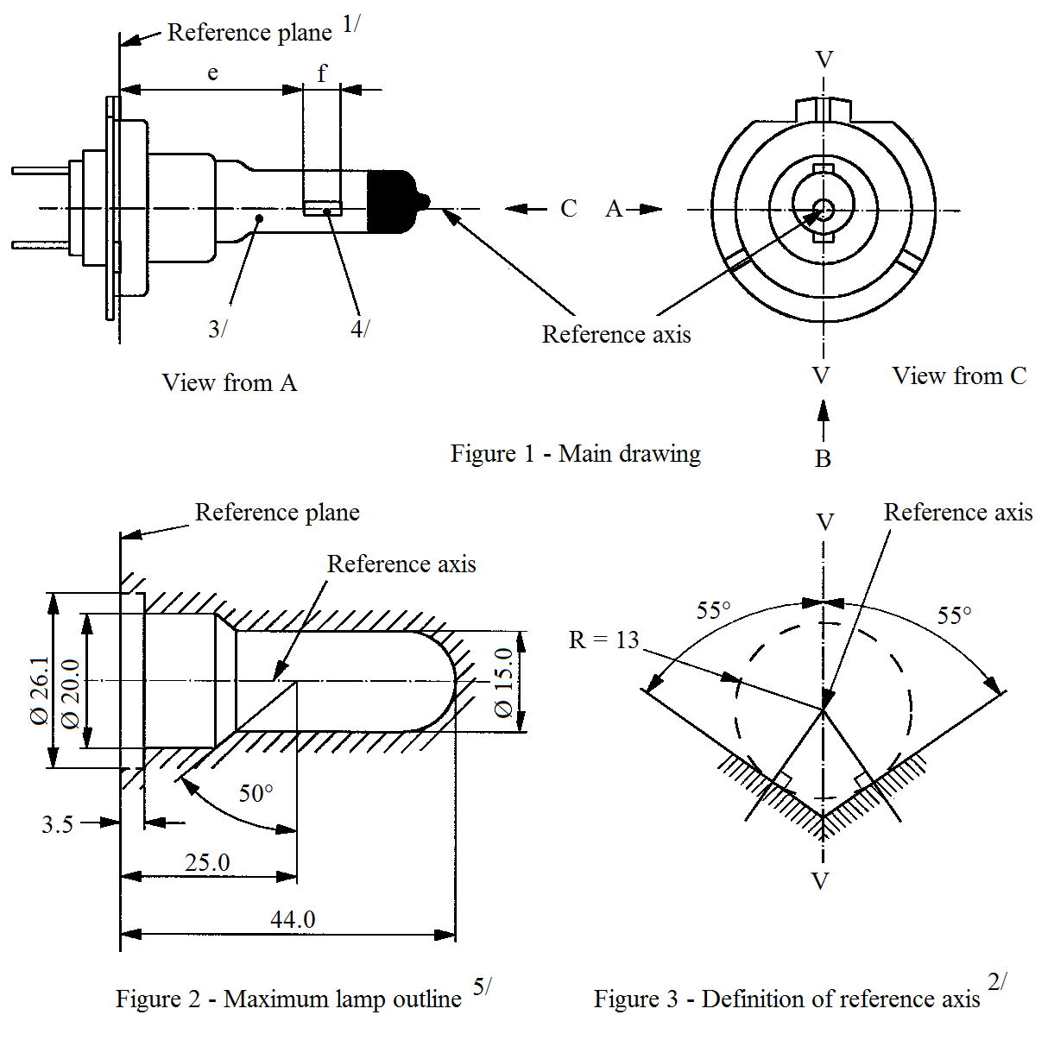
View from A
View from C
Reference axis
Reference plane^{1/}
Figure 1 – Main drawing
C A
V
3/
4/
Reference axis
Reference plane
Reference axis
V
V
B
Figure 2 – Maximum filament light source outline^{5/}
Figure 3 – Definition of reference axis^{2/}
V
R = 13
55°
55°
50°
25.0
44.0
Ø 15.0
3.5
Ø 20.0
Ø 26.1
e
f
^{1/} The reference plane is defined by the points on the surfaces of the holder on which the three supporting bosses of the cap ring will rest.
^{2/} The reference axis is perpendicular to the reference plane and crosses the intersection of the two perpendiculars as indicated in Figure 3.
^{3/} The colour of the light emitted shall be white or selective-yellow.
^{4/} Notes concerning the filament diameter.
(a) No actual diameter restrictions apply but the objective for future developments is to have d max. = 1.3 mm for 12 V and d max. = 1.7 for 24 V filament light sources.
(b) For the same manufacturer, the design diameter of standard (étalon) filament light source and filament light source of normal production shall be the same.
^{5/} Glass bulb and supports shall not exceed the envelope as indicated in Figure 2. The envelope is concentric to the reference axis.
Category H7 Sheet H7/2

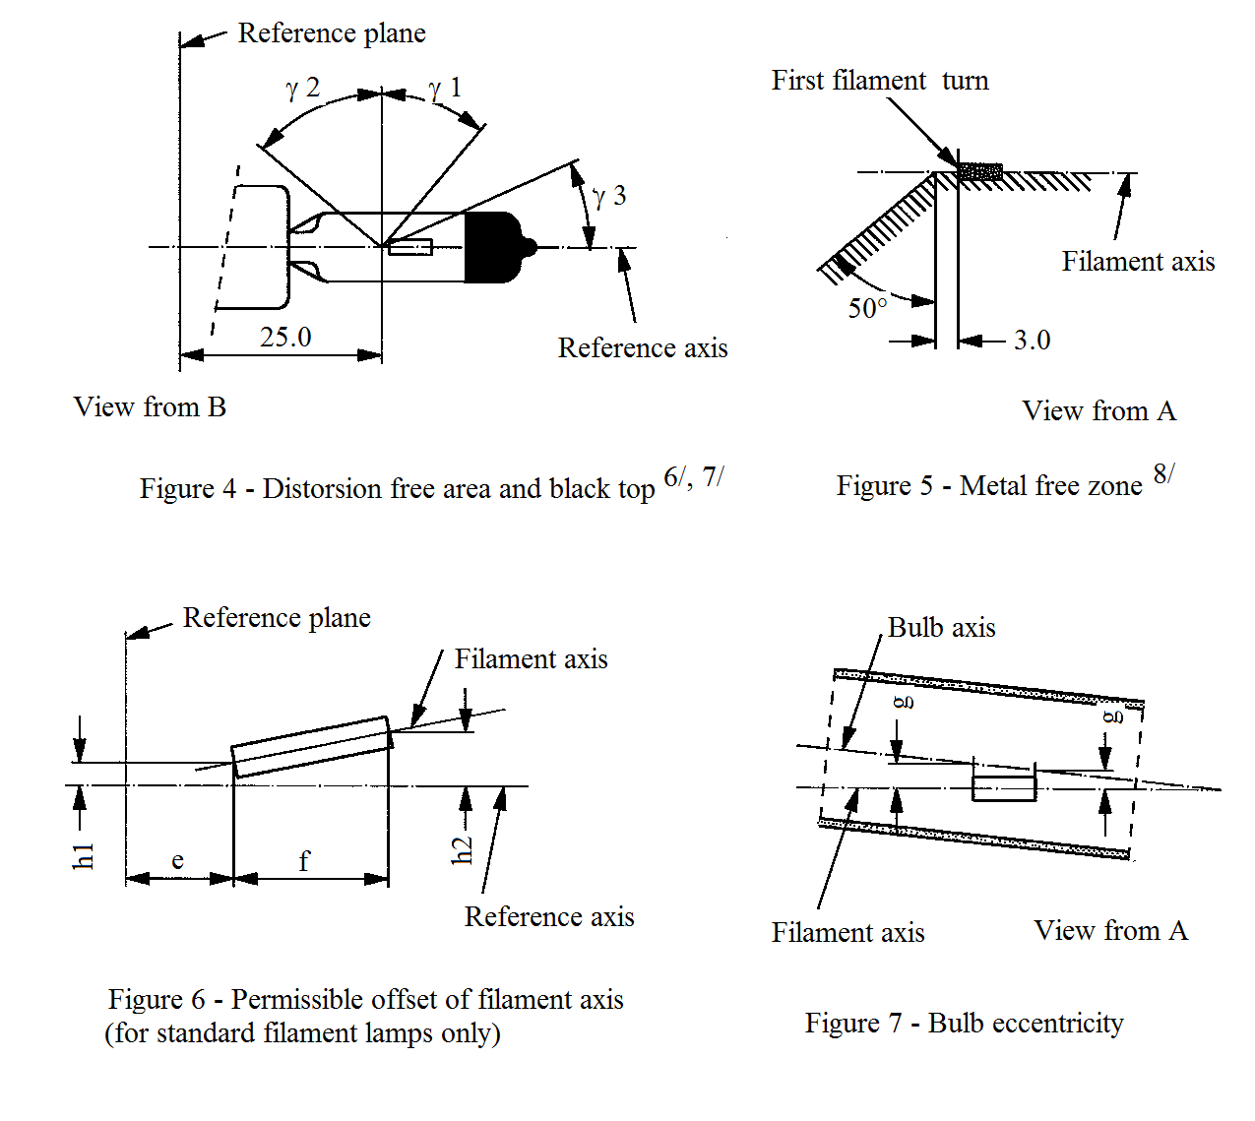
Reference axis
Reference plane
First filament turn
Filament axis
View from A
View from B
ɣ2
ɣ3
ɣ1
25.0
50°
3.0
Figure 5 – Metal free zone^{8/}
Figure 4 – Distorsion free area and black top^{6/,7/}
Reference plane
Filament axis
Reference axis
Filament axis
View from A
Bulb axis
e
f
h1
h2
g
g
Figure 6 – Permissible offset of filament axis
(for standard filament light sources only)
Figure 7 – Bulb eccentricity

^{6/} Glass bulb shall be optically distortion free within the angles γ1 and γ2. This requirement applies to the whole bulb circumference within the angles γ1 and γ2.
^{7/} The obscuration shall extend at least to the cylindrical part of the bulb on the whole bulb top circumference. It shall moreover extend at least to a plane parallel to the reference plane where γ3 crosses the outer bulb surface (view B as indicated on sheet H7/1).
^{8/} The internal design of the filament light source shall be such that stray light images and reflections are only located above the filament itself seen from the horizontal direction. (View A as indicated in Figure 1 on sheet H7/1).
No metal parts other than filament turns shall be located in the shaded area as seen in Figure 5.
Category H7 Sheet H7/3

Dimensions in mm |  | Filament light sources of normal production |  |  | Standard filament light source
 |  | 12 V | 24 V |  | 12 V
e ^{9/} |  | 25.0 ^{10/} |  |  | 25.0 ± 0.1
f ^{9/} |  | 4.1 ^{10/} | 4.9 ^{10/} |  | 4.1 ± 0.1
g ^{12/} |  | 0.5 min. |  |  | u.c.
h1 ^{11/} |  | 0 ^{10/} |  |  | 0 ± 0.10
h2 ^{11/} |  | 0 ^{10/} |  |  | 0 ± 0.15
γ1 |  | 40° min. |  |  | 40° min.
γ2 |  | 50° min. |  |  | 50° min.
γ3 |  | 30° min. |  |  | 30° min.
Cap PX26d in accordance with IEC Publication 60061 (sheet 7004-5-7)
Electrical and photometric characteristics
Rated values | Volts | 12 | 24 |  |  | 12
Rated values | Watts | 55 | 70 |  |  | 55
Test voltage | Volts | 13.2 | 28.0 |  |  | 13.2
Objectivevalues | Watts | 58 max. | 75 max. |  |  | 58 max.
Objectivevalues | Luminous flux | 1,500 ± 10 % | 1,750 ± 10 %
Reference luminous flux at approximately |  |  |  | 12 V |  | 1,100
 |  |  |  | 13.2 V |  | 1,500
^{9/} The ends of the filament are defined as the points where, when the viewing direction is direction A as shown in Figure 1 on sheet H7/1, the projection of the outside of the end turns crosses the filament axis. (Special instructions for coiled-coil filaments are under consideration).
^{10/} To be checked by means of a "Box system", sheet H7/4.
^{11/} The offset of the filament with respect to the reference axis is measured only in viewing directions A and B as shown in Figure 1 in sheet H7/1. The points to be measured are those where the projection of the outside of the end turns nearest to or furthest from the reference plane crosses the filament axis.
^{12/} Offset of filament in relation to bulb axis measured in two planes parallel to the reference plane where the projection of the outside of the end turns nearest to or furthest from the reference plane crosses the filament axis.
Category H7 Sheet H7/4
Screen projection requirements
This test is used to determine, by checking whether the filament is correctly positioned relative to the reference axis and reference plane, whether a filament light source complies with the requirements.
Dimensions in mm

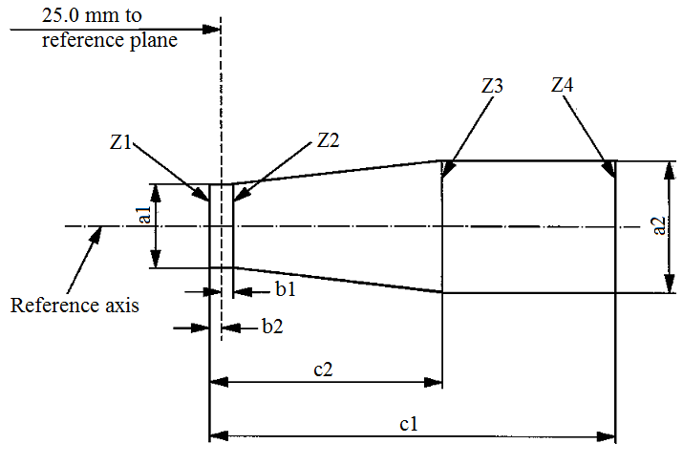
25 mm to
reference plane
Reference axis
Z1
Z2
Z3
Z4
b1
b2
c2
c1
a1
a2

 | a1 | a2 | b1 | b2 | c1 | c2
12 V | d + 0.30 | d + 0.50 | 0.2 |  | 4.6 | 4.0
24V | d + 0.60 | d + 1.00 | 0.25 |  | 5.9 | 4.4
d = diameter of filament
The filament position is checked solely in directions A and B as shown on sheet H7/1, Figure 1.
The filament shall lie entirely within the limits shown.
The ends of the filament as defined on sheet H7/3, footnote 9/, shall lie between lines Z1 and Z2 and between Z3 and Z4.
Categories H8 and H8B Sheet H8/1
The drawings are intended only to illustrate the essential dimensions (in mm) of the filament light source
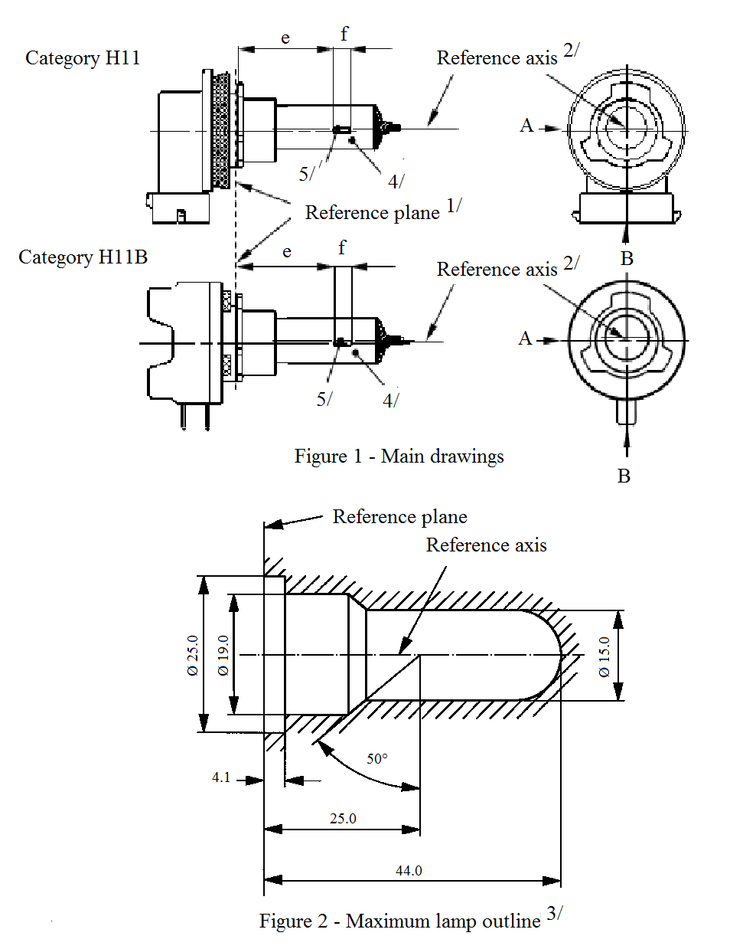
Category H8
Category H8B
Reference axis^{2/}
Reference axis^{2/}
Reference plane^{1/}
5/
4/
5/
4/
f
e
A
A
B
B
Figure 1 - Main drawings
f
e
Reference plane
Reference axis
50°
44.0
25.0
4
Figure 2 – Maximum filament light source outline^{3/}
Ø 25.0
Ø 19.0
Ø 15.0
^{1/} The reference plane is the plane formed by the underside of the bevelled lead-in flange of the cap.
^{2/} The reference axis is perpendicular to the reference plane and passing through the centre of the 19 mm cap diameter.
^{3/} Glass bulb and supports shall not exceed the envelope as indicated in Figure 2. The envelope is concentric to the reference axis.
^{4/} The colour of the light emitted shall be white or selective-yellow.
^{5/} Notes concerning the filament diameter.
(a) No actual diameter restrictions apply but the objective for future developments is to have d max. = 1.2 mm.
(b) For the same manufacturer, the design diameter of standard (étalon) filament light source and filament light source of normal production shall be the same.
Categories H8 and H8B Sheet H8/2

Reference axis
Reference plane
First filament turn
Filament axis
View A
View B
ɣ1
ɣ3
ɣ2
25.0
50°
3.0

Figure 4 – Metal free zone^{8/}
Figure 3 – Distorsion free area^{6/} and black top^{7/}
Reference plane
Filament axis
Reference axis
Filament axis
View A
Bulb axis
e
f
h1
h2
g
g
Figure 5 – Permissible offset of filament axis^{9/}
(for standard filament light sources only)
Figure 6 – Bulb eccentricity^{10/}
^{6/} Glass bulb shall be optically distortion free within the angles γ1 and γ2. This requirement applies to the whole bulb circumference within the angles γ1 and γ2.
^{7/} The obscuration shall extend at least to the cylindrical part of the bulb on the whole bulb top circumference. It shall moreover extend at least to a plane parallel to the reference plane where γ3 crosses the outer bulb surface (view B as indicated on sheet H8/1).
^{8/} The internal design of the filament light source shall be such that stray light images and reflections are only located above the filament itself seen from the horizontal direction. (View A as indicated in Figure 1 on sheet H8/1). No metal parts other than filament turns shall be located in the shaded area as seen in Figure 4.
^{9/} The offset of the filament with respect to the reference axis is measured only in viewing directions A and B as shown in Figure 1 in sheet H8/1. The points to be measured are those where the projection of the outside of the end turns nearest to or furthest from the reference plane crosses the filament axis.
^{10/} Offset of filament in relation to bulb axis measured in two planes parallel to the reference plane where the projection of the outside of the end turns nearest to or furthest from the reference plane crosses the filament axis.
Categories H8 and H8B Sheet H8/3

Dimensions in mm |  |  | Filament light sources of normal production |  |  | Standard filament light source
 |  |  | 12 V |  |  | 12 V
e ^{11/} |  |  | 25.0 ^{12/} |  |  | 25.0 ± 0.1
f ^{11/} |  |  | 3.7 ^{12/} |  |  | 3.7 ± 0.1
g |  |  | 0.5 min. |  |  | u.c.
h1 |  |  | 0 ^{12/} |  |  | 0 ± 0.1
h2 |  |  | 0 ^{12/} |  |  | 0 ± 0.15
γ1 |  |  | 50° min. |  |  | 50° min.
γ2 |  |  | 40° min. |  |  | 40° min.
γ3 |  |  | 30° min. |  |  | 30° min.
Cap: | H8: PGJ19-1  H8B: PGJY19-1 |  | in accordance with IEC Publication 60061 (sheet 7004-110-2)  in accordance with IEC Publication 60061 (sheet 7004-146-1)
Electrical and photometric characteristics
Rated values |  | Volts |  | 12 |  | 12
 |  | Watts |  | 35 |  | 35
Test voltage |  | Volts |  | 13.2 |  | 13.2
Objective  values |  | Watts |  | 43 max. |  | 43 max.
 |  | Luminous flux |  | 800 ± 15 %
Reference luminous flux at approximately |  |  |  |  | 12 V | 600
 |  |  |  |  | 13.2 V | 800
^{11/} The ends of the filament are defined as the points where, when the viewing direction is direction A as shown in Figure 1 on sheet H8/1, the projection of the outside of the end turns crosses the filament axis.
^{12/} To be checked by means of a "Box system"; sheet H8/4.
Categories H8 and H8B Sheet H8/4
Screen projection requirements
This test is used to determine, by checking whether the filament is correctly positioned relative to the reference axis and reference plane, whether a filament complies with the requirements.
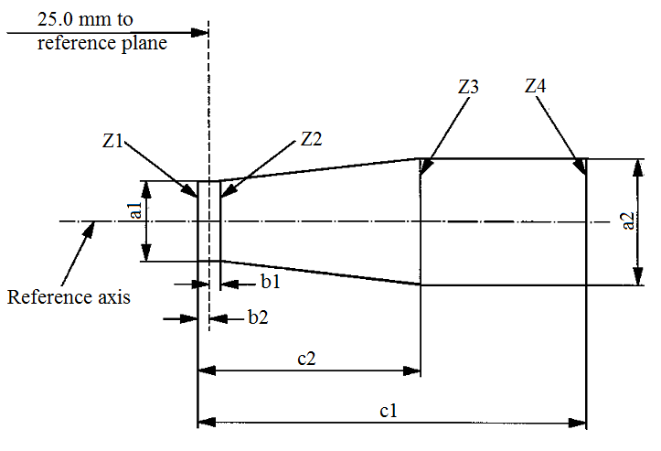
25.0 mm to
reference plane
Reference axis
Z1
Z2
Z3
Z4
b1
b2
c2
c1
a1
a2

a1 | a2 | b1 | b2 | c1 | c2
d + 0.50 | d + 0.70 | 0.25 |  | 4.6 | 3.5
d = diameter of filament
The filament position is checked solely in directions A and B as shown on sheet H8/1, Figure 1.
The filament shall lie entirely within the limits shown.
The ends of the filament as defined on sheet H8/3, footnote 11/, shall lie between lines Z1 and Z2 and between Z3 and Z4.
Categories H9 and H9B Sheet H9/1
The drawings are intended only to illustrate the essential dimensions (in mm) of the filament light source
Category H9
Category H9B
Reference axis^{2/}
Reference axis^{2/}
Reference plane^{1/}
Figure 1 – Main drawings
e
f
4/
4/
e
f
A
A
B
B
5/
5/

Reference plane
Reference axis
50°
44.0
25.0
4.1
Figure 2 – Maximumfilament light source outline^{3/}
Ø 25.0
Ø 19.0
Ø 15.0
^{1/} The reference plane is the plane formed by the underside of the bevelled lead-in flange of the cap.
^{2/} The reference axis is perpendicular to the reference plane and passing through the centre of the 19 mm cap diameter.
^{3/} Glass bulb and supports shall not exceed the envelope as indicated in Figure 2. The envelope is concentric to the reference axis.
^{4/} Notes concerning the filament diameter:
(a) No actual diameter restrictions apply but the objective for future developments is to have d max. = 1.4 mm.
(b) For the same manufacturer, the design diameter of standard (étalon) filament light source and filament light source of normal production shall be the same.
Categories H9 and H9B Sheet H9/2

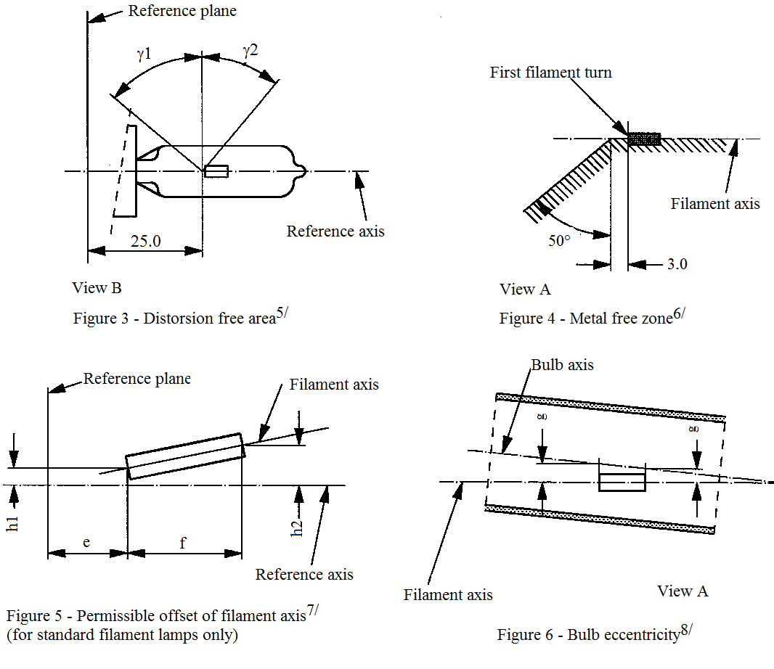
Reference plane
Reference plane
Reference axis
Reference axis
First filament turn
Filament axis
Filament axis
Filament axis
View B
Figure 3 – Distorsion free area^{5/}
View A
View A
Figure 4 – Metal free zone^{6/}
Figure 6 – Bulb eccentricity^{8/}

Figure 5 – Permissible offset of filament axis^{7/}
(for standard filament light sources only)
Bulb axis
ɣ1
ɣ2
50°
3.0
e
f
25.0
h1
h2
g
g
^{5/} Glass bulb shall be optically distortion free within the angles γ1 and γ2. This requirement applies to the whole bulb circumference within the angles γ1 and γ2.
^{6/} The internal design of the filament light source shall be such that stray light images and reflections are only located above the filament itself seen from the horizontal direction. (View A as indicated in Figure 1, sheet H9/1). No metal parts other than filament turns shall be located in the shaded area as seen in Figure 4.
^{7/} The offset of the filament with respect to the reference axis is measured only in viewing directions A and B as shown in Figure 1 on sheet H9/1. The points to be measured are those where the projection of the outside of the end turns nearest to or furthest from the reference plane crosses the filament axis.
^{8/} Offset of filament in relation to bulb axis measured in two planes parallel to the reference plane where the projection of the outside of the end turns nearest to or furthest from the reference plane crosses the filament axis.
Categories H9 and H9B Sheet H9/3

Dimensions in mm |  |  |  |  |  | Tolerance
 |  |  |  |  |  | Filament light sources of normal production |  |  | Standard filament light source
 |  |  |  |  |  | 12 V |  |  | 12 V
e ^{9/,10/} |  |  | 25 |  |  | ^{11/} |  |  | ±0.10
f ^{9/,10/} |  |  | 4.8 |  |  | ^{11/} |  |  | ±0.10
g ^{9/} |  |  | 0.7 |  |  | ±0.5 |  |  | ±0.30
h1 |  |  | 0 |  |  | ^{11/} |  |  | ±0.10 ^{12/}
h2 |  |  | 0 |  |  | ^{11/} |  |  | ±0.15 ^{12/}
γ1 |  |  | 50° min. |  |  | - |  |  | -
γ2 |  |  | 40° min. |  |  | - |  |  | -
Cap: | H9: PGJ19-5  H9B: PGJY19-5 |  | in accordance with IEC Publication 60061 (sheet 7004-110-2)  in accordance with IEC Publication 60061 (sheet 7004-146-1)
Electrical and photometric characteristics
Rated values |  | Volts | 12 |  |  |  | 12
 |  | Watts | 65 |  |  |  | 65
Test voltage |  | Volts | 13.2 |  | 12.2 |  | 13.2 | 12.2
Objective values |  | Watts | 73 max. |  | 65 max. |  | 73 max. | 65 max.
 |  | Luminous flux | 2,100 ± 10 % |  | 1,650 ± 10 %
Reference luminous flux at approximately |  |  |  | 12 V |  |  | 1,500
 |  |  |  | 12.2 V |  |  | 1,650
 |  |  |  | 13.2 V |  |  | 2,100
^{9/} The viewing direction is direction A as shown in Figure 1 on sheet H9/1.
^{10/} The ends of the filament are defined as the points where, when the viewing direction is as defined in footnote 9/ above, the projection of the outside of the end turns crosses the filament axis.
^{11/} To be checked by means of a "Box system"; sheet H9/4.
^{12/} The eccentricity is measured only in viewing directions A and B as shown in Figure 1 on sheet H9/1. The points to be measured are those where the projection of the outside of the end turns nearest or furthest from the reference plane crosses the filament axis.
Categories H9 and H9B Sheet H9/4
Screen projection requirements
This test is used to determine, by checking whether the filament is correctly positioned relative to the reference axis and reference plane, whether a filament complies with the requirements.
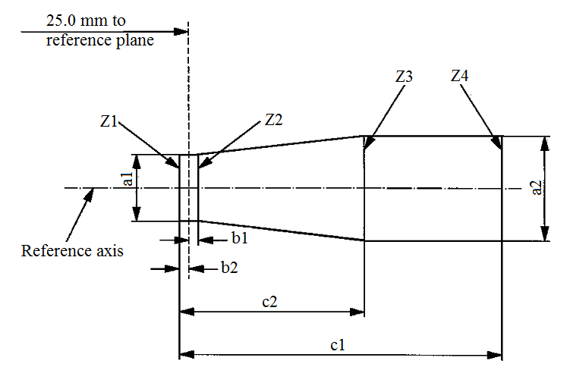
25.0 mm to
reference plane
Reference axis
Z1
Z2
Z3
Z4
b1
b2
c2
c1
a2
a1

a1 | a2 | b1 | b2 | c1 | c2
d + 0.4 | d + 0.7 | 0.25 |  | 5.7 | 4.6
d = diameter of filament
The filament position is checked solely in directions A and B as shown on sheet H9/1, Figure 1.
The filament shall lie entirely within the limits shown.
The ends of the filament as defined on sheet H9/3, footnote 10/, shall lie between lines Z1 and Z2 and between Z3 and Z4.
Category H10 Sheet H10/1
The drawings are intended only to illustrate the essential dimensions (in mm) of the filament light source
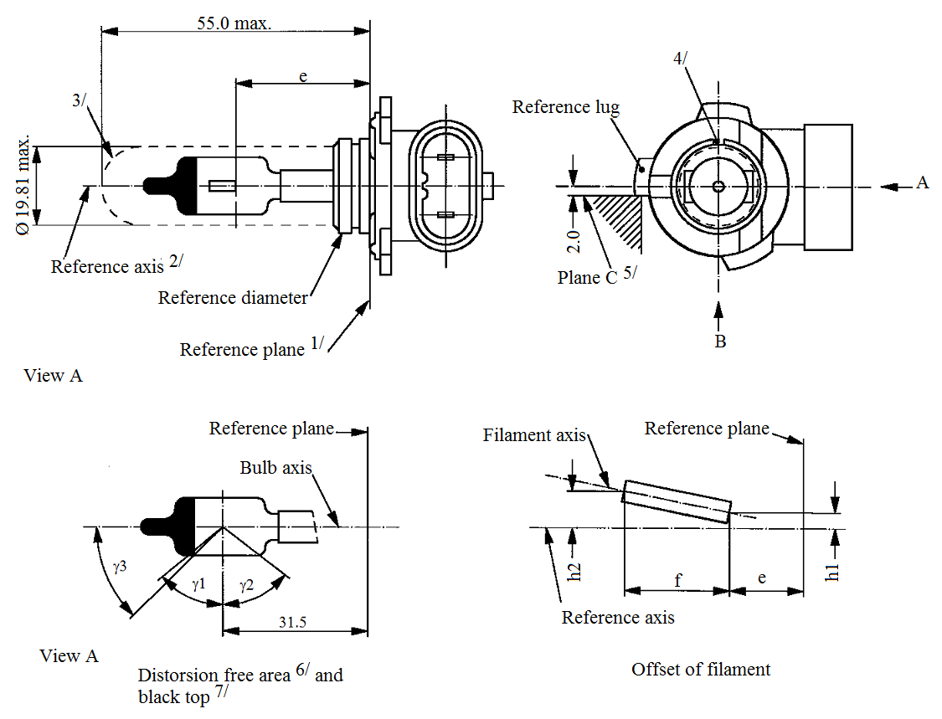
f
e
h2
h1
2.0
3/
4/
e
e
f
A
B
ɣ3
ɣ1
ɣ2
55.0 max.
Reference lug
Plane C^{5/}
Reference axis^{2/}
Reference diameter
Reference plane^{1/}
Reference plane
Reference axis
Filament axis
Reference plane
Bulb axis
View A
View A
Distorsion free area^{6/} and black top^{7/}
Offset filament
Ø 19.81 max.
31.5

^{1/} The reference plane is the plane defined by the meeting points of cap-holder fit.
^{2/} The reference axis is perpendicular to the reference plane and concentric with the reference diameter of the cap.
^{3/} Glass bulb and supports shall not exceed the envelope and shall not interfere with insertion past the filament light source key. The envelope is concentric to the reference axis.
^{4/} The keyway is mandatory.
^{5/} The filament light source shall be rotated in the measuring holder until the reference lug contacts plane C of the holder.
^{6/} Glass bulb periphery shall be optically distortion-free axially and cylindrically within the angles γ1 and γ2. This requirement applies to the whole bulb circumference within the angles γ1 and γ2 and does not need to be verified in the area covered by the obscuration.
^{7/} The obscuration shall extend to at least angle γ3 and shall be at least as far as the undistorted part of the bulb defined by angle γ1.
Category H10 Sheet H10/2

Dimensions in mm ^{8/} |  |  |  | Tolerance
 |  |  |  | Filament light sources of normal production |  | Standard filament light source
e ^{9/,10/} |  |  | 28.9 | ^{11/} |  | ±0.16
f ^{9/,10/} |  |  | 5.2 | ^{11/} |  | ±0.16
h1, h2 |  |  | 0 | ^{11/} |  | ±0.15 ^{12/}
γ1 |  |  | 50° min. | - |  | -
γ2 |  |  | 52° min. | - |  | -
γ3 |  |  | 45° | ±5° |  | ±5°
Cap PY20d in accordance with IEC Publication 60061 (sheet 7004-31-2)
Electrical and photometric characteristics
Rated values | Volts |  |  | 12 |  | 12
Rated values | Watts |  |  | 42 |  | 42
Test voltage | Volts |  |  | 13.2 |  | 13.2
Objective values |  | Watts |  | 50 max. |  | 50 max.
 |  | Luminous flux |  | 850 ± 15 %
Reference luminous flux at approximately |  |  |  |  | 12 V | 600
 |  |  |  |  | 13.2 V | 850
^{8/} Dimensions shall be checked with O-ring removed.
^{9/} The viewing direction is direction* B as shown in the figure on sheet H10/1.
^{10/} The ends of the filament are defined as the points where, when the viewing direction* as defined in footnote 9/ above, the projection of the outside of the end turns crosses the filament axis.
^{11/} To be checked by means of a "Box system", sheet H10/3*.
^{12/} The eccentricity is measured only in viewing directions* A and B as shown in the figure on sheet H10/1. The points to be measured are those where the projection of the outside of the end turns nearest to or furthest from the reference plane crosses the filament axis.
* Manufacturers may choose another set of perpendicular viewing directions. The viewing directions specified by the manufacturer are to be used by the testing laboratory when checking filament dimensions and position.
Category H10 Sheet H10/3
Screen projection requirements
This test is used to determine, by checking whether the filament is correctly positioned relative to the reference axis and reference plane, whether a filament light source complies with the requirements.
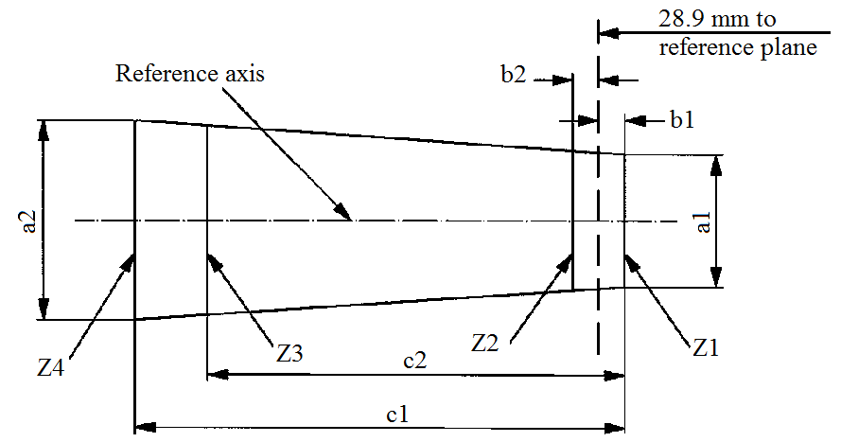
Reference axis
reference plane
28.9 mm to
Z1
Z2
Z3
Z4
b1
b2
c1
c2
a2
a1

 | a1 | a2 | b1 | b2 | c1 | c2
12 V | 1.4 d | 1.8 d | 0.25 |  | 6.1 | 4.9
d = diameter of filament
The filament position is checked solely in directions A and B as shown on sheet H10/1.
The filament shall lie entirely within the limits shown.
The ends of the filament as defined on sheet H10/2 footnote 10/ shall lie between lines Z1 and Z2 and between lines Z3 and Z4.

Categories H11 and H11B Sheet H11/1
The drawings are intended only to illustrate the essential dimensions (in mm) of the filament light source
Reference axis^{2/}
Reference axis^{2/}
Reference plane^{1/}
Category H11
Category H11B
Figure 1 – Main drawings
5/
5/
4/
4/
A
A
B
B
e
e
f
f
Reference plane
Reference axis

Figure 2 - Maximum filament light source outline^{3/}
Ø 25.0
Ø 19.0
Ø 15.0
50°
4.1
25.0
44.0

^{1/} The reference plane is the plane formed by the underside of the bevelled lead-in flange of the cap.
^{2/} The reference axis is perpendicular to the reference plane and passing through the centre of the 19 mm cap diameter.
^{3/} Glass bulb and supports shall not exceed the envelope as indicated in Figure 2. The envelope is concentric to the reference axis.
^{4/} The colour of the light emitted shall be white or selective-yellow.
^{5/} Notes concerning the filament diameter.
(a) No actual diameter restrictions apply but the objective for future developments is to have d max. = 1.4 mm.
(b) For the same manufacturer, the design diameter of standard (étalon) filament light source and filament light source of normal production shall be the same.
Categories H11 and H11B Sheet H11/2

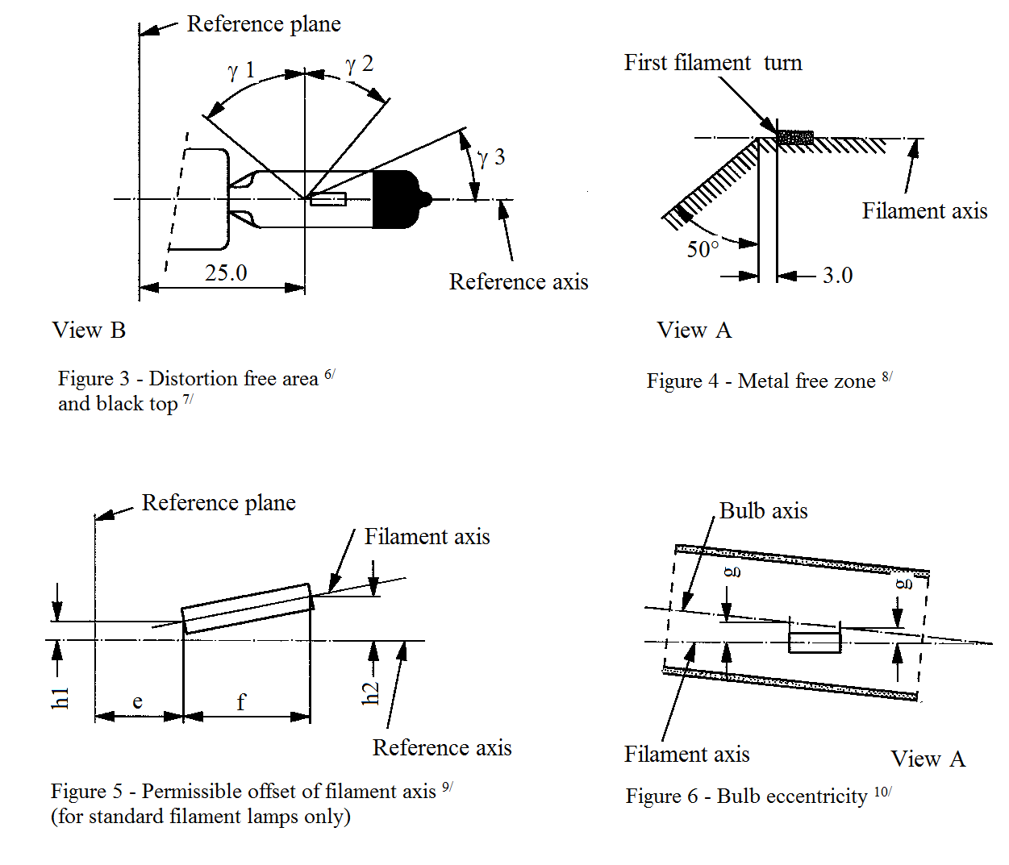
Reference plane
Reference plane
Reference axis
Reference axis
Filament axis
Filament axis
View A
View A
Filament axis
View B

Distorsion free area^{6/} and black top^{7/}
Bulb axis
Figure 4 – Metal free zone^{8/}

Figure 6 – Bulb eccentricity^{10/}
Figure 5 – Permissible offset of filament axis^{9/}
(for standard filament light sources only)
ɣ1
ɣ2
ɣ3
50°
3.0
25.0
f
e
h1
h2
g
g
Fist filament turn
^{6/} Glass bulb shall be optically distortion free within the angles γ1 and γ2. This requirement applies to the whole bulb circumference within the angles γ1 and γ2.
^{7/} The obscuration shall extend at least to the cylindrical part of the bulb on the whole bulb top circumference. It shall, moreover, extend at least to a plane parallel to the reference plane where γ3 crosses the outer bulb surface (view B as indicated on sheet H11/1).
^{8/} The internal design of the filament light source shall be such that stray light images and reflections are only located above the filament itself seen from the horizontal direction (view A as indicated in Figure 1 on sheet H11/1). No metal parts other than filament turns shall be located in the shaded area as seen in Figure 4.
^{9/} The offset of the filament with respect to the reference axis is measured only in viewing directions A and B as shown in Figure 1 on sheet H11/1. The points to be measured are those where the projection of the outside of the end turns nearest to or furthest from the reference plane crosses the filament axis.
^{10/} Eccentricity of bulb axis with respect to filament axis measured in two planes parallel to the reference plane where the projection of the outside of the end turns nearest to or furthest from the reference plane crosses the filament axis.
Categories H11 and H11B Sheet H11/3

Dimensions in mm |  |  | Filament light sources of normal production |  |  | Standard filament light source
 |  |  | 12 V | 24 V |  | 12 V
e ^{11/} |  |  | 25.0 ^{12/} |  |  | 25.0 ± 0.1
f ^{11/} |  |  | 4.5 | 5.3 ^{12/} |  | 4.5 ± 0.1
g |  |  | 0.5 min. |  |  | u.c.
h1 |  |  | 0 ^{12/} |  |  | 0 ± 0.1
h2 |  |  | 0 ^{12/} |  |  | 0 ± 0.15
γ1 |  |  | 50° min. |  |  | 50° min.
γ2 |  |  | 40° min. |  |  | 40° min.
γ3 |  |  | 30° min. |  |  | 30° min.
Cap: | H11: PGJ19-2  H11B: PGJY19-2 |  | in accordance with IEC Publication 60061 (sheet 7004-110-2)  in accordance with IEC Publication 60061 (sheet 7004-146-1)
Electrical and photometric characteristics
Rated values |  | Volts | 12 | 24 |  | 12
 |  | Watts | 55 | 70 |  | 55
Test voltage |  | Volts | 13.2 | 28.0 |  | 13.2
Objective values |  | Watts | 62 max. | 80 max. |  | 62 max.
 |  | Luminous flux | 1,350 ± 10 % | 1,600 ± 10 %
Reference luminous flux at approximately |  |  |  |  | 12 V | 1,000
 |  |  |  |  | 13.2 V | 1,350
^{11/} The ends of the filament are defined as the points where, when the viewing direction is View A as shown in Figure 1 on sheet H11/1, the projection of the outside of the end turns crosses the filament axis.
^{12/} To be checked by means of a "Box system"; sheet H11/4.
Categories H11 and H11B Sheet H11/4
Screen projection requirements
This test is used to determine, by checking whether the filament is correctly positioned relative to the reference axis and reference plane, whether a filament complies with the requirements.
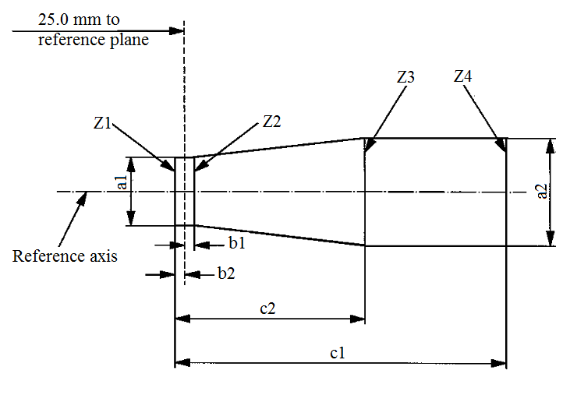
25.0 mm to
reference plane
a2
a1
Z1
Z2
Z3
Z4
b1
b2
c2
c1
Reference axis

 | a1 | a2 | b1 | b2 | c1 | c2
12 V | d + 0.3 | d + 0.5 | 0.2 |  | 5.0 | 4.0
24 V | d + 0.6 | d + 1.0 | 0.25 |  | 6.3 | 4.6
d = diameter of filament
The filament position is checked solely in directions A and B as shown on sheet H11/1, Figure 1.
The filament shall lie entirely within the limits shown.
The ends of the filament as defined on sheet H11/3, footnote 11/, shall lie between lines Z1 and Z2 and between Z3 and Z4.
Category H12 Sheet H12/1
The drawings are intended only to illustrate the essential dimensions (in mm) of the filament light source
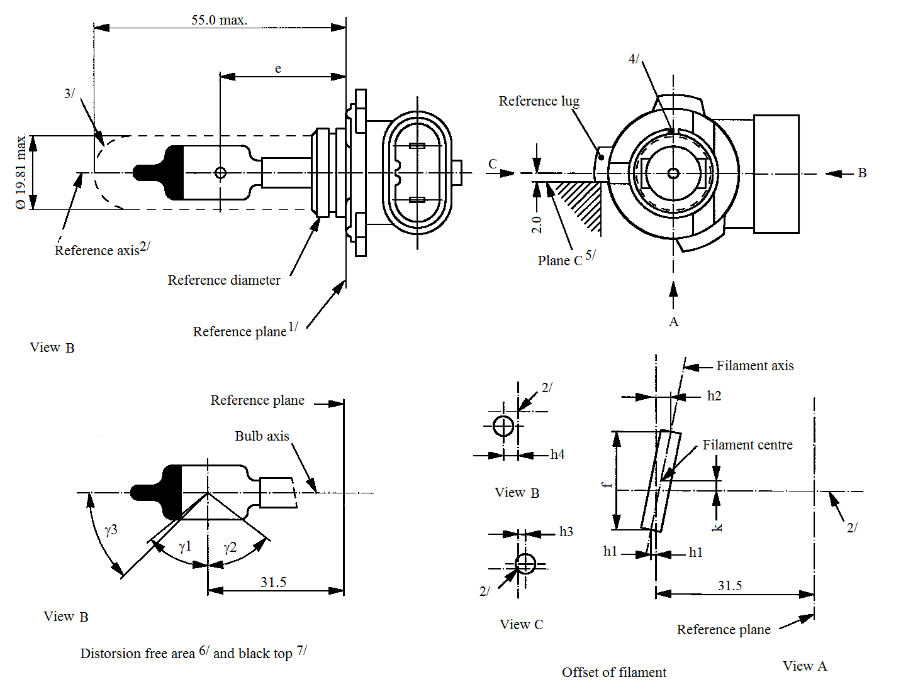
55.0 max.
3/
4/
B
2/
2/
2/
C
2.0
Reference lug
Plane C^{5/}
Reference axis^{2/}
Reference diameter
Reference plane^{1/}
Reference plane
Reference plane
Bulb axis
Filament axis
Filament centre
Ø 19.81 max.
View A
View B
View B
Distorsion free area^{6/} and black top^{7/}
Offset filament
View C
e
View B
31.5
ɣ1
ɣ2
ɣ3
31.5
h4
h3
h1
h1
h2
f
k
A
^{1/} The reference plane is the plane defined by the meeting points of cap-holder fit.
^{2/} The reference axis is perpendicular to the reference plane and concentric with the reference diameter of the cap.
^{3/} Glass bulb and supports shall not exceed the envelope and shall not interfere with insertion past the filament light source key. The envelope is concentric to the reference axis.
^{4/} The keyway is mandatory.
^{5/} The filament shall be rotated in the measuring holder until the reference lug contacts plane C of the holder.
^{6/} Glass bulb periphery shall be optically distortion-free axially and cylindrically within the angles γ1 and γ2. This requirement applies to the whole bulb circumference within the angles γ1 and γ2 and does not need to be verified in the area covered by the obscuration.
^{7/} The obscuration shall extend to at least angle γ3 and shall be at least as far as the undistorted part of the bulb defined by angle γ1.
Category H12 Sheet H12/2

Dimensions in mm ^{8/} |  |  |  | Tolerance
 |  |  |  | Filament light sources of normal production |  | Standard filament light source
e ^{9/,10/} |  | 31.5 |  | ^{11/} |  | ±0.16
f ^{9/,10/} |  | 5.5 |  | 4.8 min |  | ±0.16
h1, h2, h3, h4 |  | 0 |  | ^{11/} |  | ±0.15 ^{12/}
k |  | 0 |  | ^{11/} |  | ±0.15 ^{13/}
γ1 |  | 50° min. |  | - |  | -
γ2 |  | 52° min. |  | - |  | -
γ3 |  | 45° |  | ±5° |  | ±5°
Cap PZ20d in accordance with IEC Publication 60061 (sheet 7004-31-2)
Electrical and photometric characteristics
Rated values |  |  | Volts | 12 |  | 12
 |  |  | Watts | 53 |  | 53
Test voltage |  |  | Volts | 13.2 |  | 13.2
Objective values | Watts |  |  | 61 max. |  | 61 max.
Objective values | Luminous flux |  |  | 1,050 ± 15 %
Reference luminous flux at approximately |  |  |  |  | 12 V | 775
 |  |  |  |  | 13.2 V | 1,050
^{8/} Dimensions shall be checked with O-ring removed.
^{9/} The viewing direction is direction A as shown in the figure on sheet H12/1.
^{10/} The ends of the filament are defined as the points where, when the viewing direction as defined in footnote 9/ above, the projection of the outside of the end turns crosses the filament axis.
^{11/} To be checked by means of a "Box system"; sheet H12/3.
^{12/} Dimensions h1 and h2 are measured in viewing direction A, dimension h3 in direction C and dimension h4 in direction B as shown in the figure on sheet H12/1. The points to be measured are those where the projection of the outside of the end turns nearest to or furthest from the reference plane crosses the filament axis.
^{13/} Dimension k is measured only in viewing direction A.
Category H12 Sheet H12/3
Screen projection requirements
This test is used to determine, by checking whether the filament is correctly positioned relative to the reference axis and reference plane, whether a filament light source complies with the requirements.
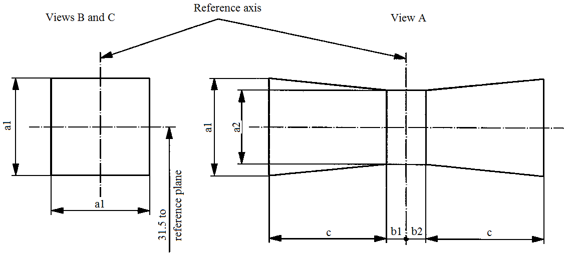
Reference axis
View A
Views B and C
reference plane
31.5 to
a1
a1
a2
b1
b2
c
a1
c

a1 | a2 | b1 | b2 | c
1.6 d | 1.3 d | 0.30 | 0.30 | 2.8
d = diameter of filament
For the directions of view A, B and C, see sheet H12/1.
The filament shall lie entirely within the limits shown.
The centre the filament shall lie between the limits of dimensions b1 and b2.

Categories H13 and H13A Sheet H13/1
The drawings are intended only to illustrate the essential dimensions (in mm) of the filament light source.

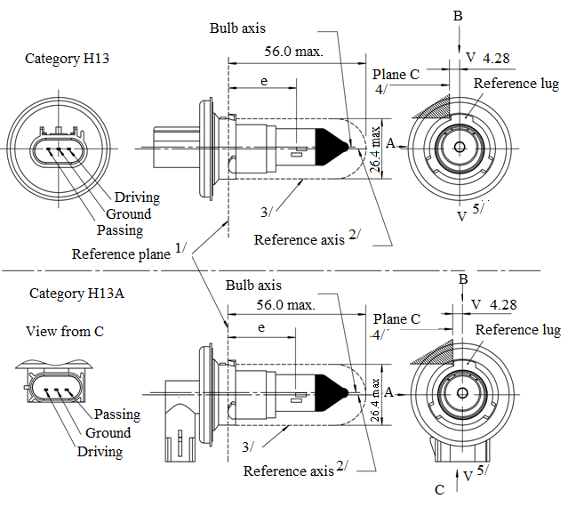
Bulb axis
Plane C
B
4/
5/
3/
V
V
Reference lug
e
e
Reference plane^{1/}
Reference axis^{2/}
Driving
Ground
Passing
Category H13
Category H13A
56.0 max.
4.28
A
26.4 max.
56.0 max.
Bulb axis
4/
Reference lug
V
V^{5/}
4.28
B
A
26.4 max.
Driving
Ground
Passing
3/
Plane C
C
Reference axis^{2/}
View from C

Figure 1 - Main drawing
^{1/} The reference plane is the plane formed by the underside of the three radiused tabs of the cap.
^{2/} The reference axis is perpendicular to the reference plane and crosses the intersection of the two perpendiculars as indicated in Figure 2 on sheet H13/2.
^{3/} Glass bulb and supports shall not exceed the envelope as indicated. The envelope is concentric to the reference axis.
^{4/} The filament light source shall be rotated in the measuring holder until the reference lug contacts plane C of the holder.
^{5/} Plane V-V is the plane perpendicular to the reference plane passing through the reference axis and parallel to plane C.
Categories H13 and H13A Sheet H13/2

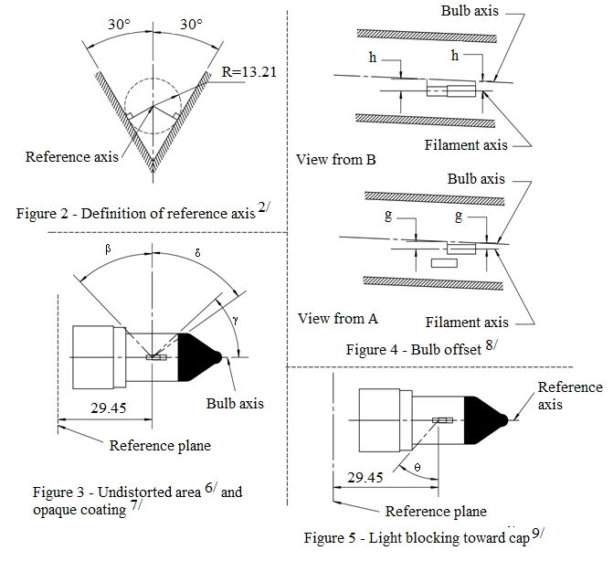
Bulb axis
Bulb axis
Bulb axis
Filament axis
Filament axis
Reference axis
Reference axis
Reference plane
View from B
View from A
Reference plane
Figure 2 – Definition of reference axis^{2/}
Figure 3 – Undistorted area^{6/} and opaque coating^{7/}
Figure 4 – Bulb offset^{8/}
Figure 5 – Light blocking toward cap^{9/}
h
h
g
g
29.45
29.45
R=13.21
30°
30°
δ
ß
ɣ
θ

^{6/} Glass bulb shall be optically distortion-free axially and cylindrically within the angles β and δ. This requirement applies to the whole bulb circumference within the angles β and δ and does not need to be verified in the area covered by the opaque coating.
^{7/} The opaque coating shall extend at least to the cylindrical part of the bulb on the whole bulb top circumference. It shall moreover extend at least to a plane parallel to the reference plane where γ crosses the outer bulb surface (view B as indicated on sheet H13/1).
^{8/} Offset of passing-beam filament in relation to the bulb axis is measured in two planes parallel to the reference plane where the projection of the outside end turns nearest to and farthest from the reference plane crosses the passing-beam filament axis.
^{9/} Light shall be blocked over the cap end of the bulb extending to angle θ. This requirement applies in all directions around the reference axis.
Categories H13 and H13A Sheet H13/3

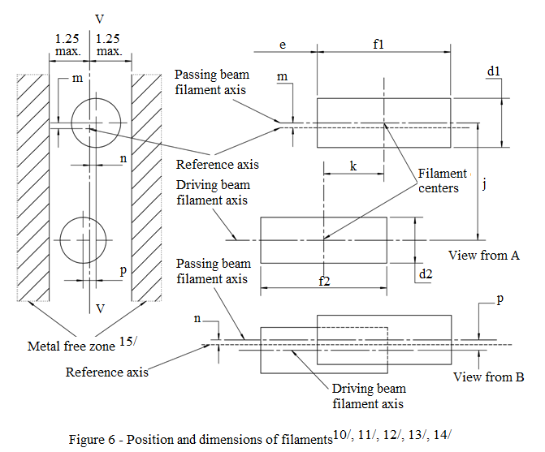
Passing-beam filament axis
Driving-beam
filament axis
Reference axis
Passing-beam filament axis
Reference axis
Driving-beam
filament axis
View from A
View from B
Metal free zone^{15/}
Filament centers
V
e
f1
d1
m
k
j
n
p
f2
d2
1.25
max.
1.25
max.
V
n
p
m
Figure 6 – Position and dimensions of filaments ^{10/, 11/, 12/, 13/, 14/}

^{10/} Dimensions j, k and p are measured from the centre of the passing-beam filament to the centre of the driving-beam filament.
^{11/} Dimensions m and n are measured from the reference axis to the centre of the passing-beam filament.
^{12/} Both filaments axis are to be held within a 2° tilt with respect to the reference axis about the centre of the respective filament.
^{13/} Note concerning the filament diameters.
(a) For the same manufacturer, the design filament diameter of standard (étalon) filament light source and filament light source of normal production shall be the same.
^{14/} For both the driving-beam and the passing-beam filament distortion shall not exceed ±5 per cent of filament diameter from a cylinder.
^{15/} The metal free zone limits the location of lead wires within the optical path. No metal parts shall be located in the shaded area as seen in Figure 6.
Categories H13 and H13A Sheet H13/4

Dimensions in mm |  |  |  | Tolerance
 |  |  |  | Filament light sources of normal production |  |  |  |  | Standard filament light source
d1 ^{13/, 17/} |  | 1.8 max. |  | - |  |  |  |  | -
d2 ^{13/, 17/} |  | 1.8 max. |  | - |  |  |  |  | -
e ^{16/} |  | 29.45 |  | ±0.20 |  |  |  |  | ±0.10
f 1 ^{16/} |  | 4.6 |  | ±0.50 |  |  |  |  | ±0.25
f 2 ^{16/} |  | 4.6 |  | ±0.50 |  |  |  |  | ±0.25
g ^{8/, 17/} |  | 0.5 d1 |  | ±0.40 |  |  |  |  | ±0.20
h ^{8/} |  | 0 |  | ±0.30 |  |  |  |  | ±0.15
j ^{10/} |  | 2.5 |  | ±0.20 |  |  |  |  | ±0.10
k ^{10/} |  | 2.0 |  | ±0.20 |  |  |  |  | ±0.10
m ^{10/} |  | 0 |  | ±0.20 |  |  |  |  | ±0.13
n ^{10/} |  | 0 |  | ±0.20 |  |  |  |  | ±0.13
p ^{10/} |  | 0 |  | ±0.08 |  |  |  |  | ±0.08
β |  | 42° min. |  | - |  |  |  |  | -
δ |  | 52° min. |  | - |  |  |  |  | -
γ |  | 43° |  | +0° / -5° |  |  |  |  | +0° / -5°
θ ^{9/} |  | 41° |  | ±4° |  |  |  |  | ±4°
Cap: | H13: P26.4t  H13A: PJ26.4t |  | in accordance with IEC Publication 60061 (sheet 7004-128-3)
Electrical and photometric characteristics ^{18/}
Rated values |  | Volts |  |  | 12 |  |  |  | 12
 |  | Watts |  |  | 55 |  | 60 |  | 55 | 60
Test voltage |  | Volts |  |  | 13.2 |  |  |  | 13.2
Objective values |  | Watts |  |  | 68 max. |  |  | 75 max. | 68 max. | 75 max.
 |  | Luminous flux |  |  | 1,100 ± 15 % |  |  | 1,700 ± 15 %
Reference luminous flux at approximately |  |  |  |  |  | 12 V |  |  | 800 |  | 1,200
 |  |  |  |  |  | 13.2 V |  |  | 1,100 |  | 1,700
^{16/} The ends of the filament are defined as the points where, when the viewing direction is direction A as shown on sheet H13/1, the projection of the outside of the end turns crosses the filament axis.
^{17/} d1 is the actual diameter of the passing-beam filament. d2 is the actual diameter of the driving-beam filament.
^{18/} The values indicated in the left-hand columns relate to the passing-beam filament and those indicated in the right-hand columns to the driving-beam filament.
Category H14 Sheet H14/1
The drawings are intended only to illustrate the essential dimensions (in mm) of the filament light source.
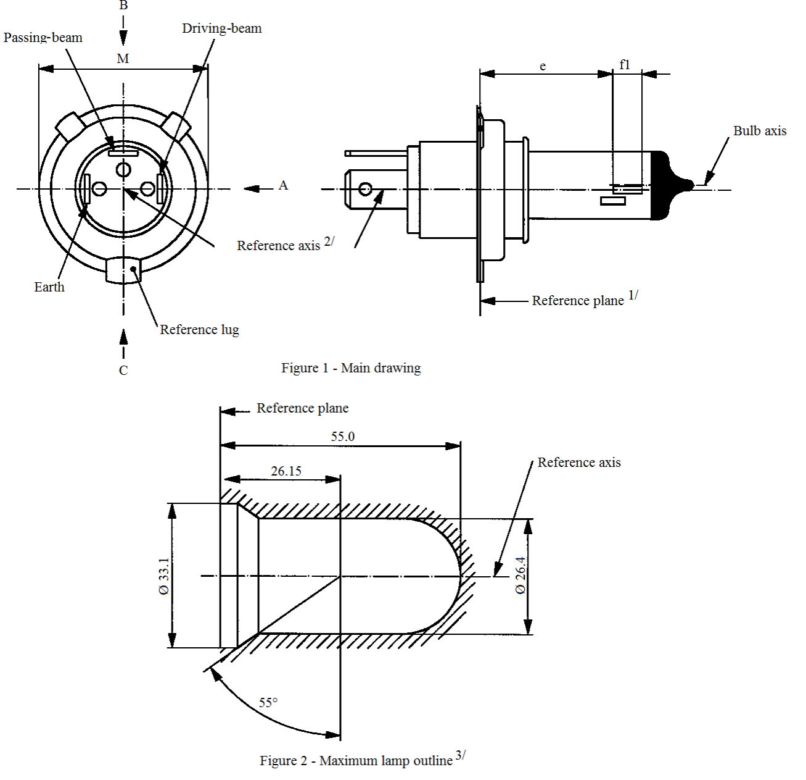
Ø 33.1
Passing-beam
Driving-beam
Reference lug
Earth
Reference axis^{2/}
Reference plane^{1/}
Reference axis
Figure 2 – Maximum filament light source outline^{3/}
Reference plane
Figure 1 – Main drawing
B
M
A
C
55.0B
26.15
55°
Bulb axis
e
f1
Ø 33.1
Ø 26.4
^{1/} The reference plane is defined by the points on the surface of the holder on which the three lugs of the cap ring will rest.
^{2/} The reference axis is perpendicular to the reference plane and passing through the centre of the cap ring diameter "M'"
^{3/} Glass bulb and supports shall not exceed the envelope as indicated in Figure 2. The envelope is concentric to the reference axis.
Category H14 Sheet H14/2

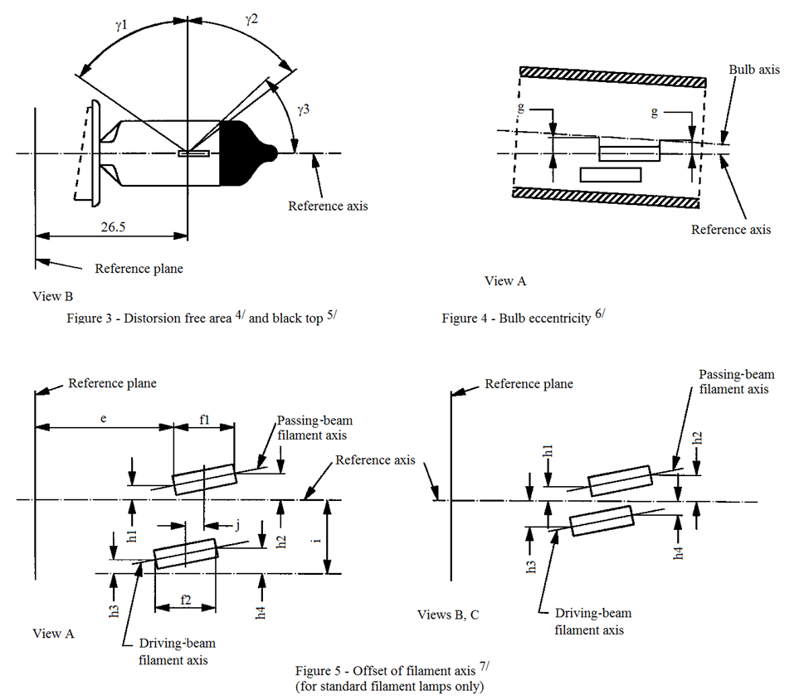
Reference axis

View B

Reference plane

View A

Reference axis

Bulb axis

Reference plane

Figure 3 – Distorsion free area^{4/} and black top^{5/}

Figure 4 – Bulb eccentricity^{6/}

Passing-beam
filament axis
Passing-beam
filament axis
Driving-beam
filament axis
Reference axis

View B

Reference plane

View A

Reference axis

Bulb axis

Reference plane

Figure 3 – Distorsion free area^{4/} and black top^{5/}

Figure 4 – Bulb eccentricity^{6/}

Passing-beam
filament axis
Passing-beam
filament axis
Driving-beam
filament axis
Reference axis

View B

Reference plane
View A

Reference axis
Bulb axis

Reference plane

Figure 3 – Distorsion free area^{4/} and black top^{5/}

Figure 4 – Bulb eccentricity^{6/}

Passing-beam
filament axis
Passing-beam
filament axis
Driving-beam
filament axis
Driving-beam
filament axis
View A

Views B, C

Reference axis
Reference plane
Figure 5 – Offset of filament axis^{7/}
(for standard filament light sources only)
ɣ1
ɣ2
ɣ3
g
g
e
f1
h1
h1
h3
h4
h2
h3
h2
h4
i
j
26.5
f2

^{4/} Glass bulb shall be optically distortion free within the angles γ1 and γ2 . This requirement applies to the whole bulb circumference within the angles γ1 and γ2 and does not need to be verified in the area covered by the obscuration.
^{5/} The obscuration shall extend at least to the cylindrical part of the bulb on the whole bulb top circumference. It shall, moreover, extend at least to a plane parallel to the reference plane where γ3 crosses the outer bulb surface (view B as indicated on sheet H14/1).
^{6/} Eccentricity of bulb with respect to passing-beam filament axis is measured in two planes parallel to the reference plane where the projection of the outside of the end turns nearest to or furthest from the reference plane crosses the passing-beam filament axis.
^{7/} The offset of the filaments with respect to the reference axis is measured only in viewing direction A, B and C as shown in Figure 1 on sheet H14/1. The points to be measured are those where the projection of the outside of the end turns nearest to or furthest from the reference plane crosses the filaments axis.

Category H14 Sheet H14/3

Dimensions in mm |  |  |  | Filament light source of normal production |  |  | Standard filament light sources
e ^{8/} |  | 26.15 |  | ^{10/} |  |  | ±0.1
f1 ^{8/,9/} |  | 5.3 |  | ^{10/} |  |  | ±0.1
f2 ^{8/,9/} |  | 5.0 |  | ^{10/} |  |  | ±0.1
g |  | 0.3 min.
h1 |  | 0 |  | ^{10/} |  |  | ±0.1
h2 |  | 0 |  | ^{10/} |  |  | ±0.15
h3 |  | 0 |  | ^{10/} |  |  | ±0.15
h4 |  | 0 |  | ^{10/} |  |  | ±0.15
i |  | 2.7 |  |  |  |  | -
j |  | 2.5 |  | ^{10/} |  |  | ±0.1
γ1 |  | 55° min. |  | - |  |  | -
γ2 |  | 52° min. |  | - |  |  | -
γ3 |  | 43° |  | 0/-5° |  |  | 0/-5°
Cap P38t in accordance with IEC Publication 60061 (sheet 7004-133-1)
Electrical and photometric characteristics
Rated values | Volts |  | 12 |  |  |  | 12
Rated values | Watts |  | 55 |  | 60 |  | 55 | 60
Test voltage | Volts |  | 13.2 |  |  |  | 13.2
Objective values | Watts |  | 68 max. |  | 75 max. |  | 68 max. | 75 max.
Objective values | Luminous flux |  | 1,150 ± 15 % |  | 1,750 ± 15 %
Reference luminous flux at approximately |  |  |  |  |  | 12 V | 860 | 1,300
 |  |  |  |  |  | 13.2 V | 1,150 | 1,750
^{8/} The ends of the filaments are defined as the points where, when the viewing direction is direction A as shown in Figure 1 on sheet H14/1, the projection of the outside of the end turns crosses the filaments axis.
^{9/} "f1" represents the length of the passing-beam filament and "f2" represents the length of the driving-beam filament.
^{10/} To be checked by means of a "Box system"; sheet H14/4.
Category H14 Sheet H14/4
Screen projection requirements
This test is used to determine, by checking whether the filaments are correctly positioned relative to the reference axis and the reference plane, whether a filament light source complies with the requirements.

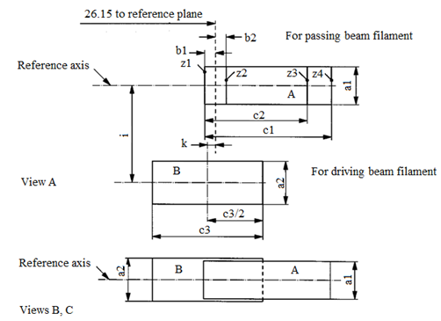
26.15 to reference plane
c2
c1
c3
View A
For passing-beam filament
For driving-beam filament
Reference axis
Reference axis
b1
b2
z1
z2
z3
z4
c3/2
B
B
A
A
a1
a1
a2
a2
Views B, C
k
i

a1 | a2 | b1 | b2 | c1 | c2 | c3 | i | k
d1 +0.5 | 1.6 * d2 | 0.2 |  | 5.8 | 5.1 | 5.75 | 2.7 | 0.15
d1 is diameter of the passing-beam filament and d2 that of the driving-beam filament.
Notes concerning the filaments diameter:
(a) No actual diameter restrictions apply but the objective for future developments is to have d1 max. = 1.6 mm and d2 max. = 1.6 mm.
(b) For the same manufacture, the design diameter of standard filament light sources and filament light sources of normal production shall be the same.

The positions of the filaments are checked solely in directions A, B and C as shown in Figure 1 on sheet H14/1.
The passing-beam filament shall lie entirely in the rectangle A and the driving-beam filament entirely in rectangle B.
The ends of the passing-beam filament as defined on sheet H14/3, footnote 8/ shall lie between lines Z1 and Z2 and between lines Z3 and Z4.
Category H15 Sheet H15/1
The drawings are intended only to illustrate the essential dimensions (in mm) of the filament light source
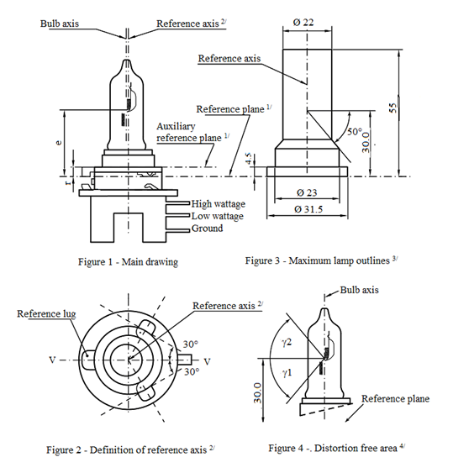
Reference axis^{2/}
Reference plane^{1/}
Bulb axis
Reference axis
Auxiliary
reference plane^{1/}
High wattage
Low wattage
Ground
Figure 1 – Main drawing
Figure 3 - Maximum filament light source outlines^{3/}
Ø 22
Bulb axis
Reference axis^{2/}
Reference lug
Ø 31.5
Ø 23
50°
30.0
55
4.5
e
r
30°
30°
30.0
ɣ1
ɣ2
Reference plane
V
V
Figure 2 – Definition of reference axis^{7/}
Figure 4 - Distorsion free area^{4/}
^{1/} The reference plane is defined by the points at which the holder touches the three lugs of the cap ring from the plug side. It is intended for use as an internal reference plane.
The auxiliary reference plane is defined by the points on the surface of the holder on which the three supporting bosses of the cap ring will rest. It is intended for use as an external reference plane.
The cap is designed for use of the (internal) reference plane, but for certain applications the (external) auxiliary reference plane may be used instead.
^{2/} The reference axis is perpendicular to the reference plane and crosses the intersection of the two perpendiculars as indicated in Figure 2 on sheet H15/1.
^{3/} Glass bulb and supports shall not exceed the envelope as indicated in Figure 3. The envelope is concentric to the reference axis.
^{4/} Glass bulb shall be optically distortion free within the angles γ₁ and γ₂ as indicated in Figure 4. This requirement applies to the whole bulb circumference within the angles γ₁ and γ₂.
Category H15 Sheet H15/2

Dimensions in mm |  |  | Filament light sources of normal production |  |  |  |  |  | Standard filament light source
 |  |  | 12 V |  |  | 24 V |  |  | 12 V
e |  |  | 30.0 + 0.35 / -0.25 |  |  | 30.0 + 0.35 / -0.25 |  |  | 30.0 + 0.20 / -0.15
γ₁ |  |  | 50°min |  |  | 50°min |  |  | 50°min
γ₂ |  |  | 50°min |  |  | 50°min |  |  | 50°min
r |  | For details see cap sheet
Cap PGJ23t-1 in accordance with IEC Publication 60061 (sheet 7004-155-1)
Electrical and photometric characteristics
Rated values | Volts |  |  | 12 ^{5/} |  |  | 24 ^{5/} |  | 12 ^{5/}
Rated values | Watts |  |  | 15 | 55 |  | 20 | 60 | 15 | 55
Test voltage | Volts |  |  | 13.2 |  |  | 28.0 |  | 13.2 | 13.2
Objective values | Watts |  |  | 19 max. | 64 max. |  | 24 max. | 73 max. | 19 max. | 64 max.
Objective values | Luminous flux |  |  | 260 | 1,350 |  | 300 | 1,500
 |  |  |  | ±10 %
Reference luminous flux at approximately 12 V |  |  |  |  |  |  |  |  |  | 1,000
Reference luminous flux at approximately 13.2 V |  |  |  |  |  |  |  |  |  | 1,350
Reference luminous flux at approximately 13.5 V |  |  |  |  |  |  |  |  | 290
^{5/} The values indicated in the left-hand columns relate to the low wattage filament. Those indicated in the right-hand columns relate to the high wattage filament.
Category H15 Sheet H15/3

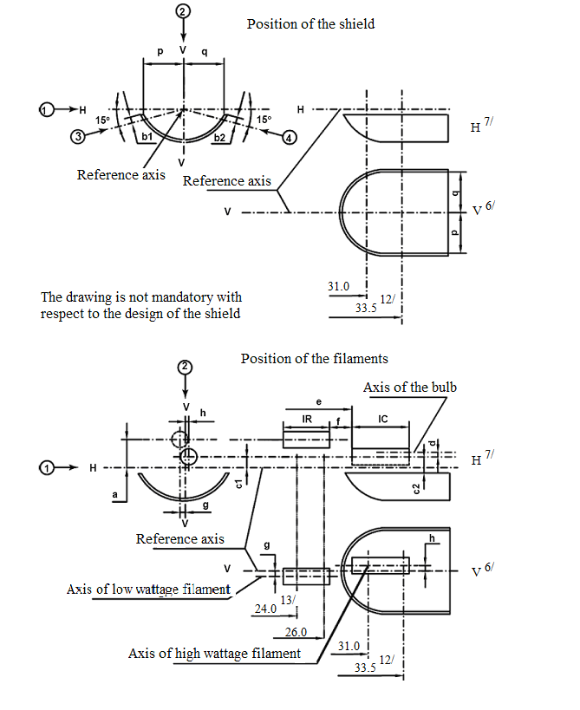
Reference axis
Position of the shield
Reference axis
The drawing is not mandatory with
respect to the design of the shield
Position of the filaments
Axis of bulb
Reference axis
H^{7/}
V^{6/}
H^{7/}
V^{6/}
Axis of low wattage filament
V
V
V
V
V
H
H
H
p
q
p
q
c1
c2
d
f
h
V
1_{R}
1_{C}
15°
15°
e
a
g
g
h
31.0
33.5
33.5
12/
12/
31.0
24.0
13/
26.0
Axis of high wattage filament
b1
Category H15 Sheet H15/4

Table of the dimensions (in mm) referred to in the drawings on sheet H15/3

Reference* |  |  | Dimension** |  |  | Tolerance
 |  |  |  |  |  | Filament light sources of normal production |  | Standard filament light source
12 V | 24 V |  | 12 V | 24 V |  | 12 V | 24 V | 12 V | 24 V
a/24.0 | a/24.5 |  | 1.8 |  |  | ±0.35 |  | ±0.20
a/26.0 |  |  | 1.8 |  |  | ±0.35 |  | ±0.20
b1/31.0 |  |  | 0 |  |  | ±0.30 |  | ±0.15
b1/33.5 | b1/34.0 |  | b1/31.0 mv |  |  | ±0.30 |  | ±0.15
b2/31.0 |  |  | 0 |  |  | ±0.30 |  | ±0.15
b2/33.5 | b2/34.0 |  | b2/31.0 mv |  |  | ±0.30 |  | ±0.15
c1/31.0 |  |  | 0 |  |  | ±0.30 | ±0.50 | ±0.15 | ±0.25
c1/33.5 | c1/34.0 |  | c1/31.0 mv |  |  | ±0.30 | ±0.50 | ±0.15 | ±0.25
c2/33.5 | c2/34.0 |  | 1.1 |  |  | ±0.30 | ±0.50 | ±0.15 | ±0.25
d |  |  | min. 0.1 |  |  | - |  | -
f ^{8/, 9/, 10/} |  |  | 2.7 |  |  | ±0.30 | ±0.40 | +0.20  -0.10 | +0.25  -0.15
g/24.0 | g/24.5 |  | 0 |  |  | ±0.50 | ±0.70 | ±0.25 | ±0.35
g/26.0 |  |  | 0 |  |  | ±0.50 | ±0.70 | ±0.25 | ±0.35
h/31.0 |  |  | 0 |  |  | ±0.50 | ±0.60 | ±0.25 | ±0.30
h/33.5 | h/34.0 |  | h/31.0 mv |  |  | ±0.30 | ±0.40 | ±0.15 | ±0.20
1_{R} ^{8/, 11/} |  |  | 4.2 | 4.6 |  | ±0.40 | ±0.60 | ±0.20 | ±0.30
1_{C} ^{8/, 9/} |  |  | 4.4 | 5.4 |  | ±0.40 | ±0.60 | ±0.20 | ±0.30
p/33.5 |  | p/34.0 | Depends on the shape of the shield |  |  | - |  | -
q/33.5 |  | q/34.0 | p/33.5 |  | p/34.0 | ±1.20 |  | ±0.60
* "…/26.0" means dimension to be measured at the distance from the reference plane indicated in mm after the stroke.
** "31.0 mv" means the value measured at a distance of 31.0 mm from the reference plane.
Category H15 Sheet H15/5

^{6/} Plane V-V is the plane perpendicular to the reference plane and passing through the reference axis and through the axis of the reference lug.
^{7/} Plane H-H is the plane perpendicular to both the reference plane and plane V-V and passing through the reference axis.
^{8/} The end turns of the filament are defined as being the first luminous turn and the last luminous turn that are at substantially the correct helix angle.
^{9/} For the high wattage filament, the points to be measured are the intersections, seen in direction 1, of the lateral edge of the shield with the outside of the end turns defined under footnote 8/.
^{10/} "e" denotes the distance from the reference plane to the beginning of the driving-beam filament as defined above.
^{11/} For the low wattage filament the points to be measured are the intersections, seen in direction 1, of a plane, parallel to plane H-H and situated at a distance of 1.8 mm above it, with the end turns defined under footnote 8/.
^{12/} 34.0 for the 24 V type.
^{13/} 24.5 for the 24 V type.
Additional explanations to sheet H15/3
The dimensions below are measured in four directions:
1) For dimensions a, c1, c2, d, e, f, lR and lC;
2) For dimensions g, h, p and q;
3) For dimension b1;
4) For dimension b2.
Dimensions b1, b2, c1 and h are measured in planes parallel to the reference plane at distances of 31.0 mm and 33.5 mm (34.0 mm for 24 V types).
Dimensions c2, p and q are measured in a plane parallel to the reference plane at a distance of 33.5 mm (34.0 mm for 24 V types).
Dimensions a and g are measured in planes parallel to the reference plane at distances of 24.0 mm (24.5 mm for 24 V types) and 26.0 mm.

Categories H16 and H16B Sheet H16/1
The drawings are intended only to illustrate the essential dimensions (in mm) of the filament light source

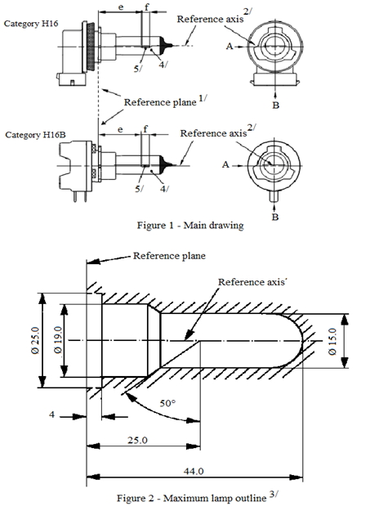
Reference axis^{2/}
Reference axis^{2/}
Reference plane^{1/}
Reference plane
Reference axis
Category H16
Category H16B
Figure 1 – Main drawing
Figure 2 - Maximum filament light source outline^{3/}
50°
44.0
25.0
4
Ø 25.0
Ø 19.0
Ø 15.0
e
e
f
f
A
A
B
B
5/
5/
4/
4/
^{1/} The reference plane is the plane formed by the underside of the bevelled lead-in flange of the cap.
^{2/} The reference axis is perpendicular to the reference plane and passing through the centre of the 19 mm cap diameter.
^{3/} Glass bulb and supports shall not exceed the envelope as indicated in Figure 2. The envelope is concentric to the reference axis.
^{4/} The light emitted shall be white or selective yellow.
^{5/} Notes concerning the filament diameter.
(a) No actual diameter restrictions apply but the objective for future developments is to have d max. = 1.1 mm.
(b) For the same manufacturer, the design diameter of standard (étalon) filament light source and filament light source of normal production shall be the same.
Categories H16 and H16B Sheet H16/2

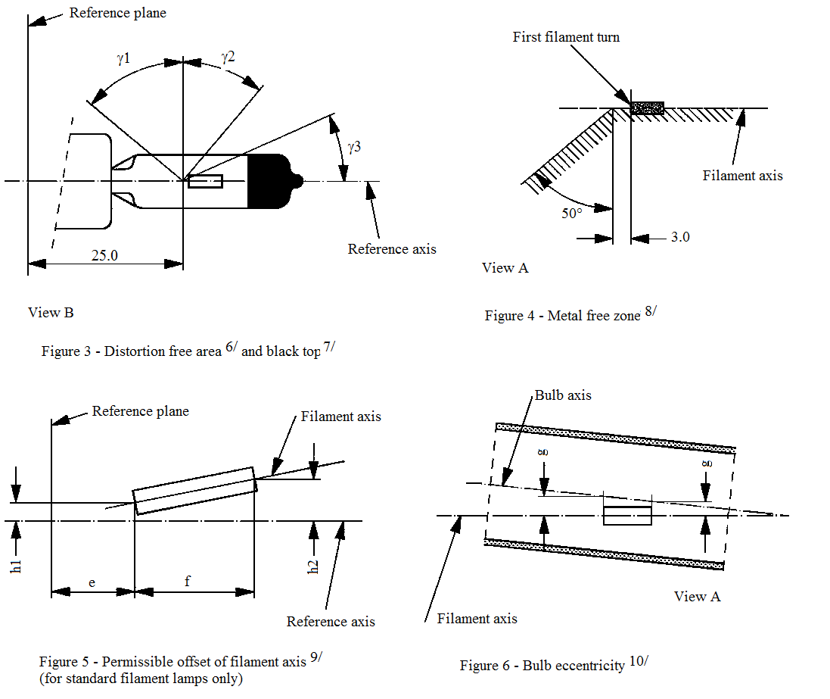
Reference plane
Reference plane
First filament turn
Reference axis
Reference axis
Filament axis
Filament axis
Bulb axis
Filament axis
View B
View A
View A
25.0
3.0
50°
ɣ2
ɣ1
ɣ3
e
f
h1
h2
g
g
Figure 3 - Distorsion free area^{6/} and black top^{7/}
Figure 4 – Metal free zone^{8/}
Figure 5 – Permissible offset of filament axis^{9/}
(for standard filament light sources only)
Figure 6 – Bulb eccentricity^{10/}

^{6/} Glass bulb shall be optically distortion free within the angles γ1 and γ2. This requirement applies to the whole bulb circumference within the angles γ1 and γ2.
^{7/} The obscuration shall extend at least to angle γ3 and shall extend at least to the cylindrical part of the bulb on the whole bulb top circumference.
^{8/} The internal design of the filament light source shall be such that stray light images and reflections are only located above the filament itself seen from the horizontal direction. (View A as indicated in Figure 1 on sheet H16/1). No metal parts other than filament turns shall be located in the shaded area as seen in Figure 4.
^{9/} The offset of the filament with respect to the reference axis is measured only in viewing directions A and B as shown in Figure 1 in sheet H16/1. The points to be measured are those where the projection of the outside of the end turns nearest to or furthest from the reference plane crosses the filament axis.
^{10/} Offset of filament in relation to bulb axis measured in two planes parallel to the reference plane where the projection of the outside of the end turns nearest to or furthest from the reference plane crosses the filament axis.
Categories H16 and H16B Sheet H16/3

Dimensions in mm |  |  | Filament light sources of normal production | Standard filament light source
 |  |  | 12 V | 12 V
e ^{11/} |  |  | 25.0 ^{12/} | 25.0 ± 0.1
f ^{11/} |  |  | 3.2 ^{12/} | 3.2 ± 0.1
g |  |  | 0.5 min. | u.c.
h1 |  |  | 0 ^{12/} | 0 ± 0.1
h2 |  |  | 0 ^{12/} | 0 ± 0.15
γ1 |  |  | 50° min. | 50° min.
γ2 |  |  | 40° min. | 40° min.
γ3 |  |  | 30° min. | 30° min.
Cap: | H16: PGJ19-3  H16B: PGJY19-3 |  | in accordance with IEC Publication 60061 (sheet 7004-110-2)  in accordance with IEC Publication 60061 (sheet 7004-146-1)
Electrical and photometric characteristics
Rated  values |  | Volts | 12 | 12
 |  | Watts | 19 | 19
Test voltage |  | Volts | 13.2 | 13.2
Objective  values |  | Watts | 26 max. | 26 max.
 |  | Luminous flux | 500 +10 % / -15 %
Reference luminous flux: 370 lm at approximately 12 V |  |  |  | 370 lm
Reference luminous flux: 500 lm at approximately 13.2 V |  |  |  | 500 lm
Reference luminous flux: 550 lm at approximately 13.5 V |  |  |  | 550 lm
^{11/} The ends of the filament are defined as the points where, when the viewing direction is direction A as shown in Figure 1 on sheet H16/1, the projection of the outside of the end turns crosses the filament axis.
^{12/} To be checked by means of a "Box system"; sheet H16/4.
Categories H16 and H16B Sheet H16/4

Screen projection requirements
This test is used to determine, by checking whether the filament is correctly positioned relative to the reference axis and reference plane, whether a filament complies with the requirements.
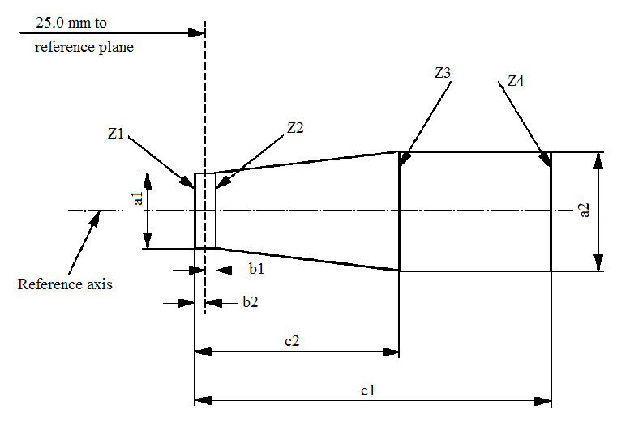
c2
reference plane
25.0 mm to
Reference axis
a1
a2
Z1
Z2
Z3
Z4
b1
c1
b2

a1 | a2 | b1 | b2 | c1 | c2
d + 0.50 | d + 0.70 | 0.25 |  | 3.6 | 2.6

d = diameter of filament
The filament position is checked solely in directions A and B as shown on sheet H16/1, Figure 1.
The filament shall lie entirely within the limits shown.
The ends of the filament as defined on sheet H16/3, footnote 11/, shall lie between lines Z1 and Z2 and between Z3 and Z4.

Category H17 Sheet H17/1

The drawings are intended only to illustrate the essential dimensions (in mm) of the filament light source

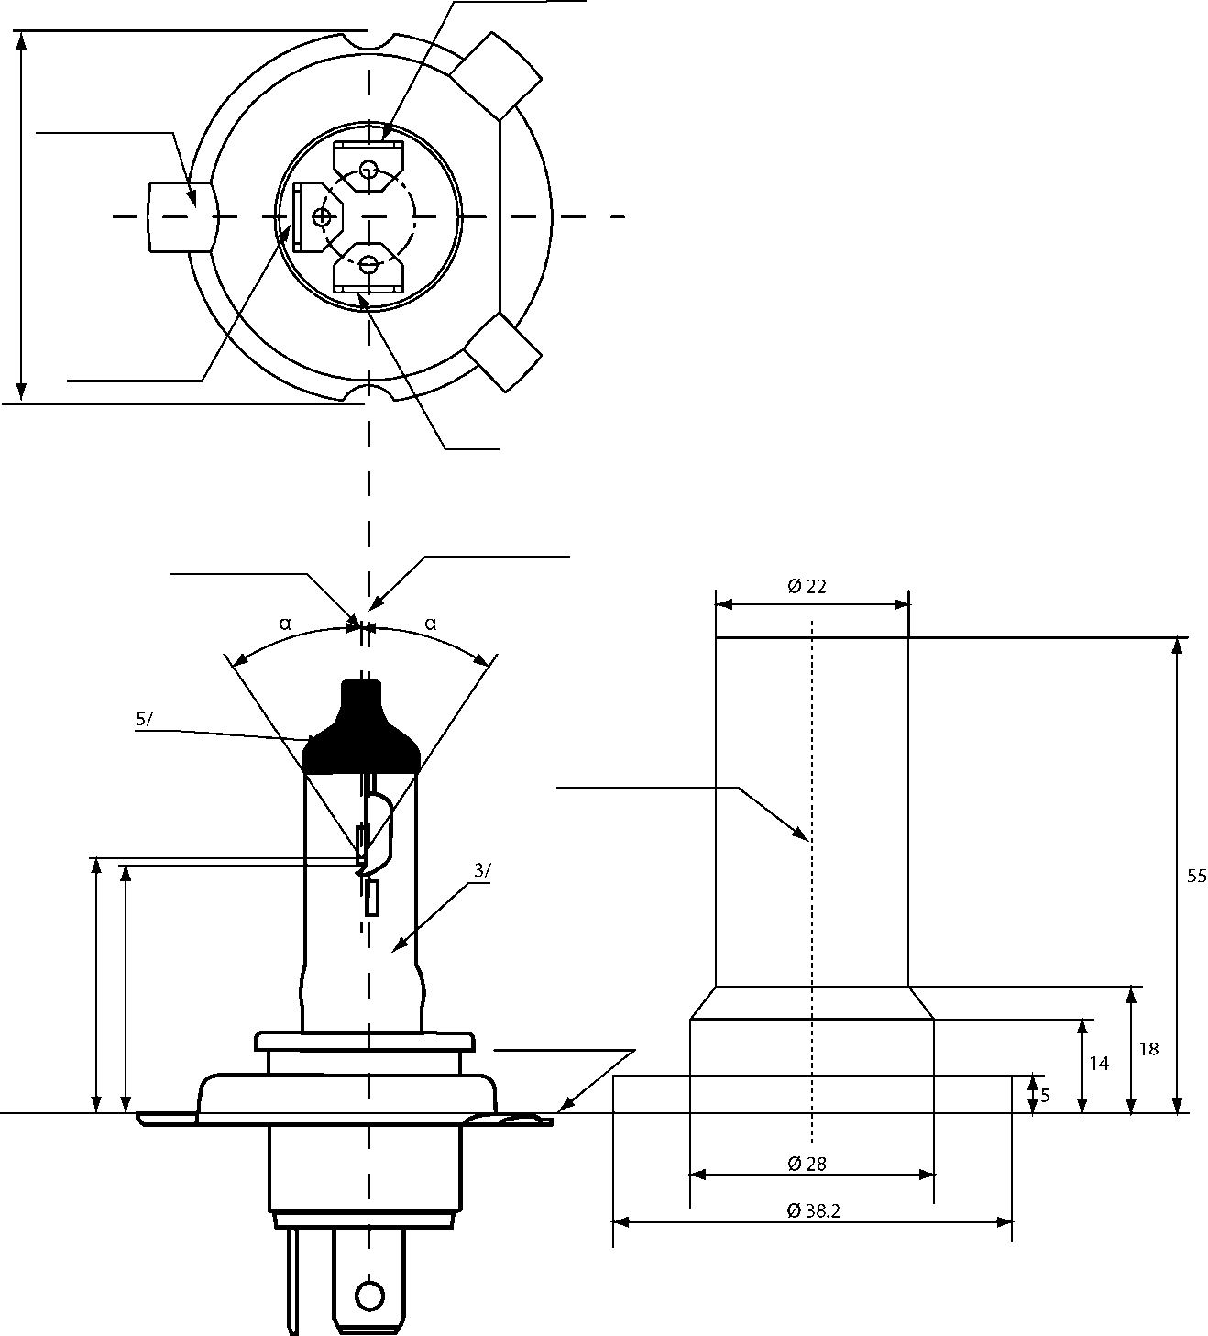
Driving-beam
Reference lug

Passing-beam

M
Earth

Axis of the bulb

Reference axis^{2/}

Reference axis

Reference plane^{1/}
Figure 1 –
Main drawing
Figure 2 - Maximum filament light source outlines^{4/}
Ø 38.2
Ø 28
Ø 22
5/
3/
55
18
14
5
α
α
e
p
p
e

For the notes see sheet H17/6
Category H17 Sheet H17/2

Dimensions in mm |  | Filament light sources of normal production |  |  | Standard filament light source
 |  | 12 V |  |  | 12 V
e |  | 28.5 + 0.35 / - 0.15 |  |  | 28.5 + 0.20 / - 0.0
p |  | 28.95 |  |  | 28.95
α |  | max. 40° |  |  | max. 40°
Cap PU43t-4 in accordance with IEC Publication 60061 (sheet 7004-171-2)
Electrical and photometric characteristics
Rated values | Volts | 12 ^{6/} |  |  | 12 ^{6/}
Rated values | Watts | 35 | 35 |  | 35 | 35
Test voltage | Volts | 13.2 | 13.2 |  | 13.2 | 13.2
Objective values | Watts | 37 max. | 37 max. |  | 37 max. | 37 max.
Objective values | Luminous flux | 900 ± 10 % | 600 ± 10 %
Reference luminous flux at approximately |  |  |  | 12.0 V | 700 | 450
 |  |  |  | 13.2 V | 900 | 600

For note 6/ see sheet H17/6
Category H17 Sheet H17/3

Position of the shield

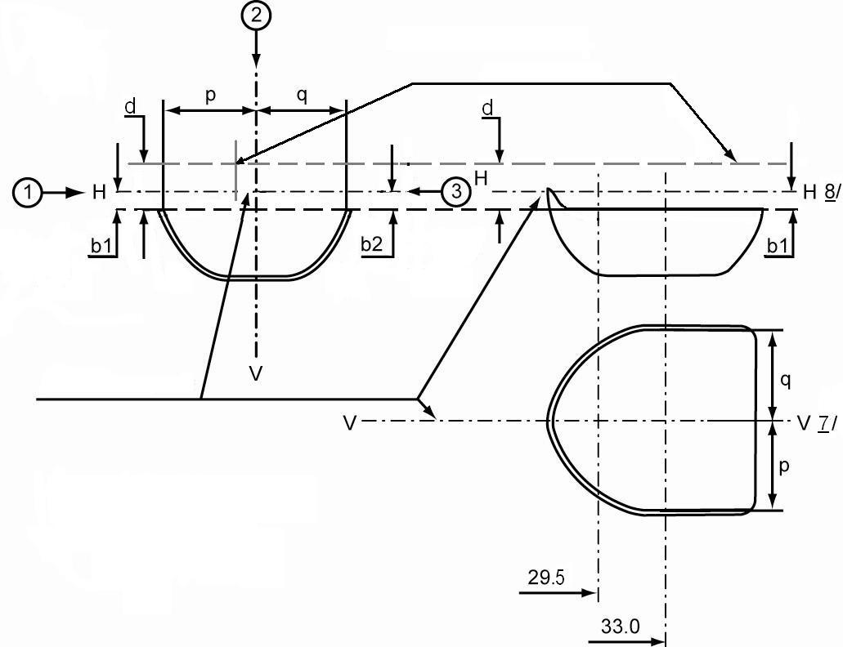
Axis of bulb

Reference axis

H^{8/}
V^{7/}
b2
b1
b1
d
d
p
q
q
p
H
H
V
V
29.5
33.0

Category H17 Sheet H17/4

Position of filaments

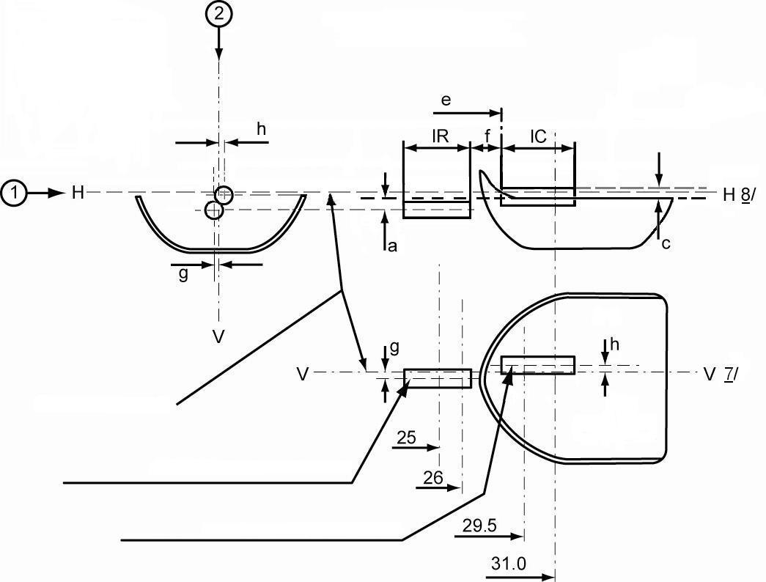
Reference axis
Axis of driving-beam filament

Axis of passing-beam filament
H^{8/}
V^{7/}
H
V
V
h
h
g
g
e
a
c
1_{R}
1_{C}
25
26
29.5
31.0
f

Category H17 Sheet H17/5
Table of the dimensions (in mm) referred to in the drawings on sheets H17/3 and H17/4

Reference* | Dimension** | Tolerance
Reference* | Dimension** | Filament light sources of normal production | Standard filament light source
a/25.0 | 0.3 | ±0.40 | ±0.20
a/26.0 | 0.3 | ±0.35 | ±0.20
b1/29.5 | 0.0 | ±0.30 | ±0.25
b1/33.0 | b1/29.5 mv | ±0.30 | ±0.15
b2/29.5 | 0.0 | ±0.30 | ±0.25
b2/33.0 | b2/29.5 mv | ±0.30 | ±0.15
c/29.5 | 0.5 | ±0.25 | ±0.15
c/31.0 | c/29.5 mv | ±0.25 | ±0.15
d | min. 0.1 | - | -
e ^{11/} | 28.5 | +0.35 / -0.15 | +0.20 / -0.0
f ^{9/, 10/, 11/} | 1.7 | ±0.30 | ±0.15
g/25.0 | 0 | ±0.50 | ±0.30
g/26.0 | 0 | ±0.40 | ±0.25
h/29.5 | 0 | ±0.40 | ±0.25
h/31.0 | h/29.5 mv | ±0.30 | ±0.15
lR ^{9/, 12/} | 4.0 | ±0.40 | ±0.20
lC ^{9/, 10/} | 4.2 | ±0.40 | ±0.20
p/33.0 | Depends on the shape of the shield | - | -
q/33.0 | (p+q)/2 | ±0.60 | ±0.30

* "../25.0" means dimension to be measured at the distance from the reference plane indicated in mm after the stroke.
** "29.5 mv" means the value measured at a distance of 29.5 mm from the reference plane.

For the notes see sheet H17/6
Category H17 Sheet H17/6
^{1/} The reference plane is the plane formed by the seating points of the three lugs of the cap ring.
^{2/} The reference axis is perpendicular to the reference plane and passes through the centre of the circle of diameter "M".
^{3/} The light emitted from standard filament light sources and from normal production filament light sources shall be white.
^{4/} The bulb and supports shall not exceed the envelope as in Figure 2.
^{5/} The obscuration shall extend at least as far as the cylindrical part of the bulb. It shall also overlap the internal shield when the latter is viewed in a direction perpendicular to the reference axis.
^{6/} The value indicated in the left hand column relate to the driving beam filament. Those indicated in the right-hand column relate to the passing-beam filament.
^{7/} Plane V-V is the plane perpendicular to the reference plane and passing through the reference axis and through the intersection of the circle of diameter "M" with the axis of the reference lug.
^{8/} Plane H-H is the plane perpendicular to both the reference plane and plane V-V and passing through the reference axis.
^{9/} The end turns of the filament are defined as being the first luminous turn and the last luminous turn that are at substantially the correct helix angle.
^{10/} For the passing beam filament, the points to be measured are the intersections, seen in direction 1, of the lateral edge of the shield with the outside of the end turns defined under note 9/.
^{11/} "e" denotes the distance from the reference plane to the beginning of the passing filament as defined above.
^{12/} For the driving beam filament the points to be measured are the intersections, seen in direction 1, of a plane, parallel to plane H-H and situated at a distance of 0.3 mm below it, with the end turns defined under note 9/.

Additional explanations to sheets H17/3 and H17/4
The dimensions below are measured in three directions:
1 For dimensions b1, a, c, d, e, f, lR and lC.
2 For dimensions g, h, p and q.
3 For dimension b2.
Dimensions p and q are measured in planes parallel to and 33.0 mm away from the reference plane.
Dimensions b1, b2 are measured in planes parallel to and 29.5 mm and 33.0 mm away from the reference plane.
Dimensions c and h are measured in planes parallel to and 29.5 mm and 31.0 mm away from the reference plane.
Dimensions a and g are measured in planes parallel to and 25.0 mm and 26.0 mm away from the reference plane.
Note: For the method of measurement, see Appendix E to IEC Publication 60809.
Category H18 Sheet H18/1
The drawings are intended only to illustrate the essential dimensions (in mm) of the filament light source
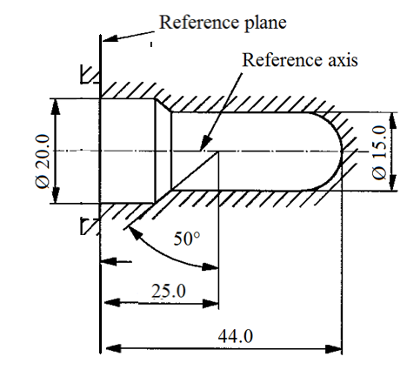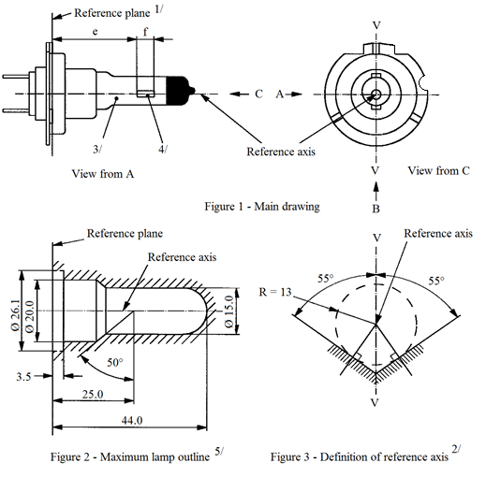
Reference plane^{1/}
Reference axis
Reference axis
Reference axis
View from A
View from C
Figure 1 - Main drawing
Figure 2 - Maximum filament light source outline ^{5/}
Figure 3 - Definition of reference axis ^{2/}
3/
4/
Reference plane
e
f
V
V
V
V
B
C
A
55°
55°
50°
R = 13
44.0
25.0
3.5
Ø 26.1
Ø 20.0
Ø 15.0
^{1/} The reference plane is defined by the points on the surfaces of the holder on which the three supporting bosses of the cap ring will rest.
^{2/} The reference axis is perpendicular to the reference plane and crosses the intersection of the two perpendiculars as indicated in Figure 3.
^{3/} The colour of the light emitted shall be white or selective-yellow.
^{4/} Notes concerning the filament diameter.
(a) No actual diameter restrictions apply but the design target is d max. = 1.3 mm.
(b) For the same manufacturer, the design diameter of standard (étalon) filament light source and filament light source of normal production shall be the same.
^{5/} Glass bulb and supports shall not exceed the envelope as indicated in Figure 2. The envelope is concentric to the reference axis.

Category H18 Sheet H18/2

Figure 6 - Permissible offset of filament axis
(for standard filament light sources only)
Figure 7 - Bulb eccentricity
View from A
Filament axis
Filament axis

Filament axis
Reference axis
Reference axis
View from B
Reference plane
Reference plane
Bulb axis
View from A
First filament turn
Figure 5 - Metal free zone^{8/}
Figure 4 - Distortion free area and black top^{6/, 7/}

ɣ2
ɣ1
ɣ3
25.0
50°
3.0
e
f
h2
h1
g
g
^{6/} Glass bulb shall be optically distortion free within the angles γ1 and γ2. This requirement applies to the whole bulb circumference within the angles γ1 and γ2.
^{7/} The obscuration shall extend at least to the cylindrical part of the bulb on the whole bulb top circumference. It shall moreover extend at least to a plane parallel to the reference plane where γ3 crosses the outer bulb surface (view B as indicated on sheet H18/1).
^{8/} The internal design of the filament light source shall be such that stray light images and reflections are only located above the filament itself seen from the horizontal direction. (View A as indicated in Figure 1 on sheet H18 /1).
No metal parts other than filament turns shall be located in the shaded area as seen in Figure 5.
Category H18 Sheet H18/3

 |  | Filaments light sources of normal production |  | Standard filament light source
 |  | 12 V |  | 12 V
e ^{9/} |  | 25.0 ^{10/} |  | 25.0 ± 0.1
f ^{9/} |  | 4.8^{10/} |  | 4.8± 0.1
g ^{12/} |  | 0.5 min. |  | u.c.
h1 ^{11/} |  | 0 ^{10/} |  | 0 ± 0.10
h2 ^{11/} |  | 0 ^{10/} |  | 0 ± 0.15
γ1 |  | 40° min. |  | 40° min.
γ2 |  | 50° min. |  | 50° min.
γ3 |  | 30° min. |  | 30° min.
Cap PY26d-1 in accordance with IEC Publication 60061 (sheet 7004-5-7)
Electrical and photometric characteristics
Rated values | Volts | 12 |  | 12
Rated values | Watts | 65 |  | 65
Test voltage | Volts | 13.2 |  | 13.2
Objective values | Watts | 69 max. |  | 69 max.
Objective values | Luminous flux | 1,700 ± 8 %
Reference luminous flux at approximately |  |  | 13.2 V | 1,700
^{9/} The ends of the filament are defined as the points where, when the viewing direction is direction A as shown in Figure 1 on sheet H18/1, the projection of the outside of the end turns crosses the filament axis.
^{10/} To be checked by means of a "Box System", sheet H18/4.
^{11/} The offset of the filament with respect to the reference axis is measured only in viewing directions A and B as shown in Figure 1 in sheet H18/1. The points to be measured are those where the projection of the outside of the end turns nearest to or furthest from the reference plane crosses the filament axis.
^{12/} Offset of filament in relation to bulb axis measured in two planes parallel to the reference plane where the projection of the outside of the end turns nearest to or furthest from the reference plane crosses the filament axis.
Category H18 Sheet H18/4
Screen projection requirements
This test is used to determine, by checking whether the filament is correctly positioned relative to the reference axis and reference plane, whether a filament light source complies with the requirements.
Dimensions in mm

Reference axis
reference plane
25.0 mm to

 | a1 | a2 | b1 | b2 | c1 | c2
12 V | d + 0.30 | d + 0.50 | 0.2 |  | 5.3 | 4.7
d = diameter of filament
The filament position is checked solely in directions A and B as shown on sheet H18/1, Figure 1.
The filament shall lie entirely within the limits shown.
The ends of the filament as defined on sheet H18/3, note 9, shall lie between lines Z1 and Z2 and between Z3 and Z4.

Category H19 Sheet H19/1

The drawings are intended only to illustrate the essential dimensions (in mm) of the filament lamp.
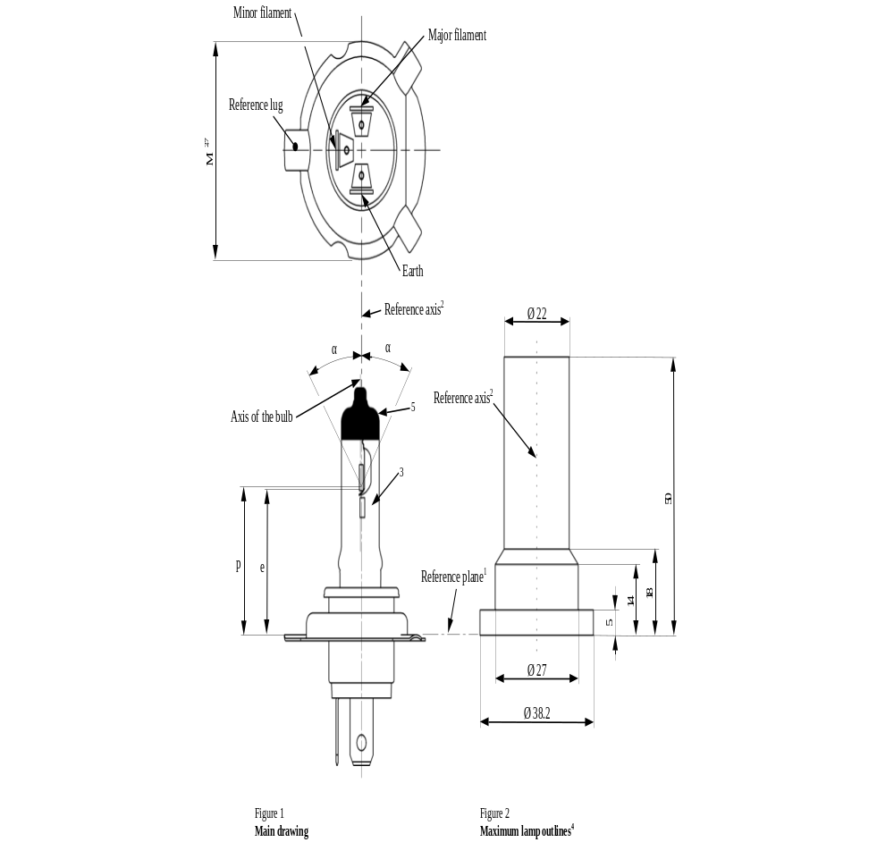
For the notes see sheet H19/5.
The drawings are intended only to illustrate the essential dimensions (in mm) of the filament light source.

Category H19 Sheet H19/2

Dimensions in mm |  | Filament lamps of normal production |  | Standard filament lamps
 |  | 12 V |  | 12 V
e |  | 28.5 + 0.35 / - 0.15 |  | 28.5 + 0.20 / - 0.0
p |  | 28.95 |  | 28.95
α |  | max. 45° |  | max. 45°
Cap PU43t-3 in accordance with IEC Publication 60061 (sheet 7004-171-1)
Electrical and photometric characteristics
Rated values | Volts | 12⁶ |  | 12⁶
Rated values | Watts | 60 | 55 | 60 | 55
Test values | Volts | 13.2 | 13.2 | 13.2 | 13.2
Objective values | Watts | 72 max. | 68 max. | 72 max. | 68 max.
Objective values | Luminous flux | 1 750 ± 10% | 1 200 ± 10%
Reference luminous flux at approximately |  |  | 13.2 V | 1 750 | 1 200

For note 6 see sheet H19/5.
Category H19 Sheet H19/3

Position of shield
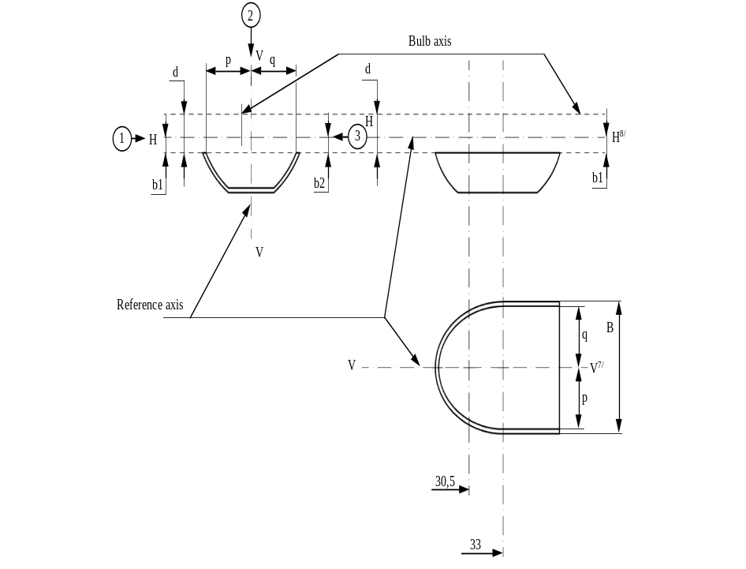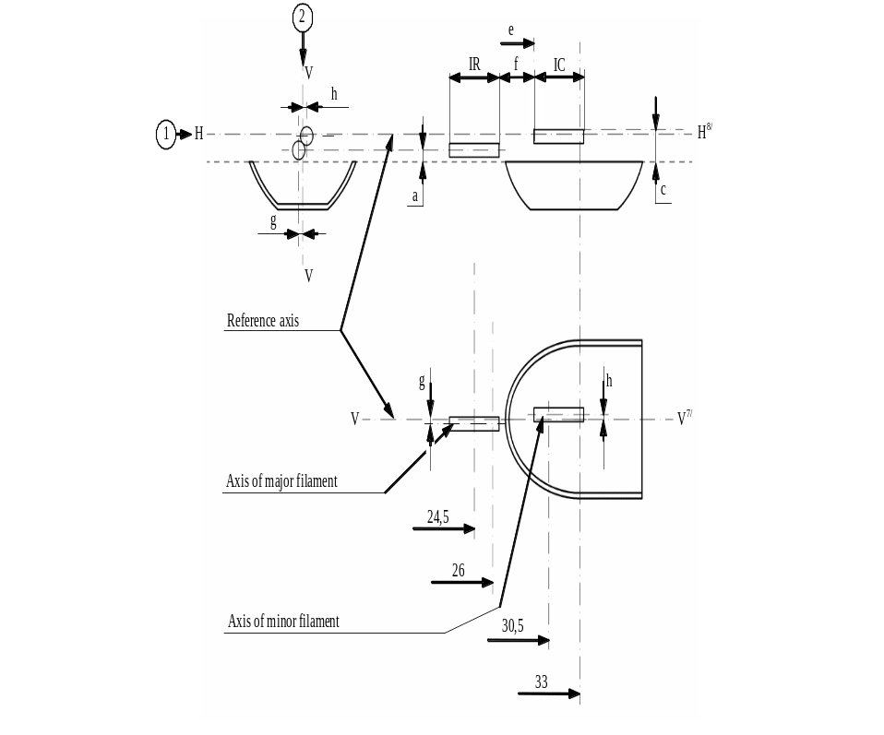
Position of filament
Category H19 Sheet H19/4
Table of the dimensions (in mm) referred to in the drawings on sheet H19/3

Reference* | Dimension** | Tolerance
Reference* | Dimension** | Filament lamps of normal production | Standard filament
a/26.0 | 0.7 | ±0.30 | ±0.20
a/24.5 | 0.7 | ±0.40 | ±0.20
b1/30.5 | 1.0 | ±0.30 | ±0.25
b1/33.0 | b1/30.5 mv | ±0.30 | ±0.15
b2/30.5 | 1.0 | ±0.30 | ±0.25
b2/33.0 | b2/30.5 mv | ±0.30 | ±0.15
c/30.5 | 1.7 | ±0.25 | ±0.15
c/33 | c/30.5 mv | ±0.25 | ±0.15
d | min. 1.1 | - | -
e¹¹ | 28.5 | +0.35 / -0.15 | +0.20 / -0.0
f ^{9, 10, 11} | 1.4 | ±0.30 | ±0.15
g/26.0 | 0 | ±0.40 | ±0.25
g/24.5 | 0 | ±0.50 | ±0.30
h/30.5 | 0 | ±0.40 | ±0.25
h/33.0 | h/30.5 mv | ±0.30 | ±0.15
lR ^{9, 12} | 4.0 | ±0.60 | ±0.30
lC ^{9, 10} | 5.2 | ±0.60 | ±0.30
p/33.0 | Depends on the shape of the shield | - | -
q/33.0 | (p+q)/2 | ±0.50 | ±0.30
B/33.0 | 8.6 | ±0.30 | ±0.30
* "../24.5" means dimension to be measured at the distance from the reference plane indicated in mm after the stroke.
** "../30.5 mv" means the value measured at a distance of 30.5 mm from the reference plane.

For the notes see sheet H19/5.

Category H19 Sheet H19/5

¹ The reference plane is the plane formed by the seating points of the three lugs of the cap ring.
² The reference axis is perpendicular to the reference plane and passes through the centre of the circle of diameter "M".
³ The light emitted from standard filament lamps and from normal production lamps shall be white.
⁴ The bulb and supports shall not exceed the envelope as in Figure 2.
⁵ The obscuration shall extend, at least, as far as the cylindrical part of the bulb. It shall also overlap the internal shield when the latter is viewed in a direction perpendicular to the reference axis.
⁶ The values indicated in the left hand column relate to the major filament. Those indicated in the right-hand column relate to the minor filament.
⁷ Plane V-V is the plane perpendicular to the reference plane and passing through the reference axis and through the intersection of the circle of diameter "M" with the axis of the reference lug.
⁸ Plane H-H is the plane perpendicular to both the reference plane and plane V-V and passing through the reference axis.
⁹ The end turns of the filament are defined as being the first luminous turn and the last luminous turn that are at substantially the correct helix angle.
¹⁰ For the minor filament, the points to be measured are the intersections, seen in direction 1, of either the lateral edge of the shield or the filament axis with the outside of the end turns defined under note 9.
¹¹ "e" denotes the distance from the reference plane to the beginning of the minor filament as defined above.
¹² For the major filament the points to be measured are the intersections, seen in direction 1, of a plane, parallel to plane H-H and situated at a distance of 0.3 mm below it, with the end turns defined under note 9.
Additional explanations to sheet H19/3
The dimensions below are measured in three directions:
1 For dimensions b1, a, c, d, e, f, lR and lC.
2 For dimensions g, h, p, q and B.
3 For dimension b2.
Dimensions B, p and q are measured in planes parallel to and 33.0 mm away from the reference plane.
Dimensions b1, b2 are measured in planes parallel to and 30.5 mm and 33.0 mm away from the reference plane.
Dimensions c and h are measured in planes parallel to and 30.5 mm and 33.0 mm away from the reference plane.
Dimensions a and g are measured in planes parallel to and 24.5 mm and 26.0 mm away from the reference plane.
Note: For the method of measurement, reference is made to Appendix E of IEC Publication 60809.

Category H20 Sheet H20/1

The drawings are intended only to illustrate the essential dimensions (in mm) of the filament light source
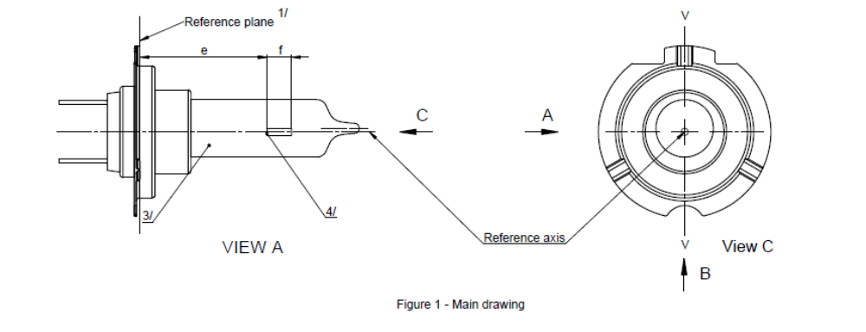
Reference plane^{1/}
View from A
View from C
Figure 1 - Main drawing
V
V
e
f
Reference axis
4/
3/
C
A
B
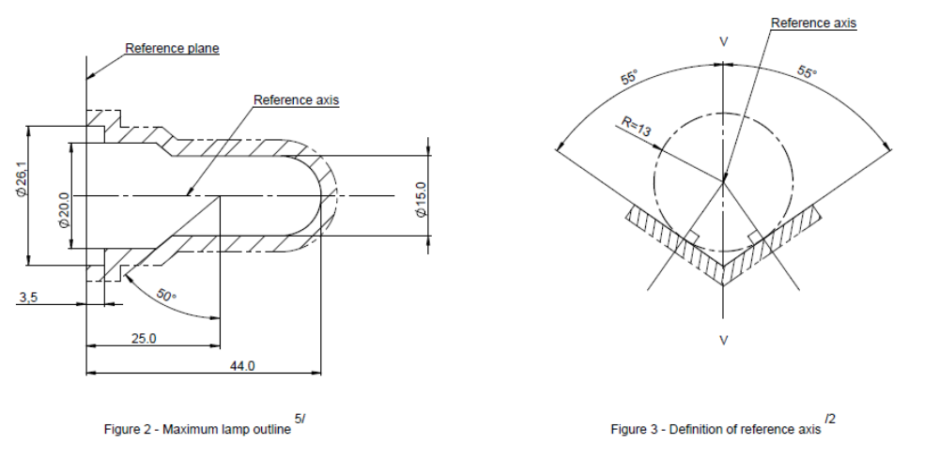
Reference axis
Reference axis
Reference plane
Figure 2 - Maximum filament light source outline^{5/}
Figure 3 - Definition of reference axis^{2/}
V
V
55°
55°
R=13
44.0
25.0
3.5
50°
Ø26.1
Ø20.0
Ø15.0
^{1/} The reference plane is defined by the points on the surfaces of the holder on which the three supporting
bosses of the cap ring will rest.
^{2/} The reference axis is perpendicular to the reference plane and crosses the intersection of the two perpendiculars as indicated in Figure 3.
^{3/} The colour of the light emitted shall be white with the restriction according to sheet H20/3.
^{4/} Notes concerning the filament diameter:
(a) No actual diameter restrictions apply but the design target is to have d max. = 1.4 mm.
(b) For the same manufacturer, the design diameter of standard (étalon) filament light source and filament light source of normal production shall be the same.
^{5/} Glass bulb and supports shall not exceed the envelope as indicated in Figure 2. The envelope is concentric to the reference axis.
Category H20 Sheet H20/2

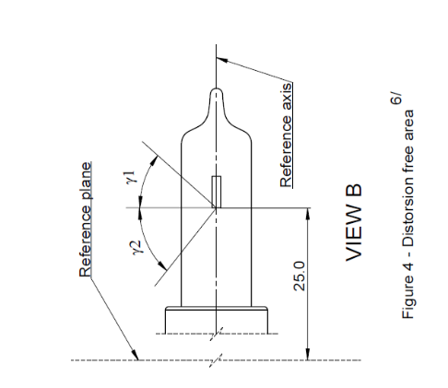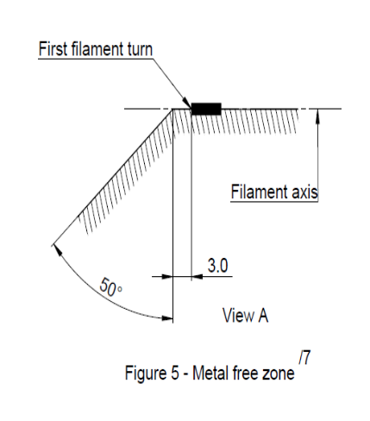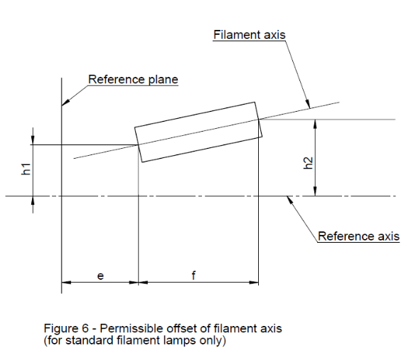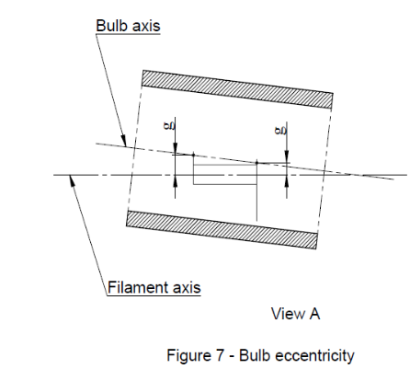
Figure 4 - Distortion free area^{6/}
Reference plane
Reference axis
View from B
First filament turn
Filament axis
Figure 5 - Metal free zone^{7/}
View from A
Reference plane
Reference axis
Filament axis
Figure 6 - Permissible offset of filament axis (for standard filament light sources only)
f
e
h2
h1
View from A
Bulb axis
Filament axis
Figure 7 - Bulb eccentricity
g
g
ɣ2
ɣ1
25.0
3.0
50°
^{6/} Glass bulb shall be optically distortion free within the angles γ1 and γ2. This requirement applies to the whole bulb circumference within the angles γ1 and γ2.
^{7/} The internal design of the filament light source shall be such that stray light images and reflections are only located above the filament itself seen from the horizontal direction. (View A as indicated in Figure 1 on sheet H20/1).
No metal parts other than filament turns shall be located in the shaded area as seen in Figure 5.

Category H20 Sheet H20/3

Dimensions in mm |  |  |  | Filaments light sources of normal production | Standard filament light source
 |  |  |  | 12 V | 12 V
e ^{8/} |  |  |  | 25.0 ^{9/} | 25.0 ± 0.1
f ^{8/} |  |  |  | 4.8 ^{9/} | 4.8 ± 0.1
g ^{11/} |  |  |  | 0.5 min. | 0.5 min.
h1 ^{10/} |  |  |  | 0 ^{9/} | 0 ± 0.10
h2 ^{10/} |  |  |  | 0 ^{9/} | 0 ± 0.15
γ1 |  |  |  | 40° min. | 40° min.
γ2 |  |  |  | 50° min. | 50° min.
Cap PY26d-6 in accordance with IEC Publication 60061 (sheet 7004-5-7)
Electrical and photometric characteristics
Rated values |  | Volts |  | 12 | 12
 |  | Watts |  | 70 | 70
Test voltage |  | Volts |  | 13.2 | 13.2
Objective values |  | Watts |  | 75 max. | 75 max.
 |  | Luminous flux |  | 1 250 ± 10 %
Reference luminous flux at approximately |  |  |  | 12 V | 900
 |  |  |  | 13.2 V | 1250
Chromaticity  Coordinates | Objective |  |  | x=0.347 | y=0.353
Chromaticity  Coordinates | Tolerance area |  | Boundaries | x=0.330 | y=0.150+0.640x
Chromaticity  Coordinates |  |  | Boundaries | x=0.370 | y=0.050+0.750x
Chromaticity  Coordinates |  |  | Intersection points | x=0.330 | y=0.298
Chromaticity  Coordinates |  |  | Intersection points | x=0.370 | y=0.327
Chromaticity  Coordinates |  |  | Intersection points | x=0.370 | y=0.387
Chromaticity  Coordinates |  |  | Intersection points | x=0.330 | y=0.361
^{8/} The ends of the filament are defined as the points where, when the viewing direction is direction A as shown in Figure 1 on sheet H20/1, the projection of the outside of the end turns crosses the filament axis. (Special instructions for coiled-coil filaments are under consideration).
^{9/} To be checked by means of a "Box System", sheet H20/4.
^{10/} The offset of the filament with respect to the reference axis is measured only in viewing directions A and B as shown in Figure 1 in sheet H20/1. The points to be measured are those where the projection of the outside of the end turns nearest to or furthest from the reference plane crosses the filament axis.
^{11/} Offset of filament in relation to bulb axis measured in two planes parallel to the reference plane where the projection of the outside of the end turns nearest to or furthest from the reference plane crosses the filament axis.

Category H20 Sheet H20/4
Screen projection requirements
This test is used to determine, by checking whether the filament is correctly positioned relative to the reference axis and reference plane, whether a filament light source complies with the requirements.
Dimensions in mm
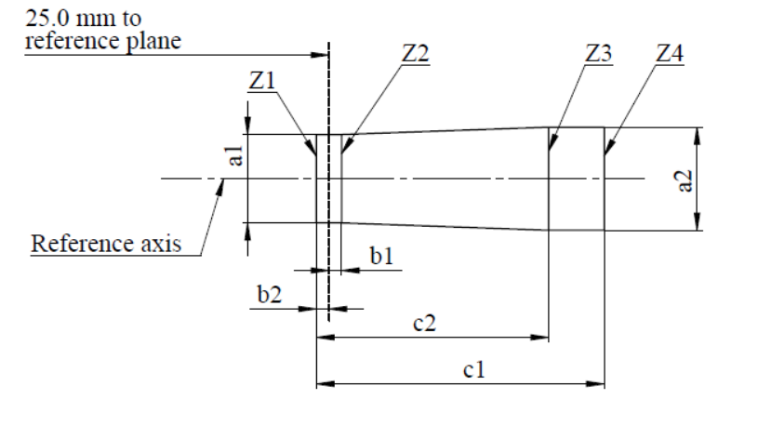
25.0 mm to reference plane
Reference axis
Z1
Z2
Z3
Z4
c1
c2
b1
b2
a1
a2

a1 | a2 | b1 | b2 | c1 | c2
d + 0.40 | d + 0.70 | 0.25 |  | 5.7 | 4.6
d = diameter of filament
The filament position is checked solely in directions A and B as shown on sheet H20/1, Figure 1.
The filament shall lie entirely within the limits shown.
The ends of the filament as defined on sheet H20/3, note 9, shall lie between lines Z1 and Z2 and between Z3 and Z4.
Categories H6W and HY6W Sheet H6W/1
The drawings are intended only to illustrate the essential dimensions (in mm) of the filament light source

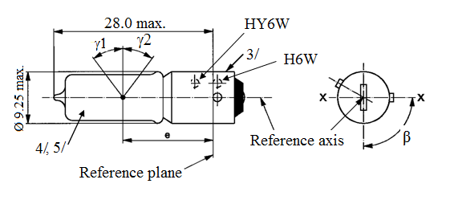
28.0 max.
HY6W
H6W
3/
Ø 9.25 max.
4/, 5/
Reference plane
Reference axis
e
ß
ɣ1
ɣ2

Dimensions in mm |  |  |  |  | Filament light sources of normal production |  |  | Standard filament light source
 |  |  |  |  | Min. | Nom. | Max. | Standard filament light source
e |  |  |  |  | 14.25 | 15.0 | 15.75 | 15.0 ± 0.25
Lateral deviation ^{1/} |  |  |  |  |  |  | 0.75 | 0.4 max
β |  |  |  |  | 82.5° | 90° | 97.5° | 90° ± 5°
γ1, γ2 ^{2/} |  |  |  |  | 30° |  |  | 30° min.
Cap: | H6W: |  | BAX9s |  | in accordance with IEC Publication 60061 (sheet 7004-8-1)
Cap: | HY6W: |  | BAZ9s |  | in accordance with IEC Publication 60061 (sheet 7004-150-1)
Electrical and photometric characteristics
Rated values |  | Volts |  |  | 12 |  |  | 12
 |  | Watts |  |  | 6 |  |  | 6
Test voltage |  | Volts |  |  | 13.5 |  |  | 13.5
Objective values |  | Watts |  |  | 7.35 max. |  |  | 7.35 max.
 |  | Luminous flux |  | H6W | 125 ± 12 %
 |  |  |  | HY6W | 75 ± 17 %
Reference luminous flux at approximately 13.5 V |  |  |  |  |  |  |  | White: 125 lm
 |  |  |  |  |  |  |  | Amber: 75 lm
^{1/} Maximum lateral deviation of filament centre from two mutually perpendicular planes both containing the reference axis and one containing axis X-X.
^{2/} In the area between the outer legs of the angles γ1 and γ2, the bulb shall have no optically distorting areas and the curvature of the bulb shall have a radius not less than 50 per cent of the actual bulb diameter.
^{3/} Over the entire length of the cap there shall be no projections or soldering exceeding the permissible maximum diameter of the cap.
^{4/} The light emitted from filament light sources of normal production shall be white for category H6W and amber for category HY6W.
^{5/} The light emitted from standard filament light sources shall be white for category H6W and amber or white for category HY6W.
Categories H10W/1 and HY10W Sheet H10W/1
The drawings are intended only to illustrate the essential dimensions (in mm) of the filament light source
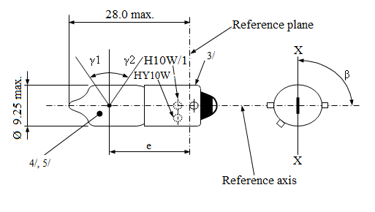
Ø 9.25 max.
28.0 max.
4/, 5/
3/
H10W/1
HY10W
ɣ1
ɣ2
e
Reference plane
Reference axis
ß
X
X

Dimensions in mm |  |  |  |  | Filament light sources of normal production |  |  |  | Standard filament light source
 |  |  |  |  | Min. |  | Nom. | Max. | Standard filament light source
e |  |  |  |  | 14.25 |  | 15.0 | 15.75 | 15.0 ± 0.25
Lateral deviation ^{1/} |  |  |  |  |  |  |  | 0.75 | 0.4 max
β |  |  |  |  | 82.5° |  | 90° | 97.5° | 90° ± 5°
γ1, γ2 ^{2/} |  |  |  |  | 30° |  |  |  | 30° min.
Cap: | H10W/1  HY10W |  | BAU9s  BAUZ9s |  | in accordance with IEC Publication 60061 (sheet 7004-150A-1)  in accordance with IEC Publication 60061 (sheet 7004-150B-1)
Electrical and photometric characteristics
Rated values |  | Volts |  |  |  | 12 |  |  | 12
 |  | Watts |  |  |  | 10 |  |  | 10
Test voltage |  | Volts |  |  |  | 13.5 |  |  | 13.5
Objective values |  | Watts |  |  |  | 12 max. |  |  | 12 max.
 |  | Luminous flux |  | H10W/1 |  | 200 ± 12 %
 |  |  |  | HY10W |  | 120 ± 17 %
Reference luminous flux at approximately 13.5 V |  |  |  |  |  |  |  |  | White: 200 lm
 |  |  |  |  |  |  |  |  | Amber: 120 lm
Categories H10W and HY10W Sheet H10W/2

^{1/} Maximum lateral deviation of filament centre from two mutually perpendicular planes both containing the reference axis and one containing axis X-X.
^{2/} In the area between the outer legs of the angles γ1 and γ2, the bulb shall have no optically distorting areas and the curvature of the bulb shall have a radius not less than 50 per cent of the actual bulb diameter.
^{3/} Over the entire length of the cap there shall be no projections or soldering exceeding the permissible maximum diameter of the cap.
^{4/} The light emitted from filament light sources of normal production shall be white for category H10W/1 and amber for category HY10W.
^{5/} The light emitted from standard filament light sources shall be white for category H10W/1 and amber or white for category HY10W.

Categories H21W and HY21W Sheet H21W/1
The drawings are intended only to illustrate the essential dimensions (in mm) of the filament light source.
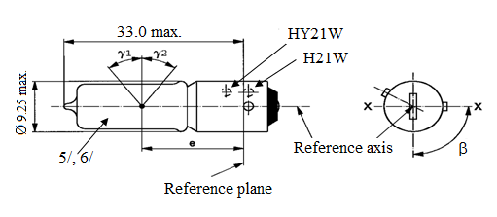
33.0 max.
Ø 9.25 max.
5/, 6/
Reference plane
Reference axis
e
ß
HY21W
H21W
ɣ1
ɣ2
Dimensions in mm |  |  |  |  |  | Filament light sources of normal production |  |  |  | Standard filament light source
 |  |  |  |  |  | Min. | Nom. |  | Max. | Standard filament light source
e |  |  |  |  |  |  | 20.0 ^{1/} |  |  | 20.0 ± 0.25
f |  | 12 V |  |  |  |  |  |  | 3.8 | 3.8 + 0 / -1
 |  | 24 V |  |  |  |  |  |  | 4.5
Lateral deviation ^{2/} |  |  |  |  |  |  |  |  | ^{1/} | 0.0 ± 0.15 ^{3/}
β |  |  |  |  |  | 82.5° | 90° |  | 97.5° | 90° ± 5°
γ1, γ2 ^{4/} |  |  |  |  |  | 45° |  |  |  | 45° min.
Cap: | H21W: |  | BAY9s |  | in accordance with IEC Publication 60061 (sheet 7004-9-1)
Cap: | HY21W: |  | BAW9s |  | in accordance with IEC Publication 60061 (sheet 7004-149-1)
Electrical and photometric characteristics
Rated values |  | Volts |  |  |  | 12 |  | 24 |  | 12
 |  | Watts |  |  |  | 21 |  | 21 |  | 21
Test voltage |  | Volts |  |  |  | 13.5 |  | 28.0 |  | 13.5
Objective values |  | Watts |  |  |  | 26.25 max. |  | 29.4 max. |  | 26.25 max.
 |  | Luminous flux |  | H21W |  | 600 ± 12 % |  | 600 ± 15 %
 |  |  |  | HY21W |  | 300 ± 17 % |  | 300 ± 20 %
Reference luminous flux at approximately |  |  |  |  |  |  |  | 12 V |  | White: 415 lm
 |  |  |  |  |  |  |  | 13.2 V |  | White: 560 lm
 |  |  |  |  |  |  |  | 13.5 V |  | White: 600 lm  Amber: 300 lm
^{1/} To be checked by means of a "Box system", sheet H21W/2.
^{2/} Maximum lateral deviation of filament centre from two mutually perpendicular planes both containing the reference axis and one containing axis X-X.
^{3/} The lateral deviation with respect to the plane perpendicular to axis X-X is measured in the position described in paragraph 1. of the test procedure specified on sheet H21W/2.
^{4/} In the area between the outer legs of the angles γ1 and γ2, the bulb shall have no optical distorting areas and the curvature of the bulb shall have a radius not less than 50 per cent of the actual bulb diameter.
^{5/} The light emitted from filament light sources of normal production shall be white for category H21W and amber for category HY21W.
^{6/} The light emitted from standard filament light sources shall be white for category H21W and amber or white for category HY21W.
Categories H21W and HY21W Sheet H21W/2
Screen projection requirements
This test is used to determine, by checking whether the filament is correctly positioned relative to the reference axis and reference plane and has an axis perpendicular, within ±7.5°, to the plane through the centre line of the reference pin and the reference axis, whether a filament light source complies with the requirements.
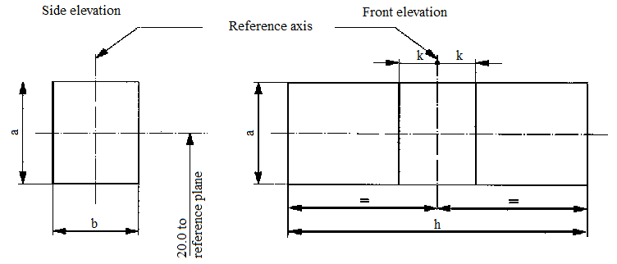
Reference axis
Side elevation
Front elevation
reference plane
20.0 to
k
k
h
b
a
a

Reference | a | b | h | k
Dimension | d + 1.0 | d +1.0 | f + 1.2 | 0.50
d = actual filament diameter
f = actual filament length
Test procedures and requirements
1. The filament light source is placed in a holder capable of being rotated about its axis and having either a calibrated scale or fixed stops corresponding to the angular displacement tolerance limits. The holder is then so rotated that an end view of the filament is seen on the screen on to which the image of the filament is projected. The end view of the filament shall be obtained within the angular displacements tolerance limits.
2. Side elevation
The filament light source placed with the cap down, the reference axis vertical and the filament seen end-on, the projection of the filament shall lie entirely within a rectangle of height "a" and width "b", having its centre at the theoretical position of the centre of the filament.
3. Front elevation
The filament light source placed with the cap down and the reference axis vertical, the filament light source being viewed in a direction at right angles to the filament axis:
3.1. The projection of the filament shall lie entirely within a rectangle of height "a" and width "h", having its centre at the theoretical position of the centre of the filament;
3.2. The centre of the filament shall not be offset by more than distance "k" from the reference axis.
Categories H27W/1 and H27W/2 Sheet H27W/1
The drawings are intended only to illustrate the essential dimensions (in mm) of the filament light source.
13.0 max.
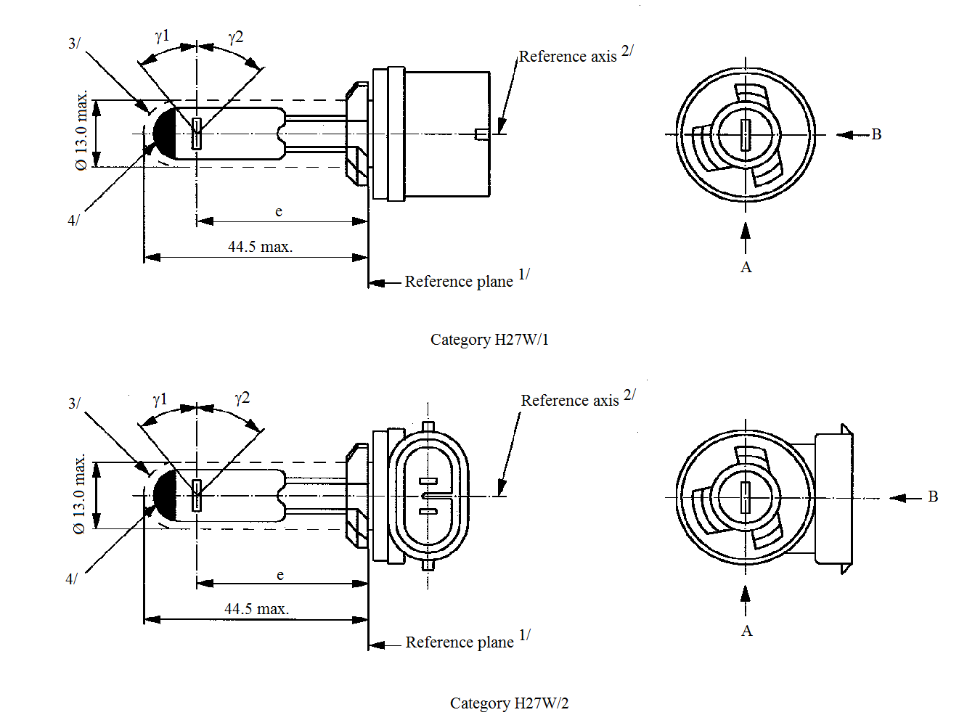
Reference axis^{2/}
Reference axis^{2/}
Reference plane^{1/}
Reference plane^{1/}
ɣ1
ɣ1
ɣ2
ɣ2
B
B
A
A
e
e
3/
3/
4/
4/
44.5 max.
44.5 max.
Ø 13.0 max.
Ø 13.0 max.
Category H27W/1
Category H27W/2

^{1/} The reference plane is defined by the plane formed by the underside of the bevelled lead-in flange of the cap.
^{2/} The reference axis is perpendicular to the reference plane and passes through the centre of
the 13.10 mm cap diameter.
^{3/} Glass bulb and supports shall not exceed the size of a theoretical cylinder centred on the reference axis.
^{4/} The obscuration shall extend over the whole bulb top including the bulb cylindrical portion up to the intersection with γ1.
Categories H27W/1 and H27W/2 Sheet H27W/2

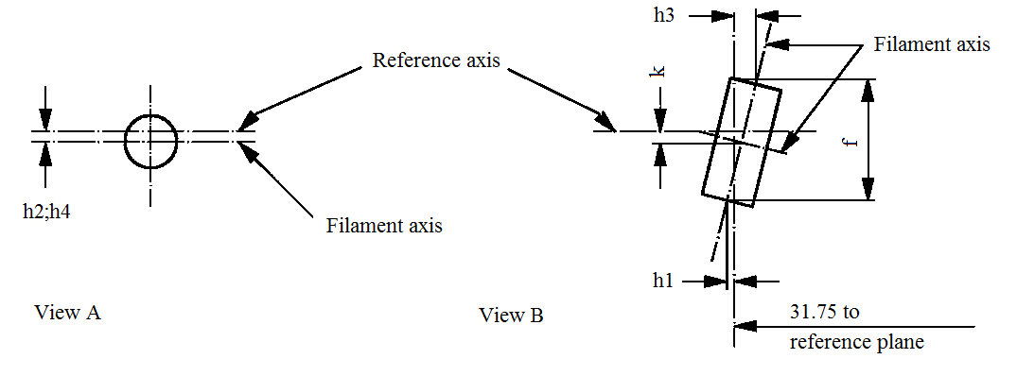
Reference axis
Filament axis
Filament axis
31.75 to
reference plane
h1
h3
h2;h4
View A
View B
k
f
Filament dimensions and position
(Dimensions f for all filament light sources)
(Dimensions h1, h2, h3, h4 and k for standard filament light sources only)
Dimensions in mm |  |  | Filament light source of normal production |  |  | Standard filament light source
e |  |  | 31.75 ^{6/} |  |  | 31.75 ± 0.25
f ^{8/} |  |  | 4.8 max. |  |  | 4.2 ± 0.20
k |  |  | 0 ^{6/} |  |  | 0.0 ± 0.25
h1, h2, h3, h4 ^{7/} |  |  | 0 ^{6/} |  |  | 0.0 ± 0.25
γ1 ^{5/} |  |  | 38° nom. |  |  | 38° nom.
γ2 ^{5/} |  |  | 44° nom. |  |  | 44° nom.
Cap: | H27W/1: PG13  H27W/2: PGJ13 |  |  | in accordance with IEC Publication 60061 (sheet 7004-107-4)
Electrical and photometric characteristics
Rated values |  | Volts | 12 |  |  |  | 12
 |  | Watts | 27 |  |  |  | 27
Test voltage |  | Volts | 13.5 |  |  |  | 13.5
Objective values |  | Watts | 31 max. |  |  |  | 31 max.
 |  | Luminous flux | 477 ± 15 %
Reference luminous flux at approximately |  |  |  |  | 12 V |  | 350 lm
 |  |  |  |  | 13.2 V |  | 450 lm
 |  |  |  |  | 13.5 V |  | 477 lm
^{5/} Glass bulb shall be optically distortion free within the angles γ1 and γ2. This requirement applies to the whole bulb circumference within the angles γ1 and γ2.
^{6/} To be checked by means of a "Box system", sheet H27W/3.
^{7/} For standard filament light sources, the points to be measured are those where the projection of the outside of the end turns crosses the filament axis.
^{8/} The ends of the filament are defined by the intersections of the outside of the first and of the last light emitting turn, respectively, with the plane parallel to and 31.75 mm from the reference plane.
Categories H27W/1 and H27W/2 Sheet H27W/3
Screen projection requirements
This test is used to determine, by checking whether the filament is correctly positioned relative to the reference axis and reference plane, whether a filament light source complies with the requirements.
Dimensions in mm
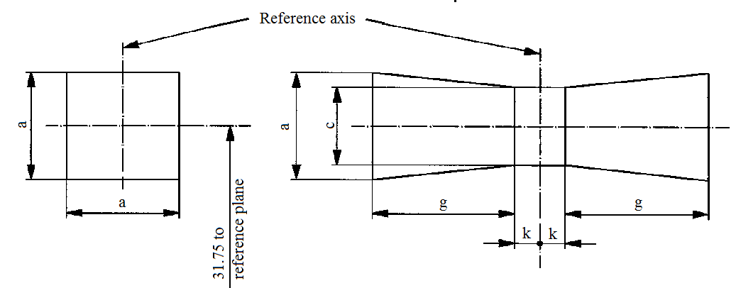
Reference axis
reference plane
31.75 to
g
g
k
k
a
a
a
c

Reference | a | c | k | g
Dimensions | d + 1.2 | d + 1.0 | 0.5 | 2.4
d = actual diameter of filament
The filament shall lie entirely within the limits shown.
The centre of the filament shall lie within the limits of dimension k.
Categories HB3 and HB3A Sheet HB3/1
The drawings are intended only to illustrate the essential dimensions (in mm) of the filament light source.
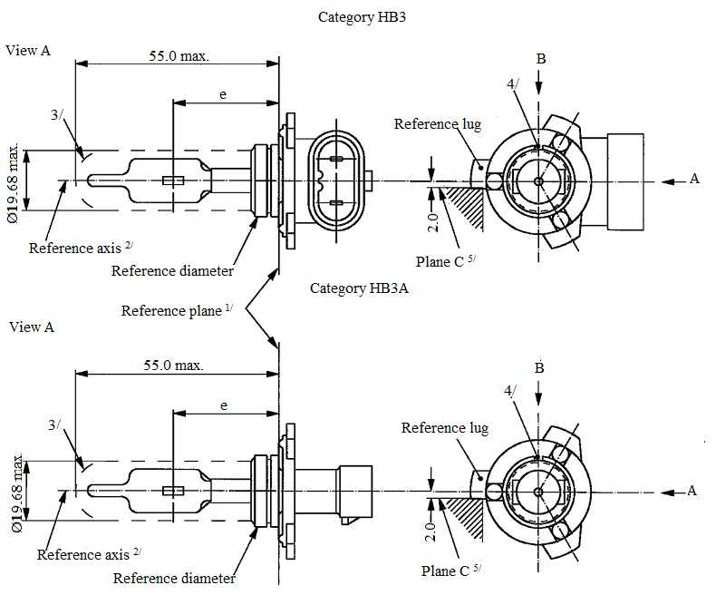
55.0 max.
55.0 max.
View A
View A
3/
3/
A
B
B
e
e
4/
4/
Ø 19.68 max.
Ø 19.68 max.
Reference axis^{2/}
Reference axis^{2/}
Reference plane^{1/}
Reference lug
Reference lug
Plane C^{5/}
Plane C^{5/}
2.0
2.0
Reference diameter
Reference diameter
Category HB3
Category HB3A
A
^{1/} The reference plane is the plane defined by the meeting points of cap-holder fit.
^{2/} The reference axis is perpendicular to the reference plane and concentric with the reference diameter of the cap.
^{3/} Glass bulb and supports shall not exceed the envelope and shall not interfere with insertion past the filament light source key.
^{4/} The keyway is mandatory for category HB3A and optional for category HB3.
^{5/} The filament light source shall be rotated in the measuring holder until the reference lug contacts plane C of the holder.
Categories HB3 and HB3A Sheet HB3/2

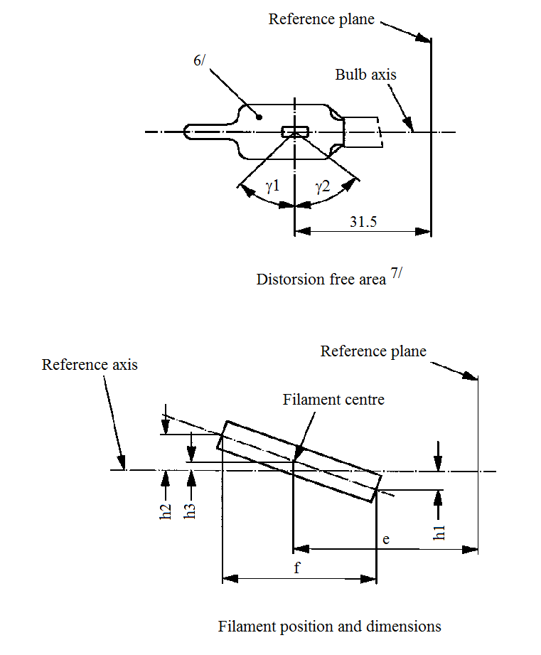
Reference axis
Reference plane
Reference plane
Bulb axis
Filament centre
Distorsion free area^{7/}
Filament position and dimensions
6/
ɣ1
ɣ2
h2
h3
h1
e
f
31.5
^{6/} The colour of the light emitted shall be white or selective-yellow.
^{7/} Glass bulb periphery shall be optically distortion-free axially within the angles γ1 and γ2.
This requirement applies to the whole bulb circumference within the angles γ1 and γ2.
Categories HB3 and HB3A Sheet HB3/3

Dimensions in mm ^{12/} |  |  |  | Tolerance
 |  |  |  | Filament light sources of normal production |  | Standard filament light source
e ^{9/, 11/} |  | 31.5 |  | ^{10/} |  | ±0.16
f ^{9/, 11/} |  | 5.1 |  | ^{10/} |  | ±0.16
h1, h2 |  | 0 |  | ^{10/} |  | ±0.15 ^{8/}
h3 |  | 0 |  | ^{10/} |  | ±0.08 ^{8/}
γ1 |  | 45° min. |  | - |  | -
γ2 |  | 52° min. |  | - |  | -
Cap P20d in accordance with IEC Publication 60061 (sheet 7004-31-2) ^{13/}
Electrical and photometric characteristics
Rated values |  |  | Volts | 12 |  | 12
 |  |  | Watts | 60 |  | 60
Test voltage |  |  | Volts | 13.2 |  | 13.2
Objective values | Watts |  |  | 73 max. |  | 73 max.
Objective values | Luminous flux |  |  | 1,860 ± 12 %
Reference luminous flux at approximately |  |  |  |  | 12 V | 1,300
 |  |  |  |  | 13.2 V | 1,860

^{8/} The eccentricity is measured only in viewing directions* A and B as shown in the figure on sheet HB3/1. The points to be measured are those where the projection of the outside of the end turns nearest to or furthest from the reference plane crosses the filament axis.
^{9/} The viewing direction is direction* B as shown in the figure on sheet HB3/1.
^{10/} To be checked by means of a "Box system"; sheet HB3/4*.
^{11/} The ends of the filament are defined as the points where, when the viewing direction* as defined in footnote 9/ above, the projection of the outside of the end turns crosses the filament axis.
^{12/} Dimensions shall be checked with O-ring removed.
^{13/} Filament light source HB3 shall be equipped with the right-angle cap and filament light source HB3A with the straight cap.
* Manufacturers may choose another set of perpendicular viewing directions. The viewing directions specified by the manufacturer are to be used by the testing laboratory when checking filament dimensions and position.
Categories HB3 and HB3A Sheet HB3/4
Screen projection requirements
This test is used to determine, by checking whether the filament is correctly positioned relative to the reference axis and reference plane, whether a filament light source complies with the requirements.
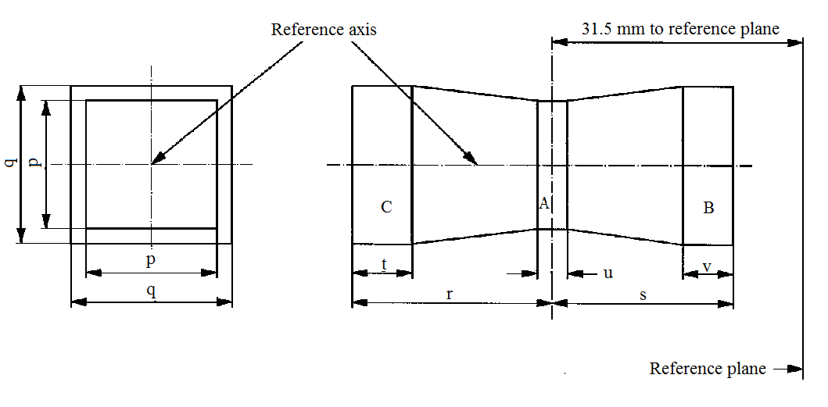
Reference axis
31.5 mm to reference plane
Reference plane
B
C
A
v
s
u
r
t
p
q
p
q

 | p | q | r | s | t | u | v
12 V | 1.3 d | 1.6 d | 3.0 | 2.9 | 0.9 | 0.4 | 0.7
d = diameter of filament
The filament position is checked solely in directions A and B as shown on sheet HB3/1.
The filament shall lie entirely within the limits shown.
The beginning of the filament, as defined on sheet HB3/3, footnote 11/, shall lie in volume "B" and the end of the filament in volume "C".
Volume "A" does not involve any filament centre requirement.
Categories HB4 and HB4A Sheet HB4/1
The drawings are intended only to illustrate the essential dimensions (in mm) of the filament light source.
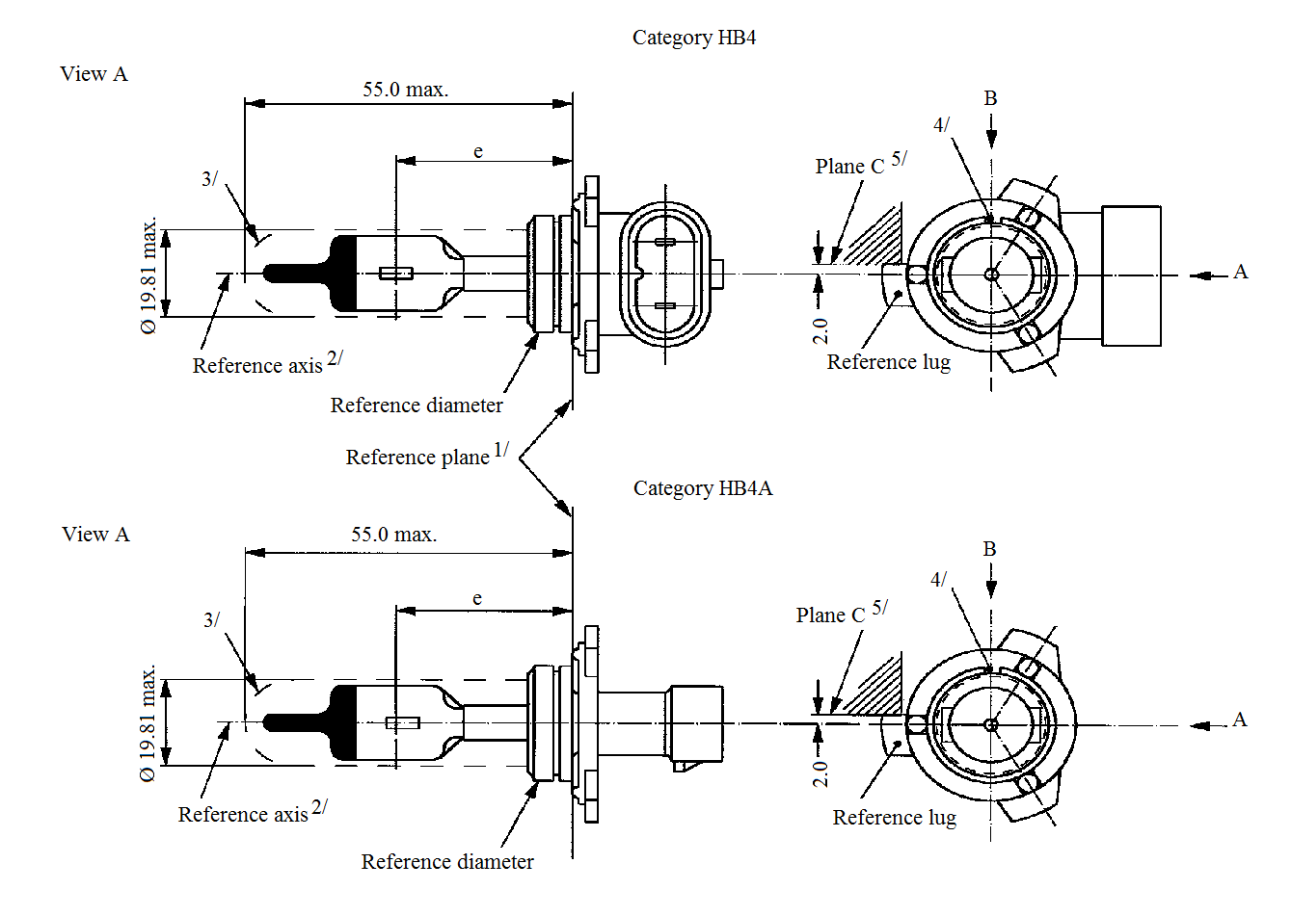
Category HB4
Category HB4A
55.0 max.
55.0 max.
View A
View A
Ø 19.8 max.
Ø 19.81 max.
3/
3/
4/
4/
B
B
A
A
Plane C^{5/}
Plane C^{5/}
Reference axis^{2/}
Reference axis^{2/}
Reference diameter
Reference diameter
Reference lug
Reference lug
2.0
2.0
Reference plane^{1/}
e
e

^{1/} The reference plane is the plane defined by the meeting points of cap-holder fit.
^{2/} The reference axis is perpendicular to the reference plane and concentric with the reference diameter of the cap.
^{3/} Glass bulb and supports shall not exceed the envelope and shall not interfere with insertion past the filament light source key. The envelope is concentric to the reference axis.
^{4/} The keyway is mandatory for category HB4A and optional for category HB4.
^{5/} The filament shall be rotated in the measuring holder until the reference lug contacts plane C of the holder.
Categories HB4 and HB4A Sheet HB4/2

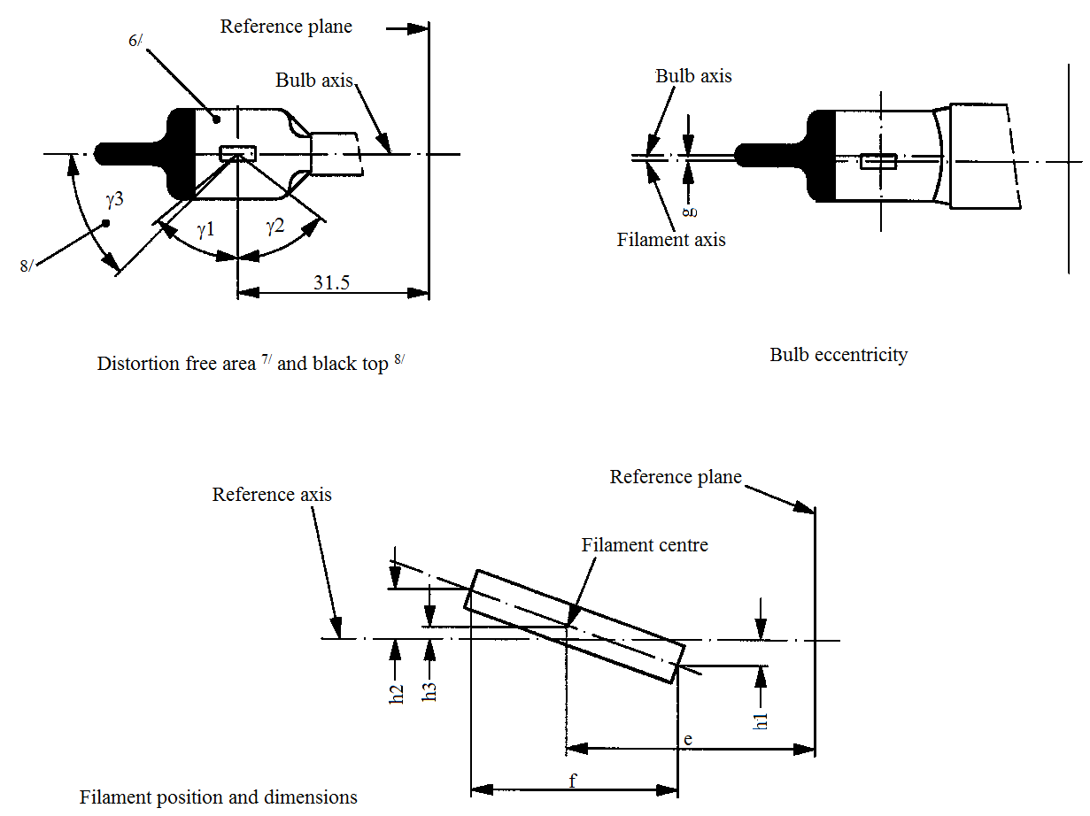
31.5
ɣ1
ɣ2
ɣ3
6/
8/
Bulb axis
Reference plane
Bulb eccentricity
Distorsion free area^{7/} and black top^{8/}
Bulb axis
Filament axis
g
h1
h2
h3
f
e
Reference plane
Reference axis
Filament centre
Filament position and dimensions

^{6/} The colour of the light emitted shall be white or selective-yellow.
^{7/} Glass bulb periphery shall be optically distortion-free axially and cylindrically within the angles γ1 and γ2. This requirement applies to the whole bulb circumference within the angles γ1 and γ2 and does not need to be verified in the area covered by the obscuration.
^{8/} The obscuration shall extend to at least angle γ3 and shall be at least as far as the undistorted part of the bulb defined by angle γ1.
Categories HB4 and HB4A Sheet HB4/3

Dimensions in mm ^{13/} |  |  |  | Tolerance
 |  |  |  | Filament light sources of normal production |  | Standard filament light source
e ^{10/, 12/} |  | 31.5 |  | ^{11/} |  | ±0.16
f ^{10/, 12/} |  | 5.1 |  | ^{11/} |  | ±0.16
h1, h2 |  | 0 |  | ^{11/} |  | ±0.15 ^{9/}
h3 |  | 0 |  | ^{11/} |  | ±0.08 ^{9/}
g ^{10/} |  | 0.75 |  | ±0.5 |  | ±0.3
γ1 |  | 50° min. |  | - |  | -
γ2 |  | 52° min. |  | - |  | -
γ3 |  | 45° |  | ±5° |  | ±5°
Cap P22d in accordance with IEC Publication 60061 (sheet 7004-32-2) ^{14/}
Electrical and photometric characteristics
Rated values |  |  | Volts | 12 |  | 12
 |  |  | Watts | 51 |  | 51
Test voltage |  |  | Volts | 13.2 |  | 13.2
Objective values | Watts |  |  | 62 max. |  | 62 max.
Objective values | Luminous flux |  |  | 1,095 ± 15 %
Reference luminous flux at approximately |  |  |  |  | 12 V | 825
 |  |  |  |  | 13.2 V | 1,095

^{9/} The eccentricity is measured only in viewing directions* A and B as shown in the figure on sheet HB4/1. The points to be measured are those where the projection of the outside of the end turns nearest to or furthest from the reference plane crosses the filament axis.
^{10/} The viewing direction is direction* B as shown in the figure on sheet HB4/1.
^{11/} To be checked by means of a "Box system"; sheet HB4/4*.
^{12/} The ends of the filament are defined as the points where, when the viewing direction* as defined in footnote 10/ above, the projection of the outside of the end turns crosses the filament axis.
^{13/} Dimensions shall be checked with O-ring removed.
^{14/} Filament light source HB4 shall be equipped with the right-angle cap and filament light source HB4A with the straight cap.
* Manufacturers may choose another set of perpendicular viewing directions. The viewing directions specified by the manufacturer are to be used by the testing laboratory when checking filament dimensions and position.
Categories HB4 and HB4A Sheet HB4/4
Screen projection requirements
This test is used to determine, by checking whether the filament is correctly positioned relative to the reference axis and reference plane, whether a filament light source complies with the requirements.
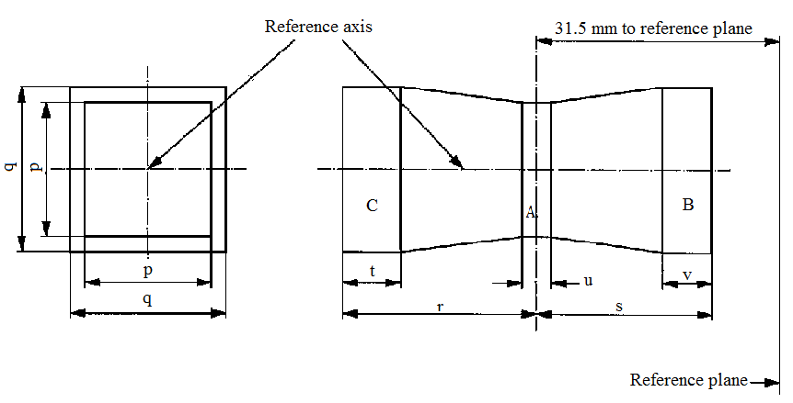
Reference axis
31.5 mm to reference plane
Reference plane
p
q
p
q
C
B
t
v
u
r
s
A

 | p | q | r | s | t | u | v
12 V | 1.3 d | 1.6 d | 3.0 | 2.9 | 0.9 | 0.4 | 0.7
d = diameter of filament
The filament position is checked solely in directions A and B as shown on sheet HB4/1.
The filament shall lie entirely within the limits shown.
The beginning of the filament as defined on sheet HB4/3 footnote 12/ shall lie in volume "B" and the end of the filament in volume "C".
Volume "A" does not involve any filament centre requirement.
Category HIR1 Sheet HIR1/1
The drawings are intended only to illustrate the essential dimensions (in mm) of the filament light source.
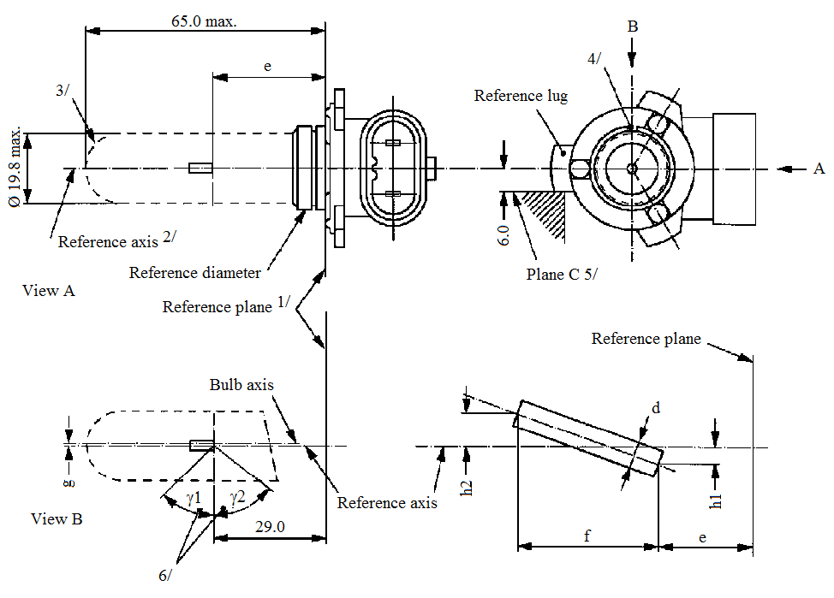
65.0 max.
Ø 19.81 max.
3/
4/
6/
e
e
d
f
A
B
Reference lug
Reference plane
Plane C^{5/}
Reference axis^{2/}
Reference diameter
Reference plane^{1/}
6.0
View A
View B
Bulb axis
Reference axis
h1
h2
ɣ1
ɣ2
29.0
g
^{1/} The reference plane is the plane defined by the three supporting bosses on the cap flange.
^{2/} The reference axis is perpendicular to the reference plane and concentric with the reference diameter of the cap.
^{3/} Glass bulb and supports shall not exceed the envelope. The envelop is concentric to the reference axis.
^{4/} The keyway is mandatory.
^{5/} The filament shall be rotated in the measuring holder until the reference lug contacts plane C of the holder.
^{6/} Glass bulb periphery shall be optically distortion-free axially within the angles γ1 and γ2. This requirement applies to the whole bulb circumference within the angles γ1 and γ2.
Category HIR1 Sheet HIR1/2

Dimensions in mm ^{11/} |  |  |  | Tolerance
 |  |  |  | Filament light sources of normal production |  | Standard filament light source
e ^{8/, 10/} |  | 29 |  | ^{9/} |  | ±0.16
f ^{8/, 10/} |  | 5.1 |  | ^{9/} |  | ±0.16
g ^{8/} |  | 0 |  | +0.7 / -0.0 |  | +0.4 / -0.0
h1, h2 |  | 0 |  | ^{9/} |  | ±0.15 ^{7/}
d |  | 1.6 max.
γ1 |  | 50° min. |  | - |  | -
γ2 |  | 50° min. |  | - |  | -
Cap PX20d in accordance with IEC Publication 60061 (sheet 7004-31-2)
Electrical and photometric characteristics
Rated values |  |  | Volts | 12 |  | 12
 |  |  | Watts | 65 |  | 65
Test voltage |  |  | Volts | 13.2 |  | 13.2
Objective values | Watts |  |  | 73 max. |  | 73 max.
Objective values | Luminous flux |  |  | 2,500 ± 15 %
Reference luminous flux at approximately |  |  |  |  | 12 V | 1,840
 |  |  |  |  | 13.2 V | 2,500

^{7/} The eccentricity is measured only in viewing directions A and B as shown in the figure on sheet HIR1/1. The points to be measured are those where the projection of the outside of the end turns nearest to or furthest from the reference plane crosses the filament axis.
^{8/} The viewing direction is direction B as shown in the figure on sheet HIR1/1.
^{9/} To be checked by means of a "Box system"; sheet HIR1/3.
^{10/} The ends of the filament are defined as the points where, when the viewing direction as defined in footnote 8/ above, the projection of the outside of the end turns crosses the filament axis.
^{11/} Dimensions shall be checked with O-ring mounted.
Category HIR1 Sheet HIR1/3
Screen projection requirements
This test is used to determine, by checking whether the filament is correctly positioned relative to the reference axis and reference plane, whether a filament light source complies with the requirements.
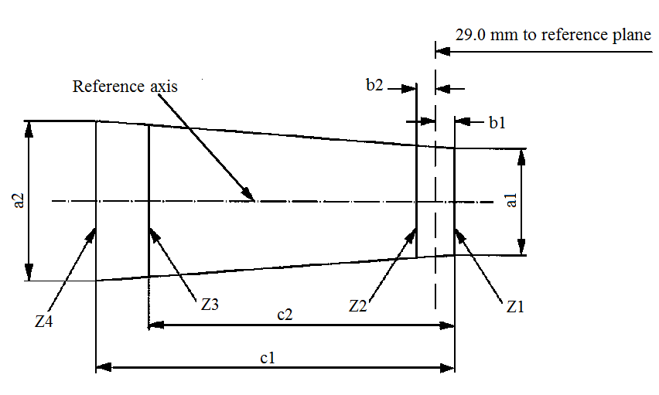
29.0 mm to reference plane
Reference axis
b2
b1
Z1
Z4
Z2
Z3
c1
c2
a2
a1

 | a1 | a2 | b1 | b2 | c1 | c2
12 V | d + 0.4 | d + 0.8 | 0.35 |  | 6.1 | 5.2
d = diameter of filament
The filament position is checked solely in directions A and B as shown on sheet HIR1/1.
The ends of the filament as defined on sheet HIR1/2 footnote 10/ shall lie between lines Z1 and Z2 and between lines Z3 and Z4.
Category HIR2 Sheet HIR2/1
The drawings are intended only to illustrate the essential dimensions (in mm) of the filament light source.
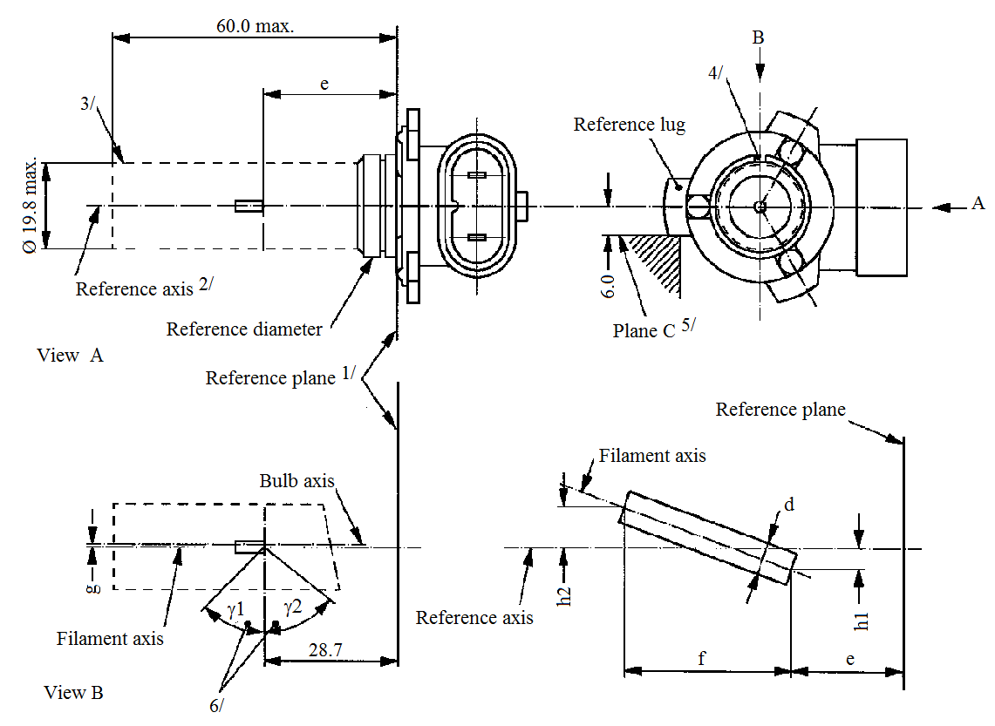
60.0 max.
3/
4/
6/
e
d
f
Reference axis^{2/}
Reference diameter
Reference plane^{1/}
View A
View B
Ø 19.8 max.
Reference lug
Plane C^{5/}
Reference plane
Filament axis
Reference axis
Reference axis
h1
h2
28.7
Bulb axis
6.0
ɣ1
ɣ2
B
A
e
g

^{1/} The reference plane is the plane defined by the three meeting points of the cap holder fit.
^{2/} The reference axis is perpendicular to the reference plane and passes through the centre of the reference diameter of the cap.
^{3/} Glass bulb and supports shall not exceed the envelope. The envelop is concentric to the reference axis.
^{4/} The keyway is mandatory.
^{5/} The filament light source shall be rotated in the measuring holder until the reference lug contacts plane C of the holder.
^{6/} Glass bulb periphery shall be optically distortion-free axially within the angles γ1 and γ2. This requirement applies to the whole bulb circumference within the angles γ1 and γ2.
Category HIR2 Sheet HIR2/2

Dimensions in mm ^{11/} |  |  |  | Tolerance
 |  |  |  | Filament light sources of normal production |  | Standard filament light source
e ^{8/, 10/} |  | 28.7 |  | ^{9/} |  | ±0.16
f ^{8/, 10/} |  | 5.3 |  | ^{9/} |  | ±0.16
g ^{8/} |  | 0 |  | +0.7 / -0.0 |  | +0.4 / -0.0
h1, h2 |  | 0 |  | ^{9/} |  | ±0.15 ^{7/}
d |  | 1.6 max. |  | - |  | -
γ1 |  | 50° min. |  | - |  | -
γ2 |  | 50° min. |  | - |  | -
Cap PX22d in accordance with IEC Publication 60061 (sheet 7004-32-2)
Electrical and photometric characteristics
Rated values |  |  | Volts | 12 |  | 12
 |  |  | Watts | 55 |  | 55
Test voltage |  |  | Volts | 13.2 |  | 13.2
Objective values | Watts |  |  | 63 max. |  | 63 max.
Objective values | Luminous flux |  |  | 1,875 ± 15 %
Reference luminous flux at approximately |  |  |  |  | 12 V | 1,355
 |  |  |  |  | 13.2 V | 1,875

^{7/} The eccentricity is measured only in viewing directions A and B as shown in the figure on sheet HIR2/1. The points to be measured are those where the projection of the outside of the end turns nearest to or furthest from the reference plane crosses the filament axis.
^{8/} The viewing direction is direction B as shown in the figure on sheet HIR2/1.
^{9/} To be checked by means of a "Box system"; sheet HIR2/3.
^{10/} The ends of the filament are defined as the points where, when the viewing direction as defined in footnote 8/ above, the projection of the outside of the end turns crosses the filament axis.
^{11/} Dimensions shall be checked with O-ring removed.
Category HIR2 Sheet HIR2/3
Screen projection requirements
This test is used to determine, by checking whether the filament is correctly positioned relative to the reference axis and reference plane, whether a filament light source complies with the requirements.
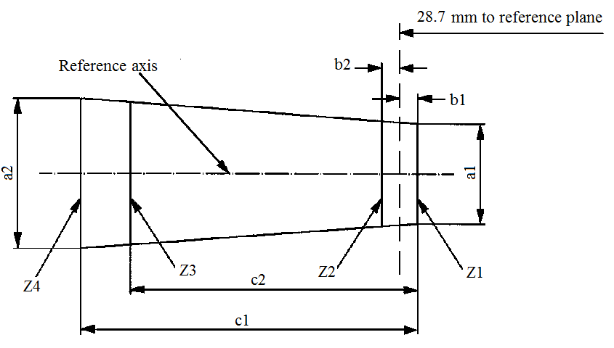
28.7 mm to reference plane
Reference axis
b2
b1
c1
c2
Z1
Z2
Z3
Z4
a1
a2

 | a1 | a2 | b1 | b2 | c1 | c2
12 V | d + 0.4 | d + 0.8 | 0.35 |  | 6.6 | 5.7
d = diameter of filament
The filament position is checked solely in directions A and B as shown on sheet HIR2/1.
The ends of the filament as defined on sheet HIR2/2 footnote 10/ shall lie between lines Z1 and Z2 and between lines Z3 and Z4.
Category HS1 Sheet HS1/1
The drawings are intended only to illustrate the essential dimensions (in mm) of the filament light source.
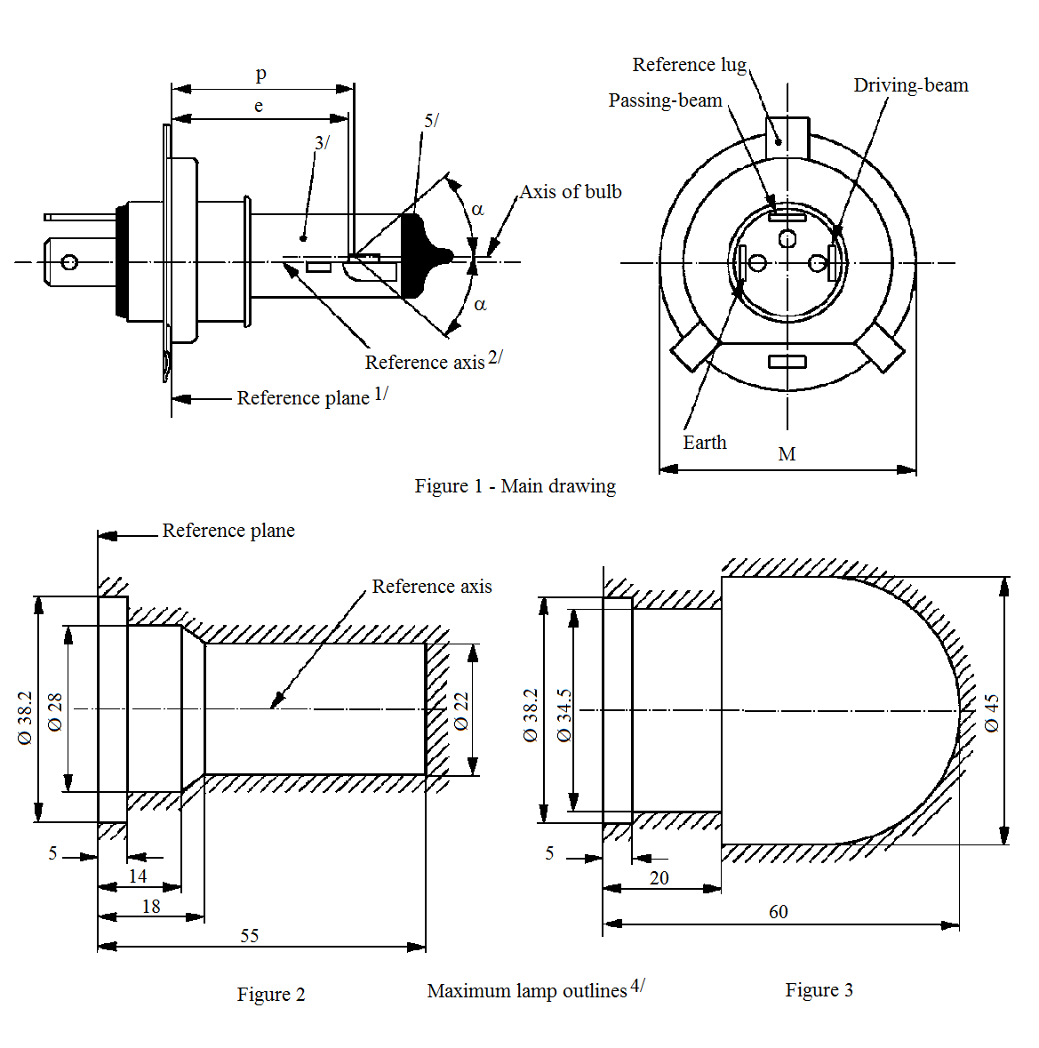
Reference lug
Driving-beam
Passing-beam
Axis of bulb
Reference axis^{2/}
Reference plane^{1/}
Figure 1 – Main drawing
Earth
M
p
e
α
α
3/
5/
Maximumfilament light source outlines^{4/}
Reference axis
Reference plane
Figure 2
Figure 3
Ø 38.2
Ø 28
Ø 22
Ø 45
Ø 38.2
Ø 34.5
5
14
18
55
5
20
60
^{1/} The reference plane is the plane formed by the seating points of the three lugs of the cap ring.
Maximum lamp outlines ^{4/}
Figure 3
Figure 2
^{2/} The reference axis is perpendicular to the reference plane and passes through the centre of the circle of diameter "M".
^{3/} The colour of the light emitted shall be white or selective-yellow.
^{4/} The bulb and supports shall not exceed the envelope as in Figure 2. However, where a selective-yellow outer bulb is used the bulb and supports shall not exceed the envelope as in Figure 3.
^{5/} The obscuration shall extend at least as far as the cylindrical part of the bulb. It shall also overlap the internal shield when the latter is viewed in a direction perpendicular to the reference axis.
Category HS1 Sheet HS1/2

Dimensions in mm |  |  | Filament light sources of normal production |  |  |  |  | Standard filament light source
 |  |  | 6 V |  | 12 V |  |  | 12 V
e |  |  | 28.5 + 0.45 / -0.25 |  |  |  |  | 28.5 + 0.20 / -0.00
p |  |  | 28.95 |  |  |  |  | 28.95
α |  |  | max. 40° |  |  |  |  | max. 40°
Cap PX43t in accordance with IEC Publication 60061 (sheet 7004-34-2)
Electrical and photometric characteristics
Rated values |  | Volts | 6 ^{6/} |  | 12 ^{6/} |  |  | 12 ^{6/}
 |  | Watts | 35 | 35 | 35 |  | 35 | 35 | 35
Test voltage |  | Volts | 6.3 |  | 13.2 |  |  | 13.2
Objective values | Watts |  | 35 | 35 | 35 |  | 35 | 35 | 35
Objective values | ± % |  | 5 |  |  |  |  | 5
Objective values | Luminous flux |  | 700 | 440 | 825 |  | 525
Objective values | ± % |  | 15
Measuring flux ^{7/} lm |  |  | - |  | - |  | 450
Reference luminous flux at approximately |  |  |  |  |  | 12 V |  | 700 | 450
 |  |  |  |  |  | 13.2 V |  | 825 | 525

^{6/} The values indicated in the left hand column relate to the driving-beam. Those indicated in the right-hand column relate to the passing-beam.
^{7/} Measuring luminous flux according to the provisions for filament light sources with an internal shield to produce the cut-off.

Category HS1 Sheet HS1/3

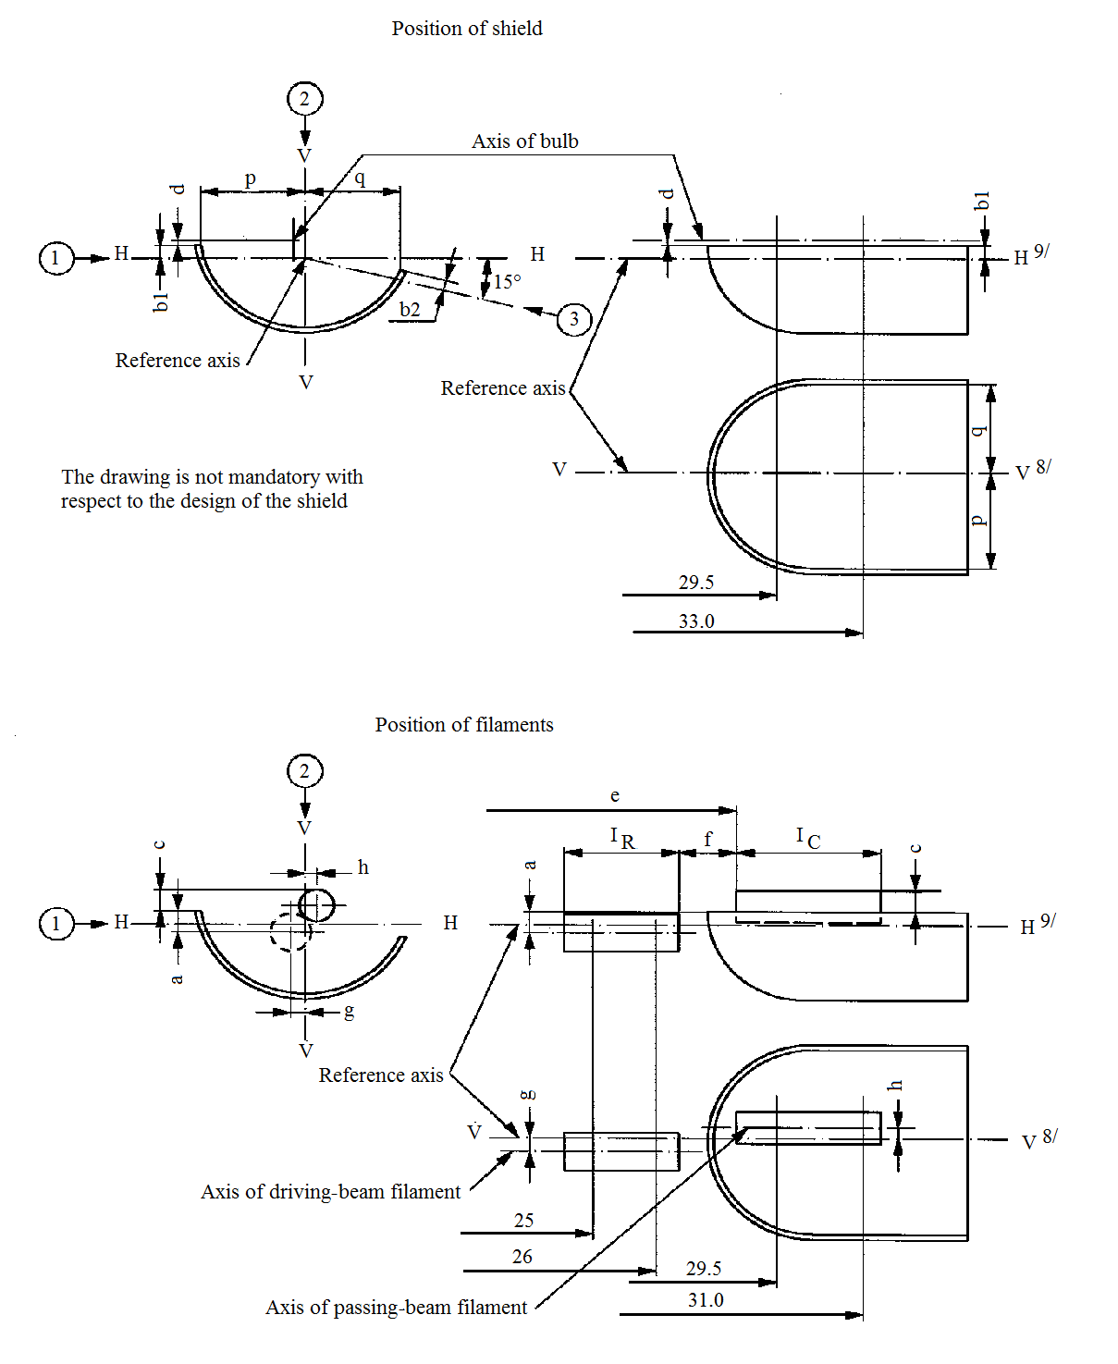
Axis of bulb
Position of shield
Reference axis
Reference axis
Reference axis
The drawing is not mandatory with
respect to the design of the shield
33.0
29.5
V^{8/}
H^{9/}
H^{9/}
b2
15°
b1
b1
H
H
H
V
V
p
q
d
d
q
q
V^{8/}
H
Position of filaments
V
V
29.5
31.0
26
25
c
c
a
a
h
g
e
h
g
V
f
1_{R}
1_{C}
Axis of passing-beam filament
Axis of driving-beam filament
Category HS1 Sheet HS1/4
Table of the dimensions (in mm) referred to in the drawings on sheet HS1/3
Reference* |  | Dimensions** |  | Tolerance
 |  |  |  | Filament light sources of normal production |  | Standard filament light source
6 V | 12 V | 6 V | 12 V | 6 V | 12 V | 12 V
a/26 |  | 0.8 |  | ±0.35 |  | ±0.20
a/25 |  | 0.8 |  | ±0.55 |  | ±0.20
b1/29.5 |  | 0 |  | ±0.35 |  | ±0.20
b1/33 |  | b1/29.5 mv |  | ±0.35 |  | ±0.15
b2/29.5 |  | 0 |  | ±0.35 |  | ±0.20
b2/33 |  | b2/29.5 mv |  | ±0.35 |  | ±0.15
c/29.5 |  | 0.6 |  | ±0.35 |  | ±0.20
c/31 |  | c/29.5 mv |  | ±0.30 |  | ±0.15
d |  | min. 0.1 / max. 1.5 |  | - |  | -
e ^{13/} |  | 28.5 |  | +0.45 / -0.25 |  | +0.20 / -0.00
f ^{11/, 12/, 13/} |  | 1.7 |  | +0.50 / -0.30 |  | +0.30 / -0.10
g/26 |  | 0 |  | ±0.50 |  | ±0.30
g/25 |  | 0 |  | ±0.70 |  | ±0.30
h/29.5 |  | 0 |  | ±0.50 |  | ±0.30
h/31 |  | h/29.5 mv |  | ±0.30 |  | ±0.20
l_{R} ^{11/, 14/} |  | 3.5 | 4.0 | ±0.80 |  | ±0.40
l_{C} ^{11/, 12/} |  | 3.3 | 4.5 | ±0.80 |  | ±0.35
p/33 |  | Depends on the shape of the shield |  | - |  | -
q/33 |  | (p+q)/2 |  | ±0.60 |  | ±0.30
* "../26" means dimension to be measured at the distance from the reference plane indicated in mm after the stroke.
** "29.5 mv" means the value measured at a distance of 29.5 mm from the reference plane.
Category HS1 Sheet HS1/5

^{8/} Plane V-V is the plane perpendicular to the reference plane and passing through the reference axis and through the intersection of the circle of diameter "M" with the axis of the reference lug.
^{9/} Plane H-H is the plane perpendicular to both the reference plane and plane V-V and passing through the reference axis.
^{10/} (Blank).
^{11/} The end turns of the filament are defined as being the first luminous turn and the last luminous turn that are at substantially the correct helix angle. For coiled-coil filaments, the turns are defined by the envelope of the primary coil.
^{12/} For the passing-beam filament, the points to be measured are the intersections, seen in direction 1, of the lateral edge of the shield with the outside of the end turns defined under footnote 11/.
^{13/} "e" denotes the distance from the reference plane to the beginning of the passing-beam filament as defined above.
^{14/} For the driving-beam filament the points to be measured are the intersections, seen in direction 1, of a plane, parallel to plane H-H and situated at a distance of 0.8 mm below it, with the end turns defined under footnote 11/.
Additional explanations to sheet HS1/3
The dimensions below are measured in three directions:
1 For dimensions a, b1, c, d, e, f, I_{R} and I_{C};
2 For dimensions g, h, p and q;
3 For dimension b2.
Dimensions p and q are measured in planes parallel to and 33 mm away from the reference plane.
Dimensions b1 and b2 are measured in planes parallel to and 29.5 mm and 33 mm away from the reference plane.
Dimensions a and g are measured in planes parallel to and 25.0 mm and 26.0 mm away from the reference plane.
Dimensions c and h are measured in planes parallel to and 29.5 mm and 31 mm away from the reference plane.
Note: For the method of measurement, see Appendix E of IEC Publication 60809.

Category HS2 Sheet HS2/1
The drawings are intended only to illustrate the essential dimensions (in mm) of the filament light source.
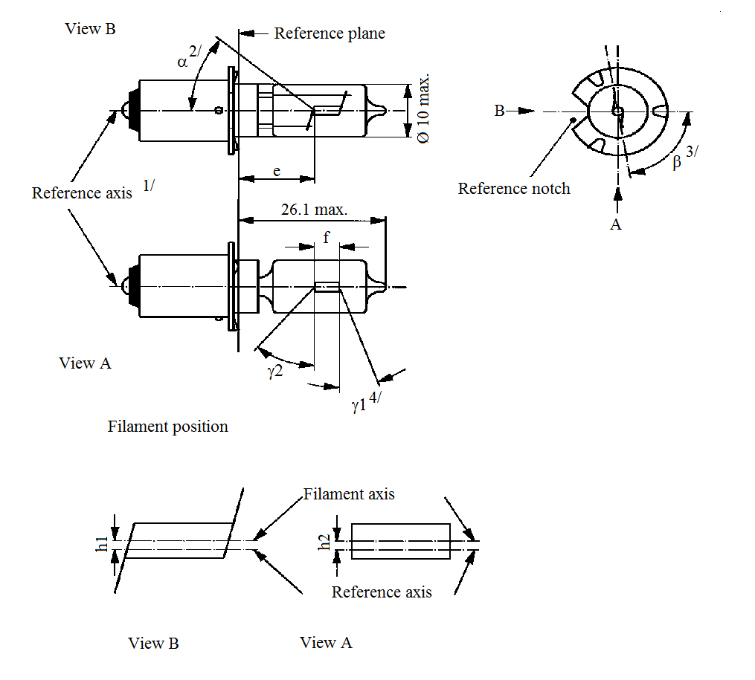
View B
View A
Reference plane
View A
View B
Reference axis^{1/}
Reference notch
Filament position
Filament axis
26.1 max.
e
A
B
f
ß^{3/}
α^{2/}/
ɣ2
ɣ1^{4/}
h1
h2
Ø 10max
Reference axis
^{1/} The reference axis is perpendicular to the reference plane and passes through the intersection of this plane with the axis of the cap ring.
^{2/} All parts which may obscure the light or may influence the light beam shall lie within angle α.
^{3/} Angle β denotes the position of the plane through the inner leads with reference to the reference notch.
^{4/} In the area between the outer legs of the angles γ1 and γ2, the bulb shall have no optically distorting areas and the curvature of the bulb shall have a radius not less than 50 per cent of the actual bulb diameter.
Category HS2 Sheet HS2/2

Dimensions in mm |  |  |  | Filament light sources of normal production |  |  |  | Standard filament light source
 |  |  |  | Min. | Nom. |  | Max. | Standard filament light source
e |  |  |  |  | 11.0 ^{5/} |  |  | 11.0 ± 0.15
f ^{6/} |  | 6 V |  | 1.5 | 2.5 |  | 3.0 | 2.5 ± 0.15
 |  | 12 V |  | 2.0 | 3.0 |  | 4.0
h1, h2 |  |  |  |  | ^{5/} |  |  | 0 ± 0.15
α ^{2/} |  |  |  |  |  |  | 40°
β ^{3/} |  |  |  | 75° | 90° |  | 105° | 90° ± 5°
γ1 ^{4/} |  |  |  | 15° |  |  |  | 15° min.
γ2 ^{4/} |  |  |  | 40° |  |  |  | 40° min.
Cap PX13.5s in accordance with IEC Publication 60061 (sheet 7004-35-2)
Electrical and photometric characteristics
Rated values | Volts |  | 6 |  |  | 12 |  | 6
Rated values | Watts |  | 15 |  |  |  |  | 15
Test voltage | Volts |  | 6.75 |  |  | 13.5 |  | 6.75
Objective values | Watts |  | 15 ± 6 % |  |  |  |  | 15 ± 6 %
Objective values | Luminous flux |  | 320 ± 15 %
Reference luminous flux: 320 lm at approximately 6.75 V
^{5/} To be checked by means of the "Box system", sheet HS2/3.
^{6/} In order to avoid rapid filament failure, the supply voltage shall not exceed 8.5 V for 6 V filament light sources and
15 V for 12 V types.
Category HS2 Sheet HS2/3
Screen projection requirements
This test is used to determine, by checking whether the filament light source complies with the requirements by checking whether the filament light source is correctly positioned relative to the reference axis and reference plane.
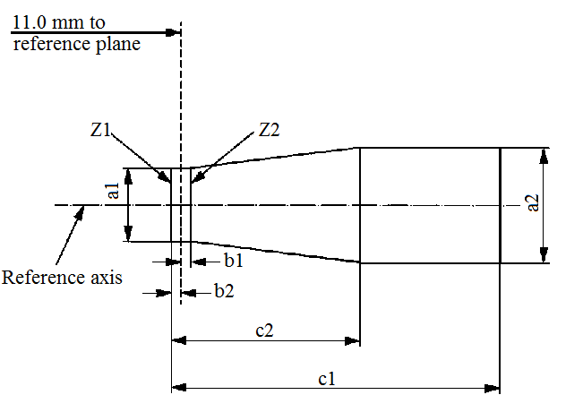
11.0 mm to
reference plane
Reference axis
Z2
Z1
b1
b2
c2
c1
a1
a2

Reference | a1 | a2 | b1 | b2 | c1 (6 V) | c1 (12 V) | c2
Dimension | d + 1.0 | d + 1.4 | 0.25 | 0.25 | 4.0 | 4.5 | 1.75
d= actual filament diameter
The filament shall lie entirely within the limits shown.
The beginning of the filament shall lie between the lines Z1 and Z2.
Category HS5 Sheet HS5/1
The drawings are intended only to illustrate the essential dimensions (in mm) of the filament light source.

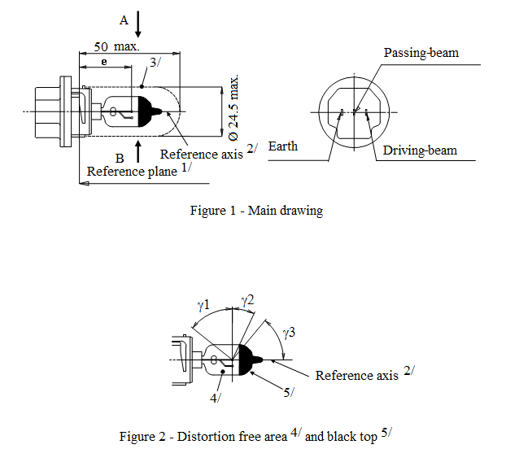
Reference axis^{2/}
A
50 max.
e
3/
4/
5/
B
Reference plane^{1/}
Ø 24.5 max
Reference axis^{2/}
Earth
Driving-beam
Passing-beam
Figure 1 – Main drawing
Figure 2 - Distorsion free area^{4/} and black top^{5/}
Reference axis^{2/}
ɣ1
ɣ2
ɣ3

^{1/} The reference plane is defined by the three ramp inside surface.
^{2/} The reference axis is perpendicular to the reference plane and passing through the centre of the 23 mm cap diameter.
^{3/} Glass bulb and supports shall not exceed the envelope as indicated in Figure 1. The envelope is concentric to the reference axis.
^{4/} Glass bulb shall be optically distortion free within the angles γ1 and γ2. This requirement applies to the whole bulb circumference within the angles γ1 and γ2.
^{5/} The obscuration shall extend at least to angle γ3 and shall extend at least to the cylindrical part of the bulb on the whole top circumference.
Category HS5 Sheet HS5/2

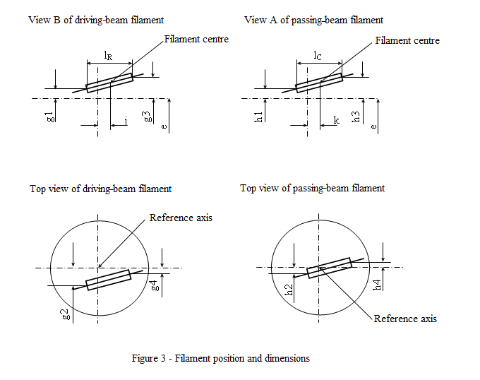
G3
View B of driving-beam filament
View A of passing-beam filament
Top view of driving-beam filament
Top view of passing-beam filament
Reference axis
Reference axis
Filament centre
Filament centre
Figure 3 – Filament position and dimensions
1_{R}
1_{C}
g1
h1
h3
h4
h2
g3
g2
g4
k
i
e
e
Category HS5 Sheet HS5/3

Dimensions in mm |  |  |  |  | Filament light sources of normal production |  |  |  | Standard filament light source
 |  |  |  |  | 12 V |  |  |  | 12 V
e |  | 26 |  |  | ^{6/} |  |  |  | ±0.15
l_{C} ^{7/} |  | 4.6 |  |  |  |  |  |  | ±0.3
k |  | 0 |  |  |  |  |  |  | ±0.2
h1, h3 |  | 0 |  |  |  |  |  |  | ±0.15
h2, h4 |  | 0 |  |  |  |  |  |  | ±0.20
l_{R} ^{7/} |  | 4.6 |  |  |  |  |  |  | ±0.3
j |  | 0 |  |  |  |  |  |  | ±0.2
g1, g3 |  | 0 |  |  |  |  |  |  | ±0.30
g2, g4 |  | 2.5 |  |  |  |  |  |  | ±0.40
γ1 |  | 50° min. |  |  | - |  |  |  | -
γ2 |  | 23° min. |  |  | - |  |  |  | -
γ3 |  | 50° min. |  |  | - |  |  |  | -
Cap P23t in accordance with IEC Publication 60061 (sheet 7004-138-2)
Electrical and photometric characteristcs
Rated values | Voltage |  | V | 12 |  |  |  | 12
Rated values | Wattage |  | W | 35 |  | 30 |  | 35 |  | 30
Test voltage |  |  | V | 13.2 |  |  |  | 13.2
Objective values | Wattage |  | W | 40 max. |  | 37 max. |  | 40 max. |  | 37 max.
Objective values | Luminous flux |  | lm | 620 |  | 515
Objective values |  |  | ± % | 15 |  | 15
Reference luminous at approximately |  |  |  |  |  |  | 12 V | 460 |  | 380
 |  |  |  |  |  |  | 13.2 V | 620 |  | 515

^{6/} To be checked by means of a "Box system". Sheet HS5/4.
^{7/} The positions of the first and the last turn of the filament are defined by the intersections of the outside of the first and the outside of the last light-emitting turn, respectively, with the plane parallel to and 26 mm distant from the reference plane.
Category HS5 Sheet HS5/4
Screen projection requirement
This test is used to determine whether a filament light source complies with the requirements by checking whether:
(a) The passing-beam filament is correctly positioned relative to the reference axis and the reference plane; and whether
(b) The driving-beam filament is correctly positioned relative to the passing-beam filament.
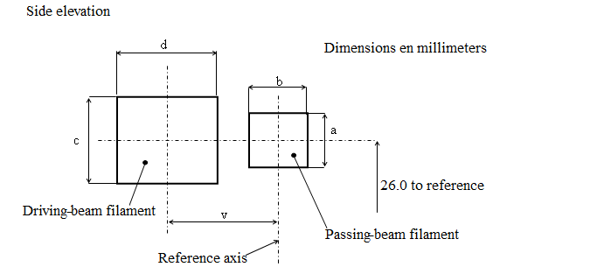
Side elevation
26.0 mm to reference
Dimensions in millimeters
Driving-beam filament
Passing-beam filament
Reference axis
d
b
c
v
a

Reference | a | b | c | d | v
Dimensions | d1+0.6 | d1+0.8 | d2+1.2 | d2+1.6 | 2.5
d1 : Diameter of the passing-beam filament
d2 : Diameter of the driving-beam filament

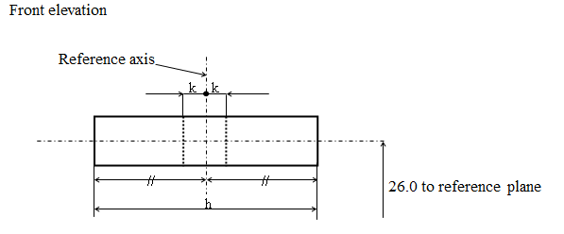
Front elevation
Reference axis
26.0 mm to reference
k
k
h

Reference | h | k
Dimensions | 6.0 | 0.5
The filaments shall lie entirely within the limits shown.
The centre of the filament shall lie within the limits of dimension k.
Category HS5A Sheet HS5A/1

The drawings are intended only to illustrate the essential dimensions (in mm) of the filament light source.
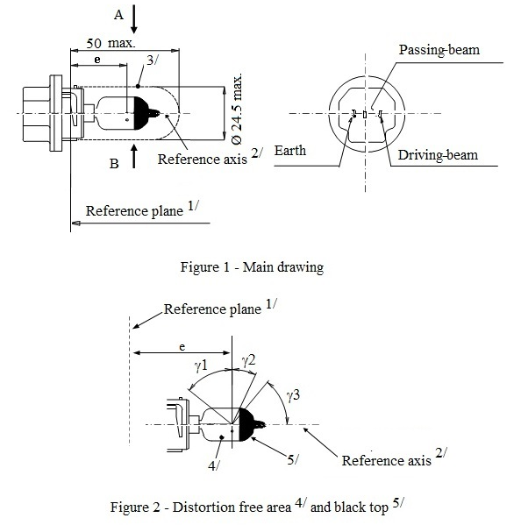
A
50 max.
B
e
e
3/
4/
5/
Reference plane^{1/}
Reference plane^{1/}
Reference axis^{2/}
Reference axis^{2/}
Ø 24.5 max.
Earth
Driving-beam
Passing-beam
ɣ1
ɣ2
ɣ3
Figure 1 – Main drawing
Figure 2 - Distorsion free area^{4/} and black top^{5/}

^{1/} The reference plane is defined by three ramps inside surface.
^{2/} The reference axis is perpendicular to the reference plane and passing through the centre of the 23 mm cap diameter.
^{3/} Glass bulb and supports shall not exceed the envelope as indicated in Figure 1. The envelope is concentric to the reference axis.
^{4/} Glass bulb shall be optically distortion free within the angles γ1 and γ2. This requirement applies to the whole bulb circumference within the angles γ1 and γ2.
^{5/} The obscuration shall extend at least to angle γ3 and shall extend at least to the cylindrical part of the bulb on the whole top circumference.
Category HS5A Sheet HS5A/2
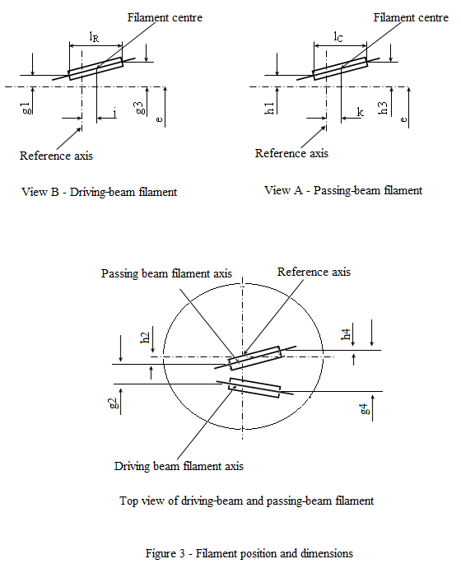
Filament centre
Filament centre
Reference axis
Reference axis
View B - Driving-beam filament
View A - Passing-beam filament
1_{R}
1_{C}
k
j
g1
g3
h1
h3
e
e
g2
h2
h44
g4
Passing-beam filament axis
Driving-beam filament axis
Reference axis
Top view of driving-beam and passing-beam filament
Figure 3 – Filament position and dimensions

Category HS5A Sheet HS5A/3

Dimensions in mm |  |  | Filament light sources of normal production |  |  |  | Standard filament light source
 |  |  | 12 V |  |  |  | 12 V
e | 26 |  | - |  |  |  | -
l_{C} ^{6/} | 4.6 |  | ±0.5 |  |  |  | ±0.3
k | 0 |  | ±0.4 |  |  |  | ±0.2
h1, h3 | 0 |  | ±0.3 |  |  |  | ±0.15
h2, h4 | 0 |  | ±0.4 |  |  |  | ±0.2
l_{R} ^{6/} | 4.6 |  | ±0.5 |  |  |  | ±0.3
j | 0 |  | ±0.6 |  |  |  | ±0.3
g1, g3 | 0 |  | ±0.6 |  |  |  | ±0.3
g2, g4 | 2.5 |  | ±0.4 |  |  |  | ±0.2
γ1 | 50° min. |  | - |  |  |  | -
γ2 | 23° min. |  | - |  |  |  | -
γ3 | 50° min. |  | - |  |  |  | -
Cap PX23t in accordance with IEC Publication 60061 (sheet 7004-138A-1)
Electrical and photometric characteristics
Rated values | Voltage | V |  | 12 ^{7/} |  |  | 12 ^{7/}
Rated values | Wattage | W |  | 45 |  | 40 | 45 | 40
Test voltage |  | V |  | 13.2 |  |  | 13.2
Objective Values | Wattage | W |  | 50 max. |  | 45 max. | 50 max. | 45 max.
Objective Values | Luminous flux | lm |  | 750 |  | 640
Objective Values | Luminous flux | ± % |  | 15 |  | 15
Reference luminous at approximately |  |  |  |  | 12 V |  | 550 lm | 470 lm
 |  |  |  |  | 13.2 V |  | 750 lm | 640 lm

^{6/} The positions of the first and the last turn of the filament are defined by the intersections of the outside of the first and the outside of the last light-emitting turn, respectively, with the plane parallel to and 26 mm distant from the reference plane.
^{7/} The values indicated in the left-hand columns relate to the driving-beam filament and those indicated in the right-hand columns to the passing-beam filament.
Category HS6 Sheet HS6/1
The drawings are intended only to illustrate the essential dimensions (in mm) of the filament light source.
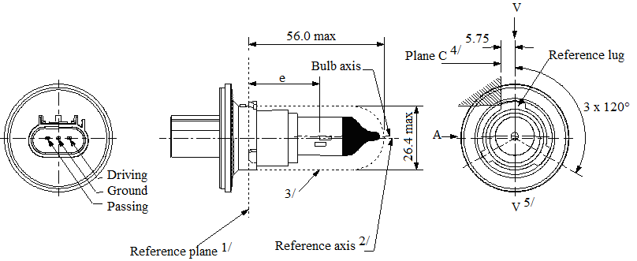
56.0 max.
5.75
3 x 120°
Plane C^{4/}
V^{5/}
V
3/
e
A
Bulb axis
Reference axis^{2/}
Reference plane^{1/}
Reference lug
Driving
Ground
Passing
Ø 26.4 max.

Figure 1 - Main drawings

^{1/} The reference plane is the plane formed by the underside of the three radiused tabs of the cap.
^{2/} The reference axis is perpendicular to the reference plane and crosses the intersection of the two perpendiculars as indicated in Figure 2 on sheet HS6/2.
^{3/} Glass bulb and supports shall not exceed the envelope as indicated. The envelope is concentric to the reference axis.
^{4/} The filament light source shall be rotated in the measuring holder until the reference lug contacts plane C of the holder.
^{5/} Plane V-V is the plane perpendicular to the reference plane passing through the reference axis and parallel to plane C.
Category HS6 Sheet HS6/2

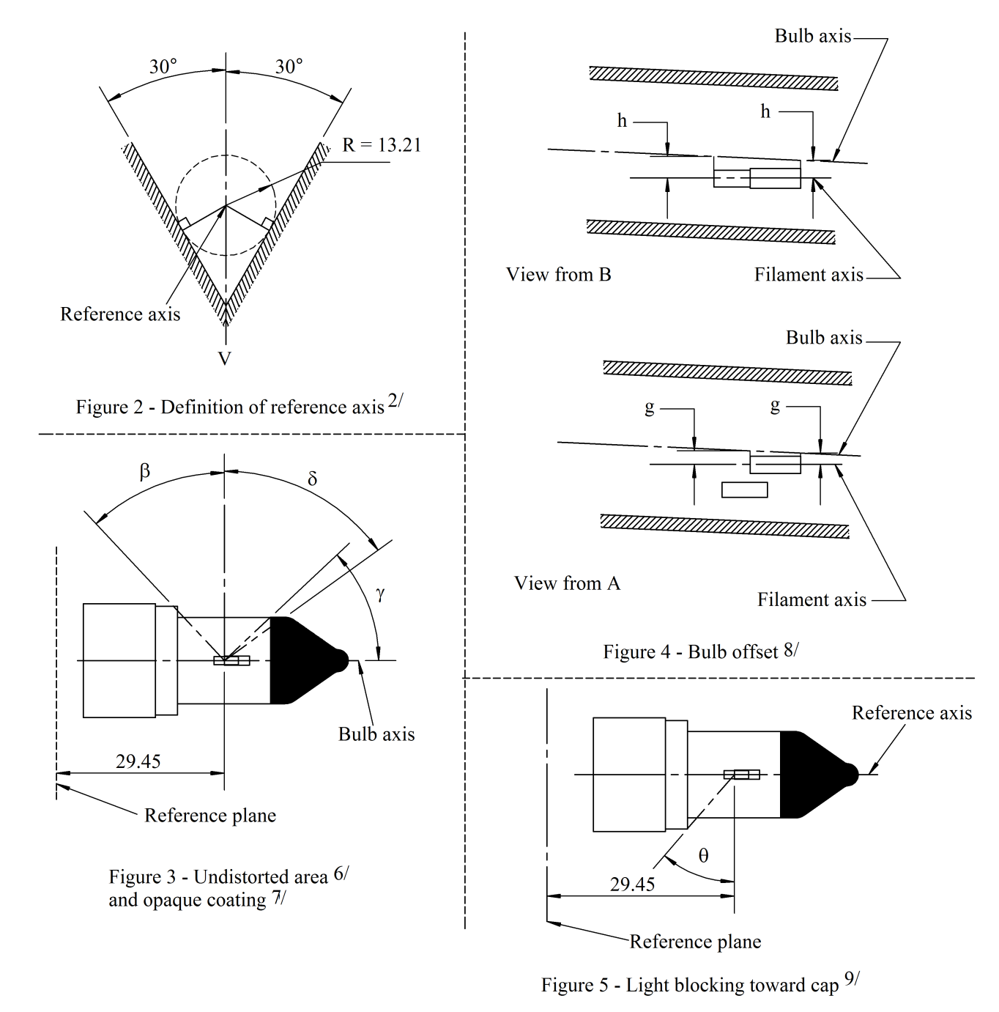
Reference axis
30°
30°
R = 13.21
Figure 2 – Definition of reference axis^{2/}
V
Figure 4 – Bulb offset^{8/}
Bulb axis
Bulb axis
Bulb axis
View from B
View from A
Filament axis
Filament axis
Reference axis
Reference plane
h
h
g
g
Reference plane
ß
ɣ
δ
Figure 3 - Undistorted area^{6/} and opaque coating^{7/}

θ
29.45
Figure 5 – Light blocking toward^{9/} cap
29.45
^{6/} Glass bulb shall be optically distortion-free axially and cylindrically within the angles β and δ. This requirement applies to the whole bulb circumference within the angles β and δ and does not need to be verified in the area covered by the opaque coating.
^{7/} The opaque coating shall extend at least to the cylindrical part of the bulb on the whole bulb top circumference. It shall moreover extend at least to a plane parallel to the reference plane where γ crosses the outer bulb surface as shown in Figure 3 (view in direction B as indicated on sheet HS6/1).
^{8/} Offset of passing-beam filament in relation to the bulb axis is measured in two planes parallel to the reference plane where the projection of the outside end turns nearest to and farthest from the reference plane crosses the passing-beam filament axis.
^{9/} Light shall be blocked over the cap end of the bulb extending to angle θ. This requirement applies in all directions around the reference axis.
Category HS6 Sheet HS6/3

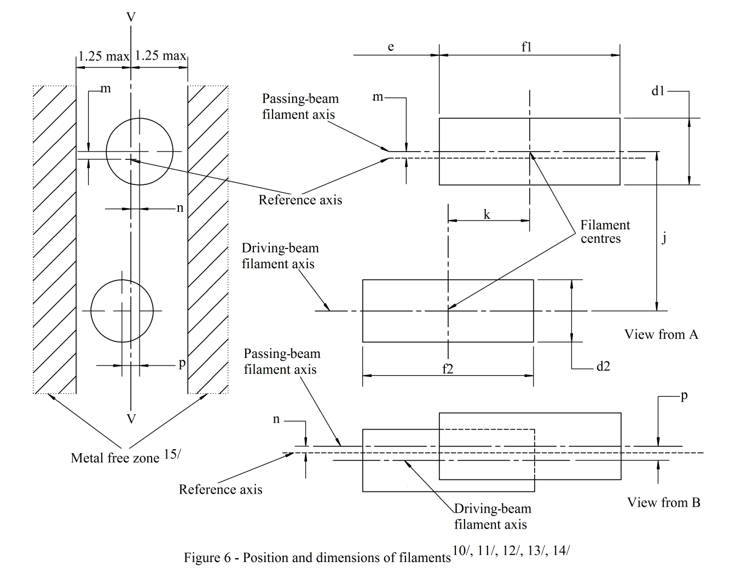
1.25 max.
1.25 max.
e
V
V
f1
m
d1
k
j
f2
d2
m
n
n
p
p
Metal free zone^{15/}
View from A
View from B
Reference axis
Filament centres
Reference axis
Passing-beam
filament axis
Passing-beam
filament axis
Driving-beam
filament axis
Driving-beam
filament axis
Figure 6 – Position and dimensions of filaments^{10/, 11/, 12/, 13/, 14/}

^{10/} Dimensions j, k and p are measured from the centre of the passing-beam filament to the centre of the driving-beam filament.
^{11/} Dimensions m and n are measured from the reference axis to the centre of the passing-beam filament.
^{12/} Both filaments axis are to be held within a 2° tilt with respect to the reference axis about the centre of the respective filament.
^{13/} Note concerning the filament diameters: for the same manufacturer, the design filament diameter of standard (étalon) filament light source and filament light source of normal production shall be the same.
^{14/} For both the driving-beam and the passing-beam filament distortion shall not exceed ±5 per cent of filament diameter from a cylinder.
^{15/} The metal free zone limits the location of lead wires within the optical path. No metal parts shall be located in the shaded area as seen in Figure 6.
Category HS6 Sheet HS6/4

Dimensions in mm |  |  |  | Tolerance
 |  |  |  | Filament light sources of normal production |  |  | Standard filament light source
d1 ^{13/,} ^{17/} |  | 1.4 max. |  | - |  |  | -
d2 ^{13/,} ^{17/} |  | 1.4 max. |  | - |  |  | -
e ^{16/} |  | 29.45 |  | ±0.20 |  |  | ±0.10
f1 ^{16/} |  | 4.4 |  | ±0.50 |  |  | ±0.25
f2 ^{16/} |  | 4.4 |  | ±0.50 |  |  | ±0.25
g ^{8/, 17/} |  | 0.5 d1 |  | ±0.50 |  |  | ±0.30
h ^{8/} |  | 0 |  | ±0.40 |  |  | ±0.20
j ^{10/} |  | 2.5 |  | ±0.30 |  |  | ±0.20
k ^{10/} |  | 2.0 |  | ±0.20 |  |  | ±0.10
m ^{11/} |  | 0 |  | ±0.24 |  |  | ±0.20
n ^{11/} |  | 0 |  | ±0.24 |  |  | ±0.20
p ^{10/} |  | 0 |  | ±0.30 |  |  | ±0.20
β |  | 42° min. |  | - |  |  | -
δ |  | 52° min. |  | - |  |  | -
γ |  | 43° |  | +0° / -5° |  |  | +0° / -5°
θ ^{9/} |  | 41° |  | ±4° |  |  | ±4°
Cap PX26.4t in accordance with IEC Publication 60061 (sheet 7004-128-3)
Electrical and photometric characteristics ^{18/}
Rated values | Volts |  | 12 |  |  |  |  | 12
Rated values | Watts |  | 40 |  |  | 35 |  | 40 | 35
Test voltage | Volts |  | 13.2 |  |  |  |  | 13.2
Objective values | Watts |  | 45 max. |  |  | 40 max. |  | 45 max. | 40 max.
Objective values | Luminous flux |  | 900 ± 15 % |  |  | 600 ± 15 %
Reference luminous flux at approximately |  |  |  |  | 12 V |  |  | 630/420
 |  |  |  |  | 13.2 V |  |  | 900/600

^{16/} The ends of the filament are defined as the points where, when the viewing direction is direction A as shown on sheet HS6/1, the projection of the outside of the end turns crosses the filament axis.
^{17/} d1 is the actual diameter of the passing-beam filament.
d2 is the actual diameter of the driving-beam filament.
^{18/} The values indicated in the left-hand columns relate to the driving-beam filament and those in the right-hand columns to the passing-beam filament.
Categories P13W and PW13W Sheet P13W/1
The drawings are intended only to illustrate the essential dimensions (in mm) of the filament light source.
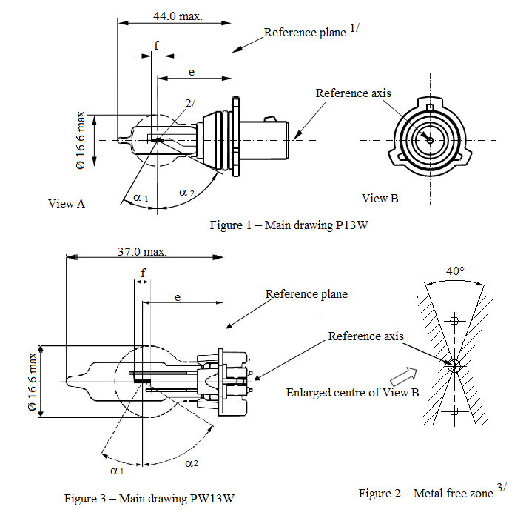
44.0 max.
37.0 max.
Reference plane^{1/}
Reference plane
Reference axis
Reference axis
Ø 16.6 max.
Ø 16.6 max.
f
f
e
e
2/
α1
α1
α2
α2
View B
40°
Figure 1 – Main drawing P13W
Figure 3 – Main drawing PW13W
Figure 2 – Metal free zone^{3/}
Enlarged centre of view B
View A

^{1/} The reference plane is defined by the meeting points of the cap-holder fit.
^{2/} No actual filament diameter restrictions apply but the objective is d max. = 1.0 mm.
^{3/} No opaque parts other than filament turns shall be located in the shaded area indicated in Figure 2. This applies to the rotational body within the angles α₁ + α₂.
Categories P13W and PW13W Sheet P13W/2

Dimensions in mm |  |  |  | Filament light sources of normal production |  | Standard filament light source
e ^{5/} | P13W |  |  | 25.0 ^{4/} |  | 25.0 ± 0.25
e ^{5/} | PW13W |  |  | 19.25 ^{4/} |  | 19.25 ± 0.25
f ^{5/} |  |  |  | 4.3 ^{4/} |  | 4.3 ± 0.25
α₁ ^{6/} |  |  |  | 30.0° min. |  | 30.0° min.
α₂ ^{6/} |  |  |  | 58.0° min. |  | 58.0° min.
P13W Cap PG18.5d-1  PW13W Cap WP3.3x14.5-7 |  |  |  | in accordance with IEC Publication 60061 (sheet 7004-147-1)  in accordance with IEC Publication 60061 (sheet 7004-164-2)
Electrical and photometric characteristics
Rated values |  | Voltage | V | 12 | 12
 |  | Wattage | W | 13 | 13
Test voltage |  |  | V | 13.5 | 13.5
Objective values |  | Wattage | W | 19 max. | 19 max.
 |  | Luminous flux | lm | 250
 |  | Luminous flux | ± | +15 % / –20 %
Reference luminous flux at approximately 13.5 V |  |  |  |  | 250 lm

^{4/} To be checked by means of a "Box system"; sheet P13W/3.
^{5/} The ends of the filament are defined as the points where, when the viewing direction is perpendicular to the plane through the filament lead-in wires, the projection of the outside of the end turns crosses the filament axis.
^{6/} No part of the cap beyond the reference plane shall interfere with angle α₂ as shown in Figure 1 on sheet P13W/1. The bulb shall be optically distortion free within the angles α₁+ α₂.
These requirements apply to the whole bulb circumference.
Categories P13W and PW13W Sheet P13W/3
Screen projection requirements
This test is used to determine, by checking whether the filament is correctly positioned relative to the reference axis and reference plane, whether a filament light source complies with the requirements.

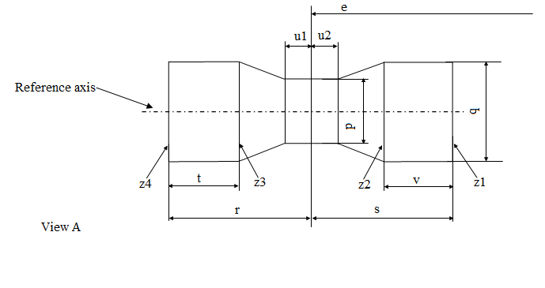
Reference axis
View A
u1
u2
z4
z3
z2
z1
t
v
r
s
q
p
e
 | p | q | u1,u2 | r,s | t,v
Filament light sources of normal production | 1.7 | 1.9 | 0.3 | 2.6 | 0.9
Standard filament light sources | 1.5 | 1.7 | 0.25 | 2.45 | 0.6

The filament position is checked in two mutually perpendicular planes, one of them being the plane through the lead-in wires.
The ends of the filament as defined on sheet P13W/2, footnote 4/, shall lie between Z1 and Z2 and between the lines Z3 and Z4.
The filament shall lie entirely within the limits shown.
Sheet P19W/1
Categories P19W, PY19W, PR19W, PS19W, PSY19W, PSR19W, PW19W, PWY19W and PWR19W
The drawings are intended only to illustrate the essential dimensions (in mm) of the filament light source.
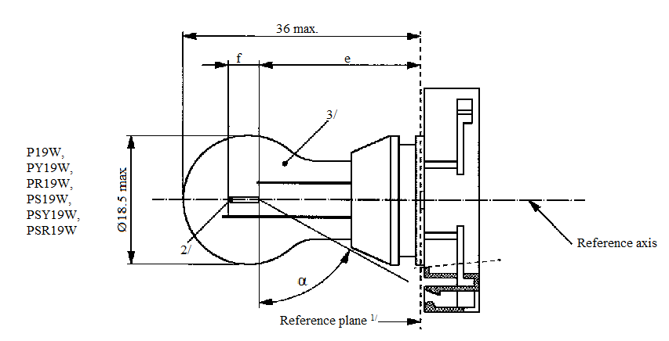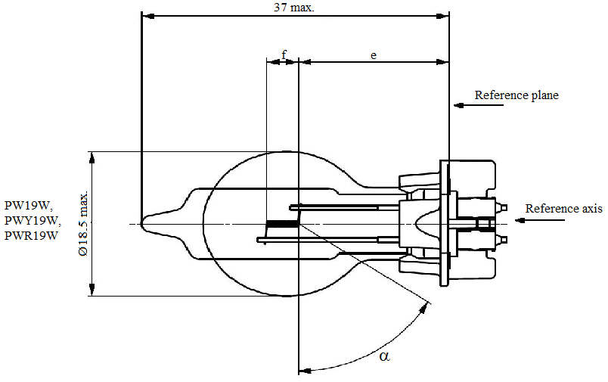
36 max.
f
e
Ø 18.5 max.
Reference axis
Reference plane^{1/}
3/
2/
α
P19W,
PY19W,
PR19W,
PS19W,
PSY19W,
PSR19W
Ø 18.5 max.
e
f
37 max.
Reference plane
α
PW19W,
PWY19W,
PWR19W
Reference axis
^{1/} The reference plane is defined by the meeting points of the cap-holder fit.
Ø18.5 max.
.
Reference plane
f
e
37 max
Reference axis

^{2/} No actual filament diameter restrictions apply but the objective is d max. = 1.1 mm.
^{3/} The light emitted from normal production filament light sources shall be white for categories P19W, PS19W and PW19W; amber for categories PY19W, PSY19W and PWY19W; red for categories PR19W, PSR19W and PWR19W (see also footnote 8/).
Sheet P19W/2
Categories P19W, PY19W, PR19W, PS19W, PSY19W, PSR19W, PW19W, PWY19W and PWR19W

Dimensions in mm ^{4/} |  |  |  | Filament light sources of normal production |  |  | Standard filament light source ^{8/}
 |  |  |  | Min. | Nom. | Max. | Standard filament light source ^{8/}
e ^{5/, 6/} | P19W, PS19W,  PY19W, PSY19W,  PR19W, PSR19W |  |  |  | 24.0 |  | 24.0
e ^{5/, 6/} | PW19W,  PWY19W,  PWR19W |  |  |  | 18.1 |  | 18.1
f ^{5/, 6/} |  |  |  |  | 4.0 |  | 4.0 ± 0.2
α ^{7/} |  |  |  | 58° |  |  | 58° min.
P19W Cap PGU20-1  PY19W Cap PGU20-2  PR19W Cap PGU20-5  PS19W Cap PG20-1  PSY19W Cap PG20-2  PSR19W Cap PG20-5 |  |  |  | in accordance with IEC Publication 60061 (sheet 7004-127-2)
PW19W Cap WP3.3x14.5-1  PWY19W Cap WP3.3x14.5-2  PWR19W Cap WP3.3x14.5-5 |  |  |  | in accordance with IEC Publication 60061 (sheet 7004-164-2)
Electrical and photometric characteristics
Rated values |  | Volts |  | 12 |  |  | 12
 |  | Watts |  | 19 |  |  | 19
Test voltage |  | Volts |  | 13.5 |  |  | 13.5
Objective values |  | Watts |  | 20 max. |  |  | 20 max.
 |  | Luminous flux | P19W  PS19W  PW19W | 350 ± 15 %
 |  | Luminous flux | PY19W  PSY19W  PWY19W | 215 ± 20 %
 |  | Luminous flux | PR19W  PSR19W  PWR19W | 80 ± 20 %
Reference luminous flux at approximately 13.5 V |  |  |  |  |  |  | White: 350 lm  Amber: 215 lm  Red: 80 lm

^{4/} For categories PS19W, PSY19W and PSR19W, dimensions may be checked with O-ring removed to assure the correct mounting during testing.
^{5/} The filament position is checked by means of a "Box system"; sheet P19W/3.
^{6/} The ends of the filament are defined as the points where, when the viewing direction is perpendicular to the plane through the filament lead-in wires as showed in the drawing on sheet P19W/1, the projection of the outside of the end turns crosses the filament axis.
^{7/} No part of the cap beyond the reference plane shall interfere with angle α. The bulb shall be optically distortion free within the angle 2α + 180°.
^{8/} The light emitted from standard filament light sources shall be white for categories P19W, PS19W and PW19W; white or amber for categories PY19W, PSY19W and PWY19W; white or red for categories PR19W, PSR19W and PWR19W.
Sheet P19W/3
Categories P19W, PY19W, PR19W, PS19W, PSY19W, PSR19W, PW19W, PWY19W and PWR19W
Screen projection requirements
This test is used to determine, by checking whether the filament is correctly positioned relative to the reference axis and reference plane, whether a filament light source complies with the requirements.

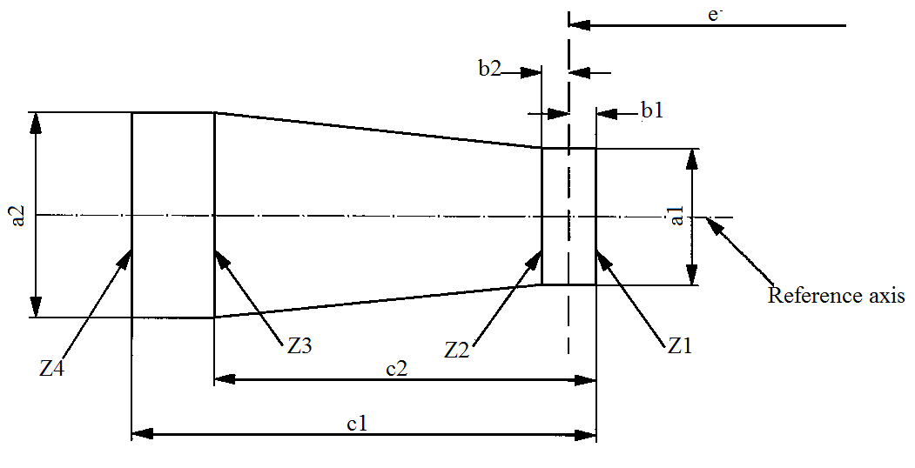
Reference axis
Z2
Z1
Z3
Z4
b1
b2
c1
e
a2
a1
c2

P19W, PY19W, PR19W, PS19W, PSY19W, PSR19W | a1 | a2 | b1, b2 | c1 | c2
Filament light sources of normal production | 2.9 | 3.9 | 0.5 | 5.2 | 3.8
Standard filament light sources | 1.5 | 1.7 | 0.25 | 4.7 | 3.8

PW19W, PWY19W and PWR19W | a1 | a2 | b1, b2 | c1 | c2
Filament light sources of normal production | 2.5 | 2.5 | 0.4 | 5.2 | 3.8
Standard filament light sources | 1.5 | 1.7 | 0.25 | 4.7 | 3.8

The filament position is checked in two mutually perpendicular planes, one of them being the plane through the lead-in wires.
The ends of the filament as defined on sheet P19W/2, footnote 6/, shall lie between Z1 and Z2 and between the lines Z3 and Z4.
The filament shall lie entirely within the limits shown.
Category P21W Sheet P21W/1
The drawings are intended only to illustrate the essential dimensions (in mm) of the filament light source.
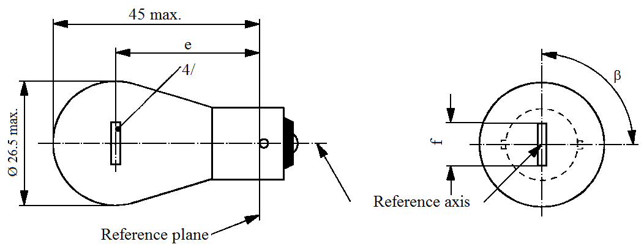
45 max.
e
ß
4/
f
Reference axis
Reference plane
Ø 26.5 max.
Dimensions in mm |  |  | Filament light sources of normal production |  |  | Standard filament light source
 |  |  | Min. | Nom. | Max. | Standard filament light source
e |  | 6, 12 V |  | 31.8 ^{3/} |  | 31.8 ± 0.3
 |  | 24 V | 30.8 | 31.8 | 32.8
f |  | 12 V | 5.5 | 6.0 | 7.0 | 6.0 ± 0.5
 |  | 6 V |  |  | 7.0
Lateral deviation ^{1/} |  | 6, 12 V |  |  | ^{3/} | 0.3 max.
 |  | 24 V |  |  | 1.5
β |  |  | 75° | 90° | 105° | 90° ± 5°
Cap BA15s in accordance with IEC Publication 60061 (sheet 7004-11A-9) ^{2/}
Electrical and photometric characteristics
Rated values | Volts |  | 6 | 12 | 24 | 12
Rated values | Watts |  | 21 |  |  | 21
Test voltage | Volts |  | 6.75 | 13.5 | 28.0 | 13.5
Objective values | Watts |  | 27.6 max. | 26.5 max. | 29.7 max. | 26.5 max.
Objective values | Luminous flux |  | 460 ± 15 %
Reference luminous flux: 460 lm at approximately 13.5 V
^{1/} Maximum lateral deviation of filament centre from two mutually perpendicular planes both containing the reference axis and one containing the axis of the pins.
^{2/} Filament light sources with cap BA15d may be used for special purposes; they have the same dimensions.
^{3/} To be checked by means of a "Box system"; sheet P21W/2.
^{4/} In this view the filament of the 24 V type may be straight or V-shaped. If it is straight, the screen projection requirements, sheet P21W/2, apply. If it is V-shaped, the filament ends shall be at the same distance within ±3 mm from the reference plane.
Category P21W Sheet P21W/2
Screen projection requirements
This test is used to determine, by checking whether the filament is correctly positioned relative to the reference axis and reference plane and has an axis perpendicular, within ±15°, to the plane through the centre line of the pins (P21W) or of the reference pin (PY21W and PR21W) and the reference axis, whether a filament light source complies with the requirements.
Side elevation Front elevation
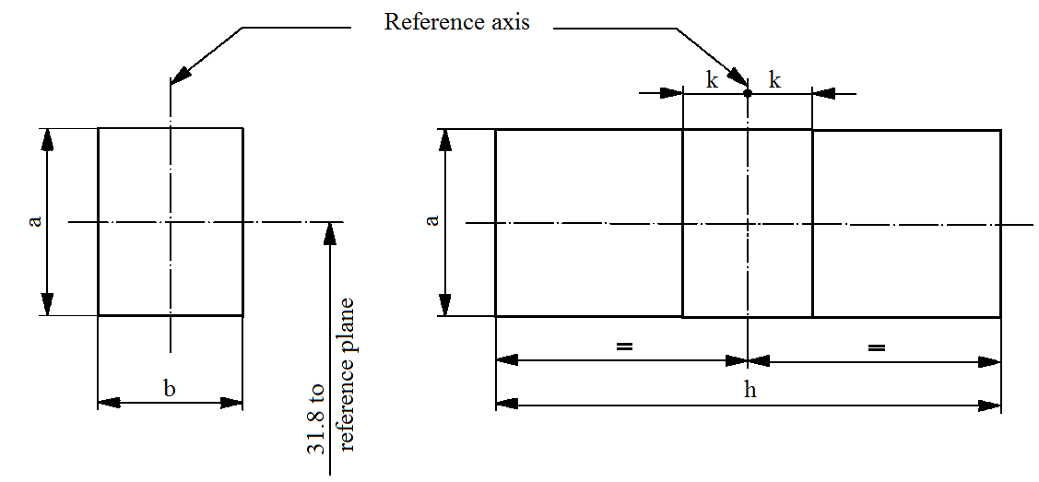
Reference axis
31.8 to
reference plane
k
k
h
b
a
a

Reference | a | b | h | k
Dimension | 3.5 | 3.0 | 9.0 | 1.0
Test procedures and requirements
1. The filament light source is placed in a holder capable of being rotated about its axis and having either a calibrated scale or fixed stops corresponding to the angular displacement tolerance limits. The holder is then so rotated that an end view of the filament is seen on the screen on to which the image of the filament is projected. The end view of the filament shall be obtained within the angular displacements tolerance limits.
2. Side elevation
The filament light source placed with the cap down, the reference axis vertical and the filament seen end-on, the projection of the filament shall lie entirely within a rectangle of height "a" and width "b", having its centre at the theoretical position of the centre of the filament.
3. Front elevation
The filament light source placed with the cap down and the reference axis vertical, the filament light source being viewed in a direction at right angles to the filament axis:
3.1. The projection of the filament shall lie entirely within a rectangle of height "a" and width "h", having its centre at the theoretical position of the centre of the filament.
3.2. The centre of the filament shall not be offset by more than distance "k" from the reference axis.
Category P21/4W Sheet P21/4W/1
The drawings are intended only to illustrate the essential dimensions (in mm) of the filament light source.
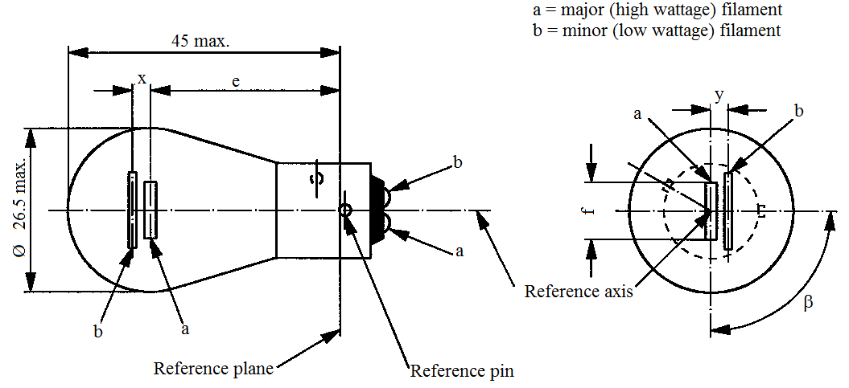
45 max.
Ø 26.5 max.
Reference axis
Reference pin
Reference plane
e
x
b
b
b
a
a
a
ß
y
f
a = major (high wattage) filament
b = minor (low wattage) filament
Dimensions in mm |  |  | Filament light sources of normal production |  |  |  | Standard filament light source
 |  |  | Min. | Nom. | Max. |  | Standard filament light source
e |  |  |  | 31.8 ^{1/} |  |  | 31.8 ± 0.3
f |  |  |  |  | 7.0 |  | 7.0 + 0 /- 2
Lateral deviation |  |  |  |  | ^{1/} |  | 0.3 max. ^{2/}
x,y |  |  | ^{1/} |  |  |  | 2.8 ± 0.5
β |  |  | 75° ^{1/} | 90° ^{1/} | 105° ^{1/} |  | 90° ± 5°
Cap BAZ15d in accordance with IEC Publication 60061 (sheet 7004-11C-3)
Electrical and photometric characteristics
Rated values | Volts | 12 |  |  | 24 |  | 12
Rated values | Watts | 21 |  | 4 | 21 | 4 | 21/4
Test voltage | Volts | 13.5 |  |  | 28.0 |  | 13.5
Objective values | Watts | 26.5 max. |  | 5.5 max. | 29.7 max. | 8.8 max. | 26.5/5.5 max.
Objective values | Luminous flux | 440 |  | 15 | 440 | 20
Objective values | ± % | 15 |  | 20 | 15 | 20
Reference luminous flux: 440 lm and 15 lm at approximately 13.5 V
^{1/} These dimensions shall be checked by means of a "Box system"^{3/} based on the dimensions and tolerances shown above. "x" and "y" refer to the major (high wattage) filament, not to the reference axis. Means of increasing the positioning accuracy of the filament and of the cap-holder assembly are under consideration.
^{2/} Maximum lateral deviation of the major filament centre from two mutually perpendicular planes both containing the reference axis and one containing the axis of the reference pin.
^{3/} The "Box system" is the same as for filament light source P21/5W; see sheets P21/5W/2 to 3.
Category P21/5W Sheet P21/5W/1
The drawings are intended only to illustrate the essential dimensions (in mm) of the filament light source.
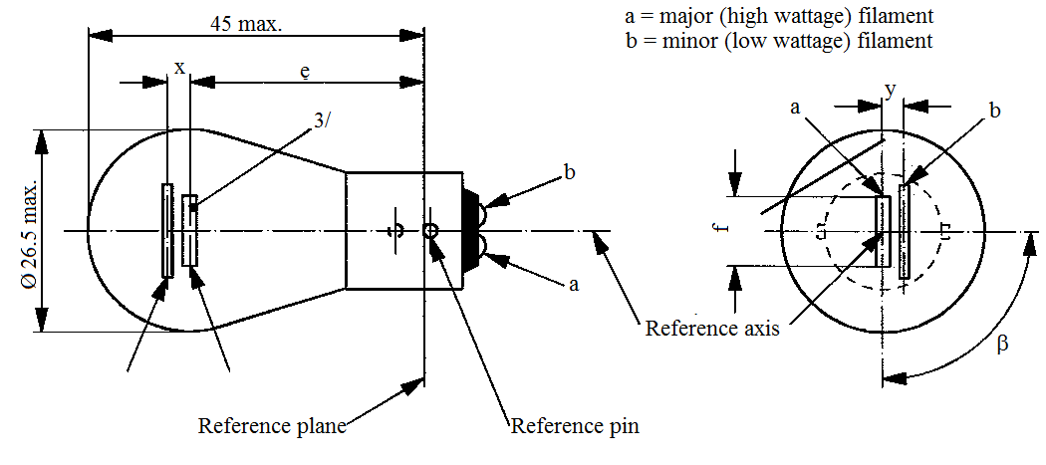
a = major (high wattage) filament
b = minor (low wattage) filament
Ø 26.5 max.
45 max.
3/
e
x
b
a
a
b
y
ß
f
Reference plane
Reference axis
Reference pin
a
b

Dimensions in mm |  |  |  | Filament light sources of normal production |  |  |  |  |  |  | Standard filament light source
 |  |  |  | Min. |  | Nom. |  |  | Max. |  | Standard filament light source
e |  | 6, 12 V |  |  |  | 31.8 ^{1/} |  |  |  |  | 31.8 ± 0.3
 |  | 24 V |  | 30.8 |  | 31.8 |  |  | 32.8
f |  | 6, 12 V |  |  |  |  |  |  | 7.0 |  | 7.0 + 0 /- 2
Lateral deviation ^{2/} |  | 6, 12 V |  |  |  |  |  |  | ^{1/} |  | 0.3 max.
 |  | 24 V |  |  |  |  |  |  | 1.5
x, y |  | 6, 12 V |  |  |  | ^{1/} |  |  |  |  | 2.8 ± 0.3
x |  | 24 V ^{3/} |  | -1.0 |  | 0 |  |  | 1.0
y |  | 24 V ^{3/} |  | 1.8 |  | 2.8 |  |  | 3.8
β |  |  |  | 75° |  | 90° |  |  | 105° |  | 90° ± 5°
Cap BAY15d in accordance with IEC Publication 60061 (sheet 7004-11B-7)
Electrical and photometric characteristics
Rated values | Volts |  | 6 |  | 12 |  |  | 24 |  |  | 12
Rated values | Watts |  | 21 | 5 | 21 |  | 5 | 21 |  | 5 | 21/5
Test voltage | Volts |  | 6.75 |  | 13.5 |  |  | 28.0 |  |  | 13.5
Objective values | Watts |  | 27.6 max. | 6.6 max. | 26.5 max. |  | 6.6 max. | 29.7 max. |  | 11.0 max. | 26.5 and 6.6 max.
Objective values | Luminous flux |  | 440 | 35 | 440 |  | 35 | 440 |  | 40
Objective values | ± % |  | 15 | 20 | 15 |  | 20 | 15 |  | 20
Reference luminous flux: 440 and 35 lm at approximately 13.5 V
For the notes see sheet P21/5W/2

Category P21/5W Sheet P21/5W/2
^{1/} These dimensions shall be checked by means of a "Box system". See sheets P21/5W/2 and P21/5W/3. "x" and "y" refer to the major (high wattage) filament, not to the reference axis.
^{2/} Maximum lateral deviation of the major (high wattage) filament centre from two mutually perpendicular planes both containing the reference axis and one containing the axis of the reference pin.
^{3/} In this view the filaments of the 24 V type may be straight or V-shaped. If the filaments are straight, the screen projection requirements apply. If they are V-shaped, the ends of each filament shall be at the same distance within ±3 mm from the reference plane.
Screen projection requirements
This test is used to determine, by checking whether:
(a) The major (high wattage) filament is correctly positioned relative to the reference axis and reference plane and has an axis perpendicular, within ±15°, to the plane through the centres of the pins and the reference axis; and whether
(b) The minor (low wattage) filament is correctly positioned relative to the major (high wattage) filament, whether a filament light source complies with the requirements.
Test procedure and requirements
1. The filament light source is placed in a holder capable of being rotated about its axis and having either a calibrated scale or fixed stops corresponding to the angular displacement tolerance limits. (i.e. 15°). The holder is then so rotated that an end view of the major filament is seen on the screen on which the image of the filament is projected. The end view of that filament shall be obtained within the angular displacement tolerance limits.
2. Side elevation
The filament light source placed with the cap down, the reference axis vertical, the reference pin to the right and the major filament seen end-on:
2.1. The projection of the major filament shall lie entirely within a rectangle of height "a" and width "b", having its centre at the theoretical position of the centre of the filament;
2.2. The projection of the minor filament shall lie entirely:
2.2.1. Within a rectangle of width "c" and height "d" having its centre at a distance "v" to the right of and at a distance "u" above the theoretical position of the centre of the major filament;
2.2.2. Above a straight line tangential to the upper edge of the projection of the major filament and rising from left to right at an angle of 25°.
2.2.3. To the right of the projection of the major filament.
3. Front elevation
The filament light source being placed with the cap down and the reference axis vertical, the filament light source being viewed in a direction at right angles to axis of the major filament:
3.1. The projection of the major filament shall lie entirely within a rectangle of height "a" and width "h", centred on the theoretical position of the centre of the filament;
3.2. The centre of the major filament shall not be offset by more than distance "k" from the reference axis.
3.3. The centre of the minor filament axis shall not be offset from the reference axis by more than ±2 mm (±0.4 mm for standard filament light sources).
Category P21/5W Sheet P21/5W/3
Dimensions in mm
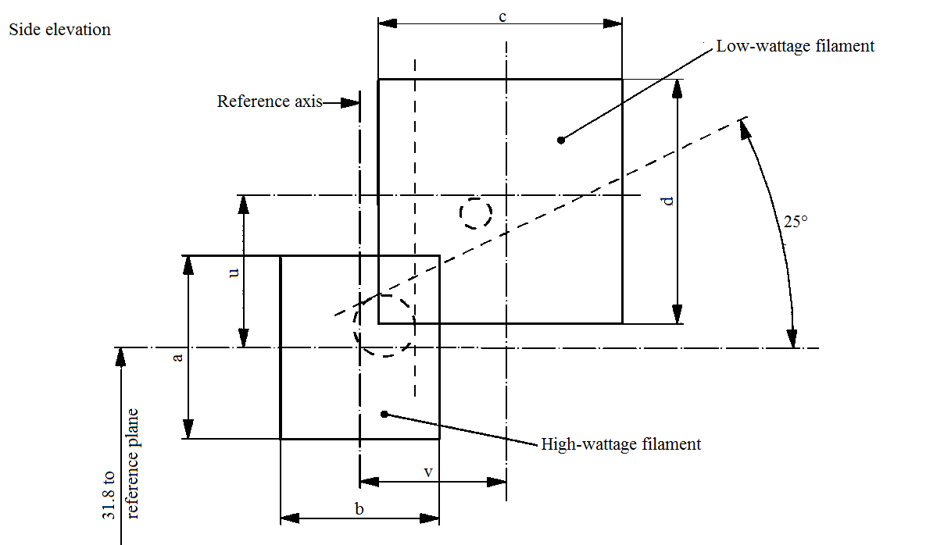
Reference axis
Side elevation
Low wattage filament
High wattage filament
31.8 to
reference plane
b
v
c
25°
a
u
d
Reference | a | b | c | d | u | v
Dimensions | 3.5 | 3.0 | 4.8 |  | 2.8
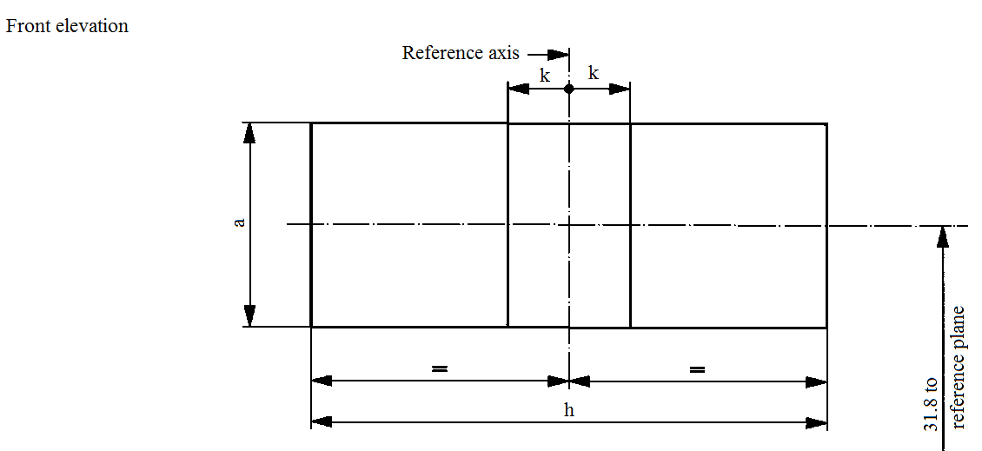
Front elevation
Reference axis
31.8 to
reference plane
k
k
h
a
Reference | a | h | k
Dimensions | 3.5 | 9.0 | 1.0
Sheet P24W/1
Categories P24W, PX24W, PY24W, PR24W, PS24W, PSX24W, PSY24W, PSR24W, PW24W,
PWY24W and PWR24W
The drawings are intended only to illustrate the essential dimensions (in mm) of the filament light source.

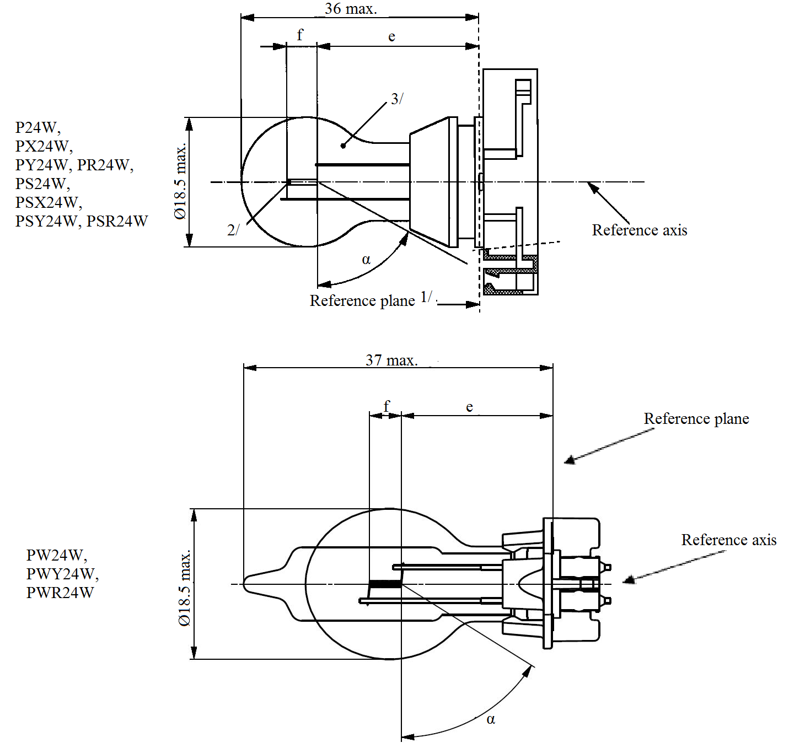
e
f
3/
2/
Ø 18.5 max.
Ø 18.5 max.
f
e
37 max.
α
α
Reference axis
Reference axis
Reference axis
Reference plane^{1/}
PW24W,
PWY24W,
PWR24W

P24W,
PX24W,
PY24W, PR24W
PS24W,
PSX24W,
PSY24W, PSR24W
36 max.

^{1/} The reference plane is defined by the meeting points of the cap-holder fit.
^{2/} No actual filament diameter restrictions apply but the objective is d max. = 1.1 mm.
^{3/} The light emitted from normal production filament light sources shall be white for categories P24W, PX24W, PS24W, PSX24W and PW24W; amber for categories PY24W, PSY24W and PWY24W; red for categories PR24W, PSR24W and PWR24W (see also footnote 8/).
Sheet P24W/2
Categories P24W, PX24W, PY24W, PR24W, PS24W, PSX24W, PSY24W, PSR24W, PW24W, PWY24W and PWR24W

Dimensions in mm ^{4/} |  |  |  | Filament light sources of normal production |  |  |  | Standard filament light source ^{8/}
 |  |  |  | Min. | Nom. |  | Max. | Standard filament light source ^{8/}
e ^{5/, 6/} | P24W, PY24W, PR24W, PS24W, PSY24W, PSR24W, PX24W, PSX24W |  |  |  | 24.0 |  |  | 24.0
e ^{5/, 6/} | PW24W, PWY24W, PWR24W |  |  |  | 18.1 |  |  | 18.1
f ^{5/, 6/} | P24W, PY24W, PR24W, PS24W, PSY24W, PSR24W, PW24W, PWY24W, PWR24W |  |  |  | 4.0 |  |  | 4.0
f ^{5/, 6/} | PX24W, PSX24W |  |  |  | 4.2 |  |  | 4.2
α ^{7/} |  |  |  | 58.0° |  |  |  | 58.0° min.
P24W Cap PGU20-3  PX24W Cap PGU20-7  PY24W Cap PGU20-4  PR24W Cap PGU20-6  PS24W Cap PG20-3  PSX24W Cap PG20-7  PSY24W Cap PG20-4  PSR24W Cap PG20-6 |  |  |  | in accordance with IEC Publication 60061 (sheet 7004-127-2)
PW24W Cap WP3.3x14.5-3  PWY24W Cap WP3.3x14.5-4  PWR24W Cap WP3.3x14.5-6 |  |  |  | in accordance with IEC Publication 60061 (sheet 7004-164-2)
Electrical and photometric characteristics
Rated values |  | Volts |  | 12 |  |  |  | 12
 |  | Watts |  | 24 |  |  |  | 24
Test voltage |  | Volts |  | 13.5 |  |  |  | 13.5
Objective values |  | Watts |  | 25 max. |  |  |  | 25 max.
 |  | Luminous flux | P24W  PS24W  PW24W | 500 +10/-20 %
 |  | Luminous flux | PX24W  PSX24W | 500 +10/-15 %
 |  | Luminous flux | PY24W  PSY24W  PWY24W | 300 +15/-25 %
 |  | Luminous flux | PR24W  PSR24W  PWR24W | 115 +15/-25 %
Reference luminous flux at approximately |  |  |  |  |  | 12 V |  | White: 345 lm
 |  |  |  |  |  | 13.2 V |  | White: 465 lm
 |  |  |  |  |  | 13.5 V |  | White: 500 lm  Amber: 300 lm  Red: 115 lm
^{4/} For categories PS24W, PSX24W, PSY24W and PSR24W, dimensions may be checked with O-ring removed to assure the correct mounting during testing.
^{5/} The filament position is checked by means of a "Box system"; sheet P24W/3.
^{6/} The ends of the filament are defined as the points where, when the viewing direction is perpendicular to the plane through the filament lead-in wires as showed in the drawing on sheet P24W/1, the projection of the outside of the end turns crosses the filament axis.
^{7/} No part of the cap beyond the reference plane shall interfere with angle α. The bulb shall be optically distortion free within the angle 2α + 180°.
^{8/} The light emitted from standard filament light sources shall be white for categories P24W, PX24W, PS24W, PSX24W and PW24W; white or amber for categories PY24W, PSY24W and PWY24W; white or red for categories PR24W, PSR24W and PWR24W.
Sheet P24W/3
Categories P24W, PX24W, PY24W, PR24W, PS24W, PSX24W, PSY24W, PSR24W, PW24W, PWY24W and PWR24W
Screen projection requirements
This test is used to determine, by checking whether the filament is correctly positioned relative to the reference axis and reference plane, whether a filament light source complies with the requirements.
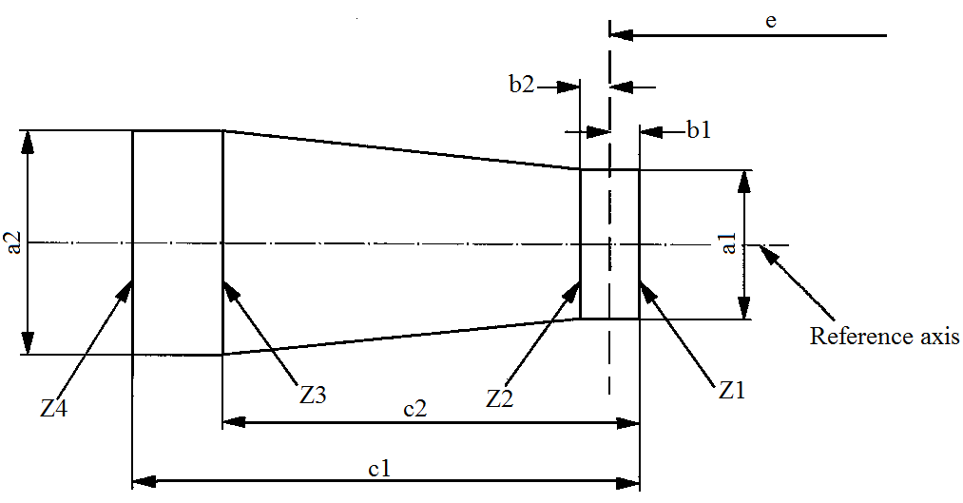
Reference axis
b2
b1
e
c2
c1
Z2
Z1
Z3
Z4
a1
a2
P24W, PY24W, PR24W,  PS24W, PSY24W, PSR24W | a1 | a2 | b1, b2 | c1 | c2
Filament light sources of normal production | 2.9 | 3.9 | 0.5 | 5.2 | 3.8
Standard filament light sources | 1.5 | 1.7 | 0.25 | 4.7 | 3.8

PW24W, PWY24W, PWR24W | a1 | a2 | b1, b2 | c1 | c2
Filament light sources of normal production | 2.5 | 2.5 | 0.4 | 5.0 | 3.8
Standard filament light sources | 1.5 | 1.7 | 0.25 | 4.7 | 3.8

PX24W, PSX24W | a1 | a2 | b1, b2 | c1 | c2
Filament light sources of normal production | 1.9 | 1.9 | 0.35 | 5.0 | 4.0
Standard filament light sources | 1.5 | 1.5 | 0.25 | 4.7 | 4.0
The filament position is checked in two mutually perpendicular planes, one of them being the plane through the lead-in wires.
The ends of the filament as defined on sheet P24W/2, footnote 6/, shall lie between Z1 and Z2 and between the lines Z3 and Z4.
The filament shall lie entirely within the limits shown.
Category P27W Sheet P27W/1
The drawings are intended only to illustrate the essential dimensions (in mm) of the filament light source.

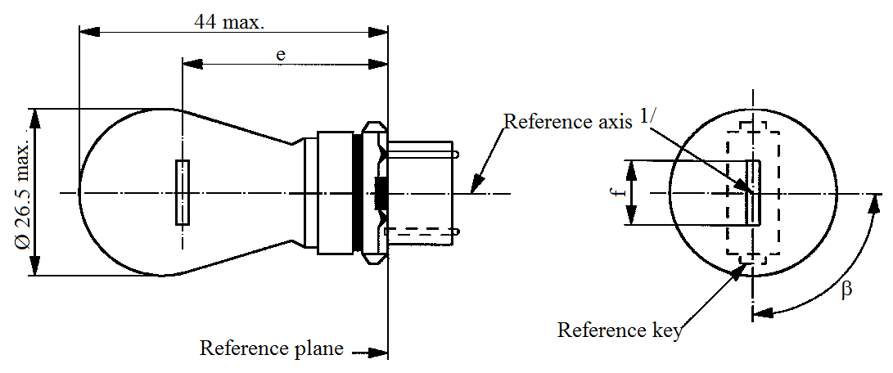
Reference axis^{1/}
Reference plane
Reference key
44 max.
e
f
ß
Ø 26.5 max

Dimensions in mm |  | Filament light sources of normal production |  |  | Standard filament light source
 |  | Min. | Nom. | Max.
e |  |  | 27.9 ^{3/} |  | 27.9 ± 0.3
f |  |  |  | 9.9 | 9.9 + 0 / - 2
Lateral deviation ^{2/} |  |  |  | ^{3/} | 0.0 ± 0.4
β |  | 75° ^{3/} | 90° | 105° ^{3/} | 90° ± 5°
Cap W2.5x16d in accordance with IEC Publication 60061 (sheet 7004-104-1)
Electrical and photometric characteristics
Rated values | Volts | 12 |  |  | 12
Rated values | Watts | 27 |  |  | 27
Test voltage | Volts | 13.5 |  |  | 13.5
Objective values | Watts | 32.1 max. |  |  | 32.1 max.
Objective values | Luminous flux | 475 ± 15 %
Reference luminous flux: 475 lm at approximately 13.5 V
^{1/} The reference axis is defined with respect to the reference keys and is perpendicular to the reference plane.
^{2/} Maximum lateral deviation of filament centre from two mutually perpendicular planes both containing the reference axis and one containing the axis through the reference keys.
^{3/} To be checked by means of a "Box system", sheet P27W/2.
Category P27W Sheet P27W/2
Screen projection requirements
This test is used to determine, by checking whether the filament is correctly positioned relative to the reference axis and reference plane and has an axis perpendicular, within ±15°, to the plane through the centres of the keys and the reference axis, whether a filament light source complies with the requirements.
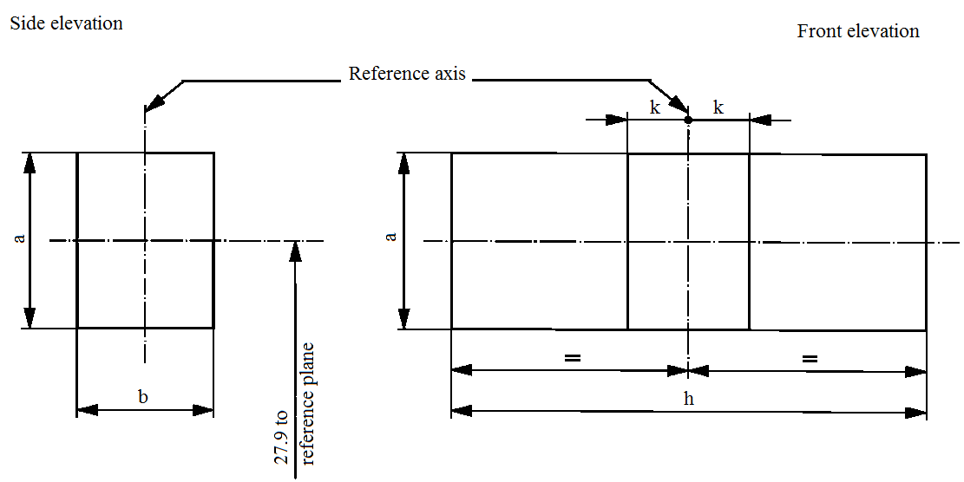
Reference axis
Side elevation
Front elevation
27.9 to
reference plane
k
k
h
b
a
a

Reference | a | b | h | k
Dimension | 3.5 | 3.0 | 11.9 | 1.0

Test procedures and requirements.
1. The filament light source is placed in a holder capable of being rotated about its axis and having either a calibrated scale or fixed stops corresponding to the angular displacement tolerance limits. The holder is then so rotated that an end view of the filament is seen on the screen on to which the image of the filament is projected. The end view of the filament shall be obtained within the angular displacements tolerance limits.
2. Side elevation
The filament light source placed with the cap down, the reference axis vertical and the filament seen end-on, the projection of the filament shall lie entirely within a rectangle of height "a" and width "b", having its centre at the theoretical position of the centre of the filament.
3. Front elevation
The filament light source placed with the cap down and the reference axis vertical, the filament light source being viewed in a direction at right angles to the filament axis:
3.1. The projection of the filament shall lie entirely within a rectangle of height "a" and width "h", having its centre at the theoretical position of the centre of the filament.
3.2. The centre of the filament shall not be offset by more than distance "k" from the reference axis.
Category P27/7W Sheet P27/7W/1
The drawings are intended only to illustrate the essential dimensions (in mm) of the filament light source.
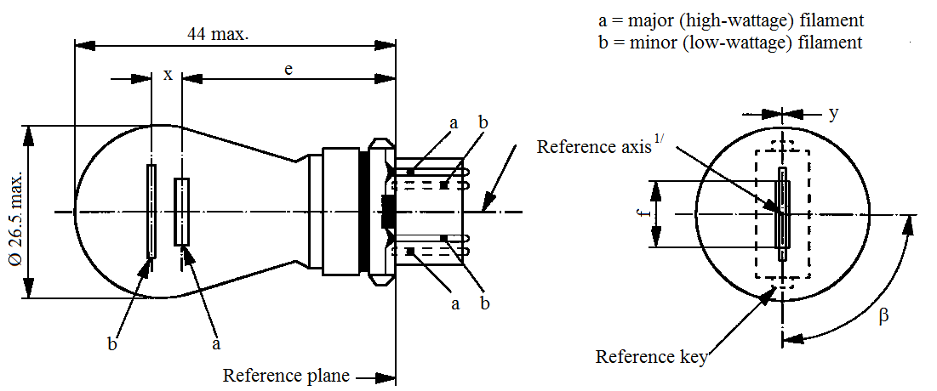
Ø 26.5 max.
44 max.
a = major (high wattage) filament
b = minor (low wattage) filament
Reference plane
Reference axis^{1/}
Reference key
e
x
a
a
b
b
b
a
y
ß
f

Dimensions in mm |  | Filament light sources of normal production |  |  |  |  | Standard filament light source
 |  | Min. | Nom. |  |  | Max.
e |  |  | 27.9 ^{3/} |  |  |  | 27.9 ± 0.3
f |  |  |  |  |  | 9.9 | 9.9 + 0 / -2
Lateral deviation ^{2/} |  |  |  |  |  | ^{3/} | 0.0 ± 0.4
x ^{4/} |  |  | 5.1 ^{3/} |  |  |  | 5.1 ± 0.5
y ^{4/} |  |  | 0.0 ^{3/} |  |  |  | 0.0 ± 0.5
β |  | 75° ^{3/} | 90° |  |  | 105° ^{3/} | 90° ± 5°
Cap W2.5x16q in accordance with IEC Publication 60061 (sheet 7004-104-1)
Electrical and photometric characteristics
Rated values | Volts | 12 |  |  |  |  | 12
Rated values | Watts | 27 |  | 7 |  |  | 27 | 7
Test voltage | Volts | 13.5 |  |  |  |  | 13.5
Objective values | Watts | 32.1 max. |  |  | 8.5 max. |  | 32.1 max. | 8.5 max.
Objective values | Luminous flux | 475 ± 15 % |  |  | 36 ± 15 %
Reference luminous flux: 475 and 36 lm at approximately 13.5 V
^{1/} The reference axis is defined with respect to the reference keys and is perpendicular to the reference plane.
^{2/} Maximum lateral deviation of the major (high wattage) filament centre from two mutually perpendicular planes both containing the reference axis and one containing the axis through the reference keys.
^{3/} To be checked by means of a "Box system", sheets P27/7W/2 and 3.
^{4/} "x" and 'y" denote the offset of the axis of the minor (low wattage) filament with respect to the axis of the major (high wattage) filament.
Category P27/7W Sheet P27/7W/2
Screen projection requirements
This test is used to determine, by checking whether:
(a) The major (high wattage) filament is correctly positioned relative to the reference axis and reference plane and has an axis perpendicular, within ±15°, to the plane through the centres of the keys and the reference axis; and whether:
(b) The minor (low wattage) filament is correctly positioned relative to the major (high wattage) filament, whether a filament light source complies with the requirements.
Test procedure and requirements.
1. The filament light source is placed in a holder capable of being rotated about its axis and having either a calibrated scale or fixed stops corresponding to the angular displacement tolerance limits. The holder is then so rotated that an end view of the major filament is seen on the screen on which the image of the filament is projected. The end view of that filament shall be obtained within the angular displacement tolerance limits.
2. Side elevation
The filament light source placed with the cap down, the reference axis vertical, the reference key to the right and the major filament seen end-on:
2.1. The projection of the major filament shall lie entirely within a rectangle of height "a" and width "b", having its centre at the theoretical position of the centre of the filament;
2.2. The projection of the minor filament shall lie entirely within a rectangle of width "c" and height "d" having its centre at a distance "u" above the theoretical position of the centre of the major filament.
3. Front elevation
The filament light source being placed with the cap down and the reference axis vertical, the filament light source being viewed in a direction at right angles to axis of the major filament:
3.1. The projection of the major filament shall lie entirely within a rectangle of height "a" and width "h", centred on the theoretical position of the centre of the filament;
3.2. The centre of the major filament shall not be offset by more than distance "k" from the reference axis;
3.3. The centre of the minor filament axis shall not be offset from the reference axis by more than ±2 mm (±0.4 mm for standard filament light sources).
Category P27/7W Sheet P27/7W/3

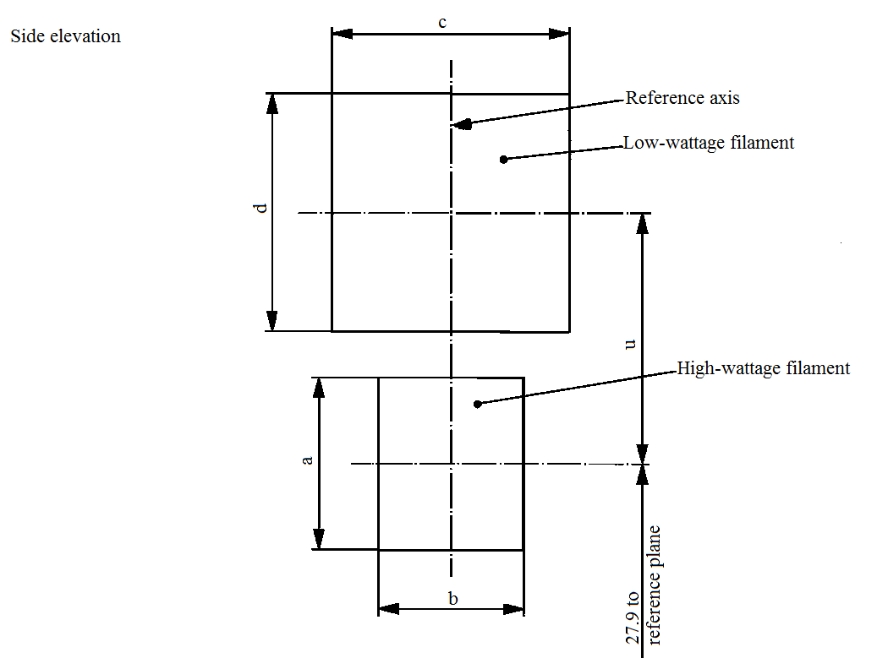
Ø 27.9 to
reference plane
Reference axis
Side elevation
Low wattage filament
High wattage filament
Ø 27.9 to
c
b
a
d
u

Reference | a | b | c | d | u
Dimension | 3.5 | 3.0 | 4.8 |  | 5.1
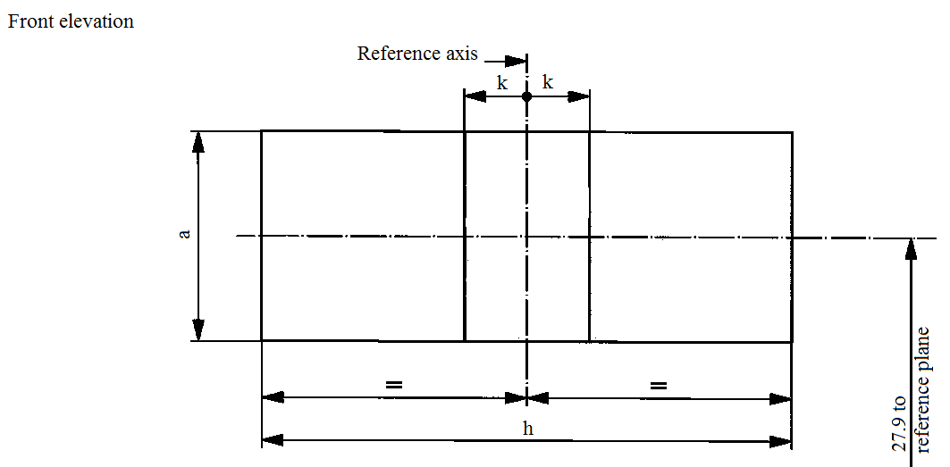
Ø 27.9 to
reference plane
Reference axis
Front elevation
k
k
h
a
Reference | a | h | k
Dimension | 3.5 | 11.9 | 1.0

Sheet PC16W/1
Categories PC16W, PCY16W, PCR16W, PW16W, PWY16W and PWR16W
The drawings are intended only to illustrate the essential dimensions (in mm) of the filament light source.

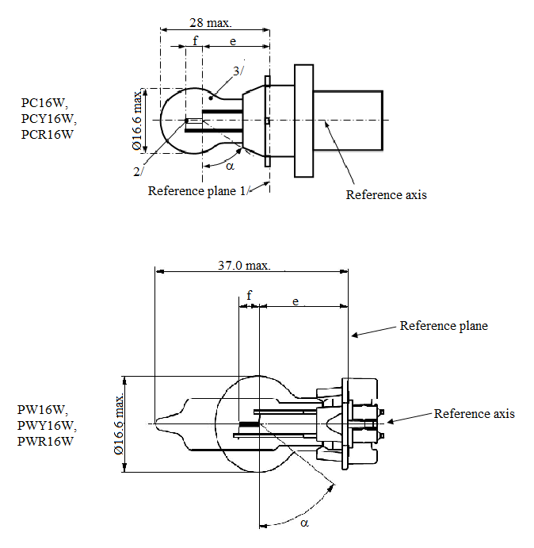
28 max.
37.0 max.
Ø 16.6 max.
Ø 16.6 max.
f
f
e
e
3/
2/
α
α
Reference plane^{1//}
Reference plane
Reference axis
Reference axis
PC16W,
PCY16W,
PCR16W
PW16W,
PWY16W,
PWR16W

^{1/} The reference plane is defined by the meeting points of the cap-holder fit.
^{2/} No actual filament diameter restrictions apply but the objective is d max. = 1.1 mm.
^{3/} The light emitted from normal production filament light sources shall be white for category PC16W and PW16W; amber for category PCY16W and PWY16W; red for category PCR16W and PWR16W.
(see also footnote 7/).
Sheet PC16W/2
Categories PC16W, PCY16W, PCR16W, PW16W, PWY16W and PWR16W

Dimensions in mm |  |  |  |  | Filament light sources of normal production |  |  |  |  | Standard filament light source ^{7/}
 |  |  |  |  | Min. |  | Nom. |  | Max. | Standard filament light source ^{7/}
e ^{4/, 5/} | PC16W  PCY16W  PCR16W |  |  |  |  |  | 18.5 |  |  | 18.5
e ^{4/, 5/} | PW16W  PWY16W  PWR16W |  |  |  |  |  | 17.1 |  |  | 17.1
f ^{4/, 5/} |  |  |  |  |  |  | 4.0 |  |  | 4.0 ± 0.2
α ^{6/} |  |  |  |  | 54° |  |  |  |  | 54° min.
PC16W Cap PU20d-1  PCY16W Cap PU20d-2  PCR16W Cap PU20d-7 |  |  |  | in accordance with IEC Publication 60061 (sheet 7004-158-1)
PW16W Cap WP3.3x14.5-8  PWY16W Cap WP3.3x14.5-9  PWR16W Cap WP3.3x14.5-10 |  |  |  | in accordance with IEC Publication 60061 (sheet 7004-164-2)
Electrical and photometric characteristics
Rated values |  | Volts |  |  |  | 12 |  |  |  | 12
 |  | Watts |  |  |  | 16 |  |  |  | 16
Test voltage |  | Volts |  |  |  | 13.5 |  |  |  | 13.5
Objective values |  | Watts |  |  |  | 17 max. |  |  |  | 17 max.
 |  | Luminous flux | PC16W  PW16W |  |  | 300 ± 15 %
 |  | Luminous flux | PCY16W  PWY16W |  |  | 180 ± 20 %
 |  | Luminous flux | PCR16W  PWR16W |  |  | 70 ± 20 %
Reference luminous flux at approximately |  |  |  |  |  |  |  | 13.5 V |  | White: 300 lm  Amber: 180 lm  Red: 70 lm
^{4/} The filament position is checked by means of a "Box system"; sheet PC16W/3.
^{5/} The ends of the filament are defined as the points where, when the viewing direction is perpendicular to the plane through the filament lead-in wires as showed in the drawing on sheet PC16W/1, the projection of the outside of the end turns crosses the filament axis.
^{6/} No part of the cap beyond the reference plane shall interfere with angle α. The bulb shall be optically distortion free within the angle 2α + 180°.
^{7/} The light emitted from standard filament light sources shall be white for category PC16W and PW16W; white or amber for category PCY16W and PWY16W; white or red for category PCR16W and PWR16W.

Sheet PC16W/3
Categories PC16W, PCY16W, PCR16W, PW16W, PWY16W and PWR16W
Screen projection requirements
This test is used to determine, by checking whether the filament is correctly positioned relative to the reference axis and reference plane, whether a filament light source complies with the requirements.

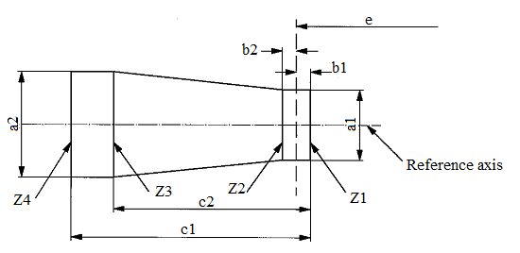
e
b2
b1
c1
c2
Z4
Z3
Z2
Z1
a2
a1
Reference axis

PC16W, PCY16W, PCR16W | a1 | a2 | b1, b2 | c1 | c2
Filament light sources of normal production | 2.9 | 3.9 | 0.5 | 5.2 | 3.8
Standard filament light sources | 1.5 | 1.7 | 0.25 | 4.7 | 3.8

PW16W, PWY16W and PWR16W | a1 | a2 | b1, b2 | c1 | c2
Filament light sources of normal production | 2.5 | 2.5 | 0.4 | 5.2 | 3.8
Standard filament light sources | 1.5 | 1.7 | 0.25 | 4.7 | 3.8

The filament position is checked in two mutually perpendicular planes, one of them being the plane through the lead-in wires.
The ends of the filament as defined on sheet PC16W/2, footnote 5/, shall lie between Z1 and Z2 and between the lines Z3 and Z4.
The filament shall lie entirely within the limits shown.
Category PR21W Sheet PR21W/1
The drawings are intended only to illustrate the essential dimensions (in mm) of the filament light source.
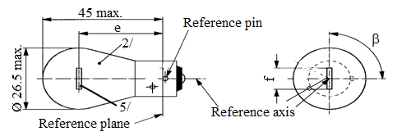
Reference axis
Reference pin
Reference plane
Ø 26.5 max.

45 max.
e
2/
5/
ß
f
Dimensions in mm |  |  | Filament light sources of normal production |  |  |  |  | Standard filament light source ^{4/}
 |  |  | Min. |  | Nom. |  | Max. | Standard filament light source ^{4/}
e | 12 V |  |  |  | 31.8 ^{3/} |  |  | 31.8 ± 0.3
e | 24 V |  | 30.8 |  | 31.8 |  | 32.8
f | 12 V |  | 5.5 |  | 6.0 |  | 7.0 | 6.0 ± 0.5
Lateral deviation ^{1/} | 12 V |  |  |  |  |  | ^{3/} | 0.3 max
Lateral deviation ^{1/} | 24 V |  |  |  |  |  | 1.5
β |  |  | 75° |  | 90° |  | 105° | 90° ± 5°
Cap BAW15s in accordance with IEC Publication 60061 (sheet 7004-11E-1)
Electrical and photometric characteristics
Rated values: |  | Volts |  | 12 |  | 24 |  | 12
 |  | Watts |  | 21 |  |  |  | 21
Test voltage: |  | Volts |  | 13.5 |  | 28.0
Objective values: |  | Watts |  | 26.5 max. |  | 29.7 max. |  | 26.5 max.
 |  | Luminous flux: |  | 110 ± 20 %
Reference luminous flux at approximately 13.5 V: |  |  |  |  |  |  |  | White: 460 lm  Red: 110 lm
^{1/} Maximum lateral deviation of filament centre from two mutually perpendicular planes both containing the reference axis and one containing the axis of the reference pin.
^{2/} The light emitted from normal production filament light sources shall be red (see also footnote 4/).
^{3/} To be checked by means of a "Box system", sheet P21W/2.
^{4/} The light emitted from standard filament light sources shall be white or red.
^{5/} In this view the filament of the 24 V type may be straight or V-shaped. If it is straight, the screen projection requirements, sheet P21W/2, apply. If it is V-shaped, the filament ends shall be at the same distance within ±3 mm from the reference plane.
Category PR21/4W Sheet PR21/4W/1
The drawings are intended only to illustrate the essential dimensions (in mm) of the filament light source.
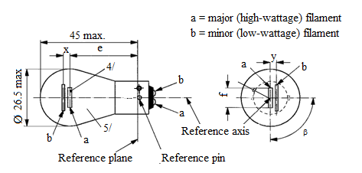
a = major (high wattage) filament
b = minor (low wattage) filament
45 max.
Ø 26.5 max.

Reference axis
Reference plane
Reference pin
e
b
a
a
b
a
b
x
ß
y
f
4/
5/
Dimensions in mm |  | Filament light sources of normal production ^{5/} |  |  |  |  | Standard filament light source ^{6/}
 |  | Min. | Nom. | Max. |  |  | Standard filament light source ^{6/}
e |  |  | 31.8 ^{1/} |  |  |  | 31.8 ± 0.3
f |  |  |  | 7.0 |  |  | 7.0 + 0 / -2
Lateral deviation |  |  |  | ^{1/} |  |  | 0.3 max.^{2/}
x,y |  | ^{1/} |  |  |  |  | 2.8 ± 0.5
β |  | 75° ^{1/} | 90° ^{1/} | 105° ^{1/} |  |  | 90° ± 5°
Cap BAU15d in accordance with IEC Publication 60061 (sheet 7004-19-2)
Electrical and photometric characteristics
Rated values | Volts | 12 |  | 24 ^{4/} |  |  | 12
Rated values | Watts | 21 | 4 | 21 |  | 4 | 21/4
Test voltage | Volts | 13.5 |  | 28.0 |  |  | 13.5
Objective values | Watts | 26.5 max. | 5.5 max. | 29.7 max. |  | 8.8 max. | 26.5/5.5 max.
Objective values | Luminous flux | 105 | 4 | 105 |  | 5
Objective values | ± % | 20 | 25 | 20 |  | 25
Reference luminous flux at approximately 13.5 V: |  |  |  |  | White: 440 lm and 15 lm  Red: 105 lm and 4 lm
^{1/} These dimensions shall be checked by means of a "Boxsystem"³ based on the dimensions and tolerances shown above. "x" and "y" refer to the major (high wattage) filament, not to the reference axis. Means of increasing the positioning accuracy of the filament and of the cap-holder assembly are under consideration.
^{2/} Maximum lateral deviation of the major filament centre from two mutually perpendicular planes both containing the reference axis and one containing the axis of the reference pin.
^{3/} The "Box system" is the same as for filament light source P21/5W; see sheets P21/5W/2 to 3.
^{4/} The 24-volt filament light source is not recommended for future embodiments.
^{5/} The light emitted from normal production filament light sources shall be red (see also footnote 6/).
^{6/} The light emitted from standard filament light sources shall be white or red.
Category PR21/5W Sheet PR21/5W/1
The drawings are intended only to illustrate the essential dimensions (in mm) of the filament light source.
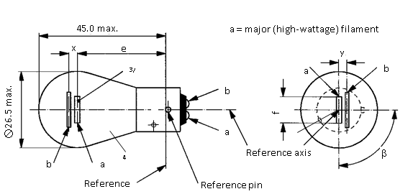
45.0 max.
Ø 26.5 max.

a = major (high wattage) filament
b = minor (low wattage) filament
Reference axis
Reference plane
Reference pin
3/
4/
e
x
b
a
b
b
a
a
y
f
ß
Dimensions in mm |  |  | Filament light sources of normal production ^{4/} |  |  |  |  |  |  | Standard filament light source ^{5/}
 |  |  | Min. |  | Nom. |  | Max. |  |  | Standard filament light source ^{5/}
e |  | 12 V |  |  | 31.8 ^{1/} |  |  |  |  | 31.8 ± 0.3
 |  | 24 V | 30.8 |  | 31.8 |  | 32.8
f |  | 12 V |  |  |  |  | 7.0 |  |  | 7.0 + 0 / -2
Lateral deviation ^{2/} |  | 12 V |  |  |  |  | ^{1/} |  |  | 0.3 max.
 |  | 24 V |  |  |  |  | 1.5
x, y |  | 12 V |  |  | ^{1/} |  |  |  |  | 2.8 ± 0.3
x |  | 24 V ^{3/} | -1.0 |  | 0 |  | 1.0
y |  | 24 V ^{3/} | 1.8 |  | 2.8 |  | 3.8
β |  |  | 75° |  | 90° |  | 105° |  |  | 90° ± 5°
Cap BAW15d in accordance with IEC Publication 60061 (sheet 7004-11E-1)
Electrical and photometric characteristics
Rated values | Volts |  | 12 |  |  | 24 |  |  |  | 12
Rated values | Watts |  | 21 | 5 |  | 21 |  |  | 5 | 21/5
Test voltage | Volts |  | 13.5 |  |  | 28.0 |  |  |  | 13.5
Objective values | Watts |  | 26.5 max. | 6.6 max. |  | 29.7 max. |  |  | 11.0 max. | 26.5 and 6.6 max.
Objective values | Luminous flux  ± % |  | 105 | 8 |  | 105 |  |  | 10
Objective values | ± % |  | 20 | 25 |  | 20 |  |  | 25
Reference luminous flux at approximately 13.5 V: |  |  |  |  |  |  |  | White: 440 lm and 35 lm  Red: 105 lm and 8 lm
^{1/} See footnote 1/ on sheet P21/5W/2.
^{2/} See footnote 2/ on sheet P21/5W/2.
^{3/} See footnote 3/ on sheet P21/5W/2.
^{4/} The light emitted from normal production filament light sources shall be red (see also footnote 5/).
^{5/} The light emitted from standard filament light sources shall be white or red.
Category PR27/7W Sheet PR27/7W/1
The drawings are intended only to illustrate the essential dimensions (in mm) of the filament light source.
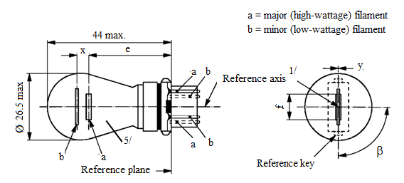
a = major (high wattage) filament
b = minor (low wattage) filament
44 max.
Ø 26.5 max.

e
x
a
a
a
b
b
b
y
5/
ß
Reference axis^{1/}
Reference plane
Reference key
Dimensions in mm |  | Filament light sources of normal production |  |  |  |  | Standard filament light source ^{6/}
 |  | Min. | Nom. |  | Max.
e |  |  | 27.9 ^{3/} |  |  |  | 27.9 ± 0.3
f |  |  |  |  | 9.9 |  | 9.9 + 0 / -2
Lateral deviation ^{2/} |  |  |  |  | ^{3/} |  | 0.0 ± 0.4
x ^{4/} |  |  | 5.1 ^{3/} |  |  |  | 5.1 ± 0.5
y ^{4/} |  |  | 0.0 ^{3/} |  |  |  | 0.0 ± 0.5
β |  | 75° ^{3/} | 90° |  | 105° ^{3/} |  | 90° ± 5°
Cap WU2.5x16q in accordance with IEC Publication 60061 (sheet 7004-104D-1)
Electrical and photometric characteristics
Rated values | Volts | 12 |  |  |  |  | 12
Rated values | Watts | 27 |  | 7 |  |  | 27 | 7
Test voltage | Volts | 13.5 |  |  |  |  | 13.5
Objective values | Watts | 32.1 max. |  | 8.5 max. |  |  | 32.1 max. | 8.5 max.
Objective values | Luminous flux | 110 ± 20 % |  | 9 ± 20 %
Reference luminous flux at approximately 13.5 V: |  |  |  |  |  | White: 475 and 36 lm  Red: 110 and 9 lm
^{1/} The reference axis is defined with respect to the reference keys and is perpendicular to the reference plane.
^{2/} Maximum lateral deviation of the major (high wattage) filament centre from two mutually perpendicular planes both containing the reference axis and one containing the axis through the reference keys.
^{3/} To be checked by means of a "Box system", sheets P27/7W/2 and 3.
^{4/} "x" and 'y" denote the offset of the axis of the minor (low wattage) filament with respect to the axis of the major (high wattage) filament.
^{5/} The light emitted from normal production filament light sources shall be red (see also footnote 6/).
^{6/} The light emitted from standard filament light sources shall be white or red.
Category PSX26W Sheet PSX26W/1
The drawings are intended only to illustrate the essential dimensions (in mm) of the filament light source.
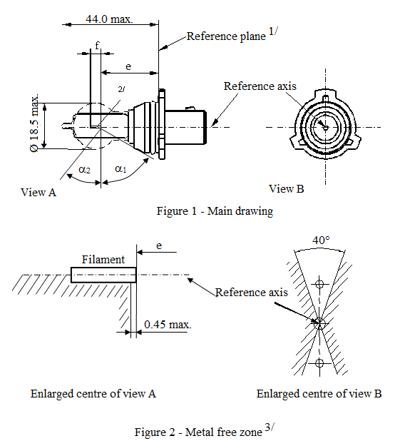
44.0 max.
Reference plane^{1/}
Ø 18.5 max.

0.45 max.
Reference axis
Reference axis
View A
View B
f
e
e
2/
α₂
α₁
Figure 1 – Main drawing
Figure 2 – Metal free zone^{3/}
40°
Filament
Enlarged centre of view A
Enlarged centre of view B

^{1/} The reference plane is defined by the meeting points of the cap-holder fit.
^{2/} No actual filament diameter restrictions apply but the objective is d max. = 1.1 mm.
^{3/} No opaque parts other than filament turns shall be located in the shaded area indicated in Figure 2. This applies to the rotational body within the angles α₁ + α₂.
Category PSX26W Sheet PSX26W/2
Dimensions in mm |  |  |  |  | Filament light sources of normal production | Standard filament light source
e ^{5/} |  |  |  |  | 24.0 ^{4/} | 24.0 ± 0.25
f ^{5/} |  |  |  |  | 4.2 ^{4/} | 4.2 ± 0.25
α₁ ^{6/} |  |  |  |  | 35.0° min. | 35.0° min.
α₂ ^{6/} |  |  |  |  | 58.0° min. | 58.0° min.
Cap PG18.5d-3 |  | in accordance with IEC Publication 60061 (sheet 7004-147-1)
Electrical and photometric characteristics
Rated values | Voltage |  | V | 12 |  | 12
Rated values | Wattage |  | W | 26 |  | 26
Test voltage |  |  | V | 13.5 |  | 13.5
Objective values | Wattage |  | W | 26 max. |  | 26 max.
Objective values | Luminous flux |  | lm | 500
Objective values |  |  | ± | +10 % / -10 %
Reference luminous flux at approximately 12 V |  |  |  |  |  | 345 lm
Reference luminous flux at approximately 13.2 V |  |  |  |  |  | 465 lm
Reference luminous flux at approximately 13.5 V |  |  |  |  |  | 500 lm

^{4/} To be checked by means of a "Box system"; sheet PSX26W/3.
^{5/} The ends of the filament are defined as the points where, when the viewing direction is perpendicular to the plane through the filament lead-in wires, the projection of the outside of the end turns crosses the filament axis.
^{6/} No part of the cap beyond the reference plane shall interfere with angle α₂ as shown in Figure 1 on sheet PSX26W/1. The bulb shall be optically distortion free within the angles α₁+ α₂.
These requirements apply to the whole bulb circumference.

Category PSX26W Sheet PSX26W/3
Screen projection requirements
This test is used to determine, by checking whether the filament is correctly positioned relative to the reference axis and reference plane, whether a filament light source complies with the requirements.
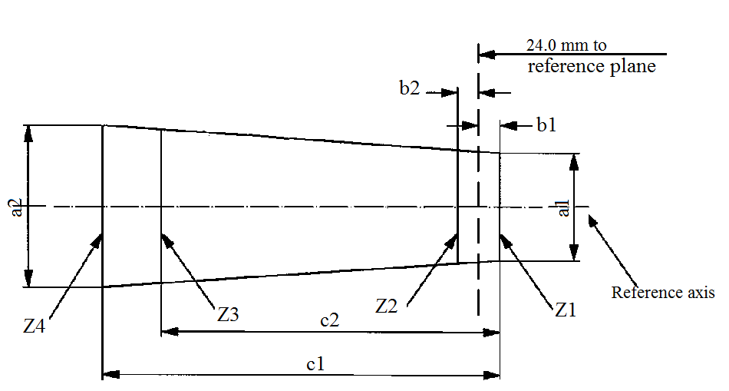
24.0 mm to
reference plane
b2
b1
c1
c2
Z2
Z1
Z3
Z4
Reference axis
a2
a1

 | a1 | a2 | b1,b2 | c1 | c2
Filament light sources of normal production | 1.7 | 1.7 | 0.30 | 5.0 | 4.0
Standard filament light sources | 1.5 | 1.5 | 0.25 | 4.7 | 4.0
The filament position is checked in two mutually perpendicular planes, one of them being the plane through the lead-in wires.
The ends of the filament as defined on sheet PSX26W/2, footnote 4/, shall lie between Z1 and Z2 and between the lines Z3 and Z4.
The filament shall lie entirely within the limits shown.
Category PY21W Sheet PY21W/1
The drawings are intended only to illustrate the essential dimensions (in mm) of the filament light source.
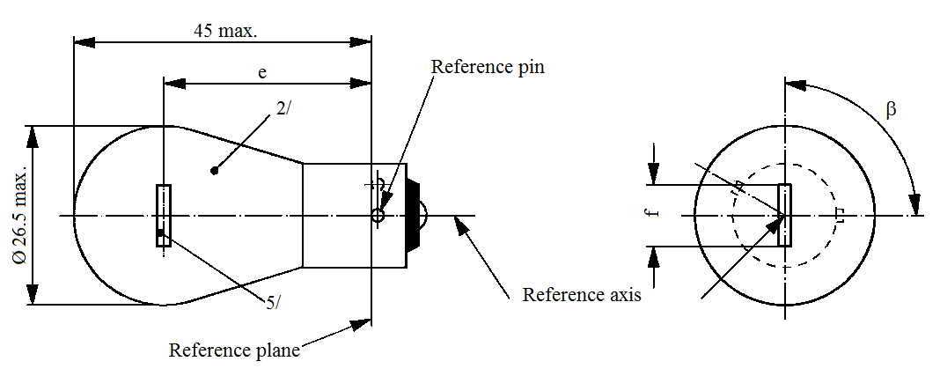
45 max.
Ø 26.5 max.

e
2/
5/
Reference plane
Reference pin
Reference axis
f
ß

Dimensions in mm |  |  |  | Filament light sources of normal production |  |  |  | Standard filament light source ^{4/}
 |  |  |  | Min. | Nom. |  | Max. | Standard filament light source ^{4/}
e |  | 12 V |  |  | 31.8 ^{3/} |  |  | 31.8 ± 0.3
 |  | 24 V |  | 30.8 | 31.8 |  | 32.8
f |  | 12 V |  |  |  |  | 7.0 | 7.0 +0 / -2
Lateral deviation ^{1/} |  | 12 V |  |  |  |  | ^{3/} | 0.3 max.
 |  | 24 V |  |  |  |  | 1.5
β |  |  |  | 75° | 90° |  | 105° | 90° ± 5°
Cap BAU15s in accordance with IEC Publication 60061 (sheet 7004-19-2)
Electrical and photometric characteristics
Rated values | Volts |  | 12 |  |  | 24 |  | 12
Rated values | Watts |  | 21 |  |  |  |  | 21
Test voltage | Volts |  | 13.5 |  |  | 28.0 |  | 13.5
Objective values | Watts |  | 26.5 max. |  |  | 29.7 max. |  | 26.5 max.
Objective values | Luminous flux |  | 280 ± 20 %
Reference luminous flux at approximately 13.5 V: |  |  |  |  |  |  |  | White: 460 lm  Amber: 280 lm

^{1/} Maximum lateral deviation of filament centre from two mutually perpendicular planes both containing the reference axis and one containing the axis of the reference pin.
^{2/} The light emitted from production filament light sources shall be amber (see also footnote 4/).
^{3/} To be checked by means of a "Box system"; sheet P21W/2.
^{4/} The light emitted from standard filament light sources shall be amber or white.
^{5/} In this view the filament of the 24 V type may be straight or V-shaped. If it is straight, the screen projection requirements, sheet P21W/2, apply. If it is V-shaped, the filament ends shall be at the same distance within ±3 mm from the reference plane.
Category PY21/5W Sheet PY21/5W/1
The drawings are intended only to illustrate the essential dimensions (in mm) of the filament light source.

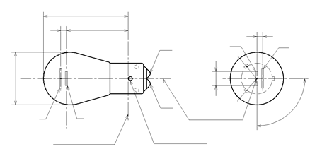
Reference plane
Reference pin
Reference axis
β
b
A

a
b
A

a
b
A

a
y
a
A

a
a
A

a
a
A

a
e
x
Ø 26.5 max.
42 max.
Dimensions in mm |  |  | Filament light sources of normal production ^{3/} |  |  |  | Standard filament light source ^{4/}
 |  |  | Min. | Nom. |  | Max.
e |  |  |  | 28.6 ^{1/} |  |  | 28.6 ± 0.3
f |  |  |  |  |  | 7.0 | 7.0 + 0/- 2
Lateral deviation ^{2/} |  |  |  |  |  | ^{1/} | 0.3 max.
x, y |  |  |  | ^{1/} |  |  | 2.8 ± 0.3
β |  |  | 75° | 90° |  | 105° | 90° ± 5°
Cap BA15d-3 (100°/130°) in accordance with IEC Publication 60061 (sheet 7004-173-1)
Electrical and photometric characteristics
Rated values | Volts | 12 |  |  |  |  |  | 12
Rated values | Watts | 21 |  |  | 5 |  |  | 21/5
Test voltage | Volts | 13.5 |  |  |  |  |  | 13.5
Objective values | Watts | 26.5 max. |  |  | 6.6 max. |  |  | 26.5 and 6.6 max.
Objective values | Luminous flux | 270 |  |  | 21
Objective values | ± % | 20 |  |  | 20
Reference luminous flux at approximately 13.5 V |  |  |  |  |  |  |  | White: 440 lm and 35 lm  Amber: 270 lm and 21 lm
^{1/} These dimensions shall be checked by means of a "Box system". See sheets PY21/5W/2 and PY21/5W/3. "x" and "y" refer to the major (high wattage) filament, not to the reference axis.
^{2/} Maximum lateral deviation of the major (high wattage) filament centre from two mutually perpendicular planes both containing the reference axis and one containing the axis of the reference pin.
^{3/} The light emitted from normal production filament light sources shall be amber (see also note 4/).
^{4/} The light emitted from standard filament light sources shall be white or amber.
Category PY21/5W Sheet PY21/5W/2
Screen projection requirements
This test is used to determine, by checking whether:
(a) The major (high wattage) filament is correctly positioned relative to the reference axis and reference plane and has an axis perpendicular, within ±15°, to the plane through the centres of the pins and the reference axis; and whether
(b) The minor (low wattage) filament is correctly positioned relative to the major (high wattage) filament, whether a filament light source complies with the requirements.
Test procedure and requirements
1. The filament light source is placed in a holder capable of being rotated about its axis and having either a calibrated scale or fixed stops corresponding to the angular displacement tolerance limits. (i.e. 15°). The holder is then so rotated that an end view of the major filament is seen on the screen on which the image of the filament is projected. The end view of that filament shall be obtained within the angular displacement tolerance limits.
2. Side elevation
The filament light source placed with the cap down, the reference axis vertical, the reference pin to the right and the major filament seen end-on:
2.1. The projection of the major filament shall lie entirely within a rectangle of height "a" and width "b", having its centre at the theoretical position of the centre of the filament;
2.2. The projection of the minor filament shall lie entirely:
2.2.1. Within a rectangle of width "c" and height "d" having its centre at a distance "v" to the right of and at a distance "u" above the theoretical position of the centre of the major filament;
2.2.2. Above a straight line tangential to the upper edge of the projection of the major filament and rising from left to right at an angle of 25°.
2.2.3. To the right of the projection of the major filament
3. Front elevation
The filament light source being placed with the cap down and the reference axis vertical, the filament light source being viewed in a direction at right angles to axis of the major filament:
3.1. The projection of the major filament shall lie entirely within a rectangle of height "a" and width "h", centred on the theoretical position of the centre of the filament;
3.2. The centre of the major filament shall not be offset by more than distance "k" from the reference axis.
3.3. The centre of the minor filament axis shall not be offset from the reference axis by more than ±2 mm (±0.4 mm for standard filament light sources).
Category PY21/5W Sheet PY21/5W/3
Dimensions in mm
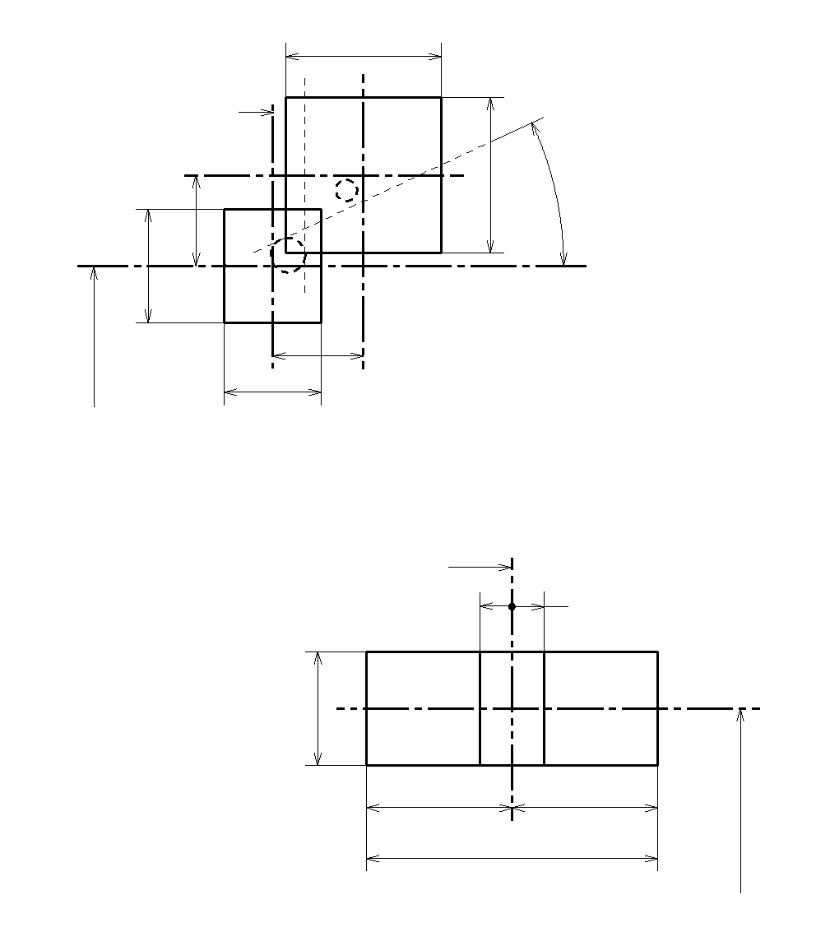
Low wattage filament
c
25°
d
Reference axis
u
v
High wattage filament
Side elevation
28.6 to
reference plane
b
a
28.6 to
reference plane
h
=
=
k
k
Reference axis
a
Front elevation
ReferenceabcduvDimensions3.53.04.82.8
Reference | a | h | k
Dimensions | 3.5 | 9.0 | 1.0
a
28.6 to
reference plane
h
=
=
k
k
Reference axis
Front elevation
Reference | a | b | c | d | u | v
Dimensions | 3.5 | 3.0 | 4.8 |  | 2.8

Reference | a | h | k
Dimensions | 3.5 | 9.0 | 1.0

Category PY27/7W Sheet PY27/7W/1
The drawings are intended only to illustrate the essential dimensions (in mm) of the filament light source.
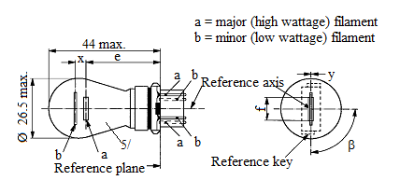
a = major (high wattage) filament
b = minor (low wattage) filament
Reference axis
Ø 26.5 max.
44 max.
e
x
a
a
a
b
b
b
5/
ß
y
Reference plane
f
Reference key
Dimensions in mm |  | Filament light sources of normal production |  |  |  | Standard filament light source ^{6/}
 |  | Min. | Nom. |  | Max.
e |  |  | 27.9 ^{3/} |  |  | 27.9 ± 0.3
f |  |  |  |  | 9.9 | 9.9 + 0 / -2
Lateral deviation ^{2/} |  |  |  |  | ^{3/} | 0.0 ± 0.4
x ^{4/} |  |  | 5.1 ^{3/} |  |  | 5.1 ± 0.5
y ^{4/} |  |  | 0.0 ^{3/} |  |  | 0.0 ± 0.5
β |  | 75° ^{3/} | 90° |  | 105° ^{3/} | 90° ± 5°
Cap WX2.5x16q in accordance with IEC Publication 60061 (sheet 7004-104A-1)
Electrical and photometric characteristics
Rated values | Volts | 12 |  |  |  | 12
Rated values | Watts | 27 |  | 7 |  | 27 | 7
Test voltage | Volts | 13.5 |  |  |  | 13.5
Objective values | Watts | 32.1 max. |  | 8.5 max. |  | 32.1 max. | 8.5 max.
Objective values | Luminous flux | 280 ± 15 % |  | 21 ± 15 %
Reference luminous flux at approximately 13.5 V: |  |  |  |  |  | White: 475 and 36 lm  Amber: 280 and 21 lm
^{1/} The reference axis is defined with respect to the reference keys and is perpendicular to the reference plane.
^{2/} Maximum lateral deviation of the major (high wattage) filament centre from two mutually perpendicular planes both containing the reference axis and one containing the axis through the reference keys.
^{3/} To be checked by means of a "Box system", sheets P27/7W/2 and 3.
^{4/} "x" and 'y" denote the offset of the axis of the minor (low wattage) filament with respect to the axis of the major (high wattage) filament.
^{5/} The light emitted from filament light sources of normal production shall be amber (see also footnote 6/).
^{6/} The light emitted from standard filament light sources shall be amber or white.
Category R2 Sheet R2/1
The drawings are intended only to illustrate the essential dimensions (in mm) of the filament light source.
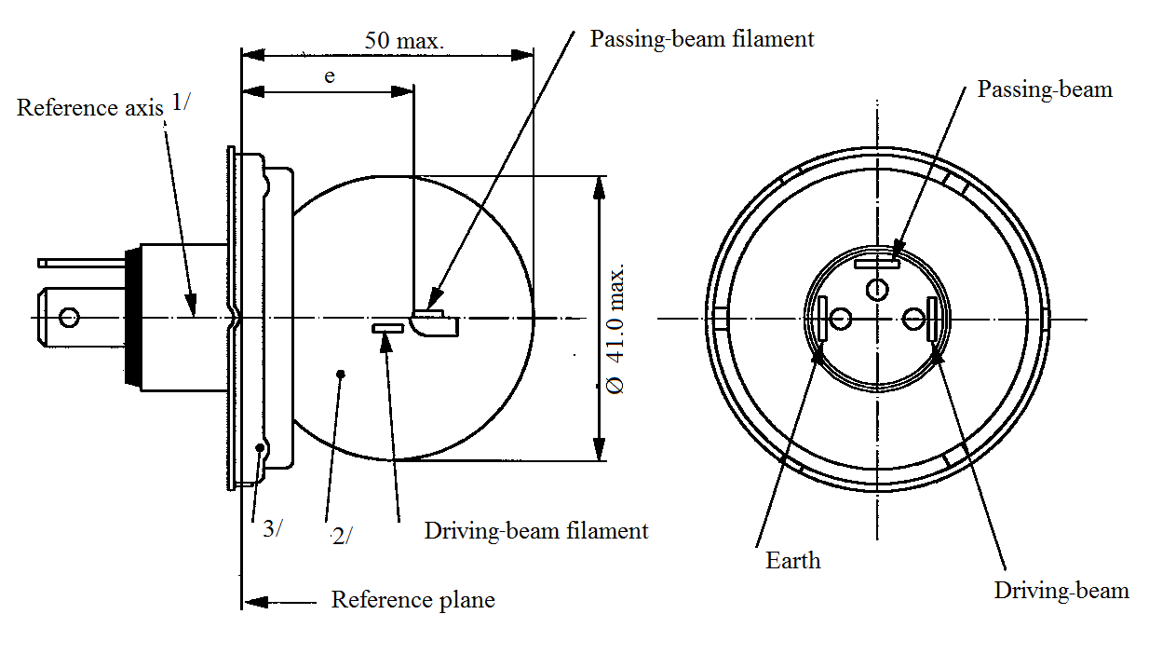
Reference axis^{1/}
50 max.
e
3/
2/
Ø 41.0 max.
Passing-beam filament
Passing-beam
Driving-beam
Earth
Reference plane
Driving-beam filament
Electrical and photometric characteristics
 |  | Filament light sources of normal production |  |  |  |  |  | Standard filament light source
Rated values | Volts | 6 ^{4/} |  | 12 ^{4/} |  | 24 ^{4/} |  | 12 ^{4/}
Rated values | Watts | 45 | 40 | 45 | 40 | 55 | 50 | 45 | 40
Test voltage | Volts | 6.3 |  | 13.2 |  | 28.0 |  | 13.2
Objective values | Watts | 53 max. | 47 max. | 57 max. | 51 max. | 76 max. | 69 max. | 52  +0 %  -10 % | 46  ±5 %
Objective values | Luminous  flux | 720 min. | 570  ±15 % | 860 min. | 675  ±15 % | 1,000 min. | 860  ±15 %
Measuring flux ^{5/} |  | - | 450 | - | 450 | - | 450
Reference luminous flux at approximately 12 V |  |  |  |  |  |  |  | 700 | 450
^{1/} The reference axis is perpendicular to the reference plane and passes through the centre of the 45 mm cap diameter.
^{2/} The colour of the light emitted shall be white or selective-yellow.
^{3/} No part of the cap shall, by reflection of light emitted by the passing-beam filament, throw any stray rising ray when the filament light source is in the normal operating position on the vehicle.
^{4/} The values indicated on the left and on the right refer to the driving-beam filament and the passing-beam filament respectively.
^{5/} Measuring luminous flux according to the provisions for filament light sources with an internal shield to produce the cut-off.
Category R2 Sheet R2/2
Position and dimensions (in mm) of shield and filaments
The drawings are not mandatory with respect to the design of the shield and filaments.
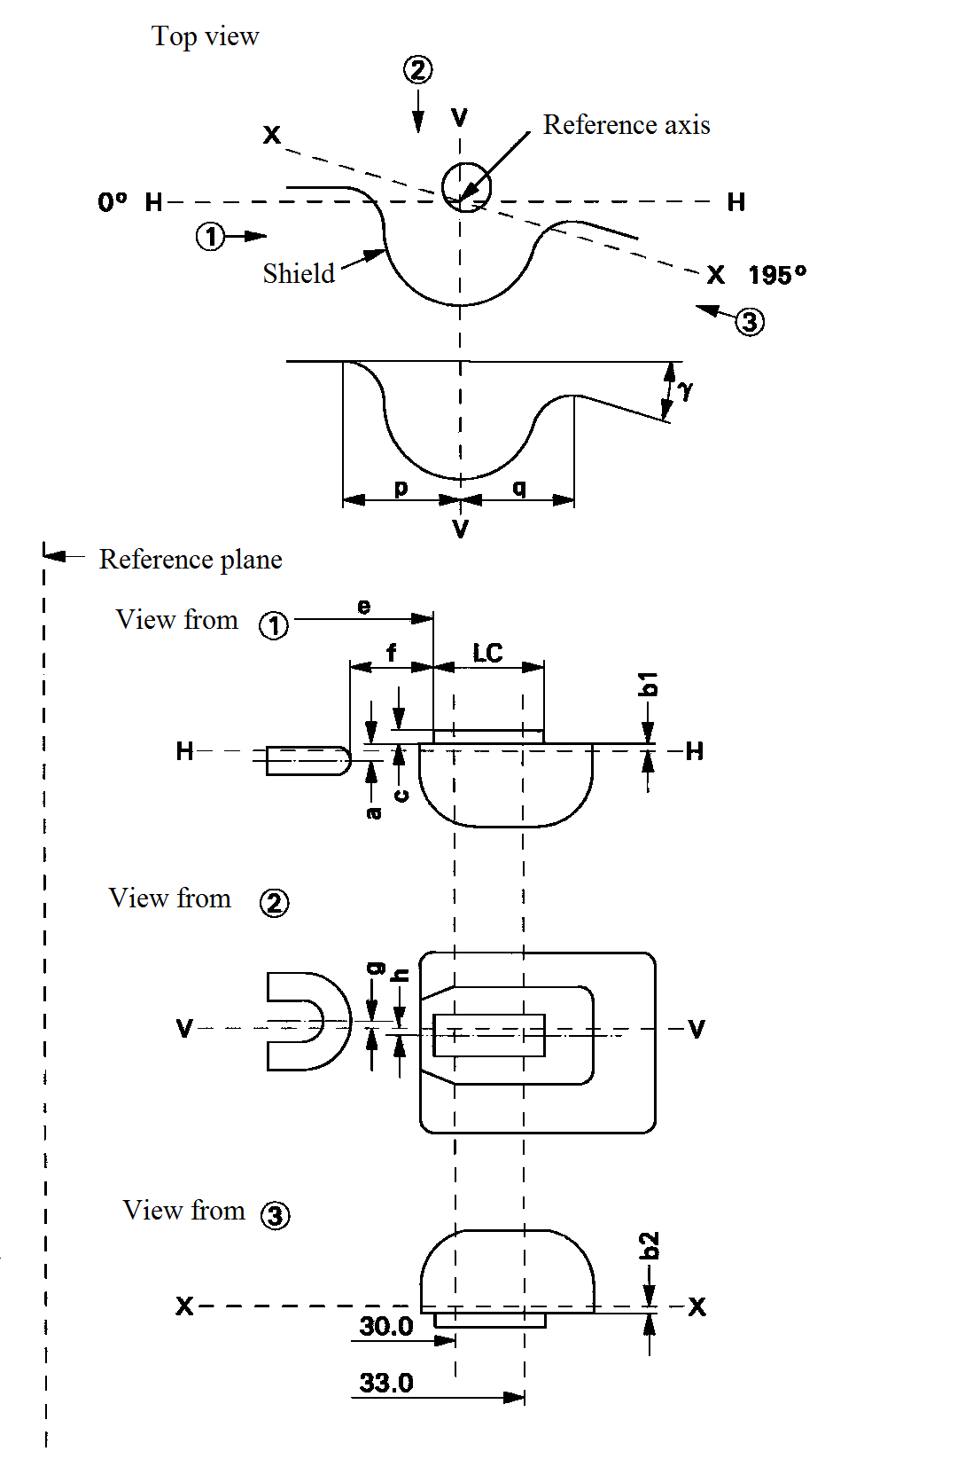
Top view
Reference axis
Reference plane
View from
View from
Shield
View from
V
0° H
H
H
H
X
X 195°
V
V
X
X
30.0
33.0
b1
b2
e
f
p
q
LC
c
h
g




●
a
ɣ
Category R2 Sheet R2/3

Filaments and shield position and dimensions ^{1/}
Dimensions in mm |  |  | Tolerance
 |  |  | Filament light sources of normal production | Standard filament light source
 |  |  | 6 V 12 V 24 V | 12 V
a |  | 0.60 | ±0.35 | ±0.15
b1/30.0 ^{2/}  b1/33.0 |  | 0.20  b1/30.0 mv ^{3/} | ±0.35 | ±0.15
b2/30.0 ^{2/}  b2/33.0 |  | 0.20  b2/30.0 mv ^{3/} | ±0.35 | ±0.15
c/30.0 ^{2/}  c/33.0 |  | 0.50  c/30.0 mv ^{3/} | ±0.30 | ±0.15
e | 6, 12 V  24 V | 28.5  28.8 | ±0.35 | ±0.15
f | 6, 12 V  24 V | 1.8  2.2 | ±0.40 | ±0.20
g |  | 0 | ±0.50 | ±0.30
h/30.0 ^{2/}  h/33.0 |  | 0  h/30.0 mv ^{3/} | ±0.50 | ±0.30
1/2(p-q) |  | 0 | ±0.60 | ±0.30
I_{C} |  | 5.5 | ±1.50 | ±0.50
γ ^{4/} |  | 15° nom.
Cap P45t-41 in accordance with IEC Publication 60061 (sheet 7004-95-5)
^{1/} The position and dimensions of the shield and filaments shall be checked by means of the method of measurement as described in IEC Publication 60809.
^{2/} To be measured at the distance from the reference plane indicated in millimetres behind the stroke.
^{3/} mv = measured value.
^{4/} The angle γ is only for shield design and has not to be checked on finished filament light sources.
Category R5W and RR5W Sheet R5W/1
The drawings are intended only to illustrate the essential dimensions (in mm) of the filament light source.
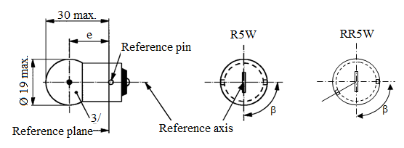
Reference axis
3/
Reference plane
Reference pin
Ø 19 max.
30 max.
R5W
RR5W
ß
ß
e

Dimensions in mm |  |  |  |  | Filament light sources of normal production |  |  |  |  |  | Standard filament light source ^{4/}
 |  |  |  |  | Min. |  |  | Nom. | Max. |  | Standard filament light source ^{4/}
e |  |  |  |  | 17.5 |  |  | 19.0 | 20.5 |  | 19.0 ± 0.3
Lateral deviation ^{2/} |  |  |  |  |  |  |  |  | 1.5 |  | 0.3 max.
β |  |  |  |  | 60° |  |  | 90° | 120° |  | 90° ± 5°
Cap: | R5W: BA15s  RR5W: BAW15s |  |  |  | in accordance with IEC Publication 60061 |  |  |  |  | (sheet 7004-11A-9) ^{1/}  (sheet 7004-11E-1)
Electrical and photometric characteristics
Rated values |  |  | Volts | 6 ^{5/} |  |  | 12 |  | 24 |  | 12
 |  |  | Watts | 5 |  |  |  |  |  |  | 5
Test voltage |  |  | Volts | 6.75 |  |  | 13.5 |  | 28.0 |  | 13.5
Objective values |  | Watts |  | 5.5 max. |  |  |  |  | 7.7 max. |  | 5.5 max.
 |  | Luminous  flux | R5W | 50 ± 20 %
 |  | Luminous  flux | RR5W | ^{5/} |  | 12 ± 25 %
Reference luminous flux at approximately 13.5 V: |  |  |  |  |  |  |  |  |  |  | White: 50 lm  Red: 12 lm
^{1/} Filament light sources with cap BA15d may be used for special purposes; they have the same dimensions.
^{2/} Maximum lateral deviation of filament centre from two mutually perpendicular planes both containing the reference axis and one containing the axis of the reference pin.
^{3/} The light emitted from filament light sources of normal production shall be white for category R5W and red for category RR5W (see also footnote 4/).
^{4/} The light emitted from standard filament light sources shall be white for category R5W; white or red for category RR5W.
^{5/} Within RR5W no 6 V rated voltage type specified.
Categories R10W, RY10W and RR10W Sheet R10W/1
The drawings are intended only to illustrate the essential dimensions (in mm) of the filament light source.
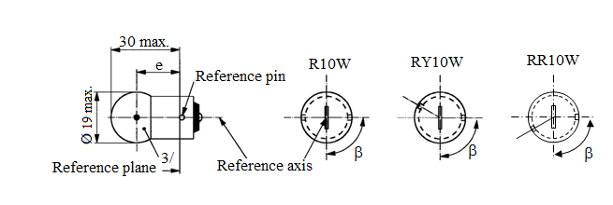
ß
ß
ß
30 max.
Ø 19 max.
3/
Reference plane
Reference pin
Reference axis
e
R10W
RY10W
RR10W
Dimensions in mm |  |  |  |  | Filament light sources of normal production |  |  |  | Standard filament light source ^{4/}
 |  |  |  |  | Min. |  | Nom. | Max. | Standard filament light source ^{4/}
e |  |  |  |  | 17.5 |  | 19.0 | 20.5 | 19.0 ± 0.3
Lateral deviation ^{2/} |  |  |  |  |  |  |  | 1.5 | 0.3 max.
β |  |  |  |  | 60° |  | 90° | 120° | 90° ± 5°
Cap | R10W: BA15s  RY10W: BAU15s  RR10W: BAW15s |  |  |  | in accordance with IEC Publication 60061 |  |  |  | (sheet 7004-11A-9) ^{1/}  (sheet 7004-19-2)  (sheet 7004-11E-1)
Electrical and photometric characteristics
Rated values |  |  |  | Volts | 6 ^{5/} | 12 |  | 24 | 12
 |  |  |  | Watts | 10 |  |  |  | 10
Test voltage |  |  |  | Volts | 6.75 | 13.5 |  | 28 | 13.5
Objective values |  | Watts |  | R10W  RY10W | 11 max. |  |  | 14 max. | 11 max.
 |  |  |  | RR10W | ^{5/} | 11 max. |  | 14 max. | 11 max.
 |  | Luminous flux |  | R10W | 125 ± 20 %
 |  |  |  | RY10W | 75 ± 20 %
 |  |  | RR10W |  | ^{5/} | 30 ± 25 %
Reference luminous flux at approximately 13.5 V: |  |  |  |  |  |  |  |  | White: 125 lm  Amber: 75 lm  Red: 30 lm
^{1/} Filament light sources R10W with cap BA15d may be used for special purposes; they have the same dimensions.
^{2/} Maximum lateral deviation of filament centre from two mutually perpendicular planes both containing the reference axis and one containing the axis of the reference pin.
^{3/} The light emitted from filament light sources of normal production shall be white for category R10W, amber for category RY10W and red for category RR10W (see also footnote 4/)
^{4/} The light emitted from standard filament light sources shall be white for category R10W; white or amber for category RY10W; white or red for category RR10W.
^{5/} Within RR10W no 6 V rated voltage type specified.
Categories S1 and S2 Sheet S1/S2/1
The drawings are intended only to illustrate the essential dimensions (in mm) of the filament light source.
Filament lamps for motorcycles
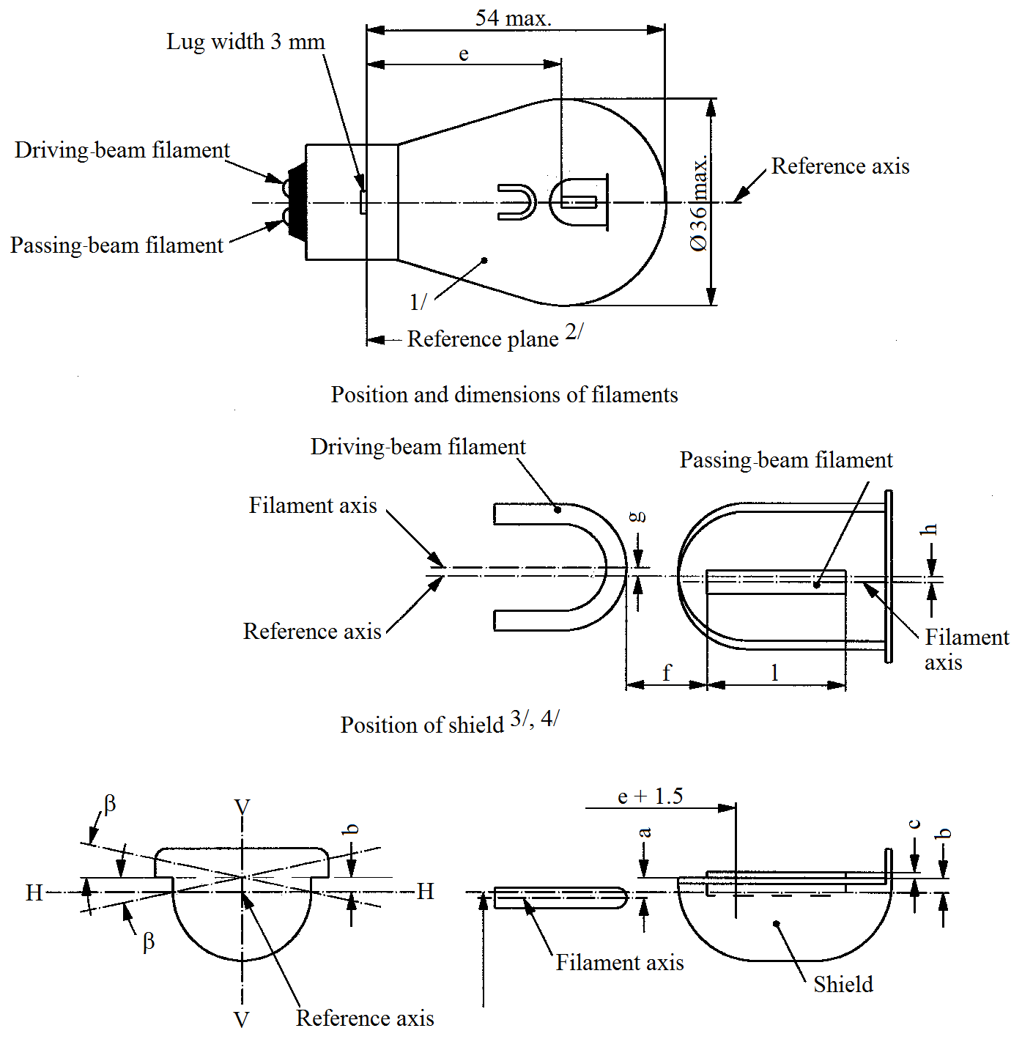
54 max.
Reference axis
Lug width 3 mm
Reference axis
Reference axis
Reference plane^{2/}
1/
e
Driving-beam filament
Passing-beam filament
Driving-beam filament
Passing-beam filament
Position and dimensions of filaments
Filament axis
Filament
axis
Filament axis
Shield
Position of shield^{3/,4/}
g
h
a
c
b
b
f
l
H
H
V
V
ß
ß
Ø 36 max.
e + 1.5
^{1/} The colour of the light emitted shall be white or selective-yellow.
Position of shield ^{3/, 4/}
Filament axis
Reference axis
Shield
^{2/} The reference plane is perpendicular to the reference axis and touches the upper surface of the lug having a width of 4.5 mm.
^{3, 4}
^{3/} Plane V-V contains the reference axis and the centre line of the lugs.
^{4/} Plane H-H (the normal position of the shield) is perpendicular to plane V-V and contains the reference axis.
Categories S1 and S2 Sheet S1/S2/2

Dimensions in mm |  |  |  | Filament light sources of normal production |  |  |  |  | Standard filament light source
 |  |  |  | Min. |  | Nom. |  | Max.
e |  |  |  | 32.35 |  | 32.70 |  | 33.05 | 32.7 ± 0.15
f |  |  |  | 1.4 |  | 1.8 |  | 2.2 | 1.8 ± 0.2
l |  |  |  | 4.0 |  | 5.5 |  | 7.0 | 5.5 ± 0.5
c ^{5/} |  |  |  | 0.2 |  | 0.5 |  | 0.8 | 0.5 ± 0.15
b ^{5/} |  |  |  | -0.15 |  | 0.2 |  | 0.55 | 0.2 ± 0.15
a ^{5/} |  |  |  | 0.25 |  | 0.6 |  | 0.95 | 0.6 ± 0.15
h |  |  |  | -0.5 |  | 0 |  | 0.5 | 0 ± 0.2
g |  |  |  | -0.5 |  | 0 |  | 0.5 | 0 ± 0.2
β ^{5/, 6/} |  |  |  | -2°30' |  | 0° |  | +2°30' | 0° ± 1°
Cap BA20d in accordance with IEC Publication 60061 (sheet 7004-12-7)
Electrical and photometric characteristics
Rated values | Volts | S1 | 6 ^{7/} |  |  |  | 12 ^{7/} |  | 6
Rated values | Volts | S2 |  |  |  |  |  |  | 12
Rated values | Watts | S1 | 25 |  | 25 |  | 25 | 25 | 25 | 25
Rated values | Watts | S2 | 35 |  | 35 |  | 35 | 35 | 35 | 35
Test voltage | Volts | S1 | 6.75 |  |  |  | 13.5 |  | 6.75
Test voltage | Volts | S2 | 6.3 |  |  |  | 13.5 |  | 13.5
Objective values | Watts | S1 | 25 ± 5 % |  | 25 ± 5 % |  | 25 ± 5 % | 25 ± 5 % | 25 ± 5 % | 25 ± 5 %
Objective values | Watts | S2 | 35 ± 5 % |  | 35 ± 5 % |  | 35 ± 5 % | 35 ± 5 % | 35 ± 5 % | 35 ± 5 %
Objective values | Luminous flux | S1 | 435 ± 20 % |  | 315 ± 20 % |  | 435 ± 20 % | 315 ± 20 %
Objective values | Luminous flux | S2 | 650 ± 20 % |  | 465 ± 20 % |  | 650 ± 20 % | 465 ± 20 %
Reference luminous flux |  | S1 | at approximately |  |  |  |  | 6 V | 398 | 284
 |  | S2 | at approximately |  |  |  |  | 12 V | 568 | 426
 |  | S2 |  |  |  |  |  | 13.2 V | 634 | 457
 |  | S2 |  |  |  |  |  | 13.5 V | 650 | 465

^{5/} Dimensions a, b, c and β refer to a plane parallel to the reference plane and cutting the two edges of the shield at a distance of e + 1.5 mm.
^{6/} Admissible angular deviation of the shield plane position from the normal position.
^{7/} Values in the left-hand column refer to the driving-beam filament. Values in the right-hand column to the passing-beam filament.
Category S3 Sheet S3/1
The drawings are intended only to illustrate the essential dimensions (in mm) of the filament light source.

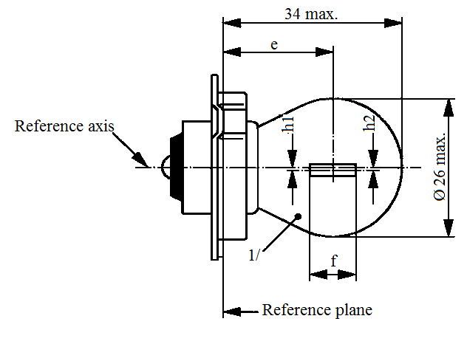
34 max.
e
1/
f
h1
h2
Ø 26 max.
Reference axis
Reference plane
Dimensions in mm |  |  | Filament light sources of normal production |  |  |  |  | Standard filament light source
 |  |  | Min. |  | Nom. |  | Max. | Standard filament light source
e ^{2/} |  |  | 19.0 |  | 19.5 |  | 20.0 | 19.5 ± 0.25
f |  | 6 V |  |  |  |  | 3.0 | 2.5 ± 0.5
 |  | 12 V |  |  |  |  | 4.0
h1, h2 ^{3/} |  |  | -0.5 |  | 0 |  | 0.5 | 0 ± 0.3
Cap P26s in accordance with IEC Publication 60061 (sheet 7004-36-1)
Electrical and photometric characteristics
Rated values | Volts |  |  | 6 |  | 12 |  | 6
Rated values | Watts |  |  | 15 |  |  |  | 15
Test voltage | Volts |  |  | 6.75 |  | 13.5 |  | 6.75
Objective values | Watts |  |  | 15 ± 6 % |  |  |  | 15 ± 6 %
Objective values | Luminous flux |  |  | 240 ± 15 %
Reference luminous flux: 240 lm at approximately 6.75 V
^{1/} The colour of the light emitted shall be white or selective-yellow.
^{2/} Distance related to the luminous centre.
^{3/} Lateral deviation of filament axis with respect to the reference axis. It is sufficient to check this deviation in two mutually perpendicular planes.
Category T1.4W Sheet T1.4W/1
The drawings are intended only to illustrate the essential dimensions (in mm) of the filament light source.
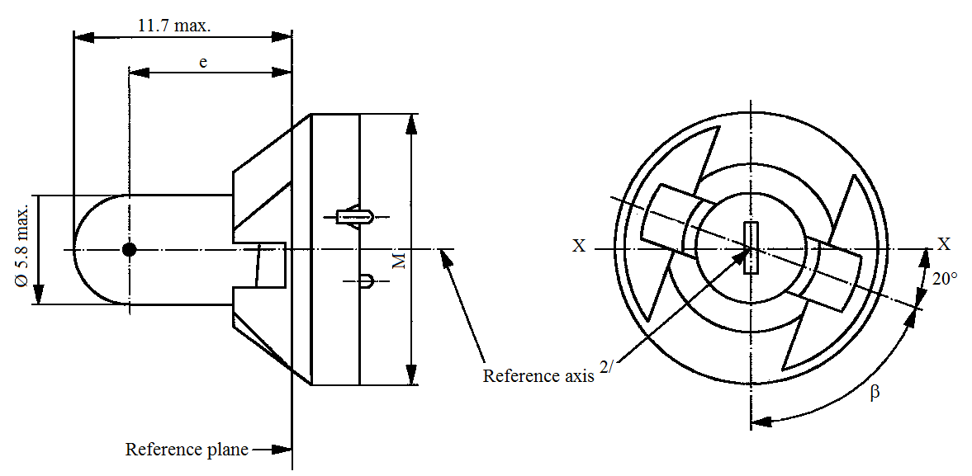
11.7 max.
Ø 5.8 max.
Reference plane^{2/}
Reference plane
e
X
X
ß
20°
M
Dimensions in mm |  |  | Filament light sources of normal production |  |  | Standard filament light source
 |  |  | Min. | Nom. | Max. | Standard filament light source
e |  |  | 7.6 | 8.3 | 9.0 | 8.3 ± 0.35
Lateral deviation ^{1/} |  |  |  |  | 0.7 | 0.35 max
β |  |  | 55° | 70° | 85° | 70° ± 5°
Cap P11.5d in accordance with IEC Publication 60061 (sheet 7004-79-1)
Electrical and photometric characteristics
Rated values | Volts | 12 |  |  |  | 12
Rated values | Watts | 1.4 |  |  |  | 1.4
Test voltage | Volts | 13.5 |  |  |  | 13.5
Objective values | Watts | 1.54 max. |  |  |  | 1.54 max.
Objective values | Luminous flux | 8 ± 15 %
Reference luminous flux: 8 lm at approximately 13.5 V
^{1/} Maximum lateral deviation of filament centre from two mutually perpendicular planes both containing the reference axis and one containing axis X-X.
^{2/} The reference axis is perpendicular to the reference plane and passes through the centre of the circle of diameter "M".
Category T4W Sheet T4W/1
The drawings are intended only to illustrate the essential dimensions (in mm) of the filament light source.
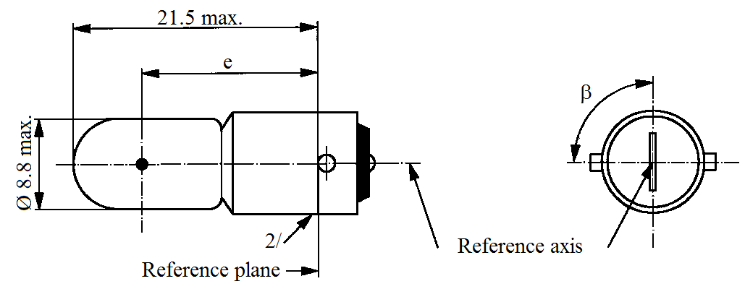
Ø 8.8 max.
21.5 max.
e
2/
Reference plane
Reference axis
ß

Dimensions in mm |  |  | Filament light sources of normal production |  |  |  | Standard filament light source
 |  |  | Min. |  | Nom. | Max. | Standard filament light source
e |  |  | 13.5 |  | 15.0 | 16.5 | 15.0 ± 0.3
Lateral deviation ^{1/} |  |  |  |  |  | 1.5 | 0.5 max
β |  |  |  |  | 90° |  | 90° ± 5°
Cap BA9s in accordance with IEC Publication 60061 (sheet 7004-14-9)
Electrical and photometric characteristics
Rated values | Volts | 6 |  | 12 |  | 24 | 12
Rated values | Watts | 4 |  |  |  |  | 4
Test voltage | Volts | 6.75 |  | 13.5 |  | 28.0 | 13.5
Objective values | Watts | 4.4 max. |  |  |  | 5.5 max. | 4.4 max.
Objective values | Luminous flux | 35 ± 20 %
Reference luminous flux: 35 lm at approximately 13.5 V
^{1/} Maximum lateral deviation of filament centre from two mutually perpendicular planes both containing the reference axis and one containing the axis of pins.
^{2/} Over the entire length of the cap there shall be no projections or soldering extending beyond the permissible maximum diameter of the cap.
Category W2.3W Sheet W2.3W/1
The drawings are intended only to illustrate the essential dimensions (in mm) of the filament light source.
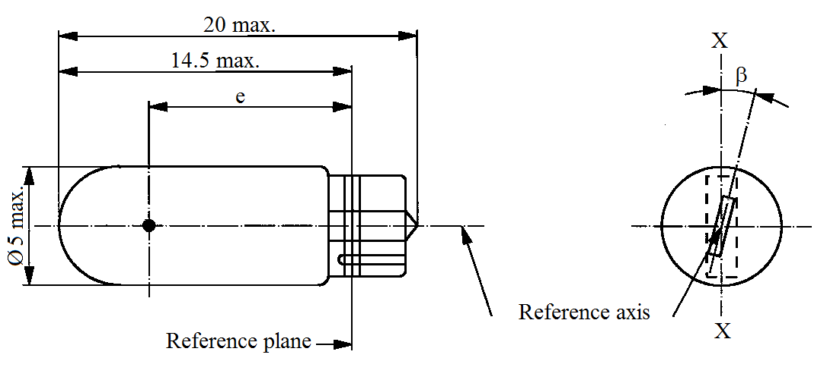
20 max.
14.5 max.
e
Ø 5 max.
Reference plane
Reference axis
X
X
ß

Dimensions in mm |  |  | Filament light sources of normal production |  |  | Standard filament light source
 |  |  | Min. | Nom. | Max. | Standard filament light source
e |  |  | 10.3 | 10.8 | 11.3 | 10.8 ± 0.3
Lateral deviation ^{1/} |  |  |  |  | 1.0 | 0.5 max
β |  |  | -15° | 0° | +15° | 0° ± 5°
Cap W2x4.6d in accordance with IEC Publication 60061 (sheet 7004-94-2)
Electrical and photometric characteristics
Rated values | Volts | 12 |  |  |  | 12
Rated values | Watts | 2.3 |  |  |  | 2.3
Test voltage | Volts | 13.5 |  |  |  | 13.5
Objective values | Watts | 2.5 max. |  |  |  | 2.5 max.
Objective values | Luminous flux | 18.6 ± 20 %
Reference luminous flux: 18.6 lm at approximately 13.5 V
^{1/} Maximum lateral deviation of filament centre from two mutually perpendicular planes both containing the reference axis and one containing axis X-X.
Category W3W Sheet W3W/1
The drawings are intended only to illustrate the essential dimensions (in mm) of the filament light source.
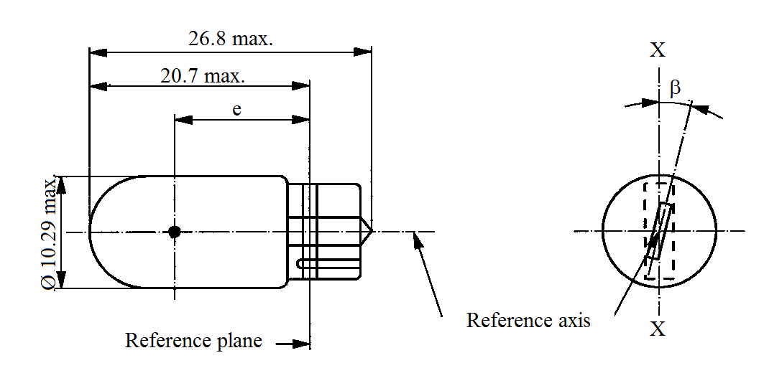
Ø 10.29 max.
26.8 max.
20.7 max.
e
X
X
ß
Reference plane
Reference axis

Dimensions in mm |  |  | Filament light sources of normal production |  |  |  | Standard filament light source
 |  |  | Min. |  | Nom. | Max. | Standard filament light source
e |  |  | 11.2 |  | 12.7.0 | 14.2 | 12.7 ± 0.3
Lateral deviation ^{1/} |  |  |  |  |  | 1.5 | 0.5 max
β |  |  | -15° |  | 0° | +15° | 0° ± 5°
Cap W2.1x9.5d in accordance with IEC Publication 60061 (sheet 7004-91-3)
Electrical and photometric characteristics
Rated values | Volts | 6 |  | 12 |  | 24 | 12
Rated values | Watts | 3 |  |  |  |  | 3
Test voltage | Volts | 6.75 |  | 13.5 |  | 28.0 | 13.5
Objective values | Watts | 3.45 max. |  |  |  | 4.6 max. | 3.45 max.
Objective values | Luminous flux | 22 ± 30 %
Reference luminous flux: 22 lm at approximately 13.5 V
^{1/} Maximum lateral deviation of filament centre from two mutually perpendicular planes both containing the reference axis and one containing axis X-X.
Category W5W, WY5W and WR5W Sheet W5W/1
The drawings are intended only to illustrate the essential dimensions (in mm) of the filament light source.
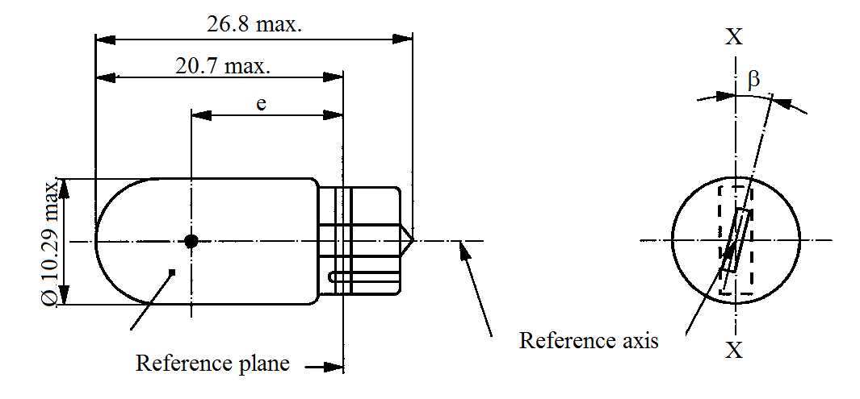
26.8 max.
20.7 max.
Ø 10.29 max.
e
X
X
ß
Reference plane
Reference axis
2/

Dimensions in mm |  |  | Filament light sources of normal production |  |  | Standard filament light source ^{3/}
 |  |  | Min. | Nom. | Max. | Standard filament light source ^{3/}
e |  |  | 11.2 | 12.7 | 14.2 | 12.7 ± 0.3
Lateral deviation ^{1/} |  |  |  |  | 1.5 | 0.5 max.
β |  |  | -15° | 0° | +15° | 0° ± 5°
Cap W2.1x9.5d in accordance with IEC Publication 60061 (sheet 7004-91-3)
Electrical and photometric characteristics
Rated values |  | Volts | 6 ^{4/} | 12 | 24 | 12
 |  | Watts | 5 |  |  | 5
Test voltage |  | Volts | 6.75 | 13.5 | 28.0 | 13.5
Objective values | Watts |  | 5.5 max. |  | 7.7 max. | 5.5 max.
Objective values | Luminous flux | W5W | 50 ± 20 %
Objective values | Luminous flux | WY5W | 30 ± 20 %
Objective values | Luminous flux | WR5W | ^{4/} | 12 ± 25 %
Reference luminous flux at approximately 13.5 V: |  |  |  |  |  | White: 50 lm  Amber: 30 lm  Red: 12 lm
^{1/} Maximum lateral deviation of filament centre from two mutually perpendicular planes both containing the reference axis and one containing axis X-X.
^{2/} The light emitted from filament light sources of normal production shall be white for category W5W, amber for category WY5W and red for category WR5W (see also footnote 3/)
^{3/} The light emitted from standard filament light sources shall be white for category W5W; white or amber for category WY5W; white or red for category WR5W.
^{4/} Within WR5W no 6 V rated voltage type specified.
Categories W10W and WY10W Sheet W10W/1
The drawings are intended only to illustrate the essential dimensions (in mm) of the filament light source.
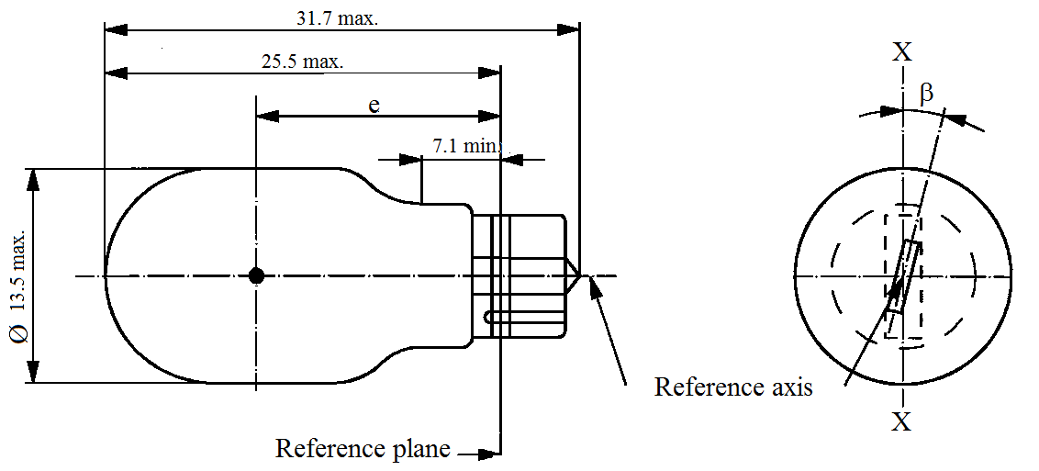
31.7 max.
25.5 max.
e
7.1 mm
Ø 13.5 max.
Reference axis
Reference plane
Reference axis
X
X
ß

Dimensions in mm |  |  | Filament light sources of normal production |  |  |  | Standard filament light source
 |  |  | Min. | Nom. |  | Max. | Standard filament light source
e |  |  | 15.5 | 17.0 |  | 18.5 | 17.0 ± 0.3
Lateral deviation ^{1/} |  |  |  |  |  | 1.0 | 0.5 max.
β |  |  | -15° | 0° |  | +15° | 0° ± 5°
Cap W2.1x9.5d in accordance with IEC Publication 60061 (sheet 7004-91-3)
Electrical and photometric characteristics
Rated values | Volts |  | 6 |  | 12 |  | 12
Rated values | Watts |  | 10 |  |  |  | 10
Test voltage | Volts |  | 6.75 |  | 13.5 |  | 13.5
Objective values | Watts |  | 11 max. |  |  |  | 11 max.
Objective values | Luminous flux | White | 125 ± 20 %
Objective values | Luminous flux | Amber | 75 ± 20 %
Reference luminous flux at approximately 13.5 V: |  |  |  |  |  |  | White: 125 lm  Amber: 75 lm
^{1/} Maximum lateral deviation of filament centre from two mutually perpendicular planes both containing the reference axis and one containing axis X-X.
Category W15/5W Sheet W15/5W/1
The drawings are intended only to illustrate the essential dimensions (in mm) of the filament light source.

a = major (high wattage) filament
b = minor (low wattage) filament
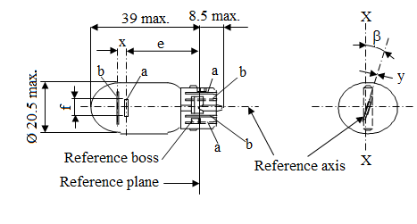
39 max.
8.5 max.
Ø 20.5 max.
Reference plane
Reference axis
Reference boss
f
X
X
y
ß
x
e
b
b
b
a
a
a
Dimensions in mm |  |  | Filament light sources of normal production |  |  |  | Standard filament light source
 |  |  | Min. | Nom. |  | Max.
e |  |  |  | 25.0 ^{1/} |  |  | 25.0 ± 0.3
f |  |  |  |  |  | 7.5 | 7.5 + 0 / -2
Lateral deviation ^{2/} |  |  |  |  |  | ^{1/} | 0.3 max.
x ^{3/} |  |  |  | 2.8 ^{1/} |  |  | 2.8 ± 0.3
y ^{3/} |  |  |  | 0.0 ^{1/} |  |  | 0.0 ± 0.3
β |  |  | -15° ^{1/} | 0° |  | +15° ^{1/} | 0° ± 5°
Cap WZ3x16q in accordance with IEC Publication 60061 (sheet 7004-151-2)
Electrical and photometric characteristics
Rated values | Volts | 12 |  |  |  |  | 12
Rated values | Watts | 15 |  |  | 5 |  | 15 | 5
Test voltage | Volts | 13.5 |  |  |  |  | 13.5
Objective values | Watts | 19.1 max. |  |  | 6.6 max. |  | 19.1 max. | 6.6 max.
Objective values | Luminous flux | 280 ± 15 % |  |  | 35 ± 20 %
Reference luminous flux: 280 lm and 35 lm at approximately 13.5 V
^{1/} To be checked by means of a "Box system"; sheets W15/5W/2 and 3.
^{2/} Maximum lateral deviation of filament centre from two mutually perpendicular planes both containing the reference axis and one containing axis X-X.
^{3/} "x" and "y" denote the offset of the axis of the minor filament with respect to the axis of the major filament.
Category W15/5W Sheet W15/5W/2
Screen projection requirements
This test is used to determine, by checking whether:
(a) The major filament is correctly positioned relative to the reference axis and reference plane and has an axis perpendicular, within ±15°, to the plane through the axis X-X and the reference axis; and whether:
(b) The minor filament is correctly positioned relative to the major filament, whether a filament light source complies with the requirements.
Test procedure and requirements.
1. The filament light source is placed in a holder capable of being rotated about its axis and having either a calibrated scale or fixed stops corresponding to the angular displacement tolerance limits. The holder is then so rotated that an end view of the major filament is seen on the screen on which the image of the filament is projected. The end view of that filament shall be obtained within the angular displacement tolerance limits. (±15°).
2. Side elevation
The filament light source placed with the cap down, the reference axis vertical and the major filament seen end-on:
2.1. The projection of the major filament shall lie entirely within a rectangle of height "a" and width "b", having its centre at the theoretical position of the centre of the filament;
2.2. The projection of the minor filament shall lie entirely within a rectangle of width "c" and height "d" having its centre at a distance "u" above the theoretical position of the centre of the major filament.
3. Front elevation
The filament light source being placed with the cap down and the reference axis vertical, the filament light source being viewed in a direction at right angles to axis of the major filament:
3.1. The projection of the major filament shall lie entirely within a rectangle of height "a" and width "h", centred on the theoretical position of the centre of the filament;
3.2. The centre of the major filament shall not be offset by more than distance "k" from the reference axis.
3.3. The centre of the minor filament axis shall not be offset from the reference axis by more than ±2 mm (±0.4 mm for standard filament light sources).
Category W15/5W Sheet W15/5W/3
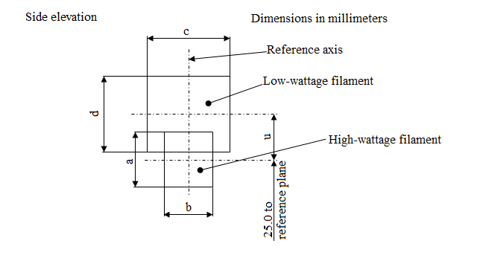
Side elevation
Dimensions in millimeters
Reference axis
Low wattage filament
High wattage filament
25.0 to
reference plane
c
b
d
a
u
Reference | a | b | c | d | u
Dimensions | 3.3 | 2.8 | 4.8 |  | 2.8

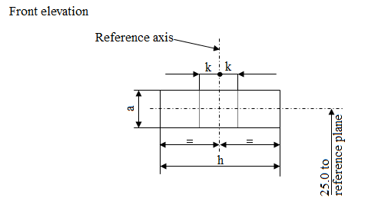
Front elevation
Reference axis
25.0 to
reference plane
k
k
h
a
Reference | a | h | k
Dimensions | 3.3 | 9.5 | 1.0
Categories W16W AND WY16W Sheet W16W/1
The drawings are intended only to illustrate the essential dimensions (in mm) of the filament light source.
38.1 max.
32 max.
e
7.1 mm
Ø 15.7 max.
Reference axis
Reference plane
Reference axis
X
X
ß

Dimensions in mm |  |  | Filament light sources of normal production |  |  | Standard filament light source
 |  |  | Min. | Nom. | Max. | Standard filament light source
e |  |  | 18.3 | 20.6 | 22.9 | 20.6 ± 0.3
Lateral deviation ^{1/} |  |  |  |  | 1.0 | 0.5 max.
β |  |  | -15° | 0° | +15° | 0° ± 5°
Cap W2.1x9.5d in accordance with IEC Publication 60061 (sheet 7004-91-3)
Electrical and photometric characteristics
Rated values | Volts |  | 12 |  |  | 12
Rated values | Watts |  | 16 |  |  | 16
Test voltage | Volts |  | 13.5 |  |  | 13.5
Objective values | Watts |  | 21.35 max. |  |  | 21.35 max.
Objective values | Luminous flux | White | 310 ± 20 %
Objective values | Luminous flux | Amber | 190 ± 20 %
Reference luminous flux at approximately 13.5 V: |  |  |  |  |  | White: 310 lm  Amber: 190 lm
^{1/} Maximum lateral deviation of filament centre from two mutually perpendicular planes both containing the reference axis and one containing axis X-X.
Category W21W Sheet W21W/1
The drawings are intended only to illustrate the essential dimensions (in mm) of the filament light source.
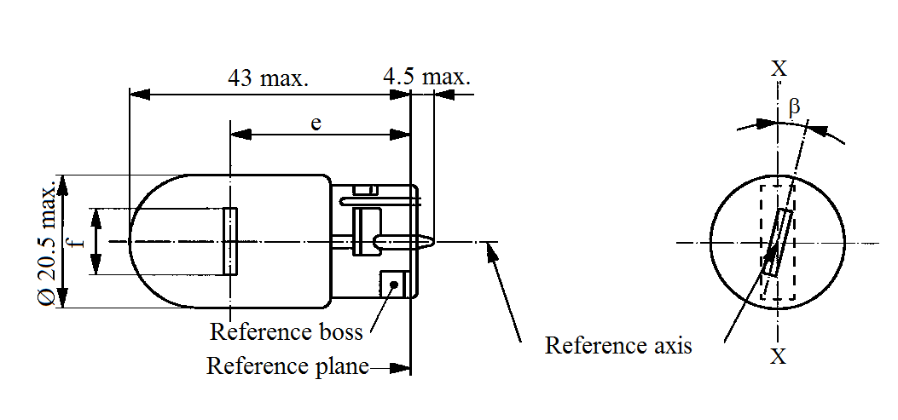
43 max.
4.5 max.
Ø 20.5 max.
f
e
X
X
ß
Reference plane
Reference boss
Reference axis

Dimensions in mm |  |  | Filament light sources of normal production |  |  | Standard filament light source
 |  |  | Min. | Nom. | Max. | Standard filament light source
e |  |  |  | 29.0 ^{2/} |  | 29.0 ± 0.3
f |  |  |  |  | 7.5 | 7.5 + 0 / -2
Lateral deviation ^{1/} |  |  |  |  | ^{2/} | 0.5 max.
β |  |  | -15° ^{2/} | 0° | +15° ^{2/} | 0° ± 5°
Cap W3x16d in accordance with IEC Publication 60061 (sheet 7004-105-3)
Electrical and photometric characteristics
Rated values | Volts | 12 |  |  |  | 12
Rated values | Watts | 21 |  |  |  | 21
Test voltage | Volts | 13.5 |  |  |  | 13.5
Objective values | Watts | 26.5 max. |  |  |  | 26.5 max.
Objective values | Luminous flux | 460 ± 15 %
Reference luminous flux: 460 lm at approximately 13.5 V
^{1/} Maximum lateral deviation of filament centre from two mutually perpendicular planes both containing the reference axis and one containing axis X-X.
^{2/} To be checked by means of a "Box system"; see sheet W21W/2.
Category W21W Sheet W21W/2
Screen projection requirements
This test is used to determine, by checking whether the filament is correctly positioned relative to the reference axis and reference plane and has an axis perpendicular, within ±15°, to the plane through the axis X-X and the reference axis, whether a filament light source complies with the requirements.
Side elevation Front elevation
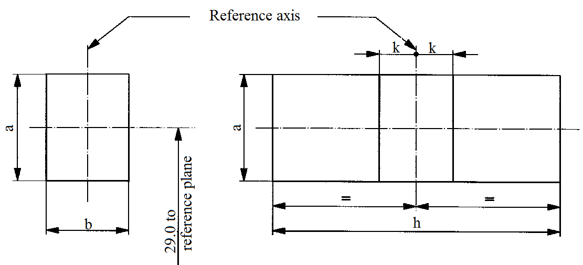
Reference axis
k
k
h
a
a
b
29.0 to
reference plane

Reference | a | b | h | k
Dimension | 3.5 | 3.0 | 9.5 | 1.0

Test procedures and requirements
1. The filament light source is placed in a holder capable of being rotated about its axis and having either a calibrated scale or fixed stops corresponding to the angular displacement tolerance limits, i.e. ±15°. The holder is then so rotated that an end view of the filament is seen on the screen on to which the image of the filament is projected. The end view of the filament shall be obtained within the angular displacements tolerance limits (±15°).
2. Side elevation
The filament light source placed with the cap down, the reference axis vertical and the filament seen end-on, the projection of the filament shall lie entirely within a rectangle of height "a" and width "b", having its centre at the theoretical position of the centre of the filament.
3. Front elevation
The filament light source placed with the cap down and the reference axis vertical, the filament light source being viewed in a direction at right angles to the filament axis:
3.1. The projection of the filament shall lie entirely within a rectangle of height "a" and width "h", having its centre at the theoretical position of the centre of the filament;
3.2. The centre of the filament shall not be offset by more than distance "k" from the reference axis.
Category W21/5W Sheet W21/5W/1
The drawings are intended only to illustrate the essential dimensions (in mm) of the filament light source.
a = major (high wattage) filament
b = minor (low wattage) filament

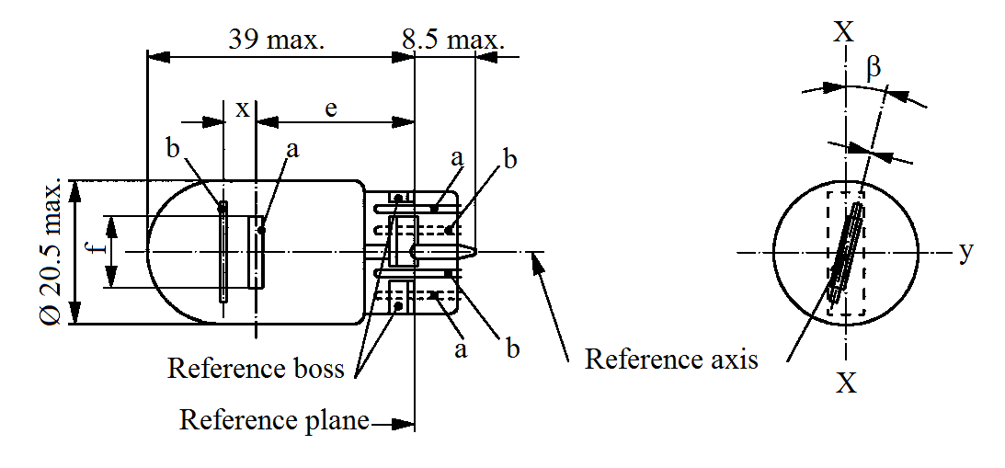
y
39 max.
8.5 max.
Ø 20.5 max.
Reference axis
Reference boss
Reference plane
X
X
ß
b
b
b
a
a
a
e
x
Dimensions in mm |  | Filament light sources of normal production |  |  |  | Standard filament light source
 |  | Min. | Nom. |  | Max.
e |  |  | 25.0 ^{1/} |  |  | 25.0 ± 0.3
f |  |  |  |  | 7.5 | 7.5 + 0 / -2
Lateral deviation ^{2/} |  |  |  |  | ^{1/} | 0.3 max.
x ^{3/} |  |  | 2.8 ^{1/} |  |  | 2.8 ± 0.3
y ^{3/} |  |  | 0.0 ^{1/} |  |  | 0.0 ± 0.3
β |  | -15° ^{1/} | 0° |  | +15° ^{1/} | 0° ± 5°
Cap W3x16q in accordance with IEC Publication 60061 (sheet 7004-106-4)
Electrical and photometric characteristics
Rated values | Volts | 12 |  |  |  | 12
Rated values | Watts | 21 |  | 5 |  | 21 | 5
Test voltage | Volts | 13.5 |  |  |  | 13.5
Objective values | Watts | 26.5 max. |  | 6.6 max. |  | 26.5 max. | 6.6 max.
Objective values | Luminous flux | 440 ± 15 % |  | 35 ± 20 %
Reference luminous flux: 440 and 35 lm at approximately 13.5 V
^{1/} To be checked by means of a "Box system"; sheets W21/5W/2 and 3.
^{2/} Maximum lateral deviation of filament centre from two mutually perpendicular planes both containing the reference axis and one containing axis X-X.
^{3/} "x" and "y" denote the offset of the axis of the minor filament with respect to the axis of the major filament.
Category W21/5W Sheet W21/5W/2
Screen projection requirements
This test is used to determine, by checking whether:
(a) The major filament is correctly positioned relative to the reference axis and reference plane and has an axis perpendicular, within ±15°, to the plane through the axis X-X and the reference axis; and whether:
(b) The minor filament is correctly positioned relative to the major filament, whether a filament light source complies with the requirements.
Test procedure and requirements.
1. The filament light source is placed in a holder capable of being rotated about its axis and having either a calibrated scale or fixed stops corresponding to the angular displacement tolerance limits. The holder is then so rotated that an end view of the major filament is seen on the screen on which the image of the filament is projected. The end view of that filament shall be obtained within the angular displacement tolerance limits (±15°).
2. Side elevation
The filament light source placed with the cap down, the reference axis vertical and the major filament seen end-on:
2.1. The projection of the major filament shall lie entirely within a rectangle of height "a" and width "b", having its centre at the theoretical position of the centre of the filament;
2.2. The projection of the minor filament shall lie entirely within a rectangle of width "c" and height "d" having its centre at a distance "u" above the theoretical position of the centre of the major filament.
3. Front elevation
The filament light source being placed with the cap down and the reference axis vertical, the filament light source being viewed in a direction at right angles to axis of the major filament:
3.1. The projection of the major filament shall lie entirely within a rectangle of height "a" and width "h", centred on the theoretical position of the centre of the filament;
3.2. The centre of the major filament shall not be offset by more than distance "k" from the reference axis;
3.3. The centre of the minor filament axis shall not be offset from the reference axis by more than ±2 mm (±0.4 mm for standard filament light sources).
Category W21/5W Sheet W21/5W/3
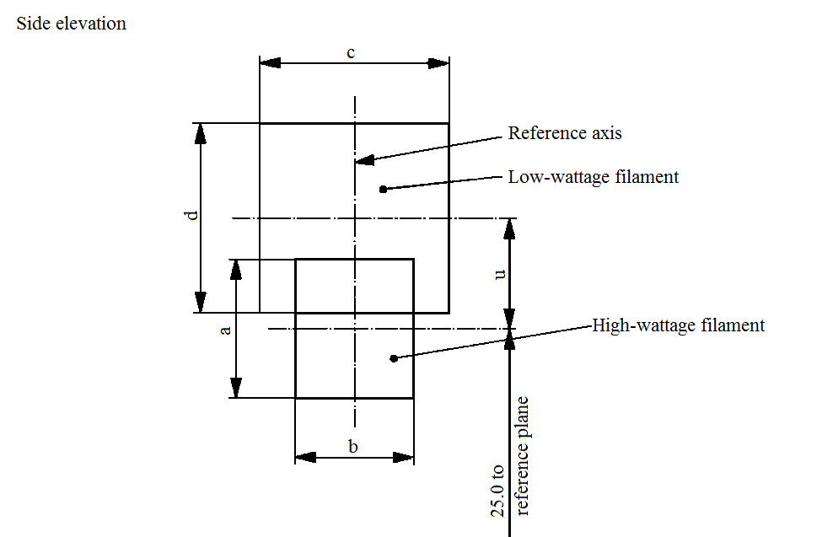
Reference axis
Side elevation
Low wattage filament
High wattage filament
25.0 to
reference plane
c
b
a
d
u
Reference | a | b | c | d | u
Dimension | 3.5 | 3.0 | 4.8 |  | 2.8

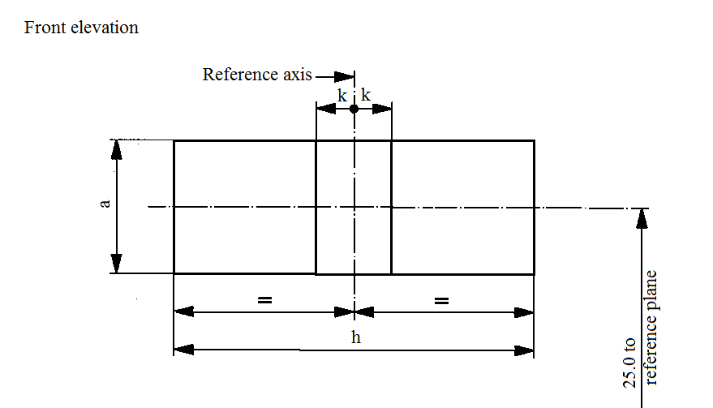
Front elevation
Reference axis
25.0 to
reference plane
k
k
h
a

Reference | a | h | k
Dimension | 3.5 | 9.5 | 1.0
Categories WP21W and WPY21W Sheet WP21W/1
The drawings are intended only to illustrate the essential dimensions (in mm) of the filament light source.
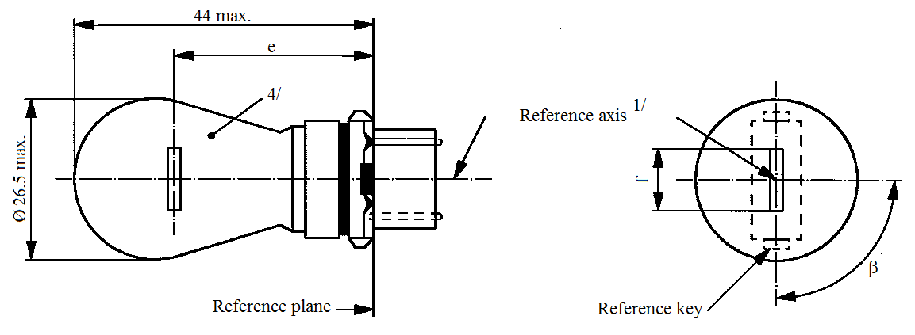
44 max.
e
4/
Reference plane
Reference axis^{1/}
Reference key
ß
f
Ø 26.5 max.
Dimensions in mm |  |  |  | Filament light sources of normal production |  |  |  | Standard filament light source
 |  |  |  | Min. |  | Nom. | Max. | Standard filament light source
e |  |  |  |  |  | 27.9 ^{3/} |  | 27.9 ± 0.3
f |  |  |  | 5.5 |  | 6.0 | 7.0 | 6.0 ± 0.5
Lateral deviation ^{2/} |  |  |  |  |  |  | ^{3/} | 0.0 ± 0.4
β |  |  |  | 75° ^{3/} |  | 90° | 105° ^{3/} | 90° ± 5°
Cap: | WP21W: WY2.5x16d  WPY21W: WZ2.5x16d |  |  | in accordance with IEC Publication 60061 |  |  |  | (sheet 7004-104B-1)  (sheet 7004-104C-1)
Electrical and photometric characteristics
Rated values |  |  | Volts |  | 12 |  |  | 12
 |  |  | Watts |  | 21 |  |  | 21
Test voltage |  |  | Volts |  | 13.5 |  |  | 13.5
Objective values |  | Watts |  |  | 26.5 max. |  |  | 26.5 max.
 |  | Luminous flux | WP21W |  | 460 ± 15 %
 |  | Luminous flux | WPY21W |  | 280 ± 20 %
Reference luminous flux at approximately 13.5 V |  |  |  |  |  |  |  | White: 460 lm  Amber: 280 lm
^{1/} The reference axis is defined with respect to the reference keys and is perpendicular to the reference plane.
^{2/} Maximum lateral deviation of filament centre from two mutually perpendicular planes both containing the reference axis and one containing the axis through the reference keys.
^{3/} To be checked by means of a "Box system"; sheet WP21W/2.
^{4/} The light emitted from filament light sources of normal production shall be white for category WP21W and amber for category WPY21W (see also footnote 5/).
^{5/} The light emitted from standard filament light sources shall be white for category WP21W and white or amber for category WPY21W.
Categories WP21W and WPY21W Sheet WP21W/2
Screen projection requirements
This test is used to determine, by checking whether the filament is correctly positioned relative to the reference axis and reference plane and has an axis perpendicular, within ±15°, to the plane through the centre line of the keys and the reference axis, whether a filament light source complies with the requirements.
Side elevation Front elevation
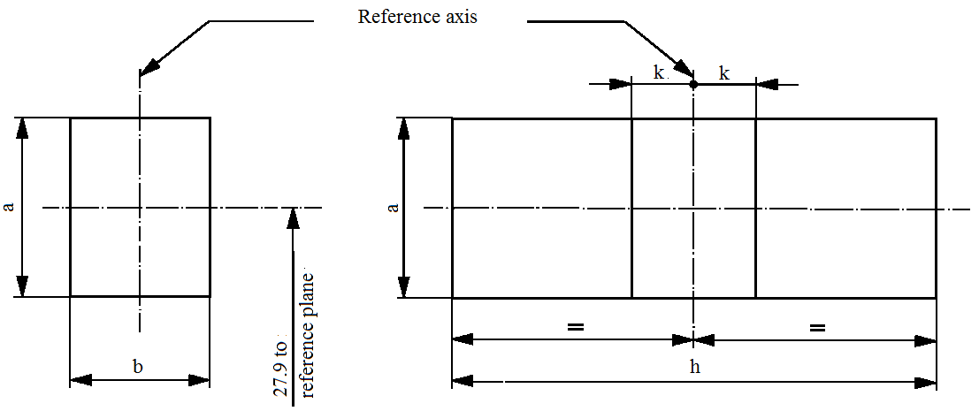
Reference axis
k
k
h
b
a
a
27.9 to
reference plane

Reference | a | b | h | k
Dimension | 3.5 | 3.0 | 9.0 | 1.0

Test procedures and requirements
1. The filament light source is placed in a holder capable of being rotated about its axis and having either a calibrated scale or fixed stops corresponding to the angular displacement tolerance limits. The holder is then so rotated that an end view of the filament is seen on the screen on to which the image of the filament is projected. The end view of the filament shall be obtained within the angular displacements tolerance limits.
2. Side elevation
The filament light source placed with the cap down, the reference axis vertical and the filament seen end-on, the projection of the filament shall lie entirely within a rectangle of height "a" and width "b", having its centre at the theoretical position of the centre of the filament.
3. Front elevation
The filament light source placed with the cap down and the reference axis vertical, the filament light source being viewed in a direction at right angles to the filament axis:
3.1. The projection of the filament shall lie entirely within a rectangle of height "a" and width "h", having its centre at the theoretical position of the centre of the filament.
3.2. The centre of the filament shall not be offset by more than distance "k" from the reference axis.
Category WR21/5W Sheet WR21/5W/1
The drawings are intended only to illustrate the essential dimensions (in mm) of the filament light source.
a = major (high wattage) filament
b = minor (low wattage) filament
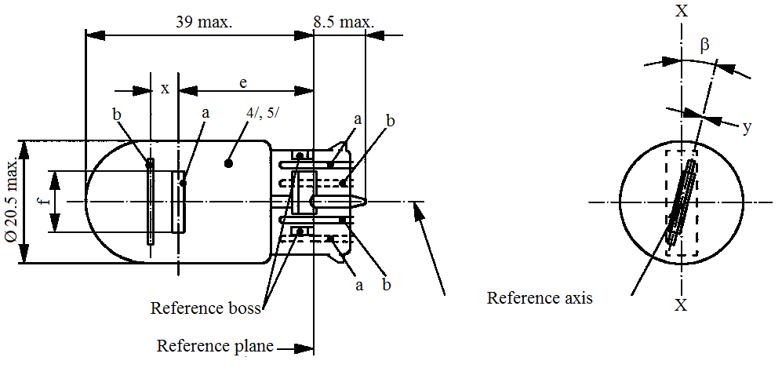
39 max.
8.5 max.
Ø 20.5 max.
Reference plane
Reference axis
Reference boss
b
b
b
a
a
a
e
x
4/,5/
f
ß
y
X
X
Dimensions in mm |  | Filament light sources of normal production |  |  |  |  | Standard filament light source
 |  | Min. | Nom. |  |  | Max.
e |  |  | 25.0 ^{1/} |  |  |  | 25.0 ± 0.3
f |  |  |  |  |  | 7.5 | 7.5 + 0 / -2
Lateral deviation ^{2/} |  |  |  |  |  | ^{1/} | 0.3 max.
x ^{3/} |  |  | 2.8 ^{1/} |  |  |  | 2.8 ± 0.3
y ^{3/} |  |  | 0.0 ^{1/} |  |  |  | 0.0 ± 0.3
β |  | -15° ^{1/} | 0° |  |  | 15° ^{1/} | 0° ± 5°
Cap WY3x16q in accordance with IEC Publication 60061 (sheet 7004-106-4)
Electrical and photometric characteristics
Rated values | Volts | 12 |  |  |  |  | 12
Rated values | Watts | 21 |  | 5 |  |  | 21 | 5
Test voltage | Volts | 13.5 |  |  |  |  | 13.5
Objective values | Watts | 26.5 max. |  | 6.6 max. |  |  | 26.5 max. | 6.6 max.
Objective values | Luminous flux | 105 ± 20 % |  | 8 ± 25 %
Reference luminous flux at approximately 13.5 V: |  |  |  |  | White: 440 lm and 35 lm  Red: 105 lm and 8 lm
^{1/} To be checked by means of a "Box system"; sheets W21/5W/2 and 3.
^{2/} Maximum lateral deviation of filament centre from two mutually perpendicular planes both containing the reference axis and one containing axis X-X.
^{3/} "x" and "y" denote the offset of the axis of the minor filament with respect to the axis of the major filament.
^{4/} The light emitted from normal production filament light sources shall be red (see also footnote 5/).
^{5/} The light emitted from standard filament light sources shall be white or red.
CategoriesWT21W and WTY21W Sheet WT21W/1
The drawings are intended only to illustrate the essential dimensions (in mm) of the filament light source.
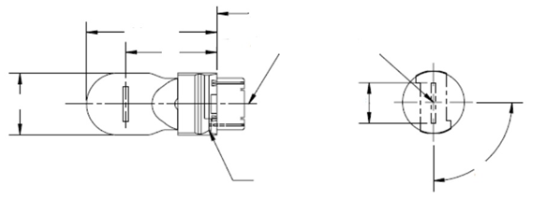
Reference key
Reference plane
Reference axis
β
ø 20.5 max.
44 max.
e
4/
f
Dimensions in mm |  |  |  |  | Filament light sources of normal production |  |  |  |  | Standard filament light source ^{5/}
 |  |  |  |  | Min. |  | Nom. |  | Max. | Standard filament light source ^{5/}
e |  |  | 12 V |  |  |  | 27.9 ^{3/} |  |  | 27.9 ± 0.3
 |  |  | 24 V |  | 26.9 |  | 27.9 |  | 28.9
f |  |  |  |  |  |  |  |  | 7.5 | 7.5 + 0 / - 2
Lateral deviation ^{2/} |  |  | 12 V |  |  |  |  |  | ^{3/} | 0.0 ± 0.4
 |  |  | 24 V |  |  |  |  |  | 1.5
β |  |  |  |  | 75° ^{3/} |  | 90° |  | 105° ^{3/} | 90° ± 5°
Cap: | WT21W: WUX2.5x16d  WTY21W: WUY2.5x16d |  |  | in accordance with IEC Publication 60061 |  |  |  |  |  | (sheet 7004-176-1)  (sheet 7004-177-1)
Electrical and photometric characteristics
Rated values |  | Volts |  |  |  | 12 |  | 24 |  | 12
 |  | Watts |  |  |  | 21 |  |  |  | 21
Test voltage |  | Volts |  |  |  | 13.5 |  | 28.0 |  | 13.5
Objective values |  | Watts |  |  |  | 26.5 max. |  | 29.7 max. |  | 26.5 max.
 |  | Luminous flux | WT21W |  |  | 460 ± 15 %
 |  | Luminous flux | WTY21W |  |  | 280 ± 20 %
Reference luminous flux at approximately 13.5 V: |  |  |  |  |  |  |  |  |  | White: 460 lm  Amber: 280 lm
^{1/} The reference axis is defined with respect to the reference keys and is perpendicular to the reference plane.
^{2/} Maximum lateral deviation of the major (high wattage) filament centre from two mutually perpendicular planes both containing the reference axis and one containing the axis through the reference keys.
^{3/} To be checked by means of a "Box system", sheets WT21W/2.
^{4/} The light emitted from filament light sources of normal production shall be white for category WT21W and amber for category WTY21W (see also note 5/).
^{5/} The light emitted from standard filament light sources shall be white for category WT21W and white or amber for category WTY21W.
CategoriesWT21W and WTY21W Sheet WT21W/2
Screen projection requirements
This test is used to determine, by checking whether the filament is correctly positioned relative to the reference axis and reference plane and has an axis perpendicular, within ±15°, to the plane through the centres of the keys and the reference axis, whether a filament light source complies with the requirements.
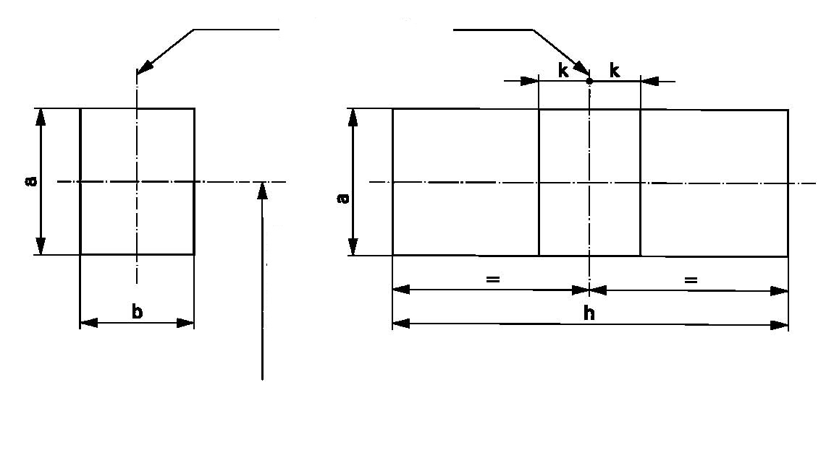
Reference axis
27.9 to
Reference plane
Side elevation
Front elevation
ReferenceabhkDimension3.53.09.51.0
reference plane
k
k
h
b
a
a
Test procedures and requirements
1. The filament light source is placed in a holder capable of being rotated about its axis and having either a calibrated scale or fixed stops corresponding to the angular displacement tolerance limits. The holder is then so rotated that an end view of the filament is seen on the screen on to which the image of the filament is projected. The end view of the filament shall be obtained within the angular displacements tolerance limits.
2. Side elevation
The filament light source placed with the cap down, the reference axis vertical and the filament seen end-on, the projection of the filament shall lie entirely within a rectangle of height "a" and width "b", having its centre at the theoretical position of the centre of the filament.
3. Front elevation
The filament light source placed with the cap down and the reference axis vertical, the filament light source being viewed in a direction at right angles to the filament axis:
3.1. The projection of the filament shall lie entirely within a rectangle of height "a" and width "h", having its centre at the theoretical position of the centre of the filament.
3.2. The centre of the filament shall not be offset by more than distance "k" from the reference axis.
Categories WT21/7W and WTY21/7W Sheet WT21/7W/1

The drawings are intended only to illustrate the essential dimensions (in mm) of the filament light source.
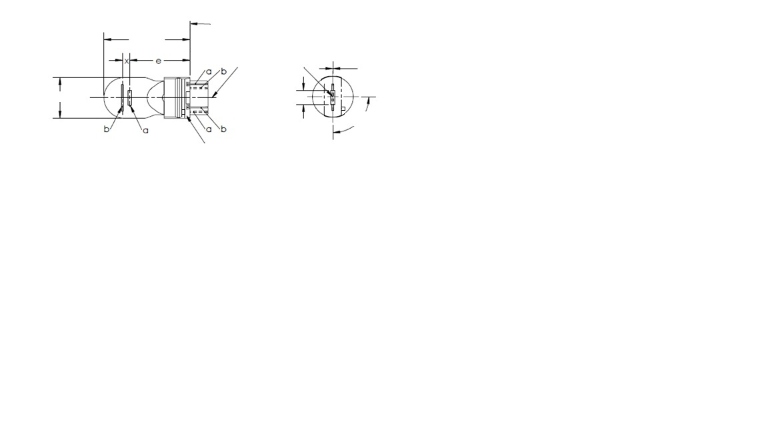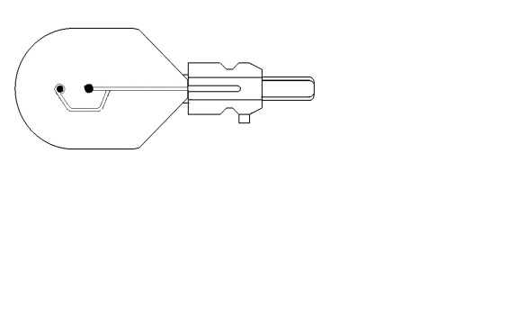
ø 20.5 max.
6/
Support^{5/}
Reference key^{5/}

Reference plane
Reference axis
44 max.
β
y
a = major (high wattage) filament
b = minor (low wattage) filament
f
e
a
a
a
b
b
b
Dimensions in mm |  |  | Filament light sources of normal production ^{6/} |  |  |  |  |  | Standard filament light source ^{7/}
 |  |  | Min. |  | Nom. |  |  | Max.
e |  |  |  |  | 27.9 ^{3/} |  |  |  | 27.9 ± 0.3
f |  |  |  |  |  |  |  | 7.5 | 7.5 + 0 / - 2
Lateral deviation ^{2/} |  |  |  |  |  |  |  | ^{3/} | 0.0 ± 0.4
x ^{4/} |  |  |  |  | 5.1 ^{3/} |  |  |  | 5.1 ± 0.5
y ^{4/} |  |  |  |  | 0.0 ^{3/} |  |  |  | 0.0 ± 0.5
β |  |  | 75° ^{3/} |  | 90° |  |  | 105° ^{3/} | 90° ± 5°
Cap: | WT21/7W: WZX2.5x16q  WTY21/7W: WZY2.5x16q |  |  | in accordance with IEC Publication 60061 |  |  |  |  |  | (sheet 7004-180-1)  (sheet 7004-181-1)
Electrical and photometric characteristics
Rated values |  | Volts | 12 |  |  |  |  |  | 12
 |  | Watts | 21 |  |  |  | 7 |  | 21 |  | 7
Test voltage |  | Volts | 13.5 |  |  |  |  |  | 13.5
Objective values |  | Watts | 26.5 max. |  |  | 8.5 max. |  |  | 26.5 max. |  | 8.5 max.
 |  | Luminous flux | 440 ± 15 % |  |  | 35 ± 20 %
 |  | Luminous flux | 280 ± 20 % |  |  | 22 ± 20 %
Reference luminous flux at approximately 13.5 V: |  |  |  |  |  | White: 440 and 35 lm  Amber: 280 and 22 lm
For the notes see sheet WT21/7W/2.
Categories WT21/7W and WTY21/7W Sheet WT21/7W/2
^{1/} The reference axis is defined with respect to the reference keys and is perpendicular to the reference plane.
^{2/} Maximum lateral deviation of the major (high wattage) filament centre from two mutually perpendicular planes both containing the reference axis and one containing the axis through the reference keys.
^{3/} To be checked by means of a "Box system", sheets WT21/7W/2 and 3.
^{4/} "x" and 'y" denote the offset of the axis of the minor (low wattage) filament with respect to the axis of the major (high wattage) filament.
^{5/} If the minor filament is positioned using an asymmetric support similar to the one shown then the reference key and support structure shall be located on the same side of the filament light source.
^{6/} The light emitted from filament light sources of normal production shall be white for category WT21/7W and amber for category WTY21/7W (see also note 7/).
^{7/} The light emitted from standard filament light sources shall be white for category WT21/7W and white or amber for category WTY21/7W.

Screen projection requirements
This test is used to determine, by checking whether:
- The major (high wattage) filament is correctly positioned relative to the reference axis and reference plane and has an axis perpendicular, within ±15°, to the plane through the centres of the keys and the reference axis; and whether:
- The minor (low wattage) filament is correctly positioned relative to the major (high wattage) filament, whether a filament light source complies with the requirements.
Test procedure and requirements.
1. The filament light source is placed in a holder capable of being rotated about its axis and having either a calibrated scale or fixed stops corresponding to the angular displacement tolerance limits. The holder is then so rotated that an end view of the major filament is seen on the screen on which the image of the filament is projected. The end view of that filament shall be obtained within the angular displacement tolerance limits.
2. Side elevation
The filament light source placed with the cap down, the reference axis vertical, the reference key to the right and the major filament seen end-on:
2.1. The projection of the major filament shall lie entirely within a rectangle of height "a" and width "b", having its centre at the theoretical position of the centre of the filament;
2.2. The projection of the minor filament shall lie entirely within a rectangle of width "c" and height "d" having its centre at a distance "u" above the theoretical position of the centre of the major filament.
3. Front elevation
The filament light source being placed with the cap down and the reference axis vertical, the filament light source being viewed in a direction at right angles to axis of the major filament:
3.1. The projection of the major filament shall lie entirely within a rectangle of height "a" and width "h", centred on the theoretical position of the centre of the filament;
3.2. The centre of the major filament shall not be offset by more than distance "k" from the reference axis;
3.3. The centre of the minor filament axis shall not be offset from the reference axis by more than ±2 mm (±0.4 mm for standard filament light sources).
Category WT21/7W AND WTY21/7W Sheet WT21/7W/3

Side elevation
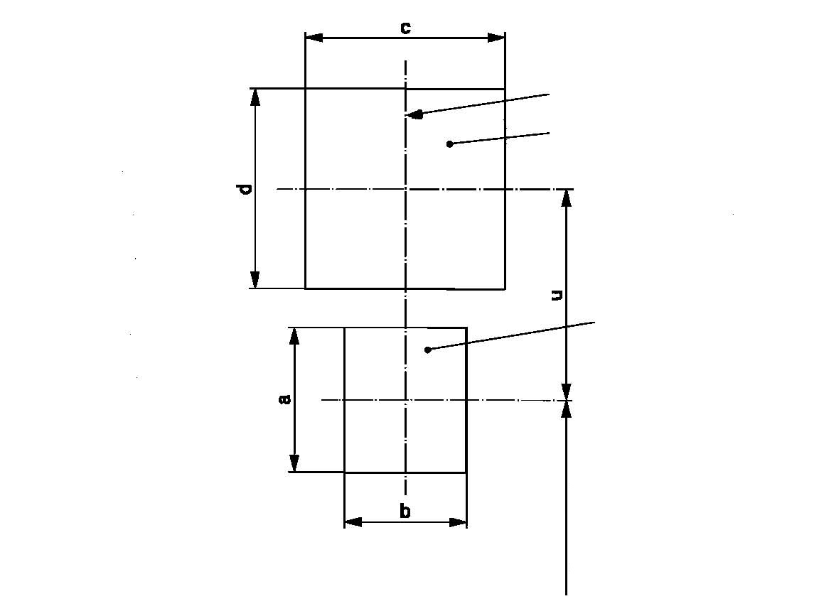
Reference axis
Low wattage filament
High wattage filament
27.9 to
reference plane
c
b
d
u
a

Reference | a | b | c | d | u
Dimensions | 3.5 | 3.0 | 4.8 |  | 5.1

Front elevation
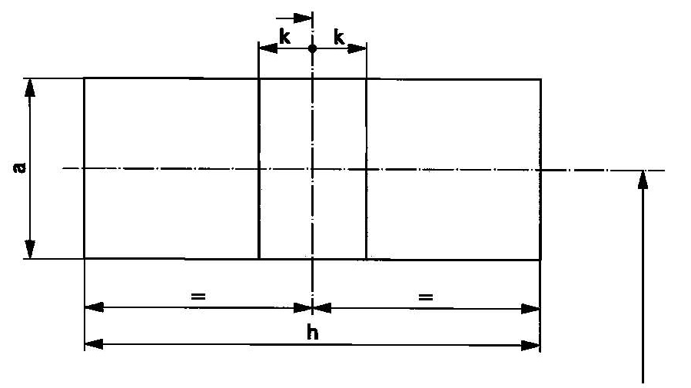
Reference axis
k
k
h
a
27.9 to
reference plane
Reference | a | h | k
Dimensions | 3.5 | 9.5 | 1.0
Category WY2.3W Sheet WY2.3W/1
The drawings are intended only to illustrate the essential dimensions (in mm) of the filament light source.
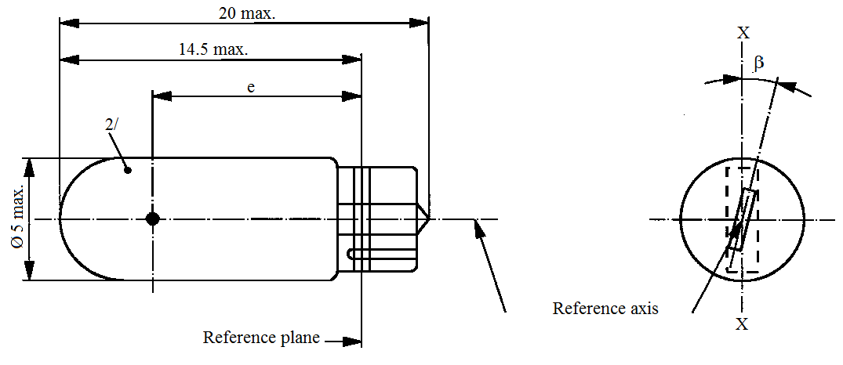
20 max.
14.5 max.
e
2/
X
X
ß
Reference axis
Reference plane
Ø 5 max.

Dimensions in mm |  |  | Filament light sources of normal production |  |  | Standard filament light source
 |  |  | Min. | Nom. | Max. | Standard filament light source
e |  |  | 10.3 | 10.8 | 11.3 | 10.8 ± 0.3
Lateral deviation ^{1/} |  |  |  |  | 1.0 | 0.5 max.
β |  |  | -15° | 0° | +15° | 0° ± 5°
Cap W2x4.6d in accordance with IEC Publication 60061 (sheet 7004-94-2)
Electrical and photometric characteristics
Rated values | Volts | 12 |  |  |  | 12
Rated values | Watts | 2.3 |  |  |  | 2.3
Test voltage | Volts | 13.5 |  |  |  | 13.5
Objective values | Watts | 2.5 max. |  |  |  | 2.5 max.
Objective values | Luminous flux | 11.2 ± 20 %
Reference luminous flux at approximately 13.5 V |  |  |  |  |  | White: 18.6 lm  Amber: 11.2 lm
^{1/} Maximum lateral deviation of filament centre from two mutually perpendicular planes both containing the reference axis and one containing axis X-X.
^{2/} The light emitted from production filament light sources shall be amber (see also footnote 3/).
^{3/} The light emitted from standard filament light sources shall be amber or white.
Category WY21W Sheet WY21W/1
The drawings are intended only to illustrate the essential dimensions (in mm) of the filament light source.

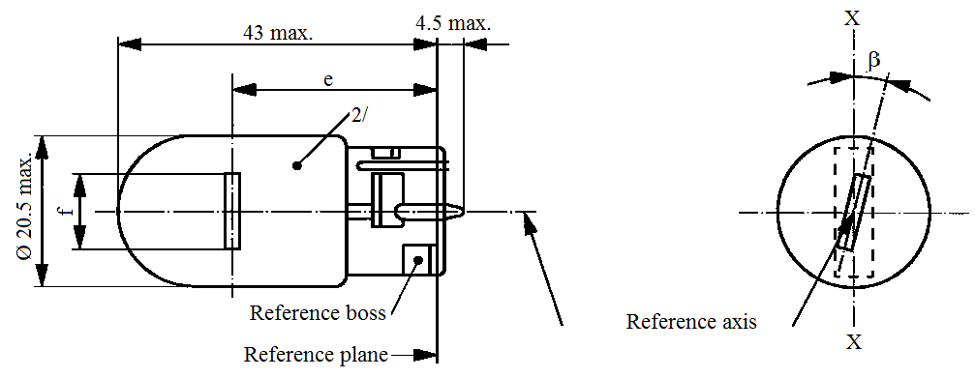
4.5 max.
43 max.
e
2/
X
X
ß
Ø 20.5 max.
f
Reference plane
Reference boss
Reference axis

Dimensions in mm |  |  | Filament light sources of normal production |  |  | Standard filament light source
 |  |  | Min. | Nom. | Max. | Standard filament light source
e |  |  |  | 29.0 ^{2/} |  | 29.0 ± 0.3
f |  |  |  |  | 7.5 | 7.5 + 0 / -2
Lateral deviation ^{1/} |  |  |  |  | ^{2/} | 0.5 max.
β |  |  | -15° | 0° | +15° | 0° ± 5°
Cap WX3x16d in accordance with IEC Publication 60061 (sheet 7004-105-3)
Electrical and photometric characteristics
Rated values | Volts | 12 |  |  |  | 12
Rated values | Watts | 21 |  |  |  | 21
Test voltage | Volts | 13.5 |  |  |  | 13.5
Objective values | Watts | 26.5 max. |  |  |  | 26.5 max.
Objective values | Luminous flux | 280 ± 20 %
Reference luminous flux at approximately 13.5 V: |  |  |  |  |  | White: 460 lm  Amber: 280 lm
^{1/} Maximum lateral deviation of filament centre from two mutually perpendicular planes both containing the reference axis and one containing axis X-X.
^{2/} The light emitted from filament light sources of normal production shall be amber (see also footnote 4/).
^{3/} To be checked by means of a "Box system"; sheet WY21W/2.
^{4/} The light emitted from standard filament light sources shall be amber or white.
Category WY21W Sheet WY21W/2
Screen projection requirements
This test is used to determine, by checking whether the filament is correctly positioned relative to the reference axis and reference plane and has an axis perpendicular, within ±15°, to the plane through the axis X-X and the reference axis, whether a filament light source complies with the requirements.
Side elevation Front elevation
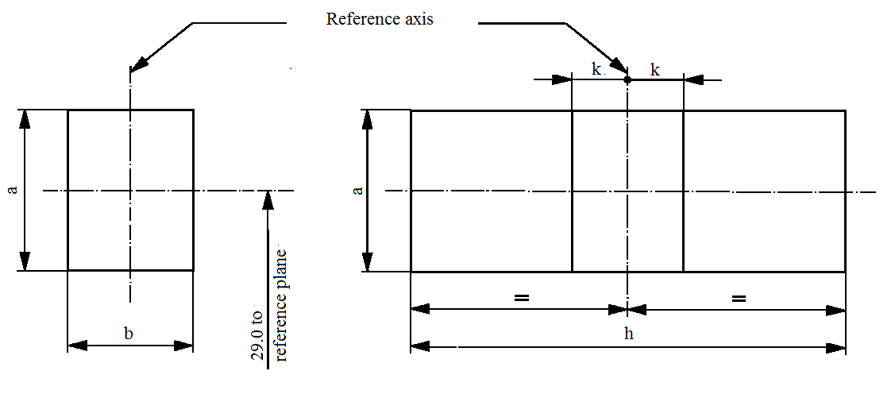
Reference axis
k
k
h
b
a
a
29.0 to
reference plane

Reference | a | b | h | k
Dimension | 3.5 | 3.0 | 9.5 | 1.0

Test procedures and requirements
1. The filament light source is placed in a holder capable of being rotated about its axis and having either a calibrated scale or fixed stops corresponding to the angular displacement tolerance limits, i.e. ±15°. The holder is then so rotated that an end view of the filament is seen on the screen on to which the image of the filament is projected. The end view of the filament shall be obtained within the angular displacements tolerance limits (±15°).
2. Side elevation
The filament light source placed with the cap down, the reference axis vertical and the filament seen end-on, the projection of the filament shall lie entirely within a rectangle of height "a" and width "b", having its centre at the theoretical position of the centre of the filament.
3. Front elevation
The filament light source placed with the cap down and the reference axis vertical, the filament light source being viewed in a direction at right angles to the filament axis:
3.1. The projection of the filament shall lie entirely within a rectangle of height "a" and width "h", having its centre at the theoretical position of the centre of the filament.
3.2. The centre of the filament shall not be offset by more than distance "k" from the reference axis.
Annex 2
Sheets for gas-discharge light sources
List of sheets for gas-discharge light sources and their sequence in this annex:
Sheet numbers
DxR/1 to 7 | (Sheet DxR/6: two pages)
DxS/1 to 6
D5S/1 to 5
D6S/1 to 5
D8R/1 to 6
D8S/1 to 5
D9S/1 to 5
Categories D1R, D2R, D3R and D4R Sheet DxR/1
The drawings are intended only to illustrate the essential dimensions (in mm) of the gas-discharge light source
Figure 1
Main drawing of category D1R - Type with cables - Cap PK32d-3

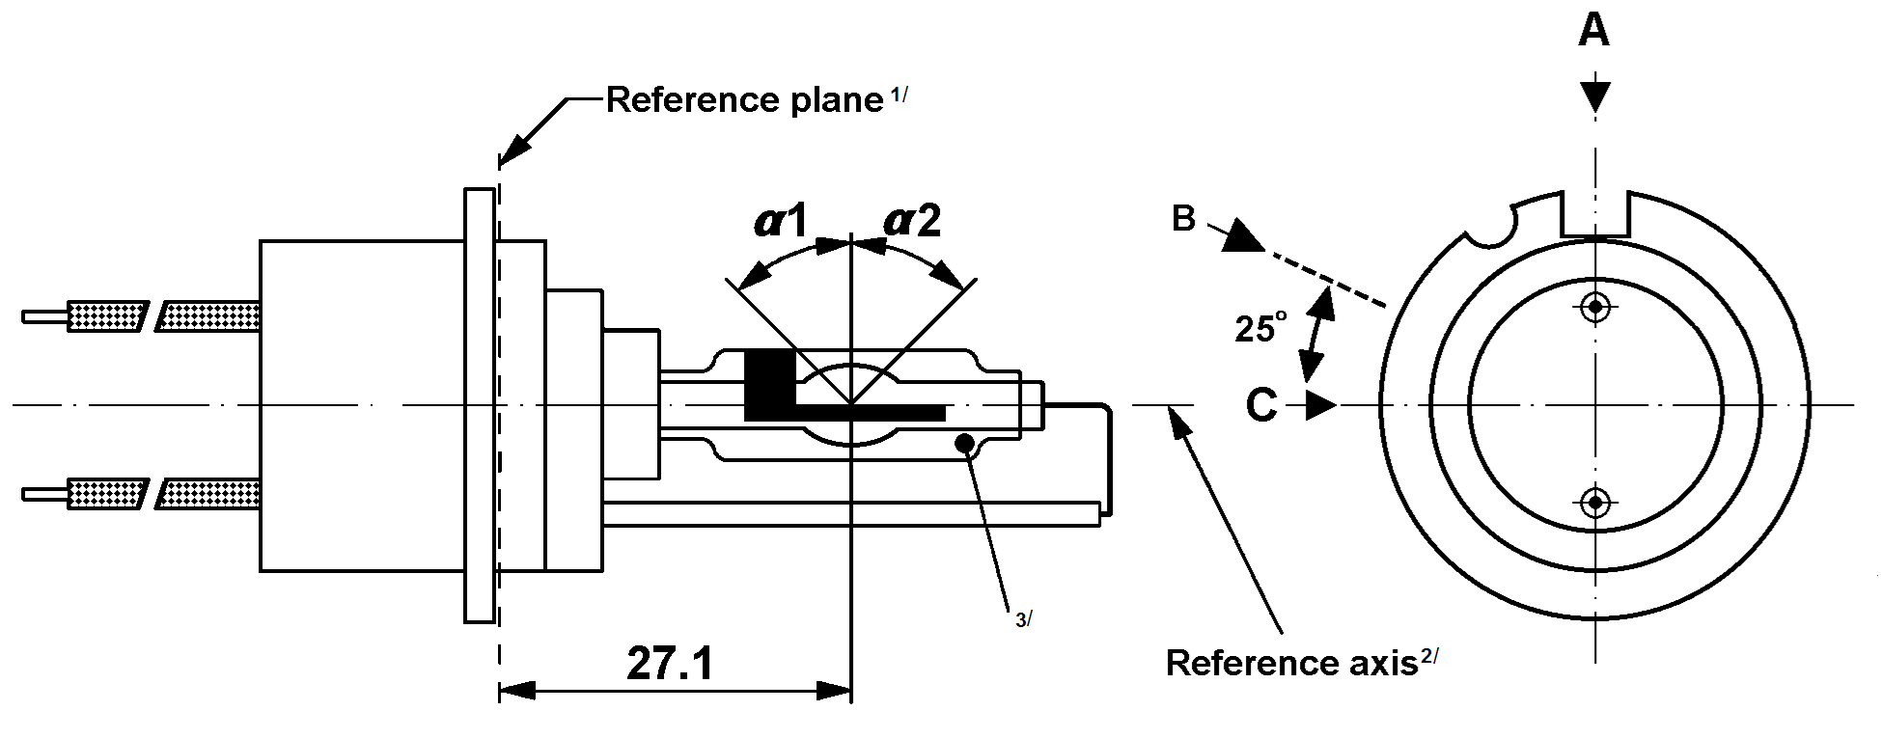

Figure 2
Main drawing of category D2R -Type with connector - Cap P32d-3
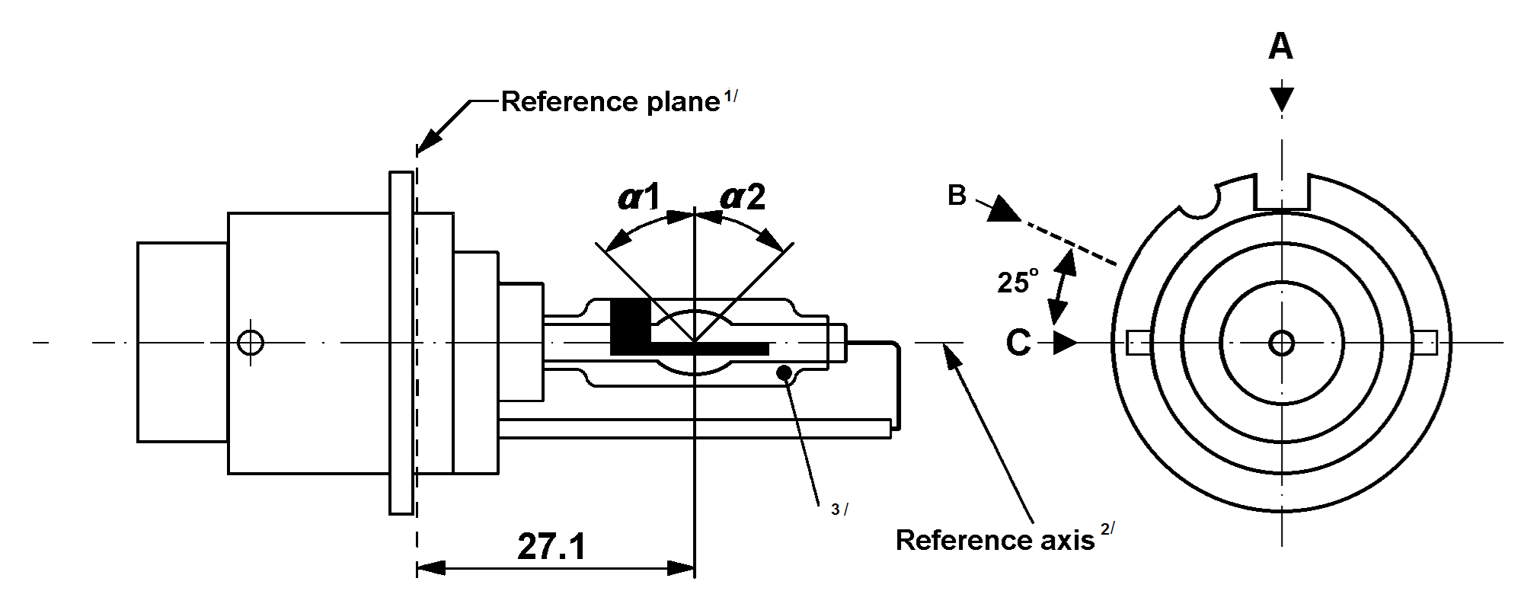
^{1/} The reference plane is defined by the positions on the surface of the holder on which the three supporting bosses of the cap ring will rest.
^{2/} See sheet DxR/3.
^{3/} With respect to the reference axis, when measured at a distance of 27.1 mm from the reference plane the eccentricity of the outer bulb shall be less than ±0.5 mm in direction C and less than -1 mm /+0.5 mm in direction A.
Categories D1R, D2R, D3R and D4R Sheet DxR/2
The drawings are intended only to illustrate the essential dimensions (in mm) of the gas-discharge light source
Figure 3
Main drawing of category D3R - Type with starter – Cap PK32d-6

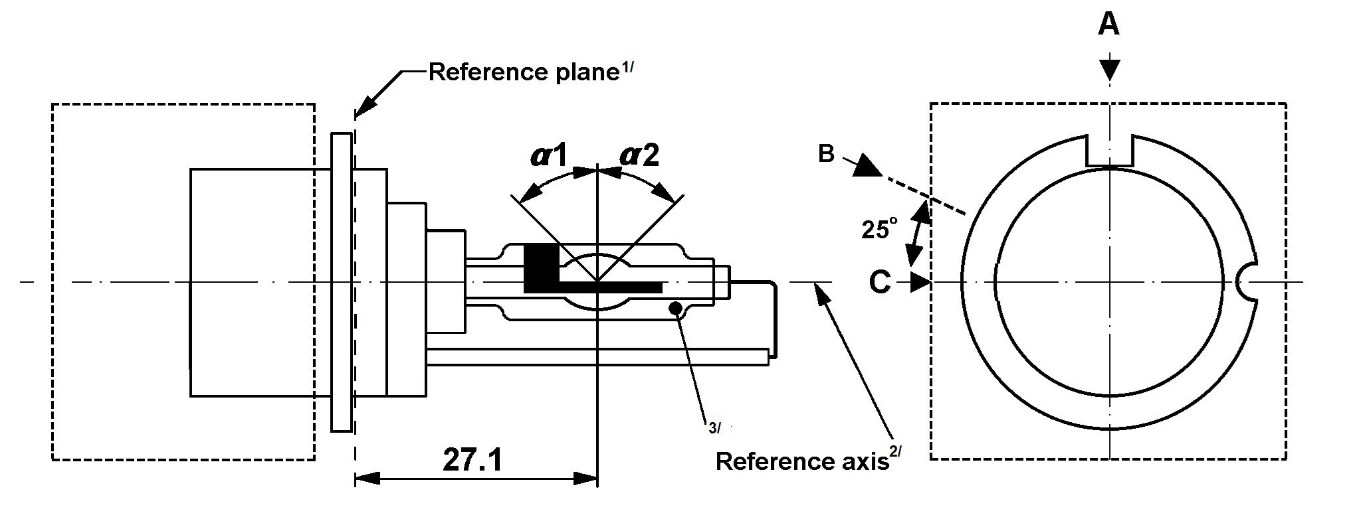

Figure 4
Main drawing of category D4R - Type with connector – Cap P32d-6

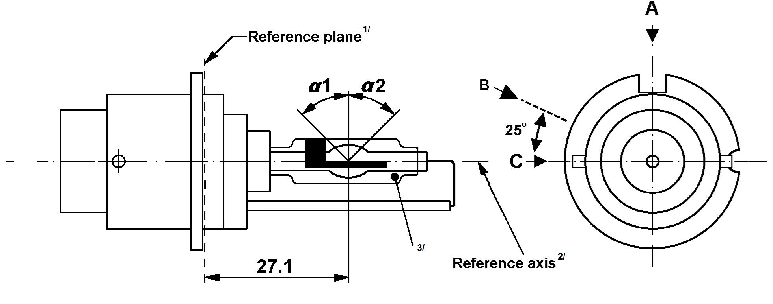
^{1/} The reference plane is defined by the positions on the surface of the holder on which the three supporting bosses of the cap ring will rest.
^{2/} See sheet DxR/3.
^{3/} With respect to the reference axis, when measured at a distance of 27.1 mm from the reference plane the eccentricity of the outer bulb shall be less than ±0.5 mm in direction C and less than -1 mm /+0.5 mm in direction A.
Categories D1R, D2R, D3R and D4R Sheet DxR/3
Figure 5
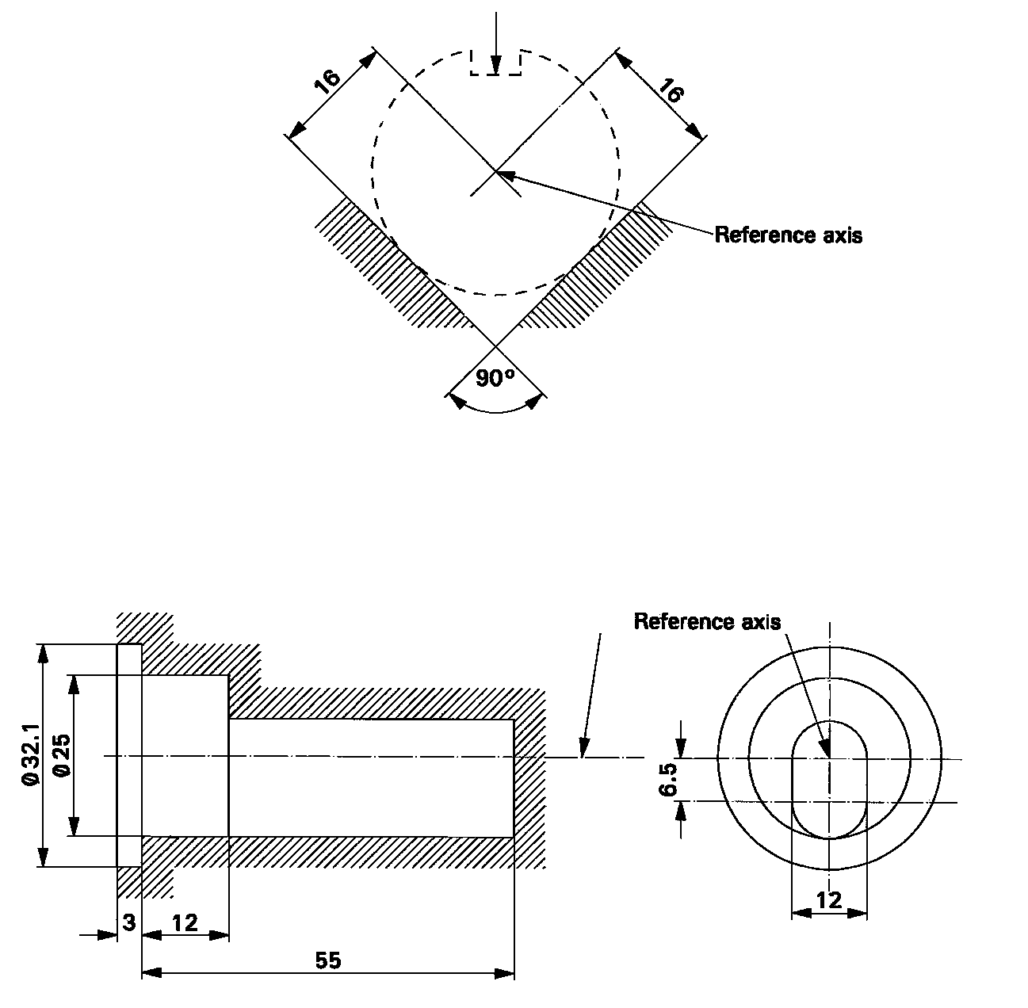
Definition of reference axis^{1/}
Reference plane
The cap shall be pushed in this direction
Figure 6
Maximum gas discharge light source outline^{2/}
^{1/} The reference axis is perpendicular to the reference plane and crosses the intersection of the two parallel lines as indicated in figure 5.
^{2/} Glass bulb and supports shall not exceed the envelope, as indicated in figure 6. The envelope is concentric with the reference axis.
Categories D1R, D2R, D3R and D4R Sheet DxR/4

Dimensions |  |  |  | Production  light sources |  | Standard  light sources
Position of electrodes |  |  |  | Sheet DxR/5
Position and form of the arc |  |  |  | Sheet DxR/6
Position of the black stripes |  |  |  | Sheet DxR/7
α1 ^{1/} |  |  |  | 45° ± 5°
α2 ^{1/} |  |  |  | 45° min.
D1R: Cap PK32d-3  D2R: Cap P32d-3  D3R: Cap PK32d-6  D4R: Cap P32d-6 |  | in accordance with IEC Publication 60061 (sheet 7004-111-5)
ELECTRICAL AND PHOTOMETRIC CHARCTERISTICS
 |  |  |  | D1R/D2R | D3R/D4R | D1R/D2R | D3R/D4R
Rated voltage of the ballast |  |  | V | 12 ^{2/} |  | 12
Rated wattage |  |  | W | 35 |  | 35
Test voltage |  |  | V | 13.5 |  | 13.5
Gas discharge light source voltage | Objective |  | V | 85 | 42 | 85 | 42
Gas discharge light source voltage | Tolerance |  | V | ±17 | ±9 | ±8 | ±4
Gas discharge light source wattage | Objective |  | W | 35 |  | 35
Gas discharge light source wattage | Tolerance |  | W | ±3 |  | ±0.5
Luminous flux | Objective |  | lm | 2800 |  | 2800
Luminous flux | Tolerance |  | lm | ±450 |  | ±150
Chromaticity co-ordinates in the case of white light | Objective |  |  | x = 0.375 |  | y = 0.375
Chromaticity co-ordinates in the case of white light | Tolerance area |  | Boundaries | x = 0.345  x = 0.405 |  | y = 0.150 + 0.640 x  y = 0.050 + 0.750 x
Chromaticity co-ordinates in the case of white light |  |  | Intersection points | x = 0.345 |  | y = 0.371
Chromaticity co-ordinates in the case of white light |  |  | Intersection points | x = 0.405 |  | y = 0.409
Chromaticity co-ordinates in the case of white light |  |  | Intersection points | x = 0.405 |  | y = 0.354
Chromaticity co-ordinates in the case of white light |  |  | Intersection points | x = 0.345 |  | y = 0.309
Hot re-strike switch-off time |  |  | s | 10 |  | 10
^{1/} The part of the bulb within the angles α1 and α2 shall be the light emitting part. This part shall be as homogeneous in form as possible and shall be optically distortion free. This applies to the whole bulb circumference within the angles α1 and α2 except for the black stripes.
^{2/} Application voltages of ballasts may differ from 12 V.
Categories D1R, D2R, D3R and D4R Sheet DxR/5

Position of the electrodes

This test is used to determine whether the electrodes are correctly positioned relative to the reference axis and the reference plane.
Reference axis
a2
b2
25mm from reference plane
c
a1
b1
Reference plane

Measuring direction: light source side and top view

Dimension  in mm | Production  light sources | Standard  light sources
a1 | d + 0.5 | d + 0.2
a2 | d + 0.7 | d + 0.35
b1 | 0.4 | 0.15
b2 | 0.8 | 0.3
c | 4.2 | 4.2
d = diameter of the electrode;
d < 0.3 for D1R and D2R;
d < 0.4 for D3R and D4R.
The top of the electrode nearest to the reference plane shall be positioned in the area defined by a1 and b1. The top of the electrode furthest from the reference plane shall be positioned in the area defined by a2 and b2.
Categories D1R, D2R, D3R and D4R Sheet DxR/6
Page 1 out of 2
Position and form of the arc
This test is used to determine the form and sharpness of the arc and its position relative to the reference axis and plane by determining its bending and diffusion; by measuring the luminance in the central cross section D, where Lmax_{C} is the maximum luminance of the arc measured from viewing direction C; see sheet DxR/2.
Lmax_{C}
Luminance (relative)
Nominal position of electrodes
D
Reference axis
r
27.1
20% of Lmax_{C}
Lmax_{C}
Reference plane
s
≈
Relative luminance distribution in the central cross section D. | The form of the arc is for illustration purpose only. | Measuring direction C as defined on sheet DxR/7.

When measuring the relative luminance distribution in the central cross section D as indicated in the drawing above, the maximum value Lmax_{C} has the distance r from the reference axis. The points of 20% of Lmax_{C} have the distance s, as shown in the drawing above.
Dimension in mm | Production light sources |  | Standard light sources
Dimension in mm | D1R/D2R | D3R/D4R | Standard light sources
r (arc bending) | 0.50 ± 0.25 | 0.50 ± 0.25 | 0.50 ± 0.20
s (arc diffusion) | 1.10 ± 0.25 | 1.10 + 0.25/-0.40 | 1.10 ± 0.25
Categories D1R, D2R, D3R and D4R Sheet DxR/6
Page 2 out of 2
Stray light
This test is used to determine unwanted reflected stray light by measuring the luminance in Zone A and at lines B and C, where Lmax_{B} is the maximum luminance of the arc measured from viewing direction B; see sheet DxR/2.
Lmax_{B}
Luminance (relative)
Nominal position of electrodes
D
Reference axis
Line C
Line B
Zone A
1.0
0.5
29.6
27.1
24.5
Lmax_{B}
Reference plane
≈
≈
≈
s

Relative luminance distribution in the central cross section D. | The form of the arc is for illustration purpose only. | Measuring direction B as defined on sheet DxR/7.
When measuring the luminances from measuring direction B as defined on sheet DxR/7, the relative luminance expressed as a percentage of Lmax_{B} (at cross section D) shall be:
Zone A | ≤ 4.5 %
Line B | ≤ 15 %
Line C | ≤ 5.0 %
The area of zone A is defined by the black coating, the outer bulb and a plane at 24.5 mm from the reference plane.
Categories D1R, D2R, D3R and D4R Sheet DxR/7
Position of black stripes
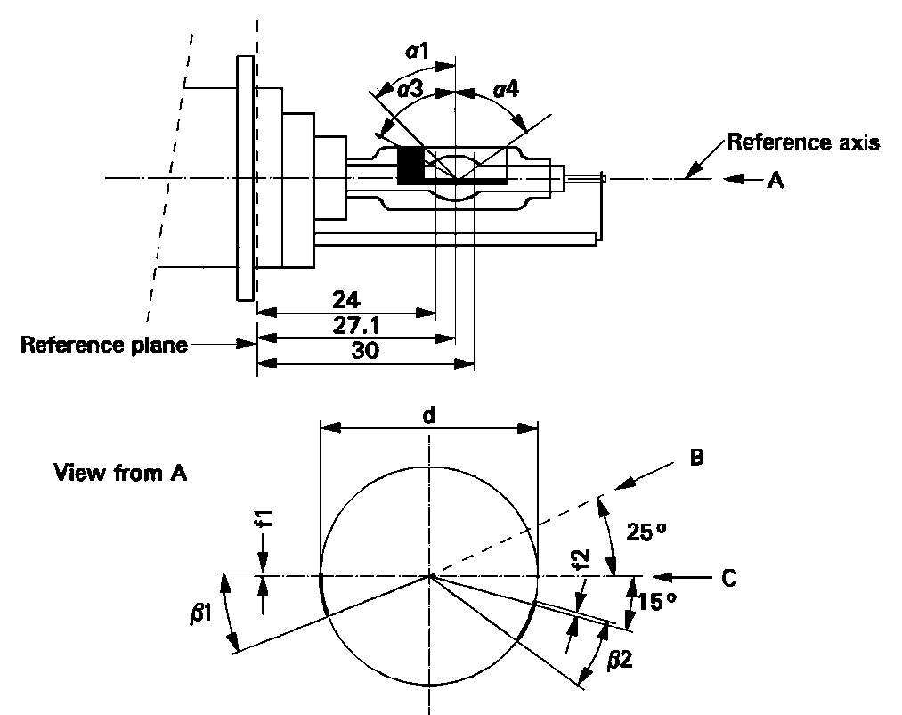
This test is used to determine whether the black stripes are correctly positioned relative to the reference axis and the reference plane.

When measuring the luminance distribution of the arc in the central cross section as defined on sheet DxR/6, after having turned the light source so that the black stripe is covering the arc, the measured luminance shall be ≤ 0.5 % of Lmax.
In the area defined by α1 and α3 the black coating may be replaced by any other means which prevents light transmission through the specified area.
Dimensions | Production light sources | Standard light sources
α1 | 45° ± 5°
α3 | 70° min.
α4 | 65° min.
β1/24, β1/30, β2/24, β2/30 | 25° ± 5°
f1/24, f2/24 ^{1/} | 0.15 ± 0.25 | 0.15 ± 0.20
f1/30 ^{1/} | f1/24 mv ± 0.15 ^{2/} | f1/24 mv ± 0.1
f2/30 ^{1/} | f2/24 mv ± 0.15 ^{2/} | f2/24 mv ± 0.1
f1/24 mv - f2/24 mv | ±0.3 max. | ±0.2 max.
d | 9 ± 1
^{1/} "f1/.." means dimension f1 to be measured at the distance from the reference plane indicated in mm after the stroke.
^{2/} "../24 mv" means the value measured at a distance of 24 mm from the reference plane.
Categories D1S, D2S, D3S and D4S Sheet DxS/1
The drawings are intended only to illustrate the essential dimensions (in mm) of the gas-discharge light source
Figure 1
Main drawing of category D1S - Type with cables - Cap PK32d-2

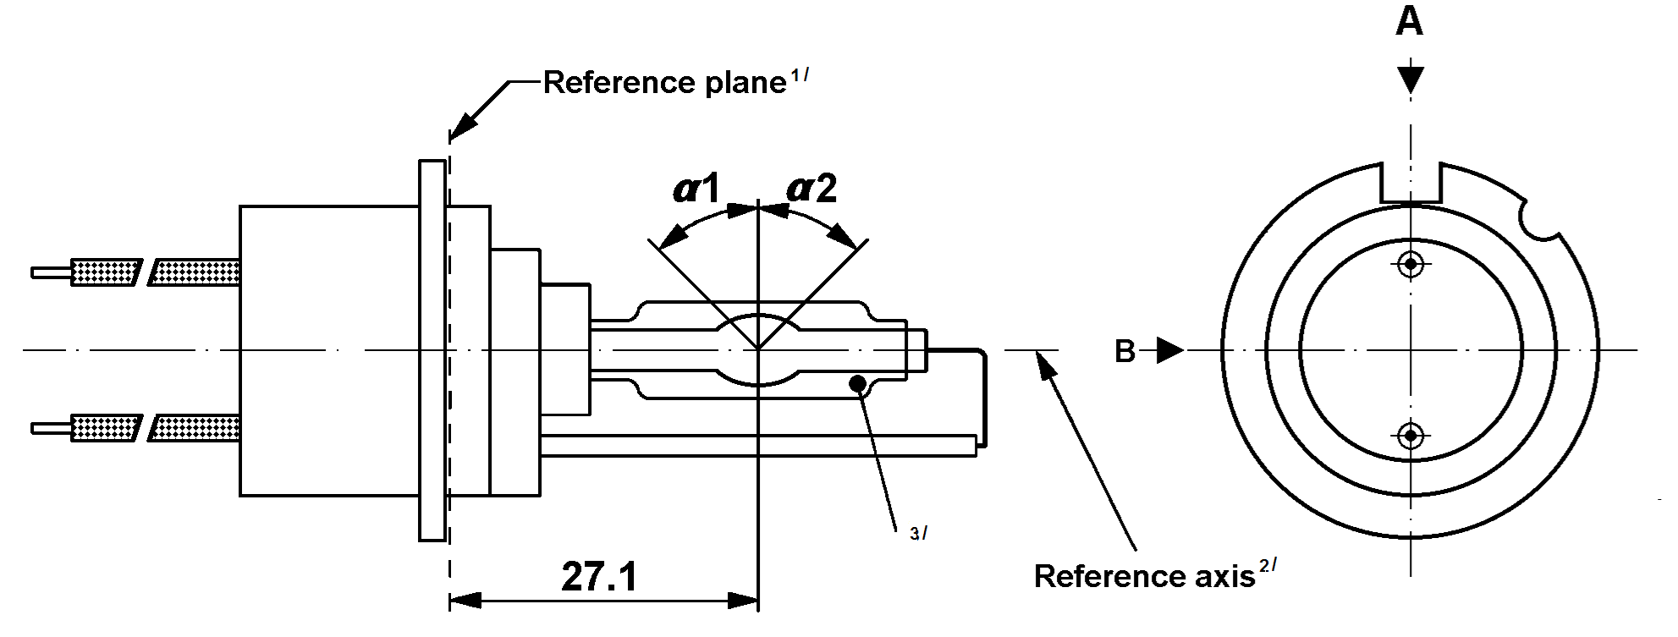
Figure 2
Main drawing of category D2S - Type with connector - Cap P32d-2
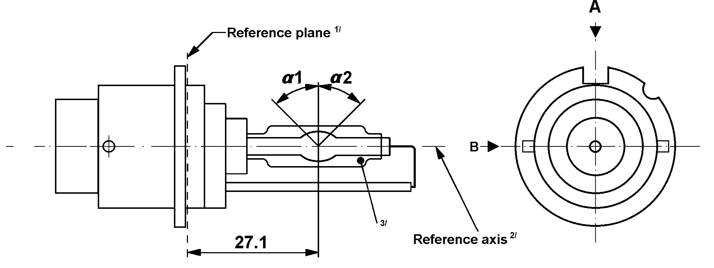
^{1/} The reference plane is defined by the positions on the surface of the holder on which the three supporting bosses of the cap ring will rest.
^{2/} See sheet DxS/3.
^{3/} When measured at a distance of 27.1 mm from the reference plane and with respect to the mid-point of the inner bulb, the outer bulb shall have an eccentricity of 1 mm max.
Categories D1S, D2S, D3S and D4S Sheet DxS/2
The drawings are intended only to illustrate the essential dimensions (in mm) of the gas-discharge light source
Figure 3
Main drawing of category D3S - Type with starter - Cap PK32d-5
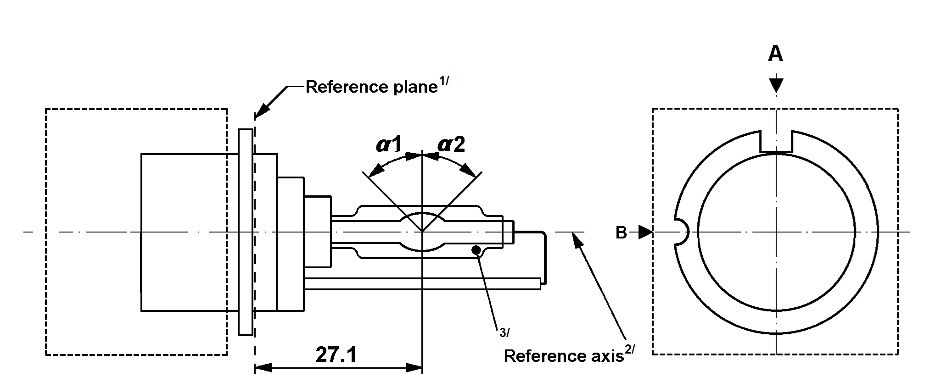

Figure 4
Main drawing of category D4S - Type with connector - Cap P32d-5

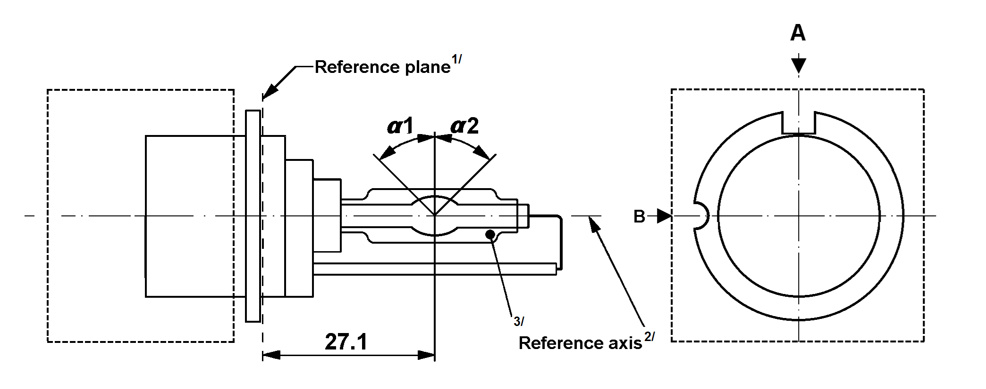
^{1/} The reference plane is defined by the positions on the surface of the holder on which the three supporting bosses of the cap ring will rest.
^{2/} See sheet DxS/3.
^{3/} When measured at a distance of 27.1 mm from the reference plane and with respect to the mid-point of the inner bulb, the outer bulb shall have an eccentricity of 1 mm max.
Categories D1S, D2S, D3S and D4S Sheet DxS/3
Figure 5
Definition of reference axis^{1/}
Reference plane
The cap shall be pushed in this direction
Figure 6
Maximum gas discharge light source outline^{2/}
^{1/} The reference axis is perpendicular to the reference plane and crosses the intersection of the two parallel lines as indicated in figure 5.
^{2/} Glass bulb and supports shall not exceed the envelope, as indicated in figure 6. The envelope is concentric with the reference axis.
Categories D1S, D2S, D3S and D4S Sheet DxS/4

Dimensions |  |  |  | Production  light sources |  | Standard  light sources
Position of electrodes |  |  |  | Sheet DxS/5
Position and form of the arc |  |  |  | Sheet DxS/6
α1, α2^{1/} |  |  |  | 55° min. |  | 55° min.
D1S: Cap PK32d-2  D2S: Cap P32d-2  D3S: Cap PK32d-5  D4S: Cap P32d-5 |  | in accordance with IEC Publication 60061 (sheet 7004-111-5)
ELECTRICAL AND PHOTOMETRIC CHARACTERISTICS
 |  |  |  | D1S/D2S | D3S/D4S | D1S/D2S | D3S/D4S
Rated voltage of the ballast |  |  | V | 12 ^{2/} |  | 12
Rated wattage |  |  | W | 35 |  | 35
Test voltage |  |  | V | 13.5 |  | 13.5
Gas discharge light source voltage | Objective |  | V | 85 | 42 | 85 | 42
Gas discharge light source voltage | Tolerance |  | V | ±17 | ±9 | ±8 | ±4
Gas discharge light source wattage | Objective |  | W | 35 |  | 35
Gas discharge light source wattage | Tolerance |  | W | ±3 |  | ±0.5
Luminous flux | Objective |  | lm | 3200 |  | 3200
Luminous flux | Tolerance |  | lm | ±450 |  | ±150
Chromaticity co-ordinates in the case of white light | Objective |  |  | x = 0.375 |  | y = 0.375
Chromaticity co-ordinates in the case of white light | Tolerance area |  | Boundaries | x = 0.345  x = 0.405 |  | y = 0.150 + 0.640 x  y = 0.050 + 0.750 x
Chromaticity co-ordinates in the case of white light |  |  | Intersection points | x = 0.345 |  | y = 0.371
Chromaticity co-ordinates in the case of white light |  |  | Intersection points | x = 0.405 |  | y = 0.409
Chromaticity co-ordinates in the case of white light |  |  | Intersection points | x = 0.405 |  | y = 0.354
Chromaticity co-ordinates in the case of white light |  |  | Intersection points | x = 0.345 |  | y = 0.309
Hot re-strike switch-off time |  |  | s | 10 |  | 10

^{1/} The part of the bulb within the angles α1 and α2 shall be the light emitting part. This part shall be as homogeneous in form as possible and shall be optically distortion free. This applies to the whole bulb circumference within the angles α1 and α2.
^{2/} Application voltages of ballasts may differ from 12 V.
Categories D1S, D2S, D3S and D4S Sheet DxS/5

Position of the electrodes

This test is used to determine whether the electrodes are correctly positioned relative to the reference axis and the reference plane.
Reference axis
a2
b2
25mm from reference plane
c
a1
b1
Reference plane

Measuring direction: light source side and top view

Dimension in mm | Production light sources | Standard light sources
a1 | d + 0.2 | d + 0.1
a2 | d + 0.5 | d + 0.25
b1 | 0.3 | 0.15
b2 | 0.6 | 0.3
c | 4.2 | 4.2
d = diameter of the electrode;
d < 0.3 for D1S and D2S;
d < 0.4 for D3S and D4S.

The top of the electrode nearest to the reference plane shall be positioned in the area defined by a1 and b1. The top of the electrode furthest from the reference plane shall be positioned in the area defined by a2 and b2.
Categories D1S, D2S, D3S and D4S Sheet DxS/6
Position and form of the arc
This test is used to determine the form of the arc and its position relative to the reference axis and the reference plane by measuring its bending and diffusion in the cross section at a distance 27.1 mm from the reference plane.
Luminance (relative)
Nominal position of electrodes
D
Reference axis
r
27.1
20% of Lmax
Lmax
Reference plane
s
≈

Relative luminance distribution in the central cross section D. | The form of the arc is for illustration purpose only. | Measuring direction B:  light source side view

When measuring the relative luminance distribution in the central cross section as indicated in the drawing above, the maximum value shall be located within the distance r from the reference axis. The point of 20% of the maximum value shall be within s:
Dimension in mm | Production light sources | Standard light sources
r (arc bending) | 0.50 ± 0.40 | 0.50 ± 0.20
s (arc diffusion) | 1.10 ± 0.40 | 1.10 ± 0.25

Category D5S Sheet D5S/1
The drawings are intended only to illustrate the essential dimensions (in mm) of the gas-discharge light source

Figure 1
Main drawing of category D5S - Cap PK32d-7
A
Reference plane^{1/}
View from rear
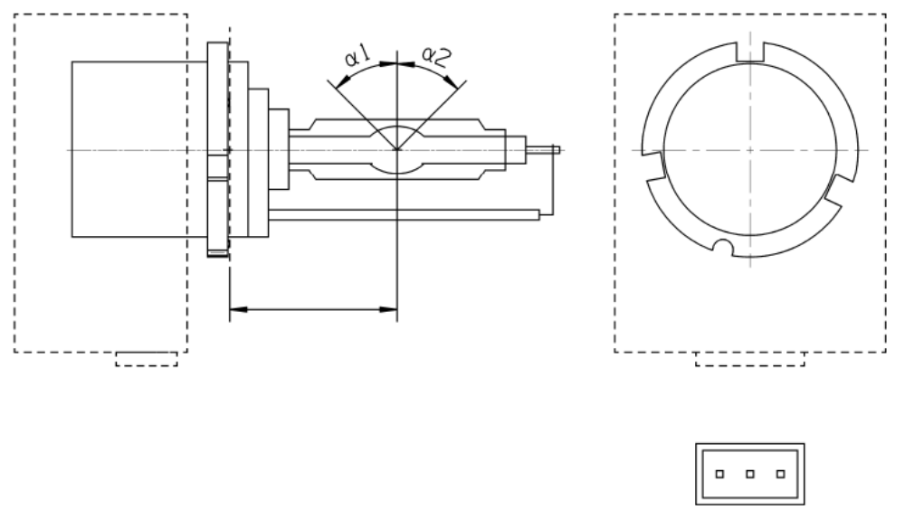
18.0
^{3/}
Reference axis ^{2/}
B
Connector
Burner side
Not connected^{4/}
V+
Ground

^{1/} The reference plane is defined by the positions on the surface of the holder on which the three supporting bosses of the cap ring will rest.
^{2/} See sheet D5S/2.
^{3/} When measured at a distance of 18.0 mm from the reference plane and with respect to the mid-point of the inner bulb, the outer bulb shall have an eccentricity of 1 mm max.
^{4/} Optional Pin.
Category D5S Sheet D5S/2

Figure 2
Definition of reference axis^{1/}

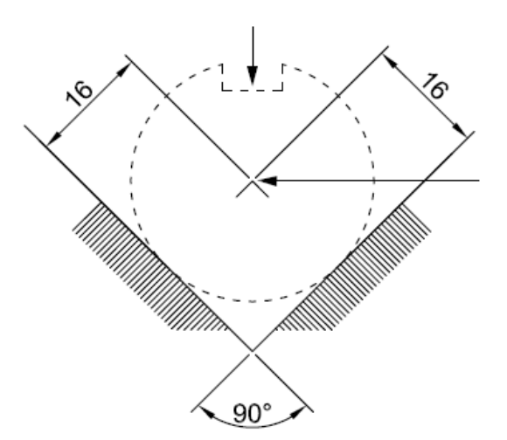
The cap shall be pushed in this direction
Reference axis

Figure 3
Maximum gas discharge light source outline^{2/}
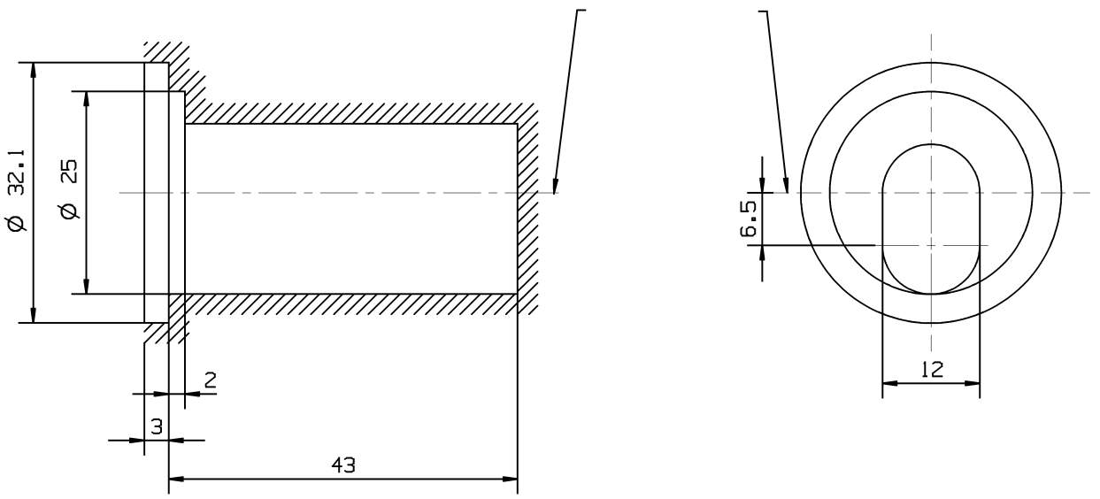
Reference axis

^{1/} The reference axis is perpendicular to the reference plane and crosses the intersection of the two parallel lines as indicated in figure 2.
^{2/} Glass bulb and supports shall not exceed the envelope, as indicated in figure 3.The envelope is concentric with the reference axis.
Category D5S Sheet D5S/3

Dimensions |  |  |  | Production  light sources | Standard  light sources
Position of the electrodes |  |  |  | Sheet D5S/4
Position and form of the arc |  |  |  | Sheet D5S/5
α1, α2^{1/} |  |  |  | 55° min. | 55° min.
D5S: Cap PK32d-7 |  | in accordance with IEC Publication 60061 (sheet 7004-111-5)
Electrical and photometric characteristics
Rated voltage |  |  | V | 12 / 24 | 12 / 24
Rated wattage |  |  | W | 25 | 25
Test voltage |  |  | V | 13.2 / 28 | 13.2 / 28
Objective gas discharge light source wattage^{2/} |  |  | W | 31 max. | 31 max.
Chromaticity coordinates | Objective |  |  | x = 0.375 | y = 0.375
Chromaticity coordinates | Tolerance area |  | Boundaries | x = 0.345  x = 0.405 | y = 0.150 + 0.640 x  y = 0.050 + 0.750 x
Chromaticity coordinates |  |  | Intersection  points | x = 0.345 | y = 0.371
Chromaticity coordinates |  |  | Intersection  points | x = 0.405 | y = 0.409
Chromaticity coordinates |  |  | Intersection  points | x = 0.405 | y = 0.354
Chromaticity coordinates |  |  | Intersection  points | x = 0.345 | y = 0.309
Objective Luminous flux |  |  | lm | 2000 ± 300 | 2000 ± 100
Hot-restrike switch-off time |  |  | s | 10 | 10
^{1/} The part of the bulb within the angles α1 and α2 shall be the light emitting part. This part shall be as homogeneous in form as possible and shall be optically distortion free. This applies to the whole bulb circumference within the angles α1 and α2.
^{2/} Wattage of gas discharge light source with ballast integrated.

Category D5S Sheet D5S/4
Position of the electrodes
This test is used to determine whether the electrodes are correctly positioned relative to the reference axis and the reference plane.
Top view (schematic):
Reference axis
a2
b2
16.05mm from reference plane
c
a1
b1
Reference plane
Side view (schematic):
Reference axis
a2
b2
16.05mm from reference plane

c
Reference plane
0.10 mm
a1
b1

Measuring direction: light source side and top view

Dimension  in mm | Production  light sources | Standard  The arc attachment point to the electrode nearest to the reference plane shall be positioned in the area defined by a1 and b1. The arc attachment point to the electrode furthest from the reference plane shall be positioned in the area defined by a2 and b2.  light sources
a1 | 0.30 | 0.20
a2 | 0.50 | 0.25
b1 | 0.30 | 0.15
b2 | 0.60 | 0.30
c | 3.90 | 3.90

Category D5S Sheet D5S/5

Position and form of the arc

This test is used to determine the form of the arc and its position relative to the reference axis and the reference plane by measuring its bending and diffusion in the cross section at a distance 18.0 mm from the reference plane.
Luminance (relative)
Reference axis
r
18.0
20% of Lmax
Lmax
Reference plane
s
≈
D

Relative luminance distribution in the central cross section D. | The form of the arc is for illustration purpose only. | Measuring direction:  light source side view
When measuring the relative luminance distribution in the central cross section as indicated in the drawing above, the maximum value shall be located within the distance r from the reference axis. The point of 20 per cent of the maximum value shall be within s.
Dimension in mm | Production light sources | Standard light sources
r (arc bending) | 0.50 +/-0.25 | 0.50 +/-0.15
s (arc diffusion) | 0.70 +/-0.25 | 0.70 +/-0.15

Category D6S Sheet D6S/1
The drawings are intended only to illustrate the essential dimensions (in mm) of the gas-discharge light source
Figure 1
Main drawing of category D6S - Cap P32d-1
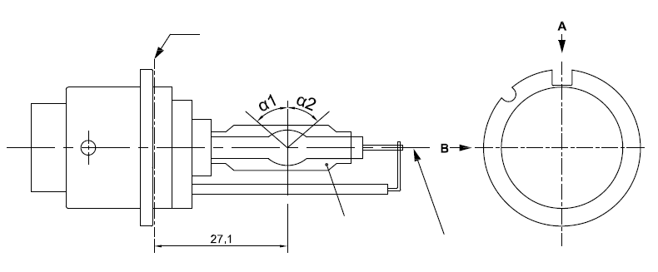
Reference plane^{1/}
Reference axis^{2/}
^{3/}
Reference axis ²
³

^{1/} The reference plane is defined by the positions on the surface of the holder on which the three supporting bosses of the cap ring will rest.
^{2/} See sheet D6S/2.
^{3/} When measured at a distance of 27.1 mm from the reference plane and with respect to the mid-point of the inner bulb, the outer bulb shall have an eccentricity of 1 mm max.
Category D6S Sheet D6S/2

Figure 2
Definition of reference axis^{1/}

The cap shall be pushed in this direction
Reference axis
Figure 3
Maximum gas discharge light source outline^{2/}
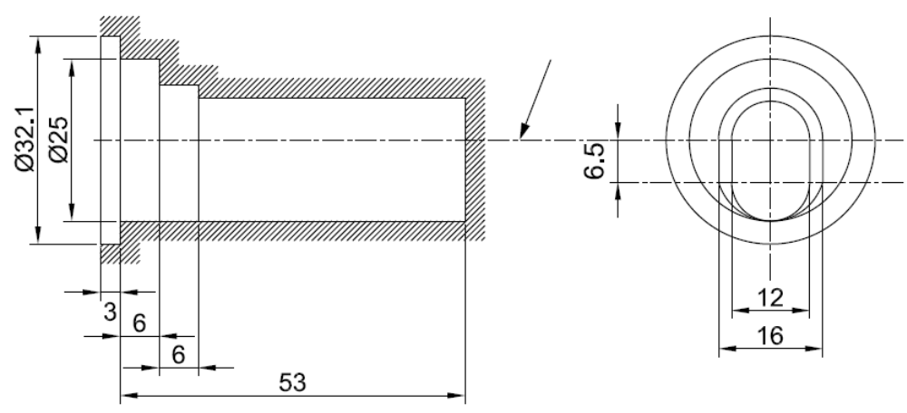
Reference axis

^{1/} The reference axis is perpendicular to the reference plane and crosses the intersection of the two parallel lines as indicated in figure 2.
^{2/} Glass bulb and supports shall not exceed the envelope, as indicated in figure 3. The envelope is concentric with the reference axis.
Category D6S Sheet D6S/3

Dimensions |  |  |  | Production  light sources | Standard  light sources
Position of the electrodes |  |  |  | Sheet D6S/4
Position and form of the arc |  |  |  | Sheet D6S/5
α1, α2^{1/} |  |  |  | 55° min. | 55° min.
D6S: Cap P32d-1 |  | in accordance with IEC Publication 60061 (sheet 7004-111-5)
Electrical and photometric characteristics
Rated voltage of the ballast |  |  | V | 12^{2/} | 12
Rated wattage |  |  | W | 25 | 25
Test voltage |  |  | V | 13.2 | 13.2
Objective gas discharge light source voltage |  |  | V | 42 ± 9 | 42 ± 4
Objective gas discharge light source wattage |  |  | W | 25± 3 | 25± 0.5
Objective Luminous flux |  |  | lm | 2000 ± 300 | 2000 ± 100
Chromaticity coordinates | Objective |  |  | x = 0.375 | y = 0.375
Chromaticity coordinates | Tolerance area |  | Boundaries | x = 0.345  x = 0.405 | y = 0.150 + 0.640 x  y = 0.050 + 0.750 x
Chromaticity coordinates |  |  | Intersection  points | x = 0.345 | y = 0.371
Chromaticity coordinates |  |  | Intersection  points | x = 0.405 | y = 0.409
Chromaticity coordinates |  |  | Intersection  points | x = 0.405 | y = 0.354
Chromaticity coordinates |  |  | Intersection  points | x = 0.345 | y = 0.309
Hot-restrike switch-off time |  |  | s | 10 | 10
^{1/} The part of the bulb within the angles α1 and α2 shall be the light emitting part. This part shall be as homogeneous in form as possible and shall be optically distortion free. This applies to the whole bulb circumference within the angles α1 and α2.
^{2/} Application voltages of ballasts may differ from 12 V.

Category D6S Sheet D6S/4
Position of the electrodes
This test is used to determine whether the electrodes are correctly positioned relative to the reference axis and the reference plane.
Top view (schematic):
Reference axis
a2
b2
25.15mm from reference plane

c
Reference plane
0.10 mm
a1
b1
Reference axis
a2
b2
25.15mm from reference plane
c
Reference plane
a1
b1
Side view (schematic):

Measuring direction: light source side and top view
The arc attachment point to the electrode nearest to the reference plane shall be positioned in the area defined by a1 and b1. The arc attachment point to the electrode furthest from the reference plane shall be positioned in the area defined by a2 and b2.
Dimension  in mm | Production  light sources | Standard  light sources
a1 | 0.30 | 0.20
a2 | 0.50 | 0.25
b1 | 0.30 | 0.15
b2 | 0.60 | 0.30
c | 3.90 | 3.90
Category D6S Sheet D6S/5

Position and form of the arc

This test is used to determine the form of the arc and its position relative to the reference axis and the reference plane by measuring its bending and diffusion in the cross section at a distance 27.1 mm from the reference plane.
Luminance (relative)
Reference axis
r
27.1
20% of Lmax
Lmax
Reference plane
s
≈
D

Relative luminance distribution in the central cross section D. | The form of the arc is for illustration purpose only. | Measuring direction:  light source side view
When measuring the relative luminance distribution in the central cross section as indicated in the drawing above, the maximum value shall be located within the distance r from the reference axis. The point of 20 per cent of the maximum value shall be within s.
Dimension in mm | Production light sources | Standard light sources
r (arc bending) | 0.50 +/-0.25 | 0.50 +/-0.15
s (arc diffusion) | 0.70 +/-0.25 | 0.70 +/-0.15

Category D8R Sheet D8R/1
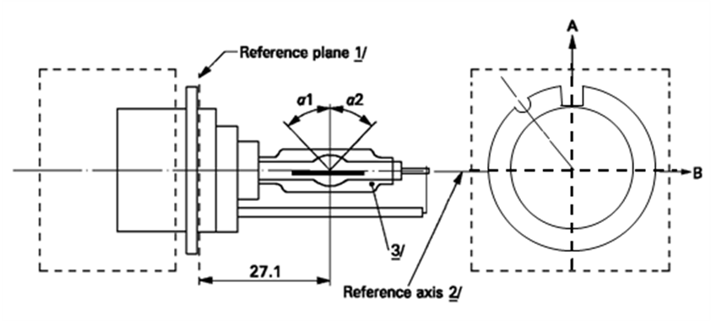
The drawings are intended only to illustrate the essential dimensions (in mm)
Reference axis ²
Reference plane ¹
View from C
C
of the gas-discharge light source

Figure 1
Main drawing of category D8R - Cap PK32d-8

¹ The reference plane is defined by the positions on the surface of the holder on which the three supporting bosses of the cap ring will rest.
² See sheet D8R/2.
³ When measured at a distance of 27.1 mm from the reference plane and with respect to the mid-point of the inner bulb, the outer bulb shall have an eccentricity of 1 mm max.
Category D8R Sheet D8R/2

The cap shall be pushed in this direction
Reference axis
Figure 2
Definition of reference axis¹
Reference axis

Figure 3
Maximum gas discharge light source outline²

¹ The reference axis is perpendicular to the reference plane and crosses the intersection of the two parallel lines as indicated in figure 2.
² Glass bulb and supports shall not exceed the envelope, as indicated in figure 3.The envelope is concentric with the reference axis.
Category D8R Sheet D8R/3

Dimensions |  |  |  | Production  light sources |  | Standard  light sources
Position of the electrodes |  |  |  | Sheet D8R/4
Position and form of the arc |  |  |  | Sheet D8R/5
α1¹ |  |  |  | 55° min.
α2¹ |  |  |  | 55° min.
D8R: Cap PK32d-8 |  | in accordance with IEC Publication 60061(sheet 7004-111-5)
Electrical and photometric characteristics
Rated voltage of the ballast |  |  | V | 12 ² |  | 12
Rated wattage |  |  | W | 25 |  | 25
Test voltage |  |  | V | 13.2 |  | 13.2
Objective gas discharge light source voltage |  |  | V | 42 ± 9 |  | 42 ± 4
Objective gas discharge light source wattage |  |  | W | 25 ± 3 |  | 25 ± 0.5
Objective Luminous flux |  |  | lm | 1900 ± 300 |  | 1900 ± 100
Chromaticity coordinates | Objective |  |  | x = 0.375 | y = 0.375
Chromaticity coordinates | Tolerance area |  | Boundaries | x = 0.345  x = 0.405 |  | y = 0.150 + 0.640 x  y = 0.050 + 0.750 x
Chromaticity coordinates |  |  | Intersection  points | x = 0.345 | y = 0.371
Chromaticity coordinates |  |  | Intersection  points | x = 0.405 | y = 0.409
Chromaticity coordinates |  |  | Intersection  points | x = 0.405 | y = 0.354
Chromaticity coordinates |  |  | Intersection  points | x = 0.345 | y = 0.309
Hot-restrike switch-off time |  |  | s | 10 |  | 10

¹ The part of the bulb within the angles α1 and α2 shall be the light emitting part. This part shall be as homogeneous in form as possible and shall be optically distortion free. This applies to the whole bulb circumference within the angles α1 and α2 except for the black stripes.
² Application voltages of ballasts may differ from 12 V.

Category D8R Sheet D8R/4
Position of the electrodes
This test is used to determine whether the electrodes are correctly positioned relative to the reference axis and the reference plane.
Top view (schematic):

Side view (schematic):
Reference axis
a2
b2
25.15mm from reference plane
c
Reference plane
a1
b1
Reference axis
a2
b2
25.15mm from reference plane

c
Reference plane
0.10 mm
a1
b1

Measuring direction: light source side and top view

Dimension  in mm | Production  light sources | Standard  The arc attachment point to the electrode nearest to the reference plane shall be positioned in the area defined by a1 and b1. The arc attachment point to the electrode furthest from the reference plane shall be positioned in the area defined by a2 and b2.  light sources
a1 | 0.50 | 0.20
a2 | 0.70 | 0.35
b1 | 0.40 | 0.15
b2 | 0.80 | 0.30
c | 3.90 | 3.90

Category D8R Sheet D8R/5

Position and form of the arc

This test is used to determine the form of the arc and its position relative to the reference axis and the reference plane by measuring its bending and diffusion in the cross section at a distance 27.1 mm from the reference plane.
Luminance (relative)
Reference axis
r
27.1
20% of Lmax
Lmax
Reference plane
s
≈
D

Relative luminance distribution in the central cross section D. | The form of the arc is for illustration purpose only. | Measuring direction:  light source side view
When measuring the relative luminance distribution in the central cross section as indicated in the drawing above, the maximum value shall be located within the distance r from the reference axis. The point of 20 per cent of the maximum value shall be within s.
Dimension in mm | Production light sources | Standard light sources
r (arc bending) | 0.50 +/- 0.25 | 0.50 +/- 0.15
s (arc diffusion) | 0.70 +/- 0.25 | 0.70 +/- 0.15

Category D8R Sheet D8R/6
Position of black stripes
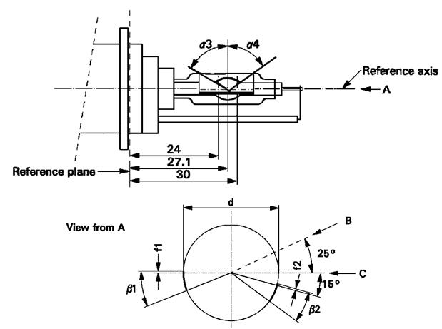
This test is used to determine whether the black stripes are correctly positioned relative to the reference axis and the reference plane.
Reference axis
Reference plane
View from A

When measuring the luminance distribution of the arc in the central cross section as defined on sheet D8R/5, after having turned the light source so that the black stripe is covering the arc, the measured luminance shall be ≤ 0.5 % of Lmax.

Dimensions | Production light sources | Standard light sources
α3 | 70° min.
α4 | 65° min.
β1/24, β1/30, β2/24, β2/30 | 25° ± 5°
f1/24, f2/24 ¹ | 0 ± 0.25 | 0 ± 0.20
f1/30 ¹ | f1/24 mv ± 0.15 ² | f1/24 mv ± 0.1
f2/30 ¹ | f2/24 mv ± 0.15 ² | f2/24 mv ± 0.1
f1/24 mv - f2/24 mv | ± 0.3 max. | ± 0.2 max.
d | 9 ± 1
¹ "f1/.." means dimension f1 to be measured at the distance from the reference plane indicated in mm after the stroke.
^{2/} "../24 mv" means the value measured at a distance of 24 mm from the reference plane.
Category D8S Sheet D8S/1
The drawings are intended only to illustrate the essential dimensions (in mm)
Figure 1
Main drawing of category D8S - Cap PK32d-1

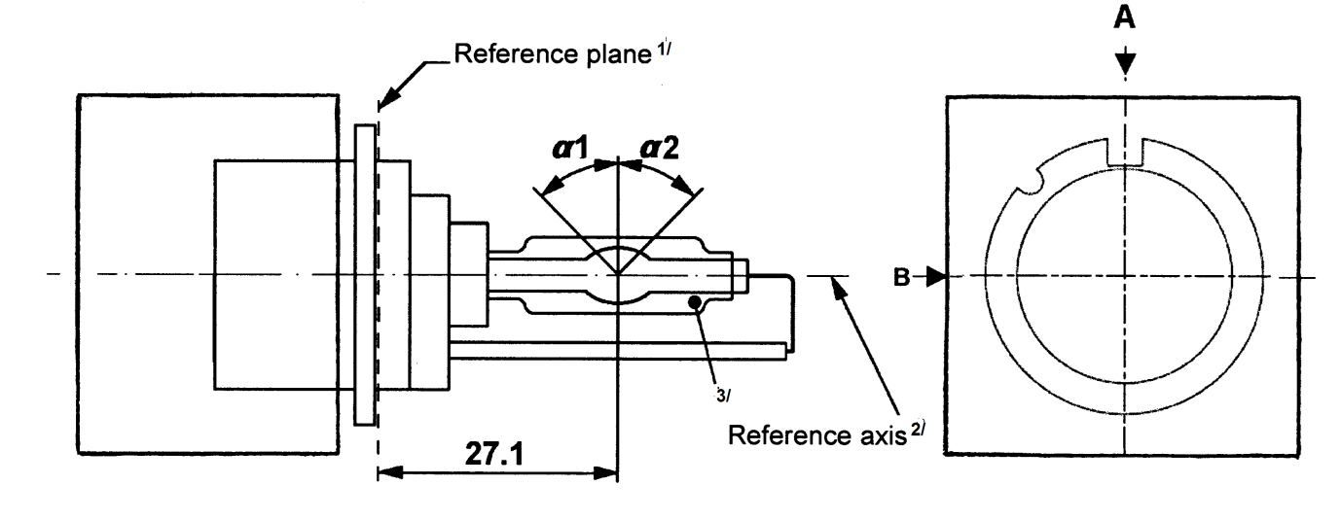

^{1/} The reference plane is defined by the positions on the surface of the holder on which the three supporting bosses of the cap ring will rest.
^{2/} See sheet D8S/2.
^{3/} When measured at a distance of 27.1 mm from the reference plane and with respect to the mid-point of the inner bulb, the outer bulb shall have an eccentricity of 1 mm max.
Category D8S Sheet D8S/2

Figure 2
Definition of reference axis^{1/}

The cap shall be pushed in this direction
Reference axis
Figure 3
Maximum gas discharge light source outline^{2/}
Reference axis

^{1/} The reference axis is perpendicular to the reference plane and crosses the intersection of the two parallel lines as indicated in figure 2.
^{2/} Glass bulb and supports shall not exceed the envelope, as indicated in figure 3.The envelope is concentric with the reference axis.
Category D8S Sheet D8S/3

Dimensions |  |  |  | Production  light sources | Standard  light sources
Position of the electrodes |  |  |  | Sheet D8S/4
Position and form of the arc |  |  |  | Sheet D8S/5
α1, α2^{1/} |  |  |  | 55° min. | 55° min.
D8S: Cap PK32d-1 |  | in accordance with IEC Publication 60061 (sheet 7004-111-5)
Electrical and photometric characteristics
Rated voltage of the ballast |  |  | V | 12^{2/} | 12
Rated wattage |  |  | W | 25 | 25
Test voltage |  |  | V | 13.2 | 13.2
Objective gas discharge light source voltage |  |  | V | 42 ± 9 | 42 ± 4
Objective gas discharge light source wattage |  |  | W | 25 ± 3 | 25 ± 0.5
Objective Luminous flux |  |  | lm | 2000 ± 300 | 2000 ± 100
Chromaticity coordinates | Objective |  |  | x = 0.375 | y = 0.375
Chromaticity coordinates | Tolerance area |  | Boundaries | x = 0.345  x = 0.405 | y = 0.150 + 0.640 x  y = 0.050 + 0.750 x
Chromaticity coordinates |  |  | Intersection  points | x = 0.345 | y = 0.371
Chromaticity coordinates |  |  | Intersection  points | x = 0.405 | y = 0.409
Chromaticity coordinates |  |  | Intersection  points | x = 0.405 | y = 0.354
Chromaticity coordinates |  |  | Intersection  points | x = 0.345 | y = 0.309
Hot-restrike switch-off time |  |  | s | 10 | 10
^{1/} The part of the bulb within the angles α1 and α2 shall be the light emitting part. This part shall be as homogeneous in form as possible and shall be optically distortion free. This applies to the whole bulb circumference within the angles α1 and α2.
^{2/} Application voltages of ballasts may differ from 12 V.

Category D8S Sheet D8S/4
Position of the electrodes
This test is used to determine whether the electrodes are correctly positioned relative to the reference axis and the reference plane.
Top view (schematic):
Reference axis
a2
b2
25.15mm from reference plane
c
Reference plane
a1
b1

Side view (schematic):
Reference axis
a2
b2
25.15mm from reference plane

c
Reference plane
0.10 mm
a1
b1

Measuring direction: light source side and top view
The arc attachment point to the electrode nearest to the reference plane shall be positioned in the area defined by a1 and b1. The arc attachment point to the electrode furthest from the reference plane shall be positioned in the area defined by a2 and b2.
Dimension  in mm | Production  light sources | Standard  light sources
a1 | 0.30 | 0.20
a2 | 0.50 | 0.25
b1 | 0.30 | 0.15
b2 | 0.60 | 0.30
c | 3.90 | 3.90
Category D8S Sheet D8S/5

Position and form of the arc

This test is used to determine the form of the arc and its position relative to the reference axis and the reference plane by measuring its bending and diffusion in the cross section at a distance 27.1 mm from the reference plane.
Luminance (relative)
Reference axis
r
27.1
20% of Lmax
Lmax
Reference plane
s
≈
D

Relative luminance distribution in the central cross section D. | The form of the arc is for illustration purpose only. | Measuring direction:  light source side view
When measuring the relative luminance distribution in the central cross section as indicated in the drawing above, the maximum value shall be located within the distance r from the reference axis. The point of 20 per cent of the maximum value shall be within s.
Dimension in mm | Production light sources | Standard light sources
r (arc bending) | 0.50 +/- 0.25 | 0.50 +/- 0.15
s (arc diffusion) | 0.70 +/- 0.25 | 0.70 +/- 0.15

Category D9S Sheet D9S/1
The drawings are intended only to illustrate the essential dimensions (in mm)

Figure 1

Main drawing of category D9S - Cap PK32d-9
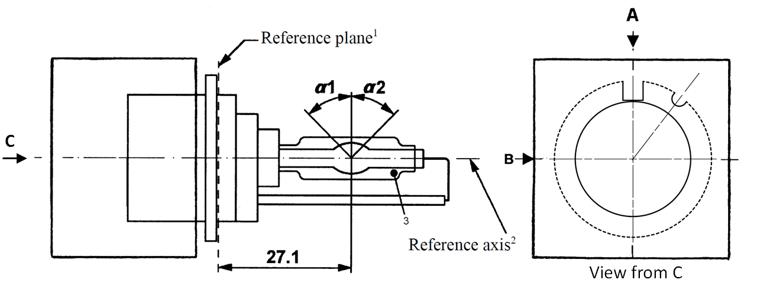

¹ The reference plane is defined by the positions on the surface of the holder on which the three supporting bosses of the cap ring will rest.
² See sheet D9S/2.
³ When measured at a distance of 27.1 mm from the reference plane and with respect to the mid-point of the inner bulb, the outer bulb shall have an eccentricity of 1 mm max.
Category D9S Sheet D9S/2

Figure 2

Definition of reference axis¹
The cap shall be pushed in this direction

Reference axis

Figure 3

Maximum gas discharge light source outline²
52
Reference axis

¹ The reference axis is perpendicular to the reference plane and crosses the intersection of the two parallel lines as indicated in figure 2.
² Glass bulb and supports shall not exceed the envelope, as indicated in figure 3.The envelope is concentric with the reference axis.
Category D9S Sheet D9S/3

Dimensions |  |  |  | Production  light sources |  | Standard  light sources
Position of the electrodes |  |  |  | Sheet D9S/4
Position and form of the arc |  |  |  | Sheet D9S/5
α1, α2 ¹ |  |  |  | 55° min. |  | 55° min.
D9S: Cap PK32d-9 |  | in accordance with IEC Publication 60061 (sheet 7004-111-5)
Electrical and photometric characteristics
Rated voltage of the ballast |  |  | V | 12 ² |  | 12
Rated wattage |  |  | W | 27 | 35 | 27 | 35
Test voltage |  |  | V | 13.5 |  | 13.5
Objective gas discharge light source voltage |  |  | V | 34 ± 6 | 38 ± 8 | 34 ± 4 | 38 ± 4
Objective gas discharge light source wattage |  |  | W | 27 ± 3 | 35 ± 3 | 27 ± 0.5 | 35 ± 0.5
Objective Luminous flux |  |  | lm | 2000 ± 300 | 3000 ± 450 | 2000 ± 100 | 3000 ± 150
Chromaticity coordinates | Objective |  |  | x = 0.375 |  | y = 0.375
Chromaticity coordinates | Tolerance area |  | Boundaries | x = 0.345  x = 0.405 |  | y = 0.150 + 0.640 x  y = 0.050 + 0.750 x
Chromaticity coordinates |  |  | Intersection  points | x = 0.345 |  | y = 0.371
Chromaticity coordinates |  |  | Intersection  points | x = 0.405 |  | y = 0.409
Chromaticity coordinates |  |  | Intersection  points | x = 0.405 |  | y = 0.354
Chromaticity coordinates |  |  | Intersection  points | x = 0.345 |  | y = 0.309
Hot-restrike switch-off time |  |  | s | 10 |  | 10
¹ The part of the bulb within the angles α1 and α2 shall be the light emitting part. This part shall be as homogeneous in form as possible and shall be optically distortion free. This applies to the whole bulb circumference within the angles α1 and α2.
² Application voltages of ballasts may differ from 12 V.

Category D9S Sheet D9S/4
Position of the electrodes
This test is used to determine whether the electrodes are correctly positioned relative to the reference axis and the reference plane.
Side and top view (schematic):

Reference axis
a2
b2
25.6mm from reference plane
c
Reference plane
a1
b1

Measuring direction: light source side and top view

Dimension  in mm | Production  light sources | Standard  The arc attachment point to the electrode nearest to the reference plane shall be positioned in the area defined by a1 and b1. The arc attachment point to the electrode furthest from the reference plane shall be positioned in the area defined by a2 and b2. The geometrical data is valid for 27W and 35W operation.  light sources
a1 | 0.30 | 0.20
a2 | 0.50 | 0.25
b1 | 0.30 | 0.15
b2 | 0.60 | 0.30
c | 3.00 | 3.00

Category D9S Sheet D9S/5

Position and form of the arc

This test is used to determine the form of the arc and its position relative to the reference axis and the reference plane by measuring its bending and diffusion in the cross section at a distance 27.1 mm from the reference plane.
Luminance (relative)
20% of Lmax
Lmax
Reference plane
27.1
D
s
r
Reference axis
Relative luminance distribution in the central cross section D. | The form of the arc is for illustration purpose only. | Measuring direction:  light source side view
When measuring the relative luminance distribution in the central cross section as indicated in the drawing above, the maximum value shall be located within the distance r from the reference axis. The point of 20 per cent of the maximum value shall be within s. The geometrical data is valid for 27W and 35W operation.
Dimension in mm | Production light sources | Standard light sources
r (arc bending) | 0.35 +/- 0.25 | 0.35 +/- 0.15
s (arc diffusion) | 0.80 +/- 0.25 | 0.80 +/- 0.15

Annex 3
Sheets for LED light sources
List of sheets for LED light sources and their sequence in this annex:
Sheet number(s)
LR1/1 to 5
LW2/1 to 5
L3/1 to 6
LR4/1 to 5
L5/1 to 6
Category LR1 Sheet LR1/1
The drawings are intended only to illustrate the essential dimensions (in mm) of the LED light source
Figure 1
Main drawing
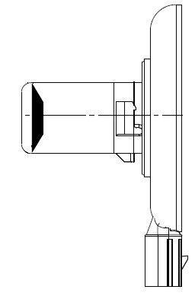
e
35 max
Ø 22 max
14
Ø 67 max
min. free air space
for convection
Reference plane ^{1/}
Reference axis 2/
3/
28
5
Connector

Figure 2

Connector detail
Not connected ^{4/}
Major Function
Ground
Minor Function

___________________
^{1/} The reference plane is the plane defined by the contact points of the cap-holder fit.
^{2/} The reference axis is perpendicular to the reference plane and passing through the centre of the bayonet core.
^{3/} Light emitting area: to be checked by means of the box system in Figure 3.
^{4/} Optional pin.
Category LR1 Sheet LR1/2
Table 1
Essential dimensional, electrical and photometric characteristics
Dimensions in mm |  | Tolerance
 |  | LED light sources of normal production |  | Standard LED light source
e ^{3/ 7/} | 24.0 | 0.2 |  | 0.1
Cap PGJ21t-1 in accordance with IEC Publication 60061 (sheet 7004-165-1)
Electrical and photometric characteristics ^{5/}
Rated values |  | Minor function | Major function | Minor function | Major function
Rated values | Volts | 12 |  | 12
Objective  Values ^{6/} | Watts  (at 13.5 V DC) | 0.75 max. | 3.5 max.  1.4 min. | 0.75 max. | 3.5 max.  1.4 min.
Objective  Values ^{6/} | Luminous flux  (in lm at 13.5V DC) |  |  | 3.5 ± 10% | 47 ± 10%
Objective  Values ^{6/} | Luminous flux  (in lm at 10-16 V DC) | 3.5 ± 20% | 47 ± 20%
^{5/} The emitted light shall be red.
^{6/} Continuous on for 30 minutes at 23 ± 2.5° C.
^{7/} Light centre length.
Failure condition behaviour
In case of LED light source failure (no light emitted) the maximum current draw – when operated within the input voltage range in major function mode – operation shall be less than 20 mA (open circuit condition).
Screen projection requirements
The following test is intended to define the requirements for the light emitting area of the LED light source and to determine whether the light emitting area is correctly positioned relative to the reference axis and reference plane in order to check compliance with the requirements.
The position of the light emitting area is checked by the box system defined in Figure 3, which shows the projections when viewing along direction γ=90º in the planes C₉₀ and C₁₈₀ (C, γ as defined in Figure 4). At least 95 per cent of the luminous flux emitted into the viewing direction has to come from the trapezoidal area defined by d1, d2 and c. Less than 70 per cent of the luminous flux shall be emitted from the rectangular area defined by d3 and c.

Category LR1 Sheet LR1/3
Figure 3
Box definition of the light emitting area

d2
d1
c
e
d3
Reference plane
Reference axis

Table 2
Dimensions of the box system in Figure 3
Dimensions in mm | e | c | d1 | d2 | d3
LED light sources of normal production | 24.0 + 0.2 | 3.6 | 21.0 | 15.0 | 7.0
Standard (etalon) LED light sources | 24.0 + 0.1 | 3.4 | 21.0 | 15.0 | 7.0
Normalized luminous intensity distribution
The following test is intended to determine the normalized luminous intensity distribution of the LED light source in an arbitrary plane containing the reference axis. The intersection of the reference axis and the upper edge of the box is used as the coordinate system origin.
The LED light source is mounted on a flat plate with the corresponding mounting lug features. The plate is mounted to the goniometer table by a bracket, so that the reference axis of the LED light source lines up with one of the rotating axis of the goniometer. The corresponding measurement set-up is described in Figure 4.
Category LR1 Sheet LR1/4

The drawings are intended only to illustrate the essential set-up for measurement of the LED light source

Figure 4
Set-up to measure the luminous intensity distribution

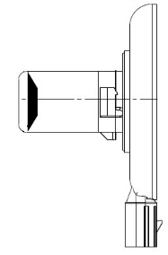
γ
e
Photo-Detector of Goniometer
Reference Plane
Reference Axis

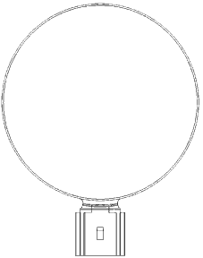
C
Any C-plane between C₃₀ and C₃₃₀

Luminous intensity data is recorded for the major function with a standard photo-goniometer. The measurement distance should be chosen appropriately, to make sure that the detector is located in the far field of the light distribution.
The measurements shall be performed in 3 C-planes, which contain the reference axis of the LED light source. The 3 C-planes shall be within C₃₀ and C₃₃₀ to avoid the connector shadows and they have to be at least 30º apart from each other. The test points for each plane for multiple polar angles γ are specified in Table 3.
The measured luminous intensity values, normalised to the measured luminous flux of the individual LED light source under test, shall be converted to normalised luminous intensity values of a 1000 lm LED light source. The data shall comply with the tolerance band as defined in Table 3.
C-planes: see CIE publication 70-1987, "The measurement of absolute intensity distributions".
Category LR1 Sheet LR1/5
Table 3
Test point values of normalized intensity for the major function of normal production and standard LED light sources, respectively.
 | LED light source of normal production |  | Standard LED light source
γ | Minimum intensity  in cd /1000 lm | Maximum intensity  in cd/1000 lm | Minimum intensity  in cd /1000 lm | Maximum intensity in cd/1000 lm
0° | 0 | 30 | 0 | 20
15° | 0 | 30 | 0 | 20
30° | 0 | 70 | 0 | 40
45° | 20 | 100 | 20 | 60
60° | 35 | 120 | 35 | 80
75° | 50 | 140 | 50 | 100
90° | 70 | 160 | 70 | 120
105° | 90 | 180 | 90 | 140
120° | 110 | 200 | 110 | 160
135° | 110 | 200 | 110 | 160
150° | 90 | 180 | 90 | 140
The luminous intensity distribution as described in Table 3 shall be substantially uniform, i.e. in between two adjacent grid points the relative luminous intensity requirement is calculated by linear interpolation using the two adjacent grid points.
Category LW2 Sheet LW2/1
The drawings are intended only to illustrate the essential dimensions (in mm) of the LED light source
Figure 1
Light emitting area ^{3/}
Reference axis ^{2/}
Reference plane ^{1/}
Main Drawing – front and side view

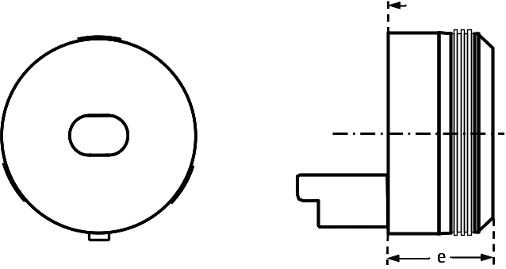
Figure 2 – Connector Detail
Major function
Ground
Not connected ^{4/}
Minor function
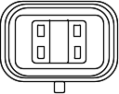
Table 1
Essential dimensional, electrical and photometric characteristics
Dimensions in mm |  | Tolerances
 |  | LED light sources of normal production |  | Standard LED light sources
e ^{8/} | 26.4 | 0.2 |  | 0.1
Cap PGJY50 in accordance with IEC Publication 60061 (sheet 7004-182-1)
Electrical and photometric characteristics ^{5/}
Rated values |  | Minor function | Major function |  | Minor function | Major function
Rated values | Volts | 12 |  |  | 12
Objective  Values ^{6/ 7/} | Watts  (at 13.5 V DC) | 1 max. | 12 max.  4 min. |  | 1 max. |  | 12 max.  4 min.
Objective  Values ^{6/ 7/} | Luminous flux  (in lm at 13.5V DC) |  |  |  | 50 ± 10% |  | 725 ± 10%
Objective  Values ^{6/ 7/} | Luminous flux  (in lm at 10-16 V DC) | 50 ± 15% | 725 ± 15%
Corresponding base temperature T_{b} in °C |  | 30 ± 2 | 55 ± 2 |  | 30 ± 0.5 |  | 55 ± 0.5
^{1/} The reference plane is given by the thermal transfer area on the backside of the LED light source.
^{2/} The reference axis is perpendicular to the reference plane and passing through the centre of the LED light source as defined by three notches on the outer perimeter.
^{3/} Light emitting area: to be checked by means of the box system in Figure 3.
^{4/} Optional pin.
^{5/} The emitted light shall be white.
^{6/} Continuous operation for 30 minutes with base temperature Tb stabilized as specified above.
^{7/} Luminous flux from the light emitting area shall be determined within a solid angle of 40° < α < + 40° and 40° < β < +40° using either integral methods or the procedure described on sheets LW2/3 and LW2/4.
^{8/} Light centre length.
Category LW2 Sheet LW2/2
Screen projection requirements
This test is intended to determine whether the light emitting area of the LED light source is correctly positioned relative to the reference axis and reference plane.
Compliance of position and dimension as defined in Table 2 is checked by the box system shown in Figure 3. The left drawing displays the projection when viewing along the reference axis with an aperture acceptance angle of ±40° while the right drawing defines the position of the reference plane and axis.
Size determination shall be done with suitable means.
Figure 3
Box definition of light emitting area
Light emitting area ^{3/}

Reference plane ^{1/}
Reference axis ^{2/}
Light Emission
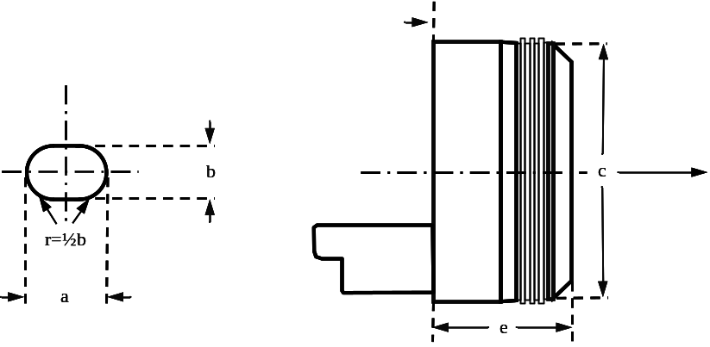
Table 2
Dimensions of the light emitting area in Figure 3
Dimensions in mm | e | a | b | c
LED light sources of normal production | 26.4 ± 0.2 | 14.5 +0/ -2.5 | 10.1 +0/ -1.5 | Ø 50.00 + 0.10/ -0
Standard (Etalon) LED light sources | 26.4 ± 0.1 | 14.5 +0/ -2.5 | 10.1 +0/ -1.5 | Ø 50.05 + 0.05/ -0

Category LW2 Sheet LW2/3
Cumulative luminous flux distribution
Measurement set-up
This test is intended to determine the cumulative luminous flux within defined solid angles of the luminous intensity distribution.
Goniophotometers of type I or II according to CIE publication No. 70 -1987 with the capability of turning the LED light source around two axes perpendicular to the axis of light emission can be used. The intersection of the reference axis and the parallel plane to the reference plane in distance e is used as the coordinate system origin.
Figure 4
Set-up to measure the luminous intensity distribution using a type I photogoniometer

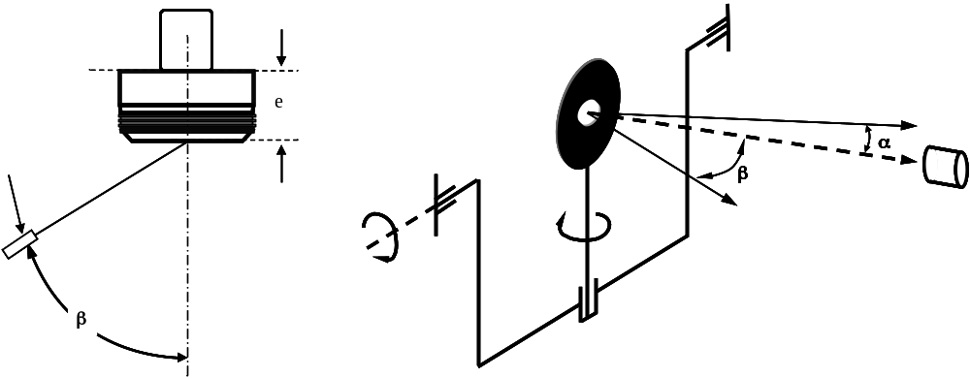
Photometer
of Goniometer
Photometer
Reference Axis
Reference Plane

The LED light source is mounted on a flat plate with the corresponding mounting lug features. The plate is mounted to the goniometer table by a bracket in such way, that the reference axis of the LED light source lines up with the measurement axis of the goniometer. The corresponding measurement set-up is described in Figure 4.
Category LW2 Sheet LW2/4
Cumulative luminous flux distribution
Measurement and calculation procedure
Data shall be recorded for the specified base temperature T_{b} from Table 1 at the location shown in Fig. 5.
Luminous intensity distribution data shall be recorded within a solid angle of -40° < α < +40° and -40° < β < +40°. The measurement distance shall be chosen in such manner that the detector is located in the far field of the light distribution. An angular step size of 1° or less is required.
After the measurement, the cumulative luminous flux distribution shall be calculated from the recorded data for various solid angles as specified in Table 3 according to CIE publication 84-1989, section 4.3. Subsequently, the distribution shall be normalized to the total luminous flux determined for -40° < α < +40° and -40° < β < +40. The data shall comply with the tolerance band defined in Table 3.
In order to secure a symmetrical distribution within each solid angle in Table 3 the luminous flux determination shall be done independently for all 4 quadrants and flux values shall not differ by more than 15%.
Table 3
Test point values of normalized cumulative luminous flux for both normal production and standard LED light sources
Angle α, β | Min. normalized flux in % | Max. normalized flux in %
-5° < α, β < +5° | 8 | 14
-10° < α, β < +10° | 31 | 37
-15° < α, β < +15° | 54 | 59
-20° < α, β < +20° | 75 | 81
-25° < α, β < +25° | 91 | 95
-30° < α, β < +30° | 97 | 100
-35° < α, β < +35° | 98 | 100
-40° < α, β < +40° | 100 (by definition)
The cumulative luminous flux distribution of the minor function may be verified by measuring the ratio of major and minor function under a fixed angle and multiplication of this factor with the luminous flux of the major function.
In case of doubt that cumulative luminous flux distributions of major and minor function differ, the procedure as described above for the major function shall be repeated for the minor function.
Thermal interface geometry
The LW2 thermal interface is located within the reference plane (shaded area in Figure 5) and described in detail in IEC Publication 60061 as indicated in Table 1 on sheet LW2/1. It shall be attached to an appropriate heat sink or thermal management system.
The luminous flux given in Table 1 shall be achieved once the base temperature T_{b} measured at the location shown in Figure 5 is stabilized.
Category LW2 Sheet LW2/5

Figure 5
Rear-view: thermal contact area and location of T_{b}-point on the vertical
symmetry axis, at a distance f from the center

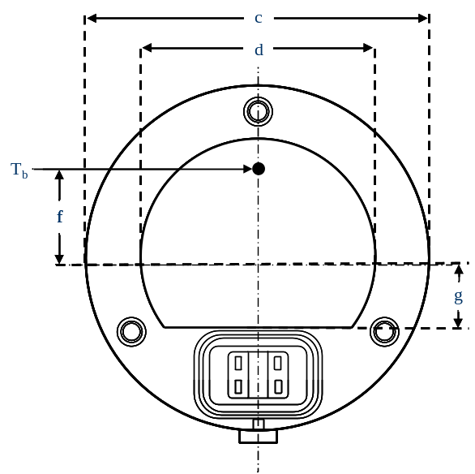
Dimensions in mm
c | 50.0
d | 34.5
f | 13.0
g | 10.0

Failure condition behaviour
In case of LED light source failure (no light emitted) the maximum current draw – when operated within the input voltage range in major function mode – shall be less than 20 mA (open circuit condition).

Categories LR3A, LR3B, LW3A, LW3B, LY3A and LY3B Sheet L3/1
The drawings are intended only to illustrate the essential dimensions of the LED light source.
Figure 1*
Main Drawing
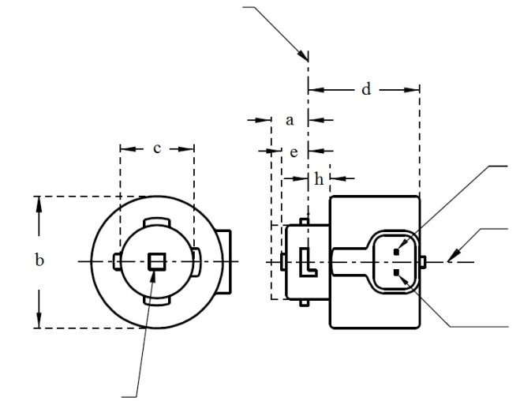
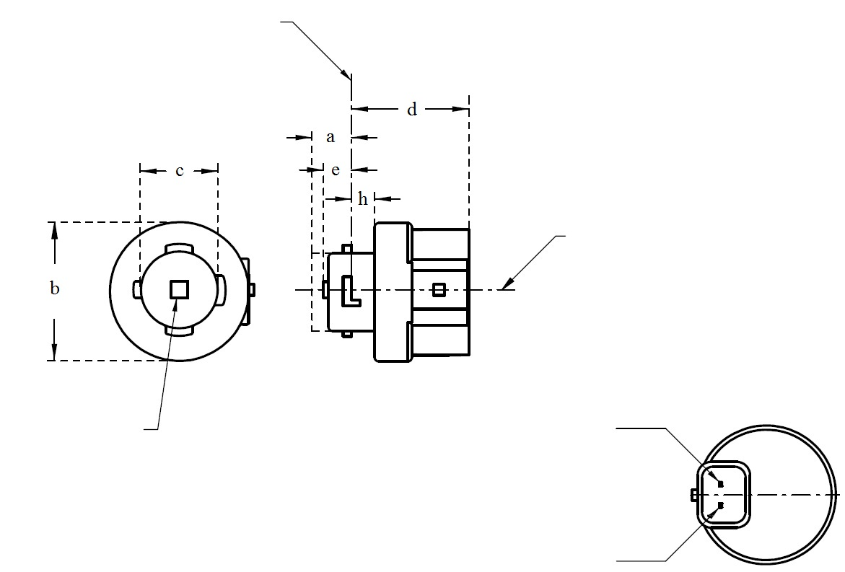
Reference plane ¹

V+
Light emitting area ³
Reference axis ²
Ground
⁴
LR3A, LW3A, LY3A
V+
Light emitting area ³
Reference axis ²
Ground
Reference plane ¹
⁴
LR3B, LW3B, LY3B

For the notes see sheet L3/2.
* Projection method:
Categories LR3A, LR3B, LW3A, LW3B, LY3A and LY3B Sheet L3/2
Table 1
Essential dimensional, electrical and photometric characteristics of the LED light source

Dimensions |  |  |  |  |  | Production LED light sources | Standard LED light sources
a |  |  |  |  | mm | 6.0 max.
b |  |  |  |  | mm | c + 10.0 min.  38.0 max.
c |  |  |  |  | mm | 18.5 ± 0.1
d |  |  |  |  | mm | 28.0 max.
e ^{13/} |  |  |  |  | mm | 3.0 ± 0.30 | 3.0 ± 0.15
h |  |  |  |  | mm | 5.5 + 0.0/ – 0.1
Cap | LR3A, LR3B  LW3A, LW3B  LY3A, LY3B |  | PGJ18.5d-1  PGJ18.5d-24 PGJ18.5d-15 |  | in accordance with IEC Publication 60061 (sheet 7004-185-1)
Electrical and photometric characteristics
Rated values |  | Volts |  |  |  | 12
 |  | Watts |  |  | LR3A, LR3B | 3
 |  |  |  |  | LW3A, LW3B  LY3A, LY3B | 4
Objective Values⁸ |  | Watts  (at 13.5 V DC) |  |  | LR3A, LR3B | 3.5 max.
 |  |  |  |  | LW3A, LW3B | 5 max.
 |  |  |  | ¹² | LY3A, LY3B
 |  | Luminous flux  (in lm at 13.5 V DC) |  | ⁵ | LR3A, LR3B | 80 ± 20%⁹ | 80 ± 10%¹⁰
 |  |  |  | ⁶ | LW3A, LW3B | 250 ± 20% | 250 ± 10%¹¹
 |  |  |  | ^{7, 12} | LY3A, LY3B | 150 ± 20%⁹ | 150 ± 10%¹⁰
 |  | Luminous flux  (in lm at 9 V DC) |  | ⁵ | LR3A, LR3B | 19 min
 |  |  |  | ⁶ | LW3A, LW3B | 50 min.
 |  |  |  | ^{7, 12} | LY3A, LY3B | 30 min
^{1/} The reference plane is the plane defined by the contact points of the cap-holder fit.
^{2/} The reference axis is perpendicular to the reference plane and passing through the centre of the bayonet core.
^{3/} Light emitting area: to be checked by means of the box system in Figure 2.
^{4/} A minimum free air space of 5mm around the light source shall be respected for convection.
^{5/} The emitted light shall be red.
^{6/} The emitted light shall be white.
^{7/} The emitted light shall be amber.
^{8/} After continuous operation for 30 minutes at 23 ± 2.5° C.
^{9/} The measured value shall be in between 100 per cent and 70 per cent of the value measured after 1 minute.
^{10/} The measured value shall be in between 85 per cent and 75 per cent of the value measured after 1 minute.
^{11/} The measured value shall be in between 100 per cent and 90 per cent of the value measured after 1 minute.
^{12/} Operated in flashing mode for 30 minutes (frequency = 1.5 Hz, duty cycle 50 per cent ON, 50 per cent OFF). Measured in the ON-state of flashing mode after 30 minutes of operation.
^{13/} Light centre length
Electrical characteristics
In case of LED light source failure (no light emitted) the max. electrical current draw, when operated between 12 V and 14 V, shall be less than 20 mA (open circuit condition).
Categories LR3A, LR3B, LW3A, LW3B, LY3A and LY3B Sheet L3/3
Screen projection requirements

The following test is intended to define the requirements for the light emitting area of the LED light source and to determine whether the light emitting area is correctly positioned relative to the reference axis and reference plane in order to check compliance with the requirements.

The position of the light emitting area is checked by the box system defined in Figure 2, which is aligned to the planes C90 and C180 and shows the projection when viewing along direction γ=0º (C, γ as defined in Figure 3).

The proportion of the total luminous flux emitted into the viewing direction shall be as described in table 3.

Figure 2
Box definition of the light emitting area with dimensions as specified in table 2

f/3
Reference axis
perpendicular in the
centre of the light-
emitting area
f/3
f/3
f/3
f/3
f/3
A
B
B
B
B
C
C
C
C
f/2
f/2
Table 2
Dimensions of the box system in Figure 2

Dimensions in mm | f
Dimensions in mm | LR3A, LR3B | LW3A, LW3B LY3A, LY3B
LED light sources of normal production | 3.0 | 4.5
Standard LED light sources | 3.0 | 4.5

Categories LR3A, LR3B, LW3A, LW3B, LY3A and LY3B Sheet L3/4

Table 3
Proportion of the total luminous flux emitted into the viewing direction from the areas specified in figure 2

Category | Area(s) | LED light sources of normal production | Standard LED light sources
LR3A  LR3B | A | ≤ 25% | ≤ 10%
LR3A  LR3B | Each B individually | ≥ 15% | ≥ 20%
LR3A  LR3B | Each C individually | - | ≤ 10%
LR3A  LR3B | A, all B and all C together | ≥ 90% | ≥ 90%
LW3A  LW3B  LY3A  LY3B | Each A,B individually | ≥ 6% | ≥ 8%
LW3A  LW3B  LY3A  LY3B | Each A, B individually | < 40% | < 30%
LW3A  LW3B  LY3A  LY3B | All A, B together | ≥ 55% | ≥ 60%
LW3A  LW3B  LY3A  LY3B | Each C individually | < 15% | < 10%
LW3A  LW3B  LY3A  LY3B | All A, B and C together | ≥ 90% | ≥ 90%

Categories LR3A, LR3B, LW3A, LW3B, LY3A and LY3B Sheet L3/5
Normalized luminous intensity distribution
The following test is intended to determine the normalized luminous intensity distribution of the light source in an arbitrary plane containing the reference axis. The intersection of the reference axis and the parallel plane to the reference plane in distance e is used as the coordinate system origin.
The light source is mounted on a flat plate with the corresponding mounting lug features. The plate is mounted to the goniometer table by a bracket, so that the reference axis of the light source lines up with one of the rotating axis of the goniometer. The corresponding measurement set-up is described in Figure 3.
Luminous intensity data is recorded with a standard photo-goniometer. The measurement distance should be chosen appropriately, to make sure that the detector is located in the far field of the light distribution.
The measurements shall be performed in C-planes C₀ (C₁₈₀) and C₉₀ (C₂₇₀), which contain the reference axis of the light source. The test points for each plane for multiple polar angles γ are specified in Tables 4a and 4b.
The measured luminous intensity values, normalised to the measured luminous flux of the individual light source under test, shall be converted to normalised luminous intensity values of a 1,000 lm light source. The data shall comply with the tolerance band as defined in Tables 4a and 4b.
The drawings are intended only to illustrate the essential set-up for measurement of the LED light source.
Figure 3
Set-up to measure the luminous intensity distribution
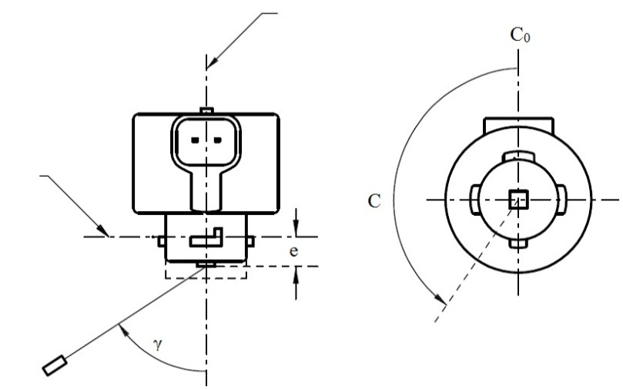
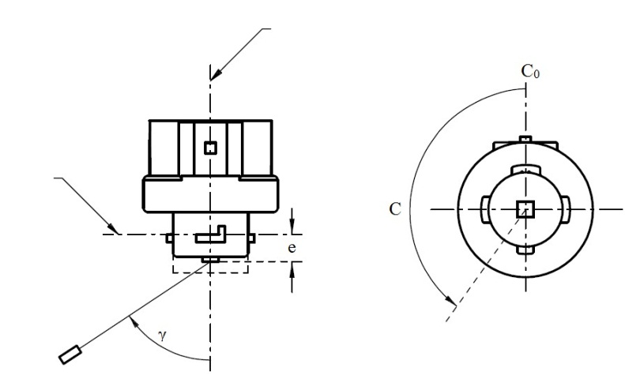
Reference axis
Reference plane
C-plane definition
Viewing direction along reference axis
Photo-Detector of Goniometer
LR3A, LW3A, LY3A
Reference axis
Reference plane
Photo-Detector of Goniometer
C-plane definition
Viewing direction along reference axis
LR3B, LW3B, LY3B

Categories LR3A, LR3B, LW3A, LW3B, LY3A and LY3B Sheet L3/6

The light pattern as described in Tables 4a and 4b shall be substantially uniform, i.e. in between two adjacent grid points the relative luminous intensity requirement is calculated by linear interpolation using the two adjacent grid points. In case of doubt this may be checked in addition to verification of the grid points given in Tables 4a and 4b.
Table 4a
Test point values of normalized intensities for categories LR3A and LR3B
 | LED light sources of normal production |  | Standard LED light sources
Angle γ | Minimum Intensity  in cd /1000 lm | Maximum Intensity  in cd/1000 lm | Minimum Intensity  in cd /1000 lm | Maximum Intensity in cd /1000 lm
-90° | 0 | 38 | 0 | 25
-75° | 0 | 160 | 0 | 140
-60° | 98 | 246 | 127 | 220
-45° | 142 | 305 | 181 | 275
-30° | 169 | 352 | 213 | 315
-15° | 192 | 389 | 239 | 340
0° | 200 | 401 | 248 | 352
15° | 192 | 389 | 239 | 340
30° | 169 | 352 | 213 | 315
45° | 142 | 305 | 181 | 275
60° | 98 | 246 | 127 | 220
75° | 0 | 160 | 0 | 140
90° | 0 | 38 | 0 | 25
Table 4b
Test point values of normalized intensities for categories LW3A, LW3B, LY3A and LY3B
 | LED light sources of normal production |  | Standard LED light sources
Angle γ | Minimum Intensity  in cd /1000 lm | Maximum Intensity  in cd/1000 lm | Minimum Intensity  in cd /1000 lm | Maximum Intensity in cd /1000 lm
-90° | 0 | 70 | 0 | 65
-75° | 0 | 160 | 0 | 150
-60° | 85 | 245 | 105 | 220
-45° | 145 | 310 | 180 | 275
-30° | 170 | 380 | 220 | 335
-15° | 190 | 415 | 240 | 370
0° | 200 | 425 | 250 | 390
15° | 190 | 415 | 240 | 370
30° | 170 | 380 | 220 | 335
45° | 145 | 310 | 180 | 275
60° | 85 | 245 | 105 | 220
75° | 0 | 160 | 0 | 150
90° | 0 | 70 | 0 | 65
Categories LR4A and LR4B Sheet LR4/1

The drawings are intended only to illustrate the essential dimensions of the LED light source.
Figure 1*
Main Drawing
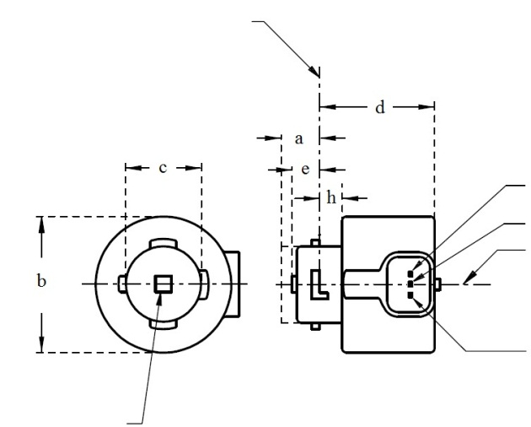
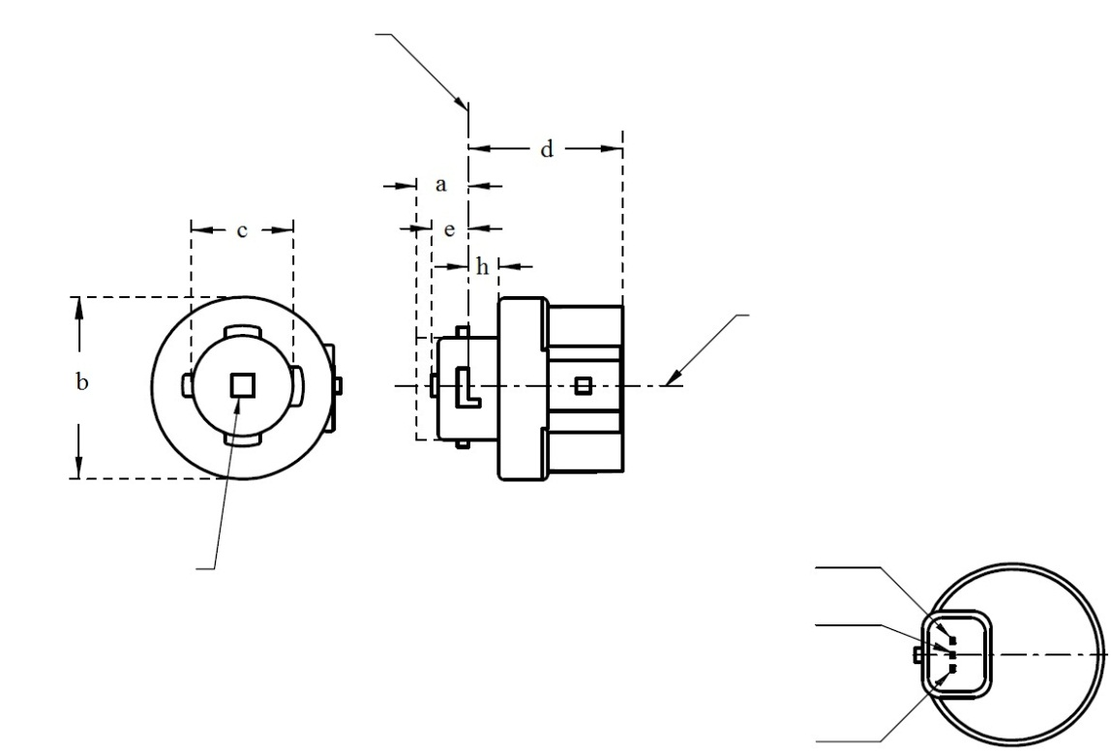
Reference plane ¹
Major Function

Light emitting area ³
Reference axis ²
Ground
Minor Function
LR4A
⁴
* Projection method:
LR4B
Major Function

Light emitting area ³
Reference axis ²
Ground
Minor Function
Reference plane ¹
⁴
For the notes see sheet LR4/2.

⁴

Categories LR4A and LR4B Sheet LR4/2

Table 1
Essential dimensional, electrical and photometric characteristics of the LED light source

Dimensions |  |  | Production LED light sources |  | Standard LED light sources
a |  | mm | 6.0 max.
b |  | mm | c + 10.0 min.  38.0 max.
c |  | mm | 18.5 ± 0.1
d |  | mm | 28.0 max.
e ^{9/} |  | mm | 3.0 ± 0.30 |  | 3.0 ± 0.15
h |  | mm | 5.5 + 0.0/ – 0.1
Cap PGJ18.5t-5 in accordance with IEC Publication 60061 (sheet 7004-185-1)
Electrical and photometric characteristics ⁵
Rated values |  |  | Minor function | Major function | Minor function | Major function
Rated values | Volts |  | 12 |  | 12
Rated values | Watts |  | 0.75 | 3 | 0.75 | 3
Objective  Values ⁶ | Watts  (at 13.5 V DC) |  | 1.0 max. | 3.5 max. | 1.0 max. | 3.5 max.
Objective  Values ⁶ | Luminous flux  (in lm at 13.5 V DC) |  | 6 ± 20% | 80 ± 20% ⁷ | 6 ± 10% | 80 ± 10% ⁸
Objective  Values ⁶ | Luminous flux  (in lm at 9 V DC) |  | 1.5 min. | 19 min.

^{1/} The reference plane is the plane defined by the contact points of the cap-holder fit.
^{2/} The reference axis is perpendicular to the reference plane and passing through the centre of the Bayonet core.
^{3/} Light emitting area: to be checked by means of the box system in Figure 2
^{4/} A minimum free air space of 5mm around the LED light source shall be respected for convection.
^{5/} The emitted light shall be red.
^{6/} After continuous operation for 30 minutes at 23 ± 2.5° C.
^{7/} The measured value shall be in between 100 per cent and 70 per cent of the value measured after 1 minute.
^{8/} The measured value shall be in between 85 per cent and 75 per cent of the value measured after 1 minute.
^{9/} Light centre length

Electrical characteristics

In case of LED light source failure (no light emitted) the max. electrical current draw, when operated between 12 V and 14 V, shall be less than 20 mA (open circuit condition).
The major and the minor function shall be operated by separate electrical circuits.

Categories LR4A and LR4B Sheet LR4/3

Screen projection requirements

The following test is intended to define the requirements for the light emitting area of the LED light source and to determine whether the light emitting area is correctly positioned relative to the reference axis and reference plane in order to check compliance with the requirements.

The position of the light emitting area is checked by the box system defined in Figure 2, which is aligned to the planes C90 and C180 and shows the projection when viewing along direction γ=0º (C, γ as defined in Figure 3).

The proportion of the total luminous flux emitted into the viewing direction shall be as described in table 3.
f/3
Reference axis
perpendicular in the
centre of the light-
emitting area
f/3
f/3
f/3
f/3
f/3
A
B
B
B
B
C
C
C
C
f/2
f/2
Figure 2
Box definition of the light emitting area with dimensions as specified in table 2

Table 2
Dimensions of the box system in Figure 2

Dimensions in mm | f
LED light sources of normal production | 4.5
Standard LED light sources | 4.5

Table 3
Proportion of the total luminous flux emitted into the viewing direction from the areas specified in figure 2

Function | Area(s) | LED light sources of normal production | Standard LED light sources
Minor | A | ≥ 75% | ≥ 80%
Major | A | ≤ 25% | ≤ 10%
Major | Each B individually | ≥ 15% | ≥ 20%
Major | Each C individually | - | ≤ 10%
Major | A, all B and all C together | ≥ 90% | ≥ 90%
Categories LR4A and LR4B Sheet LR4/4

Normalized luminous intensity distribution
The following test is intended to determine the normalized luminous intensity distribution of the light source in an arbitrary plane containing the reference axis. The intersection of the reference axis and the parallel plane to the reference plane in distance e is used as the coordinate system origin.
The light source is mounted on a flat plate with the corresponding mounting lug features. The plate is mounted to the goniometer table by a bracket, so that the reference axis of the light source lines up with one of the rotating axis of the goniometer. The corresponding measurement set-up is described in Figure 3.
Luminous intensity data is recorded with a standard photo-goniometer. The measurement distance should be chosen appropriately, to make sure that the detector is located in the far field of the light distribution.
The measurements shall be performed in C-planes C₀ (C₁₈₀) and C₉₀ (C₂₇₀), which contain the reference axis of the light source. The test points for each plane for multiple polar angles γ are specified in Table 4.
After measurement the data shall be normalized to 1,000 lm according to paragraph 3.1.11 using the luminous flux of the individual light source under test. The data shall comply with the tolerance band as defined in Table 4.

The drawings are intended only to illustrate the essential set-up for measurement of the LED light source.
Figure 3*
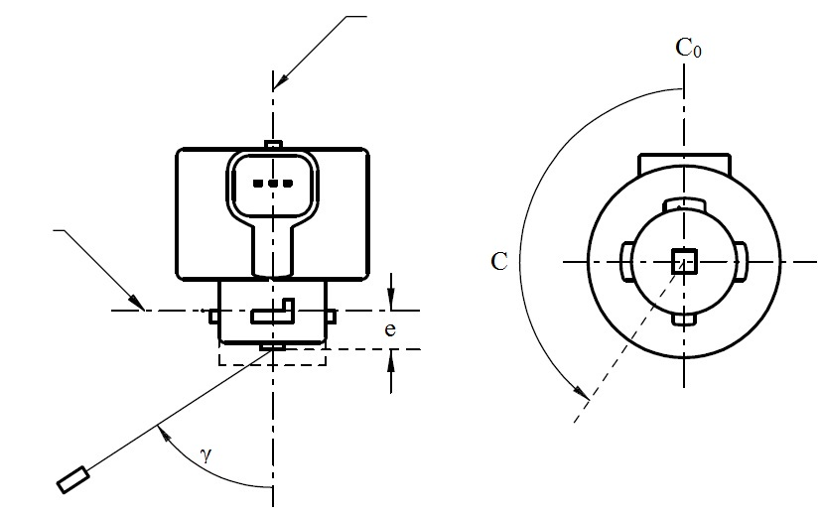
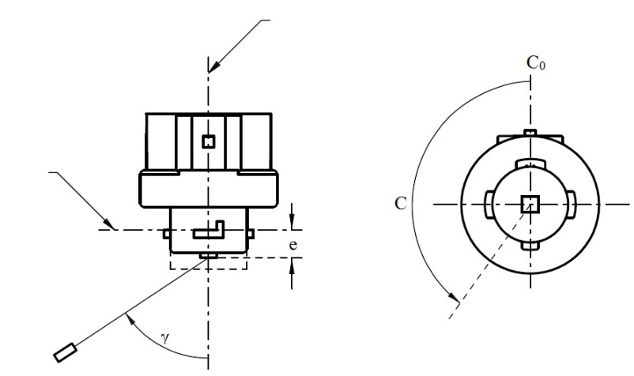
Set-up to measure the luminous intensity distribution
Reference axis
Reference plane
Photo-Detector of Goniometer
C-plane definition
Viewing direction along reference axis
LR4A
Reference axis
Reference plane
Photo-Detector of Goniometer
C-plane definition
Viewing direction along reference axis
LR4B
Categories LR4A and LR4B Sheet LR4/5

The light pattern as described in Table 4 shall be substantially uniform, i.e. in between two adjacent grid points the relative luminous intensity requirement is calculated by linear interpolation using the two adjacent grid points. In case of doubt this may be checked in addition to verification of the grid points given in Table 4.

Table 4
Test point values of normalized intensities of normal production and standard LED light sources, respectively. Requirements apply to both, major and minor function.

 | LED light sources of normal production |  | Standard LED light sources
Angle γ | Minimum Intensity  in cd /1000lm | Maximum Intensity  in cd/1000lm | Minimum Intensity  in cd /1000lm | Maximum Intensity in cd/1000lm
-90° | 0 | 38 | 0 | 25
-75° | 0 | 160 | 0 | 140
-60° | 98 | 246 | 127 | 220
-45° | 142 | 305 | 181 | 275
-30° | 169 | 352 | 213 | 315
-15° | 192 | 389 | 239 | 340
0° | 200 | 401 | 248 | 352
15° | 192 | 389 | 239 | 340
30° | 169 | 352 | 213 | 315
45° | 142 | 305 | 181 | 275
60° | 98 | 246 | 127 | 220
75° | 0 | 160 | 0 | 140
90° | 0 | 38 | 0 | 25

Categories LR5A, LR5B, LW5A, LW5B, LY5A, LY5B Sheet L5/1
The drawings are intended only to illustrate the essential dimensions of the LED light source.
Figure 1*
Main Drawing

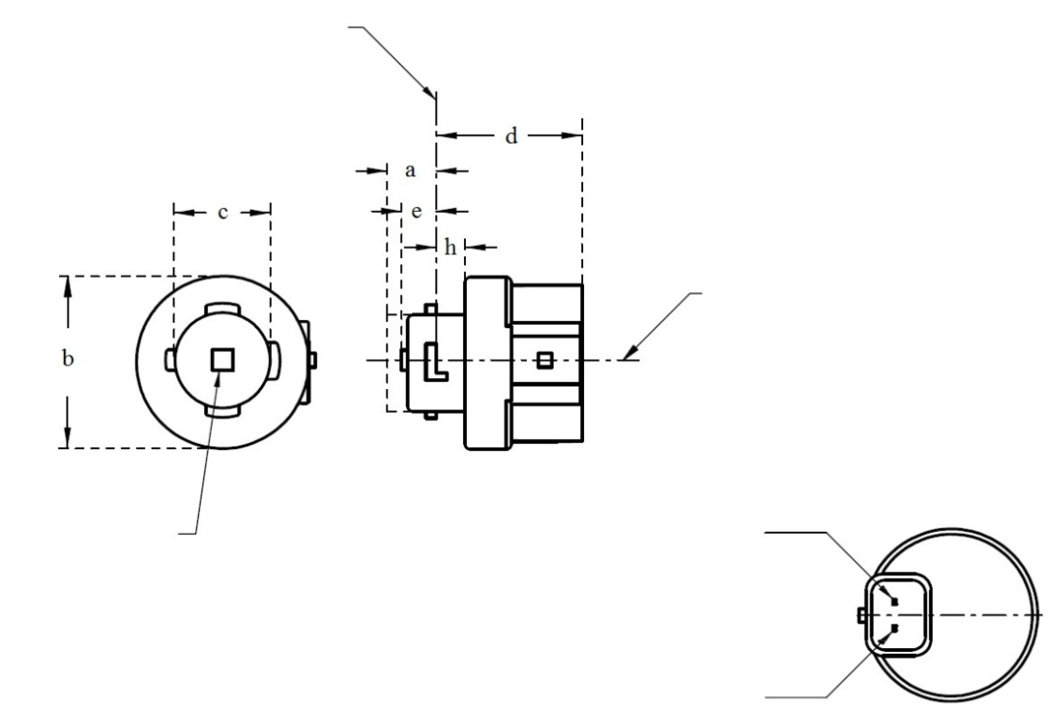
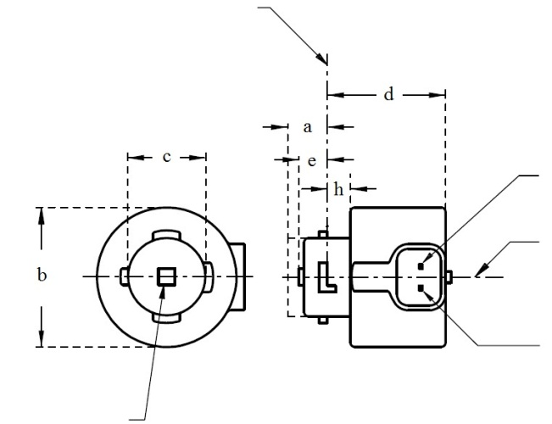
Ground
Reference plane ¹
Light emitting area ³
Reference axis ²
⁴
Reference plane ¹
V+
Ground
⁴
Light emitting area ³
Reference axis ²
LR5A, LW5A, LY5A
LR5B, LW5B, LY5B
* Projection method:
For the notes see sheet L5/2
Categories LR5A, LR5B, LW5A, LW5B, LY5A, LY5B Sheet L5/2
Table 1
Essential dimensional, electrical and photometric characteristics of the LED light source

Dimensions |  |  |  |  |  | Production LED light sources | Standard LED light sources
a |  |  |  |  | mm | 6.0 max.
b |  |  |  |  | mm | c + 10.0 min.  38.0 max.
c |  |  |  |  | mm | 18.5 ± 0.1
d |  |  |  |  | mm | 28.0 max.
e ^{11/} |  |  |  |  | mm | 3.0 ± 0.30 | 3.0 ± 0.15
h |  |  |  |  | mm | 5.5 + 0.0/ – 0.1
Cap | LR5A, LR5B  LW5A, LW5B  LY5A, LY5B |  | PGJ18.5d-10  PGJ18.5d-28  PGJ18.5d-19 |  | in accordance with IEC Publication 60061 (sheet 7004-185-1)
Electrical and photometric characteristics
Rated values |  | Volts |  |  |  | 12
 |  | Watts |  |  | LR5A, LR5B | 3
 |  |  |  |  | LW5A, LW5B  LY5A, LY5B | 6
Objective Values⁸ |  | Watts  (at 13.5 V DC) |  |  | LR5A, LR5B | 3.5 max.
 |  |  |  |  | LW5A, LW5B | 8 max.
 |  |  |  | ¹⁰ | LY5A, LY5B
 |  | Luminous flux  (in lm at 13.5 V DC) |  | ⁵ | LR5A, LR5B | 120 ± 15% | 120 ± 5% ⁹
 |  |  |  | ⁶ | LW5A, LW5B | 350 ± 20% | 350 ± 10% ⁹
 |  |  |  | ^{7, 10} | LY5A, LY5B | 280 ± 20% | 280 ± 10% ⁹
 |  | Luminous flux  (in lm at 9 V DC) |  | ⁵ | LR5A, LR5B | 28 min.
 |  |  |  | ⁶ | LW5A, LW5B | 65 min.
 |  |  |  | ^{7, 10} | LY5A, LY5B | 55 min.
^{1/} The reference plane is the plane defined by the contact points of the cap-holder fit.
^{2/} The reference axis is perpendicular to the reference plane and passing through the centre of the bayonet core.
^{3/} Light emitting area: to be checked by means of the box system in Figure 2
^{4/} A minimum free air space of 5mm around the light source shall be respected for convection.
^{5/} The emitted light shall be red.
^{6/} The emitted light shall be white.
^{7/} The emitted light shall be amber.
^{8/} After continuous operation for 30 minutes at 23 ± 2.5° C.
^{9/} The measured value shall be in between 100 per cent and 90 per cent of the value measured after 1 minute.
^{10/} Operated in flashing mode for 30 minutes (frequency = 1.5 Hz, duty cycle 50 per cent ON, 50 per cent OFF). Measured in the ON-state of flashing mode after 30 minutes of operation.
^{11/} Light centre length

Electrical characteristics

In case of LED light source failure (no light emitted) the max. electrical current draw, when operated between 12 V and 14 V, shall be less than 20 mA (open circuit condition).
Categories LR5A, LR5B, LW5A, LW5B, LY5A, LY5B Sheet L5/3

Screen projection requirements

The following test is intended to define the requirements for the light emitting area of the LED light source and to determine whether the light emitting area is correctly positioned relative to the reference axis and reference plane in order to check compliance with the requirements.

The position of the light emitting area is checked by the box system defined in Figure 2, which is aligned to the planes C90 and C180 and shows the projection when viewing along direction γ=0º (C, γ as defined in Figure 3).

The proportion of the total luminous flux emitted into the viewing direction shall be as described in table 3.

Figure 2

Box definition of the light emitting area with dimensions as specified in table 2

f/3
Reference axis
perpendicular in the
centre of the light-
emitting area
f/3
f/3
f/3
f/3
f/3
A
B
B
B
B
C
C
C
C
f/2
f/2

Table 2

Dimensions of the box system in Figure 2

Dimensions in mm | f
LED light sources of normal production | 4.5
Standard LED light sources | 4.5

CATEGORIES LR5A, LR5B, LW5A, LW5B, LY5A, LY5B Sheet L5/4

Table 3

Proportion of the total luminous flux emitted into the viewing direction from the areas specified in figure 2

Category | Area(s) | LED light sources of normal production | Standard LED light sources
LR5A  LR5B | Each B individually | ≥ 10% | ≥ 15%
LR5A  LR5B | Each A, B individually | < 40% | < 30%
LR5A  LR5B | All B together | ≥ 60% | ≥ 65%
LR5A  LR5B | Each C individually | - | < 10%
LR5A  LR5B | All A, B and C together | ≥ 90% | ≥ 90%
LW5A  LW5B  LY5A  LY5B | Each A,B individually | ≥ 6% | ≥ 8%
LW5A  LW5B  LY5A  LY5B | Each A, B individually | < 40% | < 30%
LW5A  LW5B  LY5A  LY5B | All A, B together | ≥ 55% | ≥ 60%
LW5A  LW5B  LY5A  LY5B | Each C individually | < 15% | < 10%
LW5A  LW5B  LY5A  LY5B | All A, B and C together | ≥ 90% | ≥ 90%

Categories LR5A, LR5B, LW5A, LW5B, LY5A, LY5B Sheet L5/5
Normalized luminous intensity distribution
The following test is intended to determine the normalized luminous intensity distribution of the light source in an arbitrary plane containing the reference axis. The intersection of the reference axis and the parallel plane to the reference plane in distance e is used as the coordinate system origin.
The light source is mounted on a flat plate with the corresponding mounting lug features. The plate is mounted to the goniometer table by a bracket, so that the reference axis of the light source lines up with one of the rotating axis of the goniometer. The corresponding measurement set-up is described in Figure 3.
Luminous intensity data is recorded with a standard photo-goniometer. The measurement distance should be chosen appropriately, to make sure that the detector is located in the far field of the light distribution.
The measurements shall be performed in C-planes C₀ (C₁₈₀) and C₉₀ (C₂₇₀), which contain the reference axis of the light source. The test points for each plane for multiple polar angles γ are specified in Table 4.
The measured luminous intensity values, normalised to the measured luminous flux of the individual light source under test, shall be converted to normalised luminous intensity values of a 1,000 lm light source. The data shall comply with the tolerance band as defined in Table 4.

The drawings are intended only to illustrate the essential set-up for measurement of the LED light source.

Figure 3

Set-up to measure the luminous intensity distribution
Reference axis
Reference plane
Photo-Detector of Goniometer
C-plane definition
Viewing direction along reference axis
LR5A, LW5A, LY5A

Reference axis
Photo-Detector of Goniometer
Reference plane
C-plane definition
Viewing direction along reference axis
LR5B, LW5B, LY5B

Categories LR5A, LR5B, LW5A, LW5B, LY5A, LY5B Sheet L5/6

The light pattern as described in Table 4 shall be substantially uniform, i.e. in between two adjacent grid points the relative luminous intensity requirement is calculated by linear interpolation using the two adjacent grid points. In case of doubt this may be checked in addition to verification of the grid points given in Table 4.

Table 4
Test point values of normalized intensities for categories LR5A, LR5B, LW5A, LW5B, LY5A and LY5B

 | LED light sources of normal production |  | Standard LED light sources
Angle γ | Minimum Intensity  in cd /1000 lm | Maximum Intensity  in cd/1000 lm | Minimum Intensity  in cd /1000 lm | Maximum Intensity in cd /1000 lm
-90° | 0 | 70 | 0 | 65
-75° | 0 | 160 | 0 | 150
-60° | 85 | 245 | 105 | 220
-45° | 145 | 310 | 180 | 275
-30° | 170 | 380 | 220 | 335
-15° | 190 | 415 | 240 | 370
0° | 200 | 425 | 250 | 390
15° | 190 | 415 | 240 | 370
30° | 170 | 380 | 220 | 335
45° | 145 | 310 | 180 | 275
60° | 85 | 245 | 105 | 220
75° | 0 | 160 | 0 | 150
90° | 0 | 70 | 0 | 65

* * In accordance with the programme of work of the Inland Transport Committee for 2016–2017 (ECE/TRANS/254, para. 159 and ECE/TRANS/2016/28/Add.1, cluster 3.1), the World Forum will develop, harmonize and update Regulations in order to enhance the performance of vehicles. The present document is submitted in conformity with that mandate.
* ** The title was harmonised with the other light source Regulations on the occasion of introduction of this Resolution.
? Based on term 17-267 from CIE standard CIE S 017/E:2011: ILV: International Lighting Vocabulary, online version eILV

