|  |  |  |  |
| --- | --- | --- | --- |
|  | United Nations | ECE/ADN/2016/1 | |
| _unlogo | **Economic and Social Council** | | Distr.: General  6 November 2015  English  Original: English and French |

**Economic Commission for Europe**

**Administrative Committee of the**

**European Agreement concerning the International Carriage**

**of Dangerous Goods by Inland Waterways (ADN)**

**Sixteenth session**

Geneva, 29 January 2015  
Item 5 of the provisional agenda  
**Work of the Safety Committee**

Proposed amendments to the Regulations annexed to ADN   
for entry into force on 1 January 2017

Note by the secretariat[[1]](#footnote-2)

1. 1. At its fifteenth session, the ADN Administrative Committee asked the secretariat to consolidate in a single document all the draft amendments adopted in 2014 and 2015 that had not yet been approved by the Administrative Committee (ECE/ADN/33, para.18).
2. 2. The present document is a consolidation of the proposed amendments to the Regulations annexed to ADN that the Safety Committee has adopted for entry into force on 1 January 2017:
3. (A) at its twenty-seventh session (ECE/TRANS/WP.15/AC.2/56, annex I);
4. (B) at its twenty-sixth session (ECE/TRANS/WP.15/AC.2/54, annex I);
5. (C) at its twenty-fifth session (ECE/TRANS/WP.15/AC.2/52, annex III);
6. (D) at its twenty-fourth session (ECE/TRANS/WP.15/AC.2/50, annex IV).
7. 3. Each proposed amendment is followed by a reference to the document in which the amendment was proposed, together with the letter A, B, C or D to identify the session when it was adopted (see paragraph 2 above).
8. 4. The Safety Committee is expected to verify at its twenty-eighth session the proposed amendments which are still in square brackets and to report its conclusions to the ADN Administrative Committee which will be invited to endorse all amendments.

**Chapter 1.1**

1.1.3.3. Insert a new second indent to read as follows:

"- for the upkeep of vessels,"

*B (Reference document:* ECE/TRANS/WP.15/AC.2/54*)*

**Chapter 1.2**

1.2.1 Under the definition of *"Bulk container"*, insert the following definition:

"*Flexible bulk container* means a flexible container with a capacity not exceeding 15 m3 and includes liners and attached handling devices and service equipment;".

1.2.1 Insert in alphabetical order:

"*Flexible bulk container*, see *Bulk container*;".

*B (Reference document:* ECE/TRANS/WP.15/AC.2/54*)*

**Chapter 1.4**

1.4.3.3 (u) Amend to read as follows:

"(u) He shall ascertain that during the entire duration of loading a permanent and appropriate supervision is assured."

*A (Reference document:* ECE/TRANS/WP.15/AC.2/56*)*

1.4.3.3 (v) Amend to read as follows:

"(v) When special provision 803 applies, shall guarantee and document, using an appropriate procedure, that the maximum permissible temperature of the cargo is not exceeded and shall provide instructions to the master in a traceable form."

C (*Reference document*: ECE/TRANS/WP.15/AC.2/52)

**Chapter 1.6**

1.6.7.1.2 (c) Insert the following text after "means that":

"when a vessel has benefitted from the transitional measure in paragraph (b)".

C (*Reference document*: ECE/TRANS/WP.15/AC.2/52)

1.6.7.2.2.2 Amend the following entries in the table to read as follows:

| *Paragraphs* | *Subject* | *Time limit and comments* |
| --- | --- | --- |
| 1.2.1 | Hold spaces | N.R.M. for Type N open vessels whose hold spaces contain auxiliary appliances and which are carrying only substances of Class 8, with remark 30 in column (20) of Table C of Chapter 3.2.  Renewal of the certificate of approval after 31 December 2038. |
| 7.2.3.20.1 | Fitting of ballast tanks and compartments with level indicators | N.R.M. after 1 January 2013 for Type C and Type G tank vessels and Type N double hull tank vessels.  Renewal of the certificate of approval after 31 December 2012. |
| 7.2.3.20.1 | Proof of stability in the event of a leak connected with ballast water | N.R.M. for Type G and Type N vessels.  Renewal of the certificate of approval after 31 December 2044. |
| 7.2.3.31.2 | Motor vehicles only outside the cargo area | N.R.M. for Type N vessels.  Renewal of the certificate of approval after 31 December 2034  Until then, the following requirement applies on board vessels in service: the vehicle shall not be started on board. |
| 7.2.3.51.3 | *Delete* |  |
| 7.2.4.22.3 | Sampling from other openings | N.R.M. for Type N open vessels.  Renewal of the certificate of approval after 31 December 2018  Until then, on board vessels in service, cargo tank covers may be opened during loading for control and sampling. |
| 9.3.3.8.1 | Continuation of class | N.R.M. for Type N open vessels with flame arresters  and Type N open vessels.  Renewal of the certificate of approval after 31 December 2044.  Until then, the following requirements apply on board vessels in service:  Except where otherwise provided, the type of construction, the strength, the subdivision, the equipment and the gear of the vessel shall conform or be equivalent to the construction requirements for classification in the highest class of a recognized classification society. |
| 9.3.1.11.2 (a) | Arrangement of cargo tanks  Distance between cargo tanks and side walls  Height of saddles | N.R.M. for Type G vessels whose keels were laid  before 1 January 1977.  Renewal of the certificate of approval after 31 December 2044. |
| 9.3.3.11.4 | Penetrations through the end bulkheads of hold spaces | N.R.M. from 1 January 2005 for Type N open vessels whose keels were laid before 1 January 1977.  Renewal of the certificate of approval after 31 December 2044. |
| 9.3.3.11.6 (a) | Form of cofferdam arranged as a pump room | N.R.M for Type N vessels whose keels were laid  before 1 January 1977.  Renewal of the certificate of approval after 31 December 2044. |
| 9.3.3.11.8 | Arrangement of service spaces located in the cargo area below deck | N.R.M. for Type N open vessels.  Renewal of the certificate of approval after 31 December 2038. |
| 9.3.3.12.7 | Approval of flame arresters | N.R.M for Type N vessels whose keels were laid  before 1 January 1977.  Renewal of the certificate of approval after 31 December 2018. |
| 9.3.3.16.1 | Internal combustion engine outside the cargo area | N.R.M. for Type N open vessels.  Renewal of the certificate of approval after 31 December 2034. |
| 9.3.1.16.2  9.3.3.16.2 | Hinges of doors facing the cargo area | N.R.M. for vessels whose keels were laid before 1 January 1977 where alterations would obstruct other major openings.  Renewal of the certificate of approval after 31 December 2034. |
| 9.3.3.16.2 | Engine rooms accessible from the deck | N.R.M. for Type N open vessels.  Renewal of the certificate of approval after 31 December 2034. |
| 9.3.1.17.1  9.3.3.17.1 | Accommodation and wheelhouse outside the cargo area | N.R.M. for vessels whose keels were laid before 1 January 1977, provided that there is no connection between the wheelhouse and other enclosed spaces.  Renewal of the certificate of approval after  31 December 2044.  Renewal of the certificate of approval after  31 December 2044 for vessels up to 50 m in length whose keels were laid before 1 January 1977 and whose wheelhouses are located in the cargo area even if it provides access to another enclosed space, provided that safety is ensured by appropriate service requirements of the competent authority. |
| 9.3.3.17.1 | Accommodation and wheelhouse outside the cargo area | N.R.M. for Type N open vessels.  Renewal of the certificate of approval after 31 December 2044. |
| 9.3.1.17.2  9.3.2.17.2  9.3.3.17.2 | Entrances facing the cargo area | N.R.M. for vessels up to 50 m in length whose keels were laid before 1 January 1977, provided that gas screens are installed.  Renewal of the certificate of approval after  31 December 2044. |
| 9.3.3.17.2 | Entrances and openings | N.R.M. for Type N open vessels.  Renewal of the certificate of approval after 31 December 2044. |
| 9.3.3.17.3 | *Delete* |  |
| 9.3.3.17.5 (b),(c) | Approval of shaft passages and displaying of instructions | N.R.M. for Type N open vessels.  Renewal of the certificate of approval after 31 December 2018. |
| 9.3.3.20.2 | Filling of cofferdams with pump | N.R.M. for Type N open vessels.  Renewal of the certificate of approval after 31 December 2018. |
| 9.3.3.21.1 (b) | Liquid level gauge | N.R.M. from 1 January 2005 for vessels of Type N open with flame-arresters and those of Type N open.  Renewal of the certificate of approval after 31 December 2018  Until then, on board vessels in service fitted with gauging openings, such openings shall:   * Be arranged so that the degree of filling can be measured using a sounding rod; * Be fitted with an automatically-closing cover. |
| 9.3.3.21.1 (g) | Sampling opening | N.R.M. for Type N open vessels.  Renewal of the certificate of approval after 31 December 2018. |
| 9.3.3.23.2 | Test pressure for cargo tanks | N.R.M. for vessels whose keels were laid before  1 January 1977, for which a test pressure of 15 kPa (0.15 bar) is required.  Renewal of the certificate of approval after  31 December 2044. Until then, a test pressure of  10 kPa (0.10 bar) shall be sufficient. |
| 9.3.3.23.2 | Test pressure for cargo tanks | N.R.M. for oil-separator vessels in service before  1 January 1999.  Renewal of the certificate of approval after  31 December 2044. Until then, a test pressure of  5 kPa (0.05 bar) is sufficient. |
| 9.3.3.23.3 | Test pressure for piping for loading and unloading | N.R.M. for oil-separator vessels in service before  1 January 1999.  Renewal of the certificate of approval at the latest by 1 January 2039. Until then, a test pressure of 400 kPa (4 bar) is sufficient. |
| 9.3.3.42.2 | Cargo heating system | N.R.M for Type N open vessels.  Renewal of the certificate of approval after 31 December 2034.  Until then, the following requirements apply on board vessels in service: This can be achieved by one oil separator fitted to the condensed water return pipe. |
| 9.3.3.52.1 (b), (c), (d) and (e) | Electrical installations | N.R.M. for Type N open vessels.  Renewal of the certificate of approval after 31 December 2034. |
| 9.3.1.52.1 (e)  9.3.3.52.1 (e) | Electrical installations of the "certified safe" type in the cargo area | N.R.M. for vessels whose keels were laid before  1 January 1977.  Renewal of the certificate of approval after 31 December 2034.  Until then, the following conditions shall be met during loading, unloading and gas freeing on board vessels having non-gastight wheelhouse openings (e.g. doors, windows, etc.) in the cargo area:   1. All electrical installations designed to be used shall be of a limited explosion-risk type, i.e. they shall be so designed that there is no sparking under normal operating conditions and the temperature of their outer surface does not rise above 200°C, or be of a type protected against water spray the temperature of whose outer surfaces does not exceed 200°C under normal operating conditions; 2. Electrical installations which do not meet the requirements of (a) above shall be marked in red and it shall be possible to switch them off by means of a central switch. |
| 9.3.3.52.2 | Accumulators located outside the cargo area | N.R.M. for Type N open vessels.  Renewal of the certificate of approval after 31 December 2034. |
| 9.3.1.52.3 (a)  9.3.1.52.3 (b)  9.3.3.52.3 (a)  9.3.3.52.3 (b) | Electrical installations used during loading, unloading or gas-freeing | N.R.M. for vessels whose keels were laid before  1 January 1977.  Renewal of the certificate of approval after 31 December 2034 for the following installations:   * Lighting installations in accommodation, with the exception of switches near the entrances to accommodation; * Radio telephone installations in accommodation and wheelhouses and combustion engine control appliances.   Until then, all other electrical installations shall meet the following requirements:   1. Generators, engine, etc.   IP 13 protection mode;   1. Control panels, lamps, etc.   IP 23 protection mode;   1. Appliances, etc. IP 55 protection mode. |
| 9.3.3.52.3 (a)  9.3.3.52.3 (b) | Electrical installations used during loading, unloading or gas-freeing | N.R.M. for Type N open vessels.  Renewal of the certificate of approval after 31 December 2034. |
| 9.3.3.52.4 | Red mark on electrical installations | N.R.M. for Type N open vessels.  Renewal of the certificate of approval after 31 December 2034. |
| 9.3.3.52.5 | Shutting down switch for continuously driven generator | N.R.M. for Type N open vessels.  Renewal of the certificate of approval after 31 December 2034. |
| 9.3.3.52.6 | Permanently fitted sockets | N.R.M. for Type N open vessels.  Renewal of the certificate of approval after 31 December 2034. |
| 9.3.1.56.1  9.3.3.56.1 | Metallic sheaths for all cables in the cargo area | N.R.M. for vessels whose keels were laid before  1 January 1977.  Renewal of the certificate of approval after 31 December 2034. |

1.6.7.3 Amend the entry for 9.3.3.8.1 to read as follows:

| *Paragraph* | *Subject* | *Time limit and comments* |
| --- | --- | --- |
| 9.3.3.8.1 | Classification | N.R.M. for Type N open vessels with flame arresters and  Type N open vessels.  Renewal of the certificate of approval after 31 December 2044. |

C (*Reference document*: ECE/TRANS/WP.15/AC.2/52)

Chapter 1.16

1.16.1.2.1 Amend to read as follows:

"1.16.1.2.1 The certificate of approval shall conform to the model 8.6.1.1 or 8.6.1.3 with regard to content, form and layout and include the required particulars, as appropriate. It shall include the date of expiry of the period of validity.

Its dimensions are 210 mm x 297 mm (A4). Front and back pages may be used.

It shall be drawn up in the language or one of the languages of the issuing country. If this language is not English, French or German, the title of the certificate and each entry under items 5, 9 and 10 in the certificate of approval for dry cargo vessels (8.6.1.1) and under items 12, 16 and 17 in the certificate of approval for tank vessels (8.6.1.3) shall also be provided in English, French or German."

1.16.1.3.2 Insert the following text after "model in 8.6.1.2 or 8.6.1.4": "with regard to content, form and layout" and the following text at the end:

"Its dimensions are 210 mm x 297 mm (A4). Front and back pages may be used.

It shall be drawn up in the language or one of the languages of the issuing country. If this language is not English, French or German, the title of the certificate and each entry under item 5 in the provisional certificate of approval for dry cargo vessels (8.6.1.2) and under item 12 in the provisional certificate of approval for tank vessels (8.6.1.4) shall also be provided in English, French or German."

C (*Reference document*: ECE/TRANS/WP.15/AC.2/52)

**Chapter 3.2**

3.2.3.2 , table C Add the following new entry for UN No. 3257:

|  |  |  |
| --- | --- | --- |
| UN No. or substance identification No. | (1) | 3257 |
| Name and description | (2) | ELEVATED TEMPERATURE LIQUID, N.O.S. at above 100°C and below its flash-point (including molten metals, molten salts, etc.) |
| Class | (3a) | 9 |
| Classification code | (3b) | M9 |
| Packing group | (4) | III |
| Dangers | (5) | 9+(N1, N2, N3, CMR, F or S) |
| Type of tank vessel | (6) | \* |
| Cargo tank design | (7) | \* |
| Cargo tank type | (8) | \* |
| Cargo tank equipment | (9) | \* |
| Opening pressure of the high-velocity vent valve in kPa | (10) | \* |
| Maximum degree of filling in % | (11) | 95 |
| Relative density at 20°C | (12) |  |
| Type of sampling device | (13) | \* |
| Pump room below deck permitted | (14) | yes |
| Temperature class | (15) |  |
| Explosion group | (16) |  |
| Anti-explosion protection required | (17) | no |
| Equipment required | (18) | \* |
| Number of cones/ blue lights | (19) | 0 |
| Additional requirements /Remarks | (20) | 7; 20:+250°C;22; 24; 27 \*see 3.2 3.3 |

C (*Reference document*: ECE/TRANS/WP.15/AC.2/52)

3.2.3.2, Table C, UN No. 1230 METHANOL In column (19) replace "1" with "2".

*D (Reference document:* ECE/TRANS/WP.15/AC.2/50*)*

**Chapter 3.3**

3.3.1, Special provision 803 Amend to read as follows:

"803 Hard coal, coke and anthracite, when carried in bulk, are not subject to the provisions of ADN if:

(a) The temperature of the cargo has been determined using an appropriate procedure and is not higher than 60°C before, during or immediately after loading of the hold;

(b) Depending on the temperature of the cargo before, during and immediately after loading of the hold, the expected duration of carriage without temperature monitoring does not exceed the maximum journey times shown in the table below:

| *Maximum temperature on loading (°C)* | *Maximum duration of journey (days)* |
| --- | --- |
| 60 | 10 |
| 50 | 18 |
| 40 | 32 |
| 30 | 57 |

(c) Where the effective duration of carriage exceeds the maximum duration shown in subparagraph (b), temperature monitoring is carried out from the first day over the maximum;

(d) The master is given, at the time of loading and in a traceable form, instructions on how to proceed if there is a significant heating of the cargo."

C (*Reference document*: ECE/TRANS/WP.15/AC.2/52)

**Chapter 4.1**

4.1.3 In the first sentence, replace "wagons or containers" by "wagons, containers or bulk containers".

In the first indent, delete "with the exception of BK3 containers".

*B (Reference document:* ECE/TRANS/WP.15/AC.2/54*)*

**Chapter 7.1**

7.1.1.18 In the heading, insert "in bulk containers," after "containers,".

In the text, insert "bulk containers," after "containers,".

*B (Reference document:* ECE/TRANS/WP.15/AC.2/54*)*

7.1.2.19.1, second paragraph In the list of paragraphs, insert "1.16.1.1, 1.16.1.2, 1.16.1.3," at the beginning and delete "8.1.8, 8.1.9,".

C (*Reference document*: ECE/TRANS/WP.15/AC.2/52)

7.1.4 Insert a new paragraph 7.1.4.4.4 to read as follows:

"7.1.4.4.4 The electrical equipment fitted to the outside of a closed container may be connected with removable electrical cables in accordance with the provisions of 9.1.0.56 and be put into operation provided that:

(a) Such electrical equipment is of a certified safe type; or

(b) Such electrical equipment is not of a certified safe type but is separated sufficiently from other containers containing substances of:

* Class 2 for which a label No. 2.1 is required in column (5) of Table A of   
  Chapter 3.2;
* Class 3, packing group I or II;
* Class 4.3;
* Class 6.1; packing group I or II, with an additional hazard of Class 4.3;
* Class 8, packing group I, with an additional hazard of Class 3; and
* Class 8, packing group I or II, with an additional hazard of Class 4.3.

This condition is deemed to be met if no container containing the above-mentioned substances is stowed within an area of cylindrical form with a radius of 2.4 m around the electrical equipment and an unlimited vertical extension.

This condition does not apply if containers with electrical equipment which is not of a certified safe type and containers containing the above-mentioned substances are stowed in separate holds.

Examples of stowage and segregation of containers

Legend

*R* Container (e.g. reefer) with electrical equipment which is not of a certified safe type.

*Z* Electrical equipment which is not of a certified safe type.

*X* Container not allowed when containing dangerous substances for which sufficient separation is required.

Top view   
**1. On deck**

**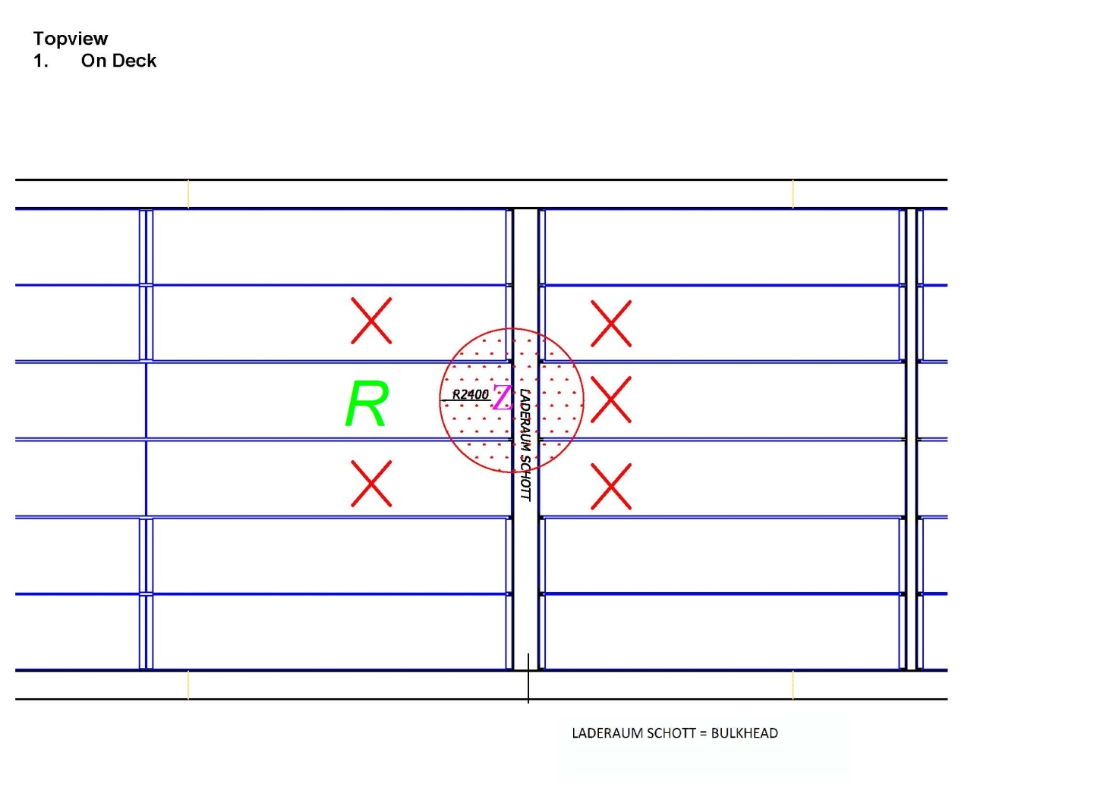**

Bulkhead

Top view   
**2. In the hold**

**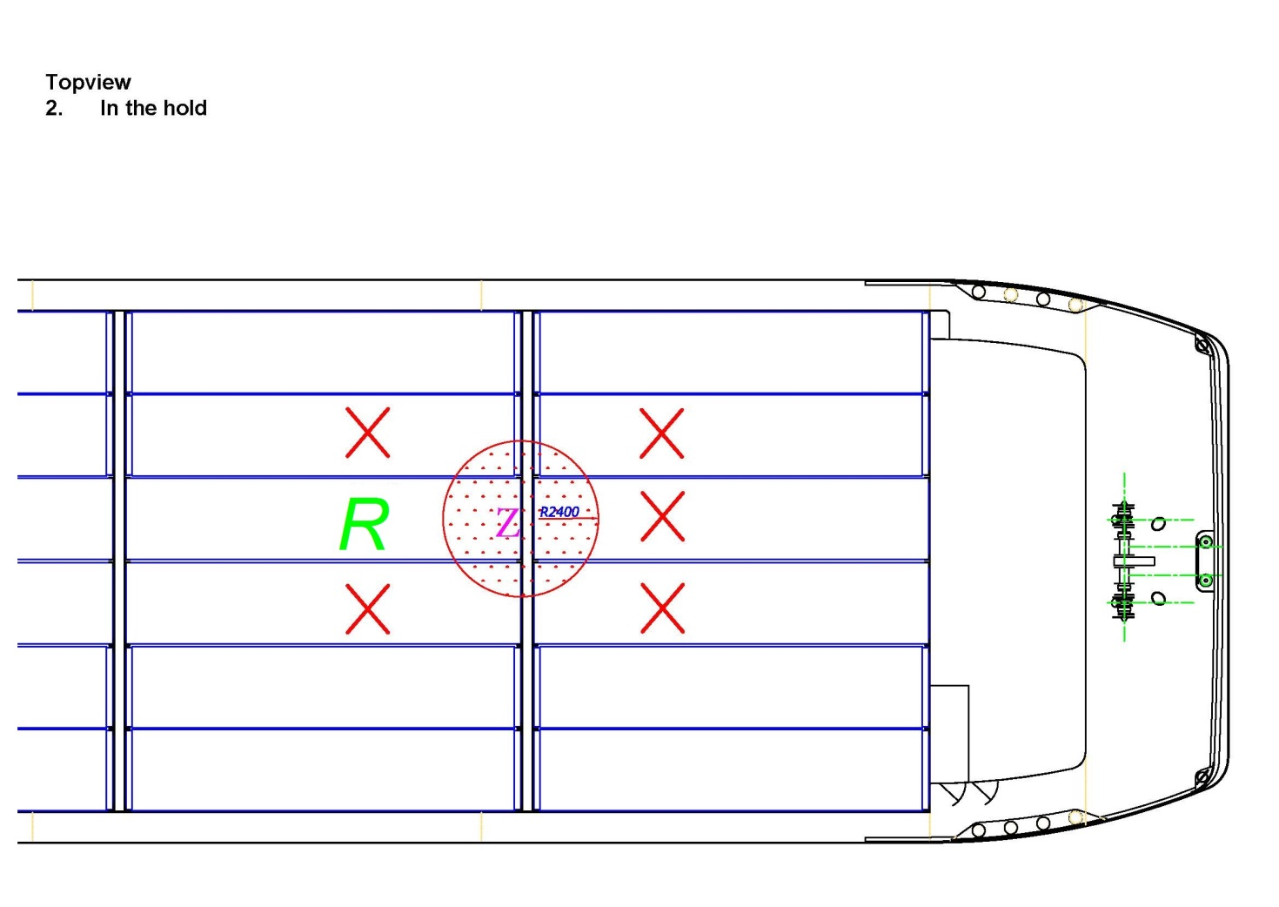**

Top view  
**2. In the hold**

*R*

Bulkhead

**Z**

Front view Front view

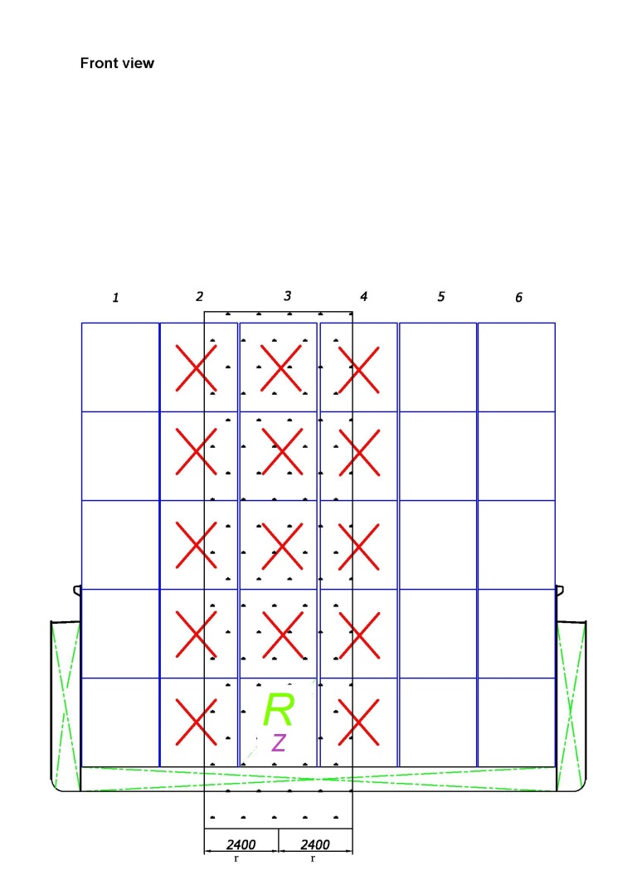 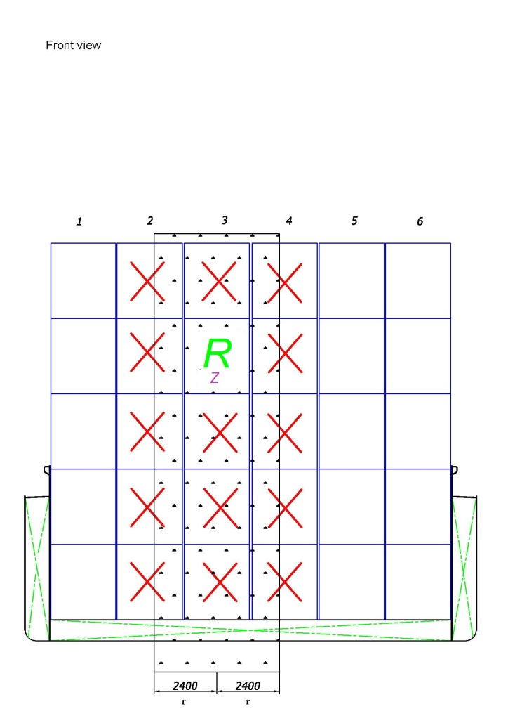

7.1.4 Insert a new 7.1.4.4.5 to read as follows:

"7.1.4.4.5 The electrical equipment fitted to an open container may not be connected with removable electrical cables in accordance with the provisions of 9.1.0.56 nor be put into operation unless it is of a certified safe type or the container is placed in a hold which does not contain containers with substances referred to in 7.1.4.4.4 (b)."

Consequential amendment:

7.1.3.51.4 Amend to read as follows:

"7.1.3.51.4 The electrical installations in the holds shall be kept switched off and protected against unintentional connection.

This provision does not apply to permanently installed cables passing through the holds, to movable cables connecting containers, stowed according to 7.1.4.4.4, and to apparatus of a certified safe type."

*B (Reference document:* ECE/TRANS/WP.15/AC.2/54*)*

7.1.4.14.1.1 Add the following sentence at the end:

"Flexible bulk containers shall be stowed in such way that there are no void spaces between them in the hold. If the flexible bulk containers do not completely fill the hold, adequate measures shall be taken to avoid shifting of cargo.".

7.1.4.14.1.2 Add the following sentence at the end:

"Flexible bulk containers may be stacked on each other in holds provided that the stacking height does not exceed three high. When flexible bulk containers are fitted with venting devices, the stowage of the flexible bulk containers shall not impede their function.".

*B (Reference document:* ECE/TRANS/WP.15/AC.2/54*)*

**Chapter 7.2**

7.2.2.19.1 In the list of paragraphs, insert "1.16.1.1, 1.16.1.2, 1.16.1.3," at the beginning and delete "8.1.8, 8.1.9,".

C (*Reference document*: ECE/TRANS/WP.15/AC.2/52)

7.2.4.77 Amend the heading in column 4 of the table to read as follows:

"3 packing group III (UN No. 1202: second and third entries in table C), 4.1".

*A (Reference document:* ECE/TRANS/WP.15/AC.2/56*)*

**Chapter 8.1**

8.1.2.1 (a) Amend to read as follows:

"(a) The vessel’s certificate of approval referred to in 1.16.1.1 or the vessel’s provisional certificate of approval referred to in 1.16.1.3 and the annex referred to in 1.16.1.4;"

C (*Reference document*: ECE/TRANS/WP.15/AC.2/52)

8.1.2.6, second sentence Insert the following text before "in his possession":

"and the annex covered by 1.16.1.4".

C (*Reference document*: ECE/TRANS/WP.15/AC.2/52)

8.1.8 and 8.1.9 Delete and replace by "(*Deleted*)".

C (*Reference document*: ECE/TRANS/WP.15/AC.2/52)

**Chapter 8.2**

8.2.1.4 Modify the beginning of the first sentence to read as follows:

"After five years, the certificate shall be renewed by the competent authority or by a body recognized by it if the expert furnishes proof of …".

8.2.1.6 Modify the beginning of the first sentence to read as follows:

"After five years, the certificate shall be renewed by the competent authority or by a body recognized by it if the expert on the carriage of gases furnishes proof that …".

8.2.1.8 Modify the beginning of the first sentence to read as follows:

"After five years, the certificate shall be renewed by the competent authority or by a body recognized by it if the expert on the carriage of chemicals furnishes proof that …".

C (*Reference document*: ECE/TRANS/WP.15/AC.2/52)

8.2.2.1, 8.2.2.3.4, 8.2.2.5, 8.2.2.6.6, 8.2.2.8 Replace "refresher and advanced course" by "refresher course".

C (*Reference document*: ECE/TRANS/WP.15/AC.2/52)

8.2.2.8 After the title, number the text as 8.2.2.8.1.

Add a new paragraph 8.2.2.8.2 to read as follows:

"8.2.2.8.2 Contracting Parties shall provide the UNECE secretariat with an example of the national model for any certificate intended for issue in accordance with this section, along with examples of models for certificates which are still valid. A Contracting Party may additionally provide explanatory notes. The UNECE secretariat shall make the information received available to all Contracting Parties."

*A (Reference document:* ECE/TRANS/WP.15/AC.2/56*)*

**Chapter 8.6**

8.6.1.3 and 8.6.1.4 On page 3, insert a row for "inerting facilities" after "cargo refrigeration installation".

*A (Reference document:* ECE/TRANS/WP.15/AC.2/56*)*

8.6.1.3 and 8.6.1.4, page 3 of the models Amend the entry for "Opening pressure of the high-velocity vent valve in kPa" to read as follows:

"Opening pressure of the high-velocity vent valve**/**safety valve in kPa"

C (*Reference document*: ECE/TRANS/WP.15/AC.2/52)

8.6.3, question 4 Amend to read as follows.

"Have suitable means in accordance with 7.2.4.77 been provided for leaving the vessel, including in cases of emergency?"

C (*Reference documents*: ECE/TRANS/WP.15/AC.2/52)

**Chapter 9.1**

9.1.0.40.2.7 (a) Insert "or, if there are no such requirements, to those of a recognized classification society" at the end.

*A (Reference document:* ECE/TRANS/WP.15/AC.2/56*)*

**Chapter 9.3**

9.3.x.13 Add a new paragraph to read as follows:

"9.3.x.13.4 Floatability after damage shall be proved for the most unfavourable loading condition. For this purpose, calculated proof of sufficient stability shall be established for critical intermediate stages of flooding and for the final stage of flooding."

9.3.x.15.2 Add a new first paragraph to read as follows:

"For the intermediate stage of flooding the following criteria have to be fulfilled:

GZ >= 0.03m

Range of positive GZ: 5°."

*A (Reference document:* ECE/TRANS/WP.15/AC.2/56*)*

9.3.1.40.2.7 (a) Insert "or, if there are no such requirements, to those of a recognized classification society" at the end.

*A (Reference document:* ECE/TRANS/WP.15/AC.2/56*)*

9.3.2.40.2.7 (a) Insert "or, if there are no such requirements, to those of a recognized classification society" at the end.

*A (Reference document:* ECE/TRANS/WP.15/AC.2/56*)*

9.3.3.40.2.7 (a) Insert "or, if there are no such requirements, to those of a recognized classification society" at the end.

*A (Reference document:* ECE/TRANS/WP.15/AC.2/56*)*

9.3.x.52.1 (b) Add the following text at the end:

"The following equipment may be installed only in double-hull spaces and double bottoms if used for ballasting:

- Permanently fixed submerged pumps with temperature monitoring, of the certified safe type."

9.3.x.52.1 (c), third indent Insert "with temperature monitoring" after "ballast pumps".

C (*Reference document*: ECE/TRANS/WP.15/AC.2/52)

1. Distributed in German by the Central Commission for the Navigation of the Rhine under the symbol CCNR/ZKR/ADN/2016/1. [↑](#footnote-ref-2)