|  |  |  |
| --- | --- | --- |
|  |  | **UN/SCETDG/49/INF.4/Add.5**  **UN/SCEGHS/31/INF.3/Add.5** |

|  |  |
| --- | --- |
| **Committee of Experts on the Transport of Dangerous Goods  and on the Globally Harmonized System of Classification and Labelling of Chemicals 15 April 2016** | |
| **Sub-Committee of Experts on the  Transport of Dangerous Goods** | **Sub-Committee of Experts on the Globally Harmonized System of Classification and Labelling of Chemicals** |
| **Forty-ninth session** | **Thirty-first session** |
| Geneva, 27 June – 6 July 2016  Item 10 (g) of the provisional agenda  **Issues relating to the Globally Harmonized System of Classification and Labelling of Chemicals: Use of the Manual of Tests and Criteria in the context of the GHS** | Geneva, 5– 8 July 2016  Item 2 of the provisional agenda  **Joint work with the Sub-Committee of Experts on the Transport of Dangerous Goods (TDG Sub-Committee)** |

Revision of the Manual of Tests and Criteria:   
Appendices

Transmitted by the Chairman of the Working Group on Explosives on behalf of the Working Group

APPENDICES

CONTENTS OF APPENDICES

**Appendix**  **Page**

**1** SPECIFICATIONS OF STANDARD DETONATORS

**2** BRUCETON AND SAMPLE COMPARISON METHODS

**3** CAVITATION OF SAMPLES

**4** NATIONAL CONTACTS FOR TEST DETAILS

**5** EXAMPLE OF A TEST METHOD FOR VENT SIZING

**6** SCREENING PROCEDURES

**7** HSL FLASH COMPOSITION TEST

**8** RESPONSE DESCRIPTORS

**9** Ballistic Projection Energy Test for Cartridges,

Small Arms (UN No. 0012)

APPENDIX 1  
  
SPECIFICATIONS OF STANDARD DETONATORS

**1. Description of the standard electric blasting cap 0.6 g PETN**

| Drawing No. | Part No. | Part | Description | Remarks |
| --- | --- | --- | --- | --- |
| I | A | Blasting cap |  |  |
|  | B | Fusehead | It must not undergo compression. Recommended amount of the pyrotechnic substance forming the bead: 20 mg to 50 mg | Example: Electrical fusehead Fa. DNAG, Germany, T 10 - U - with aluminium coating |
| II | A | Tube | Hollow-drawn tube of pure copper, (5% zinc) or of other alloys whose compositions are in the range between that of the above alloy and pure copper. The dimensions of the tube are shown in the figure. If required, the tubes for making standard detonators should be selected by checking the exact dimensions of each tube to be used. |  |
|  | B | (a) Secondary charge | Base charge: 0.40 g (± 0.01 g) PETN; compressed at 440 bar; | The PETN may contain up to 0.5% of carbonaceous matter to prevent electrostatic charges during handling and to improve the flow properties. |
|  | C |  | Intermediate charge 0.20 g (± 0.01 g) PETN; compressed at 20 bar. | Total height of secondary charge 12.3 mm (± 0.6 mm) |
|  | D | Priming charge (initiation charge) | Free choice of the substance and of its quantity. However, at least twice the minimum quantity required for initiation should be used. The total oxygen balance of the priming charge plus the secondary charge should not be more negative than -9.5% O2 | Example: 0.30 ± 0.01 g dextrinated lead azide with a purity of 88% compressed at 440 bar |
|  | E | Inner cup (pierced) | - | It is not required to use a pierced inner cup. Pressing the priming charge onto a highly compressed part of the secondary charge is excluded. |
| III | A | Fusehead | - | Example: Electrical fusehead Fa. DNAG, Germany T 10 - U - with aluminium coating |
|  | B | Closing plug | - | No special requirements. It should however provide an absolutely tight seal (to avoid the formation of cuprous azide and to ensure the desired initiating strength). The usual commercial design is satisfactory. |
|  | C | Wire | - | Free choice, providing the electrical risks (static electricity, stray currents) are taken into account. However, the use of an insulating sheath of plastic material inside the detonator tube is not allowed. |
|  | D | Short-circuiting tube | Plastic tube |  |
|  | E | Label |  |  |



I Electric blasting cap (standard detonator) II Blasting cap (standard detonator)

III Fusehead IV Tube

V Inner cup

(A) Blasting cap (B) Fusehead

(C) Intermediate charge (D) Priming charge

(E) Inner cup

**Figure A1.1: STANDARD DETONATOR (EUROPEAN)**



(A) Aluminium shell (material - 5052 aluminium alloy; length 31.8 mm; outer diameter 7.06 mm; wall thickness 0.19 mm)

(B) Brigewire and ignition charge

(C) Primer charge (0.195 g dextrinated lead azide)

(D) Base charge (0.447 g PETN pressed at 28 MPa)

**Figure A1.2: No. 8 (USA) DETONATOR**

APPENDIX 2  
  
BRUCETON AND SAMPLE COMPARISON METHODS

**1. Bruceton method**

***Introduction:*** The Bruceton method is used to determine the level of stimulus at which there is a 50% probability of obtaining a positive result.

***Procedure:*** The method involves applying different levels of stimulus and determining whether or not a positive reaction occurs. Performance of the trials is concentrated around the critical region by decreasing the stimulus by one level in the next trial if a positive result is obtained and increasing the stimulus by one level if a negative result is obtained. Usually about 5 preliminary trials are performed to find a starting level in approximately the right region and then at least 25 trials are performed to provide the data for the calculations.

***Calculation of results:*** In determining the level at which the probability of obtaining a positive result is 50% (H50), only the positives (+) or only the negatives (-) are used, depending on which has the smaller total. If the numbers are equal, either may be used. The data are recorded in a table (e.g. as in Table A2.1) and summarised as shown in Table A2.2. Column 1 of Table A2.2 contains the drop heights, in ascending order, starting with the lowest level for which a test result is recorded. In column 2, 'i' is a number corresponding to the number of equal increments above the base or zero line. Column 3 contains the number of positives (n(+)) or negatives (n(-)) for each drop height. The fourth column tabulates the result of multiplying 'i' times 'n' and the fifth column tabulates the results of multiplying the square of 'i' times 'n'. A mean is calculated from the following equation:



where , , c = lowest drop height and d = height interval.

If negative results are used, the sign inside the brackets is positive; it is negative if positive results are used. The standard deviation, s, may be estimated using:



where .

***Example of results:*** Using the data from Table A2.2, lowest drop height 10 cm, height interval 5 cm, sum of i.n(-) 16, sum of i².n(-) 30 and sum of n(-) 12; the mean height is given as:

 = 19.2 cm

and the standard deviation as:

 = 6.1

***Reference:*** *W.J. Dixon and F.V. Massey, Jr. "Introduction to Statistical Analysis, McGraw-Hill Book Co., Toronto, 1969.*

**Table A2.1: RECORDING DATA**

|  |  |  |  |  |  |  |  |  |  |  |  |  |  |  |  |  |  |  |  |  |  |  |  |  |  |  |  |
| --- | --- | --- | --- | --- | --- | --- | --- | --- | --- | --- | --- | --- | --- | --- | --- | --- | --- | --- | --- | --- | --- | --- | --- | --- | --- | --- | --- |
| Drop height (cm) | DROP RESULT | | | | | | | | | | | | | | | | | | | | | | | | | FREQUENCY | |
| 1 | 2 | 3 | 4 | 5 | 6 | 7 | 8 | 9 | 10 | 11 | 12 | 13 | 14 | 15 | 16 | 17 | 18 | 19 | 20 | 21 | 22 | 23 | 24 | 25 | + | - |
| 30 |  |  |  |  |  |  |  | + |  |  |  |  |  |  |  |  |  |  |  |  |  |  |  |  |  | 1 |  |
| 25 |  |  |  |  |  |  | - |  | + |  |  |  | + |  |  |  | + |  | + |  |  |  |  |  |  | 4 | 1 |
| 20 |  |  |  | + |  | - |  |  |  | + |  | - |  | + |  | - |  | - |  | + |  | + |  |  |  | 5 | 4 |
| 15 | + |  | - |  | - |  |  |  |  |  | - |  |  |  | - |  |  |  |  |  | - |  | + |  | + | 3 | 5 |
| 10 |  | - |  |  |  |  |  |  |  |  |  |  |  |  |  |  |  |  |  |  |  |  |  | - |  |  | 2 |
|  |  |  |  |  |  |  |  |  |  |  |  |  |  |  |  |  |  |  |  |  |  |  |  |  |  | 13 | 12 |

**Table A2.2: SUMMARISING DATA**

|  |  |  |  |  |
| --- | --- | --- | --- | --- |
| Height (cm) | CALCULATIONS USING NEGATIVES | | | |
| i(-) | n(-) | i(-).n(-) | i2(-).n(-) |
| 25 | 3 | 1 | 3 | 9 |
| 20 | 2 | 4 | 8 | 16 |
| 15 | 1 | 5 | 5 | 5 |
| 10 | 0 | 2 | 0 | 0 |
| TOTALS | | Ns = 12 | A = 16 | B = 30 |

**2. Sample comparison method**

***Introduction:*** This technique can be applied to any test where the Bruceton method is used. The Sample Comparison Test (SCT) is a non-parametric procedure designed to afford a high degree of confidence in any difference in sensitiveness in situations where the mean values given by the Bruceton method are close to one another.

***Procedure:*** Samples of explosive A are tested following a normal Bruceton method, but are tested alternately with those of sample B. However, instead of following their own up-and-down programme, each sample of explosive B is subjected to the same level of stimulus as in the immediately preceding trial with sample A. Thus, at each level of stimulus as the test proceeds, one trial is performed with sample A and one with sample B. If both react or both do not react then the result is ignored for the appraisal. Only pairs of results which have afforded different responses are used for the appraisal.

***Calculation of results:*** If there are **n** pairs of results which have afforded different responses and **x** is the number of positive reactions of the least sensitive sample from these pairs, i.e. x < (n - x), then the confidence, **K**%, that this sample is really less sensitive is calculated using Bernoullian statistics. **K** can be estimated by:



Various illustrative values of K are given in the table below for a series of values of x and n.

|  |  |  |  |  |
| --- | --- | --- | --- | --- |
| **n**  **x** | **15** | **20** | **25** | **30** |
| 2 | 99 |  |  |  |
| 3 | 98 | 99 |  |  |
| 4 | 94 | 99 |  |  |
| 5 | 85 | 98 | 99 |  |
| 6 | 70 | 94 | 99 |  |
| 7 |  | 87 | 98 | 99 |
| 8 |  | 75 | 95 | 99 |
| 9 |  | 59 | 89 | 98 |
| 10 |  |  | 79 | 95 |

Where there is no real difference in two samples, the proportion of occasions where the pairs of results are the same increases and, at the same time, (n - 2x) does not show a general tendency to increase as the testing proceeds.

***Examples of results:*** HMX admixed with 0.01% of 45-63 µm airborne grit, compared with unadulterated HMX, gave x = 3 at n = 13 indicating that the former was more sensitive at the confidence level of:

K 



Comparing a suspect sample of milled HMX with a normal sample gave x = 6 at n = 11 indicating that the former was more sensitive at the confidence level of:

K 



showing no evidence that the suspect sample was other than normal.

***NOTE:*** *The simplest way to estimate K is to use K = 100  {0.5 + G(z)} where G(z) is the Gaussian   
area between the centre ordinate and the ordinate at abscissa z where z = n0.5 - (2x+1)/n0.5. For example, where n = 13 and x = 3, z = 1.6641, G(z) = 0.452 and K = 95.2%.*

***Reference:*** *H J Scullion, Journal of Applied Chemistry and Biotechnology, 1975, 25, pp. 503 - 508.*

APPENDIX 3  
  
CAVITATION OF SAMPLES

**1. German method**

When a liquid is to be tested in the cavitated state, the cavitation may be achieved by passing a constant stream of gas bubbles through it. The test method is modified (see Figure A3.1) as follows:

The bottom of the tube (extended by 100 mm) is closed with a screw cap and PTFE gasket instead of the normal welded plate. A short steel tube of approximately 5 mm inner diameter is welded into a central hole made in this cap. A porous glass filter is attached to the inner end of the tube by means of a flexible plastics tube so that it is positioned centrally and as close as possible to the bottom of the cap. The porous disc should have a diameter of at least 35 mm and have a pore size in the range 10 to 16 μm (porosity 4). The air, oxygen or nitrogen flow rate should be 28 ± 5 litres/hour. In order to prevent build-up of pressure the top cap should have four additional 10 mm diameter holes drilled through it.

**2. USA method**

The apparatus for the detonation tests with cavitated liquids is the same as that for solids and uncavitated liquids except that a method of injecting bubbles into the liquid sample is provided. An example of the experimental set-up is given in Figure A3.2. The bubbles are injected by means of a 23.5 mm diameter loop of vinyl plastic tubing of the type used for medical catherisation with an outer diameter of 1.8 mm and a wall thickness of 0.4 mm located at the bottom of the sample. This loop is perforated with two rows of holes diametrically opposite to each other with the holes in each row spaced 3.2 mm apart. The holes are made by inserting a 1.3 mm diameter needle through the wall of the tubing. Because of the elastic nature of the tubing the holes contract almost completely when the needle is withdrawn, so the actual hole diameter is much smaller than 1 mm. The tubing is sealed at one end of the loop with epoxy cement and a length of the tubing from the other hand of the loop is led outside to the air supply through a hole in the steel tubing, which is sealed with epoxy cement. Air is supplied at a pressure of 30 to 100 kPa to obtain a flow rate of 1.2 litres/minute.

**3. French method**

This method uses glass micro-balloons (hollow closed spheres) which are commonly used to sensitize emulsion explosives e.g. soda lime borosilicate glass bubbles, apparent density 0.15, mean diameter 50 μm, maximum diameter 200 μm and with 25% having a diameter less than 30 μm. It is applicable to liquids and pastes. Glass micro-balloons are added, if necessary with the aid of a small quantity of dispersant which is compatible with the test substance, in the ratio of 500 mg to one litre of test substance. The mixture is agitated until formed into a homogeneous, stable dispersion and is then loaded into the firing tube.



(A) Lead wires (B) Electric igniter

(C) Detonator (D) Screw cap of malleable cast iron

(E) Substance under test (F) Booster charge of RDX/wax (95/5)

(G) Steel tube to DIN 2441 specification (H) Porous glass filter

material St 37 to DIN 1629

specification sheet 3

(J) Flexible plastics tube (K) Screw cap of steel St 35

(L) PTFE gasket (M) Small steel tube

**Figure A3.1: GERMAN METHOD OF CAVITATION**



(A) Spacers (B) Witness plate

(C) Steel tube (D) Substance under test

(E) Bubbler (F) Pentolite pellet

(G) Detonator holder (H) Detonator

(J) Air supply

**Figure A3.2: USA METHOD OF CAVITATION**

APPENDIX 4  
  
NATIONAL CONTACTS FOR TEST DETAILS

|  |  |  |
| --- | --- | --- |
| Country | Code | Address |
| CANADA | C | Canadian Explosives Research Laboratory  Department of Natural Resources  CANMET Complex, Bells Corners  Ontario, Canada K1A 0G1 |
| FRANCE | F | INERIS/LSE  Parc Technologique ALATA  B.P. 2  60550 Verneuil-en-Halatte  France |
| GERMANY | D | Abteilung II  Bundesanstalt für Materialforschung und -prüfung  Unter den Eichen 87  D - Berlin 12205  Germany |
| NETHERLANDS | NL | TNO  P.O. Box 45  2280 AA Rijswijk  The Netherlands |
| JAPAN | J | Technology and Safety Division  Transport Policy Bureau  Ministry of Transport  2-1-3 Kasumigaseki Chiyoda-ku  Tokyo 100, Japan |
| POLAND | PL | Institute of Industrial Organic Chemistry  Laboratory of Dangerous Properties of Materials  6, Annopol Street  03 - 236 Warsaw  Poland |
| RUSSIAN FEDERATION | RUS | The State Committee of the Russian Federation on  Defensive Branches of Industry  Central Scientific and Design Bureau  20 Goncharnaya Street  Moscow, 109240  Russian Federation |
| SPAIN | E | Laboratorio Oficial Madariaga (LOM)  Alenza, 1  Madrid 28002  Spain |
| SWEDEN | S | Saab Bofors Dynamics AB  Research and Development  Explosives  S-691 80 Karlskoga  Sweden |

**NATIONAL CONTACTS FOR TEST DETAILS (continued)**

|  |  |  |
| --- | --- | --- |
| Country | Code | Address |
| SWITZERLAND | CH | Eidg. Gefahrgutinspektorat  Richtistrasse 15  CH-8304 Wallisellen  Switzerland |
| UNITED KINGDOM | GB | HSE, Health and Safety Laboratory  Harpur Hill, Buxton  Derbyshire SK17 9JN  United Kingdom |
| UNITED STATES OF AMERICA | USA | Associate Administrator for Hazardous Materials Safety  Pipeline and Hazardous Materials Safety Administration  US Department of Transportation  1200 New Jersey Avenue, SE  Washington, D.C. 20590  USA |

APPENDIX 5  
  
EXAMPLE OF A TEST METHOD FOR VENT SIZING

**1. Introduction**

This example of a method for vent sizing is used to determine the required emergency vent capacity to be fitted to a specific IBC or tank for a particular organic peroxide Type F, or self-reactive substance Type F, or formulations thereof. The method is based on experimental data which indicates that, for organic peroxide or self-reactive substance formulations, the ratio of the minimum emergency vent area to the capacity of the IBC or tank is constant and can be determined using a reduced scale tank with a 10 litre capacity. In the tests, the reduced scale tank is heated at rates equivalent to that given by complete fire engulfment or, in the case of insulated IBC or tanks, the heat transfer through the insulation with the assumption that 1% of the insulation is missing (see 4.2.1.13.8 and 4.2.1.13.9 of the Model Regulations). Others methods may be used provided that they adequately size the emergency relief device(s) on an IBC or a tank to vent all the material evolved during self-accelerating decomposition or a period of not less than one hour of complete fire-engulfment.

***Warning: The method does not take into account the possibility of initiation of deflagration. If this is a possibility, particularly if initiation in the vapour phase can propagate to the liquid phase, then tests should be performed which take this into account.***

**2. Apparatus and materials**

The reduced scale tank consists of a stainless steel test vessel with a gross volume of 10 *l*. The top of the tank is provided with either a 1 mm opening which simulates the pressure relief valve (PRV) of the IBC or tank or a real PRV of a diameter which is scaled using the vent area to vessel volume ratio. A second opening simulates the emergency vent opening and is closed by a bursting disc. The diameter of this vent opening can be varied by using orifice plates with different apertures. The bursting pressure of the disc fixed to the 10 *l* vessel should be equal to the maximum rupture pressure of the bursting discs to be fitted to the IBC or tank. This pressure should be lower than the test pressure of the tank involved. Usually, the bursting pressure is set at a level that can cope with the pressures encountered during normal conditions such as hydrostatic pressure from the liquid due to turn over of the tank, slopping of the contents, etc. The 10 *l* vessel should be provided with a bursting disc with a set pressure in the range of the disc(s) fitted on the tank or IBC. For safety, it is recommended to provide the test vessel with an extra bursting disc (bursting pressure approximately 80% of the design pressure of the 10 *l* test vessel) with a large opening for additional emergency venting of the test vessel in the event that the chosen orifice diameter is too small.

The outer surface of the test vessel, below the liquid level, is provided with an electrical heating coil or cartridge heaters connected to a power supply. Vessel contents should be heated at a constant rate independent of the heat being generated by the organic peroxide or self-reactive substance. The resistance of the heating coil should be such that, with the power available, the calculated heating rate (see section 3) can be achieved. The whole vessel is insulated with rock wool, cellular glass or ceramic fibre.

The temperature inside the tank is measured by means of three thermocouples, two located in the liquid phase (near the top and bottom) and one in the gas phase. Two thermocouples are used in the liquid phase to check the homogeneity of the heating. The pressure is recorded by a pressure transducer(s) capable of recording slow and fast (at least 1 000 points/sec.) changes of pressure. Examples of test vessels are illustrated in Figure A5.1. Additional information may be obtained if the tank is mounted in a tray designed to collect any solids or liquids ejected.

The tests should be performed at a test site with suitable safety distances. Alternatively, the test can be performed in a bunker provided with sufficient ventilation and vent openings to prevent pressure build-up in it. Explosion-proof electrical equipment should be used in such a bunker to minimise the risk of ignition. ***However, the tests should be performed on the assumption that the decomposition products will ignite.***

**3. Calculation of the heating rate to be used in the test**

If an IBC or tank is non-insulated, a heat load of the shell as given in 4.2.1.13.8 of the Model Regulations is required. For an insulated IBC or tank, the Model Regulations require that the heat load to the shell be equivalent to the heat transfer through the insulation plus the heat load to the shell on the assumption that 1% of the insulation is missing.

The following information on the IBC or tank and organic peroxide or self-reactive substance is needed for the heating rate calculation:

|  |  |  |  |  |  |  |
| --- | --- | --- | --- | --- | --- | --- |
| Fr | = | fraction of tank directly heated (1 if non-insulated, 0.01 if insulated) | | | [─] | |
| Mt | = | total mass of organic peroxide or self-reactive substance and diluent | | [kg] | | |
| K | = | heat conductivity of the insulation layer | [W.m-1.K-1] | | | |
| L | = | thickness of insulation layer | [m] | | | |
| U | = | K/L= heat transfer coefficient | [W.m-2.K-1] | | | |
| A | = | wetted area of IBC or tank | [m2] | | | |
| Cp | = | specific heat of the organic peroxide or self-reactive substance formulation | [J.kg-1.K-1] | | | |
| Tpo | = | temperature of organic peroxide or self-reactive substance formulation at relieving conditions | | | | [K] |
| qi | = | indirectly exposed heat | | | | [W] |
| qd | = | directly exposed heat | | | | [W] |
| F | = | insulation factor | | | | [─] |

Heat input, qi (W), via indirectly exposed surface (insulated part) is calculated by equations (1) and (2):

|  |  |  |
| --- | --- | --- |
|  |  | (1) |

|  |  |  |  |
| --- | --- | --- | --- |
| where: | F | = insulation factor; |  |
|  | F | = 1 for non-insulated shells, or |  |

|  |  |  |
| --- | --- | --- |
|  | for insulated shells | (2) |

In the calculation of F a multiplication factor of 2 is introduced to take into account a 50% loss in insulation efficiency in an incident.

Heat input, qd (W), via the directly exposed surface (non-insulated part) is calculated by equation (3):

|  |  |  |  |  |
| --- | --- | --- | --- | --- |
|  | | |  | (3) |
| where: | F | = insulation factor = 1 (non-insulated) | |  |

The overall heating rate, dT/dt (K/min), due to fire engulfment is calculated by equation (4):

|  |  |  |
| --- | --- | --- |
|  |  | (4) |

***Example 1: insulated tank***

For a typical 20 m3 insulated tank:

|  |  |  |  |  |
| --- | --- | --- | --- | --- |
| Fr | = | fraction of tank directly heated | = | 0.01 |
| Mt | = | total mass of organic peroxide or self-reactive substance and diluent | = | 16 268 kg |
| K | = | heat conductivity of the insulation layer | = | 0.031 W.m-1.K-1 |
| L | = | thickness of the insulation layer | = | 0.075 m |
| U | = | heat transfer coefficient | = | 0.4 W.m-2.K-1 |
| A | = | wetted area of tank | = | 40 m2 |
| Cp | = | specific heat of the organic peroxide form | = | 2 000 J.kg-1.K-1 |
| Tpo | = | temperature of peroxide at relieving conditions | = | 100 °C |

and



***Example 2: non-insulated IBC***

For a typical 1.2 m3 non-insulated stainless steel IBC (only direct heat input, qd):

|  |  |  |  |  |
| --- | --- | --- | --- | --- |
| Fr | = | fraction of rank directly heated | = | 1 |
| Mt | = | total mass of organic peroxide and diluent | = | 1 012 kg |
| A | = | wetted area of IBC | = | 5.04 m2 |
| Cp | = | specific heat of the organic peroxide form | = | 2 190 J.kg-1.K-1 |

and



qi = 0



**4. Procedure**

Fill the test vessel shell with the amount of organic peroxide or self-reactive substance required to give the same degree of fill (by volume of the shell) as to be used in the tank (maximum degree of fill 90%, by volume) and then install the required orifice plate**[1]1** and bursting disc. For example, it is common practice to fit four 250 mm diameter bursting discs to a 20 ton tank. This corresponds to a test vessel orifice diameter of about 11 mm.

The vessel is heated at the desired rate by applying power to the heating coil. A higher than calculated heating rate may be applied initially until a temperature 5 °C above the self-accelerating decomposition temperature (for a 50 kg package) of the organic peroxide or self-reactive substance is reached. The calculated heating rate should be applied once this temperature is reached. The temperature and pressure in the test vessel are recorded during the entire experiment. After rupture of the bursting disc, the heating should be continued for approximately 30 minutes more to be sure that all dangerous effects are measured. ***Keep distance during the execution of the test and afterwards the vessel should not be approached until the contents have cooled.***

The diameter of the orifice should be varied (if necessary) until a suitable opening is determined at which the maximum recorded pressure does not exceed the pressure as specified in Section 5, Test criteria and method of assessing the results. The step size used should be related to the options available in practice for the tank, i.e. larger vent sizes or more vents. If necessary the concentration of the organic peroxide or self-reactive substances can be lowered. The test should be performed in duplicate at the level at which the total vent area has sufficient capacity.

**5. Test criteria and method of assessing the results**

The minimum or suitable (if it is acceptable to use a vent size larger than the minimum vent size) IBC or tank vent area, AIBC or Atank (m2), can be calculated using the minimum or suitable orifice vent area as tested in the 10 litre test at which the maximum pressure during venting is:

- for tanks not more than test pressure of the tank (according to 4.2.1.13.4 of the Model Regulations, tank shall be designed for a test pressure of at least 0.4 MPa),

- for IBC not more than 200 kPa gauge pressure, as tested according to 6.5.6.8.4 of the Model Regulations, or higher under an approval granted by the competent authority,

and the volumes of the test vessel and IBC or tank.

The minimum total IBC or tank vent area is given by:

For IBCs:



For tanks:



where:

|  |  |  |  |  |
| --- | --- | --- | --- | --- |
| Atest vessel | = | Area of venting of 10 litre test vessel |  | [m2] |
| AIBC | = | Area of venting of IBC |  | [m2] |
| Atank | = | Area of venting of tank |  | [m2] |
| Vtest vessel | = | Volume of 10 litre test vessel |  | [m3] |
| VIBC | = | Volume of IBC |  | [m3] |
| Vtank | = | Volume of tank |  | [m3] |

*Example:*

For a typical organic peroxide in a 20 m3 insulated tank:

|  |  |  |  |  |
| --- | --- | --- | --- | --- |
| Atest vessel | = | Minimum suitable orifice area found in test | = | 9.5 × 10-5 m2 |
| Vtank | = | Volume of tank | = | 20 m3 |
| Vtest vessel | = | Volume of test vessel | = | 0.01 m3 |

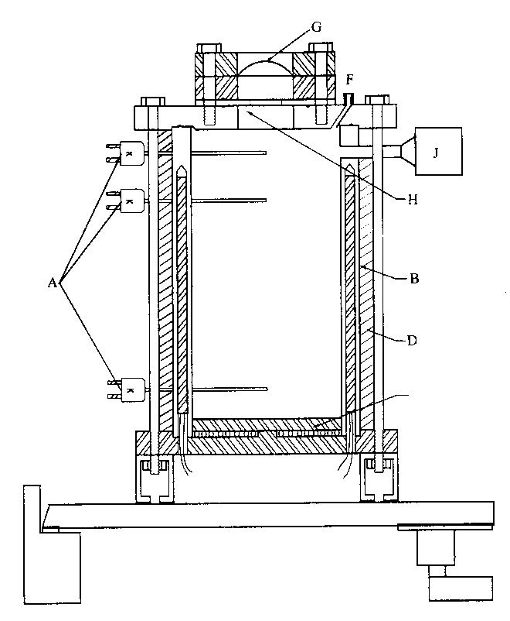

(A) Thermocouples (two in liquid and one in vapour space)

(B) Heating coil/heating cartridge

(C) Drain line, optional

(D) Insulation

(E) Manometer, optional

(F) Pressure relief valve, optional

(G) Bursting disc

(H) Orifice plate

(J) Pressure transducer or pressure relief valve and transducer on tee

**Figure A5.1: 10 LITRE VESSELS FOR VENTING TESTS**

APPENDIX 6  
  
SCREENING PROCEDURES

**1. Purpose**

1.1 Industry uses screening procedures to identify the hazard potential of raw materials, reactive mixtures and intermediates, products and by-products. The use of such procedures is essential to ensure safety during research and development and to ensure that new products and processes are as safe as possible. These procedures usually consist of a combination of a theoretical appraisal and small-scale tests and, in many cases, enable an adequate hazard evaluation to be carried out without the need for larger scale classification tests. This reduces the quantity of material required, lessens any detrimental effect on the environment and minimizes the amount of unnecessary testing.

1.2 The purpose of this Appendix is to present example screening procedures. It should be used in conjunction with any screening procedures given in the introductions to the relevant test series. With the specified safety margin, the results from the screening procedures adequately predict when it is not necessary to perform the classification test as a negative result would be obtained. They are presented for guidance and their use is not compulsory. Other screening procedures may be used provided that adequate correlation has been obtained with the classification tests on a representative range of substances and there is a suitable safety margin.

**2. Scope**

2.1A hazard evaluation for new substances should be undertaken. Initially this evaluation can use the screening procedures given in this Appendix. If the screening procedure indicates that there is a hazard, the full classification procedure should be applied.

2.2 The screening procedures are only applicable to substances and stable, homogeneous mixtures of substances. If a mixture can separate out , the screening procedure should also be performed on each reactive component of the mixture in addition to the mixture.

Some potentially corrosive materials may not be corrosive when solid but may liquefy during normal operations of transport, storage or use. Judgement needs to be applied in such cases to determine the need or otherwise for testing and classification.

2.3 The remarks 1.1.2 from section 1 "General introduction" are emphasized that competence on the part of the testing authority is assumed and responsibility for classification is left with them.

**3. Screening procedures for substances which may have explosive properties**

3.1 The screening procedure may be used for new substances which are suspected of having explosive properties. When considering the explosive properties of self-reactive substances or organic peroxides, refer to Part II of this Manual and section 5.1 of this Appendix. It should not be used for substances manufactured with the intention of producing a practical explosive or pyrotechnic effect.

3.2 Explosive properties are associated with the presence of certain chemical groups in a molecule which can react to produce very rapid increases in temperature or pressure. The screening procedure is aimed at identifying the presence of such reactive groups and the potential for rapid energy release. If the screening procedure identifies the material to be a potential explosive, the acceptance procedure(see 10.3) has to be performed.

***NOTE****: Neither a Series 1 type (a) propagation of detonation test nor a Series 2 type (a) test of sensitivity to detonative shock is required if the exothermic decomposition energy of organic materials is less than 800 J/g. For organic substances and mixtures of organic substances with a decomposition energy of 800 J/g or more, tests 1 (a) and 2 (a) need not be performed if the outcome of the ballistic mortar Mk.IIId test (F.1), or the ballistic mortar test (F.2) or the BAM Trauzl test (F.3) with initiation by a standard No. 8 detonator (see Appendix 1) is "No". In this case, the results of test 1 (a) and 2 (a) are deemed to be "-".*

3.3The acceptance procedure for explosives need not be applied:

(a) When there are no chemical groups associated with explosive properties present in the molecule. Examples of groups which may indicate explosive properties are given in Table A6.1; or

**Table A6.1 EXAMPLES OF CHEMICAL GROUPS INDICATING EXPLOSIVE PROPERTIES IN ORGANIC MATERIALS**

|  |  |
| --- | --- |
| **Structural feature** | **Examples** |
| C-C unsaturation | Acetylenes, acetylides, 1,2-dienes |
| C-Metal, N-Metal | Grignard reagents, organo-lithium compounds |
| Contiguous nitrogen atoms | Azides, aliphatic azo compounds, diazonium salts, hydrazines,  sulphonylhydrazides |
| Contiguous oxygen atoms | Peroxides, ozonides |
| N-O | Hydroxylamines, nitrates, nitro compounds, nitroso compounds,  N-oxides, 1,2-oxazoles |
| N-halogen | Chloramines, fluoroamines |
| O-halogen | Chlorates, perchlorates, iodosyl compounds |

(b) When the substance contains chemical groups associated with explosive properties which include oxygen and the calculated oxygen balance is less than -200.

The oxygen balance is calculated for the chemical reaction:

CxHyOz + [x + (y/4)-(z/2)] O2 ⮀ x CO2 + (y/2) H2O

using the formula:

oxygen balance = ; or

(c)For the organic substance or a homogenous mixture of organic substances containing chemical group (or groups) associated with explosive properties:

- when the exothermic decomposition energy is less than 500 J/g, or

- when the onset of exothermic decomposition is 500 °C or above as indicated by Table A6.2.

**Table A6.2 DECISION TO APPLY THE ACCEPTANCE PROCEDURE FOR CLASS 1 FOR AN ORGANIC SUBSTANCE OR A HOMOGENOUS MIXTURE OF ORGANIC SUBSTANCES**

|  |  |  |
| --- | --- | --- |
| **Decomposition energy (J/g)** | **Decomposition onset temperature (**°C) | **Apply acceptance procedure for Class 1?**  **(Yes/No)** |
| < 500 | < 500 | No |
| < 500 | ≥ 500 | No |
| ≥ 500 | < 500 | Yes |
| ≥ 500 | ≥ 500 | No |

The exothermic decomposition energy may be determined using a suitable calorimetric technique (see 20.3.3.3); or

(d) For mixtures of inorganic oxidizing substances with organic material(s), the concentration of the inorganic oxidizing substance is:

- less than 15%, by mass, if assigned to packing group I / category 1 (high hazard) or II / 2 (medium hazard);

- less than 30%, by mass, if assigned to packing group III / category 3 (low hazard).

3.4 When the substance is a mixture containing any known explosives, acceptance procedure has to be performed.

**4. Screening procedures for mixtureswhich may be flammable liquids**

4.1 The procedure only applies to possible flammable mixtures**[2]1** containing known flammable liquids in defined concentrations although they may contain non-volatile components e.g. polymers, additives etc. The flash point of these mixtures need not be determined experimentally if the calculated flash point of the mixture, using the method given in 4.2, is at least 5 °C**[3]2** greater than the relevant classification criterion (23 °C and 60 °C, respectively) and provided that:

(a) The composition of the mixture is accurately known (if the material has a specified range of composition the composition with the lowest calculated flash point should be selected for assessment);

(b) The lower explosion limit of each component is known (an appropriate correlation has to be applied when these data are extrapolated to other temperatures than test conditions) as well as a method for calculating the lower explosion limit of the mixture;

(c) The temperature dependence of the saturated vapour pressure and of the activity coefficient is known for each component as present in the mixture;

(d)The liquid phase is homogeneous.

4.2 A suitable method is described by Gmehling and Rasmussen (Ind. Eng. Chem. Fundament, 21, 186, (1982)). For a mixture containing non-volatile components, e.g. polymers or additives, the flash point is calculated from the volatile components. It is considered that a non-volatile component only slightly decreases the partial pressure of the solvents and the calculated flash point is only slightly below the measured value.

**5. Screening procedures for substances which may be flammable solids**

**5.1 *Substances which may be self-reactive substances***

The classification procedures (see section 20.4) for self-reactive substances need not be applied if:

(a) There are no chemical groups present in the molecule associated with explosive or self-reactive properties; examples of such groups are given in Tables A6.1 and A6.3; or

**Table A6.3: EXAMPLES OF CHEMICAL GROUPS INDICATING SELF-REACTIVE PROPERTIES IN ORGANIC MATERIALS**

|  |  |
| --- | --- |
| **Structural feature** | **Examples** |
| Mutually reactive groups | Aminonitriles, haloanilines, organic salts of oxidizing acids |
| S=O | Sulphonyl halides, sulphonyl cyanides, sulphonyl hydrazides |
| P-O | Phosphites |
| Strained rings | Epoxides, aziridines |
| Unsaturation | Olefins, cyanates |

(b) For a single organic substance or a homogeneous mixture of organic substances, the estimated SADT is greater than 75 °C or the exothermic decomposition energy is less than 300 J/g. The onset temperature and decomposition energy may be estimated using a suitable calorimetric technique (see 20.3.3.3).

**5.2 *Substances which may be liable to spontaneous combustion***

5.2.1 The classification procedure for *pyrophoric solids and liquids* need not be applied when experience, in production or handling, shows that the substance do not ignite spontaneously on coming into contact with air at normal temperatures (i.e. the substance is known to be stable at room temperature for prolonged periods of time (days)).

5.2.2 The classification procedure for *self-heating substances* need not be applied if the results of a screening test can be adequately correlated with the classification test and an appropriate safety margin is applied. Examples of screening tests are:

(a) The Grewer Oven test (VDI guideline 2263, part 1, 1990, *Test methods for the Determination of the Safety Characteristics of Dusts*) with an onset temperature 80 K above the reference temperature for a volume of 1 *l* (33.3.1.6);

(b) The Bulk Powder Screening Test (Gibson, N. Harper, D. J. Rogers, R. *Evaluation of the fire and explosion risks in drying powders,* Plant Operations Progress, 4 (3), 181 - 189, 1985) with an onset temperature 60 K above the reference temperature for a volume of 1 *l* (33.3.1.6).

**5.3 *Substances which in contact with water may react to emit flammable gases***

The classification procedure for substances which may react with water to emit flammable gases need not be applied if:

(a) The chemical structure of the substance does not contain metals or metalloids; or

(b) Experience in production or handling shows that the substance does not react with water, e.g. the substance is manufactured in water or washed with water; or

(c) The substance is known to be soluble in water to form a stable mixture.

**6. Screening procedures for substances which may be oxidizing substances and those which may be organic peroxides**

**6.1 *Substances which may be oxidizing substances***

6.1.1 For *organic compounds*, the classification procedure for oxidizing substances need not be applied if:

(a) The compound does not contain oxygen, fluorine or chlorine; or

(b) The compound contains oxygen, fluorine or chlorine and these elements are chemically bonded only to carbon or hydrogen.

6.1.2 For *inorganic substances*, the test procedure in Chapter 34 need not be applied if the substance does not contain any oxygen or halogen atoms.

**6.2 *Substances which may be organic peroxides***

6.2.1 Organic peroxides are classified by definition based on their chemical structure and on the available oxygen and hydrogen peroxide content of formulations (see 20.2.2).

APPENDIX 7  
  
HSL FLASH COMPOSITION TEST

**1.** **Introduction**

This test is used to determine whether pyrotechnic substances in powder form or as pyrotechnic units as presented in the fireworks, that are used to produce an aural effect, or used as a bursting charge or lifting charge, are considered to be flash compositions for the purposes of determining the classification of fireworks using the UN default fireworks classification table in 2.1.3.5.5 of the Model Regulations.

**2.** **Apparatus and materials**

2.1 The time/pressure apparatus (Figure A7.2) consists of a cylindrical steel pressure vessel 89 mm in length and 60 mm in external diameter. Two flats are machined on opposite sides (reducing the cross-section of the vessel to 50 mm) to facilitate holding whilst fitting the cone in firing plug and vent plug. The vessel, which has a bore of 20 mm diameter, is internally rebated at either end to a depth of 19 mm and threaded to accept 1" British Standard Pipe (BSP). A pressure take-off, in the form of a side-arm, is screwed into the curved face of the pressure vessel 35 mm from one end and at 90° to the machined flats. The socket for this is bored to a depth of 12 mm and threaded to accept the 1/2" BSP thread on the end of the side-arm. A washer is fitted to ensure a gastight seal. The side-arm extends 55 mm beyond the pressure vessel body and has a bore of 6 mm. The end of the side-arm is rebated and threaded to accept a diaphragm type pressure transducer. Any pressure-measuring device may be used provided that it is not affected by the hot gases or decomposition products and is capable of responding to rates of pressure rise of 690-2 070 kPa in not more than 1 ms.

2.2 The end of the pressure vessel furthest from the side-arm is closed with a cone in firing plug which is fitted with two electrodes, one insulated from, and the other earthed to, the plug body. The other end of the pressure vessel is closed by an aluminium bursting disc 0.2 mm thick (bursting pressure approximately 2 200 kPa) held in place with a retaining plug which has a 20 mm bore. A soft lead washer is used with both plugs to ensure a good seal.

2.3 A support stand (Figure A7.8) holds the assembly in the correct attitude during use. This comprises a mild steel base plate measuring 235 mm × 184 mm × 6 mm and a 185 mm length of square hollow section (S.H.S.) 70 × 70 × 4 mm. A section is cut from each of two opposite sides at one end of the length of S.H.S. so that a structure having two flat sided legs surmounted by an 86 mm length of intact box section results. The ends of these flat sides are cut to an angle of 60° to the horizontal and welded to the base plate.

2.4 A slot measuring 22 mm wide × 46 mm deep is machined in one side of the upper end of the base section such that when the pressure vessel assembly is lowered, firing plug end first, into the box section support, the side-arm is accommodated in this slot. A packing piece of steel 30 mm wide and 6 mm thick is welded to the lower internal face of the box section to act as a spacer. Two 7 mm thumb screws, tapped into the opposite face, serve to hold the pressure vessel firmly in place. Two 12 mm wide strips of 6 mm thick steel, welded to the side pieces abutting the base of the box section, support the pressure vessel from beneath.

2.5 The ignition system consists of a Vulcan electric fusehead, with lead wires, of the type commonly used for igniting pyrotechnic substances. Fuseheads with equivalent properties may be used.

2.6 The wires of the fusehead are cut to such a length that the fusehead sits 10 mm above the top of the cone of the firing plug (see Figure A7.1). The fusehead leads are held in position using the grub screws (see Figure A7.3).

**3. Procedure**

3.1 The apparatus, assembled complete with pressure transducer but without the aluminium bursting disc in position, is supported firing plug end down. 0.5 gof the substance is introduced into the cone of the firing plug. Where the pyrotechnic substance is in consolidated form greater than 0.5 g it should be broken to produce a piece as close to 0.5 g as possible. Where the pyrotechnic substance is in consolidated form less than 0.5 g then whole and broken units should be chosen to give 0.5 g pyrotechnic substance. The lead washer and brass or aluminium bursting disc are placed in position and the retaining plug is screwed in tightly. The charged vessel is transferred to the firing support stand, bursting disc uppermost, which should be contained in a suitable, armoured fume cupboard or firing cell. An exploder dynamo is connected to the external terminals of the firing plug and the charge is fired. The signal produced by the pressure transducer is recorded on a suitable system which allows both evaluation and a permanent record of the time/pressure profile to be achieved (e.g. transient recorder coupled to a chart-recorder).

3.2 The test is carried out three times. The time taken for the pressure to rise from 690 kPa to 2 070 kPa above atmospheric is noted. The shortest interval of three firings should be used for classification.

**4. Test criteria and method of assessing results**

The test results are interpreted in terms of whether a gauge pressure of 2 070 kPa is reached and, if so, the time taken for the pressure to rise from 690 kPa to 2 070 kPa gauge. The result is considered positive “+” and the pyrotechnic substances in powder form or as pyrotechnic units as presented in the fireworks, that are used in waterfalls, or used as a bursting charge or lifting charge, is to be considered as flash composition if the minimum time taken for the pressure rise is shown to be less than, or equal to, 6 ms for 0.5 g of pyrotechnic substance.

**Examples of results:**

|  |  |  |  |
| --- | --- | --- | --- |
| **Substance** | **Maximum pressure rise (kPa)** | **Mean time for a pressure rise from 690 to 2 070 kPa (ms)** | **Result** |
| 1 | > 2 070 | 0.70 | Flash composition |
| 2 | > 2 070 | 4.98 | Flash composition |
| 4 | > 2 070 | 1.51 | Flash composition |
| 5 | > 2 070 | 0.84 | Flash composition |
| 6 | > 2 070 | 11.98 | Not flash composition |

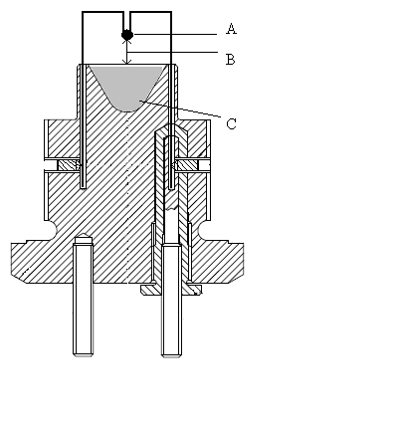

(A) Fusehead

(B) 10 mm gap

(C) Substance under test

**Figure A7.1: SAMPLE SETUP**

**Figure A7.2: APPARATUS**

**(A) Pressure vessel body  
(B) Bursting disc retaining plug  
(C) Firing plug  
(D) Lead washer  
(E) Bursting disc  
(F) Side arm  
(G) Pressure transducer thread  
(H) PTFE washer  
(J) Insulated electrode  
(K) Earthed electrode  
(L) Insulator  
(M) Insulator  
(N) Shortened grub screw**

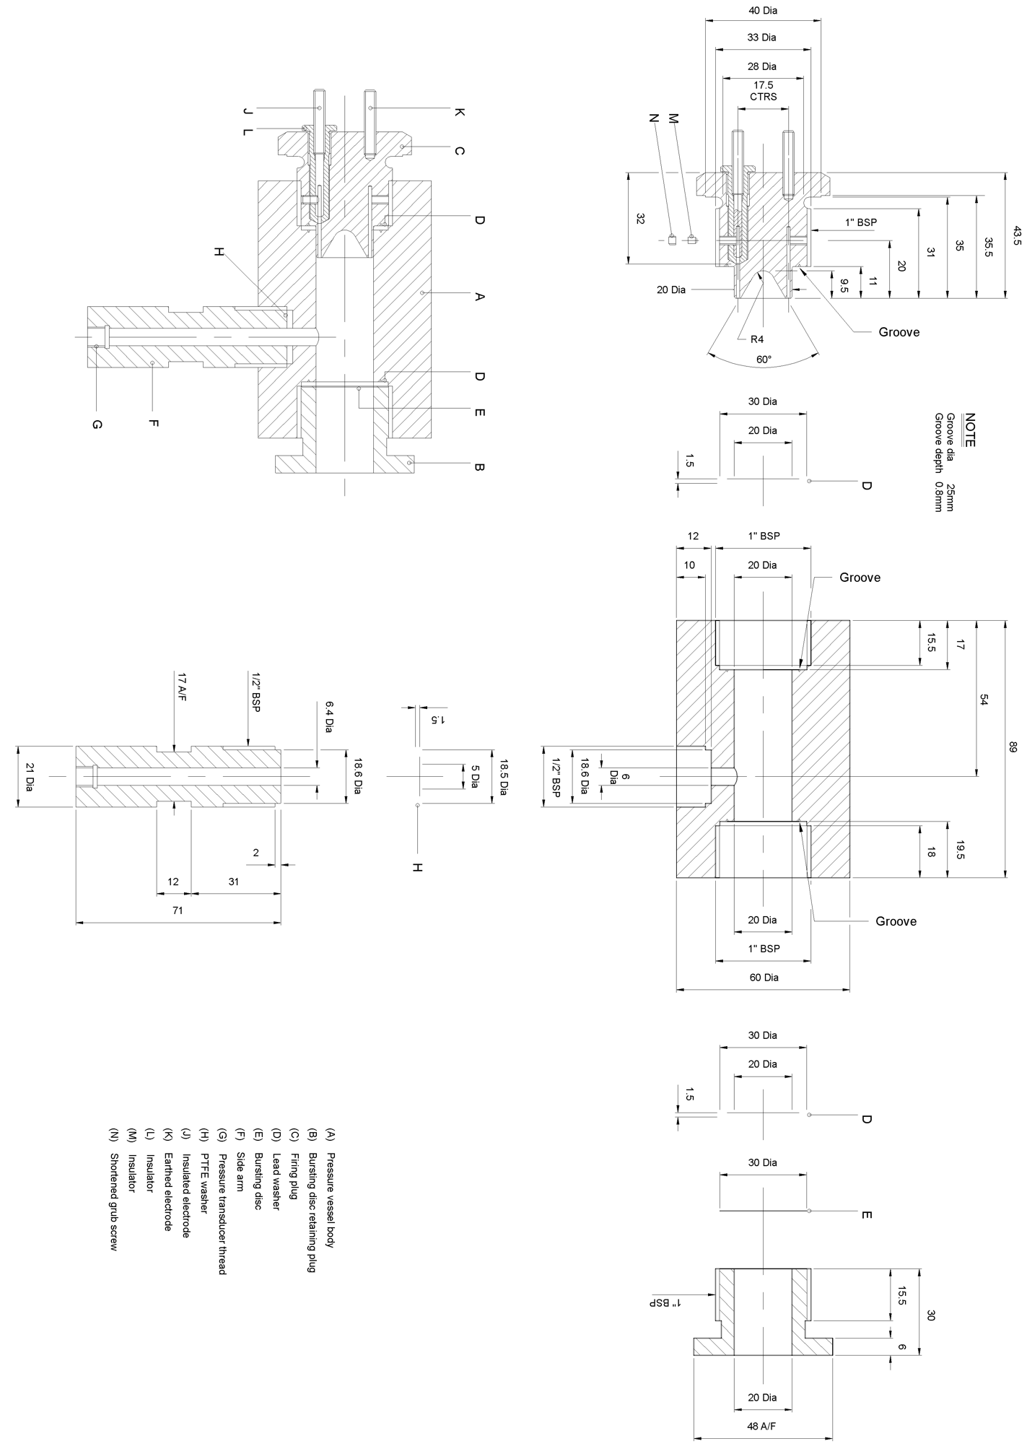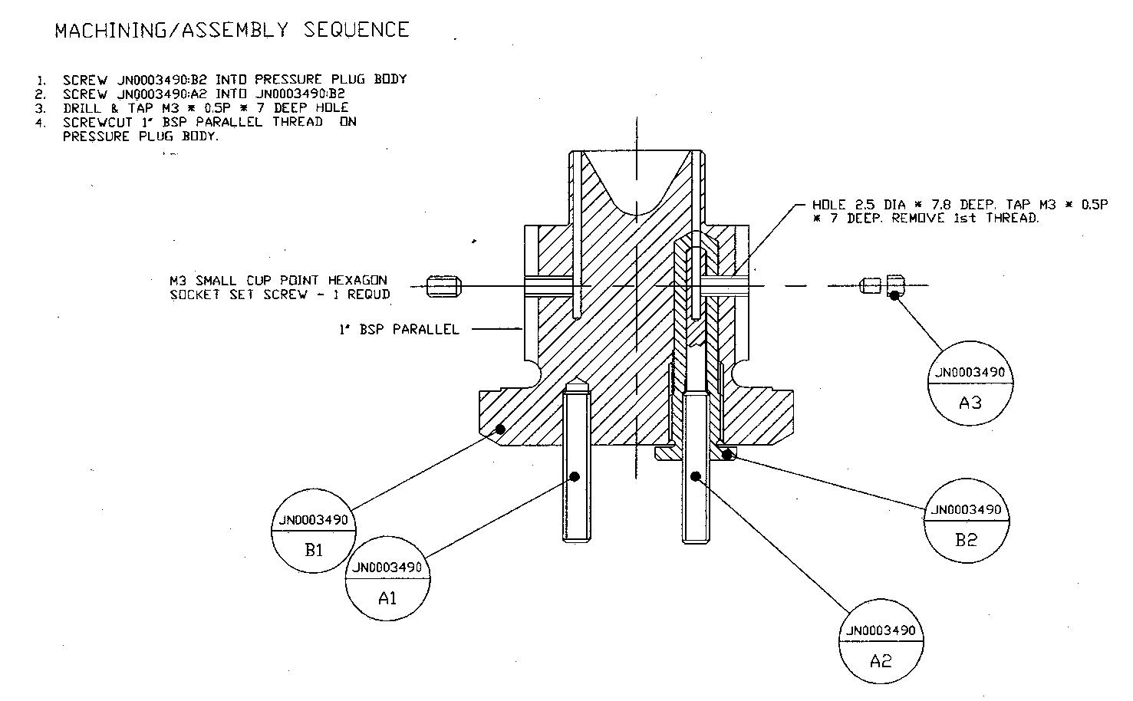

**MACHINING/ASSEMBLY SEQUENCE**

**1. SCREW JN0003490:B2 INTO PRESSURE PLUG BODY  
2. SCREW JN0003490:A2 INTO JN0003490:B2  
3. DRILL & TAP M3 * 0.5P * 7 DEEP HOLE  
4. SCREWCUT 1" BSP PARALLEL THREAD ON   
 PRESSURE PLUG BODY**

**M3 SMALL CUP POINT HEXAGON  
SOCKET SET SCREW – 1 REQUD**

**1" BSP PARALLEL**

**HOLE 2.5 DIA * 7.8 DEEP.  
TAP M3 * 0.5P * 7 DEEP.  
REMOVE 1st THREAD.**

**Figure A7.3: ASSEMBLY**



**Figure A7.4: PART B1**



**A3 A2**

**Figure A7.5: PARTS A3 AND A2**

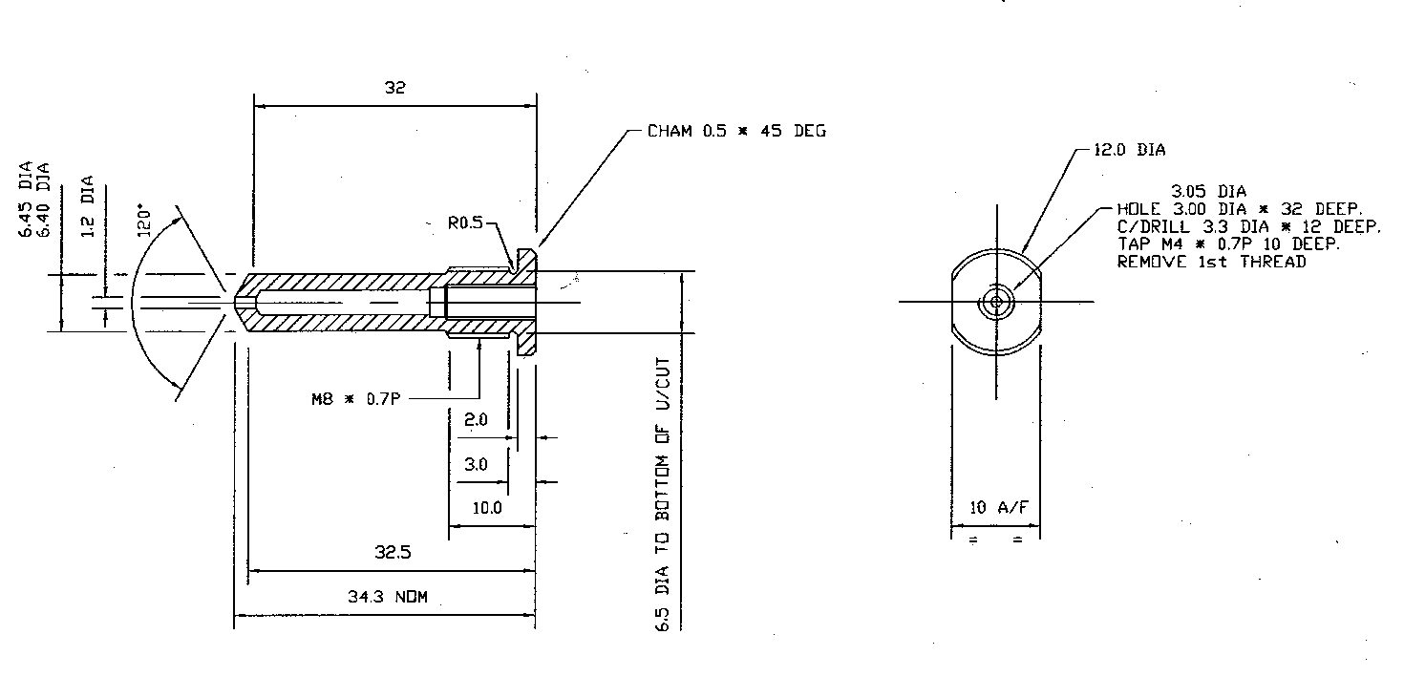

**34.3 NOM**

**CHAM 0.5 * 45 DEG**

**6.5 DIA TO BOTTOM OF U/CUT**

**10 A/F**

**∅3.05**

**HOLE 3.00 DIA * 32 DEEP.  
C/DRILL 3.3 DIA * 12 DEEP.  
TAP M4 * 0.7P * 10 DEEP.  
REMOVE 1st THREAD**

**∅6.45  
∅6.40**

**∅1.2**

**∅12**

**Figure A7.6: PART B2**

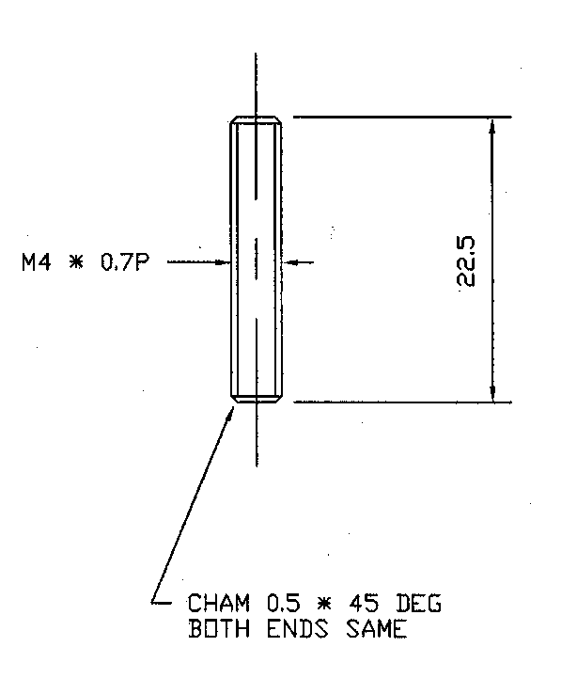

**CHAM 0.5 * 45 DEG  
BOTH ENDS SAME**

**Figure A7.7: PART A1**

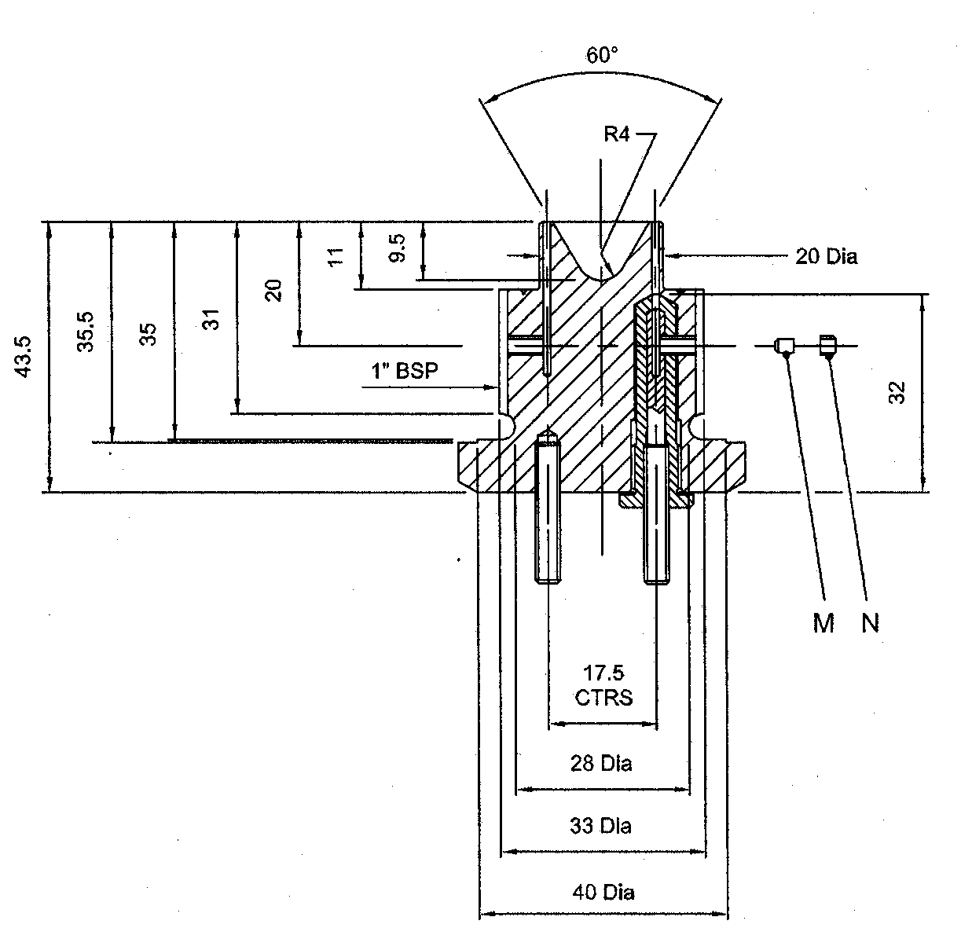

**1" BSP**

**17.5  
CTRS**

**∅20**

**∅28**

**∅33**

**∅40**

**Figure A7.8: ASSEMBLED CONE IN PLUG**



60°

**Figure A7.9: SUPPORT STAND**

**APPENDIX 8**

**RESPONSE DESCRIPTORS**

These response descriptors are to be used for the purposes of Test Series 7 criteria and designed to be used by the competent authority to determine the response type of articles. For example, articles vary greatly in size, type, packaging and explosive substances; these differences need to be taken into account. For a reaction to be judged a particular type, the primary evidence (denoted P in the table below) for that type would need to be present. The entire (both primary and secondary) body of evidence must be weighed carefully and used in its entirety by the competent authority to assess the reaction. The secondary evidence provides other indicators that may be present.

| Response  level | Observed or measured effects | | | | |
| --- | --- | --- | --- | --- | --- |
| Explosive Substances (ES) | Case | Blast | Fragment or ES projection | Other |
| Detonation | Prompt consumption of all ES once the reaction starts | (P) Rapid plastic deformation of the metal casing contacting the ES with extensive high shear rate fragmentation | (P) Shock wave with magnitude & timescale = to a calculated value or measured value from a calibration test | Perforation, fragmentation and/or plastic deformation of witness plates | Ground craters of a size corresponding to the amount of ES in the article |
| Partial detonation |  | (P) Rapid plastic deformation of some, but not all, of the metal casing contacting the ES with extensive high shear rate fragmentation | (P) Shock wave with magnitude & timescale < that of a calculated value or measured value from a calibration test Damage to neighboring structures | Perforation, plastic deformation and/or fragmentation of adjacent witness plates.  Scattered burned or unburned ES. | Ground craters of a size corresponding to the amount of ES that detonated. |
| Explosion | (P) Rapid combustion of some or all of the ES once the article reaction starts | (P) Extensive fracture of metal casings with no evidence of high shear rate fragmentation resulting in larger and fewer fragments than observed from purposely detonated calibration tests ¤ | Observation or measurement of a pressure wave throughout the test arena with peak magnitude << and significantly longer duration that of a measured value from a calibration test | Witness plate damage.  Significant long distance scattering of burning or unburned ES. | Ground craters. |
| Deflagration | (P) Combustion of some or all of the ES | (P) Rupture of casings resulting in a few large pieces that might include enclosures or attachments. * | Some evidence of pressure in the test arena which may vary in time or space. | (P) At least one piece (casing, enclosure or attachment) travels beyond 15m with an energy level > 20J based on the distance/mass relationship of Figure 16.6.1.1. Significant scattered burning or unburned ES, generally beyond 15 m. | (P) There is no primary evidence of a more severe reaction and there is evidence of thrust capable of propelling the article beyond 15m.  Longer reaction time than would be expected in an explosion reaction. |

___________________________

1. **1** *It is recommended that either small-scale vent experiments (100 - 200* *ml scale) or experiments using a very strong vessel (>100 bar) be performed prior to the performance of the 10 l vent test in order to obtain information on the maximum pressure effect from the test substance and on the required orifice diameter to be used in the first 10 l scale vent test.* 
2. **1** *Up to now, the calculation method is validated for mixtures containing up to six volatile components. These components may be flammable liquids like hydrocarbons, ethers, alcohols, esters (except acrylates), and water. It is however not yet validated for mixtures containing halogenated, sulphurous, and/or phosphoric compounds as well as reactive acrylates.*
3. **2** *If the calculated flash point is less than 5 °C greater than the relevant classification criterion, the calculation method may not be used and the flash point should be determined experimentally.*