UN/SCETDG/49/INF.20

Committee of Experts on the Transport of Dangerous Goods
and on the Globally Harmonized System of Classification
and Labelling of Chemicals 9 June 2016
Sub-Committee of Experts on the Transport of Dangerous Goods
Forty-ninth session
Geneva, 27 June – 6 July 2016
Item 2 (i) of the provisional agenda
Explosives and related matters: miscellaneous
Transport of energetic samples for further testing
Transmitted by the European Chemical Industry Council (CEFIC)
Introduction
- Research and development in industry, public institutes and universities frequently have the need to transport substances for the purpose of testing, i.e. the determination of physical, chemical, biological, toxicological or ecotoxicological properties and behavior, fitness for use or application.
- The substances usually consist of organic molecules which are active ingredients, building blocks or intermediates for pharmaceutical or agricultural chemicals.
- Generally, the amounts per substance are small (frequently milligram or lower gram scale), and reliable information about the proper classification is not available due to the lack of test data.
- In many cases, the molecules of the substances carry functional groups listed in tables A6.1 and/or A6.2 in Annex 6 (Screening Procedures) of the Manual of Tests and Criteria, thus indicating explosive or self-reactive properties; however, they are not designed to be explosives of Class 1.
- Whereas the transport of samples of self-reactive substances and organic peroxides is permitted under the provisions of 2.4.2.3.2.4 (b) and 2.5.3.2.5.1, respectively, substances considered to meet the criteria for Class 1 are prohibited for transport by 2.0.4.2 (b).
- However, at this early stage of development, test data are not available to distinguish candidates for Class 1 and self-reactive substance of Division 4.1. Thus, there is a need to find a proper solution for the transport of energetic samples for the purpose of testing in small amounts, to define appropriate criteria for classification in cases of limited test data, and to specify the required packaging.
- For practical purposes, industry has decided to focus on a solution for very small samples (milligrams to a few grams) in the first phase, and to develop solutions for medium size (up to about 100 grams) and finally lower kilogram scale samples (to cover the amounts required for test series 1 and 2 of the UN Manual of Tests and Criteria) in the next biennia.
- In the beginning of the current biennium, CEFIC had submitted informal document INF.29 (47th session) as a thought starter, suggesting developing a safe packaging specification and an entry in Division 4.1 as self-reactive substance for these energetic samples.
- Encouraged by the Sub-Committee to proceed in the suggested direction, industry performed testing at the German Federal Institute for Materials Research and Testing (BAM) in close cooperation with the German authorities. The results presented in this paper form the basis of a formal proposal to be submitted for the last session of this biennium.
Discussion
Sample size and packaging
- In a first stage of research, pharmaceutical companies frequently ship complete substance libraries for activity screenings to specialized institutes. For this purpose, substances may be arranged in so-called multi titer plates (i.e. array of several dozens or hundreds of samples) as primary packagings with about 1-10 mg of individual sample.
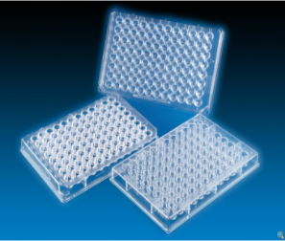
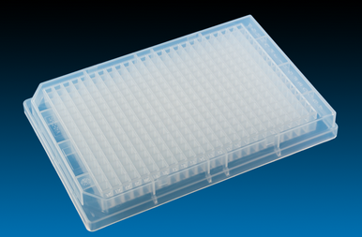

Figure 1: 96 and 384 type multi titer plate
- Substances may be dissolved in an inert solvent before transport if so required by the test institute. The number of samples in this screening phase is quite large and may reach a magnitude of 10,000 to 100,000 per year and company.
- The multi titer plates are frequently placed in dry ice (see figure 2) for quality reasons. For transport at ambient temperature, the usual cushioning material (i.e. bubble wrap, plastic chips, foam pads, etc.) is used.
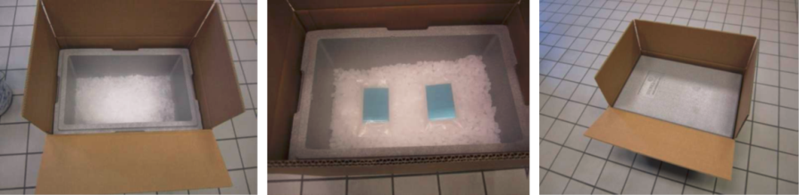
Figure 2: Multi titer plates transported on dry ice

13. At a later stage, samples may be put into individual glass bottles or plastic containers as primary packagings with up to 5 g sample.
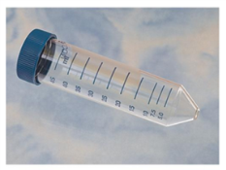
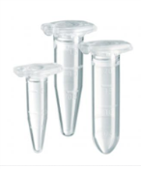

Figure 3 Plastic vessels for individual substances
Sample characteristics
14. Since this paper focuses on energetic samples, only substances with functional groups listed in tables A6.1 and/or A6.2 in Annex 6 (Screening Procedures) of the UN Manual of Tests and Criteria are considered, thus indicating explosive or self-reactive properties; however, the substances are not designed to be explosives of Class 1.
15. The energy content of the samples was determined by screening DSC (heating rate 3K/min, closed crucible) for a representative set of such substances in research (see diagram 1). Nearly all substances exhibit a decomposition energy of less than 3000 J/g, corresponding to the range of typical self-reactive substances and peroxides and clearly below the range of typical intentional explosives.

Diagram 1: Distribution of energy content (369 substances)
16. However, individual outliers do exist. Upon discussion with several authorities, CEFIC decided to take a conservative approach for further testing (see annex).
17. Another issue to be discussed is the decomposition onset: The investigation of a representative set of substances shows a distribution of the onset over a wide temperature range (see diagram 2) (DSC at 3 K/min, closed crucible).

Diagram 2 Distribution of decomposition onset (372 substances)
18. This diagram allows some important conclusions: The onset as determined by a screening DSC gives only very rough estimates of thermal stability. Substances with an onset above 200 °C are stable and formally candidates for Class 1. The candidates for self-reactive substances should primarily be found for substances with an onset below 200 °C, whereas a small fraction (decomposition onset <100 °C) might even require temperature control.
19. At this stage, however, neither can the SADT (test series H) be determined nor can test series 1 or 2 of the Class 1 Acceptance Procedure be performed, and a decision about a correct classification is simply not possible.
20. Experience from later stages of development has shown that only a very small fraction of the substances (estimated < 0.1 %) gives a positive result in the Class 1 Acceptance Procedure according to Test Series 2, whereas about 5 to 10 % turn out to be self-reactives.
Testing
21. Tests were performed on highly energetic model substances at the German Federal Institute for Materials Research and Testing with different sample receptacles, amounts and packing arrangements. The essential findings are given in the annex of this paper.
22. Due to the energy content of the samples, tests were performed
- to assess the effects of a possible thermal decomposition, and
- to investigate the initiation of a detonation and its propagation.
Further, the mechanical stability of the package was tested.
23. As a result, a safe package design was found.

Proposal
24. The Sub-Committee is requested to discuss this paper in the Explosives Working Group and to decide in principle about the path forward so CEFIC may submit a more detailed formal proposal for the December session.
(a) Multi titer plates
25. In section 3.5.1.2, create a new entry in the table as follows:
Code | Maximum net quantity  per inner packaging  (in grams for solids and ml  for liquids and gases) | Maximum net quantity per outer  packaging (in grams for solids and ml for liquids and gases, or sum of grams and ml in the case of mixed packing)
E6 | 0,01 | 20
26. Amend special provision 340 to read: “Substances carrying functional groups listed in tables A6.1 and/or A6.2 in Annex 6 (Screening Procedures) of the UN Manual of Tests and Criteria, although not individually authorized as excepted quantities in the Dangerous Goods List of Chapter 3.2, are authorized in such kits in the form of multi titer plates and are assigned Code E6 (see 3.5.1.2) provided that they are not designed with the view of producing a practical explosive or pyrotechnic effect.”
(b) Other samples in small amounts
27. Create a new section 2.0.4.3 to read “Samples of substances carrying functional groups listed in tables A6.1 and/or A6.2 in Annex 6 (Screening Procedures) of the UN Manual of Tests and Criteria may be transported under UN 3224 as self-reactive substances of Division 4.1 provided
(a) The substances are not designed with the view of producing a practical explosive or pyrotechnic effect;
(b) Available data do not allow a more precise classification;
(c) The individual substance is contained in inner packagings of glass or plastic (max. capacity 30 ml) placed in a foam matrix specified in PP23;
(d) The maximum content of each inner receptacle does not exceed 1 g for solids/1 ml for liquids;
(e) The sample is not packed together with other goods.”
28. In Packing Instruction P520, add a special packing provision PP23 specifying the dimensions of the outer package (4G only) and the foam layout as tested (see annex, initiation of detonation and its propagation); to be detailed in the formal proposal.
Justification
(a) Multi titer plates
29. Since the critical detonation diameter for a sensitive commercial explosive is about 1 mm, and since even commercial explosives are hard to initiate in small amounts without confinement, it can be concluded that in a worst case scenario the initiation of a detonation or its propagation in a multi titer plate is not possible.
30. Further, a thermal decomposition would have no effect outside the package. Due to the small amounts, any other hazardous effects can be excluded.
31. For multi titer plates, the application of the entry UN 3316 “CHEMICAL KIT” appears to be most appropriate and matches the definition of SP 251: “The entry CHEMICAL KIT or FIRST AID KIT is intended to apply to boxes, cases etc. containing small quantities of various dangerous goods which are used for example for medical, analytical or testing or repair purposes.”
32. The suggested amendment of SP340 follows the existing text which allows the carriage of Division 5.2 substances as excepted quantities in such kits using Code E2.
(b) Other samples in small amounts
33. The tests performed have shown that for the chosen packaging design
(a) A mass explosion or dangerous projection hazard can be excluded;
(b) Violent burning or strong heat radiation will not occur due to the design of the package and the large volume and mass of the packaging material compared to the sample;
(c) Fire fighting in the immediate vicinity is not hindered;
(d) There are no hazardous effects outside the package.
34. The substances are not manufactured with the view of producing a practical explosive or pyrotechnic effect. Therefore, according to the Procedure for assignment to a division of Class 1 (Section 10.4 of the UN Manual of Tests and Criteria) and the flowchart in figure 10.3, the result is “Not Class 1”.
35. Given the properties of the substances as described in the introduction of this paper, the classification as self-reactive substances of Division 4.1 seems to be the most appropriate entry.
Annex: Test results
Thermal decomposition
36. Test were performed on azodicarbonamide (solid, 1400 J/g) and a liquid organic peroxide (1900 J/g decomposition energy).
37. 5 g of the solid substance in a 50 ml glass bottle was put into a plastic bag which was placed into a 1.5 l HDPE bottle along with foam flakes. This bottle was put into a cardboard box filled with foam flakes (see figure 4); a similar arrangement was used for liquids.
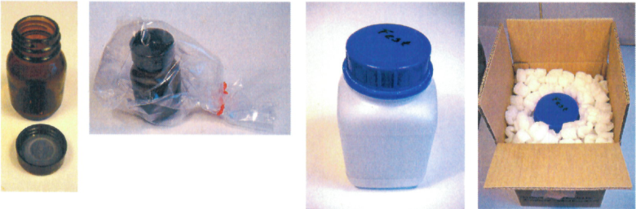
Figure 4 Packaging of solid sample for testing
38. The initiation of decomposition by a heating coil or a hot plate resulted only in minor damage (i.e., broken or melted lid); see figure 5 for results of liquid material.
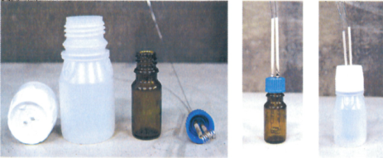
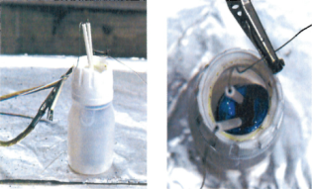
Before test
After test

Figure 5 Result of thermal decomposition test

39. From these results it can be concluded that thermal decomposition does not cause any severe effects for small amounts of energetic samples provided that proper packaging is applied; thus, temperature control for the purpose of safety is not necessary in these cases.
Initiation of detonation and its propagation
40. Tests were performed with two goals:
(a) To minimize hazardous effects outside the package, and
(b) To find a package design to prohibit propagation of detonation from one sample to the other.
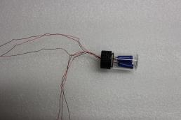
41. A major difficulty was to find an appropriate detonator. The commercial standard detonators proved to be unsuitable due to the metallic fragments which distorted the assessment of the experiments. Finally, a non-metallic pyrotechnic initiator with a detonative output was found. This initiator (see figure 6) with the energy equivalent of 1 g TNT was used throughout the detonation tests.
Figure 6: Metal-free detonative initiator

42. A fibreboard box (4G) of dimensions 60 cm (length) by 41 cm (width) by 28 cm (height) and a wall thickness of 1,3 cm was used. A foam matrix was manufactured with recesses for the samples bottles in defined distances from each other and from the package wall (figure 7).
Figure 7: Foam matrix for sample containers
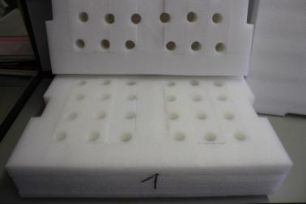
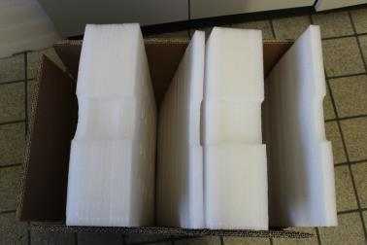

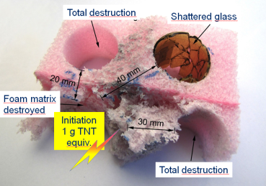
43. In order to determine safe distances to prevent a propagation of detonation from one sample to another, a pilot test was performed with an initiator (1 g TNT equivalent; see above) and sample bottles in defined distances.
Figure 8: Propagation of detonation at different distances
44. Whereas total destruction was observed up to a distance of 30 mm, the foam matrix remained intact and the glass bottle was only shattered at 40 mm distance (see figure 8).

45. Finally, the package specified above was tested with sample containers placed in the foam matrix. In order to obtain a worst case scenario, the initiator was placed in the corner at a distance of 7 cm to each wall. The results are shown in figure 9:
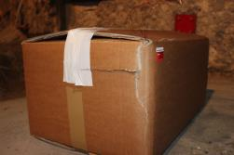
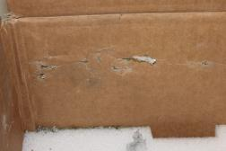
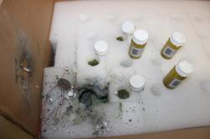

Figure 9: Effects on package (inside and outside)
46. Evidently, apart from a superficial crack in the wall of the cardboard box, all effects are limited to the inside of the package. No material was able to penetrate the walls of the box or escape to the outside. The immediately adjacent glass bottles were broken but their lower part was mostly intact. The glass bottles farther away remained fully intact.

47. A second test of the same arrangement with samples of picric acid placed around the initiator delivered the same result. A propagation of detonation did not occur.
48. An external fire test (test series 6, type 6 (c)) was not performed since the sample mass is small compared to the packaging material, and a safety relevant effect is not to be expected.
Mechanical stability
49. A drop test (1.8 m, different orientations) resulted only in a slight deformation of the corner of the cardboard box while the inner receptacles remained completely undamaged.

