|  |  |  |  |
| --- | --- | --- | --- |
|  | United Nations | ST/SG/AC.10/C.3/2017/3 | |
| _unlogo | **Secretariat** | | Distr.: General  23 April 2017  Original: English |

**Committee of Experts on the Transport of Dangerous Goods  
and on the Globally Harmonized System of Classification  
and Labelling of Chemicals**

**Sub-Committee of Experts on the Transport   
of Dangerous Goods**

**Fifty-first session**

Geneva, 3-7 July 2017

Item 2 (e) of the provisional agenda  
**Explosives and related matters: stability tests for industrial nitrocellulose**

Stability tests for industrial nitrocellulose

Transmitted by the expert from Germany[[1]](#footnote-2)

Introduction

1. The stabilization of nitrated cellulose (NC) mixture is a decisive and critical step in the production process of NC and must be done and controlled properly for each production lot in order to achieve stable industrial NC products that can be transported and used safely without the danger of self-ignition over their entire shelf life. The wetting of NC mixtures with alcohol, water or plasticizer only reduces the burning speed of the NC; it has no effect on the stability of the NC mixtures. Additional measures are necessary to ensure the stability even if the NC mixture will get completely dry.

Self-ignition temperature

2. For European land transport, provisions on tests relating to NC mixtures have been incorporated in section 2.3.2 ADR/RID. The ignition temperature test in ADR/RID is a test to determine at what temperature a substance will self-ignite when heated without an external ignition source. This test is the most important stability test for industrial NC, as it defines the conditions under which the NC mixture can be transported and used without the risk of self-ignition.

3. The self-ignition temperature test in accordance with ADR/RID has been mandatory for NC mixtures for more than 30 years. This test requires that the self-ignition temperature be higher than 180 °C for dry NC (higher than 170 °C for NC with plasticizer). The test is carried out using dry NC to make sure that even dry NC will not self-ignite. If the self-ignition temperature of dry NC is above 180 °C, this ensures that even dry NC will not self-ignite at temperatures of up to 65 °C that may occur in a container.

Long-term chemical stability

4. In addition, a 30-minute qualitative test of the chemical stability at 132 °C is also mandatory for NC mixtures to be permitted for transport in Europe in accordance with ADR/RID. This test has two disadvantages: the test duration of 30 minutes is relatively short and secondly, that this is a qualitative test without quantitative criteria. The test criterion is: “It is observed whether nitrous gases in the form of yellowish-brown fumes clearly visible against a white background are given off during 30 minutes”.

5. For several decades, the European producers within the European Nitrocellulose Producers Association (ENA) have been using the quantitative Bergmann Junk test, which determines the quantity of NO gas formed within 2 hours at 132 °C. The acceptance limit for this test is a maximum of 2.5 ml NO gas per g of NC. With these conditions that go even beyond those of the test in ADR/RID, highly reliable information about the long-term chemical stability is obtained.

6. The European NC producers have several decades of practical experience of several 100.000 tonnes of properly stabilized NC; this experience shows that NC damped with alcohol,(e.g. isopropanol or ethanol or butanol) or water, or plasticized with plasticizer is sufficiently stable after transport in a container to countries having a hot climate and additional storage of up to 2 years after production at a maximum temperature of 40 °C if the stabilization of the NC during the production process has been done properly and if the requirements of the self-ignition temperature test and the quantitative Bergmann Junk test are fulfilled. Dry NC will also have a self-ignition temperature above 180 °C after 2 years of storage.

7. Therefore, the quantitative Bergmann Junk test also gives reliable information on long-term stability if the NC-mixtures are transported in containers, where the temperature may increase to 65 °C for short periods. The quantitative Bergmann Junk test ensures that the self-ignition temperature is above 180 °C for dry NC (170 °C for plasticized NC, respectively) over the entire duration of transport, storage and use, thus allowing for safe handling of properly stabilized NC.

8. There is also a publication[[2]](#footnote-3)1 available which shows that only the quantitative Bergmann Junk test gives highly reliable information regarding the long-term chemical stability of nitrocellulose.

Proposal

9. The expert from Germany is of the opinion that the stability of NC mixtures is crucial for it being transported, stored and handled safely. Provisions should be incorporated in the Model Regulations to ensure a sufficient level of stabilisation for worldwide and multimodal transport.

10. It is proposed to require a tested minimum ignition temperature of 180°C (170 °C for plasticized NC) and a tested stability for nitrocellulose mixtures of Class 1 (UN 0340, UN 0341, UN 0342 and UN 0343) and Class 4.1 (UN 2555, UN 2556, UN 2557 and UN 3380). The ignition temperature test and the Bergmann Junk test should be included in the Manual of Tests and Criteria as applicable test methods. They could be included in a new appendix 8.

Annex 1

Proposed amendments to the Model Regulations

Insert a new number 2.1.3.4.4

2.1.3.4.4 The ignition temperature and chemical stability of nitrocellulose mixture of Class 1 (UN 0340, UN 0341, UN 0342 and UN 0343) shall be tested in accordance with the test methods given in the Manual of Tests and Criteria, appendix 8. The ignition temperature for nitrocellulose-mixtures wetted with alcohol or water shall be above 180 °C. The ignition temperature for nitrocellulose mixtures plasticized with a plasticiser shall be above 170 °C. The nitrocellulose mixtures are classified as stable for transport, if the quantity of nitrous vapours given off is not more than 2.5 ml NO.

Insert a new number 2.4.2.4.3

2.4.2.4.3 The ignition temperature and chemical stability of nitrocellulose mixture of Class 4.1 (UN 2555, UN 2556, UN 2557 and UN 3380), shall be tested in accordance with the test methods given in the Manual of Tests and Criteria, appendix 8. The ignition temperature for nitrocellulose-mixtures wetted with alcohol or water shall be above 180 °C. The ignition temperature for nitrocellulose mixtures plasticized with a plasticiser shall be above 170 °C. The nitrocellulose mixtures are classified as stable for transport, if the quantity of nitrous vapours given off is not more than 2.5 ml NO.

Amendments to the UN Manual of Tests and Criteria

Insert a new appendix 8

**Appendix 8**

Stability tests for nitrocellulose

1 Iginition temperature test

1.1 Introduction

This test is used to measure the ignition temperature of a substance without an external ignition source. The ignition temperature of a substance must be significantly higher than all temperatures which may occur during transport, storage and use of a substance in order to allow a safe transport, storage and use without the risk of a self-ignition of the substance

1.2 Apparatus and materials

The ignition temperature is determined by heating 0.2 g of substance enclosed in a glass test tube in a Wood´s alloy metal bath. The test tube is placed in the bath when the latter has reached 100 °C. The temperature of the bath is than progressively increased by 5 ° C per minute.

The test tubes must have the following dimension:

Length 125 mm

Internal diameter 15 mm

Thickness of wall 0.5 mm

The test shall be repeated three times, the temperature at which the ignition of the substance occurs, i.e., slow or rapid combustion, deflagration or detonation, being noted each time.

The lowest temperature recorded in the three tests is the ignition temperature.

1.3 Procedure

1.3.1 The drying of the sample shall be done in an apparatus, which allows to achieve a constant weight defined by the fact that the loss of mass is less per quarter hour is less than 0.3 % of the original mass and the residual moisture is less than 1 %.

1.3.2 One possibility is to dry the substance in well ventilated oven with its temperature set to 70 °C until the loss of mass is less per quarter hour is less than 0.3 % of the original mass. Another possibility is to dry a sample of the substance with a Sartorius MH 30 drying device at 85 °C until the loss of mass is less per quarter hour is less than 0.3 % of the original mass and the residual moisture is less than 1 %.

1.3.3 For performing the test 0.2 g of the substance which is dried according to 1.3.2 is put into a glass test tube immersed in a Wood´s alloy bath and the test is performed as described in 1.2.

1.3.4 Test criteria and method of assessing the results

1.3.4.1 The ignition temperature for NC mixtures wetted with alcohol or water shall be above 180 °C. The ignition temperature for NC mixtures plasticized with a plasticiser shall be above 170 °C.

2 Bergman-junk stability test

2.1 Introduction

The Bergman-Junk test is a quantitative stability test applicable to all types of nitrocellulose (NC). The test measures the quantity of nitrous vapours given off by 1 (one) or 2 (two) gram(s) of nitrocellulose heated for two hours at 132 °C ± 1 °C *(Plasticised NC: 3 (three) grams are heated for 1 hour)* is determined by titration with alkali.

2.2 Apparatus and materials

2.2.1 Analytical Balance, precision 10 mg or better.

2.2.2 Bergman-Junk tube made of clear glass, approximately 17.5mm inner diameter, 19.5 mm, outer diameter, and 270 mm to 350 mm long fitted with a condensing chamber. Several different types of suitable condensing chambers are commercially available. (for examples see Figure 23.4.4.1 and Figure 23.4.4.2).

2.2.3 Stability bath: Oil or suitable fluid bath or metal block capable of maintaining the temperature of the stability tubes at 132 °C ± 1 °C. The temperature of the bath should be monitored with a calibrated thermometer or thermocouple (precision 0.1 oC) which is located in one of the test wells.

2.2.4 Polycarbonate protective screen or safety cabinet to prevent horizontal, and limit vertical projection of material should the tubes break.

2.2.5 The following apparatus is required

10 cm3 semi-automatic pipette or equivalent.

250 cm3 conical flash with wide neck.

50 cm3 test tube.

Titration burette 10 ml to 25 ml

Sodium hydroxide (NaOH) solution N/100.

2.2.6 Suitable pH indicator e.g. methyl orange, methyl red, methyl red/methylene blue or R8 B3 coloured indicating fluid (Tacchiro). Solution composed of 1 % alcohol mixed with 8 g of methyl red and 3 g of purple methyl.

2.2.7 Fully deionized or distilled water with a conductivity < 1 µS.

2.3 Procedure

2.3.1 Weigh 1 (one) or 2 (two) gram(s) of dry NC to an accuracy of 0,001 g. *(Weigh 3 (three) grams of plasticised NC to an accuracy of 0,001 g)*. The moisture content of the sample must be below 1 % after the drying process and at the time, when it is introduced in the tube. With the help of a funnel introduce this into the tube which must be dry and clean. Wipe the ground section thoroughly and adjust the condensing chamber making sure that the above is well greased with silicone grease; it may also not be greased.

2.3.2 Measure out 15 ml to 50ml of distilled water, depending on the condenser type, in a test tube and pour into the bulbs of the condenser. Ensure that no water enters the stability tube.

2.3.3 Make sure that the stability bath has reached a temperature of 132 °C ± 1 °C and then insert each tube into one of the apertures in the bath. The depth of immersion of the tube will vary depending on the type of stability bath used but must be between 110 mm and 220 mm. Make a note of the time at which the experiment begins.

2.3.4 If using a protective screen, the operator must take care to turn the open side of the protective screen towards the wall or an unoccupied part of the room both when loading and removing the test tubes from the bath. If there is no protective screen the face should be protected with a visor.

2.3.5 Maintain the tubes at a temperature of 132 °C ± 1 °C for two hours unless pronounced fuming is observed. If fuming occurs, the test shall be stopped immediately and the duration of the heating period noted.

2.3.6 After two hours at 132 °C *(1 hour for plasticised NC)*remove the tube from the bath, place it in its stand and allow to cool behind a safety screen. During this time some water may be drawn into the lower tube. After thirty minutes cooling transfer the contents of the condensing chamber into the lower tube and rinse the condensing chamber with distilled water.

2.3.7 Transfer the contents of the lower tube into the conical flask and rinse with distilled water. The total amount of liquid should not be more than 175 ml.

2.3.8 Titrate with N/100 sodium hydroxide solution.

2.3.9 Calculations

**2 NaOH + 2 NO + ½ O2 🡪 2 NaNO2 + H20**

cNaOH x CNaOH x VNO,m

mNC

VNO = = CNaOH x 0.22

VNO = volume of the evolved nitrogen oxide in cm3/g

cNaOH = concentration of caustic soda = 0.01 mol/l

CNaOH = consumption of caustic soda in ml.

VNO,m  = molar volume of NO = 22.38 l/mol

mNC = mass nitrocellulose in g

2.3.10 The total absence of acidity in the water is verified by a mock test; otherwise the value determined by the mock test is subtracted.

2.3.11 Also aliquot portions of the water containing the NOx may be used, resulting in different factors in the formula.

2.4 Test criteria and method of assessing results

2.4.1 The tested substance is classified as stable, if the quantity of nitrous vapours given off is not more than 2.5 ml NO.

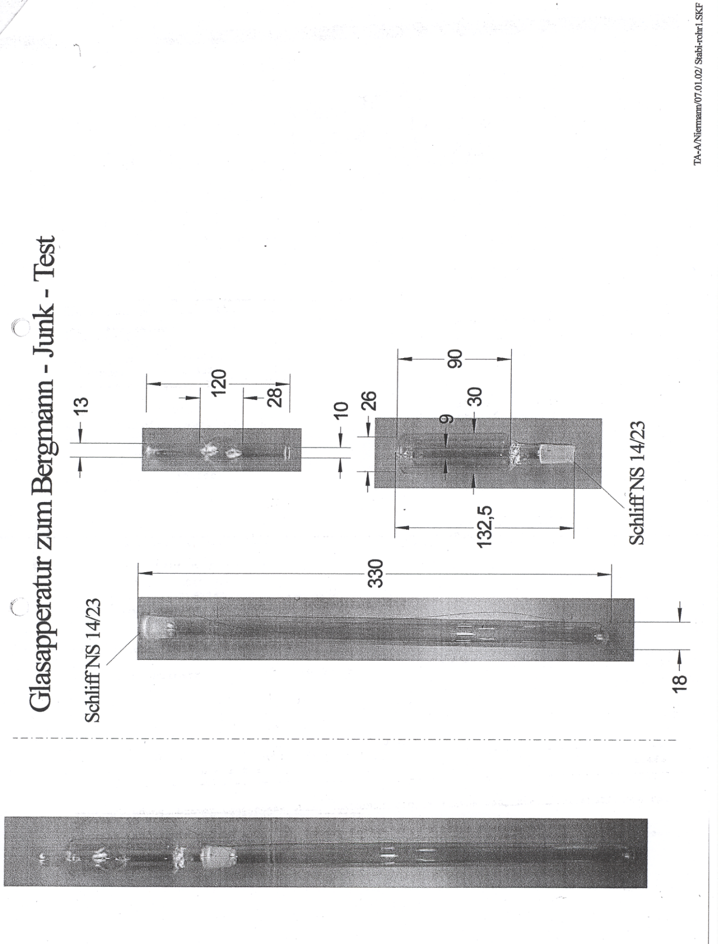

**Figure 23.4.4.1: Condensing chamber for Bergmann Junk test example 1**



**Figure 23.4.4.2: condensing chamber for Bergmann Junk test example 2**

\_\_\_\_\_\_\_\_\_\_\_\_\_\_\_\_

1. In accordance with the programme of work of the Sub-Committee for 2016–2017 approved by the Committee at its eighth session (see ST/SG/AC.10/C.3/100, paragraph 98 and ST/SG/AC.10/44, para. 14). [↑](#footnote-ref-2)
2. 1Ruth Sopranetti, Markus Fahrni and Beat Vogelsanger, Wimmis Switzerland /Aschau Germany: Nitrocellulose Characterization -Survey of standardized test methods – Stability testing of NC, AWE Nitrocellulose Symposium 2007 [↑](#footnote-ref-3)