|  |  |  |  |
| --- | --- | --- | --- |
|  | United Nations | ST/SG/AC.10/C.3/2016/82 | |
| _unlogo | **Secretariat** | | Distr.: General  9 September 2016  Original: English |

**Committee of Experts on the Transport of Dangerous Goods  
and on the Globally Harmonized System of Classification  
and Labelling of Chemicals**

**Sub-Committee of Experts on the Transport of Dangerous Goods**

**Fiftieth session**

Geneva, 28 November-6 December 2016

Item 2 (c) of the provisional agenda

**Recommendations made by the Sub-Committee   
on its forty-seventh, forty-eighth   
and forty-ninth sessions and pending issues:   
listing, classification and packing**

Special Provision 308 for Fish Meal (Fish Scrap), Stabilised (UN 2216): Class 9

Transmitted by The Marine Ingredients Organization IFFO[[1]](#footnote-2)

Introduction

1. Stabilising fishmeal by addition of the antioxidant ethoxyquin (EQ) has been done for many years, and IFFO estimates that approximately 66% of globally traded fishmeal is stabilised with ethoxyquin. The addition levels of ethoxyquin listed in the IMDG Code were determined more than 40 years ago, and are likely to be at levels well in excess of those that will achieve stabilisation, having been based on the information at that time. Unnecessarily high levels of ethoxyquin are undesirable and may lead to high residue levels in the animal which has been fed with feed which incorporates the treated fishmeal as a feed ingredient. Ethoxyquin is undergoing a reauthorisation process in the European Union for use as an animal feed ingredient, within which a safety assessment based on the levels in animal feed has been conducted.

2. Ethoxyquin is such an effective antioxidant that it has been used as a benchmark against which the efficacy of other antioxidants is measured (de Koning, 1998). When the ethoxyquin level for stabilisation of fishmeal was originally advised for incorporation into the IMDG Code in the 1970s the science was based on the antioxidant capability of the compound solely. Further research has established that the main two breakdown products of ethoxyquin, namely ethoxyquin dimer and ethoxyquin quinolone imine, are antioxidants in their own right and also confer antioxidant capability (de Koning, 2002), so there is a logical basis for assuming that the stabilisation effects of fishmeal treated with ethoxyquin extend beyond merely the original compound’s presence post-treatment. That author provides estimates for an antioxidant efficacy of 69% and 80% respectively for these products against that of ethoxyquin in fishmeal.

3. At the time of the original setting of the levels of antioxidant prior to shipping in the IMDG Code, the fishmeal industry shipped the majority of its production in bulk. Fishmeal as an ingredient in animal feed has moved position in the market place from a commodity to a strategic ingredient, and commands prices that are consistent with that position. As a result, a significant and growing proportion of global shipping of the product now occurs in packaged format, in 1 tonne and 50kg bags, for example.

4. Increased negative publicity in the European Union, and difficulties with high levels of ethoxyquin found in shrimp originating from Asian countries exporting to Japan, has drawn attention to the use of ethoxyquin. In addition, the potential carry-over of fat soluble ethoxyquin into omega-3 oils produced from by-products of farmed fish may be a cause for concern. There are strong drivers to reduce the levels of ethoxyquin present in animal feeds, and one way this may be achieved is by optimising the use of ethoxyquin in the stabilisation of fishmeal.

5. Ethoxyquin has been evaluated for re-authorisation as a feed additive according to the requirements of European Parliament and Council Regulation (EC) No 1831/2003, that sets out new rules for the authorisation, supervision and labelling of feed additives.

6. The European Food Safety Authority (EFSA) published their Opinion on ethoxyquin in November 2015 which states that the safety regarding the use of ethoxyquin remains inconclusive in terms of the risk associated with ethoxyquin to consumers, fed livestock, and the environment. EFSA identified a number of knowledge gaps where data is required to make an overall assessment of the safety of ethoxyquin. The European Commission is currently in the process of drafting a regulation based on the EFSA Opinion that may partially suspend or even ban the use of ethoxyquin within EU-28. In the meantime, the applicant for reauthorisation of ethoxyquin continues to deliver more science on points around the safety of different dosages.

7. Accordingly, reduced levels of ethoxyquin in compound feed, taking into account the level of ethoxyquin in feed ingredients such as fishmeal, may be introduced. If that is the case, it is likely that Maximum Permitted Levels in farmed fish will also be set, requiring that the fishmeal, aquafeed and fish farming industries all work towards maintaining as low a level of ethoxyquin in the end product as possible. It is critical to look at optimisation of the levels of ethoxyquin for the stabilisation of fishmeal as well as the use of alternative antioxidants to ethoxyquin.

8. As previously notified to the Sub-Committee at the session held in December 2015, IFFO commenced with a fishmeal stability trial on 9th July 2015 that was to continue for 12 months until July 2016. The aim of the trial was to compare the stability of fishmeal treated with lower inclusion rates of ethoxyquin, as well as other antioxidants, butylated hydroxytoluene (BHT) and a natural tocopherol/rosemary extract blend. All five of the sampling intervals have been performed (Day 0, Week 2, Month 3, Month 6 and Month 12) with the last analyses interval being in July 2016. The reactive anchovy fishmeal for the trial was provided by a producer from within the IFFO membership, and the trials were conducted under standard conditions, but also comparing storage volume through a comparison of 50kg and regular 1 ton bags. The concentrations and analyses are detailed in the treatment plan in Table 1 along with the content of the active component in the treatments calculated from the percentage in the dosing solution.

9. The specifications of the antioxidants are as follows:

* Ethoxyquin (EQ): Minimum 95% solution;
* Naturox Premium liquid: 23.2% tocopherols and <1% rosemary extract (containing ≈ 5% carnosic acid);
* Rendox T: 20% BHT solution.

**Table 1: Antioxidant treatments, content of the active component and analyses plan**

|  |  |  |  |  |  |  |
| --- | --- | --- | --- | --- | --- | --- |
| **Treatments** | **Antioxidant content (active component) (ppm)** | **Sampling intervals** | | | | |
| **Day** | | **Month** | | |
| **0** | **14** | **2** | **6** | **12** |
| EQ: 300 ppm | 285 | AO x 5  PV, AV, FFA, PUFA | AO, PV, AV, FFA. | AO, PV, AV, FFA | AO, PV, AV, FFA.  Self heating test (50 kg bags) | AO,  PV, AV, FFA,  PUFA  Self-heating test (all sizes) |
| EQ: 600 ppm | 570 |
| BHT solution: 2,000 ppm | 400 |
| BHT solution: 4,000 ppm | 800 |
| Tocopherol/  rosemary extract blend: 2,000 ppm | 460 ppm tocopherols + < 20 ppm rosemary extract (containing 1ppm carnosic acid) |
| Tocopherol/  rosemary extract blend: 4,000 ppm | 920 ppm tocopherols + < 40 ppm rosemary extract (containing 2 ppm carnosic acid) |

Where AO = antioxidant; PV = Peroxide value; AV = Anisidine value; FFA = Free Fatty Acid value; PUFA = polyunsaturated fatty acids

All the fishmeal treatments are stored in two sizes: 50 kg bags as well as 1,000 ton bags. The two sizes will show whether there is a difference in the deterioration rate of fishmeal in different storage volumes.

The 1 ton bags were only analysed intermittently due to cost restraints. Table 2 presents results at Day 0, after 6 and 12-months of storage.

**Table 2: Results of the treatments at Day 0, 6 months and 12 months storage**

|  |  |  |  |  |  |  |  |
| --- | --- | --- | --- | --- | --- | --- | --- |
| **Treatments** | | **Sampling intervals** | | | | | |
| **Day 0** | **6 months** | | | **12 months** | |
| **Antioxidant level**  **(**ppm) | **Antioxidant level**  **(**ppm) | **Self heating test** | **Oxygen Bomb induction period** (hrs) | **Antioxidant level**  **(ppm)** | **Self heating test** |
| EQ: 300 ppm | 50 kg bag | 318 | 259 | Neg (pass) | 9.5 | 151 | Currently not available |
| 1 ton bag | 297 |  |  | 9.5 | 213 | Currently not available |
| EQ: 30-50 ppm | 50 kg bag | 28 | <15 |  | 1.2 | <15 | Currently not available |
| 1 ton bag | 48 |  |  | 2.7 | 36 | Currently not available |
| BHT solution: 2,000 ppm | 50 kg bag | 438 | 368 | Neg (pass) | 2.4 | 290 | Currently not available |
| 1 ton bag | 438 |  |  | 2.6 | 342 | Currently not available |
| BHT solution: 4,000 ppm | 50 kg bag | 858 | 751 |  | 2.8 | 659 | Currently not available |
| 1 ton bag | 866 |  |  | 2.9 | 775 | Currently not available |
| Tocopherol/  rosemary extract blend: 2,000 ppm | 50 kg bag | 385 | 243 | Neg (pass) | 2.5 | 209 | Currently not available |
| 1 ton bag | 400 |  |  | 3.8 | 280 | Currently not available |
| Tocopherol/  rosemary extract blend: 4,000 ppm | 50 kg bag | 628 | 488 |  | 3.4 | 277 | Currently not available |
| 1 ton bag | 752 |  |  | 3.5 | 598 | Currently not available |

10. Unfortunately, there was a problem with the dosing of the 600 ppm ethoxyquin treatment and the fishmeal was dosed with ≤ 50 ppm ethoxyquin, but this material remained in the trial as a comparison.

11. The results show that the antioxidant levels after 12 months of storage have decreased to levels that are still sufficient to provide continued protection to the fishmeal. It appears that the antioxidant levels in the 1 ton bags decreased at a slower rate indicating less consumption of the antioxidant and therefore potentially a slower rate of oxidation. The percentage remaining antioxidants for each treatment along with the corresponding percentage reduction is shown in Table 3. The antioxidant levels in the 50 kg bags decreased in order from fastest to slowest by < 54.4% (ethoxyquin 30 ppm), 55.8% (Natural blend 4,000 ppm), 52.4% (ethoxyquin 300 ppm), 45.7% (Natural blend 2,000 ppm), 33.8% (BHT 2,000 ppm) and the slowest decrease of 23.2% (BHT 4,000ppm). Similarly, the antioxidants in the 1 ton bags decreased by 29.9% (Natural blend 2,000 ppm), 28.3% (ethoxyquin 300 ppm), 24.2% (50 ppm ethoxyquin), 21.9% (BHT 2,000 ppm), 20.4% (Natural blend 4,000ppm) and 10.6% (BHT 4,000ppm). The highest decrease in antioxidant of roughly 55% still leaves sufficient antioxidant remaining to protect fishmeal for another period of up to 6 months or more.

**Table 3: Percentage residual antioxidant and reduction after 6 and 12 month’s storage**

|  |  |  |  |  |  |
| --- | --- | --- | --- | --- | --- |
| **Antioxidant treatment** | **Storage bag size** | **6 months** | | **12 months** | |
| **Residual antioxidant content (%)** | **Decrease in antioxidant content (%)** | **Residual antioxidant content (%)** | **Decrease in antioxidant content (%)** |
| Ethoxyquin: 300 ppm | 50 kg | 81.4 | 18.6 | 47.6 | 52.4 |
| 1 ton |  |  | 71.7 | 28.3 |
| Ethoxyquin: 30-50 ppm | 50kg | < 53.6 | < 46.4 | < 45.6 | < 54.4 |
| 1 ton |  |  | 75.8 | 24.2 |
| BHT: 2,000 ppm | 50 kg | 84.0 | 16.0 | 66.2 | 33.8 |
| 1 ton |  |  | 78.1 | 21.9 |
| BHT: 4,000 ppm | 50 kg | 87.5 | 12.5 | 76.8 | 23.2 |
| 1 ton |  |  | 89.4 | 10.6 |
| Natural blend: 2,000 ppm | 50 kg | 63.1 | 36.9 | 54.3 | 45.7 |
| 1 ton |  |  | 70.1 | 29.9 |
| Natural blend: 4,000 ppm | 50 kg | 77.7 | 22.3 | 44.2 | 55.8 |
| 1 ton |  |  | 79.6 | 20.4 |

12. The self-heating test performed on the lowest antioxidant concentration in the 50 kg (i.e. 300 ppm EQ, 2,000 ppm BHT and 2,000 ppm Natural blend) bags at 6 months were all negative which indicated that none of the treatments had self-heating properties after 6 months of storage. The 12-month self-heating test results on all the samples were not available at the time of writing this document (6 Sept 2016)[[2]](#footnote-3). The low ethoxyquin dosage of 300 ppm passed at 6 months which indicates that lower dosage levels of ethoxyquin would effectively stabilise fishmeal. The current ethoxyquin application levels prescribed in the IMDG code SP 945 is 400 to 1000 mg/kg (ppm) ethoxyquin.

13. The Oxygen Bomb Test is used to predict stability and evaluate antioxidant systems in fats and finished products. The oxygen uptake of the sample is measured in a closed system. The rate at which oxygen is consumed indicates the oxidative stability of the tested product and measures the stability of the complete product without prior extraction of the fat. A short induction period (in hours) indicate quicker uptake of oxygen and a less stable product whereas a longer uptake period for oxygen indicates a more stable product. The Oxygen Bomb test has shown to correlate well with shelf life and the Schaal Oven accelerated test[[3]](#footnote-4).

14. Ethoxyquin (even at a low dosage level of 300 ppm) has shown to be the most effective antioxidant with the longest induction period of 9.5 hrs. [Here we can clearly see the low level of antioxidant in the 600 ppm ethoxyquin treatment although the one ton 600 ppm sample had a similar induction time (2.7 hrs) to the 2,000 ppm and 4,000 ppm BHT treated samples (2.4; 2.6; and 2.8; 2.9 hrs respectively). The difference between the two 600 ppm ethoxyquin treatments (1.2 hrs and 2.7 hrs) could be due to uneven distribution of the antioxidant in the fishmeal or the slightly higher antioxidant content in the 1 ton bag of 50ppm compared to 30 ppm in the 50kg bag.] Surprisingly, the natural antioxidant blend seemed to have performed slightly better than BHT.

15. Heat is generated when there is rapid and significant oxidation of fishmeal due to the exothermic reaction of oxygen with the highly polyunsaturated fatty acids (in particular eicosapentaenoic, EPA and docosahexaenoic acids, DHA) which result in the spontaneous combustion of fishmeal. In order for spontaneous combustion to occur there must be extensive oxidation of the fishmeal since without oxidation or with a low oxidation rate, fishmeal will not heat up sufficiently to combust. Antioxidants act by slowing down the rate of oxidation by reacting with the free radicals, which are formed after reaction with oxygen, thereby stopping the oxidation chain reaction.

16. Analyses that indicate the oxidative status of fishmeal therefore provides important information on the potential for combustion of fishmeal. Spontaneous combustion will not occur if oxidation level of the oil is low. A useful measure of the oxidation of fishmeal is to determine the decrease in polyunsaturated fatty acids during storage[[4]](#footnote-5). A comparison of the omega-3 polyunsaturated fatty acid contents for the different antioxidant treatments during storage can be seen in Figure 1 along with the omega-3 fatty acid values and % decrease in Table 4.

**Figure 1: Change in Omega-3 content of all the antioxidant treatments during 12 storage period**

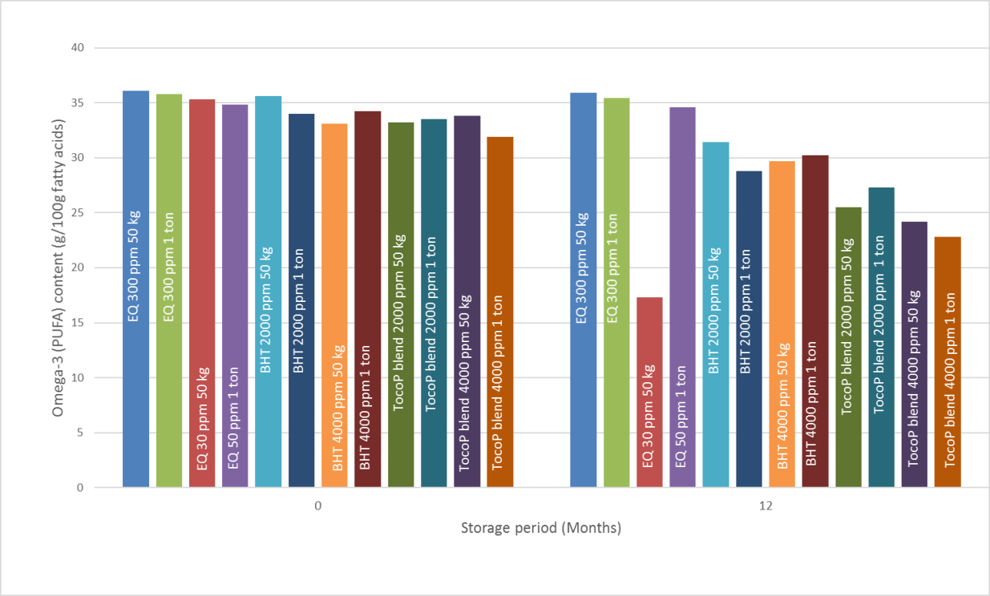

**Table 4: The omega-3 fatty acid values and decrease during 12-month storage period**

|  |  |  |  |  |
| --- | --- | --- | --- | --- |
| **Antioxidant treatment** | **Storage bag size** | **Day 0** | **12 months** | |
| **Omega-3 content (g/100g fatty acids)** | **Residual omega-3 content (g/100g fatty acids)** | **Decrease in omega-3 content (%)** |
| Ethoxyquin: 300 ppm | 50 kg | 36.1 | 35.9 | 0.6 |
| 1 ton | 35.8 | 35.4 | 1.1 |
| Ethoxyquin: 30-50 ppm | 50kg 30 ppm EQ | 35.3 | 17.3 | 51.0 |
| 1 ton 50 ppm EQ | 34.8 | 34.6 | 0.6 |
| BHT: 2,000 ppm | 50 kg | 35.6 | 31.4 | 11.8 |
| 1 ton | 34.0 | 28.8 | 15.3 |
| BHT: 4,000 ppm | 50 kg | 33.1 | 29.7 | 10.3 |
| 1 ton | 34.2 | 30.2 | 11.7 |
| Natural blend: 2,000 ppm | 50 kg | 33.2 | 25.5 | 23.2 |
| 1 ton | 33.5 | 27.3 | 18.5 |
| Natural blend: 4,000 ppm | 50 kg | 33.8 | 24.2 | 28.4 |
| 1 ton | 31.9 | 22.8 | 28.5 |

17. The 300ppm ethoxyquin treatment (50kg and 1 ton bags) clearly protected the fishmeal against oxidation showing negligible decrease (0.6% and 1.1%, respectively) in omega-3 fatty acids during the 12-month storage period due to oxidation. The EQ treatment that measured 30ppm EQ in the 50kg bags at the start of the trial showed a marked decrease (51%) in omega-3 fatty acids indicating significant oxidation. However, the EQ treatment that measured 50ppm EQ in the 1 ton bags indicated that even the slightly higher EQ content along with the bigger storage size bags, resulted in only a 0.6% decrease in omega-3 fatty acid content. The efficacy of the 50ppm EQ treatment clearly indicates how effective EQ is as antioxidant even at low dosage levels.

18. The omega-3 fatty acids in the BHT treated fishmeal samples decreased by between 10.3 and 15.3% with little difference shown between the two treatment concentrations (2,000 ppm and 4,000 ppm) as well as the storage size.

19. The omega-3 fatty acids in the Natural blend treated fishmeal samples decreased by between 18.5 % and 28.5% with the higher dosage level (4,000 ppm) showing slightly higher oxidation of the omega-3 fatty acids. According to the oxidation levels of the omega-3 fatty acids the Natural blend is slightly less effective than BHT.

20. A temperature graph of the fishmeal treatments taken during the storage period along with the ambient temperature reading can be seen in Figure 2. Apart from the normal initial spike in temperature after production none of the fishmeal treatments heated to a temperature higher than 35°C or higher than roughly 5°C higher than the ambient temperature as prescribed by SP 300. Even the low ethoxyquin dosage samples (30 – 50 ppm) samples did not overheat during the 12 month storage period. The lower ethoxyquin dosage level, the BHT as well as the natural antioxidant blends all protected fishmeal against overheating and possible combustion.

**Figure 2: Temperature graph of all the fishmeal treatments along with the ambient temperature. (BAG = 50 kg bag; BBAG = 1 ton bag; E = Ethoxyquin;   
B = BHT; N = Natural blend)**

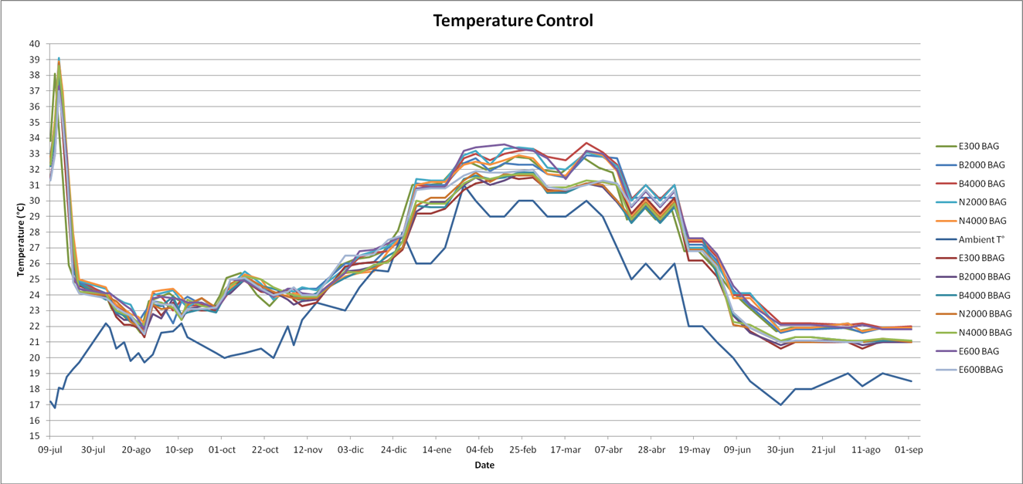

21. The results therefore indicate that due to the very low rate of oxidation of the 300 ppm ethoxyquin treatment will effectively stabilise fishmeal over a 12-month period. The alternative antioxidants tested can also be used to stabilise fishmeal because of the high levels of remaining antioxidant as well as the effective protection against oxidation as shown by the low levels of decrease in omega-3 fatty acids during the 12-month storage period.

22. Ethoxyquin has been shown to be the most efficacious of the available synthetic antioxidants[[5]](#footnote-6),[[6]](#footnote-7),[[7]](#footnote-8). The high efficacy of ethoxyquin is not only because of its chemical nature but also due to the fact that its oxidation products also possess strong antioxidant properties[[8]](#footnote-9),[[9]](#footnote-10). Two of its oxidation products, ethoxyquin-dimer and a quinolone have shown to have efficacy values of 69% and 80% of the value of ethoxyquin respectively5,[[10]](#footnote-11). The

efficacies of the oxidation products and BHT in fishmeal relative to ethoxyquin can be seen in Table 5. BHT has roughly 2/3 the activity of ethoxyquin in fishmeal and 3/4 in fish oil. The efficacies of the same antioxidant in fishmeal and fish oil are different and therefore antioxidants must be evaluated in the specific matrix that it will be used in.

**Table 5: Efficacy values of the oxidation products of ethoxyquin and BHT   
relative to ethoxyquin5**

|  |  |  |
| --- | --- | --- |
| **Antioxidant** | **Efficacy value (%)** | |
| **Fishmeal** | **Fish oil** |
| Ethoxyquin | 100 | 100 |
| EQ-Dimer | 69 | 35 |
| Quinolone | 80 | 74 |
| BHT | 67 | 77 |

23. The breakdown rate of the dimer was considerably slower than that of ethoxyquin, which has the beneficial effect that even once the ethoxyquin levels has dropped significantly there are still significant levels of ethoxyquin dimer remaining to act as antioxidant and protect the fishmeal.

24. In a previously performed long term fishmeal stability study where reactive fishmeal dosed at 400-1000 mg/kg ethoxyquin was stored in approximately 5kg polypropene buckets at 25°C for more than a year, the ethoxyquin content as well as the oxidation products, EQ-dimer and quinolone were determined[[11]](#footnote-12). The ethoxyquin content and its oxidation products as well as the calculated total ethoxyquin equivalents (based on the efficacy value compared to ethoxyquin) on the final days of the trial are shown in table 5.

**Table 6: Ethoxyquin, the quinolone and EQ-dimer in fishmeal storage at 25°C**

|  |  |  |  |  |  |  |
| --- | --- | --- | --- | --- | --- | --- |
| **Meal type and ethoxyquin concentration added either at factory or in laboratory** | **Storage time**  **(days)** | **Ethoxyquin mg/kg** | **Quinolone mg/kg** | **EQ- dimer**  **mg/kg** | **Total EQ equivalents (based on efficacy in**  **fish oil)**  **mg/kg** | **Total EQ equivalents (based on efficacy in fishmeal)**  **mg/kg** |
| Anchovy/pilchard:  ± 400 ppm EQ | 573 | 61 | 4 | 120 | 104 | 116 |
| Maasbanker meal:  ± 1,000 ppm EQ | 453 | 150 | 5 | 102 | 188 | 198 |
| Anchovy: 400 ppm EQ | 244 | 323 | 14 | 74 | 358 | 364 |
| Anchovy: 400 ppm EQ | 347 | 87 | 22 | 96 | 136 | 133 |
| Anchovy: 400 ppm EQ | 365 | 20 | 2 | 76 | 47 | 55 |

25. As shown earlier the efficacy values of antioxidants differ in fish oil and fishmeal. The total EQ equivalents (based on efficacy in fish oil) in Table 5 were calculated based on information available at the time that calculated the relative antioxidant activities of the oxidation products to ethoxyquin in fish oil. Later work5 determined the antioxidant activities based on fish meal and this was used to calculate the total EQ equivalents (based on efficacy in fish meal) on the final day of storage. To allow for variation in efficacy from

one meal to another, a safety margin was calculated from the statistical variation in results (90% lower confidence limit for an individual meal as used, giving relative efficacies of 63% for quinolone and 44% for the dimer). The formula used to calculate the ethoxyquin equivalents was:

**Total EQ equivalence = EQ + (0.63 x Quinolone) + (0.44 x EQ-dimer)**

26. It is clear that the oxidation products contribute significantly to the efficacy of ethoxyquin and these additional antioxidants should be taken into account when the ethoxyquin content at the time of shipment is considered. The oxidation products can add from 16% (fishmeal that has been stored for shortest period) to 73% additional antioxidant protection over and above that of ethoxyquin on its own. The stipulated antioxidant content of 100 ppm at the time of consignment could therefore be adjusted to allow for the additional antioxidant activity of ethoxyquin and its oxidation products compared to alternative antioxidants.

27. The current 100ppm residual ethoxyquin requirement in fishmeal works out to be 25-10% respectively, of the 400-1000ppm ethoxyquin IMDG dosage requirement. According to the data in Table 5 the residual ethoxyquin accounts for between 40 – 88% of the total antioxidant activity after a long storage period (8.5 – 20.5 months). Therefore 60 ppm residual ethoxyquin would in effect be 68 – 150 ppm of active antioxidant. This range of total residual antioxidant will therefore be 23 – 50% remaining of the proven effective lower dosage level of EQ of 300ppm. In addition, the low 50ppm ethoxyquin dosage has shown to actively protect fishmeal against oxidation as can be seen by the similar induction period to BHT in the oxygen bomb test and the limited decrease in omega-3 fatty acids similar to the 300ppm ethoxyquin. A residual of 60 ppm ethoxyquin, which is nearly 2/3 of the amount of less active alternative antioxidants such as BHT, would therefore provide safe protection against further oxidation. BHT has shown to have roughly 2/3 (Table 5) of the activity of ethoxyquin and requires 100ppm residual in fishmeal at time of shipment. Therefore, lower residual level for ethoxyquin in line with its comparable efficacy should be allowed for.

28. Natural antioxidant alternatives are increasingly demanded by pet food and feed manufacturers and is used in the growing organic aquaculture industry as well as in pet food for animals’ sensitive to ethoxyquin.

Tocopherols have successfully been used with Special Exemptions since 1995 to ship and store stabilise fishmeal.

* Self-heating test data on the stabilisation of fishmeal by the application of tocopherol products have indicated their safety (the evidence will be submitted at a later date once available).
* Special exemptions (Permits) have been issued by the following authorities allowing tocopherol products instead of synthetic antioxidants to stabilise fishmeal:

Australian Maritime Safety Authorization

Armada de Chile

Bremen Port Authority (Germany)

Federale Overheidsdienst Mobiliteit en Vervoer

Scheepvaartcontrole (Belgium)

United States Department of Transportation

United States Coast Guard

Proposal

The following Special Provisions for fishmeal (UN 2216) are written into the current UN Model Regulations (Rev 19):

29 This substance is exempt from labelling, but shall be marked with the appropriate class or division.

117 Subject to these Regulations only when transported by sea.

300 Fish meal, fish scrap and krill meal shall not be transported if the temperature at the time of loading exceeds 35°C or 5°C above ambient temperature whichever is higher.

308 Fish meal or fish scrap shall contain at least 100 ppm (mg/kg) of antioxidant (ethoxyquin) at the time of consignment.

The IMDG code has apart from the SPs above the following additional SPs:

907 The consignment shall be accompanied by a certificate from a recognized authority stating: moisture content; fat content; details of anti-oxidant treatment for meals older than 6 months (for UN 2216 only); anti-oxidant concentration at the time of shipment, which must exceed 100 mg/kg (for UN 2216 only); packing, number of bags and total mass of the consignment; temperature of fishmeal at the time of despatch from the factory; date of production.

No weathering/curing is required prior to loading. Fishmeal under UN 1374 shall have been weathered for not less than 28 days before shipment. When fishmeal is packed into containers, the containers shall be packed in such a way that the free air space has been restricted to the minimum.

928 The provisions of this Code shall not apply to:

fishmeal when acidified and wetted with more than 40% water, by mass, irrespective of other factors; consignments of fishmeal which are accompanied by a certificate issued by a recognized competent authority of the country of shipment or other recognized authority stating that the product has no self-heating properties when transported in packaged form; or fishmeal manufactured from “white” fish with a moisture content of not more than 12% and a fat content of not more than 5% by mass.

945 Stabilization of fishmeal shall be achieved to prevent spontaneous combustion by effective application of between 400 and 1000 mg/kg (ppm) ethoxyquin, or liquid BHT (butylated hydroxytoluene) or between 1000 and 4000 mg/kg (ppm) BHT in powder form at the time of production. The said application shall occur no longer than twelve months prior to shipment.

IFFO recommends to provisionally modify SP 308 as follows to be in line with SP 945 from the IMDG:

SP 308 Stabilization of fishmeal shall be achieved to prevent spontaneous combustion by effective application of ethoxyquin, BHT (butylated hydroxytoluene) or tocopherols (also used in a blend with rosemary extract) at the time of production. The said application shall occur within twelve months prior to shipment. Fish scrap or fish meal shall contain at least 60 ppm (mg/kg) of ethoxyquin and 100 ppm (mg/kg) of other alternative antioxidants at the time of consignment.

1. In accordance with the programme of work of the Sub-Committee for 2015–2016 approved by the Committee at its seventh session (see ST/SG/AC.10/C.3/92, paragraph 95 and ST/SG/AC.10/42, para. 15). [↑](#footnote-ref-2)
2. We hope to be able to provide the data at the meeting on 28 November 2016, should the agenda timing permit this [↑](#footnote-ref-3)
3. Methods to Access Quality and Stability of Oils and fat-containing Foods, (1995). Eds: Warner, K and Michael Eskin, N.A., AOCS Press, Champaign, Illinois, pp 183-184 [↑](#footnote-ref-4)
4. De Koning, A.J., (1998). A new method for measuring efficacies of antioxidants in fishmeal. International Journal of Food Properties, Vol 1, Issue 3, pp 255 - 261 [↑](#footnote-ref-5)
5. Aquaculture development and coordination programme, (1980). Fish feed technology, FAO Fisheries and Aquaculture department. Downloaded on 23 March 2016 from http://www.fao.org/docrep/x5738e/x5738e0b.htm [↑](#footnote-ref-6)
6. Blaszcyzyk, A., Augustyniak, A. and Skolimowski, J. Ethoxyquin: An antioxidant used in animal feed., International Journal of Food Science, Volume 2013 (2013), Article ID 585931, 12 pages  
   <http://dx.doi.org/10.1155/2013/585931> [↑](#footnote-ref-7)
7. Lundebye, A.-K., Hovea, H., Mage, A., Bohne, V.J.B. and Hamre, K., (2010). Levels of synthetic antioxidants (ethoxyquin, butylated hydroxytoluene and butylated hydroxyanisole) in fish feed and commercially farmed fish. Food Additives and Contaminants, Vol. 27, No. 12, 1652–1657 [↑](#footnote-ref-8)
8. De Koning, A.J., (2002). The antioxidant ethoxyquin and its analogues: A Review. International Journal of Food Properties, Vol 5, Issue 2, pp 451 - 461 [↑](#footnote-ref-9)
9. Thorrison, S., (1987). Antioxidant properties of ethoxyquin and some of its oxidation products. PhD Thesis, Faculty of Science, University of St Andrews, United Kingdom [↑](#footnote-ref-10)
10. De Koning, A.J., (1996). Determination of the antioxidant efficacies in fish meal of two oxidation products of ethoxyquin. International Fishmeal and Fish oil manufacturers Association, Research Report, 1996-4. [↑](#footnote-ref-11)
11. De Koning, A.J. and Van der Merwe, G.H. (1992). Determination of ethoxyquin and two of its oxidation products in fishmeal by Gas Chromatography, Analyst, Vol 117, pp 1571 - 1576 [↑](#footnote-ref-12)