|  |  |  |  |
| --- | --- | --- | --- |
|  | United Nations | ST/SG/AC.10/C.3/2016/33 | |
| _unlogo | **Secretariat** | | Distr.: General  11 April 2016  Original: English |

**Committee of Experts on the Transport of Dangerous Goods  
and on the Globally Harmonized System of Classification  
and Labelling of Chemicals**

**Sub-Committee of Experts on the Transport   
of Dangerous Goods**

**Forty-ninth session**

Geneva, 27 June – 6 July 2016

Item 4 (d) of the provisional agenda

**Electric storage systems: miscellaneous**

New UN number for Rechargeable Lithium Metal Polymer batteries

Transmitted by RECHARGE and the Rechargeable Battery Association (PRBA)[[1]](#footnote-2)

Introduction

1. Informal document INF.10 (48th session) has presented the rationale for the harmonization of the energy rating for Rechargeable Lithium Metal Polymer (RLMP) and Lithium-Ion batteries: primary Lithium batteries are transported undischarged when they are new, it is therefore appropriate to represent the characteristics of the battery by its lithium metal content. For example, according to special provision (SP) 188, for Lithium metal batteries (UN No. 3090), exempted cells and batteries must contain less than 1 g lithium for lithium metal or lithium alloy per cell or less than 2 g lithium per battery. On the other hand, rechargeable Lithium-Ion batteries (UN No. 3480) are characterized by their total energy content in Wh when fully charged. According to SP188, for Lithium-Ion rechargeable batteries, exempted cells and batteries must contain less than 20Wh per cell or less than 100 Wh per battery.

2. In the informal documents INF.13/Rev.1 (47th session) and INF.10 (48th session), was introduced the description of the Rechargeable Lithium battery based on a Lithium metal anode associated with a polymer electrolyte (RLMP) The uses and applications of these Rechargeable Lithium Metal Polymer batteries (RLMP) are expected to increase substantially over the next 5 to 10 years. It is worth to indicate that this new battery technology is applicable to small portable batteries for IT equipment and to large batteries for electric vehicles, as the lithium ion batteries. Based on the new design of these products, a specific definition can be proposed: definition and an illustration of an RMLP are proposed in annex 1, as well as the key features of this technology.

3. The safety characteristics of the RLMPs are equivalent or better than those of the Lithium-Ion battery technology particularly thanks to the use of the polymer electrolyte. The results of the comparative tests campaign presented in the informal document INF.10 (48th session) have been completed, RMLP cells and Li-ion cells have been submitted to the destructive tests of the UN Manual of Tests and Criteria Chapter 38.3 (test T6-crushing, test T8-overdischarge). In addition, new tests showing the safe behavior in case of thermally activated run-away, as developed for the air transport packaging standard run-away, have been applied. The results are presented in Annex 2.

4. It can be observed that the tests results are indicating equivalent safety performances for both Li-Ion and RLMP cells and batteries. In addition, the destructive tests at 100% SOC are showing the limited consequences in case of internal thermal runaway. This is due to the specific properties of the RLMP design, particularly the non-flammable polymer electrolyte.

5. Some comments about the informal document INF.10 (48th session) proposed to consider the creation of a new UN number for the RLMP batteries, in order to avoid more complexity and changes with the existing UN 3090 and 3480. Based on the discussion at the IWG meeting in Bordeaux (30 March – 1 April 2016), an in the context described above (and particularly paras. 3, 4 and 5), it is proposed to apply the same regulation for the transport of RLMP batteries than for the Li-ion batteries.

Proposal

6. It is proposed to introduce a new UN number XXXX for RLMP cells and XXXY for RLMP batteries, and a new special provision for identification of the transport conditions applicable to RLMP.

**Dangerous Goods List (UN Model Regulations 18th)**

|  |  |  |  |  |  |  |  |  |
| --- | --- | --- | --- | --- | --- | --- | --- | --- |
| *UN No.* | *Name and description* | *Class* | *Sub-*  *Sidiary*  *risk* | *UN*  *packing*  *group* | *Special*  *provisions* | *Limited and excepted quantities* | | *Packing instruction* |
| *(1)* | *(2)* | *(3)* | *(4)* | *(5)* | *(6)* | *(7a)* | *(7b)* | *(8)* |
| XXXX | RECHARGEABLE LITHIUM METAL POLYMER BATTERIES | 9 | - | - | YYY,188,230,  310, 348, 376,  377 | 0 | E0 | P903  P908  P909  LP903  LP904 |
| XXXY | RECHARGEABLE LITHIUM METAL POLYMER BATTERIES, CONTAINED IN EQUIPMENT or RECHARGEABLE LITHIUM METAL POLYMER BATTERIES PACKED WITH EQUIPMENT | 9 | - | - | YYY, 188, 230,  360, 376,  377 | 0 | E0 | P903  P908  P909  LP903  LP904 |

7. Create a new special provision.

SPYYY:

Transport conditions applicable to RLMP cells and batteries are the same which are applied to Li-ion batteries under this regulation.

Conclusion

8. The Sub-Committee is invited to consider the above proposal for the creation of a new UN number for RLMP.

Annex 1

Definition of a RLMP

A RLMP is a rechargeable electrochemical device in which the anode is based on Li metal, and characterized by:

(i) A specific treatment of the anode surface avoiding the Lithium dendrites growth during the charging of the cells or batteries;

(ii) A polymer electrolyte, which is designed to be non-flammable and endurable against long -term operations.

A description and comparison to Li-ion battery is proposed in Figure 1 below. Examples of specific aspect of the RLMP design are provided in annexes 2 and 3.

**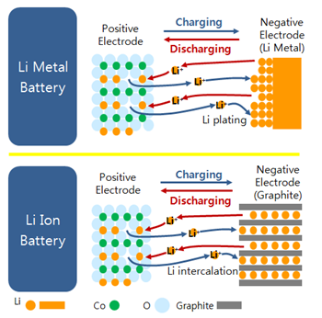**

**Fig.1 Operating principle of lithium metal and lithium ion cells**

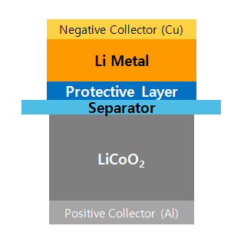

**Fig.2 Constituent of a rechargeable lithium metal cell where the two active materials are exposed to non-flammable, solid electrolyte**

**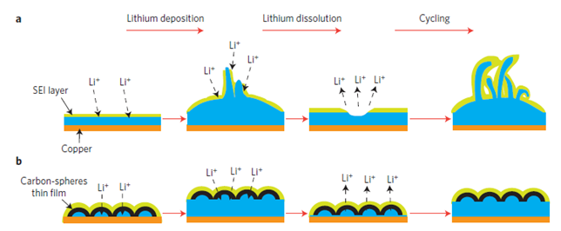**

**Fig.3 Schematic diagrams of different lithium anode structures. a, A thin film of SEI layer forms quickly on the surface of deposited lithium (blue). Volumetric changes during the lithium deposition process can easily break the SEI layer, especially at high current rates. This behavior leads to ramified growth of lithium dendrites and rapid consumption of the electrolytes. b, Modifying the Cu substrate with a hollow carbon nanosphere layer creates a scaffold for stabilizing the SEI layer. The volumetric change of the lithium deposition process is accommodated by the flexible hollow-carbon-nanosphere coating**

Constituent of a RLMB and operating principle

A RLMB cell is comprised of a negative electrode, positive electrode, separator and electrolyte. (Fig.2) A RLMB is a rechargeable lithium metal battery which can store the electrical energy by plating and stripping lithium ions at the negative electrode, and by intercalating and deintercalating lithium ions at the positive electrode in the case of oxides (Fig.3), or alloying and dealloying lithium ions in the case of sulfur composites. (Fig.4)

As for a RLMB, the anode electrode is comprised of lithium metal and a protective layer, in place of graphite as typically found in lithium ions batteries. In the case of graphite, its principle is based on the intercalating and deintercalation chemistry. On the other hand, in the case of lithium metal, the principle is based on the plating and stripping chemistry. Unlike graphite, no housing for lithium ions exists in lithium metal. Therefore, electricity is stored at the negative electrode by lithium plating. Since there is no boundary for the plating, non-uniform growth of lithium ions (i.e., dendrites) could appear at the negative electrode, which could cause safety concerns. (Fig.3) For this reason, the protective layer, an ultra thin polymer matrix including various additives like salts, carbon nanopowders and other proprietary materials, is needed.

Features of RLMBs (comparison with lithium ions batteries)

A RLMB has the following features compared to lithium ion batteries: (Table 1)

(a) The chemistry of lithium metal is plating and stripping whereas that of graphite it is intercalating and deintercalating.

(b) The gravimetric charge density of lithium metal is 10.4 times higher than that of graphite: Lithium 3,862mAh/g vs*.* Graphite 372 mAh/g.

(c) The volumetric charge density of lithium metal is about 2.4 times higher than that of graphite: Lithium 2,047 mAh/cm3 vs. 837mAh/cm3.

(d) The potential of lithium metal vs. lithium is zero whereas that of graphite it is 0.05V. This difference can be transferred to an increase in capacity.

(e) A large volumetric change appears from lithium metal, compared to that of graphite.

(f) Because lithium metal can be more reactive than lithiated graphite, these safety concerns must be addressed through proper cell and battery design and testing.

Annex 2 (English only)

Safety performance of RLMP (comparison with lithium ions batteries)

|  |  |  |  |  |
| --- | --- | --- | --- | --- |
| Manual of Tests and Criteria  UN38.3 | | T6  (Crush) | T8  (Forced Discharge, 1C) | |
| Test  Conditions | Cycle | 1 | 1 | 50 |
| SOC | 50 | 0 | 0 |
| Test | Yes | Yes | No\*\*\* |
| Criteria | cell/battery temperature does not exceed 170°C.no disassembly, no rupture, no fire | no disassembly,  no fire within seven days of the test | |
| Test Results\*\* | Lithium Ion Cell  (1750mAh, Polymer) | PASS  (25 °C) | PASS  (51.0 °C) | n/a |
| Lithium Metal Polymer Cell\*  (1750mAh, Polymer) | PASS  (25 °C) | PASS  (42.5 °C) | n/a |

\* Partially solid electrolyte is involved for required Li ion conductivity.

\*\* Lithium Ion Battery (LIB) was tested at SDI, whereas Rechargeable Lithium Metal Polymer Battery

(RLMP) at TÜV Süd Korea.

\*\*\* T8 (50 cycles) will be tested and compared in December 2015

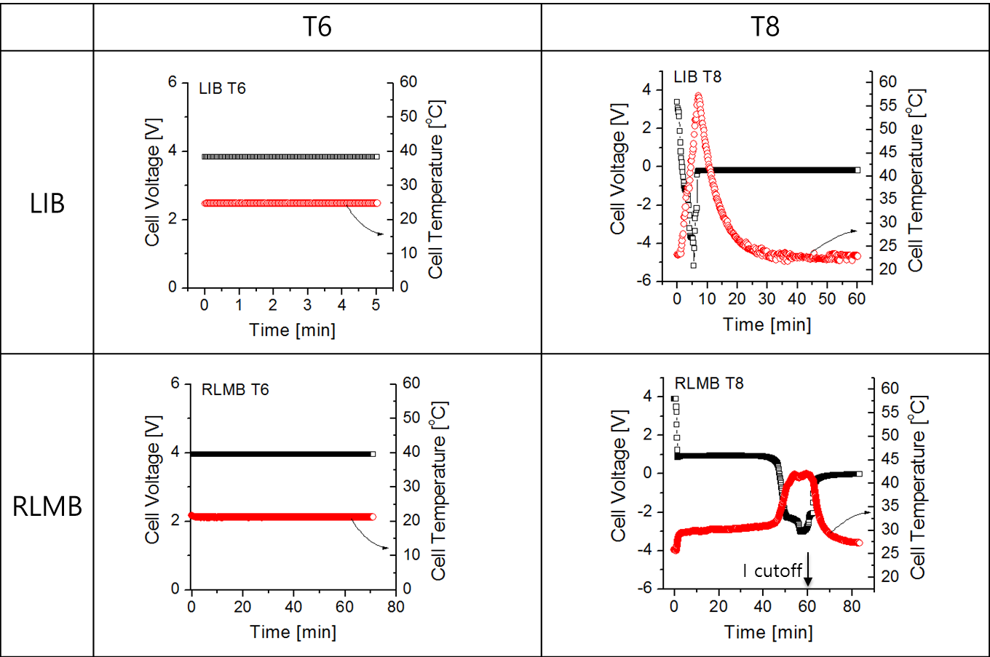

**Fig.2 Thermal behaviour of Li-ion and RLMP during the tests 38.3 T6 and T8**

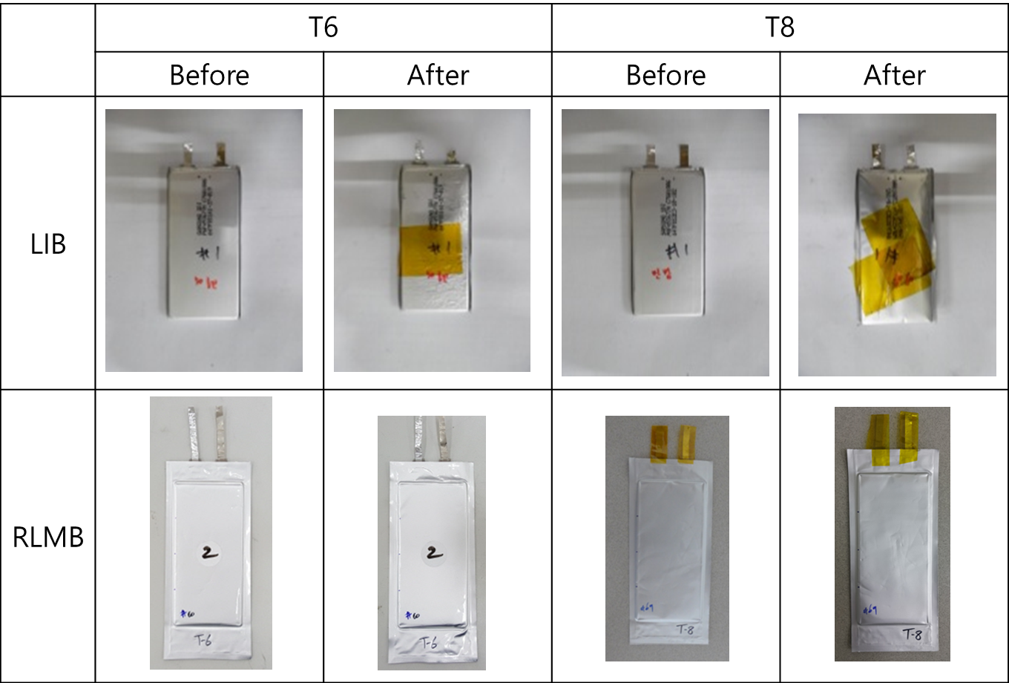

**Fig.3 Physical aspect of Li-ion and RLMP after the tests 38.3 T6 and T8**

1. Information of a Nail Penetration test: to be supplied.
2. Nail Penetration test results

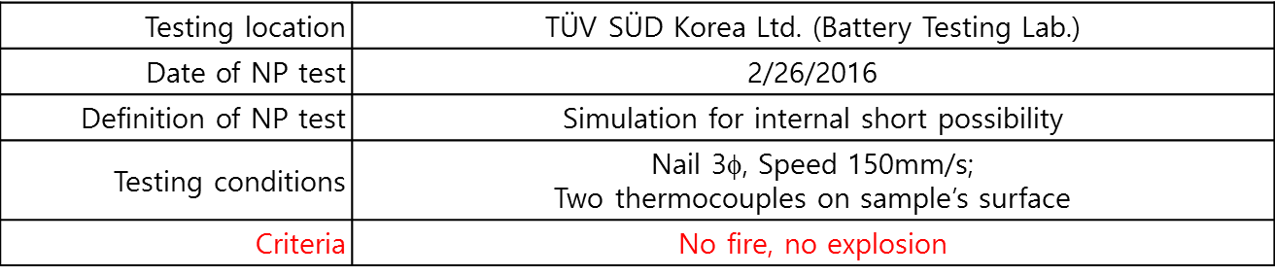

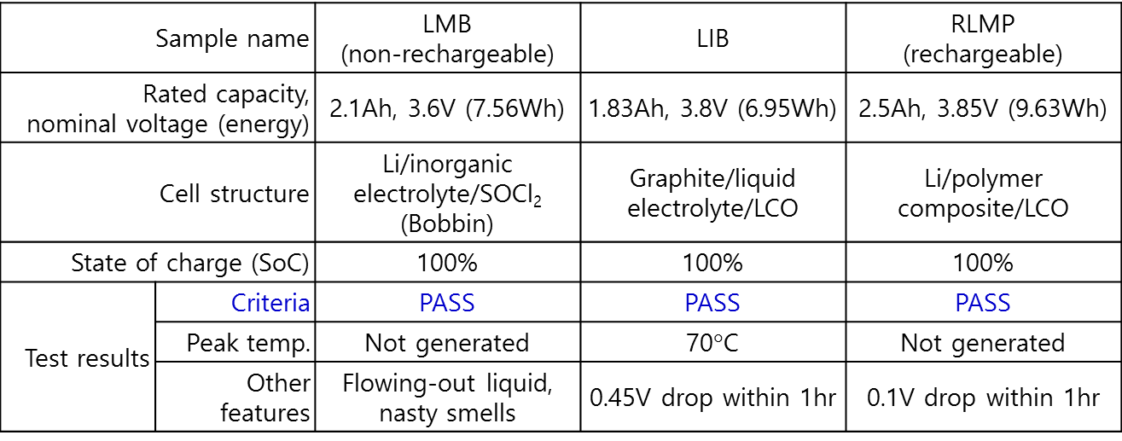

* LMB: Primary lithium metal battery; LIB: Lithium ion battery; RLMP: Rechargeable lithium metal polymer

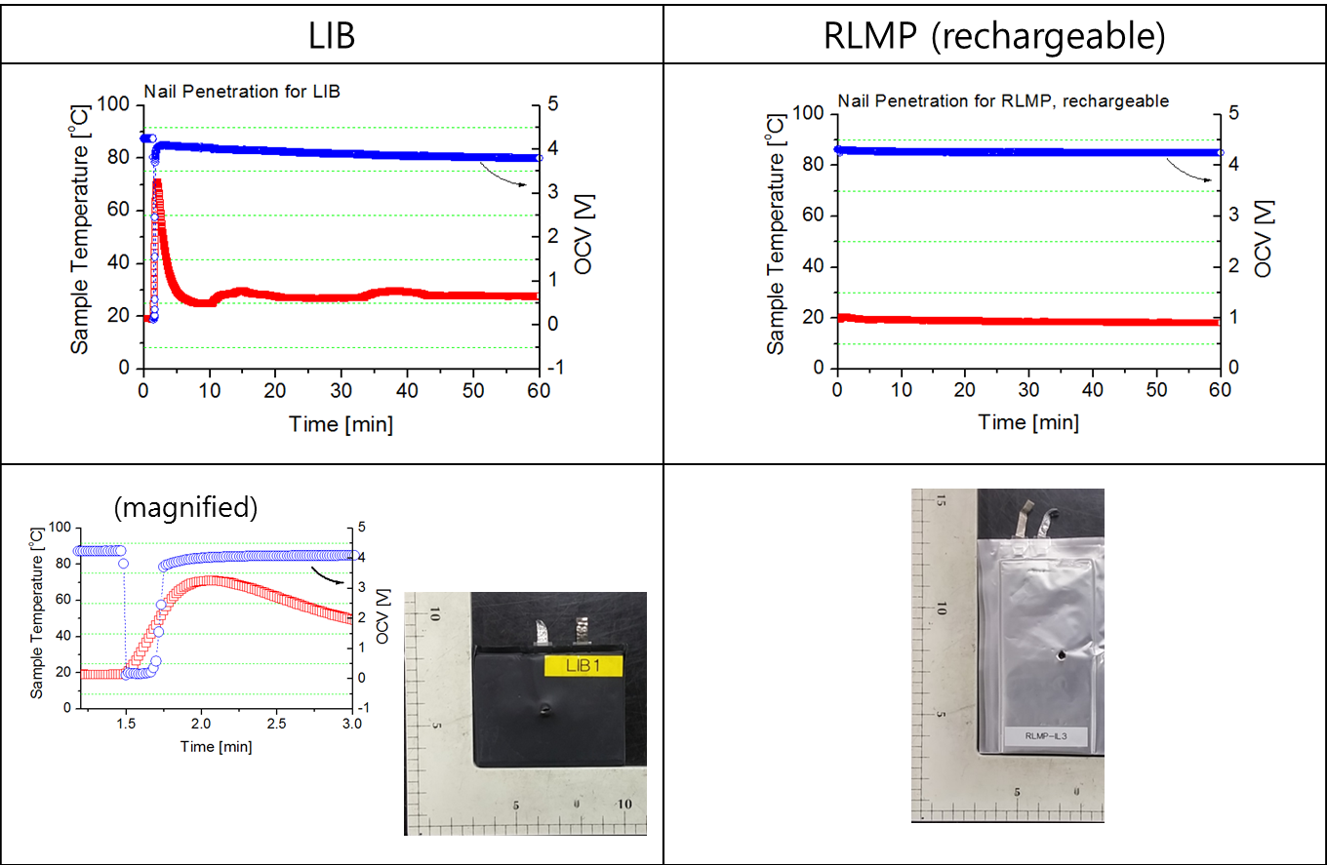



1. In accordance with the programme of work of the Sub-Committee for 2015–2016 approved by the Committee at its seventh session (see ST/SG/AC.10/C.3/92, paragraph 95 and ST/SG/AC.10/42, para. 15). [↑](#footnote-ref-2)