Proposal to introduce new criteria on the automatic levelling of headlamps based on the GTB glare and visibility studies.

This paper provides additional explanation supporting the joint GTB / OICA proposal, GRE/2015/05 and also updates some of the content of the proposed amendments to Regulation No.48.

1. **Additional information supporting GRE/2015/05**

Since the establishment of the GTB **C**oordination of **A**utomotive **V**isibility and **G**lare **S**tudies (CAVGS) taskforce in June 2011 the prime focus of its work has been to define a new technology independent criterion for the mandatory automatic static levelling of the passing beam. This has been treated with urgency because the existing 2000 lumen criterion and the current mandatory requirement to install automatic levelling on all vehicles equipped with LED headlamps is placing an unjustified burden on the exploitation of these new technologies.

The terms of reference of the GTB study included “improving the understanding of different factors that influence visibility and glare and their respective weighted importance” and it is argued that it is therefore not sufficient to limit the work to the automatic levelling issue. Clearly the complaints concerning glare of headlamps, that many administrations are receiving, indicate that more work has to be done to understand the reason why road users are complaining. However, so far, GTB has only been able to provide resources to develop the proposal that is now being presented to GRE. To give an indication of the resource involved, GTB estimates that more than 165,000 Euro have been invested in the planning and execution of the field tests in Klettwitz and this does not include the costs of the subsequent analysis of the results and the time spent in meetings to develop the proposed amendment to R48.

The proposal in GRE/2015/05 addresses the second item in the terms of reference of the GTB study; i.e. “to identify results of the study that might reveal alternatives to the adopted mandatory requirements for automatic levelling for the passing beam”.

Regarding the question of addressing the more general issue of glare complaints, GTB is considering how this could be approached and will report at subsequent GRE sessions; unless GRE will decide to manage this question in a different way. It is clear that any activity to address this general concern of glare of headlamps will be a major undertaking despite much international research that has been carried out over many years.

1.1 Background

At its sixty-fourth session, GRE considered the informal proposal (GRE-64-57 from Germany) to mandate automatic levelling for all headlamps producing a principal dipped beam.

At its sixty-fifth session, GRE adopted ECE/TRANS/WP.29/GRE/2011/27 with the addition of a 90-month transitional provision and agreed that:

* This adoption was subject to the development of a proposal, to be prepared by the expert from GTB who would lead a comprehensive study on glare and visibility during night-time driving.
* In case the results of the study revealed alternatives to the adopted mandatory requirements for automatic levelling and cleaning, the provisions of Regulation No. 48 would be re-examined at any time during the 90-month transitional period provided by ECE/TRANS/WP.29/GRE/2011/27.
* A dedicated working group based on the GTB structure would manage the study, and participation would be open to GRE experts.

GTB launched its task force for the **C**oordination of **A**utomotive **V**isibility and **G**lare **S**tudies (CAVGS) in June 2011.

In June 2012 WP29, at its 157th session, returned the proposal (ECE/TRANS/WP.29/2011/99/Corr.1and Corr.2 based upon GRE/2011/27) to GRE for further consideration and the EU requested a cost/benefit analysis before submitting a further proposal.

1.2 The GTB CAVGS Taskforce

The task force documents are available with unrestricted access on the GTB website ([www.gtb-lighting.org/VGS/indexVGS.htm](http://www.gtb-lighting.org/VGS/indexVGS.htm)).

The scope of the taskforce was: (please refer to VGS-010)

1. To improve the understanding of different factors that influence visibility and glare and their respective weighted importance.

* *This task was assigned to the GTB SVP WG and as a first step it was decided to carry out a literature survey related to the question of factors affecting glare and visibility.*

1. To identify results of the study that might reveal alternatives to the adopted mandatory requirements for automatic levelling and cleaning for the passing beam and front fog lamps.

* *This task was assigned to GTB Front Lighting WG to organise and execute a field test to investigate the relationship between headlamp design, light source technology, vehicle loading and observed glare.*

1. To identify options to decrease the possible glare of signalling lamps.

* *Due to availability of resources it was decided to work on this objective at a later time*

The scope of this taskforce was wide reaching and, as GTB was only able to devote limited resources, it was decided to focus on the urgent need to study the criteria defining the mandatory installation of automatic static levelling. However, whilst this issue is important because the current criteria are technology-restrictive and placing unjustifiable burden on industry it is important to keep the whole question of mandating automatic levelling in perspective as, at best; it will only address around 22% of the causes of unacceptable headlamp glare. This was estimated by GTB experts during a forum held in January 2011 and explained in GRE-65-17 pages 13-18.

1.3 Outcome of the preliminary work of GTB Front-Lighting (WG-FL) and Safety and Visual Performance (WG-SVP) working groups

The first objective of the CAVGS Taskforce, “To improve the understanding of different factors that influence visibility and glare and their respective weighted importance”, was addressed by the WG-SVP that undertook a literature survey. The result of this extensive survey was presented to GRE at its 71st session (GRE-71-32 pages 44-77).

To address the second objective, “To identify results of the study that might reveal alternatives to the adopted mandatory requirements for automatic levelling”, the WG-FL decided to carry out a field test in conjunction with the Technical University of Darmstadt. The objective of this field test was to evaluate the effect of loading on the vehicle pitch for a range of typical vehicles.

The field test was carried out in Klettwitz, Germany where DEKRA kindly provided access to its test facility. The glare from 25 cars equipped with halogen, HID and LED headlamps was rated by 47 observers. These cars were loaded at 0%, 50% and 100% load conditions and a total of 66 tests runs were recorded. The loading conditions were based upon the difference between the laden and unladen state of the vehicle, as defined respectively in paragraphs 2.5. and 2.4. of Regulation No. 48

The decision to investigate the effects of the 50% vehicle loading was reached after examining the results of studies, carried out in France and Germany, that provided an indication of the vehicle use and loading patterns; summarised in document GRE-65-16 It was found that no studies have been carried out specifically to determine the detailed use and loading patterns across the vehicle populations so the data derived from analysis of road accident investigation was the best available and GTB decided to base its study on these findings. The 50% loading condition, based upon the front passenger seat and the two outer seats in the row immediately behind the driver being occupied, with a mass up to 75Kg, and the remainder of the 50% of the maximum permitted load placed in the luggage / load compartments.

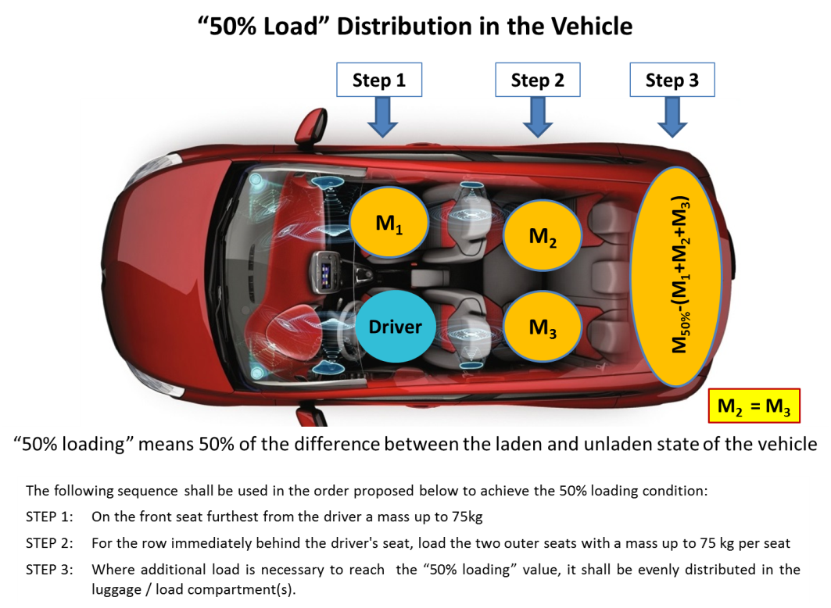

During the setting up of the test vehicles each passing beam was aimed with its horizontal cut-off at 1% down on a vertical screen at 10 metres from the car. The datum point for the position of the horizontal line on the screen, used as the reference for aiming, was the height of the centre of reference of the passing beam headlamp measured from the ground. This aiming procedure was carried out on a flat surface.

Data from the field test were collected by researchers from Darmstadt University and were subsequently evaluated.

The overall conclusion was that:

1. Vehicle pitch is the main factor contributing to unacceptable glare (rated using the de-Boer scale).
2. Light source technology was not a factor influencing the glare assessment
3. Glare was judged to be acceptable when the horizontal passing beam cut-off remains on or below the H-H line. This correlated with the pitch of test vehicles under the “50% loading” condition.

1.4 Putting the findings of the Klettwitz field test into the context of glare and visibility

Having reached the above-mentioned conclusions from the Klettwitz field tests WG-FL decided to validate the glare observations using the procedure developed by the CIE TC4-45 committee and published as CIE 188:2010 (Technical Report) and CIE S 021(Standard: Vehicle Lighting Systems Photometric Performance – Method of Assessment). Additionally, taking account of the advice of the expert from Poland at GRE, it was decided to extend the scope to determine the minimum aiming requirements to ensure adequate visibility range based upon the actual photometric characteristics of a range of existing headlamp systems. An overview of this method and its application to determine maximum upward position of the passing beam cut-off to avoid unacceptable glare was provided in GRE71-32 pages 118-152.

The determination of the upper and lower aiming limits to ensure acceptable glare and visibility was described in and GRE71-32 pages 164-167. These calculations produced the following result:



1.5 The GTB proposal for a new Criterion to determine when automatic headlamp levelling shall be mandated

Having reviewed the outcome of the GTB WG-FL “Klettwitz” field tests and the calculations produced using the CIE evaluation methods the CAVGS taskforce facilitated sessions convening the GTB-Installation, GTB-FL and GTB-SVP working groups to determine how the findings could be introduced into Regulation No.48. Although many of the vehicle manufacturers involved in the GTB working groups are also OICA members, OICA held many meetings of its experts and exchanged views frequently with GTB to ensure that any proposals offered to GRE would be practically feasible, ensure that increased glare would be avoided, and as far as possible, would not introduce unnecessary burdens for manufacturers.

The paragraphs 13-17 of the justification of GRE/2015/05 provide a summary of the key points of the proposal to amend Regulation No.48. Figure 1 compares the proposed aiming limits with the current requirements of paragraph 6.2.6.1.2. However as the proposal relates to the absolute limits of aiming, for acceptable glare and visibility, these should be compared with the provisions in Annex 9, paragraph 1.3.2. The comparison then shows:



In summary, the joint GTB / OICA proposal introduces a criterion that is technology neutral and offers improvements in visibility range whilst retaining the existing control of the position of the cut-off in respect of glare. In the case that the vehicle characteristics, under the 50% loading condition, result in pitch angles that do not remain within the limits shown in the diagram shown above, there is a mandatory requirement to install automatic levelling. It is estimated that the proposed criterion will cover the loading conditions, under normal use, of around 90% of vehicles type approved to these new requirements. The remaining 10% of loading instances are corrected by means of the manual levelling system, or at the discretion of the manufacturer, by the installation of automatic systems. In the case of manual levelling, actions to improve driver awareness of its function will have to be considered to answer the concerns regarding misuse.

1.6 Impact Assessment

It is clear that this new criterion will affect the current pattern of installation of automatic levelling systems. Significantly, it is expected that a greater proportion of passing beam headlamps equipped with halogen light sources will be automatically levelled. Manufacturers of smaller vehicles have estimated that this proportion will increase but it is impossible to accurately predict what percentage this will be. Equally, it is expected that the proportion of passing beam headlamps equipped with LED light sources that will be automatically levelled will decrease but this will encourage a greater take-up of the technology on smaller energy efficient vehicles. There is not expected to be a significant reduction in the proportion of passing beam headlamps equipped with HID light sources that will be automatically levelled; these are mainly installed on more expensive vehicles where the manufacturer will continue to offer the automatic levelling option.

It is expected that that this new criterion will not increase glare complaints nor reduce the existing rates of installation of auto-levelling. There will be a significant change to the lower aiming limit that will have the effect of increasing the minimum visibility range for the driver.

1. **Update of the content of the proposal**

Based on a further deeper examination of the current text of ECE Regulation 48, in particular Annex 6 dealing with headlamps levelling test procedure, and of the parameters used during Klettwitz tests, an additional change has been deemed necessary to give better coherence between the proposed text of paragraph[s] 6.2.6.1.2.1. and 6.2.6.1.2.2. and the existing text of paragraph 2.2. in Annex 6.

These additional changes are also perfectly coherent with the test conditions adopted in Klettwitz, that were based on the description of headlamp levelling test procedure in Annex 6. However, the introduction of these additional changes implies adjournment of paragraphs 5.8 and 5.8.2.

The additional proposed changes are as follows:

Paragraph 5.8., and its sub paragraphs, amend to read:

“ 5.8. **Except as prescribed in the following paragraphs 5.8.1. and 5.8.2. t**~~T~~he maximum height above the ground shall be measured from the highest point and the minimum height from the lowest point of the apparent surface in the direction of the reference axis.

Where the (maximum and minimum) height above the ground clearly meets the requirements of the Regulation, the exact edges of any surface need not be determined.

5.8.1. For the purposes of reducing the geometric visibility angles, the ~~position of a lamp with regard to~~ height above the ground, shall be measured from the H plane.

5.8.2. In the case of dipped-beam headlamp, the minimum height ~~in relation to~~ **above** the ground is measured from the lowest point of the effective outlet of the optical system (e.g. reflector, lens, projection lens) ~~independent of its~~ **for any** utilisation **except for the headlamp levelling, in application of paragraph 6.2.6.1.1.2., for which the height above the ground is measured from the centre of reference.”**

Paragraph 6.2.6.1.1.2., amend to read:

**“6.2.6.1.1.2.** **Depending on the mounting height in metres (h) ~~of the~~ ~~lower edge of the apparent surface in the direction of the reference axis~~ of the dipped beam headlamp, measured on the vehicles under the loading conditions prescribed in Annex 5 of this Regulation, the downward inclination of the cut-off of the dipped beam headlamp, starting from the initial inclination value set by the vehicle manufacturer as prescribed in paragraph 6.2.6.1.1.1. above, shall remain between the limits (see diagram below):**

**h = 0.5 m: from 0.0 per cent to -1.6 per cent;**

**h = 0.8 m: from 0.0 per cent to -2.0 per cent;**

**h = 1.2 m: from -0.6 per cent to - 2.6 per cent.**

(The figure is unchanged)”

-----------------------------------------------