|  |  |  |  |
| --- | --- | --- | --- |
|  | United Nations | ECE/TRANS/WP.29/GRE/2015/16 | |
| Description: _unlogo | **Economic and Social Council** | | Distr.: General  23 January 2015  Original: English |

**Economic Commission for Europe**

Inland Transport Committee

**World Forum for Harmonization of Vehicle Regulations**

**Working Party on Lighting and Light-Signalling**

**Seventy-third session**

Geneva, 14 – 17 April 2015

Item 7 (j) of the provisional agenda  
**Other Regulations – Regulation No. 112 (Headlamps emitting an asymmetrical passing-beam)**

Proposal for Supplement 7 to the 01 series of amendments to Regulation No. 112 (Headlamps emitting an asymmetrical passing-beam)

Submitted by the expert from the International Automotive Lighting and Light Signalling Expert Group (GTB)[[1]](#footnote-2)\*

The text reproduced below was prepared by the expert from GTB to correct editorial errors concerning the approval markings of Annex 2. The modifications to the existing text of the Regulation are marked in bold for new or strikethrough for deleted characters.

I. Proposal

*Annex 2, figures 5, 6, 7, 8, 9 and 10*, amend to read:

" ...

Figure 5 Figure 6  
  
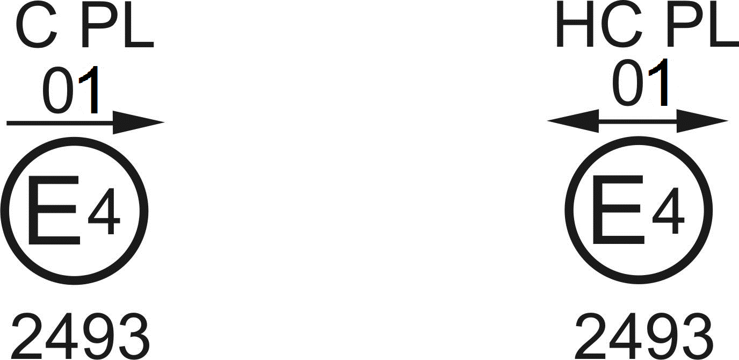

The headlamp bearing the above approval mark is a headlamp incorporating a lens of plastic material meeting the requirements of this Regulation in respect of the passing-beam only and is designed:

Figure 5: Class A for ~~both traffic systems~~ **left-hand traffic only**.

Figure 6: Class B for ~~right-hand traffic only~~ **both traffic systems**.

Figure 7 Figure 8

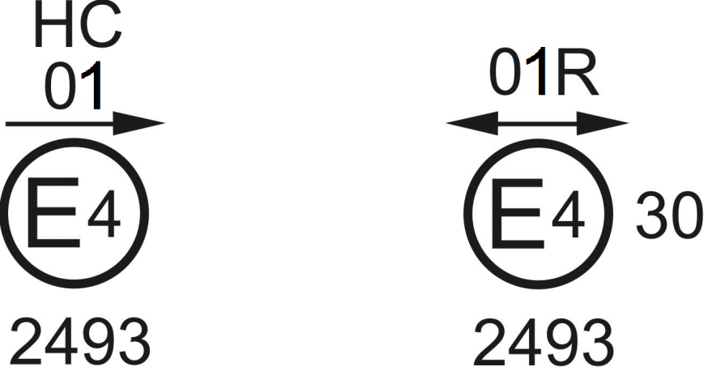

**This double headed arrow should be deleted**

The headlamp bearing the above approval mark is a headlamp meeting the requirements of this Regulation:

Figure 7: Class B in respect of the passing-beam only and is designed for left-hand traffic only.

Figure 8: Class A in respect of the driving-beam only.

Figure 9 Figure 10

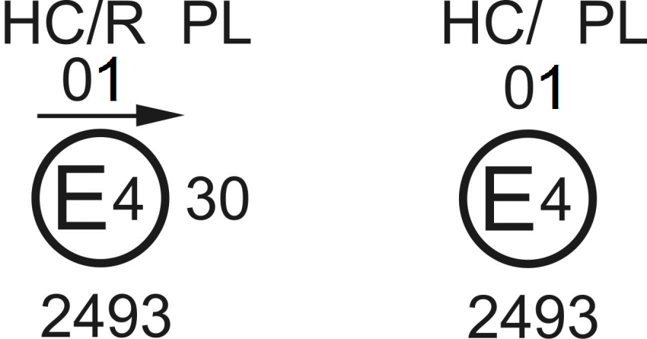

Identification of a headlamp incorporating a lens of plastic material meeting the requirements of this Regulation:

Figure 9: Class B in respect to both the passing-beam and driving-beam and designed for ~~right-hand~~ **left-hand** traffic only.

Figure 10: Class B in respect to the passing-beam only and designed for right-hand traffic only.

The passing-beam shall not be operated simultaneously with the driving-beam and/or another reciprocally incorporated headlamp…"

II. Justification

Errors have been identified in the references to “left-hand traffic” and “right-hand traffic” in the text and associated diagrams of Annex 2.

1. \* In accordance with the programme of work of the Inland Transport Committee for 2012–2016 (ECE/TRANS/224, para. 94 and ECE/TRANS/2012/12, programme activity 02.4), the World Forum will develop, harmonize and update Regulations in order to enhance the performance of vehicles. The present document is submitted in conformity with that mandate. [↑](#footnote-ref-2)