UN/SCETDG/48/INF.10
Committee of Experts on the Transport of Dangerous Goods
and on the Globally Harmonized System of Classification
and Labelling of Chemicals
Sub-Committee of Experts on the Transport of Dangerous Goods 9 November 2015
Forty-eight session
Geneva, 30 November-9 December 2015
Item 4 (d) of the provisional agenda
Electric storage system: miscellaneous
Harmonization of the energy rating under SP188 for rechargeable lithium metal polymer and lithium-Ion batteries
Transmitted by RECHARGE and PRBA
Introduction
- Primary non rechargeable Lithium metal batteries have been placed on the market for number of years. These batteries are transported undischarged when they are new, it is therefore appropriate to represent the characteristics of the battery by its lithium metal content. According to SP188, for Lithium metal batteries (UN3090), exempted cells and batteries must contain less than 1 g lithium for lithium metal or lithium alloy per cell or less than 2 g lithium per battery.
In addition, rechargeable Lithium-Ion batteries (UN3480) are characterized by their total energy content in Wh when fully charged. According to SP188, for Lithium-Ion rechargeable batteries, exempted cells and batteries must contain less than 20Wh per cell or less than 100 Wh per battery.
2. In the informal document INF.13/Rev.1 (47th session) the delegation of the Republic of Korea introduced a new rechargeable lithium battery based on a lithium metal anode associated with a polymer electrolyte. The uses and applications of these Rechargeable Lithium Metal Polymer batteries (RLMP) are expected to increase substantially over the next 5 to 10 years. It is worth to indicate that this new battery technology is applicable to small portable batteries for IT equipment and to large batteries for electric vehicles. For technical background, a definition and an illustration of an RMLP are proposed in Annex 1.
3. The safety characteristics of the RLMPs are equivalent or better than those of the Lithium-Ion battery technology particularly when considering the use of the polymer electrolyte. In a comparative tests campaign, the RMLP cells and Li-ion cells have been submitted to the destructive tests of the UN Manual of Tests and Criteria Chapter 38.3 (test T6-crushing and test T8-overdischarge). The results are presented in Annex 2.
4. It can be observed that the tests results are indicating equivalent safety performances for both Li-Ion and RLMP cells and batteries.
5. Because these rechargeable batteries are not transported fully charged but with an intermediate State of Charge of 50% to 60%, the lithium metal content during transport is lower than the total amount of lithium metal content when the cells are fully charged. Indeed, the value of lithium metal content in the anode is directly correlated to the State of

Charge of the cell or battery. Therefore, it is considered that the total lithium metal content for the RMLP is not representative of the “safety performance status” of the battery during transport.
6. It is advisable to harmonize the requirements of the Special Provisions SP188 of the United Nations Model Regulations for all types of rechargeable Lithium batteries. In order to harmonize the energy content marking of the rechargeable Lithium batteries (Li-ion and RLMP), it is proposed to use for RLMP the energy content (expressed in Wh), as it is currently the case for Li-ion cells and batteries.
7. The applicable limits in the SP188 to define the energy content of the exempted cells and batteries were discussed during the second informal working group held on August 28th in Washington DC. The initial proposal consisted in a change of the energy content limit for RMLP from 1 g lithium metal for a cell, or 2 g lithium metal for a battery, to 20 Wh for a cell or 100 Wh for a battery. Although it was recognized that the size of a RMLP cell containing 1g lithium metal is close to the size of a 20 Wh RMLP cell, concerns were raised during the discussion about the difference in size between a 2 g Lithium metal battery and a 100 Wh RLMP battery, hence resulting in possibly larger hazards.
8. Table 1 is illustrating the relation between the Lithium metal content and the energy content of Lithium batteries in the context of SP188. It can be observed the 20 Wh RLMP cell is equivalent to a 1.5 g Lithium Metal cell when fully charged. In the same way, a battery with 100 Wh would have an equivalent Lithium metal content of 7.5 grams when fully charged. As the RLMP battery is shipped with a typical 50 % State of Charge (SOC), this would represent 3.7g of Lithium metal per battery during transport.
9. Because the tests results are indicating equivalent safety performances for both types of Lithium Rechargeable Batteries, it is considered that the same values for the exemption limit under SP188 should be proposed as a first option 1: RMLP with a Wh rating of less than 20 Wh for cells or 100 Wh for batteries could fall under SP188. In addition, this would help simplify and harmonize the regulation.
10. As discussed during the second informal working group, the change in size for the 100 Wh batteries was considered as non-acceptable without further safety tests results. Although tests results are presented in annex 2 of this document, it is proposed to consider a limit of 20 Wh for cells and 60 Wh for batteries as an alternative (Option 2) to the first proposal in Option 1, in case the safety test results would still be considered as insufficient.
Proposal
Option 1:
11. Modify the text of SP 188 (a) and (b) as indicated below:
(a) For a lithium metal or lithium alloy cell, the lithium content is not more than 1 g, and for a lithium ion cell,[or a rechargeable lithium metal polymer cell] the Watt-hour rating is not more than 20 Wh;
(b) For a lithium metal or lithium alloy battery the aggregate lithium content is not more than 2 g, and for a lithium ion battery, [or a rechargeable lithium metal polymer battery] the Watt-hour rating is not more than 100 Wh. Lithium ion batteries and rechargeable lithium metal polymer battery subject to this provision shall be marked with the Watt-hour rating on the outside case, except those manufactured before 1 January2009;
Option 2:
12. Modify the text of SP 188 (a) and (b) as indicated below:
(a) For a lithium metal or lithium alloy cell, the lithium content is not more than 1 g, and for a lithium ion cell,[or a rechargeable lithium metal polymer cell] the Watt-hour rating is not more than 20 Wh;
(b) For a lithium metal or lithium alloy battery the aggregate lithium content is not more than 2 g, and for a lithium ion battery, the Watt-hour rating is not more than 100 Wh [ and for a rechargeable lithium metal polymer battery , the Wh rating is not more than 60 Wh]. Lithium ion batteries and rechargeable lithium metal polymer subject to this provision shall be marked with the Watt-hour rating on the outside case, except those manufactured before 1 January2009;
Conclusion
13. The Sub-Committee is invited to discuss the above issues and provide an opinion in order for the authors to take in account the comments and prepare a formal proposal.

 | SP188 limit in g of Li for Li metal batteries | SP 188 limit in Wh for rechargeable Li-ion | Option 1 proposal for RMLP introduction in SP188 | Option 2 proposal for RMLP introduction in SP188
Cell | 1 g Li | 20 Wh | 20Wh ( 1,5 g Li 100%SOC or 0,8 g Li at 50% SOC) | 20Wh ( 1,5 g Li 100%SOC or 0,8 g Li at 50% SOC)
Battery | 2 g Li | 100 Wh | 100 Wh (7,5 g Li 100% SOC or 3,7 g Li at 50%SOC ) | 60 Wh (4.5 g Li 100% SOC or 2,2 g Li at 50%SOC )

Table 1. Summary comparison between the lithium content and the energy content of Lithium-metal, Lithium-Ion and RLMP cells and batteries according to the proposal of Option 1 and 2.

Annex 1
Definition of a RLMP
A RLMP is a rechargeable electrochemical device in which charge and discharge can be repeated by plating or stripping lithium ions at the negative electrode, and by intercalating and deintercalating lithium ions, or alloying reaction of lithium ions at the positive electrode, depending on the chemistry of the positive active materials. The negative electrode is comprised of lithium metal. Depending on the chemistry, the positive electrode can be comprised of an oxide, sulfur composite or other material. The electrolyte used in RLMP is a partial solid polymer.
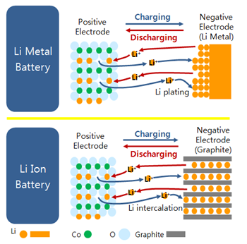

Fig.1 Operating principle of lithium metal and lithium ion cells
Annex 2
Safety performance of RLMP (comparison with lithium ions batteries)
Manual of Tests and Criteria  UN38.3 |  | T6  (Crush) | T8  (Forced Discharge, 1C)
Test  Conditions | Cycle | 1 | 1 | 50
 | SOC | 50 | 0 | 0
 | Test | Yes | Yes | No***
 | Criteria | cell/battery temperature does not exceed 170°C.no disassembly, no rupture, no fire | no disassembly,  no fire within seven days of the test
Test Results** | Lithium Ion Cell  (1750mAh, Polymer) | PASS  (25 °C) | PASS  (51.0 °C) | n/a
 | Lithium Metal Polymer Cell*  (1750mAh, Polymer) | PASS  (25 °C) | PASS  (42.5 °C) | n/a
* Partially solid electrolyte is involved for required Li ion conductivity
** Lithium Ion Battery (LIB) was tested at SDI, whereas Rechargeable Lithium Metal Polymer Battery
(RLMP) at TÜV Sud Korea
*** T8 (50 cycles) will be tested and compared in December 2015

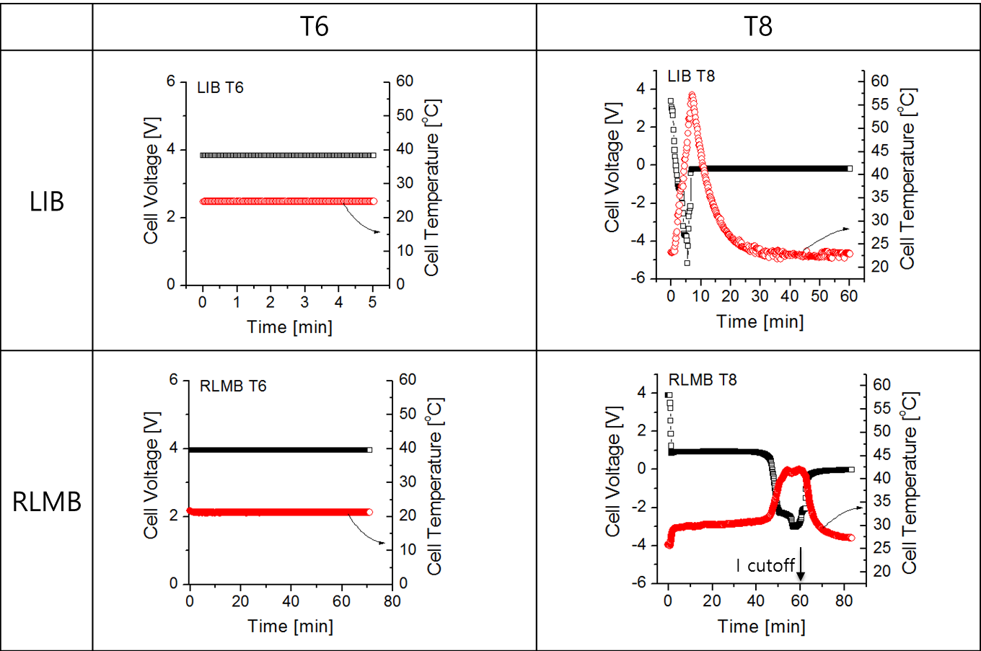
Fig.2 Thermal behaviour of Li-ion and RLMP during the tests 38.3 T6 and T8

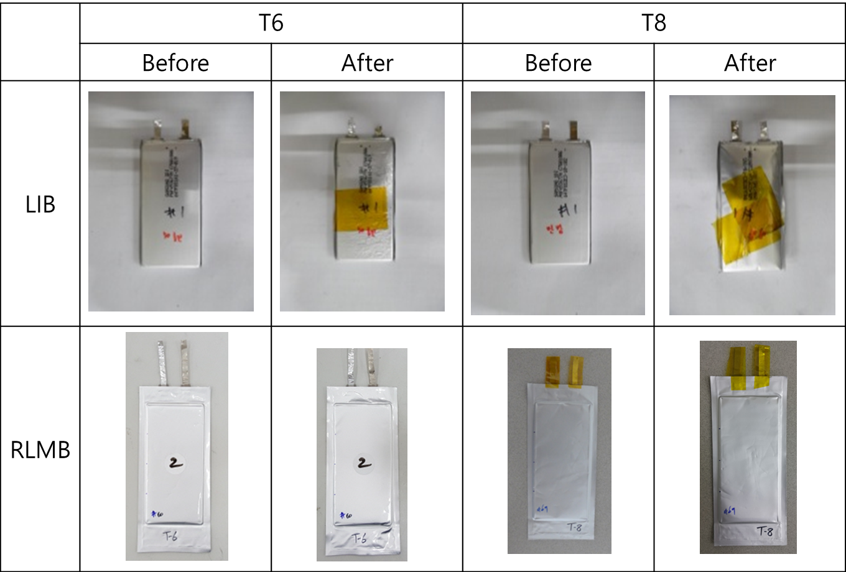
Fig.3 Physical aspect of Li-ion and RLMP after the tests 38.3 T6 and T8

