UN/SCETDG/47/INF.3

Committee of Experts on the Transport of Dangerous Goods
and on the Globally Harmonized System of Classification
and Labelling of Chemicals 17 March 2015
Sub-Committee of Experts on the Transport of Dangerous Goods
Forty-seventh session
Geneva, 22 – 26 June 2015
Item 2(c) of the provisional agenda
Explosives and related matters: Review of tests in parts I and II of the Manual of Tests and Criteria
Manual of Tests and Criteria
Recommendations for Improvement of Series 8 (c) Koenen Test
Additional Technical Background for the Explosives Working Group
Transmitted by the Institute of Makers of Explosives (IME) and the Australian Explosives Industry Safety Group (AEISG)
Introduction
- The purpose of this paper is to provide additional technical background for the explosives working group as it considers the proposal from AEISG and IME in ST/ST/AC.10/C.3/2015/2.
Discussion
- What follows is a discussion of the results of a thorough study by AEISG and IME into the construction of the tube used in the 8(c) Koenen test and its response to the prolonged exposure period required for adequate evaluation of ANEs as opposed to “traditional” explosives.
- The type of steel used for the tube that contains the substance is DC04 steel sheet, chosen for its suitability to form uniform and reproducible tubes when deep-drawn. The Manual specifies that the bursting pressure of 1% of the tubes from each production batch shall be 30 ± 3 MPa when measured appropriately, giving an allowable variation of ± 10% in their bursting pressure. The properties of this steel as a function of temperature are shown in Figure 1. From the chart it can be seen that the yield stress of that steel decreases by approximately 30% across the whole range of plastic strains when heated 25°C from to 200°C, and by approximately 40% when heated to 300°C. Since the bursting pressure of a thin-walled vessel is directly proportional to the yield stress of the wall material, this implies that the bursting pressure of the Koenen tubes would also decrease by approximately 30% if heated uniformly from 25°C from to 200°C, or by 40% if heated to 300°C. These decreases in bursting pressure are at least three times greater than allowed in the Manual.
- Figure 2 shows the temperature histories recorded by two thermocouples located at different heights above the base of the tube during a calibration run being performed with dibutyl phthalate (DBP). The close agreement between the two histories is expected for an inert low-viscosity liquid once convection cells have become established and are ensuring a well-mixed system. The histories show that the temperature of the DBP reached 200°C after about 40 to 45 seconds of heating. Since the temperature of the steel tube must have been comparable to or higher than the temperature of its contents at this time, its bursting pressure must have been reduced by at least 30% after 40 to 45 seconds of heating. This would also be the case for any inert low-viscosity liquid with a heat capacity similar to that of DBP, namely 1,710 J/kg.K, since the overall heating rate would be controlled by the external heat flux from the gas flames which is a constant independent of the contents of the tube.
- The heat capacity of ANE varies with composition, but is typically in the range from 1,650 J/kg.K to 2,400 J/kg.K. If ANEs were low-viscosity liquids that supported convection cells in a similar fashion to DBP (where the dynamic viscosity is about 20 mPa.s at ambient temperature), the bursting pressure of the steel tube during Koenen testing would degrade by at least 30% after about 40 to 60 seconds of heating. However, all current ANE are instead high-viscosity semi-liquids (with dynamic viscosities of about 20 ~ 30 Pa.s, or 10,000 time higher than DBP) that exhibit complex changes in physical and thermal properties under intense heating. Thermocouple histories from ANE heated in the Modified Vented Pipe Test and in the Koenen Test⁷ have demonstrated that the ANE in contact with the walls is heated preferentially, forming degraded lower-density lower-viscosity material that pools on top of a central plug of cooler, denser, higher-viscosity ANE still in its original condition. This central plug of cool ANE is eroded gradually by heat slowly diffusing in from the enveloping hotter degraded ANE. This is illustrated by Figure 3, which reproduces thermocouple histories collated from two Koenen tests of a typical ANE. In the test where a thermocouple was located centrally at mid-height up the sample, the recorded temperature there took about 70 seconds to exceed 200°C; in the test where the corresponding thermocouple was located against the inside surface of the tube wall, the recorded temperature had exceeded 200°C within 20 seconds. Under these conditions where the temperature distribution is uneven, the steel walls heat up faster, and the bursting pressure of the steel tube would thus decrease even faster, than is the case for low-viscosity liquids such as dibutyl phthalate where the contents are well stirred by convection currents.
- While the DC04 steel sheet specified for the tube manufacture is eminently suitable to form uniform and reproducible tubes when deep-drawn cold, it is a low carbon mild steel with limited corrosion resistance, especially at elevated temperature. This is of no particular consequence for the short test durations exhibited by traditional Class 1 materials. However, the long test durations exhibited by ANE could lead to substantial changes in the chemical and structural properties of the steel tubes. For example, Figure 4 shows the “bluing” from oxidation at elevated temperatures visible under strong lighting at various times throughout a Koenen test of a typical ANE. These changes are also apparent in the infra-red spectrum; Figure 5 shows that the measured infra-red emissivity of tubes increases by an order of magnitude between the start and the end of a Koenen test. As a second example, Figure 6 shows three frames from an infra-red video of ANFO in the Koenen test, where overflow of molten material dripped down the front of the tube. Just a few seconds of exposure had altered the emissivity of the steel from about 0.25 to about 0.76 in one region and to about 0.93 in another, indicating rapid and extensive oxidation there. This oxidation is likely to be restricted to thin surface layers on the exterior tube walls, and hence might not alter the bursting strength of the tube to any significant degree. However, it is to be anticipated that much greater depths of steel might be oxidized on the inner tube walls, where there is prolonged contact with hot ANE and its decomposition products including nitric acid throughout the whole duration of the test.
- If the tubes were made from a corrosion-resistant steel that did not tarnish and hence had a constant infra-red emissivity throughout a Koenen test with ANE, it would be straightforward to measure the temperature distribution of the tube throughout the test using a suitable infra-red video camera. Provided the variation of yield strength with temperature (similar to Figure 1) were known for the steel, it would then be possible to calculate at what time the burst strength of the tube had degraded by some set amount. However, the changes in emissivity of the tube caused by oxidation of the DC04 steel throughout the test preclude deducing the temperature distribution from the infra-red images here.
- Recently, high-speed videography at frame rates up to 40,000 frames per second has been used to examine the phenomena leading up to tube rupture and fragmentation in Koenen tests of various materials including double-base propellants and ANE. Figure 7 shows selected frames from a typical sequence covering the explosion of a double-base propellant. The flame erupting from the orifice first became visible about 0.5 ms prior to first rupture; this flame intensified rapidly, with the venting gases forming a structure called a “shock diamond”, with an embedded Mach disc which rose rapidly in height as shown in Figure 8. The top portion of the tube began to swell in the final frame (-0.035 ms) prior to first rupture. Multiple fissures in the tube walls had developed by the first frame (+0.035 ms) after first rupture, with the tube quickly disintegrating into multiple fragments. Assuming the tube burst when its internal pressure was about 30 MPa allowed the rate of internal pressurization to be estimated at about 15 MPa/ms at 0.35 ms prior to first rupture, accelerating rapidly to about 70 MPa/ms over the final 0.10 ms. These observations are consistent with an ignition at the top of the tube followed by a rapidly accelerating burn to explosion.
- Figure 9 shows a comparative sequence for an ANE, typical in all aspects but one. Whereas the tubes in all other videoed ANE Koenen tests split first down the left-hand side in the region heated directly by the left-hand gas flame, this tube showed the sole exception where the first split occurred at the back of the tube. It has been selected here because this sequence gave the clearest view of how this single split grew slowly over time, with the tube unfolding until eventually the two side wings detached after about 0.5 ms (with each wing subsequently fragmenting into two out of view of the camera). At no stage leading up to the first rupture did the tube exhibit any sudden acceleration – instead, it was visibly swollen for many milliseconds leading up to rupture. This gradual build-up to rupture was mirrored by the behavior of the Mach disc formed by the venting gases shown in Figure 10, where it can be seen that the peak pressurization rate for ANE V2P was about 3.0 MPa/ms at rupture, an order of magnitude slower than for the slowest burning double-base propellant WXR. This pressurization rate of 3.0 MPa/ms for ANE V2P has been the fastest observed to date for any ANE tested, with more common rates being 0.1 ≈ 1.5 MPa/ms.
- A series of numerical simulations using the dynamic finite element code AUTODYN-3D has been performed to complement the experimental high speed videos⁹. Figure 11 shows the predicted velocity fields in the Koenen steel tubes at the point of first rupture and after fragmentation has occurred when the tubes were at a uniform temperature of 25°C and pressurised uniformly at selected internal pressurisation rates. At pressurisation rates of 100 MPa/ms and 30 MPa/ms, the central portion of each tube had been accelerated to significant velocities (of 50 m/s of faster) before rupture first occurred; multiple fissures developed almost simultaneously down the tube walls, and quickly joined up to form multiple fragments, giving fragmentation patterns types “G” and “F” respectively that would be classed as diagnostic of “explosion”. At pressurisation rates of 10 MPa/ms and 3 MPa/ms, the central portion of each tube was essentially at rest when the first vertical fissure was created. This single fissure then bifurcated where the tube entered the threaded collar of the Koenen tube assembly, allowing the tube to split open. This fragmentation pattern is type “E”, and would be classed as diagnostic of “no explosion”. Thus, if the situation were such that the mechanical properties of the steel tube did not change throughout a Koenen test but remained constant at their 25°C values, it is predicted that internal pressurisation rates of 30 MPa/ms and above should lead to “explosion”, whereas those below 10MPa/ms should lead to “no explosion”.
- Figure 12 shows the predicted rupture process of a Koenen steel tube heated to 300°C, apart from an elliptical region heated to 400°C replicating the region influenced by the left-hand flame as evident from Figures 4 and 5, pressurised at 3 MPa/ms. Despite starting from a single vertical fissure, it was predicted that the side walls of the weakened tube would peel away from the base and from the top where it entered the threaded collar, forming the two wings observed experimentally in Figure 9. In the simulation, these two wings eventually collided at the back of the tube, stopping further tearing. In the experimental sequence shown in Figure 9, these wings rotated slightly around their attachments avoiding such a collision, and proceeded to tear away completely. Other than this small difference, the simulation was in excellent overall agreement with the experiment. The conclusion is that the multiple fragments formed in prolonged Koenen tests such as that shown in Figure 9 are the result of the steel tube having weakened substantially, rather than being diagnostic of “explosion”.

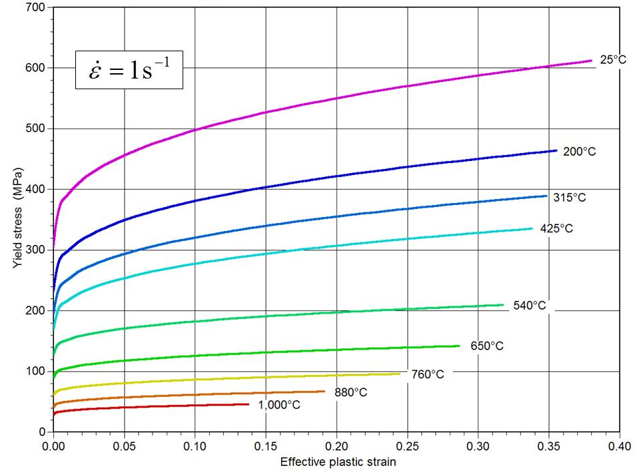
Figure 1
Yield strength of DC04 sheet steel at selected temperatures.
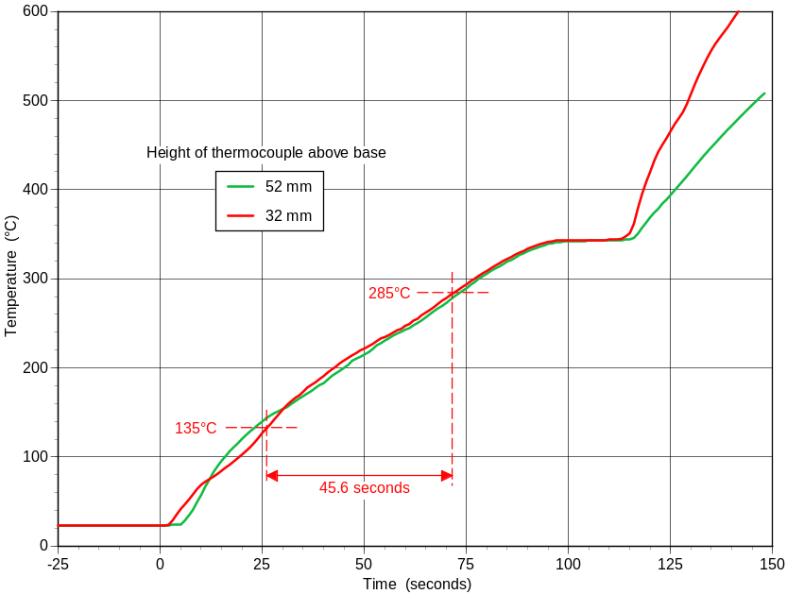
Figure 2
Temperature histories recorded by thermocouples at various heights above the base of the tube during a calibration run with dibutyl phthalate. The measured heating rate was 3.29°C/second.
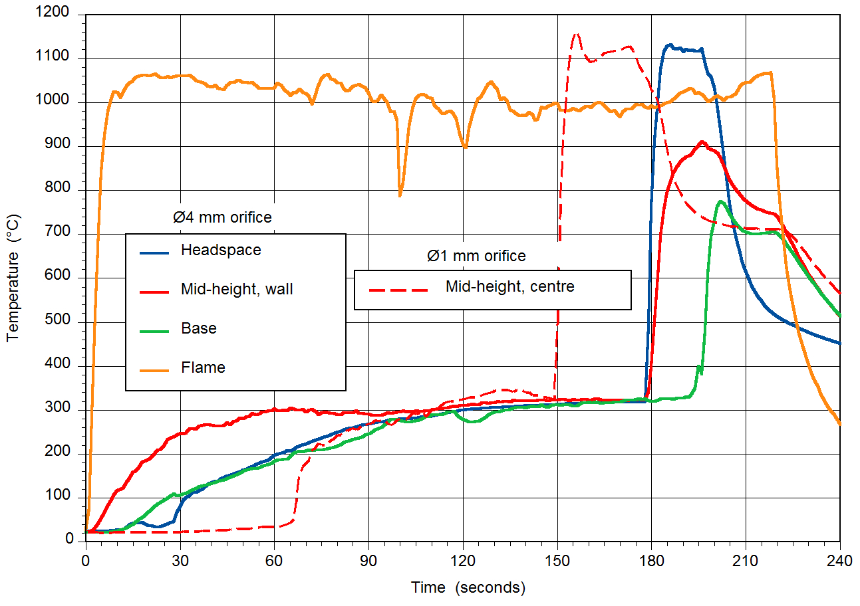
Figure 3
Collated thermocouple histories from two instrumented Koenen tests of the diesel-oil based ANE AEM2^{7, 8}.
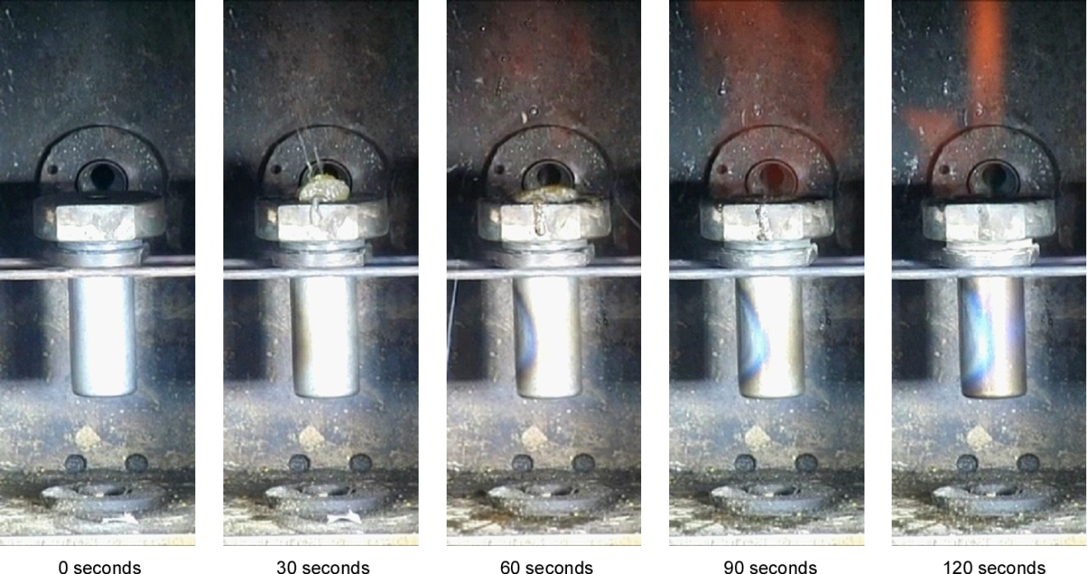
Figure 4
“Bluing” of the steel tube during Koenen testing of a typical ANE. These photographs were taken under floodlights; the propane flames are not visible under this strong external lighting. Note the ANE that has oozed out of the orifice between 30 and 60 seconds; this ANE is fully exposed to the gas flame from the back burner.
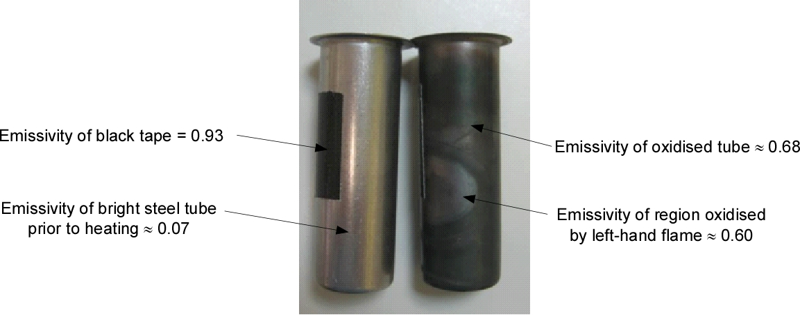
Figure 5
Emissivities measured in the infra-red. The left-hand tube is in its original condition. The right-hand tube has been used in a Koenen test where sand was heated for several minutes.
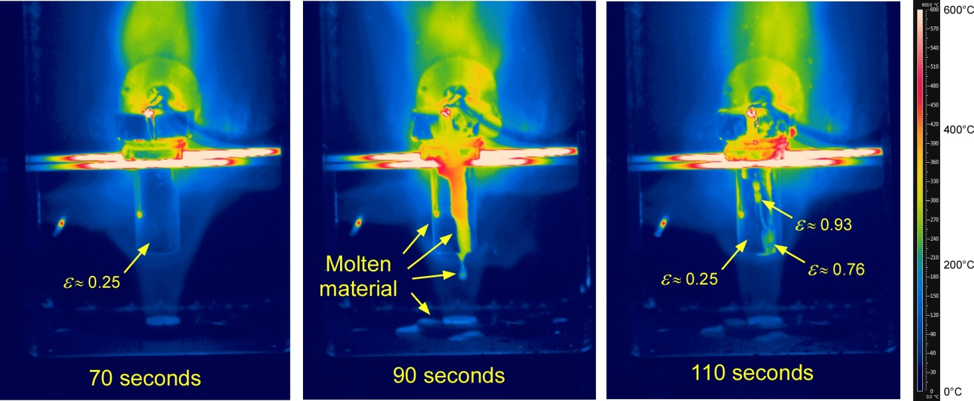
Figure 6
Infra-red images taken during an instrumented Koenen test of ANFO. The molten material overflowed through the orifice and dribbled down the front of the tube between 80 and 90 seconds, evaporating away off the tube by 105 seconds. The streaks left down the tube at 110 seconds are the result of emissivity changes during surface oxidation, and are not at a higher temperature. The emissivity (ε) of the three highlighted points was derived assuming the steel tube was at the common temperature being recorded by three internal thermocouples at this time. (The temperature scale on the right is only correct for surfaces with an emissivity of 0.60, and the technique does not measure accurately the temperature of flames which emit in narrow spectral bands.)
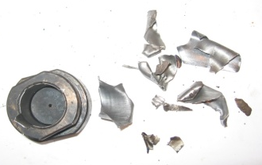
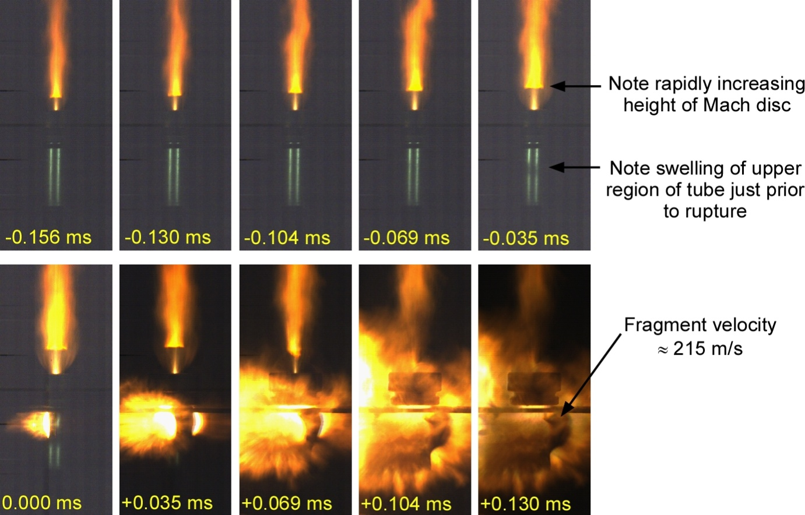
Figure 7
Consecutive frames from a high speed video recorded at 28,800 fps of the explosion of Power Pistol, a double-base propellant, in the Koenen test with a Ø2 mm orifice. The explosion occurred after 5.4 s of heating.
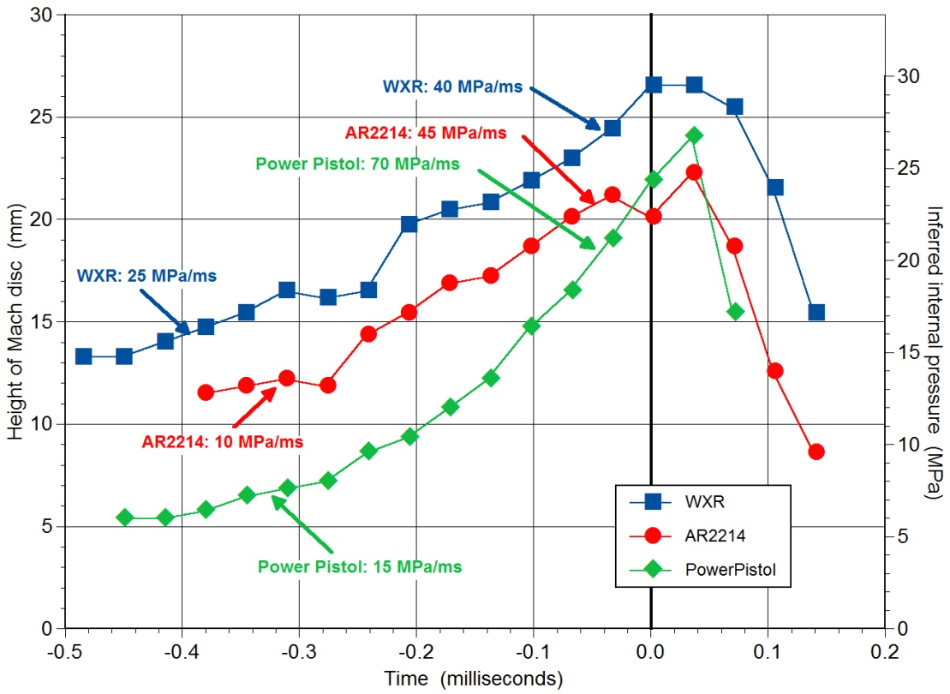
Figure 8
Height of Mach disc in venting gases from three typical double-base propellants in the Koenen test. Time zero was defined as the frame in which the first rupture was visible. The internal pressurisation rates were calculated assuming the tubes burst once the pressure reached 30 MPa.
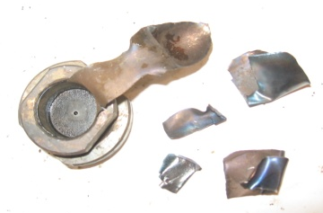
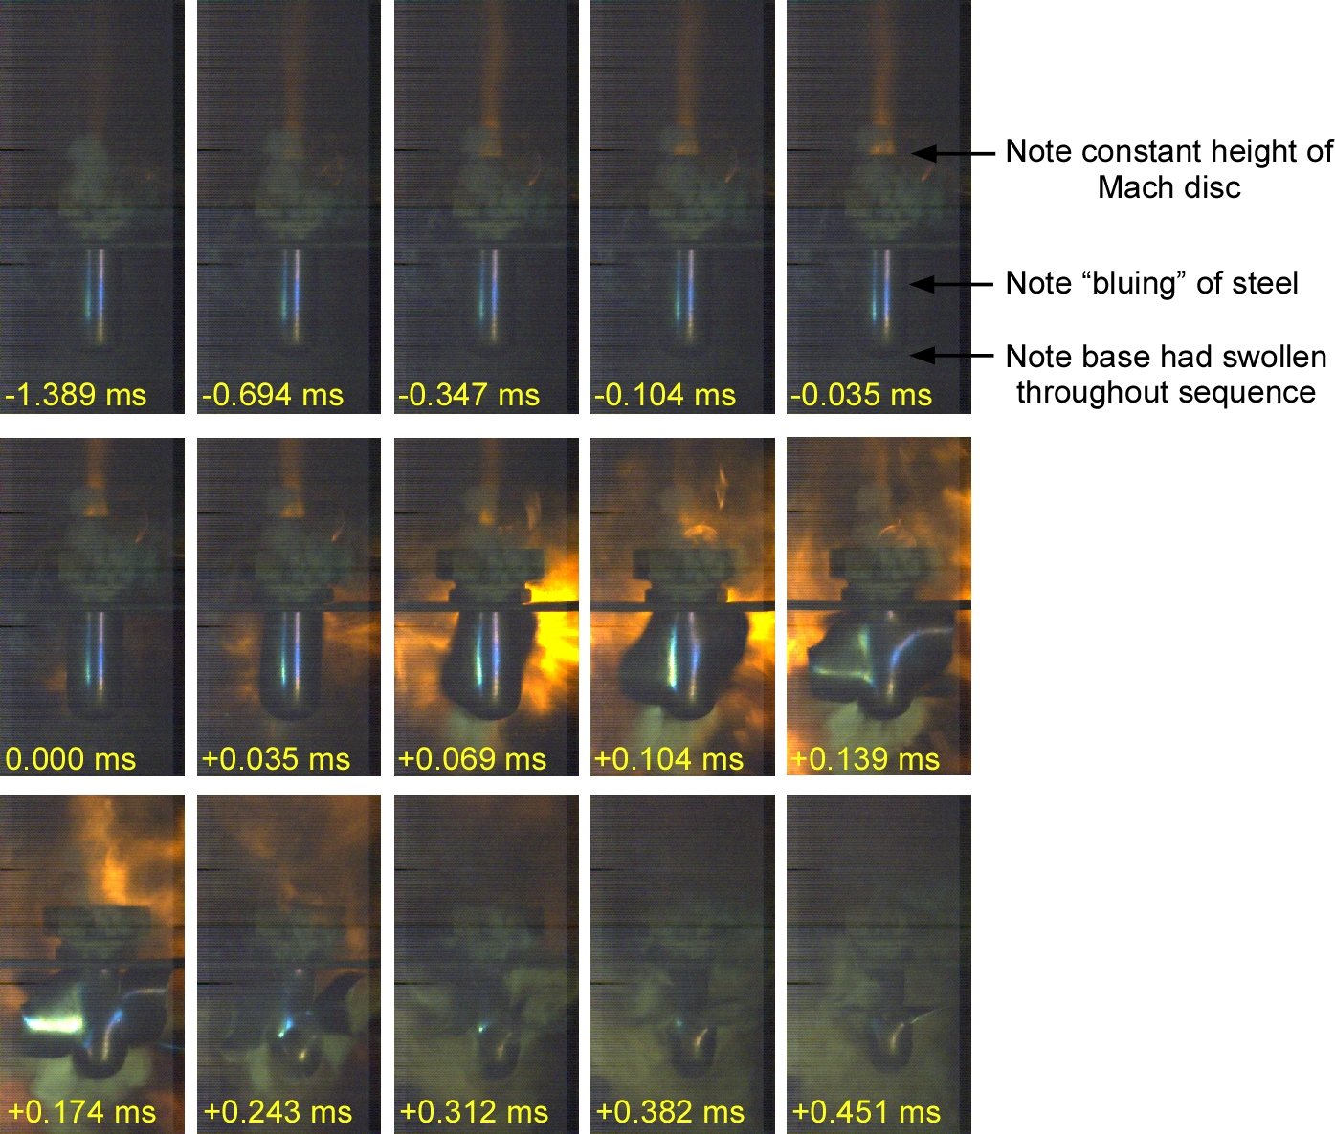
Figure 9
Selected frames from a high speed video recorded at 28,800 fps of the explosion of ANE V2P in the Koenen test with a Ø2 mm orifice. The rupture occurred after 134 s of heating.
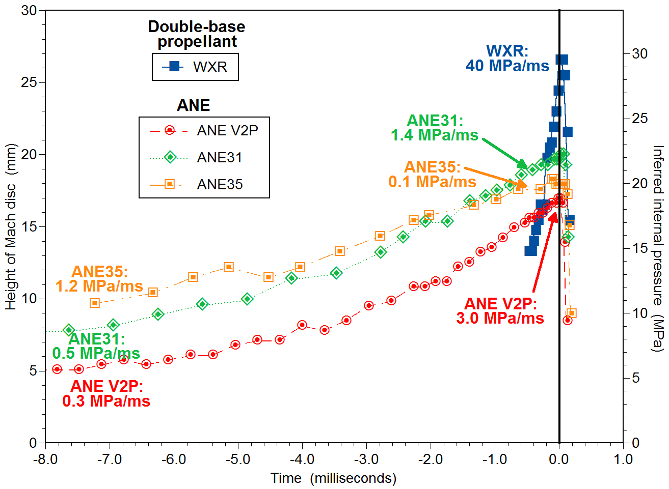
Figure 10
Height of Mach disc in venting gases from three typical ANE in the Koenen test, compared with the data for the slowest burning double-base propellant from Figure 8. Time zero was defined as the frame in which the first rupture was visible. The internal pressurisation rates were calculated assuming the tubes burst once the pressure reached 30 MPa.
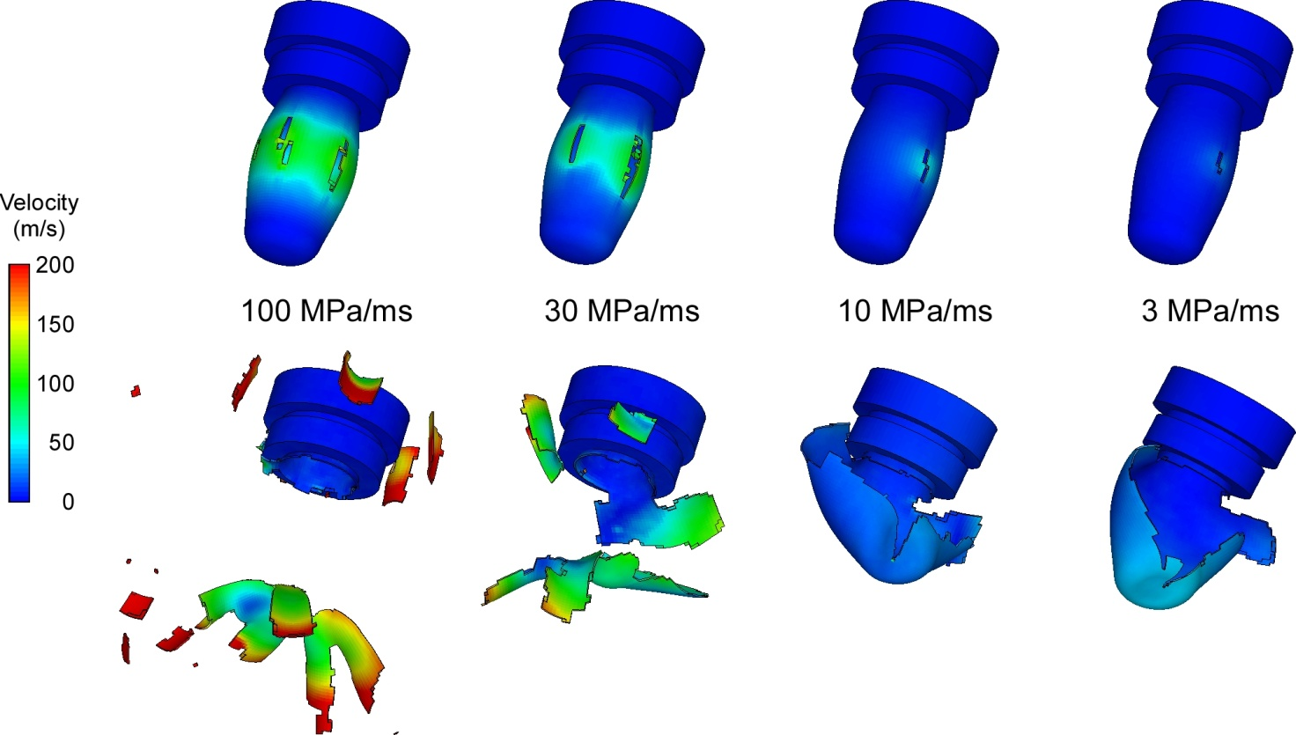
Figure 11
AUTODYN-3D simulation of rupture of Koenen steel tubes at a uniform temperature of 25°C, pressurised uniformly at various constant internal pressurisation rates. The upper images show the predicted velocity distributions at the time of first rupture, while the lower images show the distributions after the fragmentation has occurred.
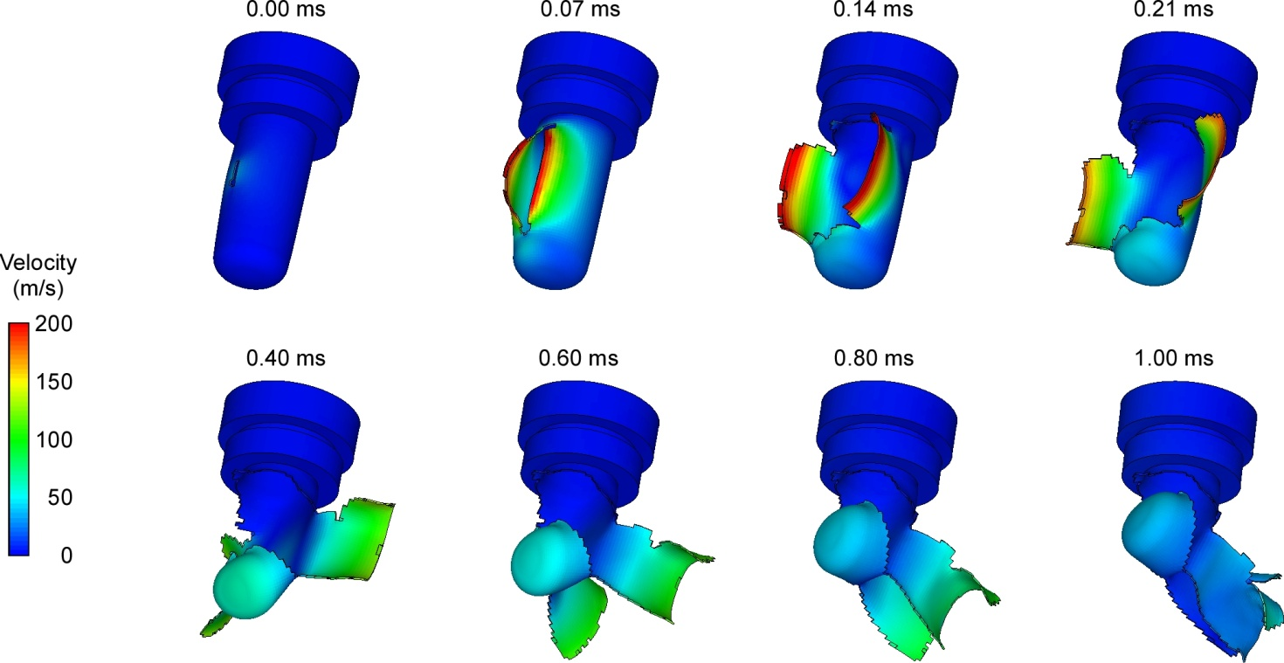
Figure 12
AUTODYN-3D simulation of rupture of a Koenen steel tube uniformly pressurised internally at the constant pressurisation rate of 3 MPa/ms when most of the tube has been heated to 300°C, but the region affected by the flame from the left-hand burner has been heated to 400°C.
_______________

Informal document INF.45 (24th session)
David Kennedy and David Coutts, “High-Speed Photography and Numerical Simulation of the UN 2(b) & 8(c) Koenen Tests”, IGUS Conference, Berlin, 2012.
D.C. Pack, “On the Formation of Shock-Waves in Supersonic Gas Jets”, Q. J. Mech. Appl. Math. 1(1) (1948) pp. 1-17.
Michael L. Norman and Karl-Heinz A. Winkler, “Supersonic Jets”, Los Alamos Science, Spring/Summer 1985, pp. 39-70.

