 | United Nations | ST/SG/AC.10/C.3/2014/53
 | Secretariat |  | Distr.: General  4 April 2014  Original: English
Committee of Experts on the Transport of Dangerous Goods
and on the Globally Harmonized System of Classification
and Labelling of Chemicals
Sub-Committee of Experts on the Transport of Dangerous Goods
Forty-fifth session
Geneva, 23 June – 2 July 2014
Item 2 (b) of the provisional agenda
Explosives and related matters: review of test series 6
Manual of Tests and Criteria
Proposed field-portable gas fuel UN 6(c) test assembly
Transmitted by the expert from the United States of America
Background
- At the previous session of the Sub-Committee of Experts on the Transport of Dangerous Goods, the United States of America described research in the development of a practical and field-portable gas fuel UN test 6(c) assembly (see informal document INF.47, 44th session).
- According to the current Manual of Tests and Criteria section 16.6.1.3 procedure for conducting the Test 6(c) external fire (bonfire test): “Suitable methods of heating include a wood fire using a lattice of wooden laths, a liquid or gas fuel fire, that produces a flame temperature of at least 800 °C”. Furthermore, section 16.6.1.3.4 states that: “If gas is to be used as a fuel, the burning area must extend beyond the packaging or unpackaged articles to a distance of 1.0 m in every direction. The gas must be supplied in such a manner to ensure the fire is evenly distributed around the packages. The gas reservoir should be large enough to keep the fire burning for at least 30 minutes. Ignition of the gas may be accomplished either by remotely ignited pyrotechnics or by remote release of the gas adjacent to a pre-existing source of ignition.”
Discussion
3. Much type 6(c) testing is still conducted with wood-fuel, even though there are advantages of using a gas fuel over a wood fuel fire such as sustainable constant temperature and less post-test clean-up. Similarly, there are advantages using gas fuel over liquid fuel including lack of heavy black smoke and less temperature variability.
4. The proposed gas fuel burner assembly is approximately 2.5 square meters (m²) when complete and fabricated of carbon steel with inlets for gas at either end. A 32 minute field trial was conducted to demonstrate the feasibility and other possible benefits such as lower thermal flux noise from fuel. In order to maintain constant flame temperature of approximately 800°C for the 32 minutes, twelve (12) cylinders surrounded with a sufficiently sized ambient temperature water bath were used. The trial consumed approximately 8.3-8.4 kg/min (16.9-17.1 l/min) over all 12 cylinders or approximately 0.7 kg/min (1.4 l/min) per cylinder. This trial was instrumented with thermal flux gauges and successfully met the general criteria for a gas fuelled 6(c) fire as detailed in paragraph 2.
5. An additional trial was conducted with propellant to see if thermal flux measurements obtained using a gas-fed 6(c) bonfire test would prove advantageous when compared to other fuels (liquid and wood) Two packages of propellant were placed on the test stand and thermal flux gauges were positioned at 5, 10, and 15 m away from two adjacent sides of the fire. The results of this trial indicate that there may be some advantage to utilizing a gas fed fire for determining thermal irradiance of a material.
6. The annex to this paper includes diagrams for the prototype field-portable Test 6(c) gas fuel burner assembly. The Sub-Committee is invited to review the information provided and to provide any comments on the adequacy of the test apparatus and procedure in applying the Manual of Tests and Criteria Test Series 6(c) directly to Mr. Brian Vos at brian.vos@dot.gov.

Annex

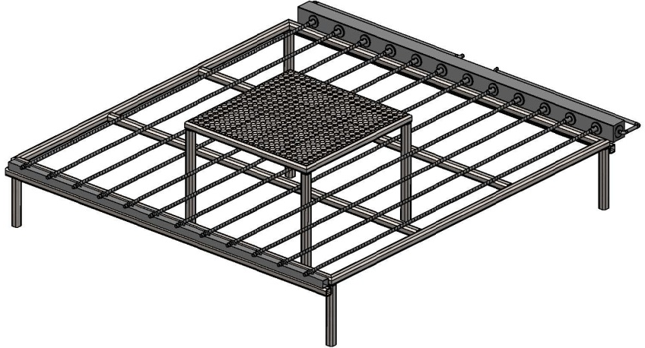

Figure 1: Proposed USA gas-fueled Test 6c burner assembly
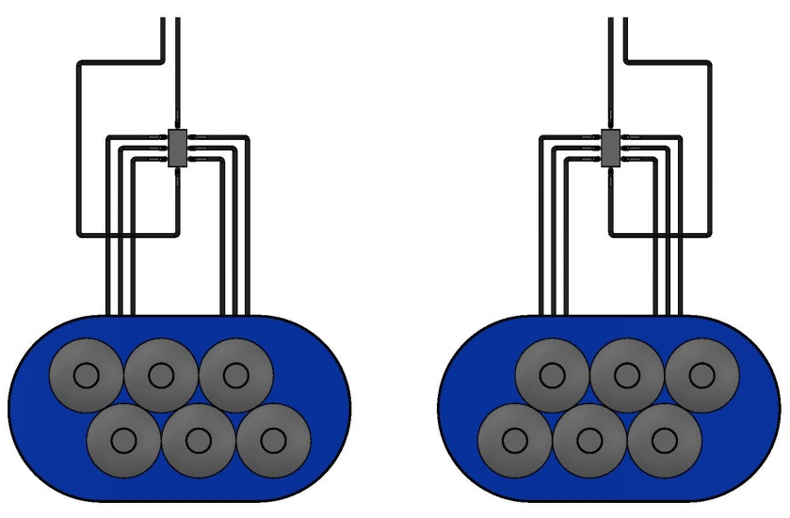
75 liter propane tanks
Quantity 12 total
8 way manifold.
Steel tube welded closed with 8 valves.
6 lines feed propane gas into manifold,
2 output valves allow gas to travel to burner
A total of 4 outlet are directed to the burner
All lines are 2 cm in diameter rubber gas hoses
75 liter propane tanks are set-up in two identical configurations.
6 tanks per side, strapped together and standing in a trough of water 50 cm high.
(Water troughs are 91 cm in height, galvanized steel construction, wall thickness is 4.5 mm). Each trough holds 757 litres of water. This set-up will prevent the propane tanks from freezing over during the 30 min burn duration.

Figure 2: Proposed USA gas-fueled Test 6c
Propane source and distribution

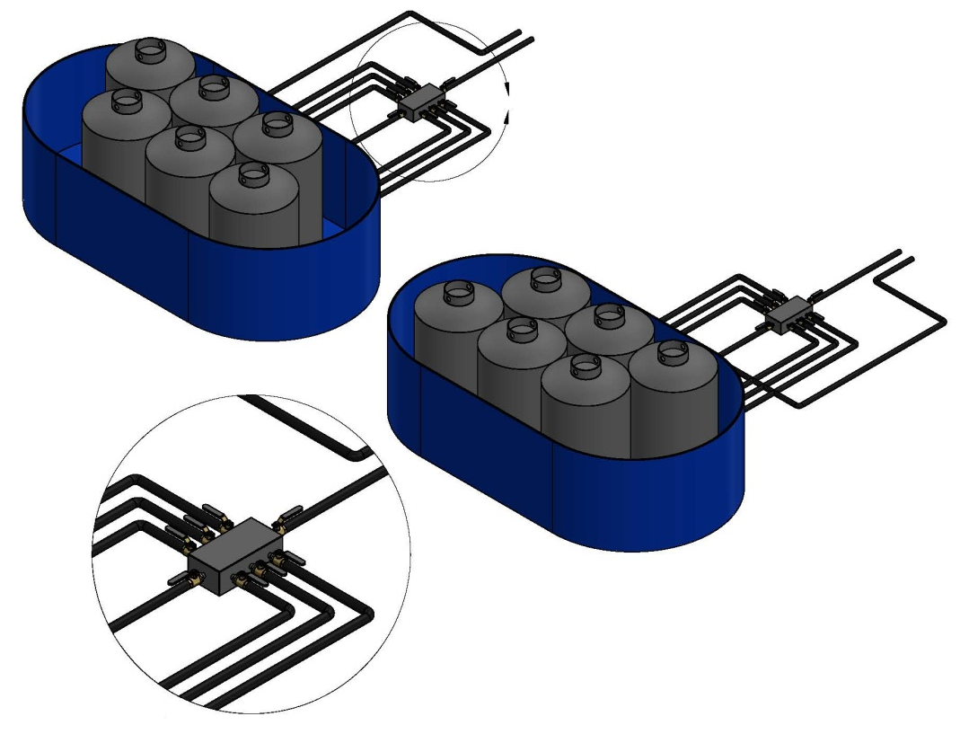
NOTE : 4 gas lines total go to burner. There should be at a minimum 25 meters of black steel pipe (1.9 cm diameter) between rubber gas lines and actual burner. This will prevent any radiant heat damage to the hoses, and prevent any accidents.
Detail A
Scale 1 :14

Figure 3: Proposed USA gas-fueled Test 6c burner assembly
Propane source and distribution

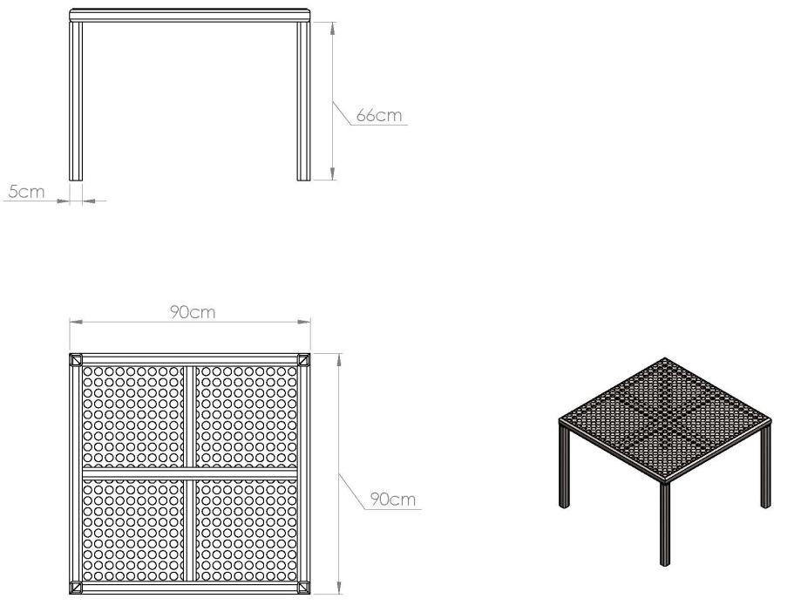
Burner grate is constructed out of welded 5cm × 5 cm square tube steel. The top is expanded steel lath to allow radiant heat to pass through and act as stand/table. Legs will pass between burner bars and be supported on ground.

Figure 4: Proposed USA gas-fueled Test 6c burner assembly
Burner grate

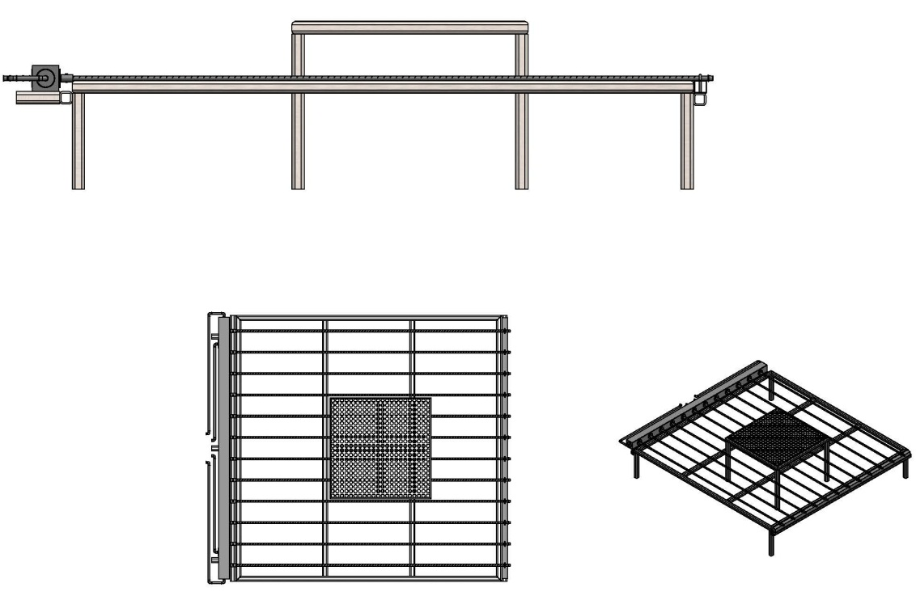

Figure 5: Proposed USA gas-fueled Test 6c burner assembly
Burner assembly

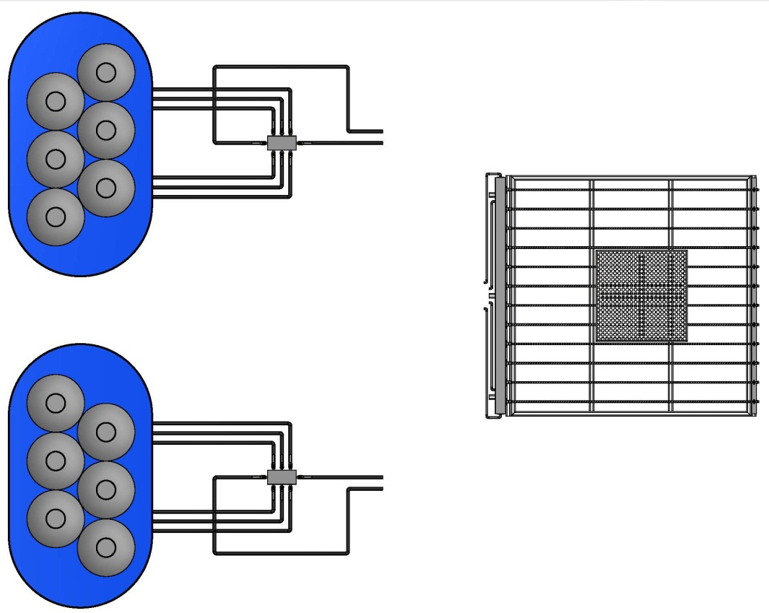
SAFETY NOTE :
The propane (gas) source should be set back 50 meters from the open flames, this is to protect the tanks from falling debris during the test. Just in general practice, all tanks, rubber hoses, and manifolds before the steel leader pipes should be protected in some manner to keep the test as safe as possible.
NOTE : Use long enough leader pipes from burner to hose to prevent hose damage due to heat. A minimum of 25 meters is recommended.

Figure 6: Proposed USA gas-fueled Test 6c burner assembly
Propane and burner assembly
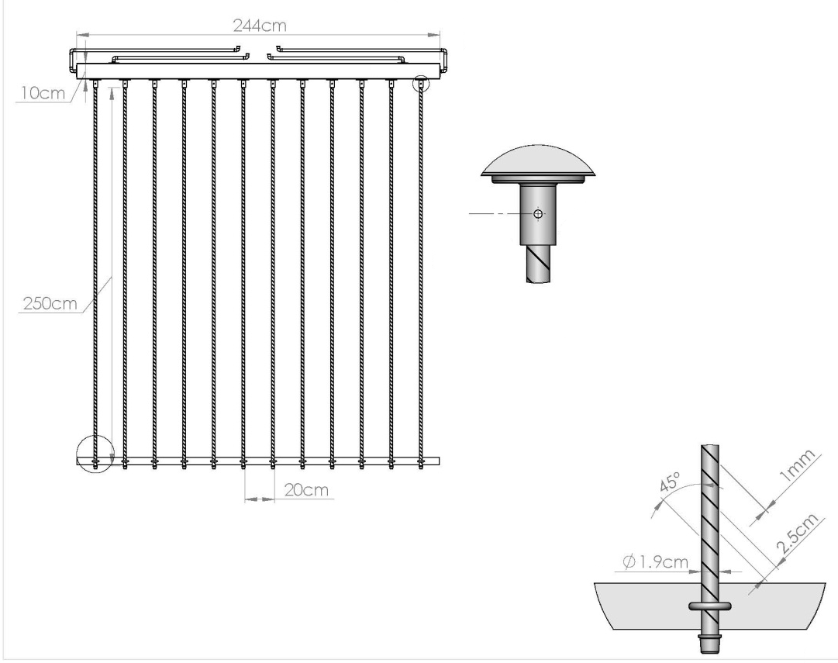
DETAIL B
SCALE 1:3
DETAIL A
SCALE 1:4
Steel manifold is 10 cm×10 cm, 244 cm long, 0.6 cm wall thickness. Burner pipes are slip fitted to the manifold and held with a bolt. The far end of the pipe is capped. Four leader gas pipes are directed away and connected to the four rubber gas lines via the propane source
This detail “B” view shows the 3 cm diameter, 5 cm long steel pipe for the split fit. A simple hole drilled through allows a bolt to hold the pipe in its place. This allows for easy set-up and dismantle. Slip fit receiver is welded to manifold.
12 burner tubes, black steel pipe, 2.5 meters long. The 1 mm slots are spaced 2.5 cm apart to keep a precise flow of gas. The depth of the cut is one half the diameter of the pipe.
NOTE : Burner pipes can be secured at the end with U-bolts or similar. The 5 cm× 5 cm steel tube keeps an equal distance between the pipes. Must be mounted to steel frame to keep rigidity during testing.

Figure 7: Proposed USA gas-fueled Test 6c burner assembly
Burner construction
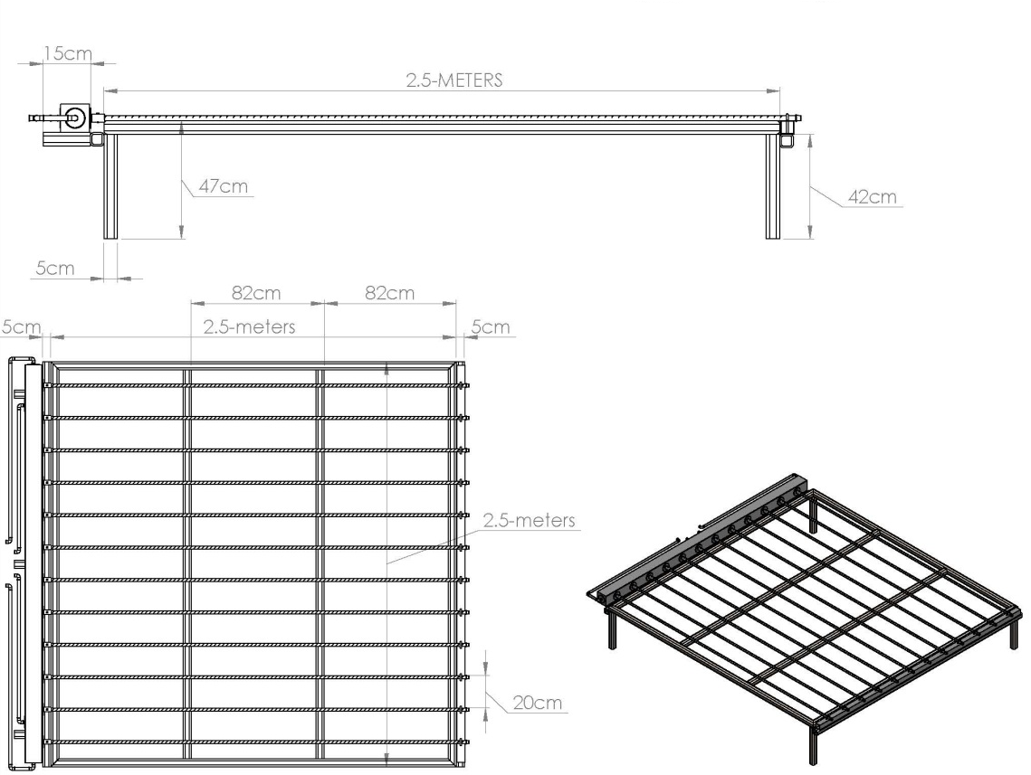
Steel base frame is made of 5 cm square tubing. 4 legs are 42 cm long. Centre supports helps with deformation of gas pipes.
Both ends of the frame have 5 cm square tube welded at 42 cm in height. This allows the burner assembly to lay flat across the frame to prevent deformation during the burn process. Burner assembly can be clamped to frame.

Figure 8: Proposed USA gas-fueled Test 6c burner assembly
Base frame

In accordance with the programme of work of the Sub-Committee for 2013-2014 approved by the Committee at its sixth session (refer to ST/SG/AC.10/C.3/84, para. 86 and ST/SG/AC.10/40, para. 14).

