Assessment of the neck rotation during simulated slow speed rear impact using Hybrid III crash test dummy as per Global Technical Regulation 7 (GTR7)

Abstract:

The vehicle seating systems are provided with head restraints to control whiplash injuries arising out of unrestrained rearward movement of the occupant head. GTR7 has established methods of assessing effectiveness of these head restraints.
The dynamic assessment involves a slow speed sled test (ΔV = 17.3 kmph) with Hybrid III crash test dummy positioned on the seat and exposed to decelerations in the rear direction. Following parameters are the assessment criteria:
- Head Injury Criteria (HIC) – calculated by processing the deceleration of the dummy head,
- Neck Rotation with respect to the Torso.

The second criterion, neck rotation, is a new criteria. Hybrid III does not contain any instrumentation capability for this measurement. GTR 7 document does not explain about any specific equipment & procedure for measuring the head rotation v/s torso i.e. neck rotation.

This paper describes Neck Rotation measurement thru high speed photographic analysis . New extension arms were developed for Torso of Hybrid III dummy for fixing of the marker stickers for the photography purpose. (The same has been applied for patent vide IPA 2543/Mum/2009).

Schematic diagrams showing Torso extension bracket for Hybrid III 50th percentile anthropometric crash test dummy.

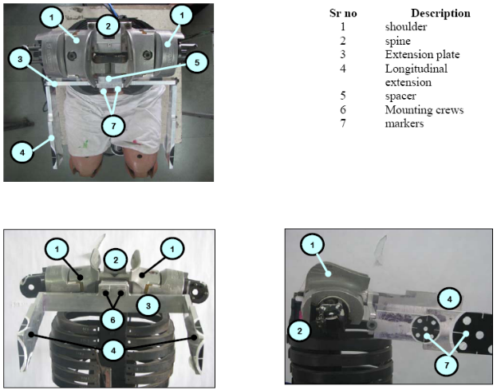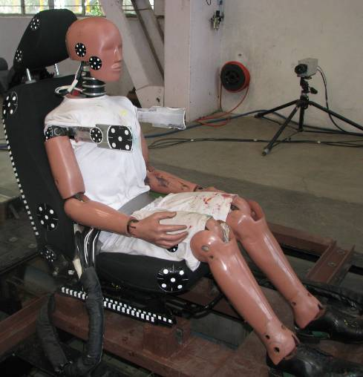

½
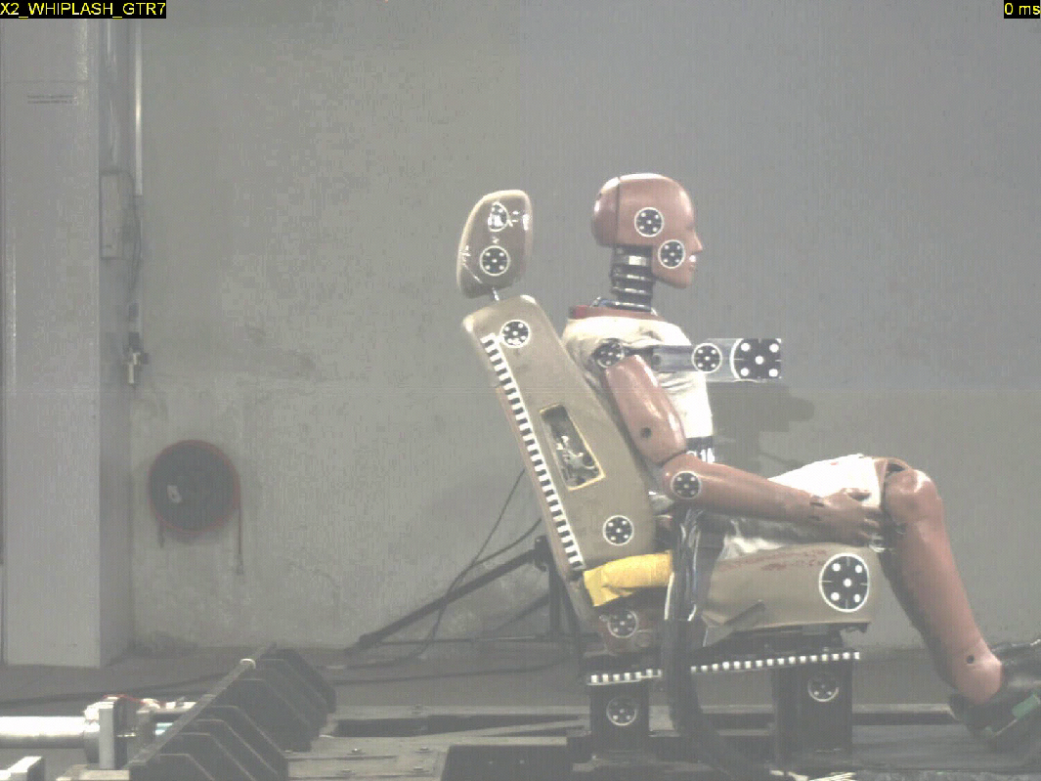
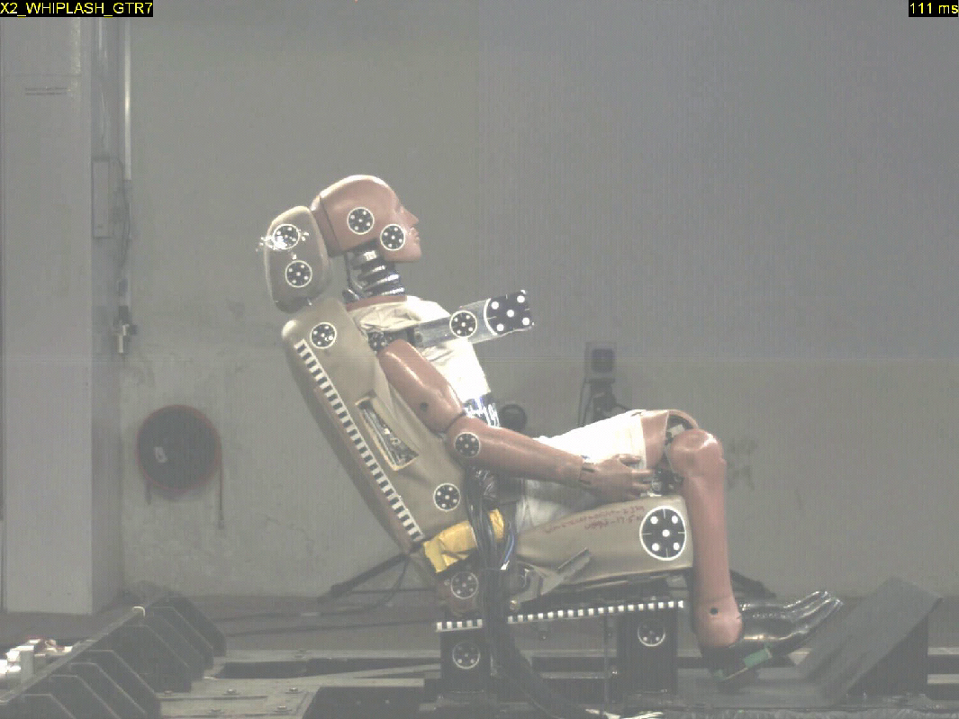
Time = 0
Time = at max head extension
Head rotation wrt torso = Δθ - Δφ
Δθ
Δφ

2/2

