Transmitted by the expert from Japan. | Informal Document No. GRE-61-13  (61th GRE, 30 March －3 April 2009  agenda item 4(c))

Information of middle-side direction indicator lamps,
provided at the centre of both sides of motor vehicles, that are mandatory in Japan

Note: This information pertains to the UK proposal (GRE2009/3, GRE/INF/60-14) on additional side direction indicator lamps.
Japan has been introducing the following measures since 1978, and has reduced significantly "caught-in accidents" of large-sized trucks.

1. Items of the Measures
a: Provision of middle-side direction indicator lamps
(to make visible more clearly to vulnerable road users)
b: Provision of under mirrors and improvement of mirrors
(to improve driver’s indirect vision)
c: Improvement of side guards of large-sized trucks
(to prevent vulnerable road users from being caught under the vehicle body)

2. Implementation
With respect to above items a, b and c,

New model vehicles: Ministry of Transport (Ministry of Land, Infrastructure, Transport and Tourism) issued emergency measures on 4 October 1978. These measures are applied to vehicles produced on and after 1 November 1978.

Vehicles already available on the market: Safety Regulations were revised on 15 March 1979. All large-sized vehicles (approximately amount 560,000 vehicles in Japan) conformed to the revised regulations by 31 October 1980.

3. Details of Safety Regulations concerned to middle-side direction indicator lamps

[Installation]

4–6 Direction indicator lamps

4–6–1 Presence (See Figure 1.)

Direction indicator lamps shall be installed to motor vehicles. …

4–6–2 Performance of lamps, etc. to be installed

Direction indicator lamps shall conform to the provisions in Paragraph 1, Article 59 of this regulation.

Direction indicator lamps shall be classified, according to its arrangement, as categories 1, 1a, 1b, 2a, 2b, 3, 5, 6 and direction indicator lamps to be installed at the centre on both sides of large-sized trucks, etc., as provided for in Attachment “Technical Standard for Direction Indicator Lamps.”

4–6–3 Number

The number of direction indicator lamps shall be as prescribed in Paragraph 4–6–4 according to its mounting position.

4–6–4 Arrangements (See Figure 1)

4–6–4–1 Motor vehicles shall be provided with one direction indicator lamp of the category posted in the right column of the following table on both sides at the front end …

4–6–4–2 Motor vehicles shall be provided with one or two direction indicator lamps …

4–6–4–3 Motor vehicles (except ordinary-sized motor vehicles with a gross vehicle weight of 8 tons or more or with a maximum loading capacity of 5 tons or more (except tractors drawing semi-trailers, motor vehicles with a passenger capacity of 11 persons or more and motor vehicles which have a shape similar to motor vehicles with a passenger capacity of 11 persons or more. Hereinafter referred to as the “large-sized trucks, etc.”) …
The categories of vehicles that shall be provided with direction indicator lamps are decided on the basis of vehicle weight.

4–6–4–4 Large-sized trucks, etc. shall be provided with direction indicator lamps of category 6 at the front end on both sides (except trailers) as well as direction indicator lamps at the centre on both sides.

4–6–4–5 Tractors (……) shall be provided with direction indicator lamps in compliance with the requirements of Paragraphs 4–6–4–1 through 4–6–4–3 in the coupled condition.

4–6–4–6 Tractors and trailers which are categorized as large-sized trucks, etc. shall be provided with direction indicator lamps at the centre on both sides in compliance with the requirement of Paragraph 4–6–4–4. …

4–6–4–7 Motor vehicles …

4–6–5 Installation position

4–6–5–1 Direction of transverse plane

The direction indicator lamps of categories 1, 1a, 1b, 2a and 2b to be installed at the front and rear ends on both sides of a motor vehicle shall be fitted …

4–6–5–2 Vertical direction

The direction indicator lamps …… shall be fitted in such a way that the height of the lower edge of the illuminating surface thereof must not be less than 350 mm above the ground (……) and that the height of the upper edge must not be more than 1,500 mm above the ground (that the upper edge of the illuminating surface thereof may be at a height up to 2,300 mm for direction indicator lamps to be mounted on large-sized special motor vehicles, …

4–6–5–3 Horizontal direction (See Figure 1)

4–6–5–3–1 The direction indicator lamps …

4–6–5–3–2 Notwithstanding the provision of Paragraph 4–6–5–3–1 …

4–6–5–3–3 The direction indicator lamps to be installed at the centre on both sides of large-sized trucks, etc. provided for in Paragraph 4–6–4–4 and the direction indicator lamps to be installed at the centre on both sides of tractors which are categorized as large-sized trucks, etc. provided for in Paragraph 4–6–4–6 shall be fitted within 2.5 m from the rear end at the outside of the driver’s compartment or the passenger compartment (or within 4.5 m from the front end of the motor vehicle in the case of trailers).

4–6–5–3–4 The direction indicator lamps (except those to be installed at the centre on both sides of large-sized trucks, etc. provided for in Paragraph 4–6–4–4) to be installed on both sides of tractors and trailers which are categorized as large-sized trucks, etc. provided for in Paragraph 4–6–4–6 shall be fitted in such a way that the foremost edge of the illuminating surface thereof may be within 60% of the length from the front end of the trailer.
4–6–6 Geometrical visibility

4–6–6–1 The visibility of the apparent surface of the direction indicator lamp …

4–6–6–2 Notwithstanding the provision of Paragraph 4–6–6–1 …

4–6–6–3 The direction indicator lamps to be installed at the centre on both sides of large-sized trucks, etc. shall be fitted in such a way that the illuminating surface can be visible from every position of the height from 1 m to 1.6 m above the ground in the plane 1 m apart from the outermost side of the motor vehicle, which is parallel to the vertical plane in respect to the longitudinal centre plane of the motor vehicle, and extending from the point 1 m ahead from the installation position of the said direction indicator lamp to the rear end of the motor vehicle.
Geometric angles of visibility

[Lamp requirements]

3−3 Of the direction indicator lamps which are designed to be provided on the centre of each side of a large-sized truck, those meeting the following standard may be deemed to conform to Article 41 of the Safety Regulations.

3−3−1 The light source shall be 15 watts or more but 60 watts or less. The projected area of the indicating surface on the longitudinal central plane of the vehicle shall be not less than 40 cm² and the projected area of the indicating surface on the vertical area intersecting with an angle of 45° to the said longitudinal central plane shall be not less than 40 cm².

3−3−2 The luminous intensity at an outermost direction indicator lamp shall be 3.0 candela, at any point of the height from 1 m to 1.6 m in the plane 1 m apart from the outermost side of the vehicle, which is parallel with the vertical plane in respect to the centre line of the motor vehicle, and extending from the point 1 m ahead from the position of said direction indicator lamp to the rear end of the vehicle.

3−3−3 The color of light emitted shall be amber.
Middle side direction indicator lamp
45゜
1m
1m
Cab back～2.5m
45゜
Apparent surface(A,B,C) ≧ 40ｃ㎡
light source：15W～60W
Ａ
C
B
1m
1.6m
Ground
In this area the apparent surface of the lamp must be visible.

Ｆｉｇｕｒｅ １

4. Explanation

The countermeasures to prevent "caught-in accidents" were implemented in Japan, intending the type of vehicles that had a high incidence of "caught-in accidents" in those days.
However, there are differences between the Japanese regulation and ECE regulation. For example, In the Japanese regulation the intended vehicle category is determined according to the weight and the specific provisions pertain to the lamp wattage, while in ECE regulation it determined based on the length and, the luminous intensity.

In order to effort for the harmonization of the N2, N3, M2 and M3 vehicles, we will prepare to examine the possibility of redefining the basis of the intended vehicle category (weight to length) and specific provisions (wattage to luminous intensity) so that the Japanese regulation about the middle-side direction indicator lamps can be incorporated into ECE regulation after making slight modifications.

[Advantages of middle-side direction indicator lamps]

* Since the lamp illuminates not only rearward but also forward, the geometric range of visibility extends widely, making visible more clearly to the vulnerable road users.

* Because the positions and number of the lamps to be provided are designated for the single-truck, the tractor and the trailer respectively, the number of the lamps is clearly defined and the wire breakage detecting function works well without a problem regardless of the combination in which the vehicles are connected. When connecting the vehicles, the driver is able to only concentrate on the connecting work and does not need to pay special attention to the specification of the lamps. If each trailer were provided with the lamps of different specifications, the driver would have to confirm the lamp specifications of the trailer and need switching the flasher relay whenever connecting the vehicles. In this case the wire breakage detecting function will not work properly when the driver has switched the flasher relay wrong. And a safety hazard will be caused.
The tractor is equipped with a circuit that detects whether the trailer is connected to the tractor, and then the circuit (flasher circuit) operates based on the result of the detection.
For most of the trucks on the market, electric power is supplied through the flasher relay to the front, side and rear lamps. If the value of the supplied electric current is normal level, the lamps will blink in the specified period, and if the current is abnormal level, the lamps change the blinking mode to notify the driver that an abnormality (wire breakage) was occurred.
This relate to the power supplied by the flasher unit on the tractor. The blinking frequency of the flasher lamp is influenced by the electric power (the value of electric current) of the lamp used on the trailer.

The UK proposal is intended on large-sized motor vehicles of categories N2, N3, M2 and M3. We also would like to introduce to you the efforts made by Japan to prevent caught-in accidents of large-sized motor vehicles of categories N2, N3, M2 and M3 vehicles, to promote the further harmonization.
We hope that Japan’s experience in taking account the problem of "caught-in accidents" about 30 years ago, which resulted in reducing the incidence, will serve as a reference in resolving similar problems.
We submitted a proposal regarding the middle-side direction indicator lamps to GTR, but the deliberation at GTR has been suspended. (5th GRE-gtr informal meeting, Ottawa, 7-11 June 2004 Working Paper No. GRE-gtr-5-6)
[Benefits of countermeasures]
Benefits of contermeasures against caught-in accidents caused by left-turning large goods vehicles

Ratio of fatal accidents caused by left-turning vehicles [%]
(=Number of fatal accidents caused by left-turning vehicles of intended category/ number of all types of fatal accidents caused by vehicles of intended category)

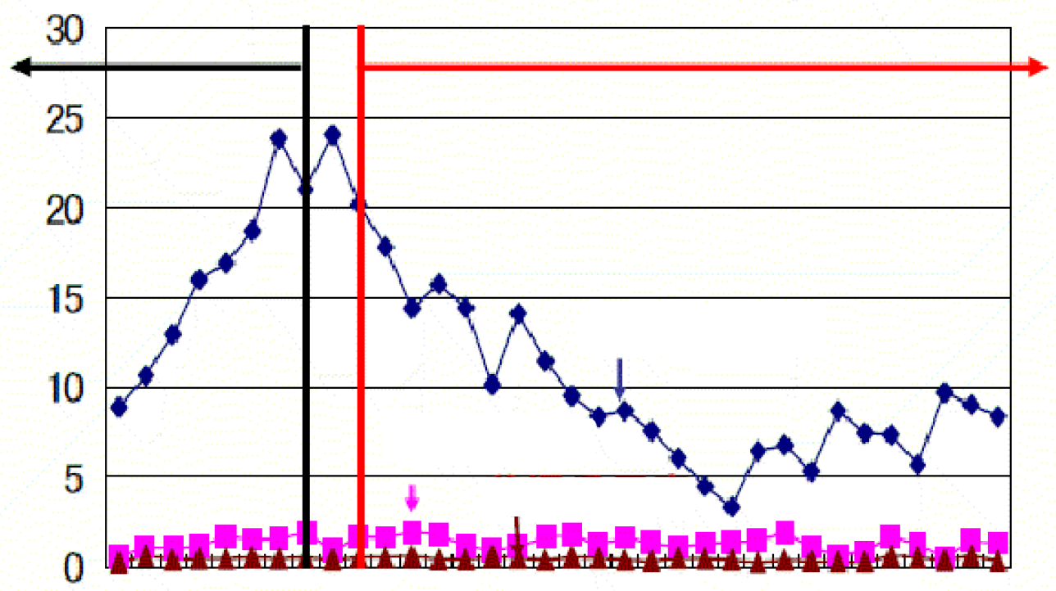
In 1977, a mother and two children riding on a bicycle were caught in a left-turning truck in Tokyo. Caught-in accidents caused by left-turning vehicles have since been recognized as serious problems.
In 1979, vehicle structure standards of large goods vehicles were tightened.
1970
1972
1974
1976
1978
1980
1982
1984
1986
1988
1990
1992
1994
1996
1998
2000
2002
Large goods vehicle
Standard-sized goods vehicle
Standard-sized passenger vehicle

Number of fatal accidents caused by left-turning vehicles per hundred million vehicle kilometer

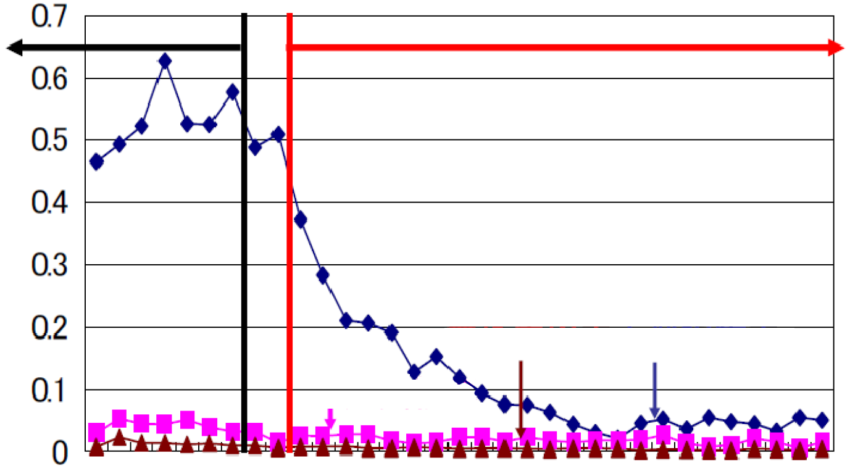
In 1977, a mother and two children riding on a bicycle were caught in a left-turning truck in Tokyo. Caught-in accidents caused by left-turning vehicles have since been recognized as serious problems.
In 1979, vehicle structure standards of large goods vehicles were tightened.
Large goods vehicle
Standard-sized goods vehicle
Standard-sized passenger vehicle
1970
1972
1974
1976
1978
1980
1982
1984
1986
1988
1990
1992
1994
1996
1998
2000
2002

[Installation examples]
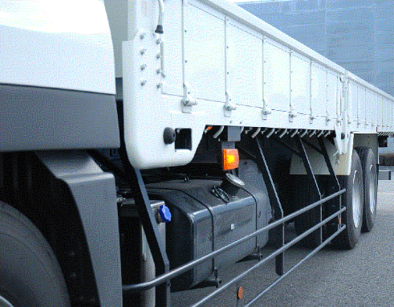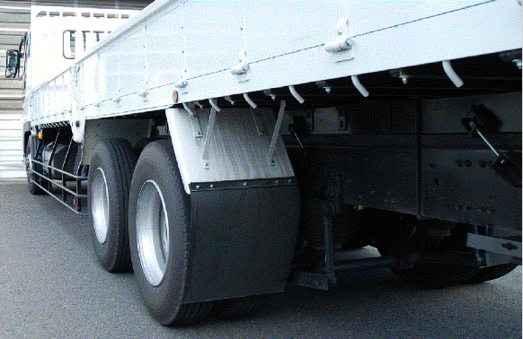
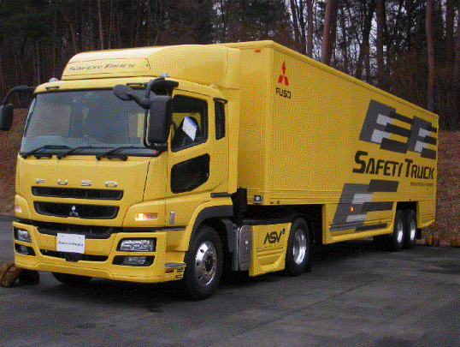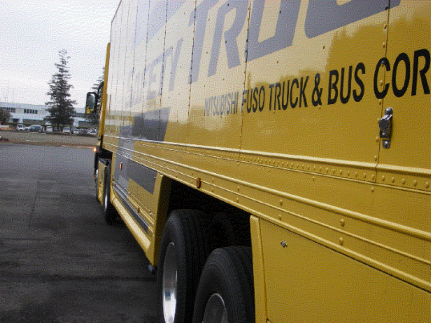

[Introduction of countermeasures against accidents other than those relating to lamps]
<Vehicles>
* Under mirror (b)
* Guard bar (c)
* Sound buzzer
* Window at the bottom of the door of the front passenger seat
<Improvement of traffic road environment and traffic rules>
* Two-stage stop lines (Provide the stop line of motorcycles ahead of that of motor vehicles)
* Two-stage right turns of bicycles and motorized bicycles
* Improvement of pavements, provision of bicycle lanes and school zones and designation of roads
on which large-sized vehicles are prohibited to turn right or left
<Awareness-raising activity>
* Safety education for pedestrians and bicycle users on the prevention of accidents caused by left-turning motor vehicles

