UN/SCETDG/36/INF.3

COMMITTEE OF EXPERTS ON THE TRANSPORT OF
DANGEROUS GOODS AND ON THE GLOBALLY
HARMONIZED SYSTEM OF CLASSIFICATION
AND LABELLING OF CHEMICALS

Sub-Committee of Experts on the

Transport of Dangerous Goods

Thirty-sixth session
Geneva, 30 November – 9 December 2009

Item 5 of the provisional agenda

MISCELLANEOUS PROPOSALS OF AMENDMENTS TO THE MODEL REGULATIONS ON THE TRANSPORT OF DANGEROUS GOODS

Possible use of flexible bulk container for the transport of dangerous goods

Transmitted by the International Dangerous Goods and Containers Association (IDGCA)

Annexes to ST/SG/AC.10/C.3/2009/51
Annex 1

Routes and volumes of bulk cargo
transportation by combined transport
in flexible nonexpendable containers МК-14-10

Item No. | Route (kind of transport) | Distance, km | Qty, th. tonnes
-1- | -2- | -3- | -4-
1. | Astrakhan – Taganrog commercial seaport (Russia): Granulated sulfur (Cl. 4.1, No.ООН 1350) | 937 | 36.7
1.1 | Motor transport: Plant "Astrakhangazprom" – River port in Set. Buzan on the Volga (Russia) | 27 | 36.7
1.2 | River-sea vessel: River port in Set. Buzan – Taganrog commercial seaport (Russia) | 910 | 36.7
2. | Astrakhan – Tuapse commercial seaport (Russia): Granulated sulfur (Cl. 4.1, No.ООН 1350) | 1,249/1,036 | 28.05
2.1 | Open railway car: Enterprise "Astrakhangazprom" – Tuapse/Taganrog commercial seaport (Russia) | 1,249/1,036 | 28.05
3. | Gorlovka – Mariupol commercial seaport (Ukraine): coal-tar pitch (Cl. 9 No.ООН 3077) | 176 | 181.3
3.1 | Support service open railway car: Through the territory of Gorlovka "Smolopererabatyvayushchy zavod" (Ukraine) | 1 | 181.3
3.2 | Open railway car: Gorlovka "Smolopererabatyvayushchy zavod" – Mariupol commercial seaport (Ukraine) | 175 | 181.3
4. | Berezniki – seaport Vostochny in Nakhodka (Russia): Potassium chloride (Cl. 5.1, No.ООН 1485) | 8,220 | 32.9
4.1 | Motor transport: Through the territory of "Uralkali" enterprises (Россия) | 1 | 32.9
4.2 | Open railway car: enterprise "Uralkali" – seaport Vostochny in Nakhodka (Russia) | 8,219 | 32.9
5. | Berezniki (Russia) – Lasi (Romania): Potassium chloride (Cl. 5.1, No.ООН 1485) | 3,187 | 16.5
5.1 | Motor transport: Through the territory of "Uralkali" enterprises (Россия) | 2 | 16.5
5.2 | Open railway car: "Uralkali" enterprise (Russia) – Lasi (Romania) | 3,185 | 16.5

6. | Solikamsk – Saint-Petersburg commercial seaport (Russia): Potassium chloride (Cl. 5.1, No.ООН 1485) | 2,020 | 11.8
6.1 | Open railway car: enterprise "Silvinit" – Saint-Petersburg commercial seaport (Russia) | 2,020 | 11.8
7. | Berezniki – Taganrog commercial seaport (Russia): Potassium sulfate | 2,707 | 12.2
7.1 | Motor transport: Through the territory of "Uralkali" enterprises (Россия) | 4 | 12.2
7.2 | Open railway car: "Uralkali" enterprise – Taganrog commercial seaport (Russia) | 2,703 | 12.2
8. | Norilsk (Russia) – Harjavalta (Finland): Nickel concentrate | 7,390 | 5.83
8.1 | Motor transport: Through the territory of the MMC "Norilsk Nickel" plant | 1 | 5.83
8.2 | Open railway car: Norilsk – Dudinka commercial seaport (Russia) | 60 | 5.83
8.3 | Sea vessel: Dudinka commercial seaport – Arkhangelsk commercial seaport (Russia) | 2,730 | 5.83
8.4 | Motor transport: Arkhangelsk commercial seaport – Arkhangelsk office-branch of "Nornickel" | 1 | 5.83
8.5 | Motor transport: Arkhangelsk office-branch of "Nornickel" – Arkhangelsk commercial seaport | 1 | 5.83
8.6 | Sea vessel: Arkhangelsk commercial seaport (Russia) – Pori commercial seaport (Finland) | 4,527 | 5.83
8.7 | Motor transport: Pori commercial seaport – "Norilsk Nickel Harjavalta Oy", Harjavalta (Finland) | 70 | 5.83
9. | Nikolaev (Украина) – Krasnoyarsk/ Sayanogorsk (Russia): Aluminum hydroxide (alumina) | 4,796  4,841  4,821 | 2,511.4
9.1 | Motor transport: "Nikolevsky Glinozyomny Zavod" – Dnieper-Bug commercial seaport, Nikolaev (Ukraine) | 1 | 2,511.4
9.2 | Sea vessel: Dnieper-Bug seaport (Ukraine) – Taganrog commercial seaport/Rostov-on-Don river port/Novorossiysk commercial seaport (Russia) | 945/  1,050/  700 | 2,511.4
9.3 | Open railway car: Taganrog commercial seaport/ Rostov-on-Don river port/Novorossiysk commercial seaport (Russia) – Krasnoyarsk/ Sayanogorsk aluminium plants (Russia) | 3,850/  3,790/  4,120 | 2,511.4
10. | Balakleya (Ukraine) – railway station Zahony (Hungary): Cement | 1,261 | 48.2
10.1 | Motor transport: Through the territory of cement plant "Balcem", Balakleya | 1 | 48.2
10.2 | Open railway car: Enterprise "Balcem", railway station Shebelinka, Balakleya (Ukraine) – railway station Zahony (Hungary) | 1,260 | 48.2
11. | Set. Zimovniki – Novorossiysk commercial seaport (Russia): Grain | 600 | 22.1
11.1 | Open railway car: Grain elevator in Set. Zimovniki – Novorossiysk commercial seaport (Russia) | 600 | 22.1
12. | Cossack village Kholmskaya – Novorossiysk commercial seaport (Russia): Grain | 100 | 14.7
12.1 | Motor transport: Grain elevator in cossack village Kholmskaya – Novorossiysk commercial seaport (Russia) | 100 | 14.7
13. | Selizharovo town – Ust-Luga commercial seaport (Russia): Pellets | 705 | 42.6
13.1 | Motor transport: Wood-working plant in Selizharovo – railway station Selizharovo | 5 | 42.6
13.2 | Open railway car: Railway station Selizharovo – Ust-Luga commercial seaport (Russia) | 700 | 42.6
14. | Kingisepp – Ust-Luga commercial seaport (Russia): deftuorinated calcium phosphate | 63 | 23.9
14.1 | Support service flat car: Through the territory of plant "Phosphorit" of MCC "EuroChem" | 1 | 23.9

Annex 2

Feedbacks

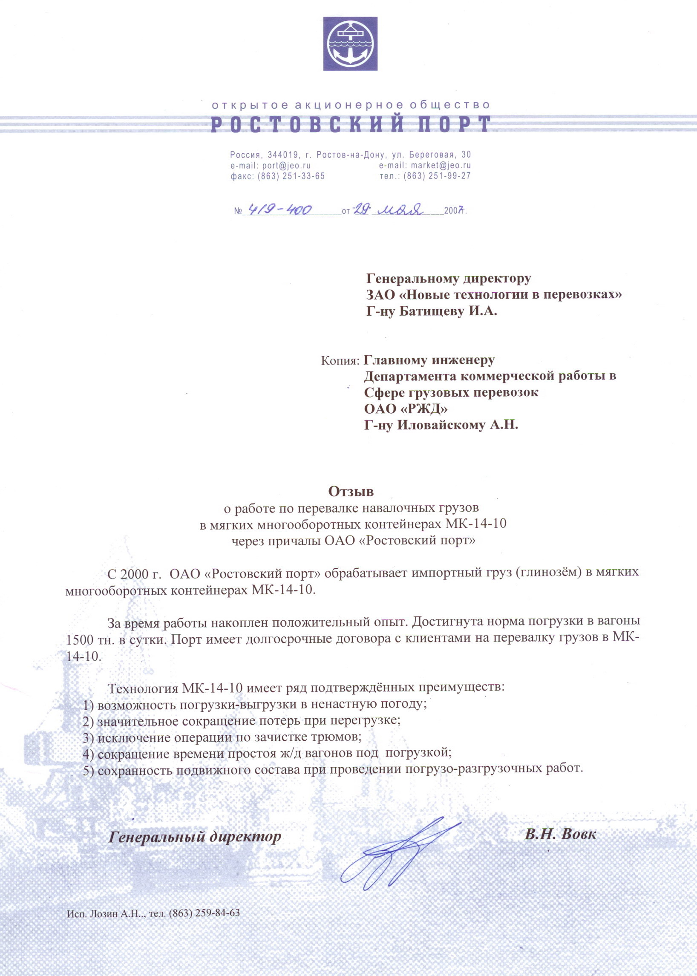

Open Joint Stock Company
Rostov Port
Russia, 344019, Rostov-on-Don, Beregovaya Str., 30
e-mail: port@jeo.ru email: market@jeo.ru
Fax: (863) 251-33-65 tel: (863) 251-99-27

No 4190400 of May 29^{th,} 2007

To: Managing Director
CJSC New Technology in Transportation
Mr. Igor. A. Batichtchev

Copy to: Сhief Engineer
Department of Commercial Operations in Freight Transportation
OAO Russian Railways
Mr. A. N. Ilovaysky

Feedback
On bulk freight transloading
in Flexible Bags (MK), flexible intermediate containers up to 14 MT capacity (MK- 14-10)
at the OJSC Rostov Port docks

Since 2000, OJSC Rostov Port has been handling foreign cargo (alumina) in Capital Bags CB-14-10.

During this period our experience has been largely positive. The rates of railway car loading have reached 1,500 ton daily. The port has long-term agreements with clients for cargo transloading in Flexible Bags МК-14-10.

Flexible Bags MK-14-10 have a range of proven advantages:
- possibility of loading-discharging in bad weather conditions
- significant reduction of losses in transloading
- elimination of cargo hold cleaning procedure
- reduction in the idle time of railway cars before loading
- cause no damage to the rolling stock during loading-discharging.

General Director
V. N. Vovk
/signature is affixed/

Executed by: A. N. Lozin, tel (863) 259-84-63

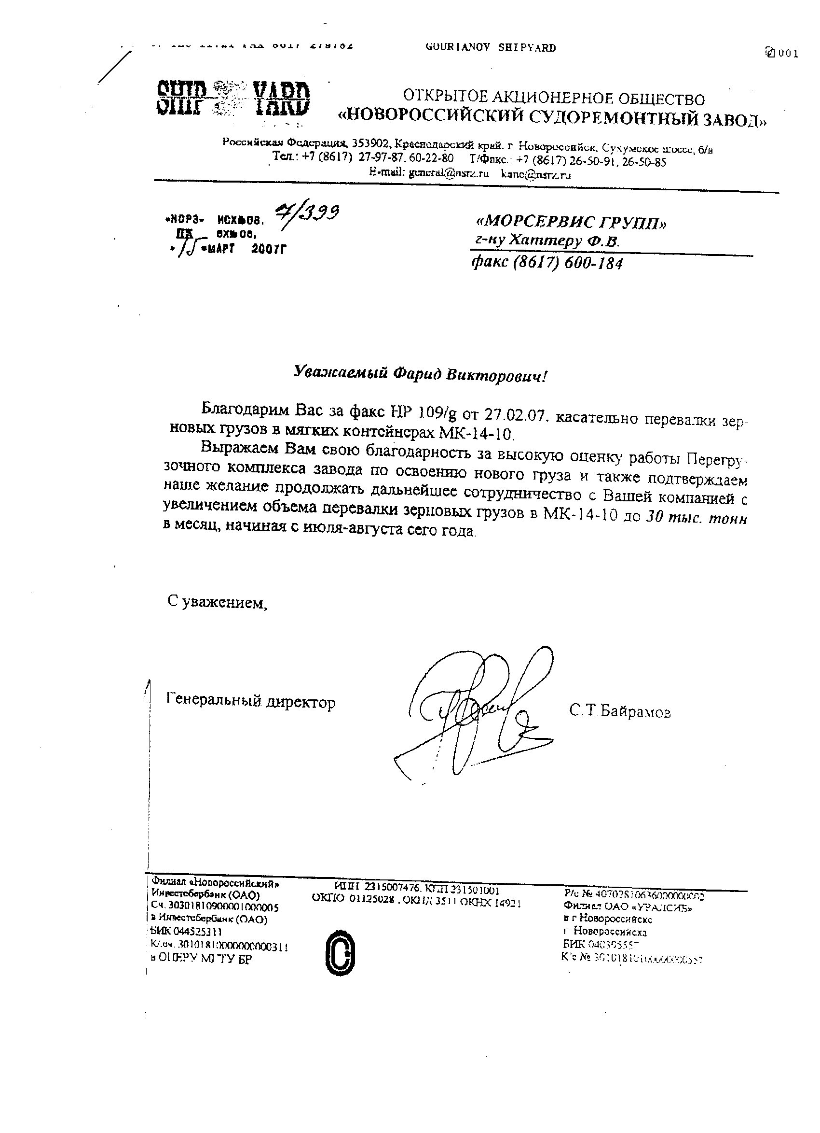

Open Joint Stock Company

Open Joint Stock Company
Novorossiysk Shipyard
Russian Federation, 353902, Krasnodar Region, Novorossiysk, Sukhumskoye Highway, 6/B
Tel: +7 (8617) 27-97-87, 60-22-80
Tel/ fax: +7 (8617) 26-50-91, 26-50-85
e-mail: general@nsrz.ru kanc@nsrz.ru

NORZ Outgoing 08 7/399  NK Incoming 08  March 15, 2007 | To: Morservice Group  Mr. A. D. Hattner  Fax (8617) 600-184

Dear Farid Viktorovich!

Thank you for you for the fax NP 109/g of 27.02.07 referring to grain freight transloading in Flexible Bags (MK), flexible intermediate containers up to 14 MT capacity.

We would like to express our gratitude for your high opinion of our Shipyard Transshipment Complex operations on handling new cargo. We also confirm our intention to continue cooperation with your company by increasing the volume of grain freight for transloading in Flexible Bags up to 30 thousand ton per month, starting from July-August this year.

Regards,
General Director
S. T. Bayramov
/signature is affixed/

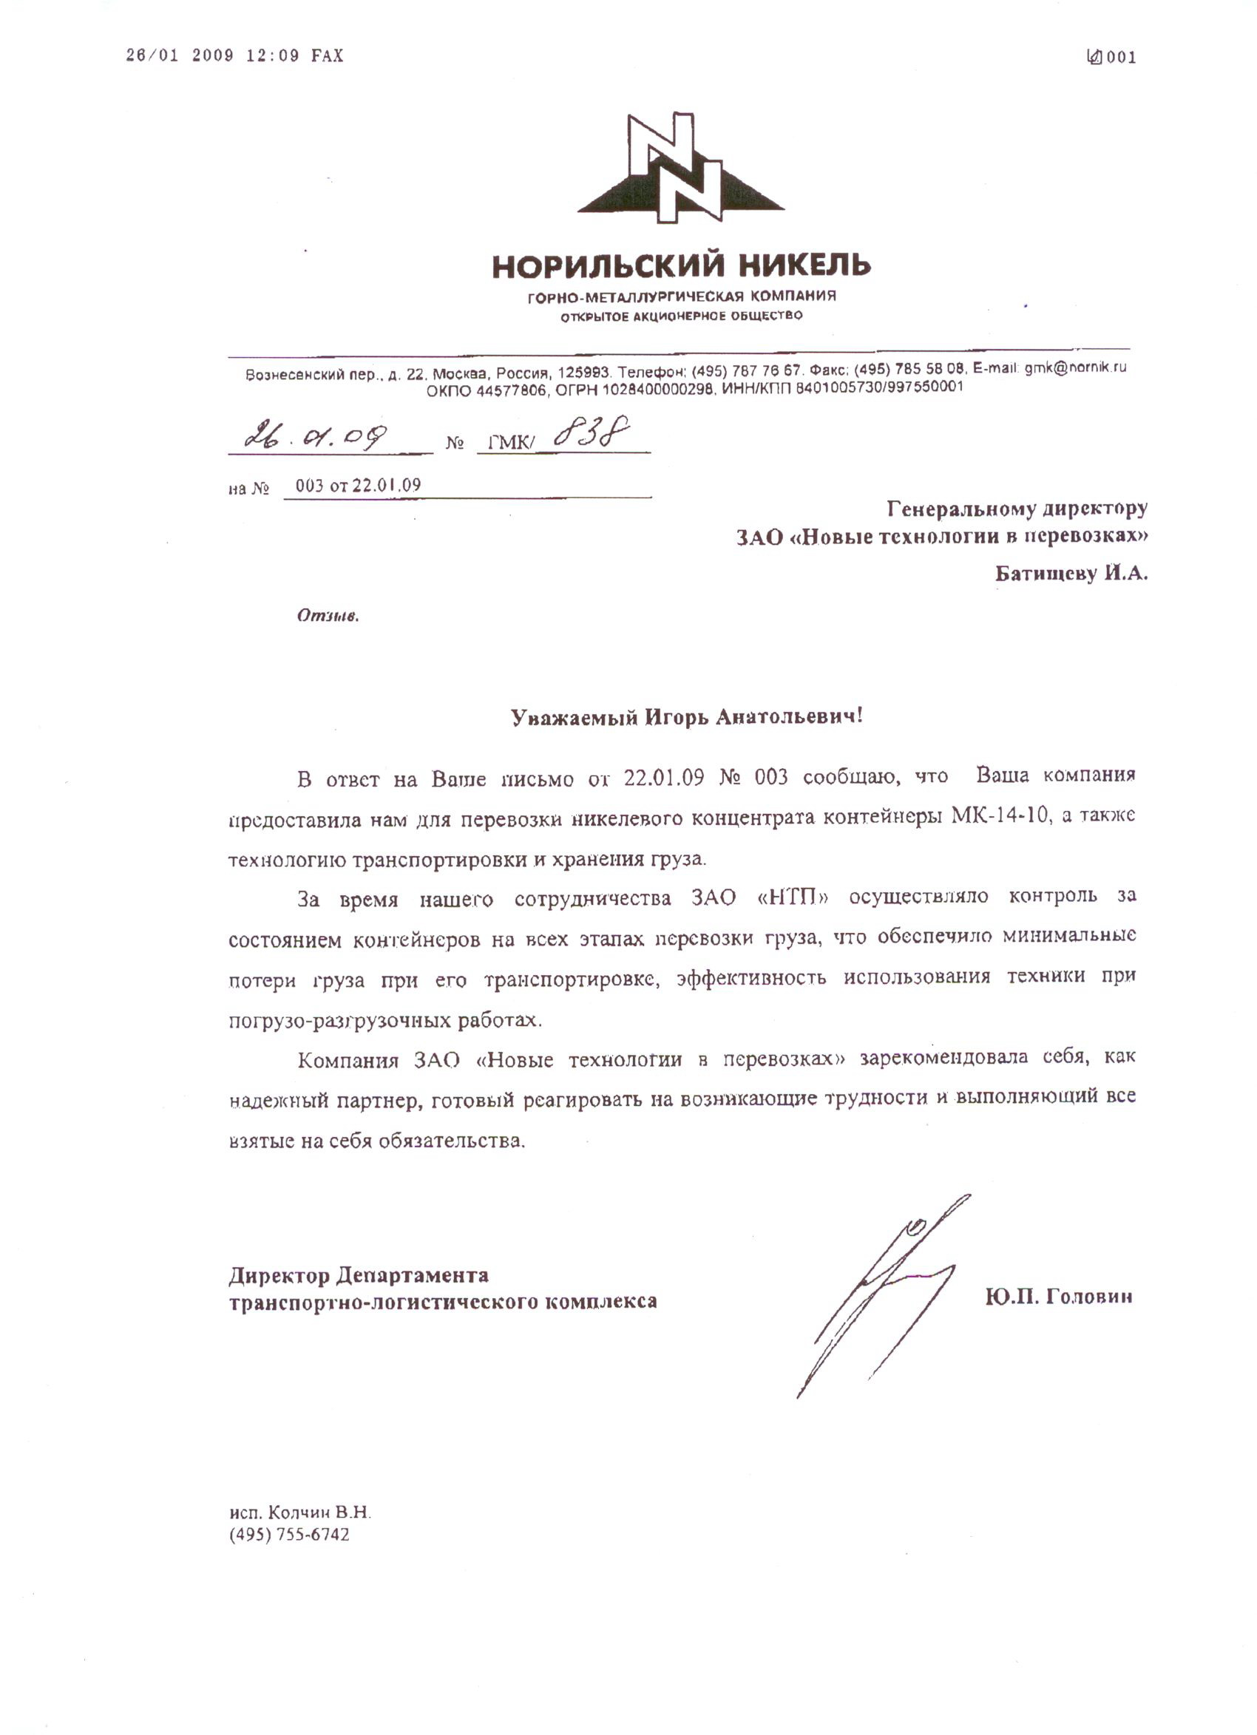

Norilsk Nickel
Mining and metallurgical company
Open joint stock company
Voznesensky Lane, 22, Moscow, Russia, 125993 Telephone (495) 767 76 57
Fax (495) 785 58 08e-mail: gme@nornik.ru
OKPO 44577806
OGRN 1028400000298
INN/KPP 8401005730/997550001

26.01.09 No GMK/ 838
for No 003 of 22.01.09

To: Managing Director
CJSC New Technology in Transportation
Mr. Igor. A. Batichtchev

Feedback

Dear Igor Anatolyevich,

In reply to your letter of 22.01.09 No 003, I would like to inform you that your company has provided us with Flexible Bags MK-14-10 for nickel concentrate shipment, as well as the technology for freight transportation and storage.

As we worked together, New Technology in Transportation was in charge of controlling the Flexible Bags condition at all cargo transportation stages, which ensured minimal cargo losses during transportation and the efficient use of equipment in loading and discharging.

New Technology in Transportation CJSC has proved to be a reliable partner that promptly responds to any arising challenges and duly performs its obligations.

Director of Transport and Logistics Department
Yu. P. Golovin
/Signature is affixed/

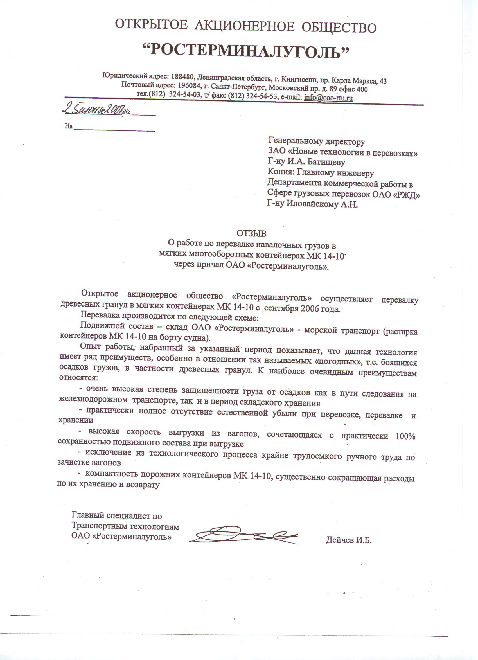

Open Joint Stock Company

ROSTERMINALUGOL
Registered address: 188480, Leningrad Region, Kingisepp, Karl Marx Prospekt, 43
Postal address: 196084, St. Petersburg, Moskovsky Prospekt, 89, Office 400
Tel (812) 324-54-03, Tel/ fax: (812) 324-54-53, e-mail: info@oao-tru.ru

June 25, 2007 No

To: Managing Director
CJSC New Technology in Transportation
Mr. Igor. A. Batichtchev

Copy to: Chief Engineer
Department of Commercial Operations in Cargo Transportation
OAO Russian Railways
Mr. A. N. Ilovaysky

Feedback

On bulk freight transloading
in Flexible Bags (MK), flexible intermediate containers up to 14 MT capacity (MK 14-10)
at the OJSC Rosterminalugol dock

Open Joint Stock Company Rosterminalugol has been involved in wood pellet transloading in Flexible Bags (MK), flexible intermediate containers up to 14 MT capacity since September, 2000.

The transloading procedure is follows:
Rolling stock – OJSC Rosterminalugol warehouse – sea transport (unloading of Flexible Bags on board the freight vessel).

Our experience shows that this technology has several advantages, especially when it comes to cargo which should not be handled during precipitation, namely wood pellets. Most obvious advantages include:

- High protection of cargo from precipitation, both during railway transportation and warehouse storage;
- Almost total elimination of natural cargo loss during transportation, transloading and storage;
- Fast discharging from railway cars, combined with nearly the 100 per cent safe operation of the rolling stock when discharging
- Eliminates the need for extremely labor-intensive railway car cleaning
- Empty Flexible Bags are compact, which reduces their storage and return costs.

Chief Expert on Transportation Technologies
OJSC Rosterminalugol
I.B. Deichev
/Signature is affixed/

