UNITED  NATIONS |  | E
 | Economic and Social  Council | Distr.  GENERAL  ECE/TRANS/WP.15/AC.2/2008/7/Rev.1  12 March 2008  Original: ENGLISH
ECONOMIC COMMISSION FOR EUROPE

INLAND TRANSPORT COMMITTEE

Working Party on the Transport of Dangerous Goods

Joint Meeting of Experts on the Regulations annexed to the
European Agreement concerning the International Carriage
of Dangerous Goods by Inland Waterways (ADN)
(ADN Safety Committee)

Thirteenth session
Geneva, 17-18 June 2008
Item 4 of the provisional agenda

PROPOSALS FOR AMENDMENTS TO THE REGULATIONS ANNEXED TO ADN

9.3.4 Alternative constructions (tank vessels)

Transmitted by the Central Commission for the Navigation of the Rhine (CCNR)

1. The CCNR proposes to include in the Regulations annexed to ADN new provisions intended to allow alternative constructions for tank vessels (e.g. for cargo tanks of higher capacity, different distances between side walls and cargo tanks), as well as provisions concerning the procedures to follow in such cases.

2. The proposals to amend Part 9 of the Regulations are reproduced below. They contain also the results of an informal working group which has met in order to harmonize the German and English versions of this document (see ECE/TRANS/WP.15/AC.2/25, para. 22).

9.3.1.11.1 (a)
9.3.2.11.1 (a)
9.3.3.11.1 (a) Insert below the table: “Alternative constructions in accordance with 9.3.4 are permitted.”

9.3.1.11.2 (a) In the footnote 1 in 9.3.1.11.2 add at the end:
“Alternative constructions in accordance with 9.3.4 are permitted.”

9.3.2.11.7 At the end add a new sub-paragraph: "Alternative constructions in accordance with 9.3.4 are permitted".

Add a new section 9.3.4 to read as follows:

"9.3.4 Alternative constructions

9.3.4.1 General

9.3.4.1.1 The maximum permissible capacity of a cargo tank in accordance with 9.3.1.11.1, 9.3.2.11.1 and 9.3.3.11.1 may be exceeded and the minimum distances in accordance with 9.3.1.11.2 a) and 9.3.2.11.7 may be deviated from provided that the provisions of this section are complied with. The capacity of a cargo tank shall not exceed 1000 m³.

9.3.4.1.2 Tank vessels whose cargo tanks exceed the maximum allowable capacity or where the distance between the side wall and the cargo tank is smaller than required, shall be protected through a more crashworthy side structure. This shall be proved by comparing the risk of a conventional construction (reference construction), complying with the ADN regulations with the risk of a crashworthy construction (alternative construction).

9.3.4.1.3 When the risk of the more crashworthy construction is equal to or lower than the risk of the conventional construction, equivalent or higher safety is proven. The equivalent or higher safety shall be proven in accordance with 9.3.4.3

9.3.4.1.4 When a vessel is built in compliance with this section, a recognised classification society shall document the application of the calculation procedure in accordance with 9.3.4.3and shall submit its conclusions to the competent authority for approval.

The competent authority may request additional calculations and proof.

9.3.4.1.5 The competent authority shall include this construction in the certificate of approval in accordance with 8.6.1.

9.3.4.2 Approach

9.3.4.2.1 The probability of cargo tank rupture due to a collision and the area around the vessel affected by the cargo outflow as a result thereof are the governing parameters. The risk is described by the following formula:

R = P • C

Wherein: R risk [m²],
P probability of cargo tank rupture [ ],
C consequence (measure of damage) of cargo tank rupture [m²].

9.3.4.2.2 The probability P of cargo tank rupture depends on the probability distribution of the available collision energy represented by vessels, which the victim is likely to encounter in a collision, and the capability of the struck vessel to absorb collision energy without cargo tank rupture. A decrease of this probability can be achieved by means of a more crashworthy side structure.
The consequence C of cargo spillage resulting from cargo tank rupture is expressed as an affected area around the struck vessel.
9.3.4.2.3 The procedure according to 9.3.4.3 shows how tank rupture probabilities shall be calculated as well as how the collision energy absorbing capacity of side structure and a consequence increase shall be determined.

9.3.4.3 Calculation procedure

9.3.4.3.1 The calculation procedure shall follow 13 basic steps. Steps 2 through 10 shall be carried out for both the alternative design and the reference design. The following table shows the calculation of the weighted probability of cargo tank rupture:

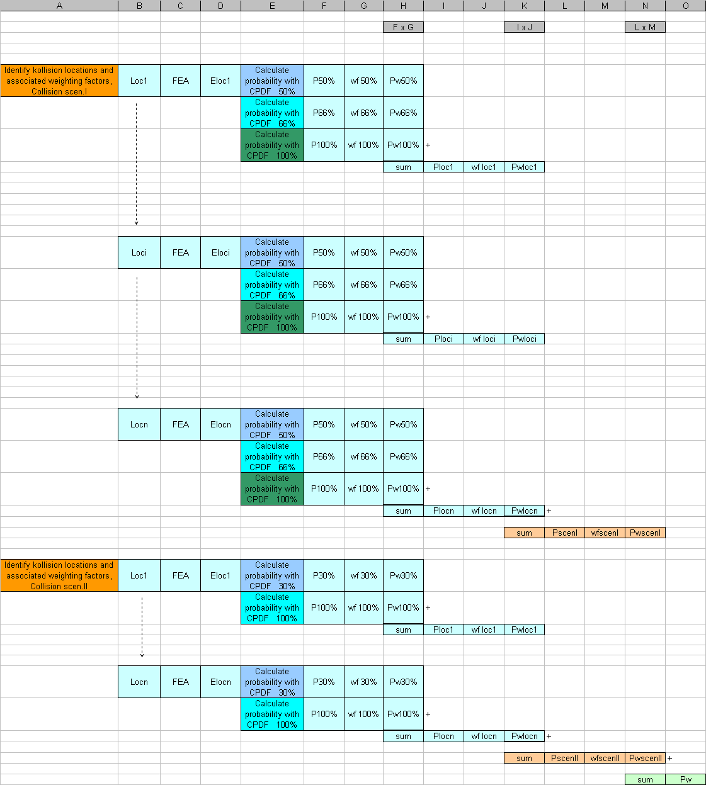

9.3.4.3.1.1 Step 1
Besides the alternative design, which is used for cargo tanks exceeding the maximum allowable capacity or a reduced distance between the side wall and the cargo tank as well as a more crashworthy side structure, a reference design with at least the same dimensions (length, width, depth, displacement) shall be drawn up. This reference design shall fulfil the requirements specified in section 9.3.1 (Type G), 9.3.2 (Type C) or 9.3.3. (Type N) and shall comply with the minimum requirements of a recognised classification society.

9.3.4.3.1.2 Step 2

9.3.4.3.1.2.1 The relevant typical collision locations i=1 through n shall be determined. The table in 9.3.4.3.1 depicts the general case where there are 'n' typical collision locations.

The number of typical collision locations depends on the vessel design. The choice of the collision locations shall be accepted by the recognised classification society.

9.3.4.3.1.2.2 Vertical collision locations

9.3.4.3.1.2.2.1 Tank vessel type C and N

9.3.4.3.1.2.2.1.1 The determination of the collision locations in the vertical direction depends on the draught differences between striking and struck vessel, which is limited by the maximum and minimum draughts of both vessels and the construction of the struck vessel. This can be depicted graphically through a rectangular area which is enclosed by the values of the maximum and minimum draught of both striking and struck vessel (see following figure).

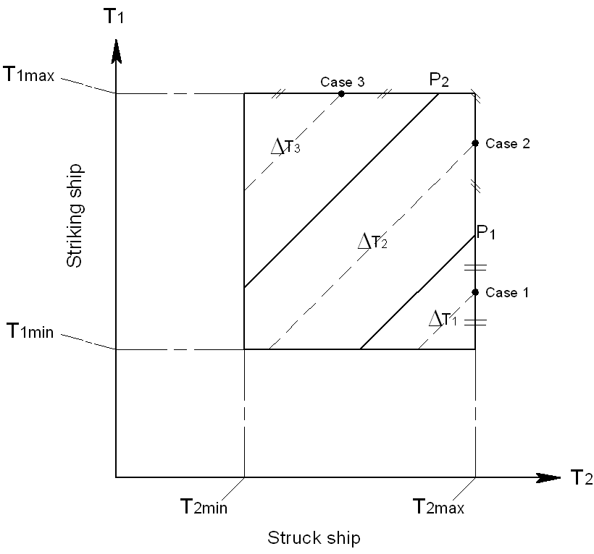

Definition of vertical striking locations

9.3.4.3.1.2.2.1.2 Each point in this area represents a possible draught combination. T_{1max} is the maximum draught and T_{1min} is the minimum draught of the striking vessel, while T_{2max} and T_{2min} are the corresponding minimum and maximum draughts of the struck vessel. Each draught combination has an equal probability of occurrence.

9.3.4.3.1.2.2.1.3 Points on each inclined line in the figure in 9.3.4.3.1.2.2.1.1 indicate the same draught difference. Each of these lines reflects a vertical collision location. In the example in the figure in 9.3.4.3.1.2.2.1.1 three vertical collision locations are defined, depicted by three areas. Point P₁ is the point where the lower edge of the vertical part of the push barge or V-bow strikes at deck level of the struck vessel. The triangular area for collision case 1 is bordered by point P₁. This corresponds to the vertical collision location “collision at deck level”. The triangular upper left area of the rectangle corresponds to the vertical collision location “collision below deck”. The draught difference ΔT_{i}, i=1,2,3 shall be used in the collision calculations (see following figure).

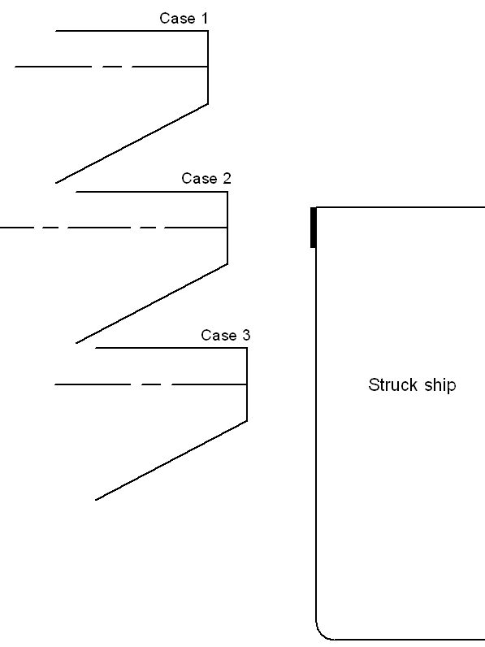
Striking ship

Example of vertical collision locations

9.3.4.3.1.2.2.1.4 For the calculation of the collision energies the maximum masses of both striking vessel and struck vessel must be used (highest point on each respective diagonal ΔT_{i}).

9.3.4.3.1.2.2.1.5 Depending on the vessel design, the recognised classification society may require additional collision locations.

9.3.4.3.1.2.2.2 Tank vessel type G

For a tank vessel type G a collision at half tank height shall be assumed. The recognised classification society may require additional collision locations at other heights. This shall be agreed with the recognised classification society.

9.3.4.3.1.2.3 Longitudinal collision location

9.3.4.3.1.2.3.1 Tank vessels type C and N

At least the following three typical collision locations shall be considered:

− at bulkhead,
− between webs and
− at web.

9.3.4.3.1.2.3.1 Tank vessel Type G
For a tank vessel type G at least the following three typical collision locations shall be considered:

− at cargo tank end,
− between webs and
− at web.

9.3.4.3.1.2.4 Number of collision locations

9.3.4.3.1.2.4.1 Tank vessel type C and N

The combination of vertical and longitudinal collision locations in the example mentioned in 9.3.4.3.1.2.1.3 and 9.3.4.3.1.2.3.1 results in 3 • 3 = 9 collision locations.

9.3.4.3.1.2.4.2 Tank vessel type G

The combination of vertical and longitudinal collision locations in the example mentioned in 9.3.4.3.1.2.2.2 and 9.3.4.3.1.2.3.2 results in 1 • 3 = 3 collision locations.

9.3.4.3.1.2.4.3 Additional examinations for tank vessels type G, C and N with independent cargo tanks

As proof that the tank seatings and the buoyancy restraints do not cause any premature tank rupture, additional calculations shall be carried out. The additional collision locations for this purpose shall be agreed with the recognised classification society.

9.3.4.3.1.3 Step 3

9.3.4.3.1.3.1 For each typical collision location a weighting factor which indicates the relative probability that such a typical collision location will be struck shall be determined. In the table in 9.3.4.3.1 these factors are named wf_{loc(i)} (column J). The assumptions shall be agreed with the recognised classification society.

The weighting factor for each collision location is the product of the factor for the vertical collision location by the factor for the longitudinal collision location.

9.3.4.3.1.3.2 Vertical collision locations

9.3.4.3.1.3.2.1 Tank vessel type C and N

The weighting factors for the various vertical collision locations are in each case defined by the ratio between the partial area for the corresponding collision case and the total area of the rectangle shown in the Figure in 9.3.4.3.1.2.2.1.1.

For example, for collision case 1 (see figure in 9.3.4.3.1.2.2.1.3) the weighting factor equals the ratio between the triangular lower right area of the rectangle, and the area of the rectangle between minimum and maximum draughts of striking and struck vessels.

9.3.4.3.1.3.2.2 Tank vessel type G

The weighting factor for the vertical collision location has the value 1.0, if only one collision location is assumed. When the recognised classification society requires additional collision locations, the weighting factor shall be determined analogous to the procedure for tank vessels type C and N.

9.3.4.3.1.3.3 Longitudinal collision locations

9.3.4.3.1.3.3.1 Tank vessel type C and N

The weighting factor for each longitudinal collision location is the ratio between the “calculational span length” and the tank length.

The calculational span length shall be calculated as follows:

(a) collision on bulkhead:
0.2 • distance between web frame and bulkhead, but not larger than 450 mm,

(b) collision on web frame:
sum of 0.2 • web frame spacing forward of the web frame, but not larger than 450 mm, and 0.2 • web frame spacing aft of the web frame, but not larger than 450 mm, and

(c) collision between web frames:
cargo tank length minus the length “collision at bulkhead” and minus the length "collision at web frame".

9.3.4.3.1.3.3.2 Tank vessel type G

The weighting factor for each longitudinal collision location is the ratio between the “calculational span length” and the length of the hold space.
The calculational span length shall be calculated as follows:

(a) collision at cargo tank end:
distance between bulkhead and the start of the cylindrical part of the cargo tank,

(b) collision on web frame:
sum of 0.2 • web frame spacing forward of the web frame, but not larger than 450 mm, and 0.2 • web frame spacing aft of the web frame, but not larger than 450 mm, and

(c) collision between web frames:
cargo tank length minus the length “collision at cargo tank end” and minus the length "collision at web frame".

9.3.4.3.1.4 Step 4

9.3.4.3.1.4.1 For each collision location the collision energy absorbing capacity shall be calculated. For that matter the collision energy absorbing capacity is the amount of collision energy absorbed by the vessel structure up to initial rupture of the cargo tank (see the table in 9.3.4.3.1, column D: E_{loc(i)}). For this purpose a finite element analysis in accordance with 9.3.4.4.2 shall be used.

            - These calculations shall be done for two collision scenarios according to the following table. Collision scenario I shall be analysed under the assumption of a push barge bow shape. Collision scenario II shall be analysed under the assumption of a V-shaped bow .

These bow shapes are defined in 9.3.4.4.8.

Table : Speed reduction factors for scenario I or scenario II with weighting factors

 |  |  |  |  | Causes
 |  |  |  |  | Communication error and poor visibility | Technical error | Human error
 |  |  |  |  | 0,50 | 0,20 | 0,30
Worst case scenarios | I | 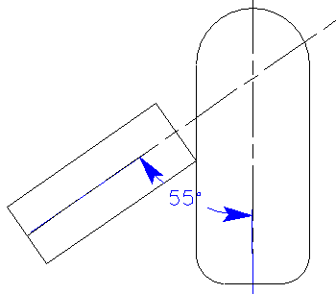 | Push barge-bow, striking angle 55º | 0,80 | 0.66 | 0.50 | 1.00
Worst case scenarios | II | 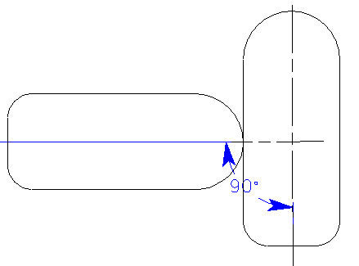 | V-shaped-bow,  striking angle 90º | 0,20 | 0.30 |  | 1.00

9.3.4.3.1.5 Step 5

9.3.4.3.1.5.1 For each collision energy absorption capacity E_{loc(i)}, the associated probability of exceedance is to be calculated, i.e. the probability of cargo tank rupture. For this purpose, the formula for the cumulative probability density functions (CPDF) below shall be used. The appropriate coefficients shall be selected from the Table in 9.3.4.3.1.5.6 for the effective mass of the struck vessel.

P_{x%} = C₁(E_{loc(i)})³ + C₂(E_{loc(i)})² + C₃E_{loc(i)} + C₄

with: P_{x%} probability of tank rupture,
C₁₋₄ coefficients from table in 9.3.4.3.1.5.6,
E_{loc(i)} collision energy absorbing capacity.

9.3.4.3.1.5.2 The effective mass shall be equal to the maximum displacement of the vessel multiplied by a factor of 1.4. Both collision scenarios (9.3.4.3.1.4.2) shall be considered.

9.3.4.3.1.5.3 In the case of collision scenario I (push barge bow at 55°), three CPDF formulas shall be used:

CPDF 50% (velocity 0.5 V_{max}),
CPDF 66% (velocity 2/3 V_{max}) and
CPDF 100% (velocity V_{max}).

9.3.4.3.1.5.4 In the case of scenario II (V-shaped bow at 90°), the following two CPDF formulas shall be used:

CPDF 30% (velocity 0.3 V_{max}) and
CPDF 100% (velocity V_{max}).

9.3.4.3.1.5.5 In the table in 9.3.4.3.1, column F, these probabilities are called P50%, P66%, P100% and P30%, P100% respectively.

9.3.4.3.1.5.6 Table: Coefficients for the CPDF formulas

effective mass of | velocity = 1 x V_{max}
struck vessel in | coefficients
tonnes | C₁ | C₂ | C₃ | C₄ | range
14000 | 4.106E-05 | -2.507E-03 | 9.727E-03 | 9.983E-01 | 4<E_{loc}<39
12000 | 4.609E-05 | -2.761E-03 | 1.215E-02 | 9.926E-01 | 4<E_{loc}<36
10000 | 5.327E-05 | -3.125E-03 | 1.569E-02 | 9.839E-01 | 4<E_{loc}<33
8000 | 6.458E-05 | -3.691E-03 | 2.108E-02 | 9.715E-01 | 4<E_{loc}<31
6000 | 7.902E-05 | -4.431E-03 | 2.719E-02 | 9.590E-01 | 4<E_{loc}<27
4500 | 8.823E-05 | -5.152E-03 | 3.285E-02 | 9.482E-01 | 4<E_{loc}<24
3000 | 2.144E-05 | -4.607E-03 | 2.921E-02 | 9.555E-01 | 2<E_{loc}<19
1500 | - 2.071E-03 | 2.704E-02 | -1.245E-01 | 1.169E+00 | 2<E_{loc}<12

effective mass of | velocity = 0.66 x V_{max}
struck vessel in | coefficients
tonnes | C₁ | C₂ | C₃ | C₄ | range
14000 | 4.638E-04 | -1.254E-02 | 2.041E-02 | 1.000E+00 | 2<E_{loc}<17
12000 | 5.377E-04 | -1.427E-02 | 2.897E-02 | 9.908E-01 | 2<E_{loc}<17
10000 | 6.262E-04 | -1.631E-02 | 3.849E-02 | 9.805E-01 | 2<E_{loc}<15
8000 | 7.363E-04 | -1.861E-02 | 4.646E-02 | 9.729E-01 | 2<E_{loc}<13
6000 | 9.115E-04 | -2.269E-02 | 6.285E-02 | 9.573E-01 | 2<E_{loc}<12
4500 | 1.071E-03 | -2.705E-02 | 7.738E-02 | 9.455E-01 | 1<E_{loc}<11
3000 | -1.709E-05 | -1.952E-02 | 5.123E-02 | 9.682E-01 | 1<E_{loc}<8
1500 | -2.479E-02 | 1.500E-01 | -3.218E-01 | 1.204E+00 | 1<E_{loc}<5

effective mass of | velocity = 0.5 x V_{max}
struck vessel in | coefficients
tonnes | C₁ | C₂ | C₃ | C₄ | range
14000 | 2.621E-03 | -3.978E-02 | 3.363E-02 | 1.000E+00 | 1<E_{loc}<10
12000 | 2.947E-03 | -4.404E-02 | 4.759E-02 | 9.932E-01 | 1<E_{loc}<9
10000 | 3.317E-03 | -4.873E-02 | 5.843E-02 | 9.878E-01 | 2<E_{loc}<8
8000 | 3.963E-03 | -5.723E-02 | 7.945E-02 | 9.739E-01 | 2<E_{loc}<7
6000 | 5.349E-03 | -7.407E-02 | 1.186E-01 | 9.517E-01 | 1<E_{loc}<6
4500 | 6.303E-03 | -8.713E-02 | 1.393E-01 | 9.440E-01 | 1<E_{loc}<6
3000 | 2.628E-03 | -8.504E-02 | 1.447E-01 | 9.408E-01 | 1<E_{loc}<5
1500 | -1.566E-01 | 5.419E-01 | -6.348E-01 | 1.209E+00 | 1<E_{loc}<3

effective mass of | velocity = 0.3 x V_{max}
struck vessel in | coefficients
tonnes | C₁ | C₂ | C₃ | C₄ | range
14000 | 5.628E-02 | -3.081E-01 | 1.036E-01 | 9.991E-01 | 1<E_{loc}<3
12000 | 5.997E-02 | -3.212E-01 | 1.029E-01 | 1.002E+00 | 1<E_{loc}<3
10000 | 7.477E-02 | -3.949E-01 | 1.875E-01 | 9.816E-01 | 1<E_{loc}<3
8000 | 1.021E-02 | -5.143E-01 | 2.983E-01 | 9.593E-01 | 1<E_{loc}<2
6000 | 9.145E-02 | -4.814E-01 | 2.421E-01 | 9.694E-01 | 1<E_{loc}<2
4500 | 1.180E-01 | -6.267E-01 | 3.542E-01 | 9.521E-01 | 1<E_{loc}<2
3000 | 7.902E-02 | -7.546E-01 | 5.079E-01 | 9.218E-01 | 1<E_{loc}<2
1500 | -1.031E+00 | 2.214E-01 | 1.891E-01 | 9.554E-01 | 0.5<E_{loc}<1

The range where the formula is valid is given in column 6. In case of an E_{loc} value below the range the probability equals P_{x%} = 1.0. In case of a value above the range P_{x%} equals 0.

9.3.4.3.1.6 Step 6

The weighted probabilities of cargo tank rupture P_{wx%} (table in 9.3.4.3.1, column H) shall be calculated by multiplying each cargo tank rupture probability P_{x%} (table in 9.3.4.3.1, column F) by the weighting factors wf_{x%} according to following table:

Table : Weighting factors for each characteristic collision speed

 |  |  | weighting factor
Scenario I | CPDF 50% | wf50% | 0.2
 | CPDF 66% | wf66% | 0.5
 | CPDF 100% | wf100% | 0.3
Scenario II | CPDF 30% | wf30% | 0.7
 | CPDF 100% | wf100% | 0.3

9.3.4.3.1.7 Step 7

The total probabilities of cargo tank rupture P_{loc(i)} (table in 9.3.4.3.1, column I) resulting from 9.3.4.3.1.6 (step 6) shall be calculated as the sum of all weighted cargo tank rupture probabilities P_{wx%} (table in 9.3.4.3.1, column H) for each collision location considered.

9.3.4.3.1.8 Step 8

For both collision scenarios the weighted total probabilities of cargo tank rupture P_{wloc(i)} shall, in each case, be calculated by multiplying the total tank probabilities of cargo tank rupture P_{loc(i)} for each collision location, by the weighting factors wf_{loc(i)} corresponding to the respective collision location (see 9.3.4.3.1.3 (step 3) and table in 9.3.4.3.1, column J).

9.3.4.3.1.9 Step 9

Through the addition of the weighted total probabilities of cargo tank rupture P_{wloc(i)} , the scenario specific total probabilities of cargo tank rupture P_{scenI} and P_{scenII} (table in 9.3.4.3.1, column L) shall be calculated, for each collision scenario I and II separately.

9.3.4.3.1.10 Step 10

Finally the weighted value of the overall total probability of cargo tank rupture P_{w} shall be calculated by the formula below (table in 9.3.4.3.1, column O):

P_{w} = 0.8 • P_{scenI} + 0.2 • P_{scenII}

9.3.4.3.1.11 Step 11

The overall total probability of cargo tank rupture P_{w} for the alternative design is called P_{n}. The overall total probability of cargo tank rupture P_{w} for the reference design is called P_{r}.

9.3.4.3.1.12 Step 12

9.3.4.3.1.12.1 The ratio (C_{n}/C_{r}) between the consequence (measure of damage) C_{n} of a cargo tank rupture of the alternative design and the consequence C_{r} of a cargo tank rupture of the reference design shall be determined with the following formula:

C_{n}/C_{r} = V_{n} / V_{r}

With C_{n}/C_{r} the ratio between the consequence related to the alternative design, and the consequence related to the reference design,
V_{n} maximum capacity of the largest cargo tank in the alternative design,
V_{r} maximum capacity of the largest cargo tank reference design.

9.3.4.3.1.12.2 This formula was derived for characteristic cargoes as listed in the following table.

Table: Characteristic cargoes

 | UN | Description
Benzene | 1114 | Flammable liquid  Packing group II  Hazardous to health
Acrylonitrile  Stabilised  ACN | 1093 | Flammable liquid  Packing group I  Toxic, stabilised
n-Hexane | 1208 | Flammable liquid  Packing group II
Nonane | 1920 | Flammable liquid  Packing group III
Ammonia | 1005 | Toxic, corrosive gas  Liquefied under pressure
Propane | 1978 | Flammable gas  Liquefied under pressure

9.3.4.3.1.12.3 For cargo tanks with capacities between 380 m³ and 1000 m³ containing flammable, toxic and acid liquids or gases it shall be assumed that the effect increase relates linearly to the increased tank capacity (proportionality factor 1.0).

9.3.4.3.1.12.4 If substances are to be carried in tank vessels, which have been analysed according to this calculation procedure, where the proportionality factor between the total cargo tank capacity and the affected area is expected to be larger than 1.0, as assumed in the previous paragraph, the affected area shall be determined through a separate calculation. In this case the comparison as described in 9.3.4.3.1.13 (step 13) shall be carried out with this different value for the size of the affected area, t.

9.3.4.3.1.13 Step 13
Finally the ratio 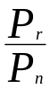 between the overall total probability of cargo tank rupture P_{r} for the reference design and the overall total probability of cargo tank rupture P_{n} for the alternative design shall be compared with the ratio 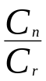 between the consequence related to the alternative design, and the consequence related to the reference design.

When 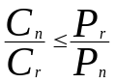 is fulfilled, the evidence according to 9.3.4.1.3 for the alternative design is provided.

9.3.4.4 Determination of the collision energy absorbing capacity

9.3.4.4.1 General

9.3.4.4.1.1 The determination of the collision energy absorbing capacity shall be carried out by means of a Finite Element Analysis (FEA). The analysis shall be carried out using a customary finite element code (e.g. LS-DYNA, PAM-CRASH, ABAQUS etc.) capable of dealing with both geometrical and material non-linear effects. The code shall also be able to simulate rupture realistically.

9.3.4.4.1.2 The program actually used and the level of detail of the calculations shall be agreed upon with a recognised classification society.

9.3.4.4.2 Creating the finite element models (FE models)

9.3.4.4.2.1 First of all, FE models for the more crashworthy design and one for the reference design shall be generated. Each FE model shall describe all plastic deformations relevant for all collision cases considered. The section of the cargo area to be modelled shall be agreed upon with a recognised classification society.

9.3.4.4.2.2 At both ends of the section to be modelled all three translational degrees of freedom are to be restrained. Because in most collision cases the global horizontal hull girder bending of the vessel is not of significant relevance for the evaluation of plastic deformation energy it is sufficient that only half beam of the vessel needs to be considered. In these cases the transverse displacements at the centre line (CL ) shall be constrained. After generating the FE model, a trial collision calculation shall be carried out to ensure that there is no occurrence of plastic deformations near the constraint boundaries. Otherwise the FE modelled area has to be extended.

9.3.4.4.2.3 Structural areas affected during collisions shall be sufficiently finely idealized, while other parts may be modelled more coarsely. The fineness of the element mesh shall be suitable for an adequate description of local folding deformations and for determination of realistic rupture of elements.

9.3.4.4.2.4 The calculation of rupture initiation must be based on fracture criteria which are suitable for the elements used. The maximum element size shall be less than 200 mm in the collision areas. The ratio between the longer and the shorter shell element edge shall not exceed the value of three. The element length L for a shell element is defined as the longer length of both sides of the element. The ratio between element length and element thickness shall be larger than five. Other values shall be agreed upon with the recognised classification society.

9.3.4.4.2.5 Plate structures, such as shell, inner hull (tank shell in the case of gas tanks), webs as well as stringers can be modelled as shell elements and stiffeners as beam elements. While modelling, cut outs and manholes in collision areas shall be taken into account.

9.3.4.4.2.6 In the FE calculation the 'node on segment penalty' method shall be used for the contact option. For this purpose the following options shall be activated in the codes mentioned:

− “contact_automatic_single_surface” in LS-DYNA,

− “self impacting” in PAMCRASH, and

− similar contact types in other FE-programs.

9.3.4.4.3 Material properties

9.3.4.4.3.1 Because of the extreme behaviour of material and structure during a collision, with both geometrical and material non-linear effects, true stress-strain relations shall be used:

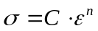,

where

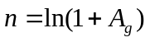,
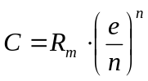,

A_{g} = the maximum uniform strain related to the ultimate tensile stress R_{m} and
e = the natural logarithmic constant.

9.3.4.4.3.2 The values A_{g} and R_{m} shall be determined through tensile tests.

9.3.4.4.3.3 If only the ultimate tensile stress R_{m} is available, for shipbuilding steel with a yield stress R_{eH} of not more than 355 N/mm² the following approximation shall be used in order to obtain the A_{g} value from a known R_{m} [N/mm²] value:

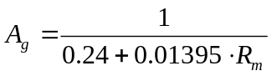

9.3.4.4.3.4 If the material properties from tensile tests are not available when starting the calculations, minimum values of A_{g} and R_{m}, as defined in the rules of the recognised classification society, shall be used instead. For shipbuilding steel with a yield stress higher than 355 N/mm² or materials other than shipbuilding steel, material properties shall be agreed upon with a recognised classification society.

9.3.4.4.4 Rupture criteria

9.3.4.4.4.1 The first rupture of an element in a FEA is defined by the failure strain value. If the calculated strain, such as plastic effective strain, principal strain or, for shell elements, the strain in the thickness direction of this element exceeds its defined failure strain value, the element shall be deleted from the FE model and the deformation energy in this element will no longer change in the following calculation steps.

9.3.4.4.4.2 The following formula shall be used for the calculation of rupture strain:

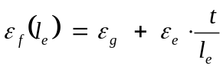

where
ε_{g} = uniform strain
ε_{e} = necking
t = plate thickness
l_{e} = individual element length.

9.3.4.4.4.3 The values of uniform strain and the necking for shipbuilding steel with a yield stress R_{eH} of not more than 355 N/mm² shall be taken from the following table:

Table

stress states | 1-D | 2-D
ε_{g} | 0.079 | 0.056
ε_{e} | 0.76 | 0.54
element type | truss beam | shell plate

9.3.4.4.4.4 Other ε_{g} and ε_{e} values taken from thickness measurements of exemplary damage cases and experiments may be used in agreement with the recognised classification society.

9.3.4.4.4.5 Other rupture criteria may be accepted by the recognised classification society if proof from adequate tests is provided.

9.3.4.4.4.6 Tank vessel type G

For a tank vessel type G the rupture criterion for the pressure tank shall be based on equivalent plastic strain. The value to be used while applying the rupture criterion shall be agreed upon with the recognised classification society. Equivalent plastic strains associated with compressions shall be ignored.

9.3.4.4.5 Calculation of the collision energy absorbing capacity

9.3.4.4.5.1 The collision energy absorbing capacity is the summation of internal energy (energy associated with deformation of structural elements) and friction energy.

The friction coefficient 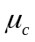 is defined as:

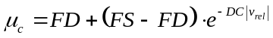,

with FD = 0.1,
FS = 0.3,
DC = 0.01
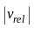 = relative friction velocity.
Note: Values are default for shipbuilding steel.

9.3.4.4.5.2 The force penetration curves resulting from the FE model calculation shall be submitted to the recognised classification society.

9.3.4.4.5.3 Tank vessel type G

9.3.4.4.5.3.1 In order to obtain the total energy absorbing capacity of a tank vessel type G the energy absorbed through compression of the vapour during the collision shall be calculated.

9.3.4.4.5.3.2 The energy E absorbed by the vapour shall be calculated as follows:

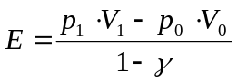

with:

γ 1.4
(Note: The value 1.4 is the default value c_{p}/c_{v} with, in principle:
c_{p} = specific heat at constant pressure [J/(kgK)]
c_{v} = specific heat at constant volume [J/(kgK)])
p₀ pressure at start of compression [Pa]
p₁ pressure at end of compression [Pa]
V₀ volume at start of compression [m³]
V₁ volume at end of compression [m³]
9.3.4.4.6 Definition of striking vessel and striking bow

9.3.4.4.6.1 At least two types of bow shapes of the striking vessel shall be used for calculating the collision energy absorbing capacities:

- bow shape I: push barge bow (see 9.3.4.4.8),

- bow shape II: V-shape bow without bulb (see 9.3.4.4.8).

9.3.4.4.6.2 Because in most collision cases the bow of the striking vessel shows only slight deformations compared to the side structure of the struck vessel, a striking bow will be defined as rigid. Only for special situations, where the struck vessel has an extremely strong side structure compared to the striking bow and the structural behaviour of the struck vessel is influenced by the plastic deformation of the striking bow, the striking bow shall be considered as deformable. In this case the structure of the striking bow should also be modelled. This shall be agreed upon with the recognised classification society.

9.3.4.4.7 Assumptions for collision cases

For the collision cases the following shall be assumed:

- As collision angle between striking and struck vessel 90° shall be taken in case of a V-shaped bow and 55° in case of a push barge bow; and

- The struck vessel has zero speed, while the striking vessel runs into the side of the struck ship with a constant speed of 10 m/s.

The collision velocity of 10 m/s is an assumed value to be used in the FE analysis.

9.3.4.4.8 Drawings

9.3.4.4.8.1 Push

barge bow

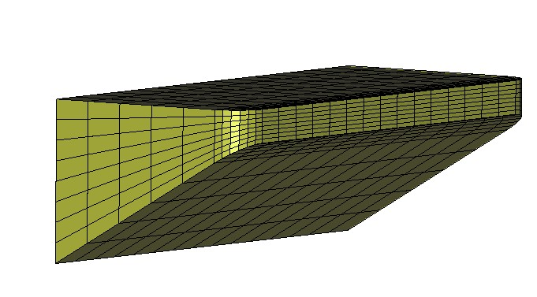
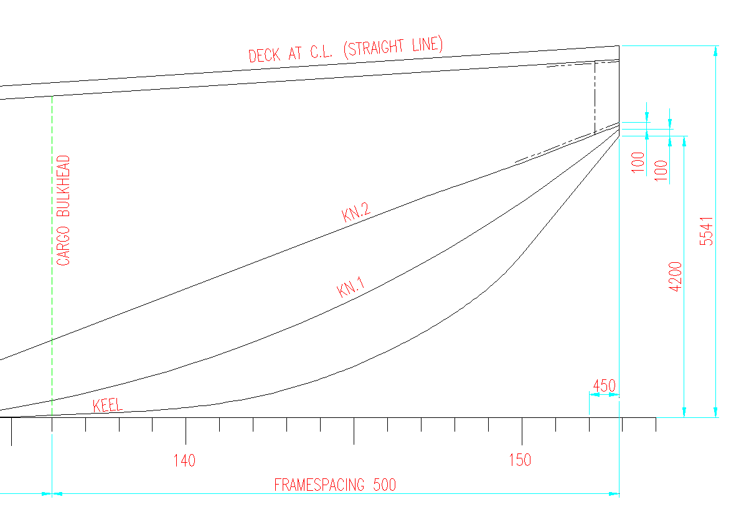

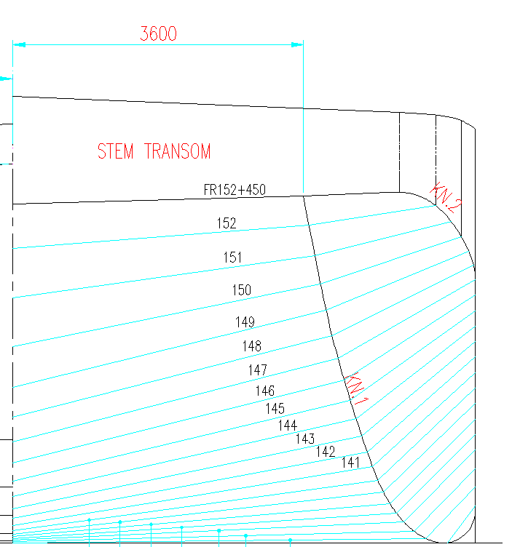

Width: 11,50 m (default value)
9.3.4.4.8.2 V-shaped bow

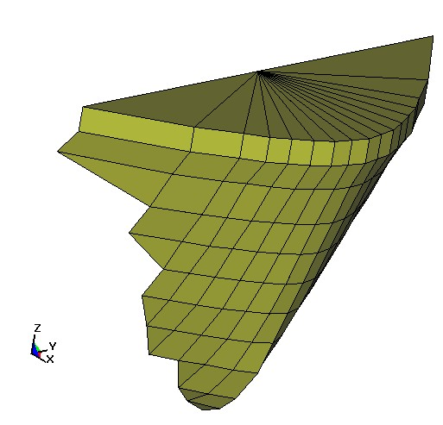

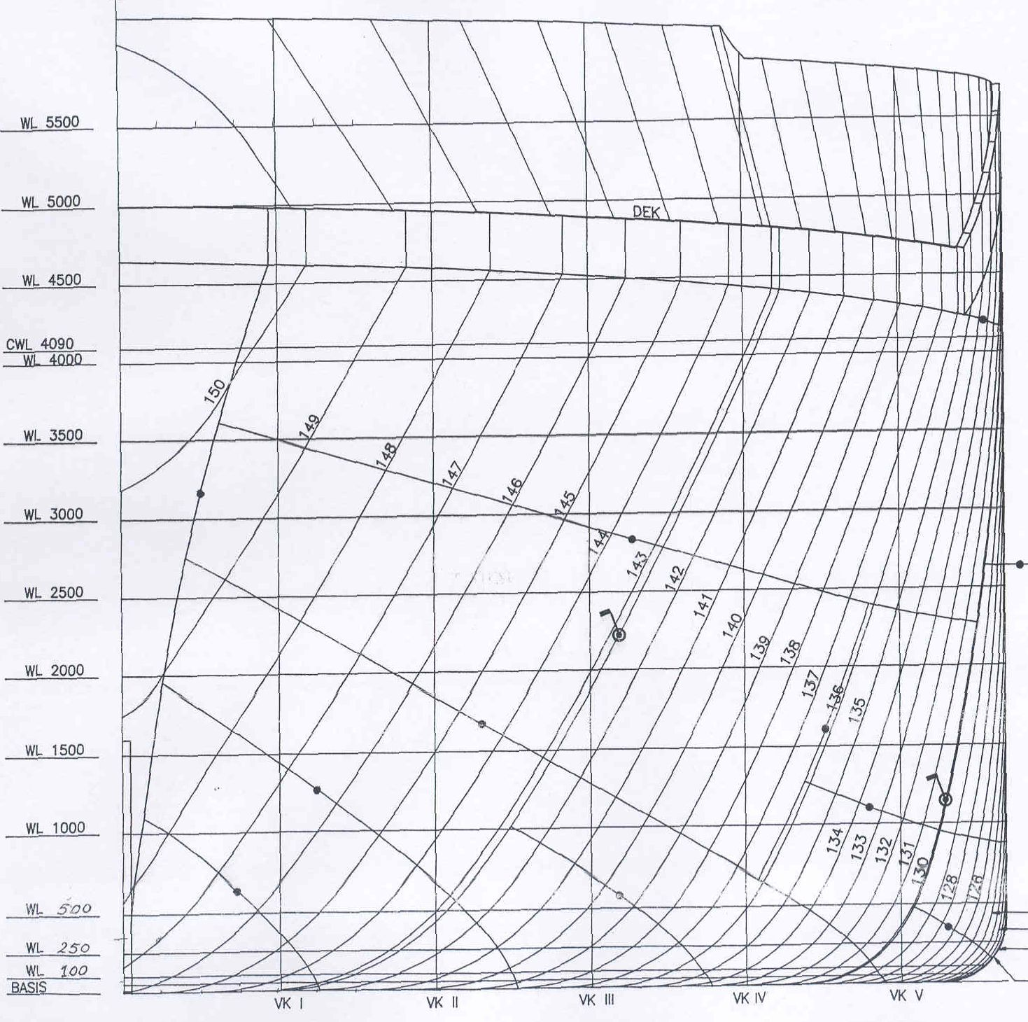

Width: 11,35 m (default value) Framespacing: 500 mm (default value)
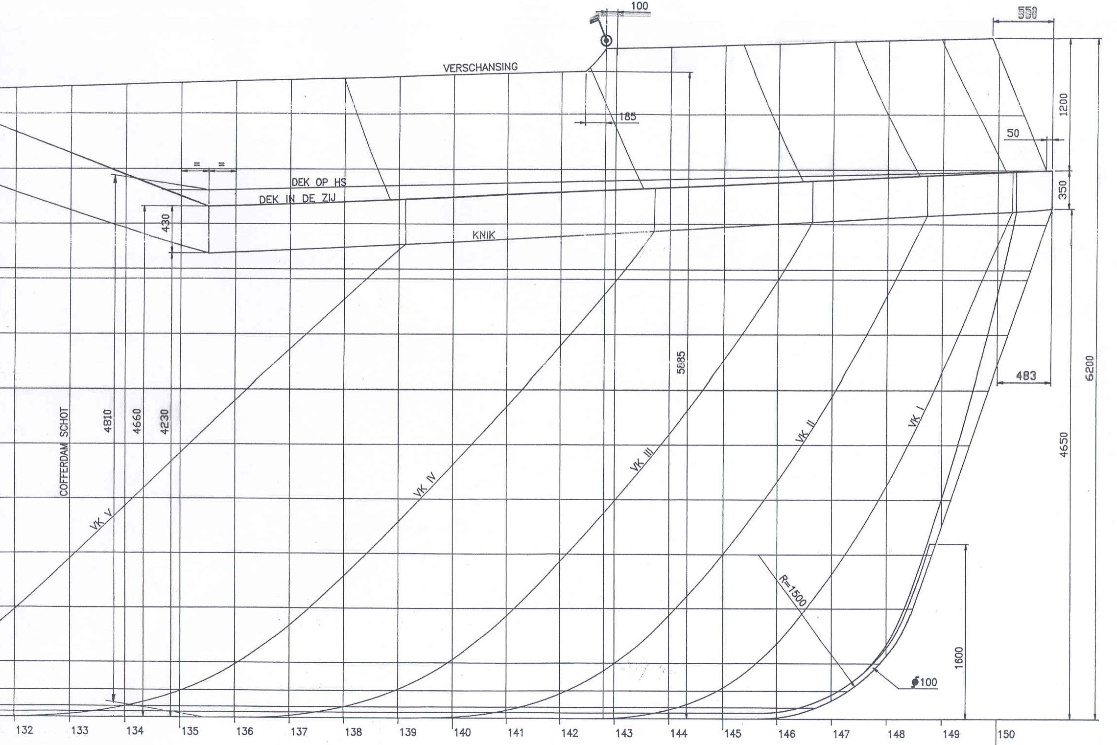

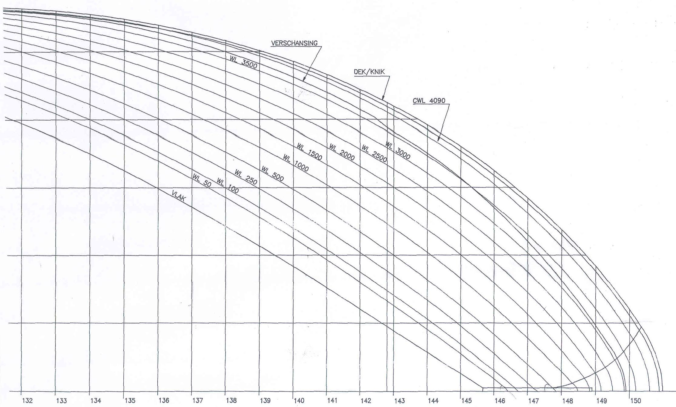

Spacing between verticals: 1000 mm (default value)

(((Replace all figures by tables )))
__________

This meeting is organized jointly by the Economic Commission for Europe and the Central Commission for the Navigation of the Rhine (CCNR).
The Joint Meeting of Experts was established jointly by the Economic Commission for Europe and the Central Commission for the Navigation of the Rhine (CCNR) pursuant to the invitation by the Diplomatic Conference for the Adoption of a European Agreement concerning the International Carriage of Dangerous Goods by Inland Waterways (ADN) in its resolution adopted on 25 May 2000. The said resolution makes provision for the Joint Meeting of Experts to take the place of the Safety Committee referred to in article 18 of the ADN after entry into force of the Agreement. As the ADN entered into force on 29 February 2008, the Joint Meeting of Experts will henceforth play the role of the ADN Safety Committee.
Distributed in German by the CCNR under the symbol CCNR/ZKR/ADN/WP.15/AC.2/2008/7/Rev.1.
In accordance with the programme of work of the Inland Transport Committee for 2006-2010 (ECE/TRANS/166/Add.1, programme activity 02.7 (b)).
LSTC, 7374 Las Positas Rd, Livermore, CA 94551, USA Tel : +1 925 245-4500
ESI Group, 8, Rue christophe Colomb, 75008 Paris, France Tel: +33 (0)1 53 65 14 14, Fax: +33 (0)1 53 65 14 12, E-mail: info@esi-group.com
SIMULIA, Rising Sun Mills, 166 Valley Street, Providence, RI 02909-2499 USA Tel: +1 401 276-4400, Fax: +1 401 276-4408, E-mail: info@simulia.com

