UNITED NATIONS |  | ST
 | Secretariat | Distr.  GENERAL  ST/SG/AC.10/C.3/2008/32  9 April 2008  Original: ENGLISH

COMMITTEE OF EXPERTS ON THE TRANSPORT OF

DANGEROUS GOODS AND ON THE GLOBALLY

HARMONIZED SYSTEM OF CLASSIFICATION

AND LABELLING OF CHEMICALS

Sub-Committee of Experts on the

Transport of Dangerous Goods

Thirty-third session
Geneva, 30 June-9 July (a.m.) 2008
Item 2 of the provisional agenda

EXPLOSIVES AND RELATED MATTERS

Classification as a consequence of Net Explosive Quantity (NEQ)

Transmitted by the expert from Australia

Background

1. The expert from Australia submitted two documents to the 31st session (ST/SG/AC.10/C.3/2007/17 and informal document UN/SCETDG/31/INF.19) in regards to the classification of fireworks of a division other than 1.1 as a consequence of the NEQ in a freight container. As noted in paragraph 19(d) of the report (ST/SG/AC.10/C.3/62) it was agreed more work was required in this regard, with further proposals expected from the United Kingdom and France. The report of the working group (UN/SCETDG/31/INF.45) noted further that there was no supporting case made for a limitation of 1000kg NEQ in the Australian paper, with the United Kingdom indicating that violent and unexpected explosions can occur with lower quantities of fireworks.
- It was also noted in the Netherlands submission (informal document UN/SCETDG/31/INF.27) that tests carried out under the “Quantification and Control of the Hazards Associated with the Transport and Bulk Storage of Fireworks” (CHAF) project, found that in most cases the hazards of an accidental explosion in a 20 foot freight container corresponded with the hazards as indicated by the transport classification. According to the more detailed outline for a possible follow up to the CHAF project, there were exceptions to the rule which appear to call into question the effectiveness of Series 6 testing, specifically:

(a) Articles selected to represent the most energetic 1.3 articles which were classified as 1.3 according to the default list (i.e. 150 mm shells and 60 gram rockets without stick) behaved as a mass explosive when tested according to Series 6 tests.

(b) For 150 mm shells (normally classified as 1.3G), propagation velocity between the firework packages as measured in the large-scale tests was 2 to 5 times larger (12 and 35 m/s) than measured in the medium scale test (7 m/s), but no definitive reason for this outcome was derived.

(c) A container full of waterfalls properly classified as 1.3G according to Series 6 testing resulted in a violent mass explosion. No explanation for this behaviour could be found within the framework of the project.

3. The original submission made by the expert from Australia focused on an incident at a fireworks storage facility at Carmel in Western Australia. This incident involved a variety of classifications and the proposed 1000kg NEQ was drawn from the behaviour of a magazine loaded with 725kg NEQ of fireworks classified as 1.3G. The low-level mass explosion, although not consistent with the overall default classification of the contents of this magazine as 1.3 G, was much less energetic than the other explosions that occurred. This prompted the suggestion of a 1000kg limit.

4. The expert from Australian has no difficulty with a lower limit but considers that a limit needs to be set as a matter of urgency in light of a further incident with a fireworks storage facility involving fireworks classified as 1.3G. This incident indicates that classification carried out in accordance with Series 6 test is inadequate for fireworks where stored or carried in freight containers with an NEQ in excess of 500kg.

5. The incident occurred in mid-December 2007 at a fireworks manufacturing and storage site near Lithgow in New South Wales. The explosions occurred in magazines being used to store assorted fireworks, some of which were awaiting destruction, and manufacturing precursors such as stars. All magazines used to store explosives classified as 1.3G on the site were converted freight containers. The event resulted in the destruction of approximately 19 magazines and created five significant craters on the site related to detonation events in 12 of the magazines (sited in pairs). The other magazines were destroyed by deflagrating events and fires as fireworks burned. Debris was strewn out to approximately 1 kilometre with blast overpressure damage to all structures on site, adjoining properties within 500m and window breakage at approximately 4.5 kilometres. An image of one of the craters is provided below and the Australian Expert can provide additional images taken immediately after the event if required.
6. Investigations are ongoing, but it appears the initial explosion occurred in a magazine used to store incomplete articles used in the manufacture of fireworks. This explosion led to the sympathetic detonation of nine other magazines in the immediate vicinity (being used to store articles classified as 1.3G) and the detonation of two more magazines over 100m away, both containing fireworks classified as 1.3G. The latter two magazines were sited immediately adjacent to each other and were loaded solely with 5 and 6 inch shells which were classified as 1.3G (consistent with the UN default classification table). The significance of this observation is that this event involved articles classified as 1.3G other than waterfalls, in contrast to the observations noted in the initial CHAF project.

7. Noting that these explosions occurred with articles stored in modified freight containers, the expert from Australian contends that this incident provides a graphic illustration of the nature of the damage that could be expected in the event of a fire (or similar incident) where such goods are loaded on a ship, carried by road or rail in a built-up area (or in a tunnel) or stored in a container terminal.

Image: One of five significant craters on site.
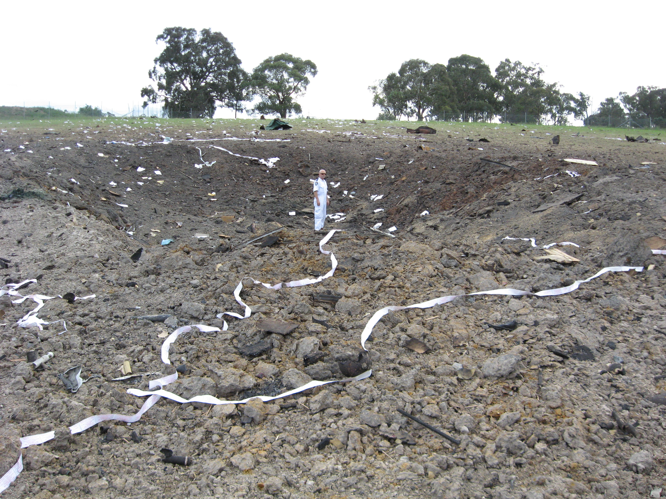

8. It is important to note that the modified freight containers involved in this incident were utilised in a manner that could have provided a greater safety margin than a loaded standard freight container, such as reduced loading, better insulation and non-incendive linings. It is highly likely that if this incident had involved shipping containers packed in the manner normally employed for transport, the detonation could have been of a higher magnitude. In any case this incident clearly suggests that the Series 6 test may not be adequate for classifying the effects of densely packed fireworks confined within shipping containers.

9. Subject to potential submissions from the United Kingdom and/or France, the expert from Australia proposes that the classification of fireworks of divisions 1.2 and 1.3 should be subject to a maximum NEQ in a closed cargo transport unit if they are to retain their assigned classification. While agreeing with the United Kingdom position of the United Kingdom that violent and unexpected explosions can occur with quantities of fireworks less than 1000kg NEQ, if data is not available to support agreement on a lower value at the time of the 33rd session, the expert from Australian believes the following proposal should be supported.

Proposal

10. It is proposed that section 2.1.3.5.1 be amended and a new section 2.1.3.5.1.1 be added to read:

2.1.3.5.1 Notwithstanding 2.1.3.5.1.1, fireworks shall normally be assigned to hazard divisions 1.1, 1.2, 1.3, and 1.4 on the basis of test data derived from Test Series 6. However, since the range of such articles is very extensive and the availability of test facilities may be limited, assignment to hazard divisions may also be made in accordance with the procedure in 2.1.3.5.2.

2.1.3.5.1.1 Where division 1.2 and 1.3 fireworks are loaded in closed cargo transport units, and the NEQ exceeds 1000kg, they shall be classified as division 1.1.

_______________

In accordance with the programme of work of the Sub-Committee for 2007-2008 approved by the Committee at its third session (refer to ST/SG/AC.10/C.3/60, para. 100 and ST/SG/AC.10/34, para. 14) (Provisions for the transport of dangerous goods in open cryogenic receptacles).

