UNITED

NATIONS
STSTE


Distr.
Secretariat

GENERAL

ST/SG/AC.10/C.3/2006/52
13 April 2006

Original: ENGLISH

COMMITTEE OF EXPERTS ON THE TRANSPORT OF

DANGEROUS GOODS AND ON THE GLOBALLY

HARMONIZED SYSTEM OF CLASSIFICATION

AND LABELLING OF CHEMICALS

Sub-Committee of Experts on the

Transport of Dangerous Goods

Twenty-ninth session

Geneva, 3-12 (a.m.) July 2006

Item 6 of the provisional agenda

LISTING, CLASSIFICATION AND PACKING

Transport of Nitroguanidine, wetted, (UN 1336) in flexible IBCs

Transmitted by the International Council of Chemical Associations (ICCA)

Background

1. NITROGUANIDINE (PICRITE), WETTED with not less than 20% water, by mass (UN 1336) is a solid desensitized explosive and is classified in Division 4.1, PG I.

2. Currently this substance may be packed according to packing instruction P406 in combination packagings as well as in plastics, plywood, fibreboard or metal drums, etc. Neither in the UN Model Regulations nor in the modal regulations is there a packing instruction that allows UN 1336 to be packed and transported in IBC.

3. At the 27th session of the Sub-Committee, the ICCA proposed to permit the transport of wetted Nitroguanidine (UN 1336) in flexible IBCs by amending a new packing instruction IBC4xx (ST/SG/AC.10/C.3/2005/10 and INF.15). Taking into account the comments of the delegates, the proposal was revised, and additional test results were provided.

Introduction

4. NITROGUANIDINE (PICRITE), WETTED (UN 1336) is an important raw material for the chemical industry. The worldwide market for this substance is estimated to be about 7,000 metric tons with increasing tendency. Such volumes require efficient procedures for transportation, storage and handling. This demand can be fulfilled by use of bigger packages which, at the same time, allow industry to increase workplace safety.

5. The transport of Nitroguanidine, wetted, in flexible IBCs (FIBCs) has been safely conducted in Germany under national derogations for more than 15 years.

6. This practice was authorized by the Federal Institute for Materials Research and Testing (BAM) based on comprehensive testing (mainly Test Series 1, 2, 5 and 6 as well as stability and homogeneity of water content).

7. According to section 2.1.3.6.2 of the UN Model Regulations, a substance excluded from Class 1 by Test Series 6 should be listed in the Dangerous Goods List with a special provision specifying the type of package and the maximum permitted quantity.

Proposals

- Insert "xxx" in column 6 for UN 1336.

- Insert the following new Special Provision xxx in Chapter 3.3.:

xxx This substance may also be transported in IBCs. Only flexible IBCs (13H3, 13H4, 13H5, 13L3, 13L4) conforming to the packing group I performance level are permitted on the following conditions:

  - The substance shall be approved by the competent authority with regard to the mode and to the duration of the transport on the basis of appropriate test results, ensuring that the content of water will not fall below 20 % and will be homogeneously distributed at any time during transport;

  - The IBC shall meet the general provisions of 4.1.1 and 4.1.2;

  - The IBC shall be designed and constructed to prevent the loss of water;

  - The IBC shall not exceed a net mass of 1000 kg;

  - The segregation provisions for each particular mode of transport shall be based on the principles of subsection 7.1.2.3;

  - The IBC shall be transported in closed transport units;

  - The IBCs shall be stowed in the transport unit so as to prevent friction between each other and the wall of the transport unit.
Justification

10. "Nitroguanidine, wetted with not less than 20 % water by mass" passes Test Series 2 of the Manual of Tests and Criteria, Part I, Section 12. Therefore, no risk of explosion is given, provided the package keeps the water and the water content stays homogenously distributed. The material does not feel moist but is capable of free flowing. To confirm this, the water content of the material packaged in FIBCs has been checked to stay above 20 % in different heights over a period of 4 months. The tests confirm that the used FIBCs keep the water and there is no danger the material turns into the dry explosive substance.

11. Additionally, the "External fire (bonfire) test" (Test 6c, Manual of Tests and Criteria, Part I, Section 16) has been performed on a FIBC (13H3) filled with 579 kg nitroguanidine, wetted with about 15 % water. During this test, no hazardous effect at all was observed (no mass explosion, no fireball or jet flame, thermal flux << 4 kW/m² (found: 0,21 kW/m² in 15 m distance) and no projection of substance).

12. Based on these test result, BAM stated that Nitroguanidine, wetted with not less than 20 % water, by mass, packaged in a flexible IBC (13H3), fulfils the criteria for an exemption from Class 1.

13. Practical experience in Germany for more than 15 years (approximately 3,000 tons per year over more than 1,000,000 km by rail and by road without a single accident) has shown that such transports can be considered as safe.

14. The test results, as shown in Annexes 1 and 2, as well as practical experience demonstrate that there is no detonation or mass explosion risk under transport conditions, even in case of a fire.

15. Additional test data and further information will be submitted in a separate informal document by end of May 2006.

______________

Annex 1 (ENGLISH ONLY)

BAM
Bundesanstalt für
Materialforschung
und –prüfung
Unter den Eichen 87
12205 Berlin
Tel. (030) 8104-0
E-mail: info@bam.de
Internet: www.bam.de

Test Report and Expert Opinion on the testing of Nitroguanidine,
wetted with approx. 15% water by mass, in a flexible IBC
according to Test 6 (c) of the UN Test Manual

File reference II.2-135/06

Copy No. 1 of 2

Date 17 February 2006

Applicant/ Dynamit Nobel GmbH
Client Explosivstoff- und Systemtechnik
Kalkstraβe 218
51377 Leverkusen

Application 7 February 2006

File ref. -

Received on 9 February 2006

Subject of Testing of Nitroguanidine, wetted with
expert report approximately 15% water by mass, in a flexible IBC
according to Test 6 (c) of the UN Recommendations on the Transport of Dangerous Goods,
Manual of Tests and Criteria, Fourth Revised Edition,
United Nations New York and Geneva, 2003

This Expert Report comprises pages 1 to 5

This document may only be published with its full text and without additions.
The prior revocable written consent of the BAM is required if it is to be reproduced in altered form or in the form of an extract. The contents of the expert opinion relate solely to the substances for which the opinion is given.
1. Background
In their letter of 31 January 2006, the company Dynamit Nobel, Explosivstoff- und Systemtechnik, requested that the Bundesanstalt für Materialforschung und –prüfung (BAM) carry out testing according to Test 6 (c) of the UN Manual of Tests and Criteria on Nitroguanidine, wetted with approx. 15% water by mass, packaged in a flexible intermediate bulk container (IBC), type 13H3, with lattice box.

A 579 kg sample of Nitroguanidine, packaged in a flexible IBC, type 13H3, with lattice box, was received for testing by the BAM open-air experimental facility on 16 January 2006.

2. Composition
The company stated the test specimen consisted of Nitroguanidine, wetted with 15.3% water (an appropriate Certificate of Analysis was provided).
Determination of the water content by BAM through Karl Fischer titration showed that the water content was in the range 16.8% to 18.4% by mass.

3. Preliminary remarks
Nitroguanidine (picrite), dry or wetted with less than 20% water by mass, is a Class 1 substance and assigned to UN number 0282, Class 1.1 D, of the Dangerous Goods Regulations. Nitroguanidine, wetted with not less than 20% water, by mass, is a “desensitized explosive” of the Dangerous Goods Regulations and has been assigned the UN number 1336, Class 4.1.
The company Dynamit Nobel requested an investigation of whether Nitroguanidine, wetted with not less than 20% water, by mass, and packaged in a flexible IBC, type 13H3, with lattice box, satisfied the requirements for exemption from Class 1 in that packaging, primarily for land transport.
Dynamit Nobel requested that a batch containing approx. 15% water by mass be used for the test. The BAM agreed to this proposal, as combustion tests performed by BAM with smaller quantities of Nitroguanidine, wetted with not less than 20% water by mass, showed that the combustion times were very long.
The reduced water content results in more rapid combustion and thus shortens the duration of the test. The test results of Nitroguanidine, wetted with approx. 15% water by mass, can be used in the sense of Test 6 (c) for an assessment of the behaviour of Nitroguanidine, wetted with not less than 20% water, by mass, in a flexible IBC, type 13H3, with lattice box.

4. Test methods
The methods used are those described in the UN Recommendations on the Transport of Dangerous Goods, Manual of Tests and Criteria, Fourth Revised Edition, New York and Geneva, 2003.
Transport regulations allow the exemption of a substance in the envisaged packaging on the basis of the results of Test Series 6.
Test Series 6 comprises three test methods:
6 (a) Single package test
6 (b) Stack test
6 (c) External fire (bonfire) test

These tests are to be performed in the sequence a to c. It is not necessary to perform all of the tests of Test Series 6 (Tests 6(a) and 6(b)) if it has been demonstrated that the substance does not undergo detonation or deflagration even under conditions of greater strain (with stronger confinement than the intended packaging).
On the basis of test results and experience of BAM with dry Nitroguanidine and with Nitroguanidine, wetted with not less than 20% water, by mass, concerning their ability to propagate a detonation upon initiation with a detonator – which for Nitroguanidine is the most severe test condition for Test 6 (a) – a detonative conversion can be ruled out if the explosive power in the Trauzl Test (UN Test F.3) is only very low. Nitroguanidine, wetted with approx. 15% water by mass, was found to exhibit a lead block expansion of 19 ml per 10 g substance in UN Test F.3. In view of the low explosive power found (dry Nitroguanidine gives a lead block expansion of 309 ml for 10 g substance), there was no need to carry out UN Tests 6(a) and 6(b) using a standard detonator.
UN Tests 6(a) and 6(b) using an igniter were not carried out as studies of BAM with dry Nitroguanidine did not show any mass explosion upon such initiation.

5. External fire (bonfire) test – UN Test 6 (c)

5.1. Test conditions and description

The test was carried out on 17 January 2006 at BAM’s open-air facility in Horstwalde under dry conditions at temperatures of -6 °C to -4 °C and wind speeds of 0 m/s to 2 m/s.

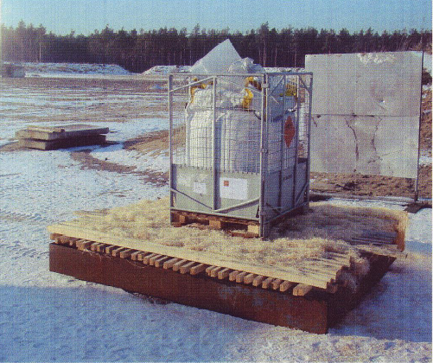
The type 13H3 flexible IBC was placed directly on a wooden pallet to which the lattice box was secured. Metal sheets were fitted in the lower part of the lattice box to protect the stack from being damaged by fork lifts (see Figure 1). According to the manufacturer, the IBC contained 579 kg Nitroguanidine, wetted with approx. 15% water by mass. The IBC and its pallet were placed on a steel support in a steel tray measuring 2.8 m x 3.0 m, with sufficient wood and wood wool underneath. Approximately 20 liters of a diesel/petrol mixture were poured over the wood stack just before it was ignited.
Figure 1 Test set-up

The fire was recorded through two video cameras, and the heat radiation was measured through two sensors positioned 30 meters from the fire and further two sensors 40 meters from the fire.

The substance burned with a very small flame or reacted without flame. After a short period, the IBC material burnt through below and some of the contents trickled out into the wood pile during the combustion process.
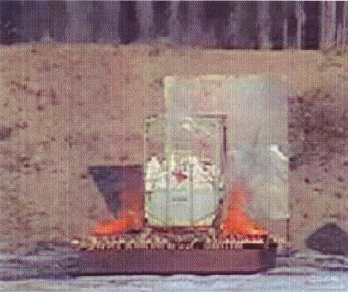
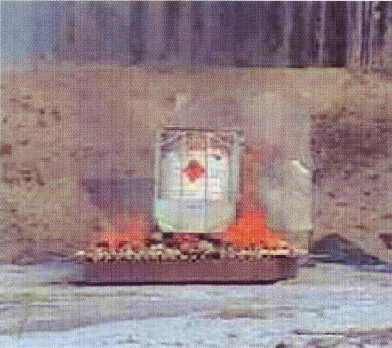
Figure 3 Approx. 3 minutes after ignition
Figure 2 Combustion after approx. 13 minutes

After approx. 27 minutes the substance was converted down to the height of the protective sheets. The released substance in part extinguished the wood fire. However, the Nitroguanidine wetted with approx. 15% water by mass burnt in full. Combustion was complete after approx. 140 minutes.

The time required for conversion of the whole mass is determined as follows:

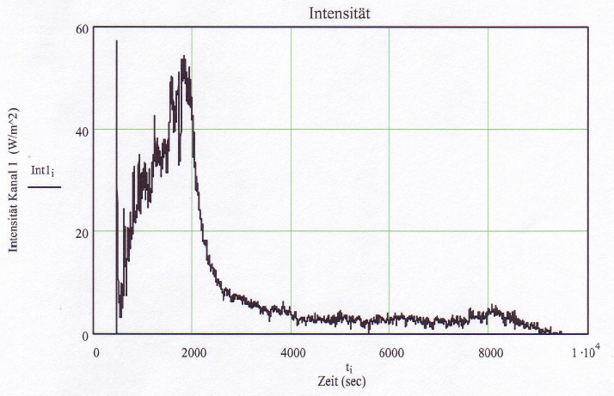
Figure 4 Thermal flux at 30 m distance. Ignition occurs at 443 sec. The first peak represents the ignition peak.

From the course of the thermal flux (Figure 4), the maximum was attained after 1820 seconds (approx. 23 minutes upon ignition). The thermal flux then decreased because the flames of the wood fire were no longer acting directly on the substance. After approx. 60 minutes, the thermal flux had fallen to 5% of the maximum value. At this time there were only residual quantities of the substance still present. The thermal flux at a distance of 15 m was calculated to be 0.21 kW/m², based on the measured value at a distance of 30 m. The upper limit (criterion for the 6 (c) Test) of 4 kW/m² at a distance of 15 m was not reached.

5.2. Evaluation of results according to the UN Test Manual

The test was evaluated on the basis of the criteria of UN Test 6 (c) with the following outcome:

• No mass explosion, no fireball and no splinters
• Thermal flux < 4 kW/m² at a distance of 15 m
• No projection from the product during combustion, with combustion being quiet and slow

The thermal flux at a distance of 15 m was below 4 kW/m², and the combustion time was > 35 s per 100 kg of substance.

6. Expert opinion on the transport of Nitroguanidine, wetted with not less than 20% water by mass, in a flexible IBC with lattice box*

When evaluating the test results it must be borne in mind that the following conditions need to be satisfied for Nitroguanidine, wetted with water, in order to be classified as a “desensitized explosive substances” (see, for example, Annex A to the ADR, marginal 2401, No. 21, Annex to the Federal Gazette Part II, No. 44 of 22 October 1998):

- The water must be homogeneously distributed within the explosive substance. During transport, no segregation shall occur that would reduce the desensitization.
- The explosive substances wetted with water must not be detonable through a standard detonator (standard electric blasting cap 0.6 g PETN) or undergo mass explosion upon initiation with a powerful booster charge.

The above conditions can only be satisfied with sufficient certainty if the Nitroguanidine is wetted with not less than 20% water by mass, so that, in the opinion of BAM, a general exemption from Class 1 based on Test Series 6 can only be considered if the water content is not less than 20% by mass.
The results of the UN Test 6 (c) for Nitroguanidine, wetted with approx. 15% water by mass, in a flexible IBC with lattice box, show that the thermal flux at a distance of 15 m is < 4 kW/m² and the combustion time is > 35 s for 100 kg. On the basis of the test results for Nitroguanidine, wetted with approx. 15% water by mass, it can be concluded that Nitroguanidine, wetted with not less than 20% water by mass, packed in a flexible type 13H3 IBC with lattice box, satisfies the criteria of UN Test 6 (c) for exemption from Class 1.

Bundesanstalt für Materialforschung und prüfung (BAM)
Working Group “Explosive substances for the chemical industry”
12200 Berlin

[Signature] [Stamp] [Signature]
Dr. K. Wehrstedt Dr. H. Michael-Schulz
Regierungsdirektor Oberregierungsrätin

[Signature]
Dr. M. Rudolph

Circulation: 1st copy to client
2nd copy archived by BAM

*) This Expert Report has been drafted to the best of our knowledge and belief, objectively and without any external influence on the results. The BAM reserves the right to change, supplement or revoke this Expert Report if there are important reasons for doing so (e.g. because of substantial new findings).

Legends:

Figure 1: Test set-up

Figure 2: Approx. 3 minutes after ignition

Figure 3: After combustion for approx. 13 minutes

Figure 4:

Intensity - Channel 1

Time

Thermal radiation intensity at a distance of 30 m. Ignition occurs at 443 seconds. The first peak represents the ignition peak

Annex 2 (ENGLISH ONLY)

BAM
Bundesanstalt für
Materialforschung
und –prüfung

Your letter of: 31 October 2005
Our ref.: II.2-711/05
Tel. (030) 8104 4413
Fax. (030) 8104 1227
Email: Fachgruppe-II.2@bam.de
Date: 9 December 2005

Bayer Industry Services GmbH & Co. OHG
Verfahrens- und Anlagensicherheit
For the attention of Dr. Heitkamp
SUA-VA1 Building B 407
51368 Leverkusen

Nitroguanidine

Dear Dr. Heitkamp

We refer to your letter of the above date and report the test results as follows:

1. Nitroguanidine, technically pure (data from “Explosivstoffe” #9, 1961)
Steel tube test (Koenen test) Limiting diameter < 1.0 mm
Friction sensitivity (BAM) None up to 360 N
Impact sensitivity (BAM) None up to 50 J
BAM 2” steel tube (50 g booster) Full propagation
(UN test 1(a)(i), UN Test Manual, 1st edition)
BAM 1” steel tube (NP 8) Full propagation
Trauzl lead block test 305 ml

2. Nitroguanidine, technically pure (additional test data)
UN Test 1(a)(iii) Gap Test (gap 0 mm) “+”
(UN Test Manual, 1st edition)
UN Test 2(a)(iii) Gap Test (gap 57.2 mm) “-“
(UN Test Manual, 1st edition)
UN Test 2(a)(iii) Gap Test (gap 50.8 mm) “+”
(UN Test Manual, 1st edition)
UN Test 5(a) Cap Sensitivity Test (0.6 g PETN) “+”
(UN Test manual, 3rd edition)
3. Nitroguanidine, wetted with more than 20% water (homogeneously distributed)
UN Test 1(a)(i) BAM steel tube test No propagation
(50 g booster, UN Test Manual, 1st edition) “-“
UN Test 5(a) Cap Sensitivity Test (0.6 g PETN) “-“
(UN Test Manual, 3rd edition)
UN Test 6(c) with approx. 200 kg in an FIBC “-“
(UN Test Manual, 3rd edition)

It follows from the test data presented that technically pure Nitroguanidine is a Class 1 substance under the Dangerous Goods Regulations. Nitroguanidine, wetted with at least 20% water (homogeneously distributed), however, may be regarded as a “desensitized explosive” under the known preconditions and assigned to Class 4.1.

Yours sincerely

[Signature]

Dr. Wehrstedt
Regierungsdirektor
Specialist Group II.2 “Reactive substances and substance systems”
Working Group “Explosive substances of the chemical industry”

