Informal document No. GRSP-37-2
(37th GRSP session, 23-27 May 2005
agenda item B.1.4.)

PROPOSAL FOR DRAFT AMENDMENTS TO REGULATION No. 44
(Child restaints)

Transmitted by the expert from the Netherlands

Introduction

A manufacturer has approached the approval authority of the Netherlands RDW, requesting a Reg. 44 type approval for a “product” that adapts the route of the adult belt, only the diagonal part, over the shoulder of the child. In the following images it is shown where we were confronted with. These are pictures from internet, the manufacturer did not provide us with complete information.
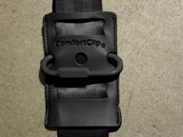
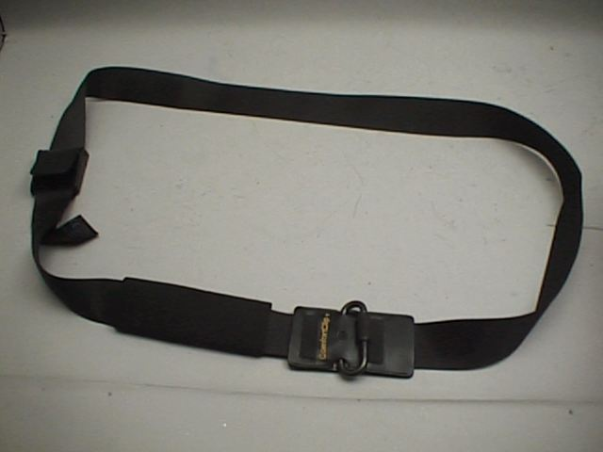

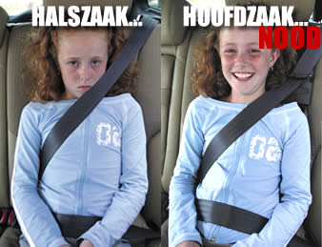
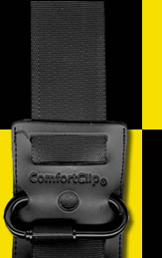

It was suggested that this product could be approved, making use of the definition of “guide strap”.

Follow up

Case in the Netherlands

RDW has replied to the request of the manufacturer that this produkt cannot be approved according to UN-ECE Regulation 44 and mentioned two reasons (we only focussed on these two because the manufacturer did not provide us with a full application for approval):

- The guide strap does not fulfil the following par. of Reg.44:
6.2.2. For groups I, II and III, all restraint devices utilizing a "lap strap" must positively guide the "lap strap" to ensure that the loads transmitted by the "lap strap" are transmitted through the pelvis

- The guide strap makes use of the seat back as a kind of upper anchorage point. However, contrary to making use of a real upper anchorage point, making use of the seat back in this mode does not provide the guaranteed values than can be expected from an upper anchorage point.

International aspect of this case

The Netherlands believe that it is confusing that the definition of “guide strap” is placed under the heading of child restraints of the non-integral class (see text below) and would like to prevent wrong interpretations.

Therefore, during the March 2005 TAAM (Type Approval Authorities meeting of the European Union) the Netherlands explained the case and offered to make a proposal for clarification. This was agreed.

Proposal:

In the text below the part which is struck through should be deleted, and
be reintroduced in a new separate par. with number 2.38.

2.1.3. Child restraint systems may be of two classes:
an integral class comprising a combination of straps or flexible components with a securing buckle, adjusting device, attachments, and in some cases a supplementary chair and/or impact shield, capable of being anchored by means of its own integral strap or straps;
a non-integral class that may comprise a partial restraint, which, when used in conjunction with an adult belt, which passes around the body of the child or restrains the device in which the child is placed, forms a complete child restraint system;

2.1.3.1. 'partial restraint' means a device, such as a booster cushion, which, when used in conjunction with an adult seat belt, which passes around the body of the child or restrains the device in which the child is placed, forms a complete child restraint system;

2.1.3.2. 'booster cushion' means a firm cushion, which can be used with an adult seat belt;
      - 'guide strap' means a strap which constrains the shoulder strap of the adult seat belt in a position to suit the child and where the effective position at which the shoulder strap changes direction can be adjusted by means of a device which can be moved up and down the strap to locate the wearer's shoulder, and then locked into that position. This guide strap is not meant to carry a significant part of the dynamic load.

Take the text of the deleted subpar. and reintroduce it under the following new par. 2.38.

  - 'guide strap' means a strap which constrains the shoulder strap of the adult seat belt in a position to suit the child and where the effective position at which the shoulder strap changes direction can be adjusted by means of a device which can be moved up and down the strap to locate the wearer's shoulder, and then locked into that position. This guide strap is not meant to carry a significant part of the dynamic load.

- - - - -

