UN-GRPE PMP Phase 3
Inter-laboratory Correlation Exercise: Framework and Laboratory Guide
A Document For The UK Department for Transport

Q55022
6 January 2005
RD 04/80801.3
Client Confidential

Authors
Jon Andersson
David Clarke
Contributors

Approved
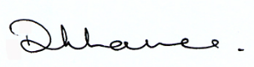

Diane Lance
Manager
Chemistry and Aftertreatment
Contents
1. INTRODUCTION 1
2. SCOPE 1
3. REFERENCES 1
4. TEST SPECIFICATIONS 2
4.1 Testing Environment 2
4.2 Vehicle Specifications 2
4.3 Lubricating Oil 2
4.3.1 Lubricant Flush and Fill 2
4.4 Test Fuel 3
5. TEST PROTOCOL 3
5.1 Delivery and Preparation of Vehicles 3
5.2 Test Cycles 3
5.3 Criterion for Repeat Tests 3
5.4 Testing Approach 3
5.5 Test Order and System Preconditioning 3
5.5.1 Diesel System Preconditioning 3
5.5.2 Gasoline System Preconditioning 4
5.5.3 Shared Dilution System 4
6. MEASUREMENT AND SAMPLING SYSTEMS FOR GASEOUS EMISSIONS 4
7. MEASUREMENT AND SAMPLING SYSTEMS FOR PARTICULATES 5
7.1 Introduction 5
7.2 Primary Dilution System 5
7.3 Particulate Mass Sampling 5
7.4 Sample Pre-classifier 5
7.5 Sampling Filters 6
7.5.1 Filter holder assembly 6
7.5.2 Filter medium 6
7.5.3 Filter size and Stain Area 6
7.5.4 Filter face velocity/ volumetric sample flow rate (xcm/s, ylitres/min) 6
7.5.5 Filter Preparation 6
7.5.6 Sample Filter Weighing 6
7.6 Measurement Equipment and Environment 7
7.6.1 Microgram balance 7
7.6.2 Weighing Chamber Parameters 7
7.7 Calibration Requirements 7
7.7.1 Microbalance Calibration 7
7.7.2 Reference Filter Weighing 7
8. GOLDEN PARTICLE MEASUREMENT SYSTEM AND SAMPLING SYSTEMS 7
8.1 Particle Sampling System 7
8.1.1 Sample Probes 8
8.1.2 Particle Pre-classifier 9
8.2 Volatile Particle Remover (VPR) 9
8.2.1 Description 9
8.2.2 Elements of the VPR 9
8.2.3 Performance 9
8.2.4 Location of Sampling and Measurement Equipment 10
8.3 Particle Counter (Particle Number Measurement Unit, PNC) 10
8.3.1 PNC Performance Characteristics 10
8.4 Sampling lines 10
8.5 Calibration of Particle Number Measurement System 11
8.5.1 Calibration of Particle Number Concentration Measurement Device 11
8.5.2 Calibration of the diluters 11
8.5.3 Calibration of the Volatile Particle Remover 11
8.6 Additional Sampling And Measurement System For Particles 12
9. TEST PROCEDURES 12
9.1 Preparation of the Vehicle 12
9.2 Dynamometer Preparation 12
9.3 Test and Conditioning Protocols 12
9.4 Test Procedures – Gaseous Emission 13
9.5 Preparation for the Test 13
9.6 During the test 13
9.7 Post-test 13
9.8 Test Procedures – Particulate Emissions 13
9.8.1 Preparation for the Test (filter weighing, switch to bypass) 13
9.8.2 During the test (switch to sample) 13
9.8.3 Post-test (condition and weigh filters) 13
9.9 Test Procedures – Particle Emissions 14
9.9.1 Equipment Arrival at Laboratory 14
9.9.2 List Of Equipment/Components 14
9.9.3 Initial Checks and Assembly of GPMS 14
9.9.4 Preparation for the Daily Protocol: Instrument Warm-up and Daily Verification Exercises 15
9.10 During the test 16
9.11 Post-test 16
9.11.1 Repeat Daily Verification Exercise 17
9.12 On Completion Of The Test Matrix 17
10. DATA CAPTURE AND PRESENTATION IN CORRECT FORMAT 17
10.1 Regulated Emissions 17
10.2 Particulate Mass 18
10.3 Particle Number 18

PMP PHASE 3 – Inter-laboratory Correlation Exercise

INTRODUCTION
This document has been prepared in response to a request from UK DfT as part of the Particle Measurement Programme (PMP).
The document’s purpose is to specify the testing guidelines and protocol for an inter-laboratory correlation exercise. This exercise is specifically designed to evaluate the draft revised Regulation 83 document - and its approach to particulate mass and particle number measurements - generated as part of the UK PMP Phase 2 reporting process.
In Section 9, the document contains specific and detailed guidelines on how the testing should be conducted at each laboratory.

SCOPE
This document proposes the scope for Phase III of PMP, the inter-laboratory correlation exercise and addresses the measurement and evaluation methods for particulate (all materials collected by the conventional filter method) and particle (exhaust aerosol; solid particles as defined by the measurement system) exhaust emissions from light duty vehicles under transient conditions on a chassis dynamometer. It is derived from the existing LD procedure and from draft procedures for future HD legislation (Regulation 49, ISO 16183 and US 2007).
Regulated gaseous emissions will be measured at the same time as particulate and particle emissions, using established regulatory measurement techniques.
This document is specifically concerned with an exhaust dilution system comprising a full flow primary tunnel with constant volume sampler (CVS).

REFERENCES
This specification is based upon or draws from the following documents:
Draft UN Working documents:
· R83 - Working Document 6/Rev. 1
· R49 - Working Document 7a (summary)/Rev. 2
Code of Federal Regulations Title 40 Part 86 Subpart N – Emission Regulations for New Otto-Cycle and Diesel Heavy-Duty Engines; Gaseous and Particulate Exhaust Test Procedures (Revised July 1 2001). “US2007”
ISO/DIS 16183 Heavy-Duty Engines – Measurement of gaseous emissions from raw exhaust gas and of particulate emissions using partial flow dilution systems under transient test conditions. Not yet an approved document and referred to as “16183”.
Euro Directives 1999/96/EC Annex III and 1998/69/EC “Euro”
Aerosol Measurements: Principles, Techniques and Applications.
Ed: Klaus Willeke and Paul A Baron 1993. Van Nostrand Reinhold

TEST SPECIFICATIONS

Testing Environment
The participating laboratories shall provide facilities and resources required to perform light duty vehicle emissions tests according to the Regulation 83, plus additional capability as required for particulate and particle measurements as defined in this document. They will also be required to supply test vehicles and measurement systems, and to liaise with the managing agent and “golden engineer”

Vehicle Specifications
A “golden” vehicle will be supplied by the managing agent and tested at all participating laboratories. This will be a diesel-fuelled vehicle equipped by the manufacturer with a diesel particulate filter (DPF) and nominated as Au-DV1.
Optionally, a number of additional vehicles, up to a total of four, shall be selected and supplied by each laboratory. Additional vehicles shall meet the following criteria:
- A Euro IV compliant conventional diesel (without DPF); nominally DV2
- A Euro IV compliant conventional petrol fuelled vehicle; nominally PV1
- A Euro III/IV compliant direct injection spark ignition vehicle (DISI); nominally GDIV1

Lubricating Oil
The lubrication oil shall meet the standard specified by the engine manufacturer. Where a range of oils are specified, the minimum sulphur level standard shall be employed.
A large single batch of lubricant will be secured by the project-managing laboratory, analysed and shipped to the test laboratories in advance of the arrival of the test vehicles. The total volume acquired will be sufficient for a rigorous flush and fill procedure for all vehicles tested at each laboratory across the entire inter-laboratory correlation exercise.

Lubricant Flush and Fill
A defined flush and fill procedure will be developed, and this employed upon arrival of each vehicle at each test laboratory. Each vehicle will then be subjected to identical conditioning procedures to ensure equivalence between laboratories. An example flush and fill procedure is shown in Appendix 1.

Test Fuel
The diesel and gasoline fuels to be employed during this programme will be secured by the project-managing laboratory, analysed and shipped to the test laboratories in advance of the arrival of the test vehicles. Both fuels will be drawn from single batches, will comprise sulphur levels of <10ppm and will otherwise comply with Annexes 3 and 4 of Directive 2003/17/EC describing fuel specifications to be employed after 1st January 2009.

TEST PROTOCOL

Delivery and Preparation of Vehicles
All vehicles to be tested shall be inspected for damage on arrival at the laboratory. Any problems shall be reported to the golden engineer and project manager. Vehicles shall be stored in an appropriate manner prior to pre-test conditioning.

Test Cycles
All vehicles shall be tested over the NEDC cold start drive cycle as defined in European Directive 70/220/EC as amended by 98/69/EC.

Criterion for Repeat Tests
A minimum of 5 tests shall be performed on each vehicle. Additional tests shall be carried out if one or more of the initial tests appears to be an outlier. A result is defined as an outlier if the specific particulate mass for that test lies outside ±2 σ of the mean of the remaining tests. The outlier will only be rejected if it remains outside the distribution inferred from 5 tests. The results of all tests, including those deemed to be outliers, shall be reported.

Testing Approach
The test work shall be carried out according to a pre-defined schedule for vehicle conditioning, measurement system checks and test cycles. This schedule will depend on the number of different vehicles being tested, and will be subject to agreement with the project manager.

Test Order and System Preconditioning
Test order shall consider the possibility of contamination of test results by a previously tested vehicle, and in general, a low particulate emitting vehicle shall always be tested prior to a less clean vehicle. For example, an outline daily test protocol for testing four vehicles within one laboratory is shown in Figure 1: this ensures that Au-DV1 is always tested before DV2 and PV1 is always tested before GDIV1. Further example test protocols can be found in Appendix 1.

Diesel System Preconditioning
In a dedicated diesel dilution system, Au-DV1 shall always be last vehicle to be conditioned each day. This ensures that the entire transfer and dilution system is preconditioned with the cleanest vehicle. This final conditioning shall comprise a 20 minute 120kph steady state followed by the standard diesel conditioning.

Gasoline System Preconditioning

In a dedicated gasoline dilution system, the same PFI vehicle of at least Euro 3 specification shall always be last vehicle to be conditioned each day. This ensures that the entire transfer and dilution system is preconditioned with a clean vehicle. This final conditioning shall comprise a 30 minute 120kph steady state followed by the standard gasoline conditioning. If the only vehicle to be tested is GDIV1, then this may be used for the preconditioning.

Shared Dilution System
In a shared dilution system, where the GDIV1 vehicle must be tested in a diesel dilution tunnel, the GDIVI vehicle shall follow the Au-DV1 vehicle in the test order, but precede any conventional (non-DPF equipped) diesel. The preconditioning for the dilution tunnel shall follow the protocol described in Section 5.5.1.
It is not recommended that PFI gasoline vehicles be tested in a dedicated diesel dilution system.

Figure 1: Example Test Protocol: Four Vehicles Tested in One Laboratory
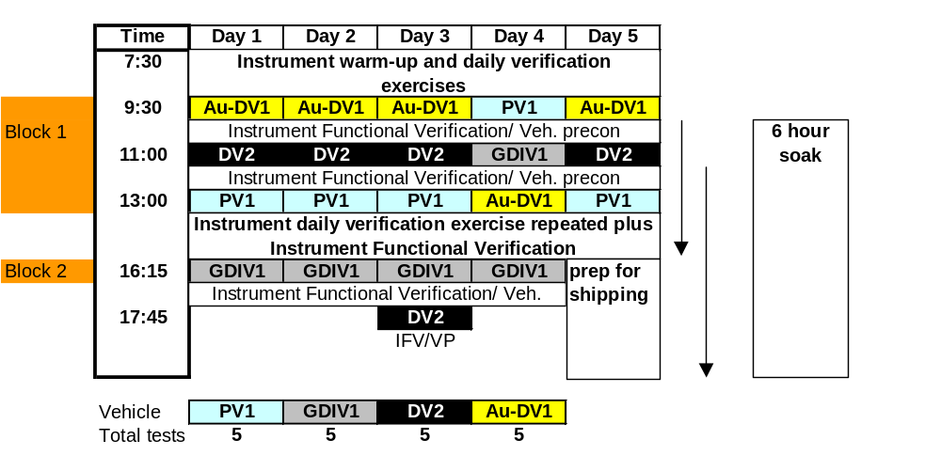

MEASUREMENT AND SAMPLING SYSTEMS FOR GASEOUS EMISSIONS
The mass of gaseous emissions shall be measured during all tests in accordance with the current R83 regulation. If possible, raw tailpipe and engine out emissions shall also be measured on a continuous basis throughout the test.

MEASUREMENT AND SAMPLING SYSTEMS FOR PARTICULATES

Introduction
The mass of particulate material emitted by each engine technology and for the combined phases of the NEDC test will be measured using the system defined below.

Primary Dilution System
A full flow CVS exhaust dilution tunnel system meeting the requirements of Regulation 83 shall be used. The flow rate of dilute exhaust gas through the tunnel shall be 12m³/min at standard reference conditions (20°C and 1bar).
It is recommended that the dilution air used for the primary dilution of the exhaust in the CVS tunnel shall be first charcoal scrubbed and then passed through a secondary filter. The secondary filter should be capable of reducing particles in the most penetrating particle size of the filter material by at least 99.95%, or through a filter of at least class H13 of EN 1822; this represents the specification of High Efficiency Particulate Air (HEPA) filters.
If both gasoline and diesel vehicles are to be tested, then there shall be a dedicated dilution tunnel for each fuel type. If a single tunnel only is available, then priority should be placed on testing the golden vehicle and other diesel vehicles.

Particulate Mass Sampling
A sample probe shall be fitted in the dilution tunnel. It shall be installed near the tunnel centre-line, 10 - 20 tunnel diameters downstream of the gas inlet and have an internal diameter of at least 12 mm. The sample probe will be sharp-edged and open ended, facing directly into the direction of flow.
A cyclone or impactor based pre-classifier shall be employed.
A pump will draw a sample of dilute exhaust gas proportional to the total tunnel flow through the sample pre-classifier and filter holder.
The distance from the sampling tip to the filter mount shall be at least five probe diameters, but shall not exceed 1,020 mm.

Sample Pre-classifier
In accordance with the recommendations of the draft Regulation 83 document, a cyclone or impactor pre-classifier shall be located upstream of the filter holder assembly. The pre-classifier 50% cut point particle diameter shall be between 2.5 µm and 10 µm at the volumetric flow rate selected for sampling particulate mass emissions. The pre-classifier shall allow at least 99% of the mass concentration of 1µm particles entering the pre-classifier to pass through the exit of the pre-classifier at the volumetric flow rate selected for sampling particulate mass emissions. Evidence of compliant performance to this specification shall be presented (e.g. manufacturer’s calibration certificate).

Sampling Filters

Filter holder assembly
The filter holder assembly shall be of a design that provides for a single filter only. The shape of the holder should be such that an even flow distribution of sample across the filter stain area is achieved.
In order to meet the requirement that a temperature of 47±5°C be maintained for a period of at least 0.2s within 2.5cm of the filter face, the filter holder and transfer tubing from the CVS tunnel will either need to be heated directly, or be mounted inside a temperature-controlled enclosure.

Filter medium
Pallflex TX40 Fluorocarbon coated glass fibre filters shall be employed. All filters will be drawn from a single batch procured by the project-managing laboratory.

Filter size and Stain Area
The filter diameter shall be 47mm and the stain area shall be at least 1075 mm².

Filter face velocity/ volumetric sample flow rate (xcm/s, ylitres/min)
Filter face velocity shall be in the range 50cm/s to 80cm/s , which corresponds to a flow rate range of 35l/min to 51l/min. Filter face velocity should be calculated at 47°C.

Filter Preparation
The particulate sampling filters shall be conditioned (as regards temperature and humidity) in an open dish that has been protected against dust ingress for at least 2 and for not more than 80 hours before the test in an air-conditioned chamber. After this conditioning the uncontaminated filters will be weighed and stored until they are used. If the filters are not used within one hour of their removal from the weighing chamber they shall be re-weighed.
The one-hour limit may be replaced by an eight-hour limit if one or both of the following conditions are met:
- a stabilised filter is placed and kept in a sealed filter holder assembly with the ends plugged, or;

- a stabilised filter is placed in a sealed filter holder assembly which is then immediately placed in a sample line through which there is no flow.

Sample Filter Weighing
Once loaded, the used particulate filter shall be taken to the weighing chamber within one hour following the analyses of the exhaust gases. The filter shall be conditioned for at least 2 hours and not more than 80 hours and then weighed.

Measurement Equipment and Environment

Microgram balance
The analytical balance used to determine filter weight must have a precision (standard deviation) of better than 2 µg for a clean filter; better than 0.25µg for a reference weight and a resolution or readability of 1µg or better. To eliminate the effects of static electricity: the balance should be grounded through placement upon an antistatic mat and particulate filters should be neutralised prior to weighing; this can be achieved by a Polonium neutraliser or a device of similar effect.

Weighing Chamber Parameters
The temperature of the chamber (or room) in which the particulate filters are conditioned and weighed must be maintained to within 295K ± 3 K (22°C ± 3°C) during all filter conditioning and weighing. The humidity must be maintained to a dew point of 282.5K ± 3 K (9.5°C ± 3°C) and a relative humidity of 45 % ± 8 %. The environmental conditions of the weighing room during the test programme shall be monitored and reported.
Limited deviations from weighing room temperature and humidity specifications will be allowed provided their total duration does not exceed 30 minutes in any one filter conditioning period. The weighing room should meet the required specifications prior to personal entrance into the weighing room. During the weighing operation no deviations from the specified conditions are permitted.

Calibration Requirements

Microbalance Calibration
The microbalance shall be calibrated according to the manufacturer’s specification within 3 months prior to the commencement of the test programme.

Reference Filter Weighing
At least two unused reference filters must be weighed within 4 hours of, but preferably at the same time as the sample filter weighings. They must be the same size and material as the sample filters. If the average weight of the reference filters changes between sample filter weighings by more than ± 5µg, then the sample filter must be discarded and the emissions test repeated.

GOLDEN PARTICLE MEASUREMENT SYSTEM AND SAMPLING SYSTEMS
The number of particles emitted by each engine technology and for each test cycle shall be determined using the ‘Golden Particle Measurement System’ (GPMS) defined below. The majority of these components will be provided, though certain items indicated in the text shall be provided by the laboratory (Table 1, Page 14).

Particle Sampling System
The particle sampling system shall consist of a sampling tube in the dilution tunnel (PST), a particle pre-classifier (PCF) and the GPMS particle conditioning and measurement system comprising a volatile particle remover (VPR) upstream of the particle number counter (PNC_GOLD) unit. The particle sampling system is required to draw a sample from the CVS, size classify it, transfer it to a diluter, condition the sample so that only solid particles are measured, and pass a suitable concentration of those particles to the particle counter.

Sample Probes
A particle sampling tube shall be installed near the tunnel centre line, roughly ten tunnel diameters downstream of the gas inlet, facing upstream into the tunnel gas flow with its axis at the tip parallel to that of the dilution tunnel. The tube shall be sharp edged and open-ended and have an internal diameter of approximately 12.5mm. The PST may be heated to no greater than 52°C.
The distance from the sampling tip to the point at which the probe leaves the dilution tunnel shall be less than 200 mm and the distance from the sampling tip to the entrance to the particle pre-classifier unit shall not exceed 1,000 mm. The particle sampling tube shall be placed in a position equivalent to that of the probe employed for particulate mass sampling: all sampling probes and tubes shall be equally spaced about the centre line of the dilution tunnel with at least 5cm separation between them.

Particle Pre-classifier
The upper limit of the particle size range to be measured shall be determined by the use of the cyclone particle size pre-classifier provided. The 50% cut-point of the particle pre-classifier shall lie at 2.5µm. The laboratory will provide a suitable pump capable of 90l/min (+/- 5l/min) to ensure an upper limit of particles sampled into the measurement system of ~2.5µm.

Volatile Particle Remover (VPR)
The VPR shall be used to define the nature of the particles to be measured.

Description
The VPR provides heated dilution, thermal conditioning of the sample aerosol, further dilution for selection of particle number concentration and cooling of the sample prior to entry into the particle number counter.

Elements of the VPR
The VPR shall comprise the following elements:

First Particle Number Diluter (PND₁)
The PND₁ diluter shall be specifically designed to dilute particle number concentration and output a dilute sample equal to 150°C +/- 5°C. The diluter should be supplied with HEPA filtered dilution air and be capable of a dilution ratio range of 1 to 1000 times. For the Golden Vehicle, the dilution ratio of this diluter; PNDR₁ will be ~17:1 as determined by a potentiometer setting of 75%. This setting should be employed for MPI gasoline vehicles and other DPF-equipped Diesels. An initial setting of 5%-10% may be appropriate for conventional Diesel vehicles, but this should be optimised.

Evaporation Tube
The ET shall be a length of tubing 240mm +/-10 mm and I.D 6mm +/- 0.1mm equipped with a heating mantle. The entire length of the ET must be controlled to a temperature greater than that of PND₁, with a portion of the length equivalent to a gas residence time of 0.2s +/- 0.05s held at a constant temperature (+/-20°C) of 300°C.

Second Particle Number Diluter (PND₂)
The PND₂ device shall be specifically designed to dilute particle number concentration. The diluter shall be supplied with HEPA filtered dilution air and be capable of a dilution ratio of ~ 10 times. The dilution ratio of this diluter; PNDR₂ is selected such that particle number concentration downstream the PND₂ diluter is <10⁴ particles/cm³ and the gas temperature prior to entry to the PNC_GOLD is <35°C.

Performance
The VPR shall operate under conditions that achieve greater than 99% reduction of 30nm C₄₀ (tetracontane) particles and greater than 80% solid particle penetration at 30, 50 and 100nm particle diameter.

Location of Sampling and Measurement Equipment
The distance from the sampling tip of the PST to the entrance to the PND₁ shall not exceed 1000mm.
The distance from the sampling tip to the point at which the probe leaves the dilution tunnel shall be less than 200 mm.
The distance from the sampling tip to the entrance to the particle number counting instrument shall not exceed 2,500 mm.

Particle Counter (Particle Number Measurement Unit, PNC)
The particle counter is used to determine the number concentration of solid particles in a diluted sample of vehicle exhaust aerosol continuously drawn from the CVS.

PNC Performance Characteristics
The particle number concentration measurement unit (PNC_GOLD) shall meet the following conditions:
- It shall operate under full flow operating conditions.
- It shall have a counting accuracy of ± 10% across the range 10²cm⁻³ to 10⁴cm⁻³ and +/- 10cm⁻³ below this concentration against a traceable standard.
- It shall have a readability of 0.1 particles/cm³.
- It shall have a linear response to particle concentration over 1 to 10,000 particles/cm³.
- It shall have a data logging frequency of equal to or less than 0.5 Hz.
- It shall have a T90 response time of between 5s and 15s
- It shall have a data-averaging period of between 1 and 6s and shall not incorporate automatic data manipulation functions.
The lower particle size limit characteristics of the PNC_GOLD shall be such that the 10% (D10), 25% (D25), 50% (D50) and 90% (D90) inlet efficiencies of the instrument correspond to the particle sizes 16nm (+/-nm), 18nm (+/-2nm), 23nm (+/-3nm and 37nm (+/-4nm)) respectively.

Reference Particle Counter
A second particle counter (PNC_REF), with identical specification to PNC_GOLD will be transported with PNC_GOLD to act as a reference instrument. This instrument will also be operating during testing to indicate the real time function of the VPR.

Sampling lines
All sampling lines shall be either TYGON (specifically R3603), conductive silicone tubing or of stainless steel composition, contain smooth internal surfaces and be of minimal length. Sharp bends and abrupt changes in section should be avoided in all sampling lines.

Calibration of Particle Number Measurement System
Prior to commencement of the test programme, calibration of the PNCs, diluters and VPR will be undertaken. This may be undertaken by the instrument manufacturers, but shall be according to the protocols described in the following sections:

Calibration of Particle Number Concentration Measurement Device
The particle counter shall be calibrated according to the manufacturer’s specification within one month prior to testing in the first laboratory. Calibration shall be traceable to a standard calibration method:
- comparison of the response of the counter under calibration with that of a calibrated aerosol electrometer when simultaneously sampling electrostatically classified calibration particles, or
- comparison of the response of the counter under calibration with that of a second counter which has been calibrated by the above method.
In either case, calibration shall be undertaken at five concentrations spaced as uniformly as possible across the single particle detection region of the counter’s measurement range. Calibration spacing will be ~10000, ~8000, ~6000, ~4000, ~2000cm⁻³ (plus zero check). Measured concentrations shall be within ±10% of the standard concentration for each calibration concentration used. The gradient from a linear regression of the two data sets shall be calculated and recorded. Linearity of response is calculated as the square of the Pearson product moment correlation coefficient (R²) of the two data sets and shall be equal to or greater than 0.95.

Calibration of the diluters
It is considered unlikely that fully characterised diluters (with fully understood size-related losses) will be available within the timeframe of the inter-laboratory correlation exercise and it is recognised that calibration with gases will not necessarily indicate the exact dilution ratios obtained for aerosols. However, the practicality of the inter-laboratory exercise is for consistency between test laboratories, and this can be provided by a well designed diluter with low predicted losses and stable gas dilution ratio performance.
The diluter shall be calibrated with a traceable standard gas mixture within one month prior to testing in the first laboratory. Calibration shall be undertaken by measuring the concentration of the standard gas with a calibrated gas monitor at the inlet and outlet of the diluter.
Calibration shall be undertaken at least 5 dilution ratios spaced as uniformly as possible across the dilution ratio range from 0 to 1000.
Measured dilution ratios shall be within ±10% of nominal dilution ratio settings. If a diluter is to be used over a narrower dilution range, then the 5-point calibration should span that range.

Calibration of the Volatile Particle Remover
The penetration efficiency of solid particles through the apparatus shall be established within one month prior to testing in the first laboratory.
The test aerosol for these measurements shall be solid particles of diameters 30, 50 and 100 nm and a minimum concentration of 1,000 particles/cm³. Particle concentrations shall be measured upstream and downstream of the apparatus operating at the temperature and flow conditions employed during an emission test. A minimum penetration efficiency of 80% shall be achieved at all three test particle diameters.

Additional Sampling And Measurement System For Particles
The laboratory shall propose its own specific particle number measurement system and operate this in tandem with the GPMS. Data from this system shall be collected simultaneously with that from the GPMS, and the two sets compared and contrasted. The sampling and measurement of particles with the laboratories’ own systems shall not interfere with measurements from the GPMS. Alternative systems installations will be subject to apporval by the Golden Engineer and/or project manager.

TEST PROCEDURES

Preparation of the Vehicle
Vehicles shall be prepared in accordance with R83 and good engineering practice for emissions testing. The fuel and lube oil used shall be as specified in section 4 of this document.

Dynamometer Preparation
The chassis dynamometer controller shall be adjusted to simulate the inertia of the test vehicle. The inertia shall be set according to the generic inertia classes given in R83, with corresponding coefficients for the road load curve. The road load setting shall be verified by performing a coast-down test on the golden vehicle.

Test and Conditioning Protocols
The vehicle shall be conditioned prior to each test in accordance with Regulation 83. In addition, the first vehicle to be tested on the subsequent day shall be the last conditioned on the previous night. In addition to the conditioning required by Regulation 83, this last daily conditioning shall be preceded by a 20 minute period of operation at 120kph. This period of high temperature operation is required to raise the temperature of the vehicle’s exhaust and transfer system above that to be encountered during the NEDC test and thus eliminate the possibility of cross contamination from other vehicles and artefact formation.
If an elastomer coupling is used to connect a vehicle’s tailipipe to the CVS transfer tube, care must be taken to minimise the exposure of the elastomer surface to the exhaust stream.
Regulated emissions must be logged during the conditioning procedure and if possible DPF backpressure, in order to determine whether a regeneration has occurred. If a regeneration does occur, additional vehicle conditioning will be required and the Golden Engineer and/or Project Manager must be consulted prior to any further testing.
A minimum soak period of six hours shall be included between successive tests on each vehicle.
Warm-up and pre-conditioning procedures shall be carried out on the measurement and sampling systems as appropriate. System verification and calibration checks as required shall be performed daily, but not necessarily as part of the warm-up schedule.
An example test protocol for 4 vehicles is given in Figure 1, Section 5.4.

Test Procedures – Gaseous Emission

Preparation for the Test
Prior to the test the gaseous emissions analysers shall be calibrated using suitable reference gases, on the ranges that will be used during the test. The zero and span readings shall be recorded.

During the test
At the start of the test, the bag-sampling unit shall be switched to start filling the sample and ambient bags.
During each test the data from the gaseous emissions analysers shall be recorded with a logging rate of at least 0.5 Hz.

Post-test
At the end of the test the bag sampling unit shall be stopped.
Following the test the zero and span readings of the gaseous emissions analysers shall be checked and recorded. The analysers shall then be calibrated using suitable reference gases, on the ranges that will be used for analysing bag samples. The emissions concentrations in the bag samples shall then be measured and recorded.

Test Procedures – Particulate Emissions
These procedures are applicable to the single filter used for the single sample from the combined phases of the NEDC cycle.

Preparation for the Test (filter weighing, switch to bypass)
Prior to the test the test filter shall be conditioned in the weighing room. The initial filter mass shall be measured and recorded on a microbalance with 1µg resolution.
During the system stabilisation procedure the particulate sampling system shall be operated on bypass

During the test (switch to sample)
At the start of the test, the particulate sampling system shall be switched from the bypass to sample filter.

Post-test (condition and weigh filters)
On completion of the test the particulate sampling system shall be stopped. The filter holder shall be removed and the filter returned to the weighing room or chamber for conditioning.
After conditioning the filter shall be weighed and the mass recorded

Test Procedures – Particle Emissions
The following sections describe the procedures that shall be followed by each laboratory in receiving, installing and operating the GPMS.

Equipment Arrival at Laboratory
On arrival at the laboratory, all equipment shall be unpacked and inspected for damage. If any components are missing or damaged the Golden Engineer and Project Manager shall be informed.

List Of Equipment/Components
The equipment accompanying the Golden Vehicle which will be circulated between laboratories is summarised in Table 1.
Table 1: Components For Circulation Around Participating Laboratories
Golden Particle Measurement System Components | Transport (Y/N) | Comments
Cyclone | Y
Sampling point, Stainless steel tube to 90l/min pump | N
90l/min pump | N
Diluter head (rotating disc) | Y
2 x cables (1m sampling line, 3m dilution air line) | Y
VPR assembly (diluter controllers, heaters and ET) | Y
Exhaust tube from peristaltic pump | Y
Tube from upstream of ET to PNC_REF | Y
Tube from downstream of PND2 to t-piece | Y
Steel t-piece for diluted samples | Y
Tube from t-piece to PNC_GOLD | Y
Tube to spill excess overpressure air from t-piece | Y
Tube bypassing cooler assembly | Y
PNC_REF | Y
PNC_REF pump plus 2 x clear plastic tubes | Y
PNC_GOLD | Y
PNC_GOLD pump plus 2 x clear plastic tubes | Y
Teflon t-piece to dump exhaust from PNC pumps | Y
2 x power plugs (PNCs) | Y
2 x serial cables (PNCs) | Y
Compressed air line for VPR secondary dilution | N
1 x power plug for VPR | Y
2 x HEPA filter | N
Particulate Matter Sampling Components
Cyclone | Y
Other Components
TSI software for data logging | Y
Packaging for VPR, diluter etc | Y
All instrument booklets, plus copies of certificates | Y

Initial Checks and Assembly of GPMS
A PNC linearity check will be carried out on PNC_GOLD and PNC_REF simultaneously. The purpose of this procedure is to verify the similarity of the counters and their responses across the concentration range of interest. Using an aerosol source with an initial concentration of less than 100000/cm³, and a calibrated diluter supplied as part of the GPMS, five dilution factors spanning at least a factor of 20 shall be selected: for example; 300, 200, 100, 50, 15. The R² (correlation coefficient) value of the five concentration values obtained shall then be compared with the R² value from the CPC_GOLD calibration certificate. Linearity of response is calculated as the square of the Pearson product moment correlation coefficient (R²) of the two data sets and shall be equal to or greater than 0.95.
The GPMS will then be assembled ready for analysis, and all elements of the system tested for functionality. The system shall be installed in the chassis dynamometer facility with suitable connections to a sample probe in the CVS tunnel such that the requirements of Section 8.1.1 and Section 8.4 are fulfilled. A schematic of the assembled system is shown in Figure 2. The laboratory will provide a suitable particle pre-classifier (Section 8.1.2) and pump to ensure that the upper size limit of particles sampled into the measurement system is 2.5µm. Good aerosol sampling practice will be employed in the construction of the GPMS with the best available diluters, ET and PNC employed and aerosol transport distances minimised.
Figure 2: Schematic Layout for GPMS
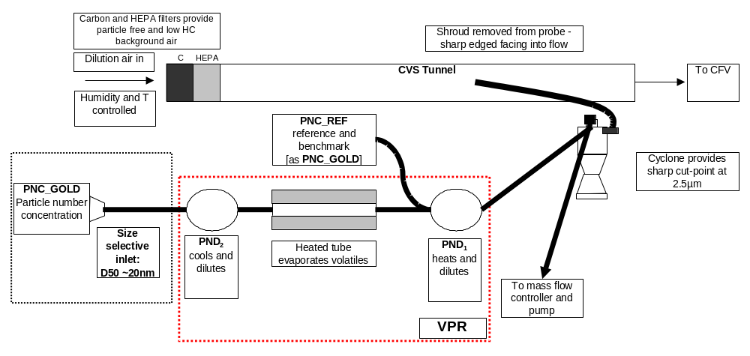
Appropriate dilution ratios for PND₁ and PND₂ will be determined in the first laboratory, and these shall be employed for the first test at each subsequent laboratory.

Preparation for the Daily Protocol: Instrument Warm-up and Daily Verification Exercises
First thing each morning all the elements of the measurement system will be activated, and left for at least 30 minutes to stabilise. This includes pumps, heaters, diluters and particle counters. The temperature of heated sections will be inspected to ensure compliance with the requirements of Section 8.2.2.
Instrument manufacturers of the various elements of the GPMS will provide calibration certification for the diluter(s), evaporation tube and particle counter employed for PMP particle number measurements. These data will be appropriate to address those requirements for primary calibration of instrumentation defined in the draft R83 regulation. However, it should be noted that the regulations are drafted with the intention that instrument manufacturers will have time to develop entirely suitable equipment and at this time exact compliance of all instrumentation with the draft regulations may not be possible.
Therefore the main issues are that operation consistent with the baseline calibrations is ensured, and that repeatable and valid operation can be demonstrated and maintained. In order to ensure this, regular calibration checks shall be performed. These are summarised as follows:

Verification of Free Sample Flow and Flow rate– The GPMS shall be checked for physical blockages and the CPC flow rate checked. The measured flow rate shall be within 5% of the instrument’s nominal value.

Verification of Counter Zero – An initial concentration of around 10000/cm³ (e.g. background number concentration) will be applied to both PNCs via a HEPA filter and using clean, particle free tubing. Testing shall commence if the measured particle count is less than 1/cm³.

Verification of Counter High Response – Background particle concentration will be simultaneously sampled into both PNC_GOLD and PNC_REF. Testing may commence when a comparable response is observed from both PNCs. If the source aerosol shows a concentration above 10⁴cm⁻³, a diluter may be employed to reduce the concentration introduced to the CPCs.

Verification of System Contamination and Leak Integrity – After heating the evaporation tube a HEPA filter will be applied to the inlet of the diluter and particle number concentration through the whole system measured using PNC_GOLD. Testing can commence providing the measured particle count is less than 5/cm³.
The GPMS shall then be fully reassembled. A sample line connected downstream of the particle pre-classifier shall then be connected to the inlet of the VPR. Sampling shall commence.
Any problems encountered during the daily verification exercise should be referred to the Golden Engineer or Project Manager who will make a decision on whether to proceed with the test programme.

During the test
During each emissions test, particle number concentrations from both PNC_Gold and PNC_REF shall be measured continuously in the particle sampling system with a frequency of >=0.5 Hz. The average concentrations shall be determined by integrating the analyser signals over the test cycle, with data recorded electronically. The system response time shall be ≤20 s, and shall be co-ordinated with sampling time/test cycle offsets, if necessary.

Post-test
Following each emissions test, the following instrument function verification tests will be performed:
Verification of Free Sample Flow – The GPMS shall be checked for physical blockages. (Section 9.9.4.1). The PNC flow rate will be checked.
Verification of Counter Zero – An initial concentration of around 10000/cm³ (e.g. background number concentration) will be applied to both PNCs via a HEPA filter and using clean, particle free tubing. Testing shall commence if the measured particle count is less than 1/cm³. (Section 9.9.4.2)
Verification of Counter High Response – Background particle concentration (below 10⁴cm⁻³) will be simultaneously sampled into both PNC_GOLD and PNC_REF. If background concentration is >10⁴cm⁻³ dilution may be employed to reduce the concentration. Testing may commence when a comparable response is observed from simultaneously from both PNCs. (9.9.4.3)
Data from each test will be inspected to determine whether instantaneous concentrations at the PNC_GOLD have exceeded 10⁴ particles cm/³ during the emissions cycle. If this has occurred, the dilution ratios of PND₁ and PND₂ may need to be modified. These modifications shall be discussed with and approved by the project manager or golden engineer prior to the next test on that vehicle.

If necessary, the PND₁ and PND₂ diluters should be cleaned at this stage. It is not anticipated that this will be required with the Golden Vehicle, but laboratories testing conventional diesels may encounter contamination issues.

Repeat Daily Verification Exercise
Prior to Block 2 testing, correct VPR functional temperatures will be established and the checks described in Sections 9.9.4.1 to 9.9.4.4 inclusive conducted.

On Completion Of The Test Matrix
On completion of all testing, the GPMS and Golden vehicle will be prepared for despatch to the next laboratory for testing.
However, prior to testing at the first laboratory and subsequent to testing at some additional laboratories, the VPR will be returned to a predefined calibration facility for a performance check. This check will determine the penetration and volatile removal performance of the VPR as described below:

Verification of VPR Function – When the VPR is fully operational, the removal of at least 99% of a volatile test aerosol where the initial concentration is >10,000/cm³ and concentration downstream of the thermoconditioner is >100/cm³ shall be demonstrated. A polydisperse volatile aerosol of modal diameter between 20 and 60nm will be generated using a suitable aerosol generator. Measurements will be made before and after the thermoconditioner using a PNC.
VPR Penetration - A second verification is to demonstrate that the solid particle (a particle that is not volatile under the VPR operating conditions) penetration through the VPR conforms to the manufacturer’s specification. A polydisperse aerosol will be classified in order to produce solid particles with a modal diameter of 60nm and passed through the VPR. Measurements will be made pre- and post-VPR at 20:1 and 300:1 dilution settings, and the actual penetration determined and recorded.
These performance evaluations will be undertaken during the shipping process for the Golden Vehicle and shall not delay the test programme. The decision as to when the VPR will be returned to the calibration facility will depend on the number of participating laboratories and will be at the discretion of the project manager and Golden Engineer.

DATA CAPTURE AND PRESENTATION IN CORRECT FORMAT
All data will be presented in a format compatible with Microsoft Excel. A standard spreadsheet for these data will be provided, prior to the commencement of testing, by the Project manager.

Regulated Emissions
Summary regulated gaseous emissions, carbon dioxide and fuel consumption data shall be quoted as g/km according to current European regulations. Data will be presented from individual UDC, EUDC phases and from the combined, NEDC, cycle.
In addition, raw and dilute logged gaseous regulated emissions shall be logged at a frequency of at least 1Hz in order to provide diagnostic capability if repeatability or reproducibility of vehicle tests is poor. On gasoline vehicles, the air/fuel ratio should be recorded or calculated at a frequency of 1Hz. These data shall be employed to interpret catalytic activity and engine management control. All logged data shall be presented in a time-aligned format on a CD-R.

Particulate Mass
Summary particulate mass data shall be quoted as g/km according to current European regulations. Data will be presented from the combined, NEDC, cycle.

Particle Number
Summary particle number data shall be quoted as number/km. Data will be presented from individual UDC, EUDC phases and from the combined, NEDC, cycle.
In addition, logged particle number data, time-aligned and synchronised with the regulated gaseous emissions shall be presented in a time-aligned format on a CD-R.
Appendix 1: Fill and Flush Procedure
- Warm the oil by 10 minutes low load driving
- Install vehicle on elevated ramp
- Release sump plug and drain oil. Retain 1 litre sample
- Drain oil filter and replace
- Lower ramp add 4.5 litres of fresh oil to the engine.
- Start engine and idle for a fixed period (40 minutes), sufficient to reach operating temperature
- Install vehicle on elevated ramp. Drain oil again
- Remove oil filter and discard.
- Fill engine with 4.5 litres test oil.
- Switch ignition off and allow to settle for 5 minutes. Check dipstick to ensure correct oil level
APPENDIX 2: Example Protocols
3 Vehicles – Golden Vehicle Plus Two Petrol Vehicles
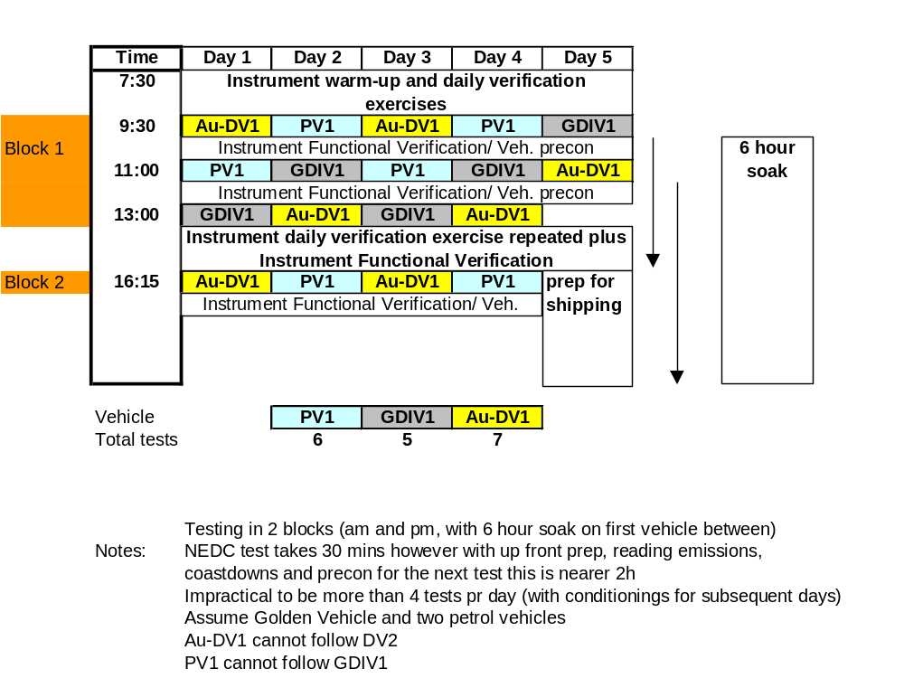
3 Vehicles – Golden Vehicle Plus One Diesel and One Petrol Vehicle
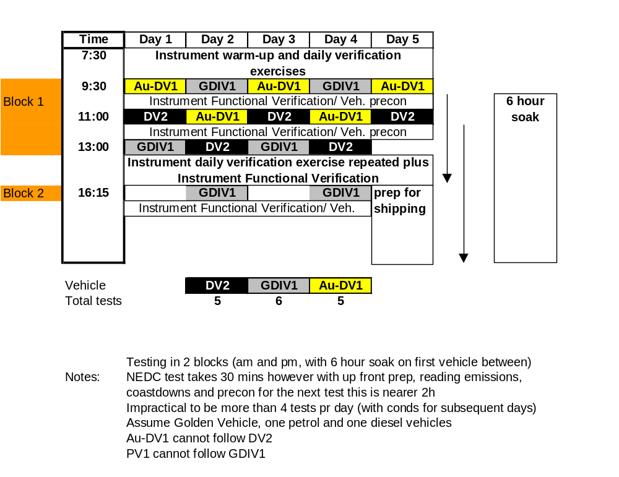
2 Vehicles – Golden Vehicle Plus One Diesel
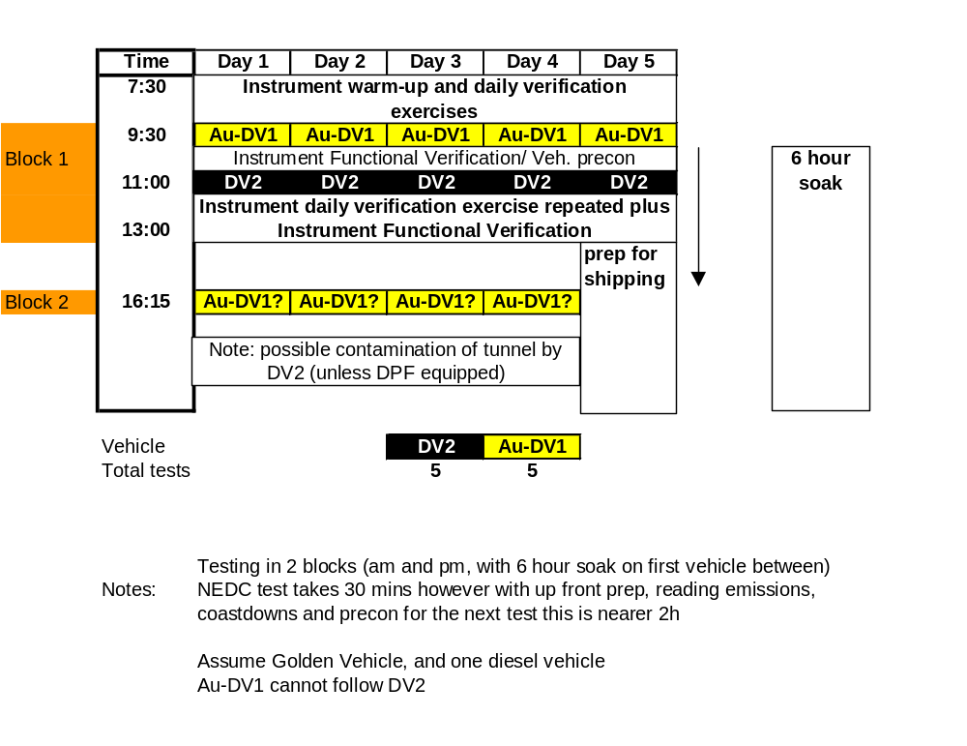
2 Vehicles – Golden Vehicle Plus One Petrol
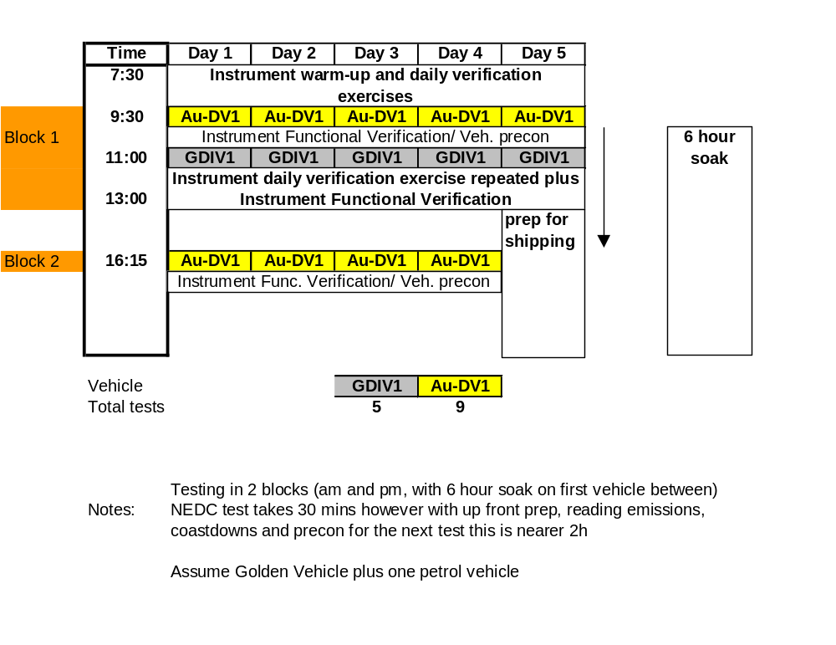
1 Vehicles – Golden Vehicle
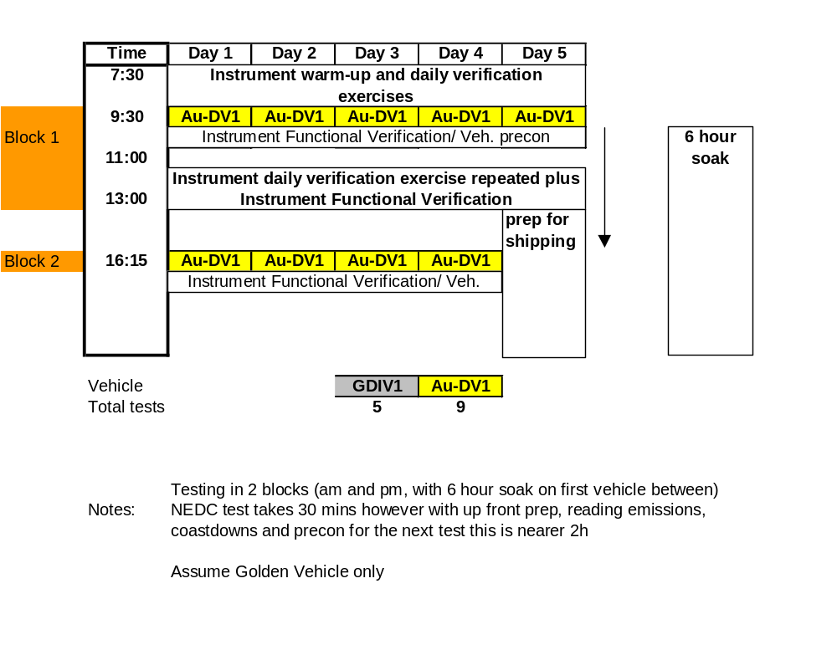

This paragraph previously contained the option to trigger elective regeneration. This is not possible on the Golden Vehicle, so sentence is deleted.
Clarification that a single PM measurement is required from the combined ECE (UDC) and EUDC phases of the NEDC drive cycle.
Filter face velocity temperature reference added.
Pump requirements included, now that 2.5µm @ 90l/min cyclone is being provided.
Mandatory setting for PND1 after Golden Vehicle tests in first laboratory.
Matter Engineering VPR employed.
PND₂ has fixed dilution ratio of ~9.5:1
Reference to dedicated sample probe for alternative systems deleted: there are circumstances where this is not necessary.
This is the minimum preconditioning required prior to the standard 3 x EUDC conditioning. More severe conditioning up to 130kph, 30 minutes will be permitted upon approval by the Golden Engineer and/or Project Manager.
Additional paragraph added addressing procedure to detect regeneration and subsequent actions required by laboratory.
Clarification that a single filter should be used both ECE and EUDC phases of the NEDC.
Requirement for diluter cleaning added
Particulate mass reported from the combined cycle only
40 minute idle period determined at Lab 1: JRC

