UNITED

NATIONS
STSTE


Distr.
Secretariat

GENERAL

ST/SG/AC.10/C.3/2005/43
13 September 2005

Original: ENGLISH

COMMITTEE OF EXPERTS ON THE TRANSPORT OF

DANGEROUS GOODS AND ON THE GLOBALLY

HARMONIZED SYSTEM OF CLASSIFICATION

AND LABELLING OF CHEMICALS

Sub-Committee of Experts on the

Transport of Dangerous Goods

Twenty-eighth session, 28 November-7 December 2005

Item 5 of the provisional agenda

LISTING, CLASSIFICATION AND PACKING

Discussion of issues on PRBA's lithium ion battery proposals

Transmitted by the Portable Rechargeable Battery Association (PRBA)

Introduction

1. PRBA is providing this paper for the information of the Sub-committee in its deliberations on the three PRBA proposals (ST/SG/AC.10/C.3/2005/44, -/45, and -/46). This paper responds to comments made during the twenty-seventh session in relation to ST/SG/AC.10/C.3/2005/13 and also subsequent informal comments indicating that it may be helpful to provide the Sub-Committee with further information on lithium ion battery technology.

Lithium ion batteries – What are they?

2. Lithium ion batteries are somewhat unique within the UN Recommendations in that their hazard is not a chemical hazard of the sort presented by chemicals commonly subject to the UN Model Regulation. Much like other batteries, including those not subject to regulation, the hazard of lithium ion batteries stems from their energy content. While lithium primary batteries contain metallic lithium, lithium ion batteries contain no lithium. This is confirmed in paragraph 38.3.3.2 of the UN Manual of Tests and Criteria which states:

“Lithium ion cell or battery means a rechargeable electrochemical cell or battery in which the positive and negative electrodes are both intercalation compounds (intercalated lithium exists in an ionic or quasi-atomic form with the lattice of the electrode material) constructed with no metallic lithium in either electrode.”

3. A lithium ion cell’s electrodes are rigid intercalation compounds that receive lithium ions without the lithium ions bonding to the electrode material. Lithium ions move from one electrode to the other depending on the state of charge (SOC) of the cell. The figure below illustrates the reactions that take place within a typical lithium ion cell. In an uncharged state, the majority of the lithium ions reside at the cathode. Lithium cobalt dioxide is the most commonly used cathode material. This material in the uncharged state is thermally stable. Graphite is normally used as the anode material. It is also thermally stable in the uncharged state. The electrodes are separated by a high flashpoint organic material (flashpoint point higher than 100ºC). As such none of the components of a lithium ion cell are thermally unstable in the uncharged state or meet the criteria for dangerous goods under the UN Model Regulation.

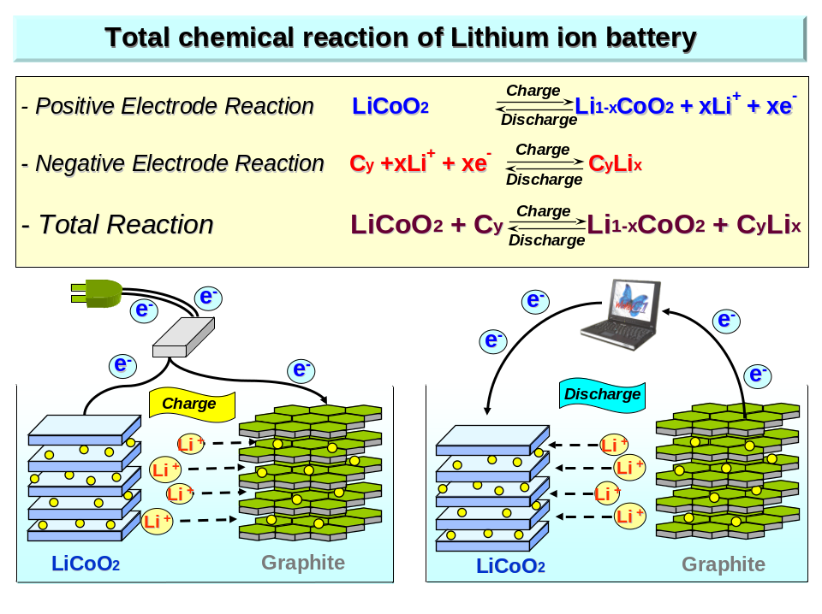

4. Cells in batteries typically used in larger portable electronic devices such as laptops and power tools are cylindrical in shape. The figure below illustrates how the electrodes and electrolyte are rolled up to fit in a cell.
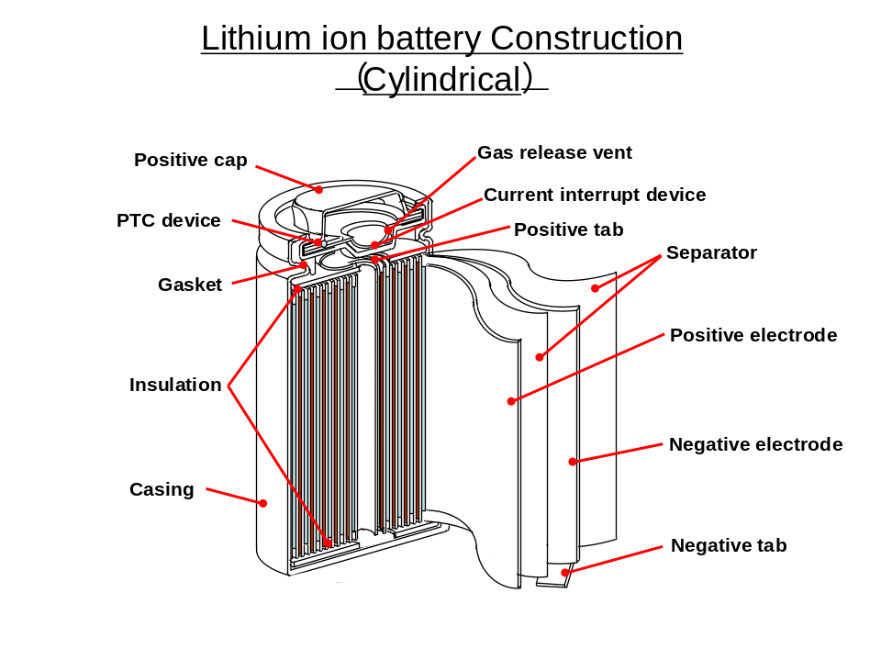
5. Cells are typically fitted with safety devices. A PTC (Positive Temperature Coefficient) Device limits current to a cell in the event of higher than expected temperature or external current draw. A CID (Circuit Interrupt Device) interrupts charging current to the cathode when internal gas pressure in a cell exceeds specified limits. A Safety Vent opens in response to a sudden increase in cell pressure and allows gas to escape.

6. Lithium ion batteries consist of one or more cells. Batteries also frequently include electronic safety circuits and other devices to manage the charging and discharging of the individual cells within the battery.

7. As with all cell and battery types, it is imperative that lithium ion cells and batteries be manufactured to rigorous quality control standards to ensure their safety and reliability. At this time PRBA and other battery organizations worldwide are actively engaged in establishing uniform quality standards through the Institute of Electrical and Electronics Engineers (IEEE). For example, PRBA members and other battery and electronic equipment manufacturers have developed IEEE Standard 1625 – Rechargeable Batteries for Portable Computing – that defines approaches to designing, testing, and evaluating a cell, battery pack, and host device (notebook computer) to mitigate battery system failure in user environments. A similar IEEE standard for cellular phones is near completion.

8. There are frequently many steps in the transport chain from the time a lithium ion cell is manufactured to the time it is purchased by the consumer. In practice cells may be manufactured by one company, transported to a second company (a battery assembler) who in turn assembles the cells and accompanying safety circuitry into a finished battery “pack” for use in electronic equipment. The completed batteries are then transported to an equipment manufacturer who then installs them and transports the completed electronic equipment to a distributor for delivery to a retail outlet.

Short circuit hazard of lithium ion cells and batteries

9. As in the case of virtually all battery types, a short circuit is the primary hazard of lithium ion cells and batteries. Charging a cell or battery causes the lithium ions residing at the cathode to move through the electrolyte and into the anode. As the cell is charged, it increasingly takes on more potential energy. A short circuit is an uncontrolled release of this stored up energy. A short circuit occurs any time the resistance between the anode and cathode is reduced to a very low level. This would happen, for example, if a copper wire were to connect the positive and negative terminals of the cell. In the event of a short circuit, electrons moving along the low resistance path generate heat that in turn heats battery components. High temperatures from a short circuit may cause the electrolyte to expand causing it to vent and possibly ignite as it exits the cell.

10. Many of the tests in Section 38.3 of the Manual of Tests and Criteria are designed to abuse the cell or battery in some manner (high altitude, high and low temperature, vibration, shock, etc) and evaluate how a cell or battery exposed to such conditioning reacts when it is short circuited externally or internally. Only cell and battery types that do not cause fire or disassemble when exposed to the tests are allowed to be transported.

11. Research has demonstrated that the severity of an internal short circuit is dependent on the SOC of the cell or battery. In tests sponsored by PRBA and the Cellular Telecommunications and Internet Association (CTIA) on cells from three manufacturers, cells at various states of charge were intentionally crushed to create worst case short circuit conditions (i.e., an internal short without breaching the cell case so that confinement is maximized). PRBA provided a summary presentation of the study at the twenty-seventh session of the Sub-Committee. In general the study showed that severity of results of a worst case internal short circuit varied with the SOC. The tests demonstrate that results of short circuiting at a 50% SOC are minor. Of the 22 cells tested at 50% SOC, only one cell suffered a minor crack in its case. At 50% SOC, the temperature of the outside case of cells tested never exceeded 120ºC.

Fire tests on lithium batteries and lithium ion batteries

12. The US Department of Transportation (DOT) has conducted fire tests on lithium primary batteries to ascertain whether a fire involving these batteries can be extinguished using a Halon suppression system, the type of fire extinguishing system commonly used in cargo compartments of passenger aircraft. These test concluded that a Halon system is not effective against burning lithium primary cells and batteries. The US DOT is currently conducting similar tests on lithium ion batteries.

13. While questioning the appropriateness of the severe tests carried out by DOT, PRBA and CTIA-sponsored tests closely matching those of the US DOT on lithium ion cells that revealed:

.1 When placed in an alcohol fire (flame temperatures for alcohol fires are on the order of 2000ºC), unpackaged lithium ion cells and batteries with a 50% or less SOC vent gases which then ignite.

.2 Halon is effective in controlling a fire from burning lithium ion cells.

.3 Direct flame impingement for five minutes on packages containing lithium ion cells with a 50% SOC or less did not lead to significant venting or involvement of the lithium ions cells in the fire.

.4 Aircraft compartment lining material is not adversely affected by burning gases from lithium ion cells at 50% SOC subjected to heating.

Testing by the UK Civil Aviation Authority (CAA)

14. The UK CAA conducted tests to determine whether a battery fire on an aircraft could be extinguished by fire extinguishing media already provided. The report is entitled, “Dealing With In-Flight Lithium Battery Fires in Portable Electronic Devices” (CAA Paper 2003/4). Lithium primary, lithium ion and nickel metal hydride batteries were tested.

15. The authors noted, “Battery pack manufacturers recognize that cells can be hazardous under abuse conditions, and include various protective devices to avoid these conditions. The cells can contain thermal or pressure disconnects, and shutdown separators. The packs will contain overcharge and over-discharge protection circuits. The charger units will limit the maximum voltage and current. In combination, these features make the probability of a fire occurring extremely low.”

16. To cause fire with the batteries, testers bypassed the safety features and overcharged lithium ion batteries at excessively high charging rates. They found that battery fires could be extinguished by fire extinguishing media aboard aircraft, including water, Halon, FE-36 (Halon Replacement), ABC powder, BC powder and fire blankets.

Safety record of lithium ion cells and batteries

17. During the discussion of the twenty-seventh session it was noted that lithium ion cells and batteries were subject to recalls, in some cases involving a million or more cells or batteries. PRBA considers these numbers somewhat misleading in that the actual number of cells and batteries that precipitated these recalls were quite small amounting to fewer than 100 incidents in all. These incidents occurred while cells and batteries were in the hands of consumers and were not transport related. It should also be pointed out that other battery types including nonregulated AA- Alkaline batteries (due to “possible short circuit and overheating in the battery compartment”) have also been subject to recalls. When non regulated nickel-based rechargeables were causing problems in European cell phones, Siemens stated, “These, for the most part, technically inferior products can, in extreme cases, explode when on charge for long periods in the home or in car chargers since some of these batteries have no safety functions to protect against overcharging.” Unfortunately, to the general public, the blame for any incident is attributed to the battery, regardless of chemistry as opposed to the design of the specific product which may be pirated (counterfeit) copies.

18. Rather than focusing on cell or battery recalls stemming from consumer use, a more appropriate question is how frequently have there been incidents involving lithium ion cells and batteries in transportation. A review of the US Department of Transportation (DOT) hazardous materials Incident Data Base found two reported incidents involving lithium ion cells and batteries in the past 10 years. The US Federal Aviation Administration (FAA) has collected anecdotal battery incident information since 1991. In 2004, the US provided a listing of 42 battery incidents involving air passenger or cargo transport collected by the US FAA to the ICAO Dangerous Goods Panel (DGP-WG/04-IP/9). The 42 incidents are summarized as follows:

Battery type and number of incidents | Incident type and number
Alkaline(5) | Short circuit/fire(2)  Burning smell (1)  Flashlight explosion – 9 minor injuries(1)  Sparking (1)
Lead-Acid including Wet Nonspillable (20) | Short circuit and fire/burning (14)  Heat and/or smoke (3)  Sparking (2)  Short circuit (1)
Lithium (5) | Short circuit/fire (1)  Smoke/fumes (3)  Mishandling/fire (1)
Lithium ion(1) | Fire (large prototype/violation of DOT) (1)
Nickel – Cadmium (4) | Short circuit and fire (3)  Battery hot (1)
Unknown (7) | Laptop battery – hot to touch (1)  Burning smell/charring (3)  Power supply units exploded (1)  Smoldering in camcorder (1)  Unknown (1)

The data shows that all battery types, including those not subject to the Model Regulations, pose some danger. Only one of the incidents involved a lithium ion battery. That battery was a very large prototype battery module containing approximately 135 cells for use in an electrical vehicle and allegedly transported in violation of a US DOT Special Approval.

Hazard communication currently provided by SP188

19. At the Sub-Committee’s twenty-seventh session, one delegation mentioned that the presence of lithium ion batteries was not communicated when they were transported under Special Provision 188. PRBA notes that there are requirements to communicate the presence of cells and batteries in SP188 (see SP 188(e)(i) and (ii)) which requires both information on the package and on a transport document. A standardized label appearing on packages is shown below.

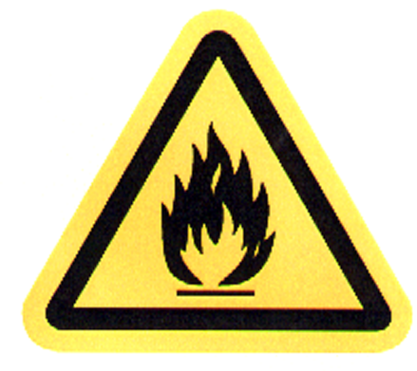
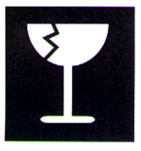
CAUTION
Lithium ion rechargeable batteries inside.
(No lithium metal)
Do not damage or mishandle
this package.

If package is damaged, batteries must be
quarantined, inspected, and repacked.

!
IF DAMAGED

____________

