UN/SCETDG/25/INF.19

COMMITTEE OF EXPERTS ON THE TRANSPORT OF
DANGEROUS GOODS AND ON THE GLOBALLY
HARMONIZED SYSTEM OF CLASSIFICATION
AND LABELLING OF CHEMICALS

Sub-Committee of Experts on the
Transport of Dangerous Goods

Twenty-fifth session
Geneva, 5-14 July 2004
Item 3 (a) of the provisional agenda

EXPLOSIVES, SELF-REACTIVE SUBSTANCES AND ORGANIC PEROXIDES

Classification criteria for fireworks

Transmitted by the expert from Spain

- Introduction

At the 24th session of the Sub-Committee of Experts on the Transport of Dangerous Goods held during December 2003, the expert from Spain introduced INF.50 with preliminary results of Series 6 type (c) test on packaged and unpackaged Flash Bangers, and agreed to perform Series 6 type (a) and (b) tests on different weighed Flash Bangers in order to find the mass explosion limitation (see ST/SG/AC.10/C.3/48/Add.1).
The Series 6 type (a) tests performed by Madariaga Official Laboratory (LOM) on 2,8 net weight Flash Bangers resulted in an unexpected mass explosion. After reflecting on this unforeseen situation, it was decided to perform all Series 6 tests with less weight. The attached document explains Series 6 Tests performed on 1 g and 2 g net weight Flash Bangers.
This paper provides criteria for Flash Bangers classification.
2. Proposal

Modify the table shown in ST/SG/AC.10/C.3/48/Add.1 as follows:

Type | Includes: / Synonym: | Definition | Calibre /Mass | Classification
[Banger | Salute, flash banger, lady cracker | Non-metallic tube containing report composition intended to produce an aural effect | > 2 g flash composition or ? g black powder | 1.1G
[Banger | Salute, flash banger, lady cracker |  | > 1 g and ≤ 2 g flash composition; or ? g black powder | 1.3G
[Banger | Salute, flash banger, lady cracker |  | ≤ 1 g flash composition or ? g black powder | 1.4G]

Annex

SERIES 6 TESTS ON LOW WEIGHT FLASH BANGERS
Jesús García Garzón
Javier Nieto Maestre
Madariaga Official Laboratory (LOM), c/ Alenza, 1 28003 MADRID (SPAIN)

SCOPE

The following tests were performed:

- Series 6(a) Tests on 2 g net weight Flash Bangers 3 tests
- Series 6(b) Tests on 2 g net weight Flash Bangers 3 tests
- Series 6(c) Tests on 2 g net weight Flash Bangers 3 tests

- Series 6(a) Tests on 1 g net weight Flash Bangers 3 tests
- Series 6(b) Tests on 1 g net weight Flash Bangers 3 tests
- Series 6(c) Tests on 1 g net weight Flash Bangers 3 tests

PREPARATION OF TESTS

Fireworks

Flash Bangers 2 g net weight 1 g net weight
Classification: 1.3G 1.4G
Net Explosive Quantity: 2 g 1 g
Nº items per box: 5 5
Nº boxes per wrap: 100 100

An opened wrap that shows the boxes inside is detailed in Figure 1.

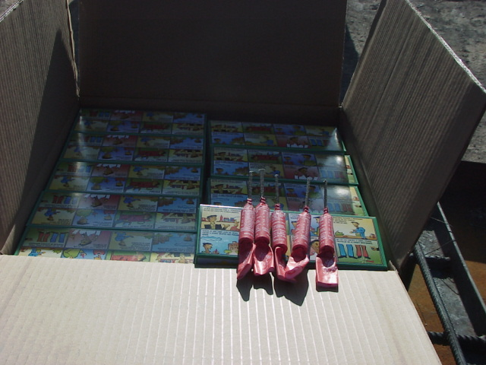

1 g net weight Flash Bangers, opened wrap with boxes and 5 items.

Series 6(a) Test

A closed wrap was placed on a witness plate as shown in Figure 1(1). Then, the wrap was surrounded with sand bags Figure 1(2)) until it was completely covered (Figure 1 (3)).

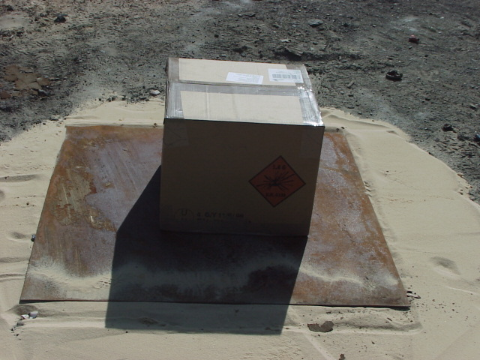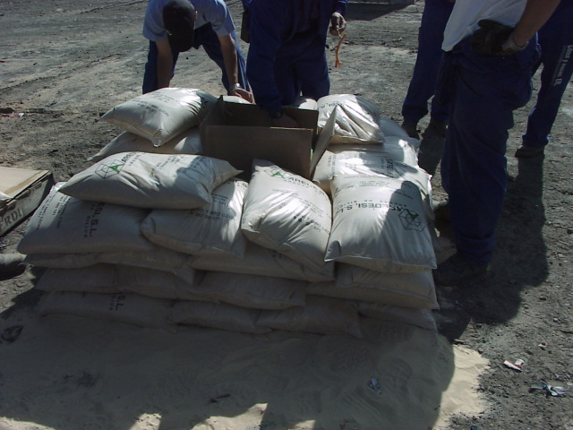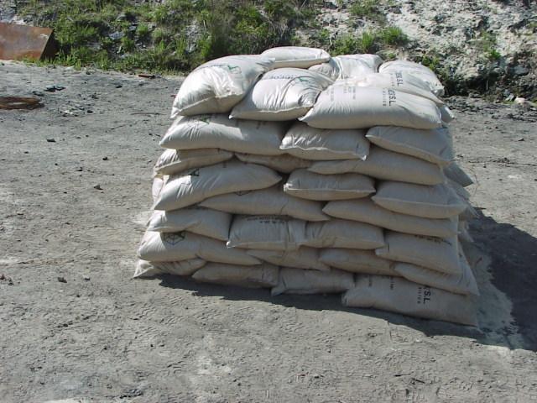
(1) (2) (3)

Preparation of SeriesSeriess 6(a) Test

Series 6(b) Test

Three closed wraps were placed on a witness plate as shown in Figure 2. Then the wraps were surrounded with sand bags until they were completely covered

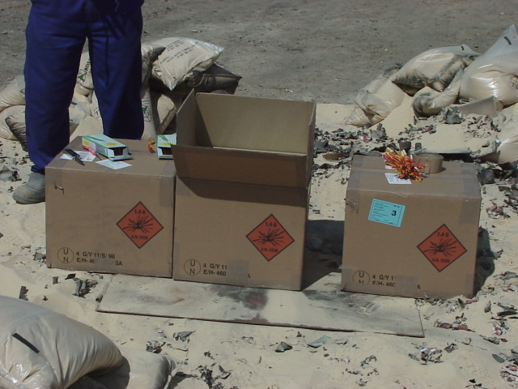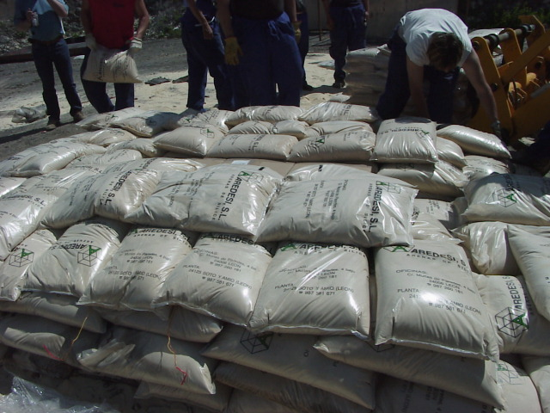

Preparation of SeriesSeriess 6(b) Test

Series 6(c) Test

Three closed wraps were placed on a grid as shown in Figure 3. The grid was on a shelf where some oil was poured in order to get a continuous fire that involved fireworks wraps.
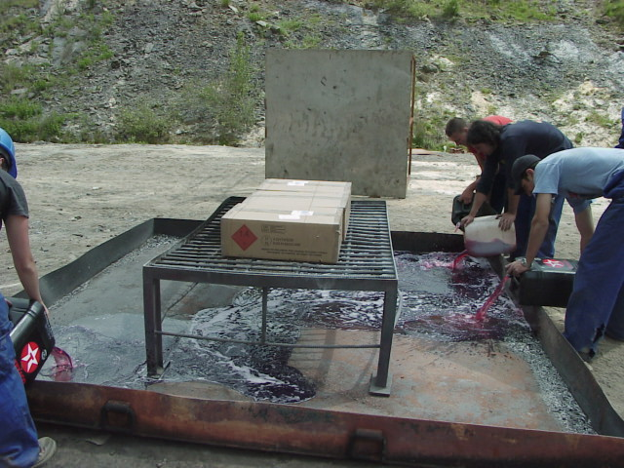

Preparation of Series 6(b) Test

Both the grid and shelf were rounded by three witness plates to detect the projections of fireworks.

RESULTS

- 2 g net weight Flash Bangers

  - Series 6(a) Test

All tests showed several explosions but no mass explosion. Beginning (1) and execution (2) of a test are shown in Figure 4.

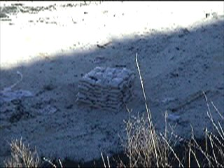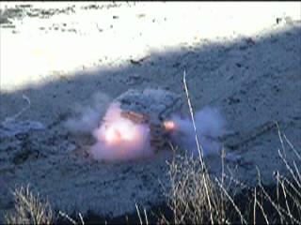
(1) (2)

Beginning and execution of Series 6(a) Test on 2 g. Flash Bangers

Results

- No holes were observed below the fireworks wrap after the test
- Witness plate was not damaged or bent
- No shock wave was detected
- The sand bags were not dispersed

Conclusion

Series 6(b) and 6 (c) Tests were needed to properly classify these fireworks.

  - Series 6(b) Test

All tests showed several explosions but no mass explosion was detected. Beginning (1) and execution (2) of a test are shown in Figure 6

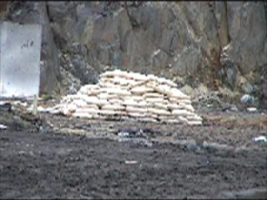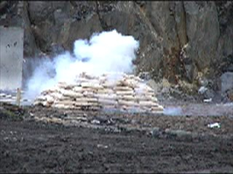
(1) (2)

Beginning and execution of Series 6(b) Test on 2 g. Flash Bangers

Results

- No holes were observed below the fireworks wrap after the test
- Witness plate was not damaged or bent
- No shock wave was detected
- The sand bags were not dispersed

Conclusion

Series 6 (c) Tests were needed to properly classify these fireworks.

  - Series 6(c) Test

Projection of burning objects further than 15 m was observed (1.3G). Fireballs were detected but they did not involve the witness plates. Projection of ignited fireworks was observed.

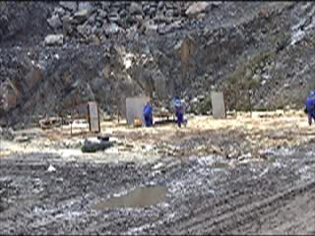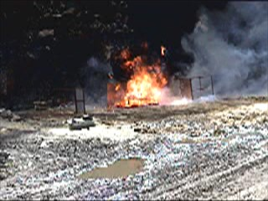
(1) (2)

Beginning and execution of Series 6(b) Test on 2 g. Flash Bangers

Results

- There were fireworks projections
- Burning objects projected further than 15 m from the side of wraps (1.3 G)
- No hole or damage in witness plates was observed.

Conclusion

Classification for 2 g Flash Bangers is HD 1.3G

    - 1 g net weight Flash Bangers

  - Series 6(a) Test

All tests showed several explosions but no mass explosion. Beginning (1) and finishing (2) of a test are shown in Figure 7.

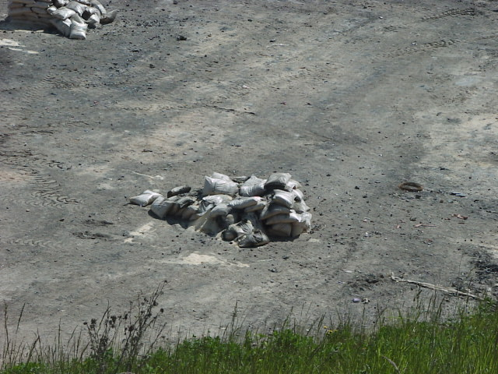
(1) (2)

Beginning and finishing of Series 6(a) Test on 1 g. Flash Bangers

Results

- No holes were observed below the fireworks wrap after the test
- Witness plate was not damaged or bent
- No shock wave was detected
- The sand bags were not dispersed

Conclusion

Series 6(b) and 6 (c) Tests were needed to properly classify these fireworks.

  - Series 6(b) Test

All tests showed several explosions but no mass explosion was detected. Beginning (1) and finishing (2) of a test are shown in Figure 8

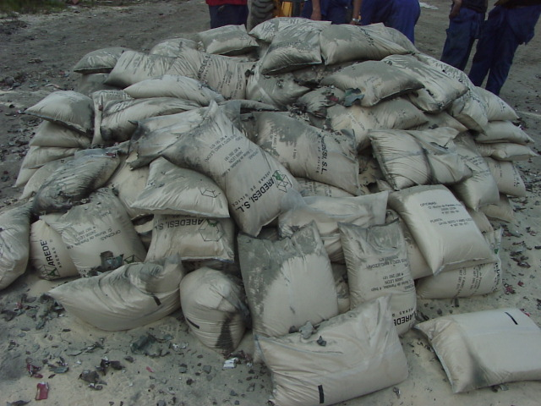
(1) (2)

Beginning and execution of Series 6(b) Test on 1 g. Flash Bangers

Fireworks in two packages were not ignited during the test (Figure 9)

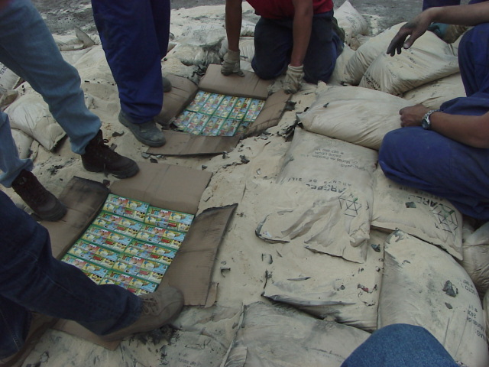

Two packages were not ignited

Results
- No holes were observed below the fireworks wrap after the test
- Witness plate was not damaged or bent
- No shock wave was detected
- The sand bags were not dispersed

Conclusion
Series 6 (c) Tests were needed to properly classify 1 g Flash Bangers.

  - Series 6(c) Test

Projection of burning objects further than 5 m was observed (1.4G) though no objects were found further than 15 m. Fireballs did not involve the witness plates, though they passed flames over 1 m (1.4G). Projection of ignited fireworks was observed.

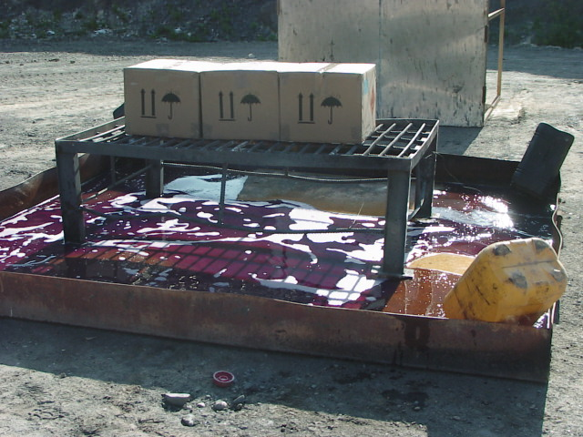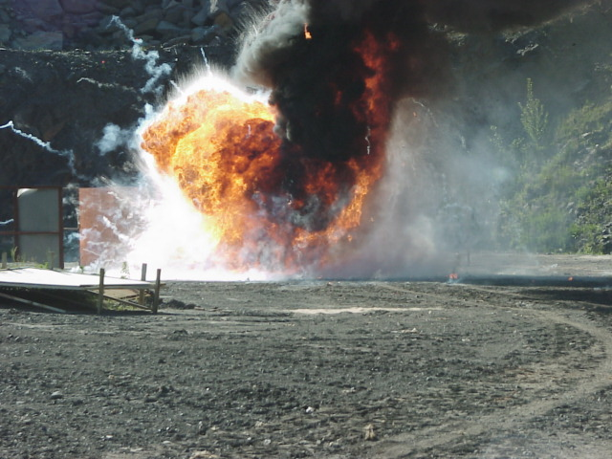
(1) (2)

Beginning and execution of Series 6(b) Test on 1 g. Flash Bangers

Results

- There were fireworks projections
- Burning objects projected further than 5 m from the side of wraps (1.4)
- Fireballs passed flames over 1 m (1.4)
- No hole or damage in witness plates was observed.

Conclusion

Classification for 1 g Flash Bangers is HD 1.4G

FINAL - CONCLUSION

- UN Classification for 2 g. Flash Bangers is 1.3G
- UN Classification for 1 g. Flash Bangers is 1.4G

____________

