UN/SCETDG/22/INF.37

COMMITTEE OF EXPERTS ON THE TRANSPORT OF

DANGEROUS GOODS AND ON THE GLOBALLY

HARMONIZED SYSTEM OF CLASSIFICATION

AND LABELLING OF CHEMICALS

Sub-Committee of Experts on the
Transport of Dangerous Goods
(Twenty-second session, 2-6 December 2002,
agenda item 2)

ADDITIONAL PROVISIONS FOR THE TRANSPORT OF GASES

Cylinder Safety, Beverage Gas

Transmitted by the Expert from the United Kingdom

Background

- The United Kingdom wishes to inform other members of the Sub-Committee of a series of failures of gas cylinders used in the Beverage Gas Industry. These failures have resulted in material damage and have the potential to cause fatalities but to date, due to good fortune, there have been no injuries. Photograph 1 shows the aftermath of one such explosion in the cellar of a public house (bar). This failure occurred at 9pm on a Saturday night but fortunately the floor did not collapse and no one was in the cellar at the moment of the explosion.

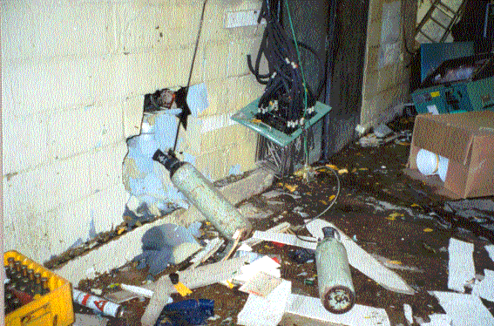

Photograph 1
- To enhance the flow characteristics and taste of some beers a mixture of carbon dioxide and nitrogen is added as the beer is poured. The gas is transported within the United Kingdom as UN 1956, COMPRESSED GAS, N.O.S. The gas is typically stored and transported at 200 bar in either Aluminium alloy or steel gas cylinders. The failures have all been in steel cylinders, which have been made to an approved design specification and tested to 345 bar.

- There have been 14 such failures in a 30-month period and each failure is due to stress corrosion cracking from the inside of the cylinder. In each case moisture has entered an empty cylinder and then remained in the cylinder when it has been refilled. Photograph 2 clearly shows a "waterline" half way up the cylinder wall, this also shows the poor practice of laying a cylinder on its side.

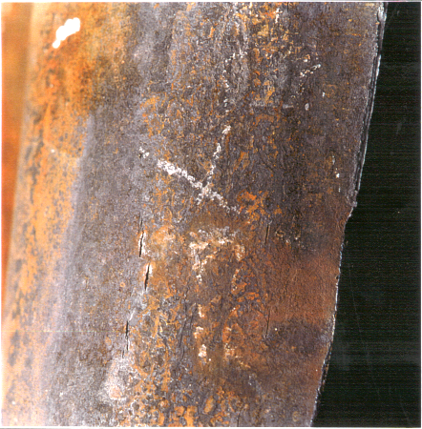

Photograph 2

- In addition, there has been the failure of a supercharged carbon dioxide fire extinguisher, which uses carbon dioxide compressed with nitrogen. In this failure it is believed that the moisture required to initiate the stress corrosion cracking came from water left in the cylinder after hydraulic test. The drying of cylinders after test is adequately covered in all periodic examination standards for gas cylinders and so it is assumed that the test house did not follow these standards.

- In each case the stress corrosion cracking has been extensive with thousands of cracks found on the inner surface of each cylinder. Photograph 3 shows a cylinder that came close to failing into separated parts and photograph 4 shows the inner surface of the same cylinder.

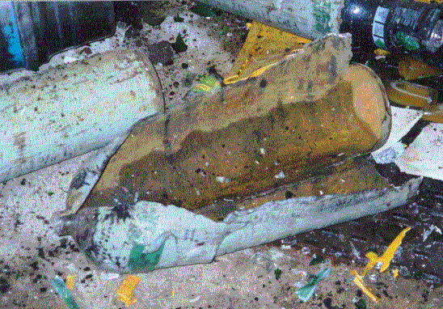

Photograph 3

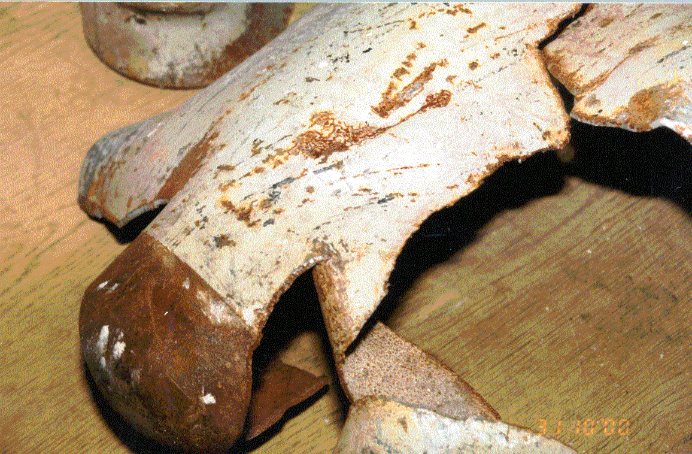

Photograph 4

- This type of failure can be avoided by ensuring that moisture does not enter the cylinder. The fitting of a residual pressure valve, which incorporates a non – return function, and checking at each fill that the valve is working correctly can achieve this. The UK has recommended the use of these valves in the HSE guidance note INDG308 Rev 2 "Safe Use of Gas Cylinders".

- The expert from the United Kingdom is aware that this is a new issue and there is probably not enough time to deal with it fully in the time allotted during the December 2002 Sub-Committee meeting; therefore the proposals to alleviate this problem suggested below are tentative. The United Kingdom is not asking the Sub-Committee to adopt new text this biennium but instead invites comments with a view to putting forward a full working paper for the July meeting 2003 meeting. If appropriate the expert from the United Kingdom would also include a safety data sheet. One approach would be simply to add a new special provision 3xx against UN 1956. An alternative approach would be to introduce a new entry for the carbon dioxide and nitrogen mixture of compressed gas.

Proposals

1. Add the following new entry in the Dangerous Goods List in Chapter 3.2:

"3xxx/CARBON DIOXIDE AND NITROGEN MIXTURE, COMPRESSED/2.2/-/-/3xx/
120 ml/P200/-/-/-"

2. Add a new Special Provision 3xx to Chapter 3.3 to read:

"Where this gas is carried in a steel cylinder for use as a beverage gas, the cylinder shall be fitted with a residual pressure valve, which incorporates a non-return function, that prevents moisture entering the cylinder when empty. The functioning of the residual pressure valve shall be confirmed before each occasion the cylinder is filled."

3. Add the following new entry to Table 1 of Packing Instruction P200 in Chapter 4.1:

"3xxx/CARBON DIOXIDE AND NITROGEN MIXTURE, COMPRESSED/2.2/-/-/x/x/x/x/x/
10/-/-/-"

4. Add the following entry to the index:

"CARBON DIOXIDE AND NITROGEN MIXTURE, COMPRESSED/2.2/3xxx"

Or

Add the following Special Provision 3xxx against UN 1956, to read:

"Where this gas is carried in a steel cylinder for use as a beverage gas, the cylinder shall be fitted with a residual pressure valve, which incorporates a non-return function, that prevents moisture entering the cylinder when empty. The functioning of the residual pressure valve shall be confirmed before each occasion the cylinder is filled."

-----------------------------

