UNITED

NATIONS
STSTE


Distr.
Secretariat

GENERAL

ST/SG/AC.10/C.3/2001/33
3 September 2001

ORIGINAL : ENGLISH

COMMITTEE OF EXPERTS ON THE TRANSPORT OF

DANGEROUS GOODS AND ON THE GLOBALLY

HARMONIZED SYSTEM OF CLASSIFICATION

AND LABELLING OF CHEMICALS

Sub-Committee of Experts on the

Transport of Dangerous Goods

(Twentieth session, 3-12 December 2001,

agenda item 8 (d))

EXPLOSIVES, SELF-REACTIVE SUBSTANCES

AND ORGANIC PEROXIDES

Miscellaneous proposals

Self-reactive substances, Type G

Transmitted by the expert from Germany

Background

Note 1, Chapter 2.4.3.2.3.1 of the UN Model Regulations requires that self-reactive substances, except for Type G, giving also a positive result with the test method for Class 4.2 (see Manual of Test and Criteria, Part III, sub-section 33.3.1.6), shall not be classified in Division 4.2 but in Division 4.1 (see 2.4.2.3.1.1). The competent authority of Germany is of the opinion that self-reactive substances, Type G are not candidates for Class 4.2.

Characteristics for self-reactives, Type G

- No propagation of detonation
- No deflagration
- No effect during heating under confinement
- 75 °C ≥ SADT > 60 °C
- explosive power: none

GE.01-
but all substances of this type and even substances with an SADT > 75 °C will give a positive result (ΔT > 60 K) in the 1 l Bowes-Cameron-test (UN test N.4).

Definitions, Criteria and Models

Definitions and Criteria

 | Self-reactive (class 4.1) | Self heating (class 4.2)
 | SADT <= 75 °C,  models 50-200 l package  ΔH_{decomp} > 300 J/g | 1 l Bowes-Cameron / 140 °C models 27 m³ volume
Application to | Solids + liquids | Solids only
Characteristics | Thermally unstable substances liable to undergo a strongly exothermic decomposition even without the participation of oxygen (air) | Substances, which in contact with air without energy supply are liable to self-heating. The substances will ignite only when in large amounts (kg) and after long periods of time (hours or days)
Initiation | Heat, contact with catalytic impurities, friction of impact | Self-heating of solids, leading to spontaneous combustion, is caused by reaction of the substance with oxygen (in the air) and the heat being developed not being conducted away rapidly enough to the surroundings

Models for Testing

Class 4.1 | Class 4.2
SADT models behavior of 50 – 200 kg packages | 1 l Bowes-Cameron-Test models 27 m³ bulk; reference: charcoal

Testing

- Under Bowes-Cameron conditions, such substances will give the same temperature rise in the presence of air as well as under nitrogen atmosphere
- In a plot of critical temperature vs. volume, the slope for such substances will be considerably flatter than for the self-heating reference system (charcoal)
- The behavior of self-reactive substances is to be described in terms of thermal properties due to decomposition rather than reaction with oxygen (air). Therefore, the SADT is the appropriate criterion rather than the autoignition temperature.
The graph of the auto-ignition temperature of self-heating substances (coal)/critical temperature (SADT) of self-reactive substances (type G) vs. volume of packagings is attached as an annex to this document.
Conclusion

- Self-heating substances exhibit a totally different behavior with respect to oxidation than self-reactive substances, type G
- Thus, self-reactive substances, type G should not be considered for classification under Class 4.2.

Proposal

- Delete Note 1, Chapter 2.4.3.2.3.1 in the Model Regulations and Chapters 20.2.6 and 33.3.1.3.3.5 in the Manual of Tests and Criteria.

Annex
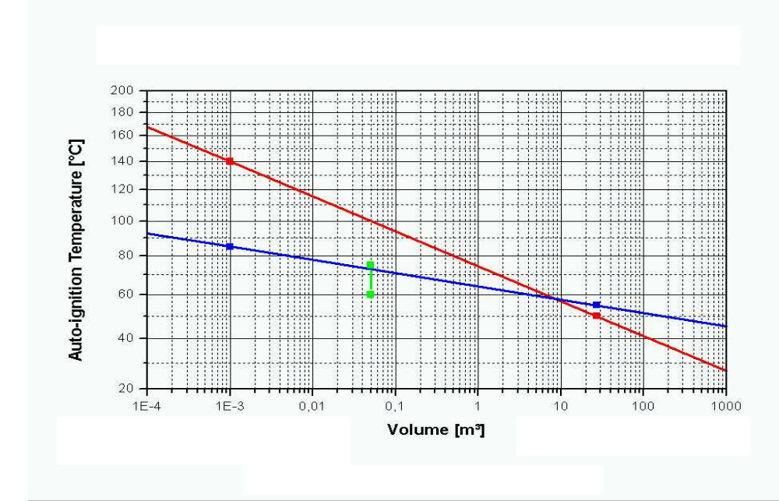
Auto-ignition
temperature
of
coal
Critical
temperature
(SADT)
of a
self-
reactive
substance
SADT (50 kg)
of a
self-reactive
substance
type G
Volume [m³]
Auto-ignition temperature of self-heating substances (coal)/critical temperature (SADT) of self-reactive substances (type G) vs. volume of packagings

