Template for Case Studies

Please submit your respective case study by Tuesday, 31st July 2018 to regulatory.cooperation@un.org.
The Standards for the Sustainable Development Goals (SDGs) event creates an enabling environment for peer learning. Through the sharing of practical solutions, the event will demonstrate the important role of standards in the achievement of the SDGs. Governments, policymakers and standards bodies will learn from sharing concrete experiences, best practices and challenges. Case studies will form the basis of the breakout session.

Governments, policymakers and other stakeholders are kindly asked to provide case studies from their national experience in standards implementation. The case studies will be compiled in a document and shared with participants in advance of the event. The document will also be published online. A selection of case studies will be presented during the Standards for the Sustainable Development Goals event.

WHEN ?
WHY ?

HOW ?

Please fill in the template below. Note: the maximum word count is 1,000 words.
Country
Please specify the country: _________________________________

Please indicate whether the case study applies to the national, subnational or local level. Please tick the relevant box.

☐national level ☐ subnational level ☐ local level

SDG addressed
The case study must address at least one of the SDGs under in-depth review. Please tick the relevant box(es).

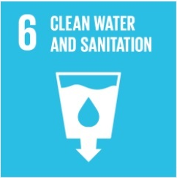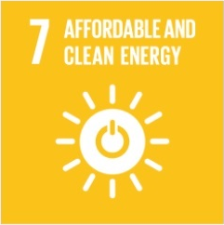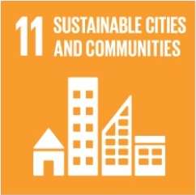
☐ ☐ ☐ ☐

Please list any other SDGs that are addressed (for the full list of SDGs click here).
Title
Please provide a title that reflects the core issues addressed in your case study.

Summary
Please briefly summarise the objective of the case study and the approach chosen (max 200 words).

Background
Please elaborate on the specific situation and what problem you sought to address (max 100 words).

Strategy
Please discuss the standards you used to address the problem.

Results and impact
Please elaborate on the specific impact of the standards. Preferably, summarise the results in bullet points.

Challenges and lessons learned
Please identify challenges encountered during the implementation of the standards and the lessons learned.

Potential for Replication
Please elaborate on whether the concrete experience is replicable in other locations or contexts.

Contact

Name:

Organisation:

Please indicate, if you do not wish your contact details to be published in the compiled document. The document will be published on our website. Please bear in mind, however, that other stakeholders might wish to contact you to replicate the case study.

